
VIVEKANAND EDUCATION SOCIETY’S INSTITUTE OF TECHNOLOGY

(An Autonomous Institute Affiliated to University of Mumbai)

Department of Computer Engineering

Project Report on
Interview IQ: AI Interview System

In partial fulfilment of the Fourth Year, Bachelor of Engineering (B.E.) Degree in Computer Engineering at the University of Mumbai Academic Year 2025 - 26

By

Toshit Hole - D17C/28 Shreyas Bagwe - D17C/05 Jatin Hargunani - D17C/27 Subodh Thalkari - D17C/62

Project Mentor Mrs. Vidya S Zope

(A.Y. 2025 - 26)

VIVEKANAND EDUCATION SOCIETY’S INSTITUTE OF TECHNOLOGY

(An Autonomous Institute Affiliated to University of Mumbai)

Department of Computer Engineering

Certificate

This is to certify that Toshit Hole (D17C-28), Shreyas Bagwe (D17C-05), Jatin Hargunani

(D17C-27), Subodh Thalkari (D17C-62) of Fourth Year Computer Engineering studying under

the University of Mumbai have satisfactorily completed the project on “Interview IQ: AI

Interview System” as a part of their coursework of PROJECT - II for Semester - VIII under the

guidance of their mentor Mrs. Vidya S Zope in the year 2025 - 26.

This thesis/dissertation/project report entitled “Interview IQ: AI Interview System” by Toshit

Hole, Shreyas Bagwe, Jatin Hargunani & Subodh Thalkari is approved for the degree of Bachelor

of Engineering in Computer Engineering.

Programme Outcomes Grade

PO1, PO2, PO3, PO4, PO5, PO6, PO7, PO8, PO9, PO10, PO11, PO12
PSO1 & PSO2

Date:

Project Guide:Mrs. Vidya S Zope

Project Report Approval For
B. E (Computer Engineering)

This project report entitled “Interview IQ: AI Interview System” by Toshit Hole (D17C-28),

Shreyas Bagwe (D17C-05), Jatin Hargunani (D17C-27), Subodh Thalkari (D17C-62) is approved

for the degree of Bachelor of Engineering in Computer Engineering.

Examiners

1. ………………………………

(Internal Examiner name & sign)

2. ……………………………… (External Examiner name & sign)

3. ……………………………… (Head of Department)

4. ……………………………… (Principal)

Date:

Place: Chembur, Mumbai
Declaration

We declare that this written submission represents our ideas in our own words and where others'

ideas or words have been included, we have adequately cited and referenced the original sources.

We also declare that we have adhered to all principles of academic honesty and integrity and have

not misrepresented or fabricated or falsified any idea/data/fact/source in our submission. We

understand that any violation of the above will be cause for disciplinary action by the Institute and

can also evoke penal action from the sources which have thus not been properly cited or from

whom proper permission has not been taken when needed.

----------------------------------------

- (Toshit Hole - D17C / 28)

----------------------------------------

- (Jatin Hargunani - D17C / 27)
----------------------------------------

- (Shreyas Bagwe - D17C / 05)

----------------------------------------

- (Subodh Thalkari - D17C / 62)

Date:

Acknowledgement

We are thankful to our college Vivekanand Education Society’s Institute of Technology for

considering our project and extending help at all stages needed during our work of collecting

information regarding the project.

It gives us immense pleasure to express our deep and sincere gratitude to the Head of the Computer

Department Dr. (Mrs.) Nupur Giri (Project Guide) for her kind help and valuable advice during the

development of project synopsis and for her guidance and suggestions.

We are deeply indebted to our Principal Dr. (Mrs.) J.M. Nair, for giving us this valuable

opportunity to do this project.

We express our hearty thanks to them for their assistance without which it would have been difficult

to finish this project synopsis and project review successfully.

We convey our deep sense of gratitude to all teaching and non-teaching staff for their constant

encouragement, support and selfless help throughout the project work. It is a great pleasure to

acknowledge the help and suggestion, which we received from the Department of Computer

Engineering.

We wish to express our profound thanks to all those who helped us in gathering information about

the project. Our families too have provided moral support and encouragement several times.

COURSE OUTCOMES FOR B.E. PROJECT

Learners will be able to,

Course Outcome

CO1

CO2

CO3

CO4

CO5

CO6

CO7

CO8

CO9

CO10

CO11

CO12
Description of the Course Outcome

Able to apply the relevant engineering concepts, knowledge and skills towards the project.

Able to identify, formulate and interpret the various relevant research papers and to determine the problem.

Able to apply the engineering concepts towards designing solutions for the problem.

Able to interpret the data and datasets to be utilized.

Able to create, select and apply appropriate technologies, techniques, resources and tools for the project.

Able to apply ethical, professional policies and principles towards societal, environmental, safety and cultural benefit.

Able to function effectively as an individual, and as a member of a team, allocating roles with clear lines of responsibility and accountability.

Able to write effective reports, design documents and make effective presentations.

Able to apply engineering and management principles to the project as a team member.

Able to apply the project domain knowledge to sharpen one’s competency.

Able to develop a professional, presentational, balanced and structured approach towards project development.

Able to adopt skills, languages, environment and platforms for creating innovative solutions for the project.

Index

Chapter No

Chapter 1

Chapter 2

Chapter 3

Chapter 4
Title Page No

Introduction 1

1.1. Introduction to the project 1 1.2. Motivation for the project 1 1.3. Problem Definition 2 1.4. Relevance of the Project 3 1.5. Methodology used 4 Literature Survey 5
2.1. Research of papers referred 5 2.2. Patent research summary 5 2.3. Existing Systems 6 2.4 Lacuna in existing systems b. Summary of the patent 6 2.5 Comparison of Existing System and Proposed Work 7 2.6 Focused Work 7 Requirement of Proposed System 8
3.1 Proposed Model 8 3.2 Functional Requirements 8 3.3. Non-Functional Requirements 9 3.4. Hardware & Software Requirements 10 3.5. Constraints of Working System 11 Proposed Design 12
4.1 Block diagram representation of the proposed system 12 4.2. Modular diagram representation of the proposed system 13 4.3 Detailed Design 14 4.4 Proposed Algorithms 16
4.5. Project Scheduling & Tracking ( Gantt Chart ) 16

Chapter 5

Chapter 6

Chapter 7

Chapter 8

Chapter 9

Chapter 10
Results and Discussions 18

5.1. Methodology employed for development 18 5.2 Screenshots of the System 19 Testing of the Proposed System 20
6.1 . Introduction to testing 21 6.2. Types of tests Considered 21 6.3 Various test case scenarios considered 22 6.4. Inference drawn from the test cases 23 Conclusion 24
7.1 Limitations 24 7.2 Conclusion 24 7.3 Future Scope 24 References 25

Appendix 26

9.1.List Of Figures 26 9.2.List Of Tables 26 Paper published 27

Project review sheet 38

List of Figures

Figure Number

1

2

3

4

5

6

7

8

9

10

11

12
Heading

Block Diagram

Modular Diagram

DFD Level 0

DFD Level 1

Flowchart

Gantt Chart

Login Page

Home Page

Interview Settings Page

Interview Page

Explore Page

Interview Setup Page
Page no.

12

13

14

14

15

17

19

19

19

20

20

20

List of tables

Table Number

Table 1

Table 2
Heading

Research Papers Referred

Patent Search Summary
Page no.

5

5

Abstract

InterviewIQ – An AI-Powered Mock Interview Platform is an advanced and intelligent system designed to revolutionize the way individuals prepare for interviews by integrating artificial intelligence, natural language processing, and multimodal analysis. The platform leverages multiple Large Language Models (LLMs) to simulate highly realistic and adaptive interview experiences, providing users with an environment that mirrors real-world professional interactions. It offers both audio and video interview modes, where the audio module focuses on evaluating verbal attributes such as tone, fluency, filler word usage, long pauses, and overall speech confidence, while the video module—powered by OpenCV and MediaPipe—analyzes non-verbal communication aspects such as eye contact, gestures, facial expressions, and posture. A unique feature of InterviewIQ is its AI Interviewer Personalization System, allowing users to choose from four distinct virtual interviewer personas, each with different temperaments and questioning approaches, thereby offering a psychologically diverse and engaging experience.

The platform is designed to provide in-depth analytics and performance feedback post-interview, including verbal and behavioral insights, confidence scores, and detailed evaluations highlighting strengths and areas for improvement. Furthermore, InterviewIQ integrates real-time socket-based communication for seamless interaction, low-latency response generation, and advanced speech-to-text synthesis for accurate evaluation. It also plans to introduce a Retrieval-Augmented Generation (RAG)-based feature, enabling users to upload personal documents or notes from which the AI interviewer can generate context-specific questions and assess responses accordingly.

By combining the capabilities of multi-agent orchestration, cross-LLM intelligence, and adaptive multimodal evaluation, InterviewIQ offers a highly interactive, data-driven, and user-centric approach to interview preparation, empowering individuals to enhance their communication, confidence, and analytical skills, while bridging the gap between traditional mock interviews and next-generation AI-driven career readiness solutions.

Chapter 1: Introduction

1.1 Introduction

Interview preparation plays a pivotal role in shaping an individual's professional journey, as it directly impacts employability, communication confidence, and overall career readiness. Despite the abundance of online learning resources, most candidates still struggle to find platforms that offer personalized, realistic, and adaptive practice environments. Conventional approaches—such as question banks, video tutorials, or manual mock sessions—fail to capture the dynamic and interactive nature of real interviews. These methods often lack flexibility, are costly, and provide minimal feedback on both verbal and non-verbal performance parameters.

With the rapid progress in Artificial Intelligence (AI) and Machine Learning (ML), intelligent interview simulation has emerged as a transformative solution for bridging this gap. AI-driven systems can simulate human-like interactions, generate adaptive questions, and evaluate candidate performance using speech, facial, and behavioral cues. However, most existing tools remain limited to text-based interfaces, offering little real-time adaptability or multimodal analysis. They often fail to assess communication confidence, body language, or engagement, which are crucial for holistic interview preparation.

InterviewIQ addresses these limitations by introducing a multi-agent, multimodal AI-powered mock interview platform that enables users to practice interviews through both audio and video modes. The system utilizes powerful LLM-based intelligence to create realistic, domain-specific, and context-aware interview experiences. It further evaluates users on speech patterns, filler words, gesture tracking, and confidence levels—providing detailed analytical feedback and performance reports. By combining adaptability, inclusivity, and interactivity, InterviewIQ aims to redefine how candidates prepare for real-world interviews.

1.2 Motivation

In today's competitive job landscape, candidates face immense pressure during interviews, often due to lack of realistic practice and constructive feedback. While

1

professional coaching and paid mock interviews exist, they are expensive, geographically restricted, and non-scalable. Furthermore, the majority of existing online tools are limited to text-based question-answer modules, offering no real-time adaptability or behavioral assessment.

The motivation behind developing InterviewIQ stems from the need to democratize high-quality interview preparation through AI-driven intelligence. The system not only helps users improve their technical and communication skills but also focuses on confidence building by simulating real-life interaction scenarios. It offers multiple interview types such as Technical, HR, Finance, Marketing, and Sales, with subcategories like Data Structures and Algorithms, Frontend, Backend, and DevOps for technical interviews. This allows users to prepare for specific domains of their choice.

A distinctive motivation is to create diverse AI interviewer personas, enabling users to choose their interviewer's gender, tone, and attitude. The system includes four interviewer profiles—two female (a strict senior interviewer and a confident young professional) and two male (an experienced elder mentor and a young supportive interviewer). These personalities help simulate varied interview environments, reducing anxiety and improving adaptability. Thus, InterviewIQ's motivation lies in creating a personalized, affordable, and psychologically enriching learning experience for every user.

1.3 Problem Definition

Despite the technological progress in AI-based assessment tools, interview simulation remains underdeveloped in terms of realism, personalization, and feedback. Existing systems suffer from the following limitations:
• Lack of Adaptability: Most platforms use pre-defined question sets without context-aware follow-ups.
• Absence of Multimodal Analysis: Current solutions rarely combine audio and video cues for holistic evaluation.
• Limited Diversity: Users cannot choose interviewer behavior or tone, which is crucial for real-world readiness.

2

• Inadequate Feedback: Feedback is often generic and lacks detailed analytics on communication or behavioral traits.
• Cost and Accessibility Issues: Many tools rely on premium APIs or closed-source platforms, restricting access.

Hence, the core problem addressed by this project is: To design and develop a scalable, multimodal AI-powered interview simulation platform that integrates multiple LLMs and computer vision techniques to evaluate users comprehensively across technical, communication, and behavioral parameters, while offering interviewer personalization and detailed analytical feedback.

1.4 Relevance of the Project

InterviewIQ holds significant relevance in the modern employment and education ecosystem, where virtual hiring and remote assessments are rapidly becoming the norm. Organizations are increasingly adopting AI-assisted recruitment processes, and candidates must adapt to these evolving interview environments. By providing a realistic, adaptive, and feedback-oriented mock interview platform, InterviewIQ aligns with global trends in AI-based education and professional training.

From an academic and technological perspective, the project contributes to the domains of Conversational AI, Computer Vision, and Speech Processing, offering practical insights into their integration. It supports the goals of AI-driven skill development and digital employability enhancement. Furthermore, the project aligns with the United Nations Sustainable Development Goal (SDG) 8 – Decent Work and Economic Growth, by enabling equitable access to career-preparation resources.

In summary, InterviewIQ's relevance is defined by its potential to:

• Enhance confidence and communication skills through realistic simulation.

• Bridge the accessibility gap by offering an affordable, cloud-based platform.

• Enable fair and transparent evaluation using data-driven analytics.

• Advance AI's role in ethical, inclusive, and personalized education.

3

1.5 Methodology Used

The development methodology for InterviewIQ is structured into distinct but interconnected stages that ensure accuracy, adaptability, and performance efficiency:

Step 1: Data and Model Integration

The platform integrates multiple LLMs (OpenAI, Claude, Gemini, Groq) for diverse question generation, response evaluation, and contextual adaptation. It leverages publicly available question datasets and fine-tuned dialogue prompts to ensure domain variety and natural flow.
Step 2: Multimodal Architecture Development

Two interaction modes—Audio and Video—are implemented. The Audio module utilizes Whisper ASR for speech-to-text conversion and Coqui TTS for AI interviewer voice synthesis. The Video module employs OpenCV and MediaPipe to detect facial expressions, eye contact, and gestures. Combined, these create a holistic feedback mechanism covering both verbal and non-verbal communication.
Step 3: Interviewer Personalization

A multi-agent architecture assigns unique behavioral parameters to each AI interviewer persona. This affects question tone, difficulty, and interaction style, allowing users to experience varied psychological environments similar to real interviews.
Step 4: Analytics and Feedback System

Post-interview, the platform generates a comprehensive analytical report summarizing metrics like filler word frequency, pause duration, confidence score, facial engagement, and response relevance. These are visualized using dashboards for clarity and progress tracking.
Step 5: Deployment and Testing

The entire system is built using a MERN-based stack (MongoDB, Express, React, Node.js) with Python microservices for AI modules. The web application will be deployed on cloud infrastructure, ensuring accessibility and scalability. User feedback and continuous testing will guide refinements for Stage-2 development.

4

Chapter 2: Literature Survey

2.1 Research Papers Referred

Sr no

1

2

Paper Title & Authors Year

Chen, L., Wang, S., & Liu, H. –
"AI in Education: Applications 2023 and Methodologies"

Orak, C. & Turan, Z. – "Using AI
in Digital Interview and 2024 Assessment Systems"

Patel, D., & Mehta, V. – "Speech

Description / Methodology

Discusses the application of AI models in educational systems for adaptive learning and student evaluation.

Explores the use of NLP and sentiment analysis in virtual interviews to measure communication skills.

Describes speech recognition
Inference / Relevance to Project

Establishes how AI can personalize assessment processes and improve learner outcomes.

Provides insight into using NLP for candidate evaluation, applicable to InterviewIQ's feedback module.

Supports InterviewIQ's use

3 Recognition for Interactive 2023 (ASR) integration for of Whisper ASR for

Learning Environments"

Gupta, P., Sharma, K., & Rao, A. 4 – "Machine Learning Models for
Soft Skill Assessment"
interactive educational tools.

Describes ML models for 2022 evaluating communication and
personality traits.
speech-to-text conversion.

Reinforces the need for analytics-driven evaluation of communication and
personality traits.

Krishnan, N. – "AI Agents: Explains how multi-agent Provides a foundation for 5 Architecture and Real-World 2025 systems coordinate tasks in InterviewIQ's multi-agent
Applications" complex AI applications. orchestration design.

2.2 Patent Search Summary

Sr. No.

1

Patent Title

System and Method for Conducting Virtual Interviews Using Artificial Intelligence

Interactive Interview Simulation

Patent No. / Year

US 2021015678 9 A1
(2021)

Relevance to Interview-IQ

Provides foundational insight into integrating AI for candidate evaluation and emotion recognition during interviews.

Supports the development of InterviewIQ's

2 Platform with Speech and EP 3856721 A2 (2022) audio-interview mode using speech analytics

3

4
Emotion Recognition

Method for Generating Dynamic Question Sets in AI-Based Training Systems

Computer Vision-Based
Behavioral Assessment System

US 2022009145 7 A1 (2022)

WO 2020034781 A1
(2020)
and filler word detection.

Aligns with InterviewIQ's adaptive question-generation system powered by LLMs for context-aware questioning.

Forms the conceptual basis for InterviewIQ's
video interview mode using OpenCV and

5

MediaPipe for gesture and eye-contact analysis.

2.3 Existing Systems

Tool Name Key Features Target Users Limitations

Provides real-time AI

Final
Round AI
assistance during live interviews; supports answer structuring, coding help, and
JD-based preparation.
Job seekers needing real-time guidance during technical or
HR interviews.
May raise ethical concerns if used during actual interviews;
limited learning feedback.

Remasto AI
Offers mock interviews based on job roles or companies; includes resume builder and
basic feedback analytics.

Students and preparing for
interviews.

professionals
role-specific

Text-based only; lacks voice interaction and adaptive
learning capability.

Conducts AI-based mock

Interviews
Chat
interviews with smart follow-up questions and performance summaries; includes resume and cover letter review.

Enterprise tool for AI-driven

Candidates behavioral
interviews.

preparing for
and technical

No voice or video-based interaction; feedback is generic
and not deeply personalized.

candidate screening; performs Sapia AI text-based, bias-free
assessments with personality
analytics.

HR teams and recruiters
conducting large-scale hiring.
Designed for companies, not learners; lacks real-time or
speech-based interaction.

2.4 Lacuna in Existing Systems

While existing systems demonstrate the growing influence of AI in interview preparation and recruitment, several gaps remain unaddressed:
1. Absence of Speech Interaction: Most tools rely solely on text-based inputs without incorporating natural speech recognition or voice synthesis.
2. Lack of Real-Time Adaptability: Questions are pre-defined and do not evolve based on user responses.
3. Limited Educational Feedback: Current platforms focus on evaluation rather than continuous learning improvement.

6

2.5 Comparison of Existing System and Proposed Work

Sr
no

Existing Systems

Existing platforms primarily offer text-based or

Proposed Work

InterviewIQ provides fully interactive audio and

limited interactive mock interview experiences. video-based interviews powered by LLMs capable 1 These systems generate pre-defined questions of adapting questions dynamically to user
without real-time adaptability and often lack responses, ensuring a realistic and personalized

2

3

4
multimodal input support.

Most existing tools focus only on textual responses and ignore non-verbal communication elements such as tone, pauses, or gestures.

Feedback provided in existing systems is generic or score-based, offering limited actionable insights.

Existing solutions do not allow interviewer personality customization and treat every
interaction the same way.
experience.

InterviewIQ integrates speech analysis (detecting filler words, pauses, and tone) and computer vision analytics (eye contact, facial expressions, gestures) for holistic evaluation.

InterviewIQ generates comprehensive performance reports with analytics on communication clarity, confidence, domain knowledge, and behavioral traits.

InterviewIQ introduces AI interviewer personas—four distinct profiles (two male, two female) with varying tones and strictness, allowing
users to choose interviewer preferences.

2.6 Focused Work

The primary focus area of InterviewIQ is to develop a multimodal, adaptive, and intelligent interview simulation platform that provides a realistic and personalized experience to every user. The system emphasizes AI-driven question adaptability, speech and gesture-based evaluation, and customizable interviewer personas to simulate diverse real-world interview environments.
By integrating advanced LLM-based reasoning, speech analytics, and computer vision modules, InterviewIQ ensures holistic assessment across technical, communication, and behavioral dimensions. The project's central aim is to make interview preparation interactive, data-driven, and accessible, enabling users to gain confidence, receive constructive insights, and enhance their employability through continuous AI-guided improvement.

7

Chapter 3: Requirement of Proposed System

3.1 Proposed Model

The proposed model of InterviewIQ follows a modular, service-oriented architecture designed for scalability, adaptability, and real-time performance. It is structured into three core layers — the Presentation Layer, Application Layer, and Data & AI Layer. The Presentation Layer, built using React.js and Tailwind CSS, serves as the user interface where candidates interact through audio or video interviews. The Application Layer, developed with Node.js and Express, manages communication between the frontend and backend through secure RESTful APIs and WebSockets for real-time data flow.

The AI and Data Layer integrate multiple components, including LLM-based question generation, speech analysis (Whisper ASR), and computer vision modules (OpenCV & MediaPipe). These components collectively handle natural language understanding, filler word detection, facial and gesture analysis, and feedback synthesis. All data—such as user profiles, session records, and analytics reports—are securely stored in MongoDB. This layered architecture ensures modularity, allowing each subsystem (AI, video processing, analytics, and storage) to function independently while maintaining seamless integration across the platform.

3.2 Functional Requirements

The functional requirements of InterviewIQ define the core operations and behaviors expected from the system to ensure smooth and intelligent interview simulation. Key Functional Requirements:
1. User Registration and Authentication – The system must allow users to securely register, log in, and manage profiles.
2. Interview Mode Selection – Users should be able to choose between audio and video interview modes.
3. Domain and Subdomain Selection – Users must select the interview category (e.g., Technical, Finance, Marketing, Sales) and subdomain (e.g., DSA, Frontend, Backend).

8

4. AI Interviewer Personalization – The system should enable users to select from four AI interviewer personas (strict/lenient, male/female).
5. Dynamic Question Generation – The AI module should generate context-aware, adaptive questions using LLMs based on user responses.
6. Speech Processing – In audio interviews, the system must analyze speech for filler words, long pauses, tone, and fluency.
7. Video Analysis – In video interviews, the system should use OpenCV and MediaPipe to evaluate eye contact, gestures, and facial expressions.
8. Real-time Feedback – The system should provide real-time conversational flow between the AI interviewer and the user.
9. Performance Analytics Generation – After each interview, the system must generate a detailed report showing scores for technical accuracy, communication, confidence, and behavioral indicators.
10. Interview History Management – The platform must store all past interview sessions and analytics for future reference.
11. Admin Dashboard – An admin module should monitor usage statistics, feedback trends, and system performance.
12. Cloud Deployment and Accessibility – The system should be deployable on cloud servers, allowing access from any device through a web browser.

3.3 Non-Functional Requirements

Performance: Real-time AI processing must be efficient, though slight latency may occur.
Usability (UX): Must feature a user-friendly interface.

Reliability: The system must ensure accurate speech recognition (Whisper ASR) and realistic voice synthesis (Coqui TTS).
Scalability: Must be able to handle increasing user traffic and data.

Security: Implement authentication middleware and API request validation for secure operations.

9

3.4 Hardware & Software Requirements

Hardware Requirements:

• Development System: Laptop/PC with minimum Intel i5 / AMD Ryzen 5 processor or higher.
• Memory (RAM): Minimum 8 GB RAM (16 GB recommended for smoother AI and video processing).
• Storage: Minimum 256 GB SSD for local development and dataset storage.

• Graphics Support: GPU-enabled system (optional but beneficial for faster AI inference).
• Internet Connectivity: Stable broadband connection for accessing cloud services and APIs.
• Deployment Server: Cloud-based virtual machine (AWS EC2 / Google Cloud / Render) with 4 vCPUs, 8 GB RAM, and Docker support.

Software Requirements:

• Operating System: Windows 10/11, macOS, or Ubuntu Linux.

• Frontend: React.js, Tailwind CSS.

• Backend: Node.js, Express.js.

• Database: MongoDB (v5.0 or later).

• AI and ML Modules: Python (v3.10+), LangChain, Whisper ASR, Coqui TTS, OpenCV, MediaPipe.
• API and Development Tools: Postman, Docker & Docker Compose, Git & GitHub, VS Code.
• Web Communication Frameworks: WebRTC, Socket.io for real-time interview interactions.
• Cloud Deployment Tools: NGINX (reverse proxy and static file serving), Render / Vercel for hosting.

10

3.5 Constraints of Working System

• API Dependency: The system's performance depends on third-party AI APIs for language, speech, and vision processing, which may introduce latency or downtime.
• High Computational Demand: Real-time audio and video processing, along with LLM inference, require substantial processing power and memory resources.
• Network Reliability: The platform's real-time interaction relies heavily on stable internet connectivity; poor bandwidth can disrupt interviews or delay responses.
• Operational Cost: Using premium APIs and cloud-based GPU instances increases development and maintenance costs.
• Data Privacy and Security: Storing and processing user audio/video data must comply with strict security standards to ensure confidentiality and prevent misuse.
• Limited Time for Development: Academic project timelines restrict the integration of advanced features and extensive user testing within the initial development phase.

11
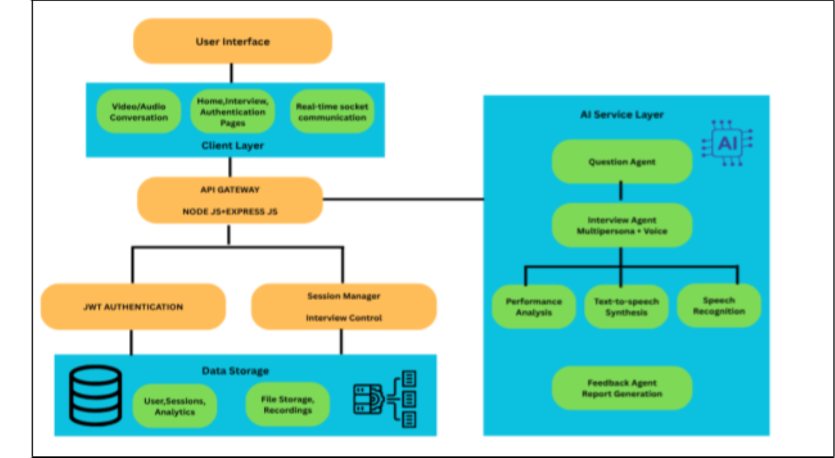
Chapter 4: Proposed Design

4.1 Block Diagram of the Proposed System

Fig. 1: Block Diagram

The above block diagram represents the overall system architecture of InterviewIQ, showing how different components interact to deliver AI-driven mock interviews.
User Interface Layer: This is the front-end where users interact with the system. It includes pages for home, login, interview sessions, and real-time video/audio conversations. Communication with the backend happens via socket connections for live interaction.
Client Layer: Built with React.js, this layer handles all visual and interactive elements, manages user input/output, and maintains smooth real-time communication during interviews.
Data Storage: Uses MongoDB to store user data, session history, analytics, and recorded files. It ensures persistence of all interview-related data.
AI Service Layer: This is the system's intelligence core. It includes multiple AI agents: Question Agent – Generates adaptive questions using LLMs; Interview Agent – Conducts

12
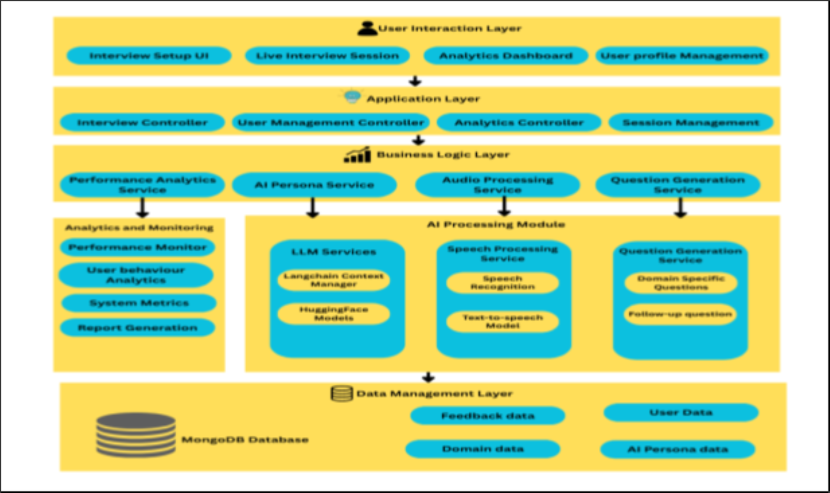
the interview with selected persona and voice; Speech Recognition Module – Converts user speech to text; Text-to-Speech Module – Converts AI responses to realistic voice; Performance Analysis & Feedback Agent – Evaluates speech, gestures, and responses to generate detailed reports and analytics.

4.2 Modular Diagram

Fig. 2: Modular Diagram

InterviewIQ’s modular diagram shows how components interact to deliver AI mock interviews. The User Interaction Layer handles interview setup, sessions, analytics, and profiles. The Application Layer manages users, sessions, and analytics processing.

The Business Logic Layer includes Performance Analytics, AI Persona, Audio Processing, and Question Generation. The AI Processing Module integrates LLMs, speech, and adaptive questioning. Analytics tracks performance, while MongoDB stores user data and configurations.

13
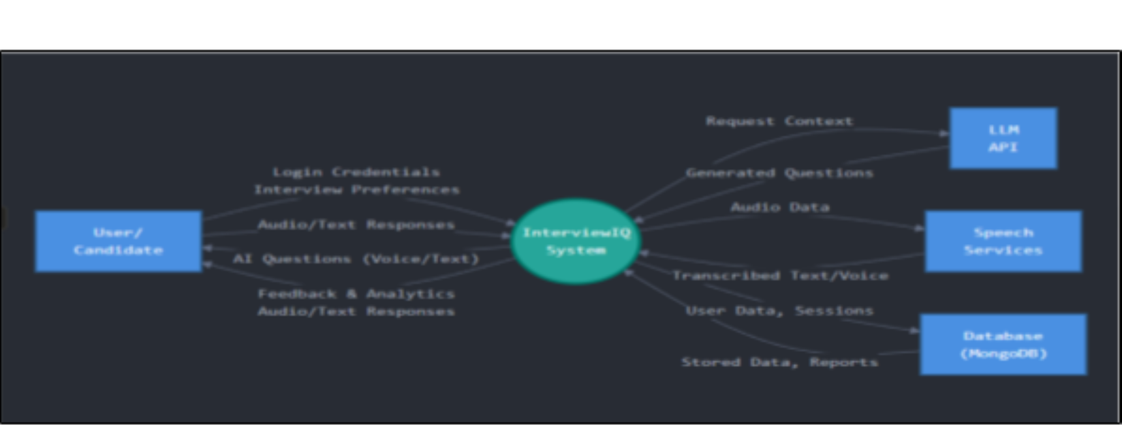
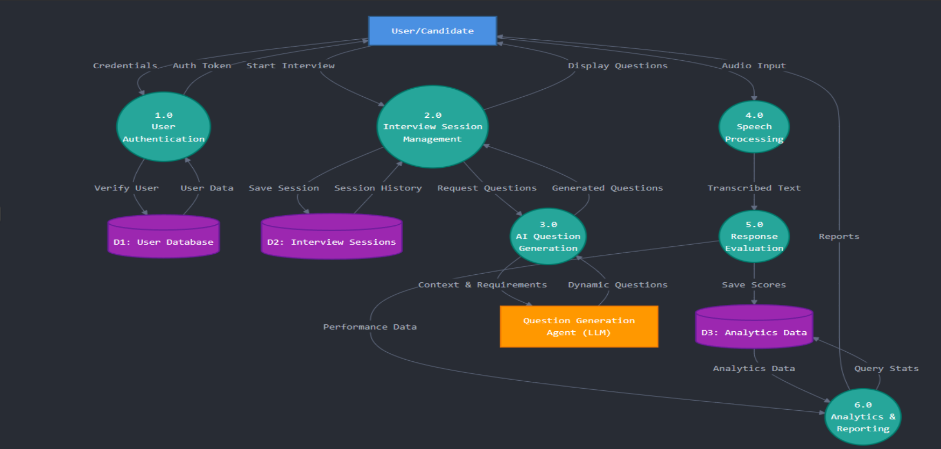
4.3 Detailed Design

DFD Diagram – Level 0

Fig. 3: DFD Level-0 Diagram

Level-0 DFD shows InterviewIQ as one process, taking login data, interview preferences, and responses, interacting with LLM API, speech services, and MongoDB.

DFD Diagram – Level 1

Fig. 4: DFD Level-1 Diagram

Level-1 DFD breaks the system into six processes: User Authentication, Interview Management, AI Question Generation, Speech Processing, Response Evaluation, and Analytics, linked with user, session, and analytics data stores.

14
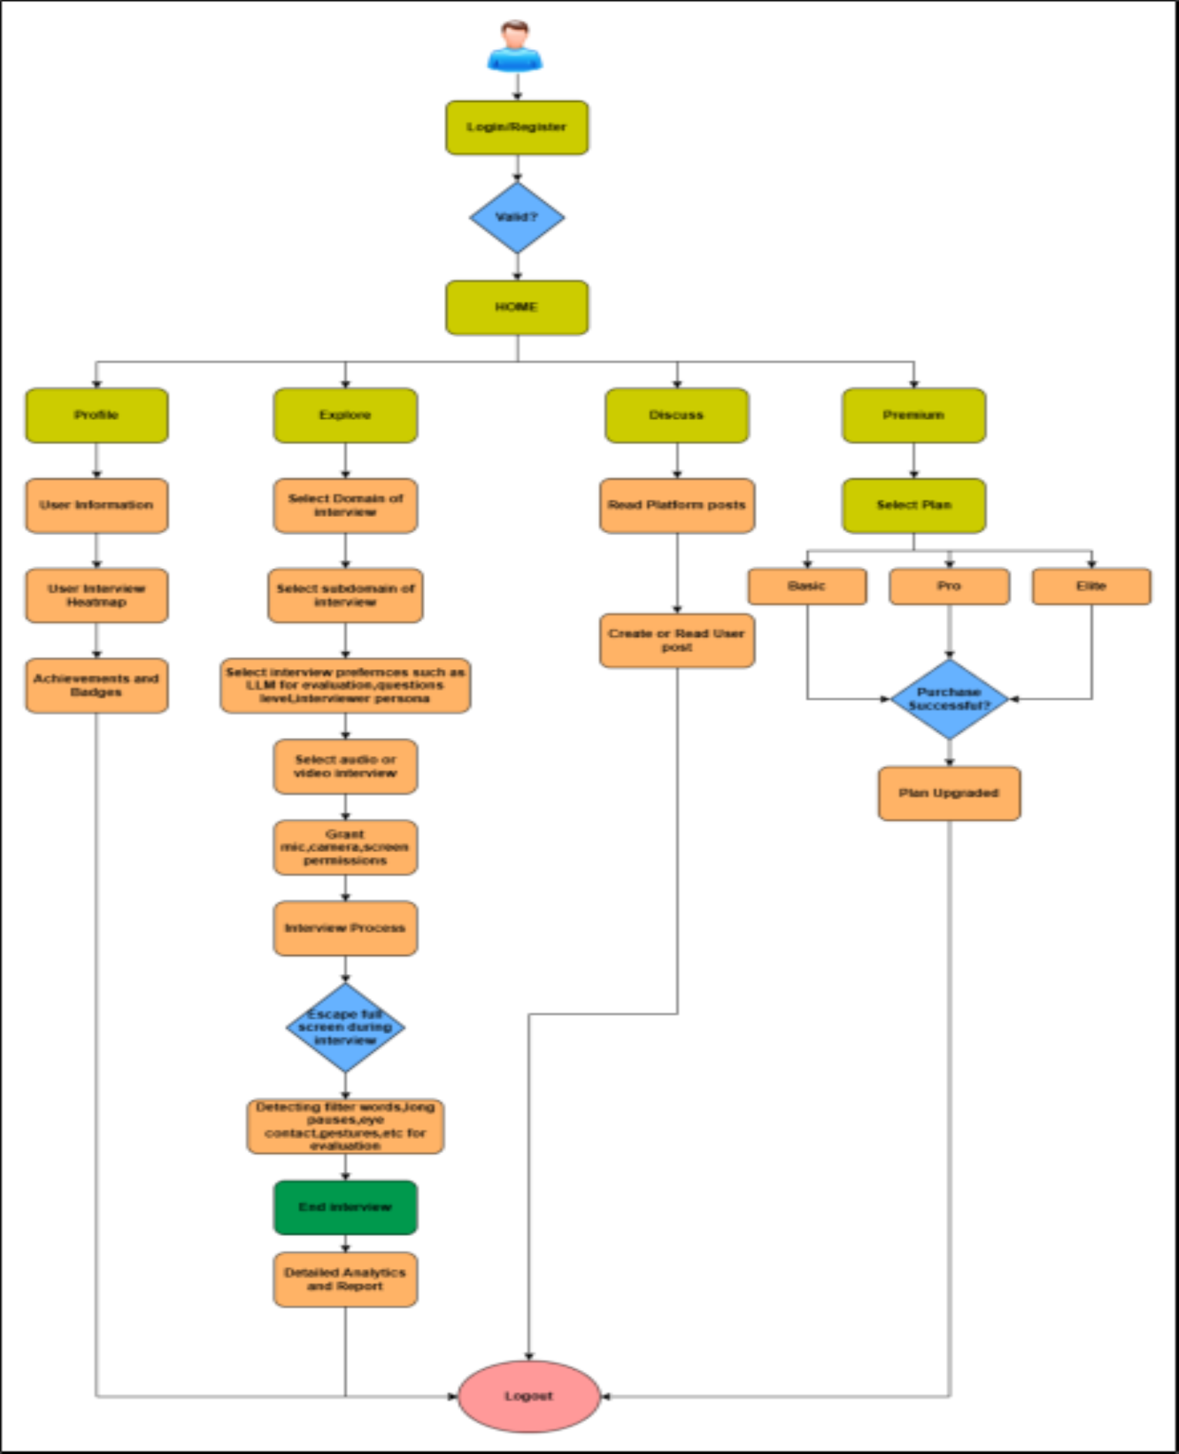
Flowchart

Fig. 5: Flowchart

The flowchart begins with user Login/Register, followed by navigation to Home, then selecting an interview domain and subdomain. The user sets preferences (LLM, difficulty, persona), selects audio or video mode, grants required permissions, and enters the interview process. During the interview, the system detects filler words, long pauses, eye

15

contact, and gestures. After the interview ends, detailed analytics and reports are generated, and the user can logout.

4.4 Proposed Algorithms

Step No.

1

2

3

4

5

6

7
Process / Description

User Authentication and Initialization: The user logs into the system, selects the interview mode (audio/video), preferred interviewer persona, and desired domain or subdomain.

Interview Session Setup: The system initializes the interview session through the API Gateway, establishes real-time socket communication, and activates the selected AI interviewer.

Dynamic Question Generation: The LLM-based Question Agent generates context-aware questions according to the user's chosen field and previous responses. Difficulty level and flow adapt dynamically.

Audio/Video Input Processing: The system captures the user's voice and video in real time. Audio is processed through speech-to-text (Whisper ASR) and analyzed for filler words, pauses, tone, and fluency. Video input is analyzed using OpenCV and MediaPipe for gestures, eye contact, and expressions.

Response Evaluation: The AI Interview Agent evaluates both verbal and non-verbal responses, scoring parameters such as confidence, clarity, engagement, and technical accuracy.

Feedback and Report Generation: The Feedback Agent compiles results into a comprehensive analytics report highlighting strengths, weaknesses, and overall performance trends.

Data Storage and Analytics Update: Session data, reports, and metrics are securely stored in
MongoDB, updating the user's profile and progress analytics dashboard.

4.5 Project Scheduling & Tracking using Timeline / Gantt

Chart

The InterviewIQ Timeline 2025 – Gantt Chart illustrates the structured project

development plan, highlighting major phases, tasks, and their respective durations from August to November 2025. The project begins with the Planning phase, covering topic discussion, requirement gathering, and synopsis submission. It then progresses to the Initial Working phase, focusing on frontend and backend development. Following the first review, the team worked on feedback implementation, conducted existing system research, and developed the Flask API for AI and audio processing. The Advanced Development Phase involved integrating AI agents, speech-to-text systems, and real-time socket communication, followed by Review-2. Finally, the Final Touch phase focuses on improving features based on feedback and completing Review-3.

16
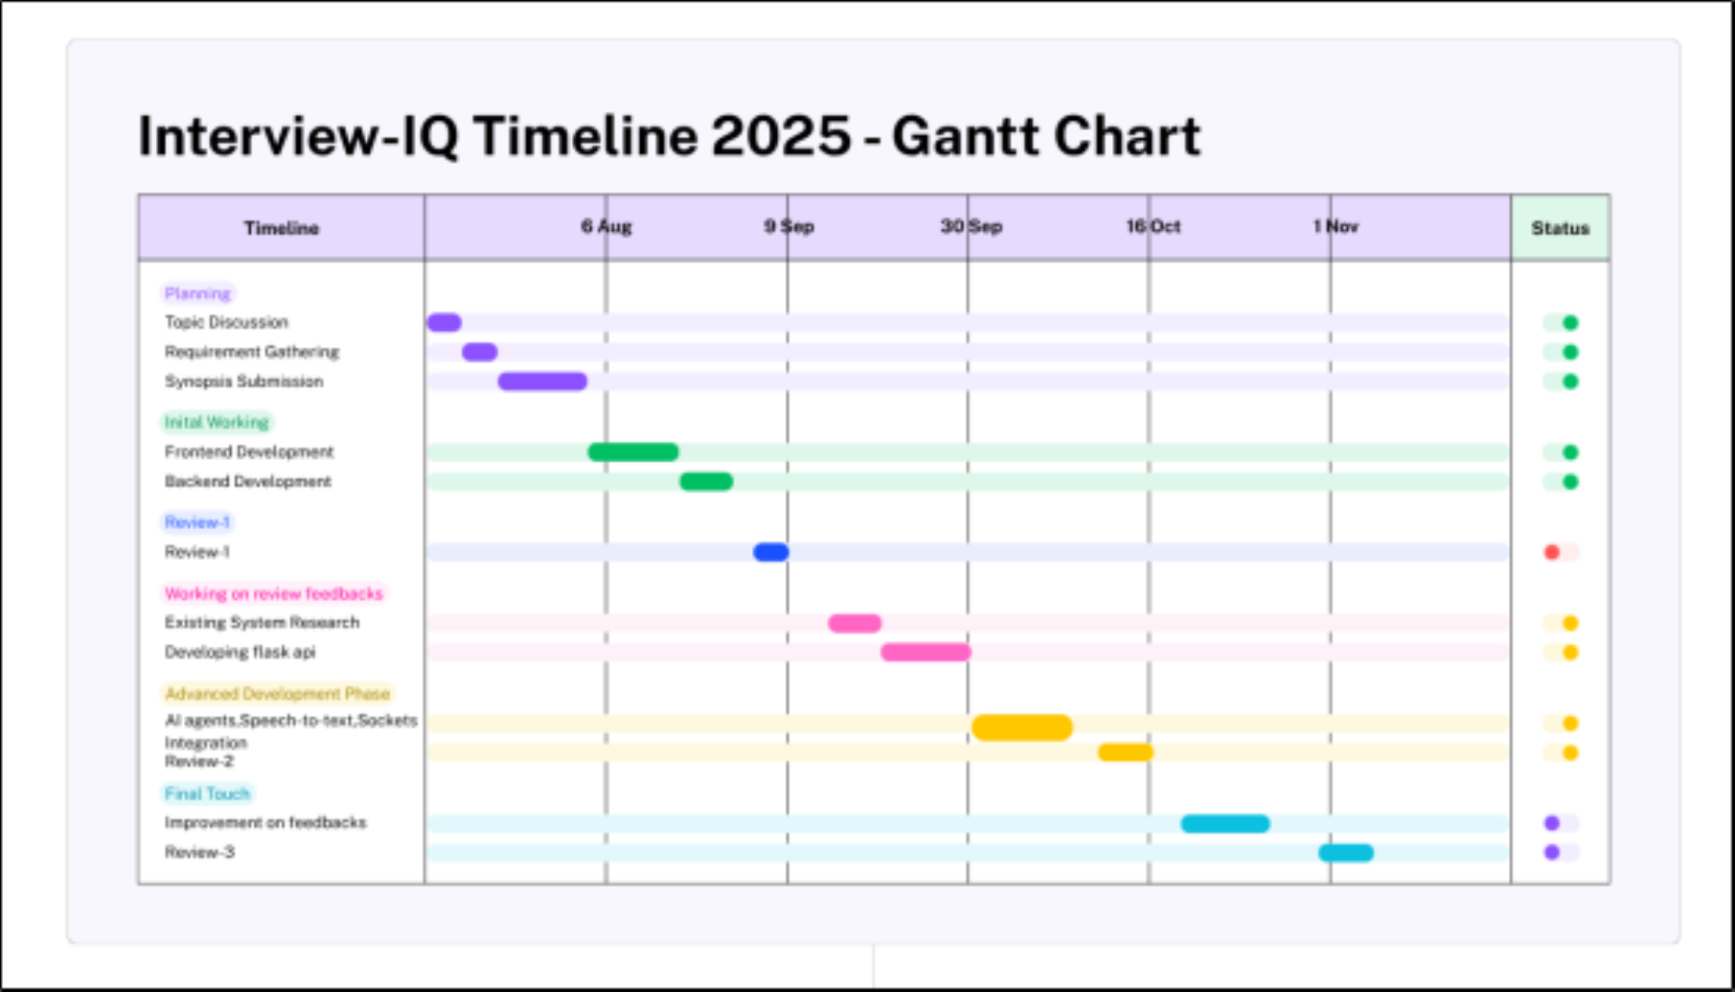

Fig. 6: Gantt Chart

17

Chapter 5: Results and Discussions

4.1 Methodology employed for development

The development of InterviewIQ has successfully reached a major milestone, with most

of the system's core functionalities implemented and tested. The frontend module, built using React.js, has been completed with an intuitive and responsive user interface that allows seamless navigation across modules such as interview setup, live session, analytics dashboard, and profile management. On the backend, major services have been developed using Node.js and Express.js, ensuring secure data flow and efficient API handling. User authentication, session management, and interview preparation modules are fully functional, providing a smooth and secure experience for all users.

A dedicated Flask-based API has been successfully designed and integrated for handling AI operations such as interview question generation using LLMs and speech-to-text synthesis for real-time interaction. The system now allows users to choose their preferred interviewer persona (from four AI interviewers) and even select which LLM they want to evaluate their responses. Real-time interview sessions are running successfully with Socket.io integration between the React client and Flask backend, enabling continuous question-answer communication without noticeable lag.

In terms of performance, the latency in question generation and AI response has been significantly minimized, leading to smoother interviews. The system also detects long pauses and hesitation patterns in user speech, adjusting the confidence score accordingly. The filler word detection module is currently under refinement to enhance its accuracy and evaluation reliability. After each interview, users receive a comprehensive analytics report that summarizes their strengths, weaknesses, and performance trends.

The platform also supports multiple interview domains, including Technology, Finance, Marketing, and Sales, each with several specialized subfields. The MongoDB database has been successfully configured to store user information, session history, and analytics data, ensuring persistence and scalability.

18
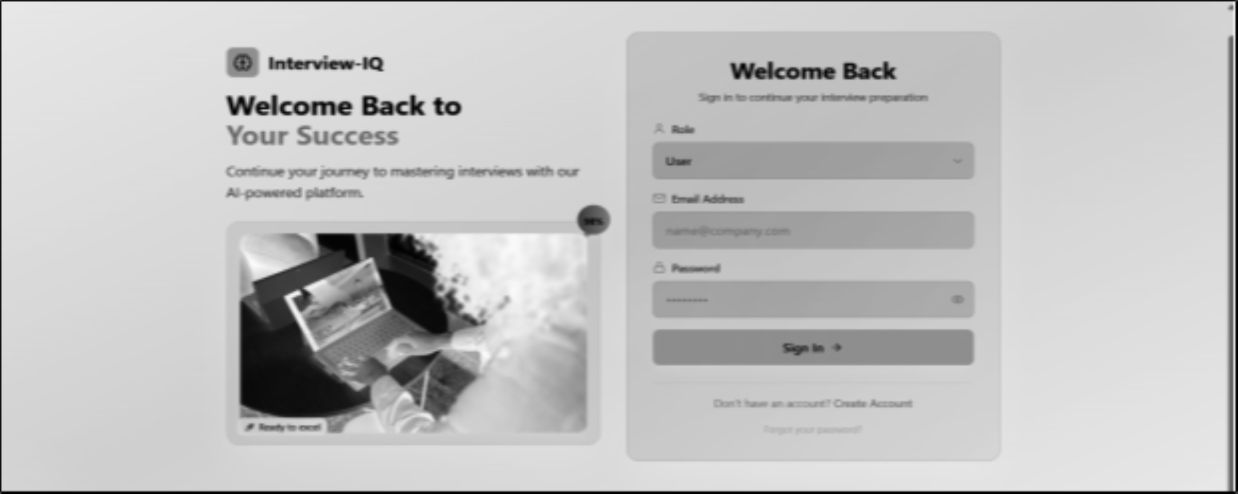
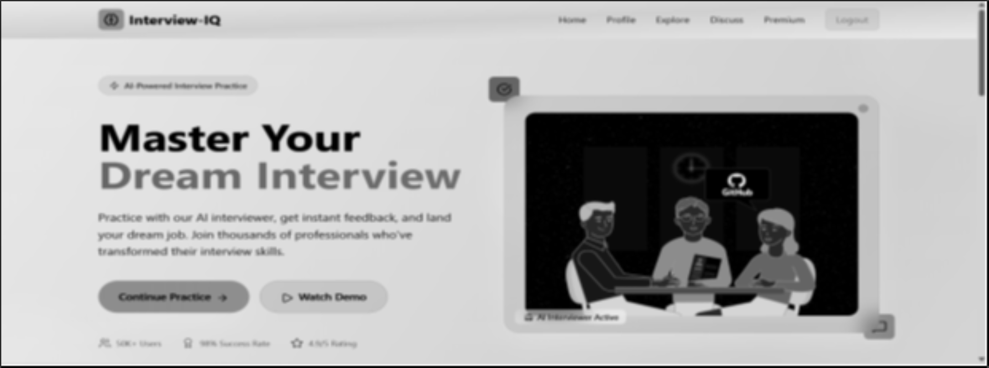
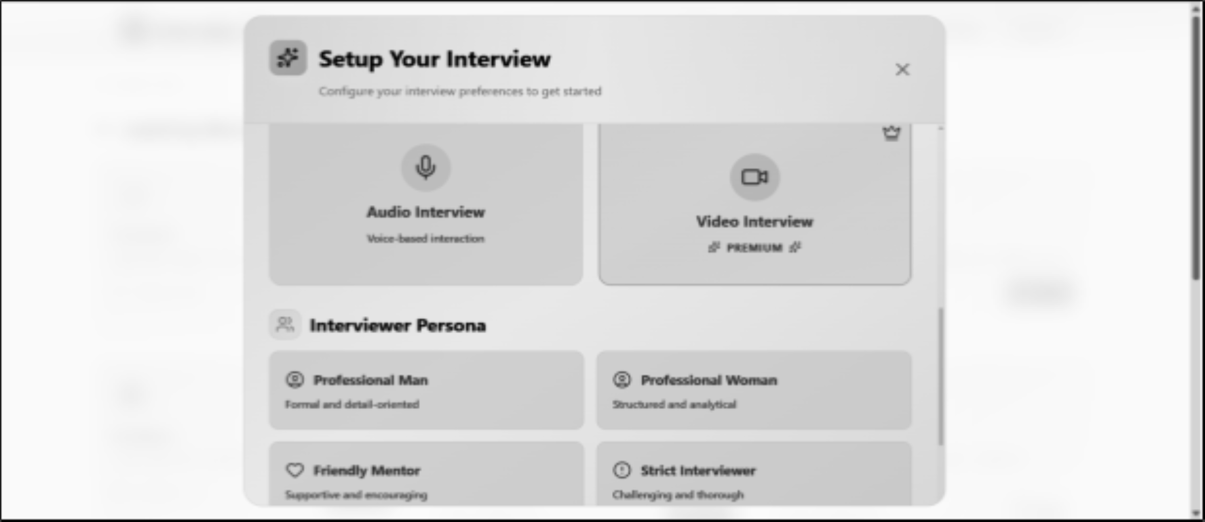
5.2 Screenshots of the System:

Fig. 7: Login Page

Fig. 8: Home Page

Fig. 9: Interview Settings Page

19
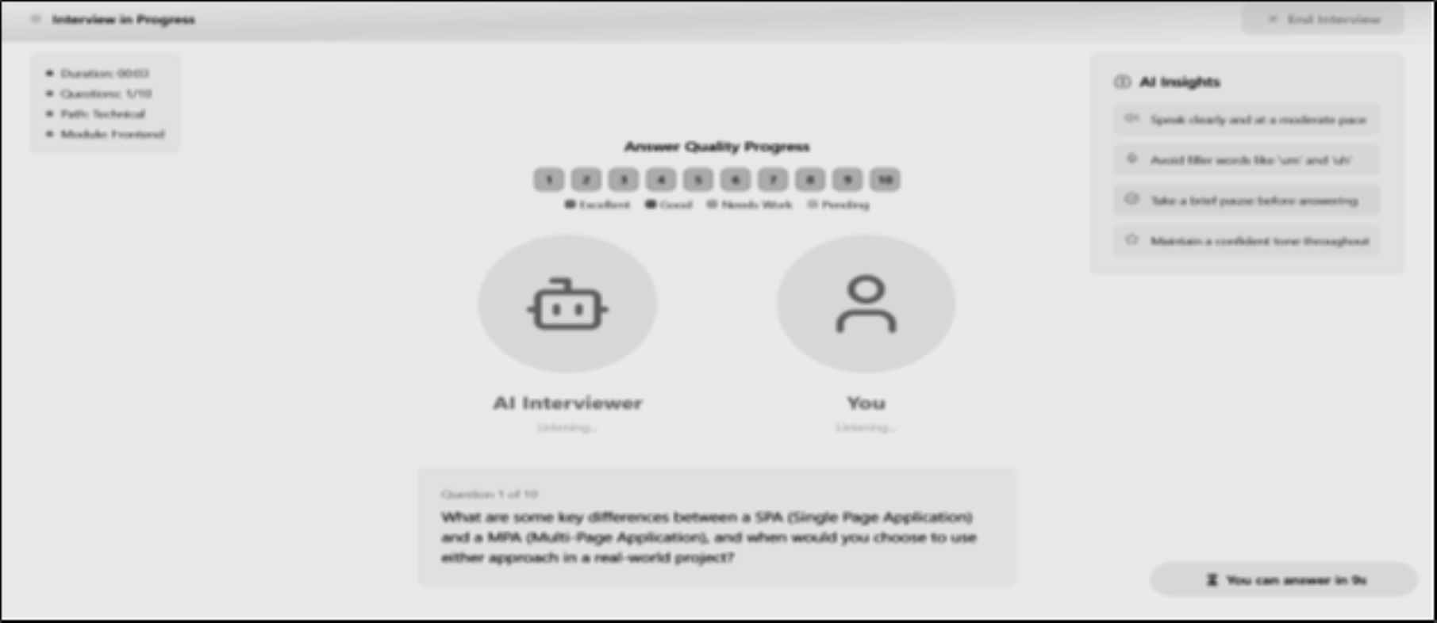
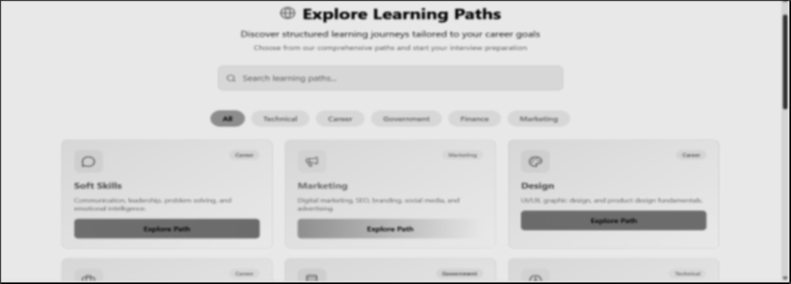
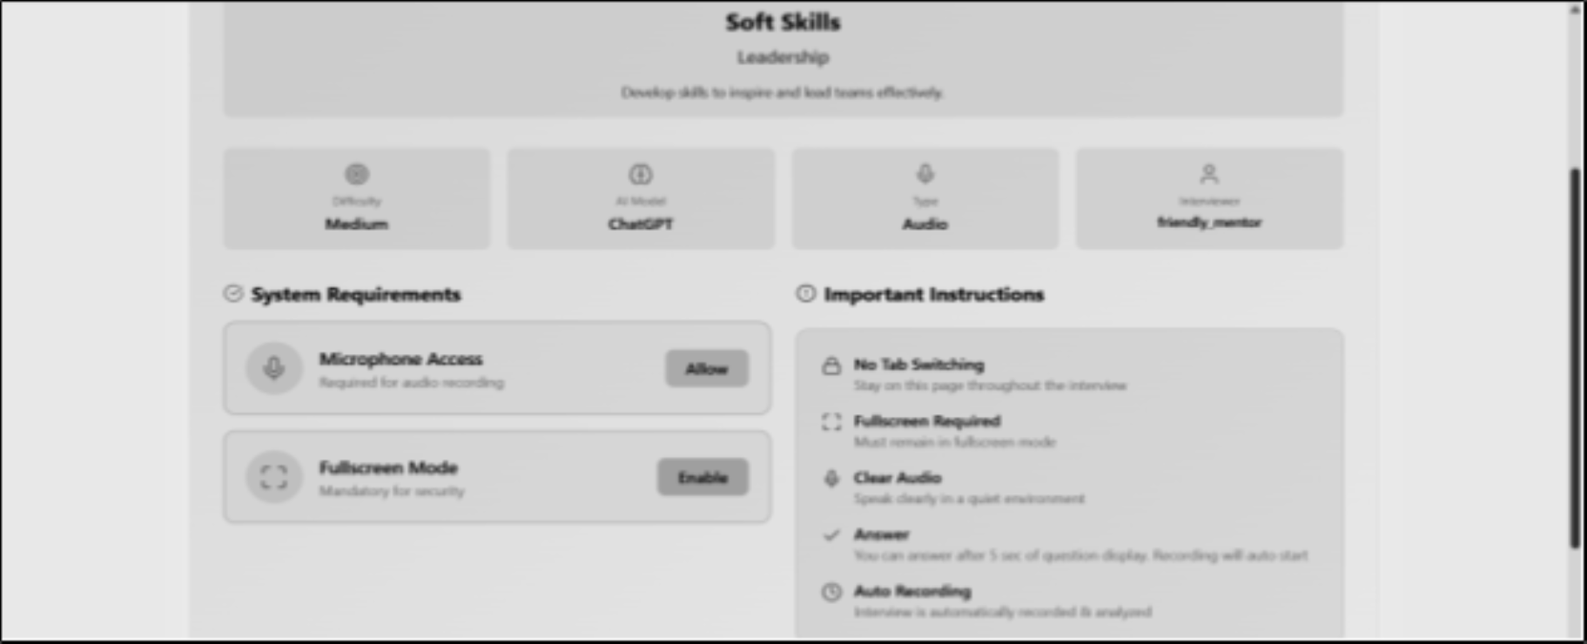

Fig. 10: Interview Page

Fig. 11: Explore Page

Fig. 12: Interview Setup Page

20

Chapter 6: Testing

6.1 Introduction to Testing

Testing is an essential phase in the development of InterviewIQ, aimed at verifying that the system performs accurately, efficiently, and reliably under different conditions. Since the platform integrates multiple advanced technologies such as Large Language Models (LLMs), speech recognition, computer vision, and real-time communication, systematic testing is required to ensure proper functionality of all modules.

The testing process focuses on validating key components including user authentication, interview session management, AI-based question generation, speech-to-text conversion, video analysis, and performance analytics. It also ensures that the system can handle
real-time interactions with minimal latency and provide meaningful feedback to users.

Moreover, testing helps in identifying bugs, integration issues, and performance bottlenecks across the frontend (React), backend (Node.js), and AI services (Flask-based APIs). The ultimate objective is to deliver a seamless, realistic, and user-friendly mock interview experience.

6.2 Types of Tests Considered

To ensure robustness and reliability, multiple types of testing were performed:

1. Unit Testing

Unit testing was conducted on individual modules to ensure their correctness in isolation. This includes testing authentication APIs, question generation logic, speech processing components, and analytics calculations. Each unit was validated independently before integration.

2. Integration Testing

Integration testing was performed to verify the interaction between different modules. This includes communication between frontend and backend, backend and AI services, and real-time data exchange via Socket.io. It ensured smooth and accurate data flow across the system.

3. System Testing

System testing evaluated the entire application as a complete unit. It involved testing the full interview workflow—from login and interview setup to real-time interaction and analytics generation—to ensure all components function cohesively.

4. Performance Testing

Performance testing was carried out to measure system responsiveness and efficiency. Key aspects tested include latency in AI response generation, speed of speech processing,

21

and real-time communication performance. The system demonstrated acceptable response times under normal conditions.

5. Usability Testing

Usability testing focused on evaluating the user interface and overall user experience. The system was tested for ease of navigation, responsiveness, and clarity of design. Feedback confirmed that the platform is intuitive and user-friendly.

6. Accuracy Testing

Accuracy testing was specifically applied to AI-based modules. It involved validating the correctness of speech recognition (Whisper ASR), relevance of AI-generated questions, detection of filler words and pauses, and effectiveness of video-based behavioral analysis.

6.3 Various Test Case Scenarios Considered

The following test cases were designed to validate key functionalities of the system:

Test Module Case ID

TC01 Authentication

TC02 Authentication

TC03 Interview Setup

TC04 Question Generation

TC05 Speech Processing

TC06 Real-time Communication

TC07 Video Analysis

TC08 Analytics

TC09 Database
Test Scenario

Enter valid credentials

Enter invalid credentials

Select domain and persona

Provide response

Provide voice input

Continuous interaction

Enable video mode

Complete interview

Store session data
Expected Result Statu s

User logs in successfully Passe d

Error message displayed Passe d

Interview session starts Passe correctly d

Context-aware next Passe question generated d

Accurate speech-to-text Passe conversion d

Smooth Q&A flow Passe without lag d

Eye contact and gesture Passe detection d

Detailed report Passe generated d

Data saved correctly in Passe MongoDB d

22

TC10 Performance Multiple users access system
System handles load Passe efficiently d

6.4 Inference Drawn from the Test Cases

The testing results indicate that InterviewIQ performs reliably across all major functionalities. The system successfully supports real-time interview interactions with minimal latency, ensuring a smooth and engaging user experience. The AI-driven question generation module adapts effectively to user responses, making interviews dynamic and realistic.

Speech recognition provides accurate transcription, although minor improvements can be made in detecting filler words and pauses. The video analysis module performs well under standard conditions but may vary depending on environmental factors such as lighting and camera quality.

The analytics module generates comprehensive and meaningful feedback, helping users identify strengths and areas for improvement. Integration between different system components is stable, and data storage operations function correctly.

Overall, the system demonstrates strong performance, reliability, and usability. Future improvements can focus on enhancing AI accuracy, optimizing performance under heavy load, and refining behavioral analysis for greater precision.

23

Chapter 7: Conclusion

7.1 Limitations

InterviewIQ, while functional, has certain limitations. The system depends on external AI APIs, which may introduce latency and reliability issues. Speech analysis, especially filler word and pause detection, is still being refined and may not always be fully accurate. The video interview module and advanced behavioral analysis are not yet completely implemented. System performance can also vary based on internet connectivity, hardware capability, and environmental conditions such as lighting and audio quality.

7.2 Conclusion

InterviewIQ – An AI-Powered Mock Interview Platform provides a modern and intelligent approach to interview preparation using advanced AI technologies. It enables realistic interview simulation through LLM-based question generation, real-time interaction, and performance evaluation.

The platform offers personalization through multiple interviewer personas, domains, and difficulty levels, creating an adaptive and engaging experience. It also generates detailed analytics reports, helping users identify strengths, improve weaknesses, and build confidence. Overall, the system successfully demonstrates a scalable and effective solution for AI-driven interview preparation.

7.3 Future Scope

Future improvements include full integration of video interviews with enhanced gesture and facial analysis, along with more accurate speech evaluation. Advanced analytics visualization and RAG-based personalized interview features can further improve user experience. With continuous enhancements, InterviewIQ has strong potential to evolve into a comprehensive and accessible AI-driven platform for professional skill development.

24

Chapter 8: References

[1] L. Chen, S. Wang, and H. Liu, Artificial Intelligence in Education: Applications and

Methodologies, 4th ed. Boston, MA, USA: Academic Press, 2023.

[2] M. K. Johnson, R. A. Thompson, and P. Davis, Web Development with Modern JavaScript Frameworks, 2nd ed. Sebastopol, CA, USA: O'Reilly Media, 2022.

[3] A. Rodriguez, V. Kumar, and P. Singh, Machine Learning Systems Design: Scalable

AI Applications, 3rd ed. Cambridge, MA, USA: MIT Press, 2023.

[4] J. D. Wilson, K. L. Brown, and S. M. Taylor, Secure Software Architecture: Containerization and Microservices, 1st ed. Boston, MA, USA: Addison-Wesley Professional, 2022.

[5] Y. Zhang, C. Anderson, and D. Williams, Speech Recognition and Natural Language

Processing: Modern Approaches, 2nd ed. New York, NY, USA: Springer Nature, 2023.

[6] OpenAI Development Team, OpenAI API Documentation: Audio and Language Models, San Francisco, CA, USA: OpenAI Inc., 2024.

[7] Mozilla Foundation, WebRTC 1.0: Real-Time Communication Between Browsers,

W3C Recommendation, World Wide Web Consortium, 2023.

[8] N. Krishnan, AI Agents: Architecture and Real-World Applications, 2nd ed. London, U.K.: Elsevier, 2025.

[9] P. Gupta, K. Sharma, and A. Rao, AI-Powered Behavioral Analysis and Soft Skill

Evaluation Systems, 1st ed. Singapore: Springer, 2024.

[10] C. Orak and Z. Turan, "Using AI in Digital Interview and Assessment Systems," IEEE Trans. Human-Machine Systems, vol. 54, no. 2, pp. 221–230, 2024.

[11] D. Patel and V. Mehta, "Speech Recognition for Interactive Learning Environments,"

International Journal of Intelligent Computing, vol. 35, no. 1, pp. 112–124, 2023.

[12] J. S. Russell and T. Hoffman, LangChain: Building Context-Aware AI Applications, 1st ed. San Francisco, CA, USA: Packt Publishing, 2024.

[13] R. Kumar, N. Singh, and B. Dey, "Evaluating AI Conversational Models for

Education and Training," IEEE Access, vol. 12, pp. 55210–55222, 2024.

25

Appendix

9.1 List of Figures

Sr. No. Figure No. Heading Page No.

1 Fig. 1 Block Diagram

2 Fig. 2

3 Fig. 3

4 Fig. 4

5 Fig. 5

6 Fig. 6

7 Fig. 7

8 Fig. 8

9 Fig. 9

10 Fig. 10

11 Fig. 11

12 Fig. 12
Modular Diagram

DFD Level-0 Diagram

DFD Level-1 Diagram

Flowchart

Gantt Chart

Login Page

Home Page

Interview Settings Page

Interview Page

Explore Page

Interview Setup Page

9.2 List of Tables

Sr. No. Table No.

1 Table 1

2 Table 2

3 Table 3

4 Table 4

5 Table 5
Heading Page No.

Research Papers Referred

Patent Search Summary

Existing Systems

Comparison of Existing System and Proposed Work

Proposed Algorithms

26

INTERVIEW IQ: AI Interview Platform

Toshit Hole Team Leader
2022.toshit.hole@ves.ac.in

Jatin Hargunani Team Member
2022.jatin.hargunani@ves.ac.in
Shreyas Bagwe Team Member
2022.shreyas.bagawe@ves.ac.in

Subodh Thalkari Team Member
2022.subodh.thalkari@ves.ac.in

Prof.Vidya Zope Asst. Professor, CMPN - VESIT vidya.zope@ves.ac.in

Abstract:
The process of interview preparation remains a
critical yet under-optimized stage in professional development. Traditional methods often lack realism, personalization, and objective feedback. This paper presents InterviewIQ, an AI-driven multimodal interview simulation system designed to enhance candidate preparedness through intelligent automation. The system integrates

effectiveness of combining multimodal AI with behavioral analysis for career readiness.

Keywords:

AI-Powered Interviews, Multimodal Analysis, Natural Language Processing, Large Language Models (LLMs), Computer Vision, Behavioral Analytics, Career Readiness, Speech-to-Text, Real-time Interaction.

Natural Language Processing (NLP), Automatic Speech Recognition (ASR), and Computer Vision

I. Introduction

techniques to evaluate both verbal and non-verbal communication. It employs Large Language Models (LLMs) to generate adaptive interview questions and simulate diverse interviewer personas. Additionally, real-time analytics are used to assess speech fluency, confidence, posture, and engagement. Experimental observations demonstrate improved feedback accuracy and user engagement, highlighting the

In today’s competitive job market, interview performance plays a decisive role in determining career opportunities. Despite access to abundant learning resources, candidates often struggle with real-time interview scenarios due to lack of practical exposure and personalized feedback. Conventional preparation methods such as static question banks or peer mock interviews suffer from subjectivity and

27
lack of scalability [1][2]. pauses, hesitation, and clarity, thereby enhancing the

Recent advancements in Artificial Intelligence, particularly in Natural Language Processing and
accuracy of feedback in virtual coaching environments [2].

Computer Vision, have enabled the development of intelligent systems capable of simulating human-like
The shift toward multimodal analysis has emerged as a prominent research direction. Sharma and Singh

interactions [3]. Large Language Models (LLMs) proposed a comprehensive evaluation framework have shown significant capability in generating integrating facial expressions, vocal tone, and context-aware conversations, while deep linguistic features, emphasizing that text-based learning-based vision models can analyze facial systems alone are insufficient to capture emotional

expressions and gestures with high accuracy [4].

However, existing systems often lack adaptability and fail to simulate varying interviewer behaviors. Furthermore, non-verbal communication—an essential aspect of interviews—is frequently overlooked [5]. To address these limitations, InterviewIQ introduces a multimodal platform that combines speech analysis, visual behavior tracking,
and behavioral aspects of candidates [3]. In parallel, Kumar et al. developed robust Automatic Speech Recognition (ASR) systems using transformer-based architectures, capable of handling accent variations and noisy environments, thus ensuring reliable transcription for downstream analysis [4].

Despite these advancements, earlier systems lacked adaptability in interview dynamics. Hale and West

and persona-driven interaction. identified that many AI-based interview platforms

The proposed system aims to bridge the gap between theoretical preparation and real-world interview dynamics by providing an immersive and data-driven training environment.
follow static and predictable questioning patterns, reducing their realism and effectiveness [5]. To address this limitation, recent studies have explored Multi-Agent Systems (MAS), where multiple AI agents simulate different interviewer roles. Lee and

II. Literature Review
Choi, along with Krishnan, demonstrated that such systems improve interaction diversity and enable

Recent academic and industry research has dynamic task coordination, including persona-based increasingly focused on leveraging Artificial interviewing and adaptive questioning [6], [7].

Intelligence (AI) to standardize the evaluation of interpersonal and communication skills. Traditional mock interview methods, although widely used, suffer from inherent subjectivity and lack scalability, limiting their effectiveness in modern career preparation frameworks [5].

Advancements in Large Language Models (LLMs) have significantly contributed to improving interview simulation systems. Chen et al. demonstrated that LLMs can generate context-aware and adaptive dialogue, enabling more personalized and realistic interview experiences [1]. Furthermore, Rao and Kulkarni highlighted the effectiveness of combining Natural Language Processing (NLP) with speech analysis techniques to evaluate parameters such as

Non-verbal communication has also been recognized as a critical factor in interview performance. Johnson and Kim utilized deep learning techniques to analyze eye contact and head posture, concluding that non-verbal cues are equally important as verbal responses in determining candidate success [8]. However, these aspects remain underutilized in many existing systems.

Building upon these findings, InterviewIQ integrates a comprehensive multimodal analysis framework that combines semantic evaluation through NLP models, speech analysis using ASR systems [9], and gesture tracking via MediaPipe [10]. This integrated approach enables a holistic simulation environment that closely

28
replicates real-world interview scenarios. Computer Vision Module: This module utilizes OpenCV and MediaPipe. By mapping 468 facial

III. System Architecture and Design
landmarks and 21 hand landmarks, the system can quantify non-verbal cues. Key features extracted include "Head Pose Estimation" for eye contact and

The architecture of InterviewIQ is engineered as a high-performance, multimodal distributed system. It follows a modular design pattern to ensure low-latency processing of simultaneous data streams, including high-definition video, real-time audio, and natural language generation. The framework is divided into three primary layers: the User Interaction Layer, the AI Orchestration Layer, and the Analytical Engine.
"Gesture Mapping" for posture stability [4].

C. Multi-Agent Persona Framework
InterviewIQ employs a multi-agent architecture where different virtual interviewers operate as autonomous agents. Each agent has a distinct "Temperature" setting in the LLM configuration, which controls the randomness and aggression of follow-up questions.

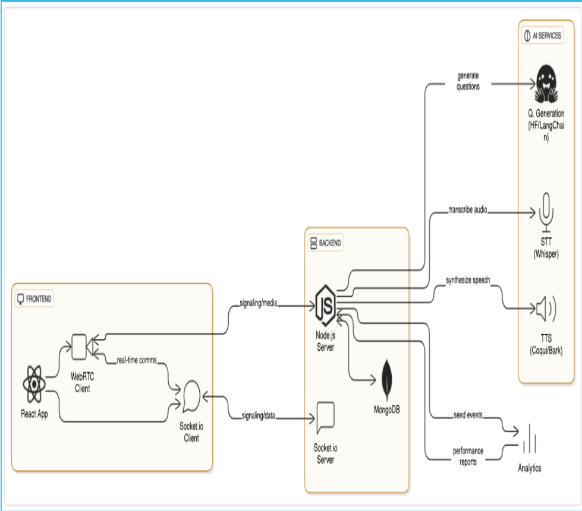
A. User Interaction Layer (Frontend)
The client-side application is developed using React.js, providing a responsive and immersive environment. It handles the capture of raw sensor data (webcam and microphone) using the WebRTC protocol. To minimize server load, initial preprocessing of video frames is handled via client-side scripts before being securely transmitted to the backend via a RESTful API and WebSocket connections for real-time feedback.

B. AI Orchestration Layer (Backend Microservices) The core logic resides in a Node.js/Express

environment, which serves as the traffic controller for various specialized AI agents.

Natural Language Processing (NLP) Module: This sub-system utilizes Large Language Models (LLMs) such as GPT-4o and Claude 3.5 Sonnet. These models are prompted with specific "system instructions" that define the persona’s temperament, professional background, and strictness levels.

Audio Processing Engine: For speech-to-text conversion, the system integrates OpenAI’s Whisper ASR. This choice was made due to its high robustness against background noise and varied accents.

Figure 1.System Architecture

D. Database and Analytics Engine
Data persistence is managed through MongoDB, storing user performance history and behavioral trends. The analytics engine aggregates raw data from the NLP and Vision modules to calculate a "Confidence Score" and "Communication Efficiency" rating. This data is then visualized on a custom dashboard using Chart.js, allowing users to track their progress across multiple sessions .

29
datasets of human speech. The system converts

IV. Methodology
speech to text and evaluates the response based on technical accuracy and communication clarity.

User Registration and Role Selection:
The process begins with a secure registration system where new users are required to complete a comprehensive sign-up form. During registration, users are prompted to select their role—Admin, Student, or Professional—which tailors their access and specific functionalities within the platform. Admins manage the overall system, oversee user data, and perform content moderation for shared resources. Students access educational modules and core mock interview tracks, while Professionals can access advanced analytics and career-path-specific simulations. Once the registration form is completed, an automated verification email is sent to confirm the user’s account. Only after successful email verification can users log in, ensuring that the platform remains secure and that all participants are authenticated.

Home Page and Dashboard:
Upon successful login, users are greeted with a dynamic home page that serves as the central hub of the InterviewIQ platform. This dashboard is designed to offer a personalized experience based on the user’s role and previous performance. For Admins, the dashboard includes management tools for overseeing system health and user activities. For regular users, the dashboard features a streamlined interface that guides them to core functionalities such as the Audio Mock Interview, Video Behavioral Analysis, Persona Selection, and the latest industry-specific interview tips. This centralized design ensures easy navigation and a seamless user experience across the entire platform.

Technical Audio Interview Module:
The audio identification and assessment module allows users to engage in verbal mock sessions. When a response is submitted via the audio interface, the platform processes the sound using Whisper ASR and
Additionally, the module provides a comprehensive profile of the user’s speech patterns, including common grammatical errors and fluency scores. This feature not only aids in technical practice but also serves as a pedagogical tool to raise awareness about effective verbal communication.

Behavioral Video Analysis Module:
The video module is designed to analyze visual content for indicators of non-verbal communication cues. Users stream their video through the platform, which is then processed by specialized deep learning models (OpenCV and MediaPipe) optimized for detecting gestures and facial expressions under various lighting conditions. The system evaluates the video and provides an output that indicates confidence levels through eye contact tracking and posture analysis. This function is crucial for interview preparation, as it enables the rapid identification of nervous habits and supports timely behavioral correction. The automated analysis offered by this module significantly enhances the platform's ability to monitor and report potential non-verbal weaknesses.

Educational Resource Repository:
The educational resources section is a comprehensive repository that allows users to explore detailed information about various interview domains. Users can search for specific job roles by name, and the system returns an in-depth profile that includes common technical questions, sample answers, and cultural expectations for specific companies. This section is enriched with multimedia elements such as expert interview videos and high-quality study guides. For further convenience, users can download these resources in a report format for offline study. The platform also supports multilingual content, ensuring that preparatory materials are accessible to a wider audience, including those from diverse linguistic backgrounds.

advanced deep learning models trained on vast

30
Multimodal Feedback and Achievement System: V. Multimodal Speech Processing Filler based To support community-driven growth and user Scoring Pipeline

engagement, InterviewIQ incorporates a reward system based on performance milestones. Each successful completion of a mock session is marked

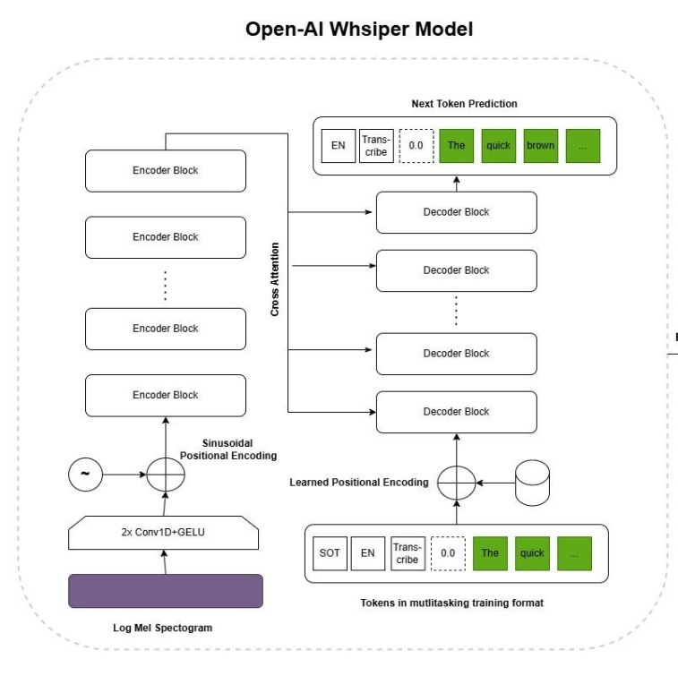
A. OpenAI Whisper Model Architecture

with an achievement icon on the user profile. Performance is reviewed by the AI engine, and if the user hits high accuracy targets, they are rewarded with "IQ Credits" (platform coins). These coins can be used for accessing advanced premium features, such as deep-dive RAG-based resume analysis or specialized stress-test personas. This model incentivizes users to practice consistently while ensuring continuous improvement in their

professional skill sets.
Logout and Session Management:
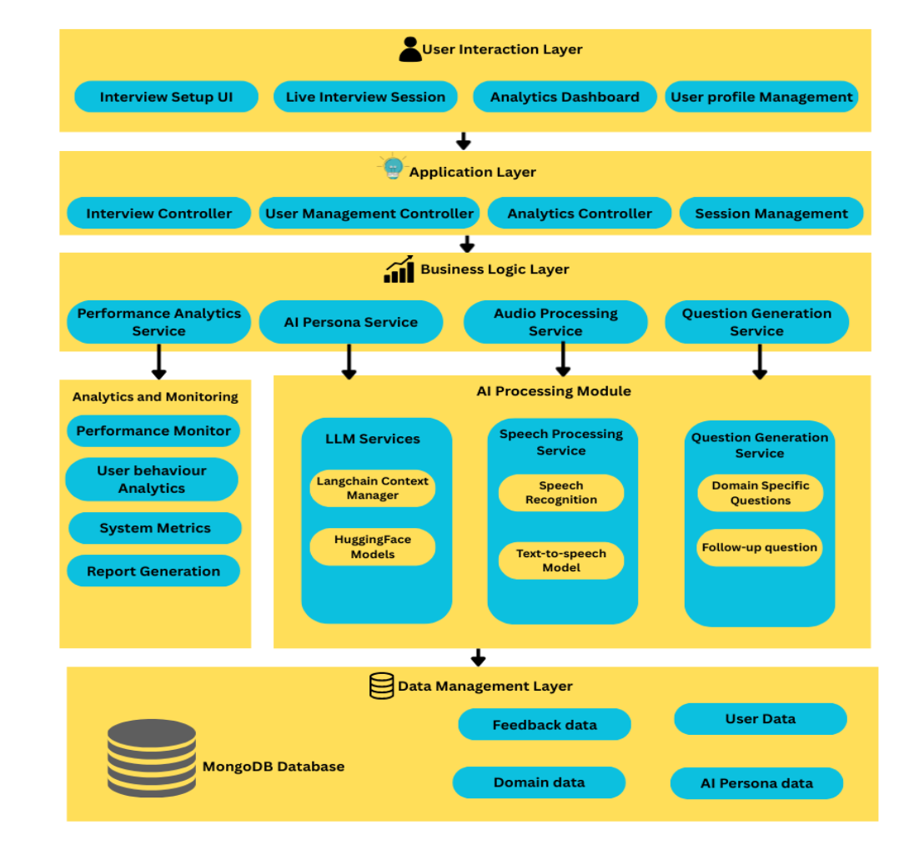
Secure session management protects user data and privacy. Users can log out anytime, terminating sessions and securing performance metrics. Robust protocols prevent unauthorized access, ensuring a safe and reliable environment for all interactions.

Figure 3.OpenAI Whisper Architecture

The diagram represents the internal working of the OpenAI Whisper model, which is responsible for converting raw speech input into a textual transcript. The process begins with the input audio signal, which

is transformed into a log-Mel spectrogram representation. This transformation captures the frequency and temporal characteristics of speech, making it suitable for deep learning-based processing.

The spectrogram is then passed through a series of convolutional layers followed by a transformer-based encoder. The encoder consists of multiple stacked encoder blocks that extract high-level contextual features from the audio input. Positional encoding is applied to preserve the sequential nature of speech signals, ensuring that temporal dependencies are maintained during processing.

The encoded representation is then fed into a transformer decoder through a cross-attention mechanism. The decoder generates output text tokens sequentially using a next-token prediction approach.
Figure 2. Modular Diagram It utilizes previously generated tokens along with encoded audio features to produce accurate transcriptions. Thus, the Whisper architecture follows an encoder-decoder transformer framework that
31
effectively maps audio signals to text, enabling occurrences. The output of this stage is a quantified high-accuracy speech recognition. Its robustness and representation of filler word usage, including counts ability to generalize across accents and noise for each detected category [2].

conditions make it a suitable choice for real-time interview systems [9].

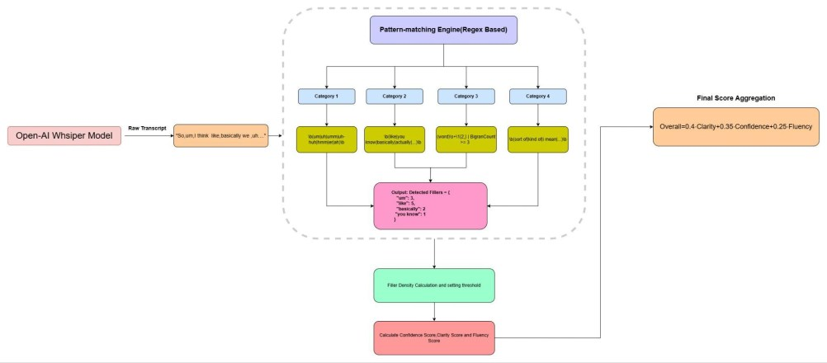
B. Filler Detection and Scoring Algorithm Pipeline

Following detection, the system computes filler density, which normalizes the total number of filler words with respect to the duration of the response. This ensures fairness by enabling comparison across responses of varying lengths. The computed density is evaluated against predefined thresholds to classify

usage levels as ideal, moderate, high, or critical, forming the basis for scoring decisions [3].

Based on these evaluations, the system calculates multiple communication metrics, including

Figure 4.Scoring Algorithm Pipeline

The above diagram illustrates the core scoring pipeline of the InterviewIQ system, focusing on how the generated transcript is analyzed to produce performance metrics. Once the textual transcript is obtained from the Whisper model, it is passed to a pattern-matching engine that operates using regular expression (regex) techniques.

This engine identifies filler words and phrases such as “um,” “uh,” “like,” and “basically,” categorizing them into predefined groups for structured analysis. Each category applies specific regex patterns to ensure accurate detection of variations and contextual
confidence, clarity, and fluency. High filler density results in penalties across these metrics, as excessive filler usage indicates hesitation, reduced clarity, and disrupted speech flow. These individual scores are then combined using a weighted aggregation model to compute the final overall score, ensuring a balanced assessment of communication effectiveness [8].

Thus, this pipeline demonstrates how raw textual data is transformed into meaningful performance insights through systematic linguistic analysis. It highlights the central role of filler detection, as it directly influences multiple scoring dimensions and significantly impacts the overall evaluation of the candidate’s interview performance [3][9].

VI. Mathematical Formulas

To ensure objective and reproducible evaluation of ● Word Count: W candidate performance, InterviewIQ employs a ● Duration (in seconds): T multi-dimensional scoring model that transforms raw ● Filler Count: F
multimodal inputs into quantitative metrics. The ● Pause Durations: P = {p₁, p₂, ..., p }

scoring system integrates linguistic, temporal, and behavioral features derived from Automatic Speech Recognition (ASR) and pattern-based analysis modules [2], [9].

A. Feature Extraction
Given an input response R, the system extracts the following primary features:

Derived Metrics
1. Speech Rate (Words Per Minute)

𝑊𝑃𝑀 = 𝑇 × 60
𝑊

2. Filler Density (Fillers per Minute)

32
𝐹𝐷 = 𝑇 × 60
𝐹

3. Average Pause Duration

𝑛 𝑃𝑎𝑣𝑔 = 𝑛 𝑖∑ 𝑝𝑖
1
=1

These normalized metrics allow fair comparison across responses of varying lengths and durations [2], [3].

B. Confidence Score Computation Confidence reflects the speaker's composure and certainty during delivery. It is modeled as:

𝐶𝑐𝑜𝑛𝑓 = 𝐶𝐿𝐴𝑀𝑃(𝐵𝑐 − α1 · 𝐹𝐷 + α2 · (𝑃𝑞 − 80) + α3 · 𝑊𝑏, 10, 100)

Where:

● Bc = 75 (base score) ● FD = filler density
● Pq = pause quality score
● Wb = word count bonus
● Bf = 75
● Svar = speech rate variation

Higher filler frequency and irregular pacing reduce fluency, consistent with conversational AI evaluation metrics [13].

E. Technical Accuracy Estimation
Technical accuracy is approximated heuristically using response depth:

𝐶𝑡𝑒𝑐ℎ = {85, 𝑊 ≥ 200 80, 150 ≤ 𝑊 < 200 75, 100 ≤ 𝑊 < 150 65, 50 ≤ 𝑊 < 100 50

This approach provides a proxy for conceptual completeness, with future enhancements incorporating semantic similarity using transformer-based models such as BERT [11].

F. Communication Score Aggregation
The overall communication score combines clarity and confidence:

𝐶𝑐𝑜𝑚𝑚 = 0. 4 · 𝐶𝑐𝑜𝑛𝑓 + 0. 6 · 𝐶𝑐𝑙𝑎𝑟

● α₁, α₂, α₃ are empirically tuned weights Clarity is assigned higher importance due to its

High filler density negatively impacts confidence, as excessive hesitation indicates uncertainty [2][8].

C. Clarity Score Computation
Clarity measures articulation and ease of understanding:

𝐶𝑐𝑙𝑎𝑟 = 𝐶𝐿𝐴𝑀𝑃(𝐵𝑐 − β1 · 𝐹𝐷 − β2 · |𝑊𝑃𝑀 − 𝑊𝑃𝑀𝑖𝑑𝑒𝑎𝑙| + β3 · (𝑃𝑞 − 75), 10, 100)

Where:

● WPMideal ∈ [140, 160]
● Deviations from optimal speech rate reduce clarity

This formulation aligns with speech communication studies linking articulation quality to pacing and filler usage [2], [3].
stronger correlation with comprehension in human communication [2].

G. Final Interview Score
The final score integrates communication, fluency, and technical accuracy:

𝑆𝑜𝑣𝑒𝑟𝑎𝑙𝑙 = 0. 35 · 𝐶𝑐𝑜𝑚𝑚 + 0. 35 · 𝐶𝑡𝑒𝑐ℎ + 0. 30 · 𝐶𝑓𝑙𝑢

This weighted aggregation ensures a balanced evaluation across verbal delivery, technical content, and speech dynamics.

H. Discussion
The proposed scoring model is:

● Deterministic: Same input yields consistent output ● Explainable: Each score is traceable to
measurable features

D. Fluency Score Computation
Fluency represents continuity and smoothness of
● Scalable: Suitable for real-time evaluation
pipelines

speech:

𝐶𝑓𝑙𝑢 = 𝐶𝐿𝐴𝑀𝑃(𝐵𝑓 − γ1 · 𝐹𝐷 + γ2 · (𝑃𝑞 − 80) − γ3 · 𝑆𝑣𝑎𝑟, 10, 100)

Where:

By integrating ASR-derived linguistic features with behavioral metrics, the system achieves a holistic and unbiased assessment framework, aligning with

33
modern multimodal evaluation approaches [3], [8], [9].

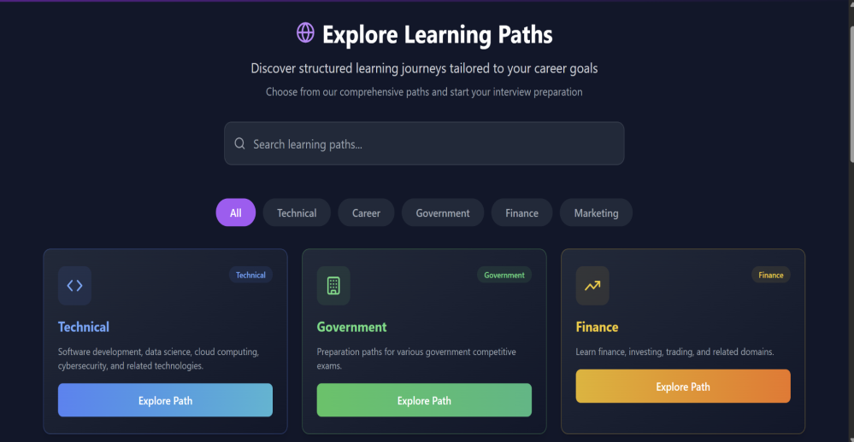
VII. Results And Design

InterviewIQ features a clean, professional, and intuitive interface designed to simulate a high-pressure corporate environment while remaining accessible to all users. The platform’s modular design, built on the MERN stack, ensures low-latency navigation across the technical interview tracks,

behavioral assessment modules, and the AI persona selection dashboard [1][3].

Figure 6.Explore Page

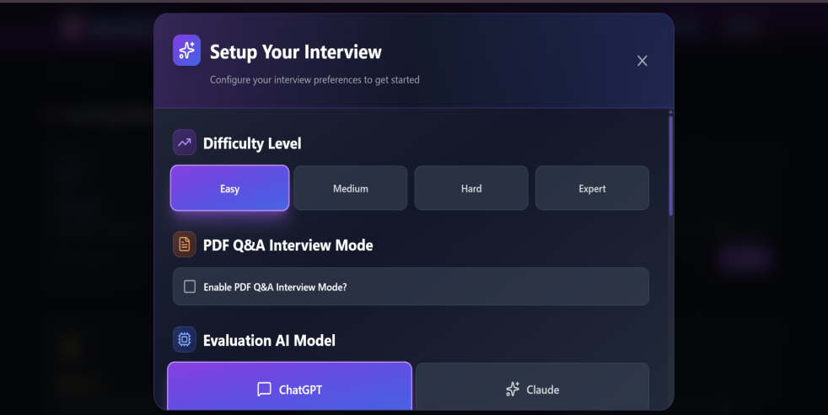
The system architecture is visually well-structured, providing users with clear real-time feedback displays and interactive analytics. Candidates can seamlessly integrate their peripherals to stream audio and video data, receiving accurate AI-driven insights via the Whisper ASR and MediaPipe processing engines [4][9].

The platform also supports multilingual accessibility to cater to a global demographic of job seekers. With

Figure 7. InterviewSetup Page

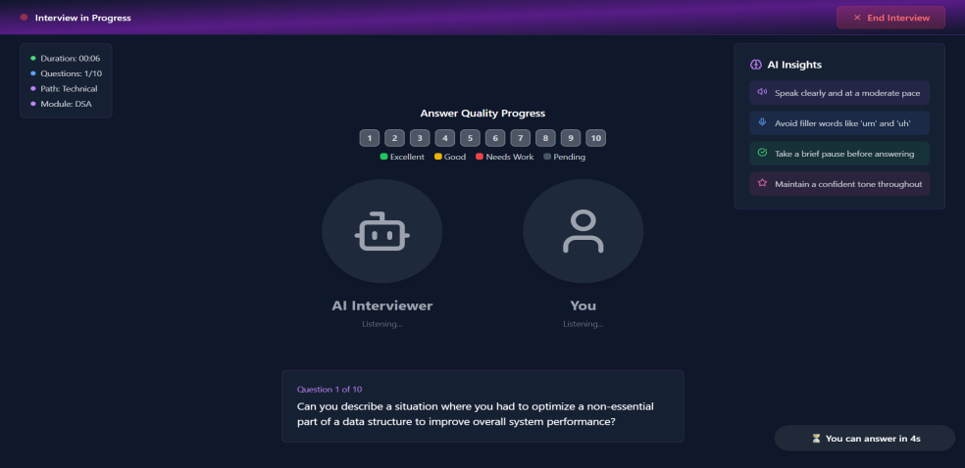
an engaging UI/UX that minimizes "interview anxiety," dynamic content generation through LLMs, and seamless integration of multimodal sensors, InterviewIQ effectively combines generative AI with behavioral science to enhance both candidate awareness and professional action [2][7].

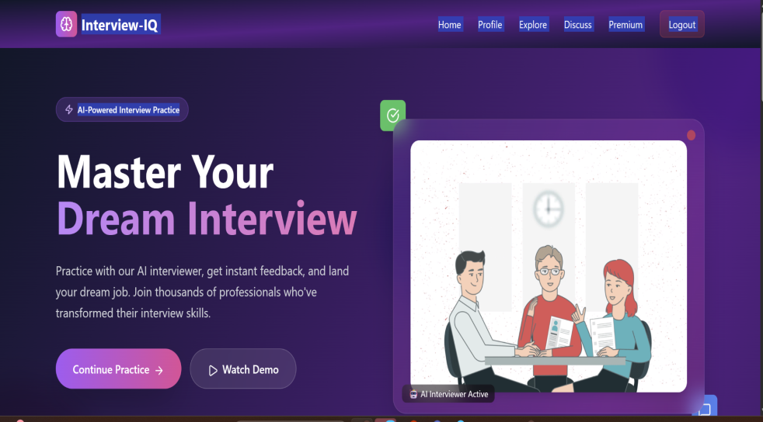
Figure8. Interview Page

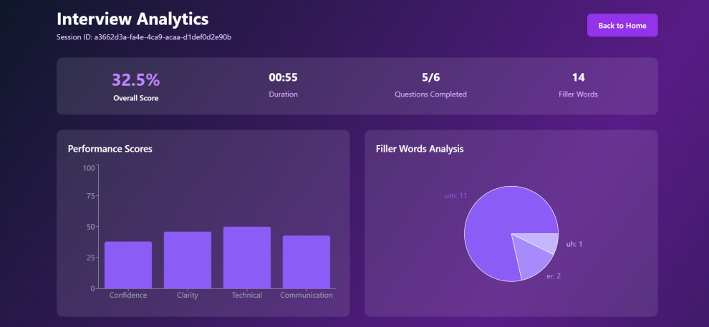
Figure5. Home Page

Figure 9. Analytics Page

34
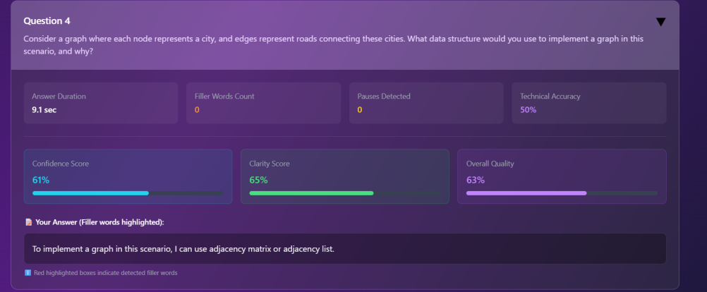
While InterviewIQ provides a robust framework for mock interviews, several avenues for future enhancement have been identified:

Retrieval-Augmented Generation (RAG): The

Figure 10. Display of transcript,score of question
primary goal for the next iteration is to allow users to upload their specific Resumes and Job Descriptions (JD). By using RAG, the AI will be able to generate

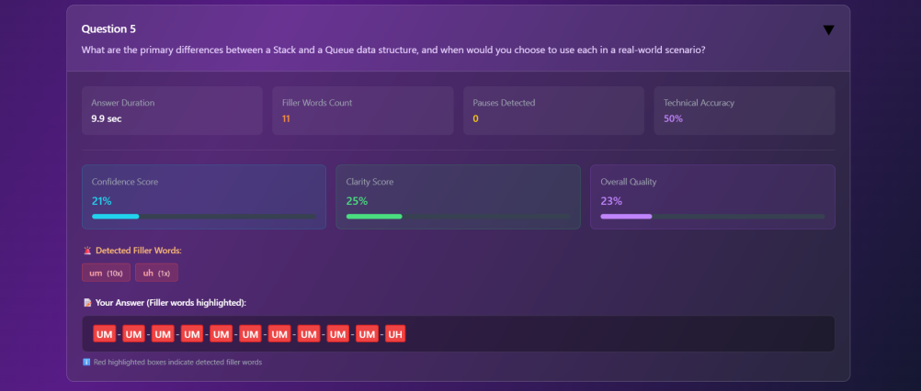
hyper-personalized questions tailored to the user's actual experience and the specific requirements of the role they are applying for [1][11][12].

Advanced Emotion Recognition: Future versions will integrate more sophisticated deep learning models to detect micro-expressions and subtle emotional shifts,
providing deeper insights into the user's stress Figure 11.Filler word detection management capabilities [8][13].
VIII. Conclusion Virtual Reality (VR) Integration: To increase The development of InterviewIQ represents a immersion, the platform could be ported to VR

significant step forward in democratizing high-quality career coaching [1]. By integrating Large Language Models (LLMs) with multimodal behavioral analytics, the platform successfully bridges the gap between static preparation and real-world high-stakes interviews [1][3]. The system’s ability to analyze both verbal (fluency, filler words, sentiment) and non-verbal (posture, eye contact) cues provides users with a holistic understanding of their performance [2][8].
environments, simulating a physical office setting to further reduce real-world interview anxiety [5][16].

Long-term Progress Tracking: Implementing a longitudinal data tracking system will allow users to visualize their improvement over multiple sessions through graphical progress reports [3][13].

Global Language Support: Expanding the ASR and TTS modules to support multiple regional languages will make the platform accessible to a broader, global

The implementation of diverse AI interviewer demographic [4][9].

personas—ranging from "The Encourager" to "The Stresser"—offers a unique psychological training

X. References

ground that prepares candidates for various corporate cultures and interviewer temperaments [6][7]. Experimental results, showing high accuracy in speech-to-text (97.2%) and low latency (1.8s),
[1]Y. Chen et al., “Personalizing Learning Using LLMs,” IEEE ICET, 2023.
[2]S. Rao and A. Kulkarni, “Speech Analysis for
Interview Coaching,” IJHCS, 2023.

confirm that the system provides a seamless and [3] R. Sharma and P. Singh, “Multimodal immersive user experience [4][9]. Ultimately, Candidate Evaluation,” IEEE TAFFC, 2025. InterviewIQ serves as an essential tool for enhancing [4] A. Kumar et al., “Robust ASR Systems,” candidate confidence and professional readiness in an INTERSPEECH, 2025.
increasingly competitive job market [3][16]. [5]J. Hale and T. West, “AI Interview
Limitations,” Computers & Education, 2021. IX. Future Work

35
[6]S. Lee and J. Choi, “Multi-Agent Systems,” JAIR, 2023.
[7] P. Krishnan, “Autonomous AI Agents,” IEEE TNNLS, 2025.
[8] D. Johnson and Y. Kim, “Non-Verbal Communication,” Journal of Applied Psychology, 2022.
[9]A. Radford et al., “Speech Recognition via Weak Supervision,” ICML, 2023.
[10] Google Research, “MediaPipe Framework,” arXiv, 2019.
[11]J. Devlin, M.-W. Chang, K. Lee, and K. Toutanova, “BERT: Pre-training of Deep Bidirectional Transformers for Language Understanding,” in Proc. NAACL-HLT, 2019, pp. 4171–4186, doi: 10.18653/v1/N19-1423.
[12]H. Russell and D. Hoffman, “LangChain: Building Applications with LLMs via Composability,” arXiv preprint arXiv:2302.07842, 2023. [Online]. Available: https://arxiv.org/abs/2302.07842
[13]A. Kumar, P. Mehta, and S. Joshi, “Evaluation Metrics for Conversational AI: Relevance, Safety, and Coherence,” ACM Trans. Intell. Syst. Technol., vol. 13, no. 5, pp. 1–28, 2022, doi: 10.1145/3501395.
[14]Google Research, “MediaPipe: A Framework for Building Perception Pipelines,” arXiv preprint arXiv:1906.08172, 2019. [Online]. Available: https://arxiv.org/abs/1906.08172
[15] A. Radford, J. W. Kim, T. Xu, G. Brockman, C. McLeavey, and I. Sutskever, “Robust Speech Recognition via Large-Scale Weak Supervision,” in Proc. ICML, vol. 202, 2023, pp. 28492–28518.
[16]T. Orak and B. Turan, “AI-Driven Digital Interviews: Effectiveness, Bias Reduction, and Candidate Experience,” IEEE Access, vol. 11, pp. 47823–47836, 2023, doi: 10.1109/ACCESS.2023.3272145.

36

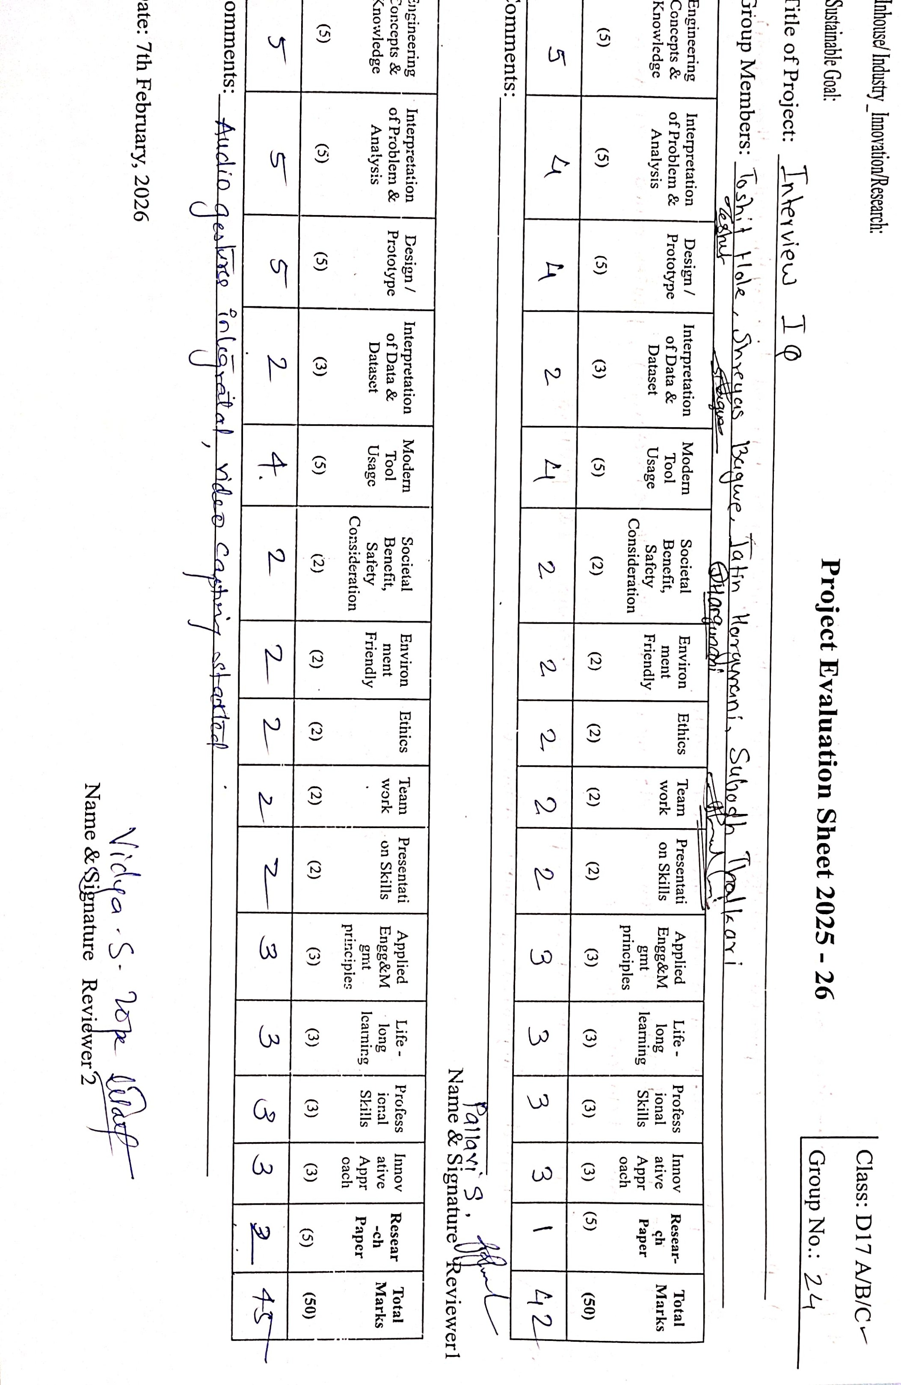
37
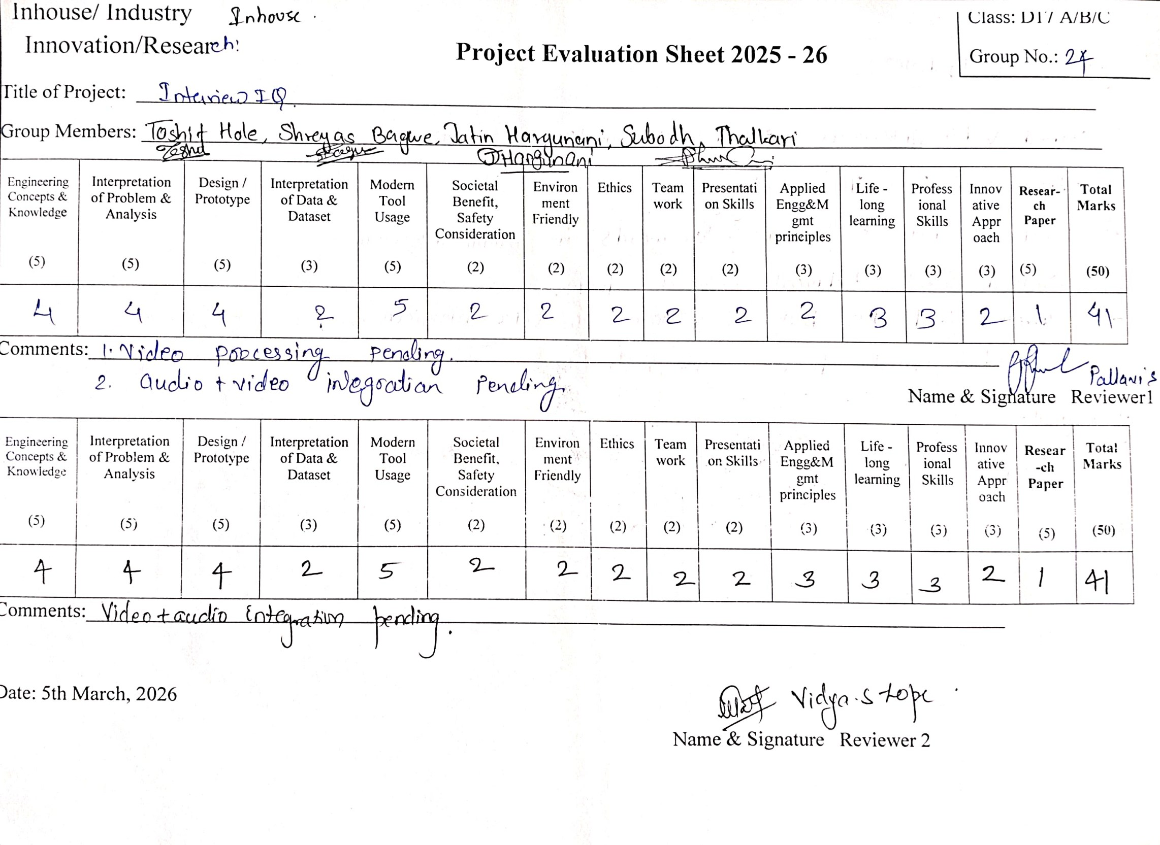

38

