IntelliTender: A Role-Based Tender Management System with Locally Deployed AI as an Assistant for Tender Bid Evaluation and Milestone Evaluation
Dr. Dashrath Mane, Anish Udasi, Moneet Bhiwandkar, Khushi Lachhani, Aditya Sarvankar
Academic Capstone Project Research Group
Department of Computer Science and Engineering
ABSTRACT
In this work, we developed IntelliTender, a web-based application for tender management and decision support. The evaluated workflow ran the configured Qwen3-4B-2507 and BGE-M3 components on an NVIDIA RTX 3050 workstation with an AMD Ryzen 5 5600G CPU; tender documents were processed by the local model workflow and were not transmitted to external AI services during the reported run. The system combines role-scoped retrieval, document-grounded bid analysis, application-level JSON parsing with retry handling, deterministic backend score recomputation, and milestone review. The case study contains one synthetic tender and three synthetic bid submissions. Because it does not include independently reviewed ground truth, labeled retrieval queries, or repeated reliability trials, this paper reports a proof-of-concept agreement comparison rather than general scoring accuracy. The available table gives a provisional agreement of 75.48% with a rule-derived reference assessment for two eligible bids. The measured queue time was 84 seconds, compared with 902 seconds of recorded committee portal work. These results support the feasibility of combining local inference, hybrid retrieval, structured outputs, deterministic scoring, and human review within one role-based workflow; they do not establish autonomous procurement validity or complete system security.
Index Terms—Tender management, procurement analytics, retrieval-augmented generation, hybrid retrieval, local AI, milestone monitoring, bid evaluation, MongoDB, role-based access control, structured JSON validation.

INTRODUCTION
Modern procurement systems deal with two main forms of information. The first includes structured records such as tender details, bidder metadata, and project milestones. The second consists of large volumes of unstructured documents, including proposals, licenses, financial audits, and technical charts [5]. In practice, evaluation committee members often have to review these documents manually. This increases their workload and can contribute to fatigue, longer evaluation cycles, clerical mistakes, and inconsistencies during the evaluation process [6].
Commercial LLM APIs provide one possible way to automate document analysis. But their use in tender management introduces several practical issues:
- Data Protection and Privacy: Tender documents mostly contain sensitive bidder information, bills, and private audit records. When such information is sent to a third-party server, the organization has less control over the data that is processed and stored. This can create problems with confidentiality and data-security requirements [2, 5].
- Financial Overhead: A procurement system may need to process several documents and perform repeated LLM queries throughout the entire lifecycle. For larger or continuous workflows, these costs can become difficult to justify as part of the system's regular operation [1, 5].
- Schema Disruption: Another issue arises when LLM responses are directly used in the application. The model may not always return JSON in the same format. Therefore, a missing field, unexpected value, or formatting change can interrupt the next stage of processing and create problems for relational databases and pipelines [5].
The study evaluates an integrated workflow rather than repeating the local-processing claim: hybrid retrieval supplies document evidence, the local model produces candidate structured outputs, the application validates and retries malformed JSON, the backend recomputes scores, and authorized officials retain decision authority. The evaluated run did not transmit tender documents to external AI services; this observation is revisited only where it affects interpretation of the results.

A. Problem Statement
Conventional tender administration often keeps tender creation, bid review, contract tracking, and document-based questioning as separate activities. Because these tasks are handled independently, tracing supporting evidence, comparing bids consistently, and monitoring contract milestones within a single auditable workflow becomes difficult. Standard language models face a similar limitation: without a retrieval mechanism, they cannot reliably work with updated information stored in private document collections [1].
The research and engineering problem is to design a procurement workflow that can connect structured tender records with heterogeneous bid and milestone documents, retrieve role-appropriate evidence, produce machine-readable evaluation candidates, and recompute tender scores deterministically while preserving an authorized human decision boundary. The difficulty is not merely document classification: the workflow must handle eligibility failures, missing or inconsistent evidence, criterion-specific marks, QCBS normalization, milestone delays, and auditability without treating an unverified language-model response as the final procurement decision. IntelliTender addresses this problem by integrating role-scoped access control, hybrid retrieval, local model-assisted evidence extraction, schema validation with retry handling, backend score calculation, and auditable human review.

B. Project Objectives
The primary objectives of this research project are as follows.
• Implement a role-based tender platform supporting Chief Procurement Officer (CPO), Procurement Officer (PO), Committee Member, and Vendor roles.
• Integrate AI-assisted bid scoring with structured MongoDB storage, timing logs, and risk metadata.
• Implement AI-assisted milestone analysis with delay calculation, automated alerts, severity classification, and system notifications.
• Build a local hybrid document retrieval pipeline that combines embeddings, lexical token ranking, and keyword intent routing [5].
• Evaluate the prototype using a controlled synthetic municipal tender dataset and conduct repeated task trials with performance metric logs [5].

RELATED WORK

A. Retrieval-Augmented Generation (RAG)
Retrieval Augmented Generation (RAG) frameworks separate parametric model weights from non‑parametric document corpora, allowing model outputs to be grounded in explicit, auditable facts retrieved from external sources. Generations therefore rely on verifiable evidence rather than ungrounded internal weights. Architecture is essential in legal, audit, and public‑sector operations, where hallucinated or unverifiable responses cannot be tolerated [1, 5].

B. Dense vs. Lexical Hybrid Retrieval
Dense dual-encoder models convert text into embedding vectors that capture semantic meaning, as in BGE-M3, allowing the system to match a query with relevant document chunks based on semantic similarity rather than relying only on matching individual keywords [2]. However, procurement compliance often depends on exact details, license registration numbers, ISO standard identifiers, and budget values, where small textual differences can be significant [5]. Combining dense embeddings with sparse lexical ranking (BM25) and exact phrase matching therefore provides a better balance between retrieving semantically related content and retrieving documents containing the required keywords or exact terms [3, 5].

C. Knowledge Graph RAG (GraphRAG)
GraphRAG adopts a more advanced retrieval approach in which entities and their relationships are organized into structured networks across document collections, enabling multi-hop reasoning and the generation of global summaries [4]. This approach can be valuable for long-term tracking across multiple contracts but requires considerable computation for tasks such as entity extraction, relation resolution, and graph indexing [4, 5]. For a localized compliance audit running on a single workstation, a hybrid pipeline combining MongoDB transactional records with chunk-level dense and lexical search offers a simpler architecture with lower maintenance requirements and efficient retrieval performance [5].
D. AI-Assisted Public Procurement and Tender Evaluation
Recent public-procurement research has examined machine learning for anomalous proposal detection and AI assistance for the analysis and construction of procurement notices [5], [6]. These studies motivate automated review but do not by themselves specify an auditable workflow that combines role-scoped records, heterogeneous tender documents, criterion-level evidence, and deterministic recomputation of final scores. Retrieval-augmented generation adds a mechanism for grounding model responses in source documents [1], while evidentiality-oriented generation emphasizes making supporting evidence visible to the reader [7]. For procurement use, these ideas must be coupled with eligibility gates, access control, schema validation, and a human authority boundary because a plausible generated explanation is not proof of compliance.
Research gap. The reviewed work does not provide a small-workstation proof-of-concept that evaluates these controls together in one role-based tender workflow and explicitly separates model-produced candidate marks from backend-calculated totals. IntelliTender addresses this engineering gap by connecting role-scoped retrieval, local document analysis, structured output handling, deterministic QCBS calculation, and milestone evidence review, while treating the present experiment as feasibility evidence rather than a validated autonomous evaluator.

PROPOSED SYSTEM & ARCHITECTURE
IntelliTender separates these four distinct operating roles to apply administrative checks and balances:

- Chief Procurement Officer (CPO): Oversees high-level organization analytics, milestone timelines, risk flags, and system-wide AI activity logs.
- Procurement Officer (PO): Instantiates tender notices, manages bid review queues, tracks contract milestones, and receives automated risk notifications.
- Committee Member: Evaluates technical bid documents, records manual scores, and uploads milestone site-verification reports.
- Vendor: Views tender notices, submits technical and commercial proposals, and tracks active milestone progress.

A. Separation of Responsibilities
The multi-layered architecture separates role-specific React dashboards, an Express API with JWT and route-level role checks, MongoDB workflow records and document chunks, and a configured local AI service. This separation supports traceability and scoped access; it is not by itself a security certification.
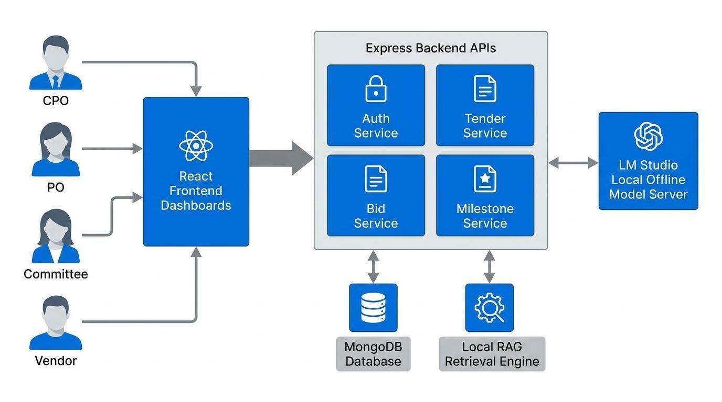
Fig. 1. Overall system architecture showing role-scoped components, database structure, the retrieval workflow, and the configured local model boundary.

LOCAL CHATBOT OPERATION & RETRIEVAL PIPELINE
Before retrieval, the chatbot applies a role-based access filter. Vendor requests matching sensitive evaluation terms are rejected before document retrieval, while PO, CPO, and Committee requests are restricted to their role-scoped tender and contract records. In the evaluated workflow, tender documents were not transmitted to external AI services; this operational observation should not be interpreted as a claim of complete system security.
competitor bid documents, committee score matrices, or evaluation logs, returning a secure, fixed response prior to any retrieval execution [5].
The chatbot execution pipeline (Figure 2) integrates five distinct retrieval branches to optimize compute efficiency and speed [5]:
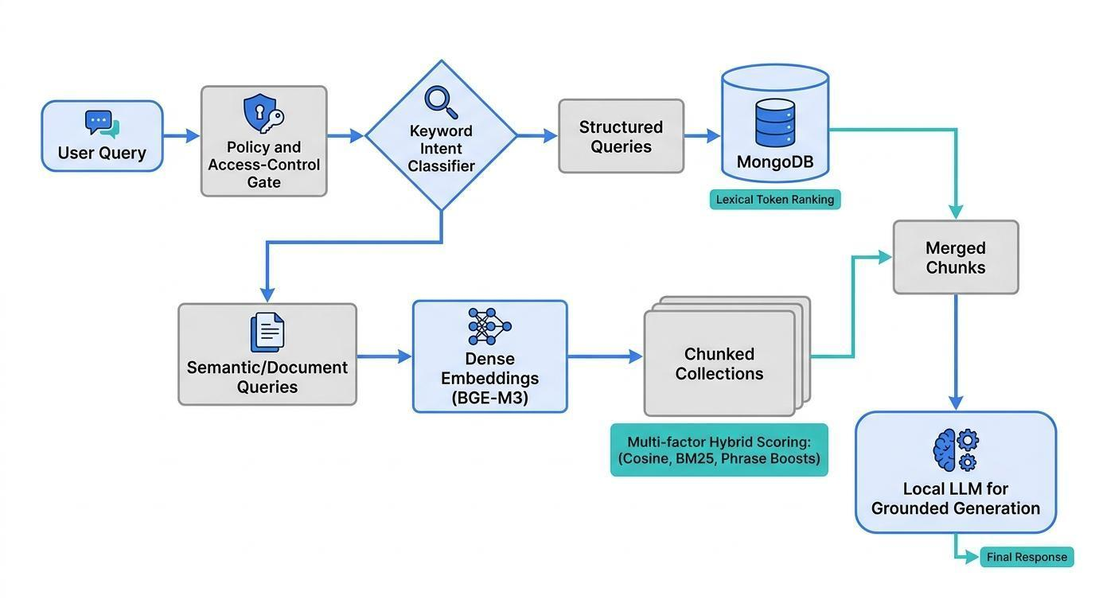
Fig. 2. Chatbot query-processing pipeline showing access checks, intent routing, parallel retrieval, and context preparation.

A. Intent Classification
A user query $q$ is classified before executing dense embeddings or expensive generation [5]. The system calculates category scores $I_{c}\left(q\right)$ across structured, semantic, knowledge, document, and tool/analytics categories:
$I_{c}\left(q\right)=\sum_{k∈K_{c}}{}1\left(k⊆q\right)$
Here, q is the user query, K_c is the keyword set for category c, and 1[k is in q] is an indicator equal to 1 when keyword k appears in q and 0 otherwise. The category with the highest score is selected as the primary branch; ties follow the implementation's fixed branch order. Simple database inquiries bypass the LLM entirely, conserving local GPU resources [5].

B. Structured Branch (Lexical Token Ranking)
For the records inside MongoDB collections, the system ranks documents that are based on lexical token matching [5].
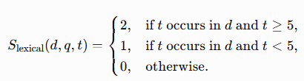
Here, T_q is the set of query tokens and l(t) is the token length in characters. The implementation assigns twice the weight to longer tokens, which helps exact lookup of proper nouns, identifiers, and tender values without neural generation [5].

C. Semantic Branch (Cosine Similarity)
In the cosine-similarity equation, q is the query embedding, d is the candidate chunk embedding, q dot d is their dot product, and the denominator is the product of their Euclidean norms. The result is used for explanatory, meaning-based procurement queries [5].
$Cosine\left(q,d\right)=\frac{q⋅d}{∥q∥∥d∥}$

D. Document Branch (Multi-Factor Hybrid Matching)
Unstructured bid and contract PDFs were split into paragraph chunks of approximately 1,200 characters with a 180-character overlap to preserve continuity across chunk boundaries [5]. Chunks are scored via a multi-factor hybrid retrieval function [5]:
where Scosine is dense BGE-M3 similarity, SBM25 is sparse lexical relevance, Sphrase is a bigram exact matching boost (+1.3 points per matching query bigram), and $C$ represents query-term coverage [5]:
$C=\frac{Query Terms Found in Chunk}{Total Query Terms}$
Here, B_source = +0.7 is the source-kind boost and B_authority = +0.4 is the authority-term boost. The phrase contribution is +1.3 for each exact query bigram. These constants were manually selected as engineering settings during prototype construction; the project did not preserve a held-out tuning set or pilot sweep from which an optimum could be claimed. Accordingly, they are not presented as learned parameters. A reproducible sensitivity analysis should compare the reported setting with each boost removed and with low/medium/high alternatives, using the same labeled queries and reporting Recall@k, MRR, and nDCG@k. No sensitivity percentage is invented here because the original run did not log those ablations.

TENDER EVALUATION METHODOLOGY & MODEL CONFIGURATIONS
The automated bid evaluation engine executes a four-phase process (Fig. 3): ingestion, eligibility gate, technical scoring, and QCBS selection. Ingestion receives and normalizes tender and bid documents; the eligibility gate screens mandatory identity and submission requirements; technical scoring evaluates criterion evidence; and QCBS selection applies configured technical and commercial weights.
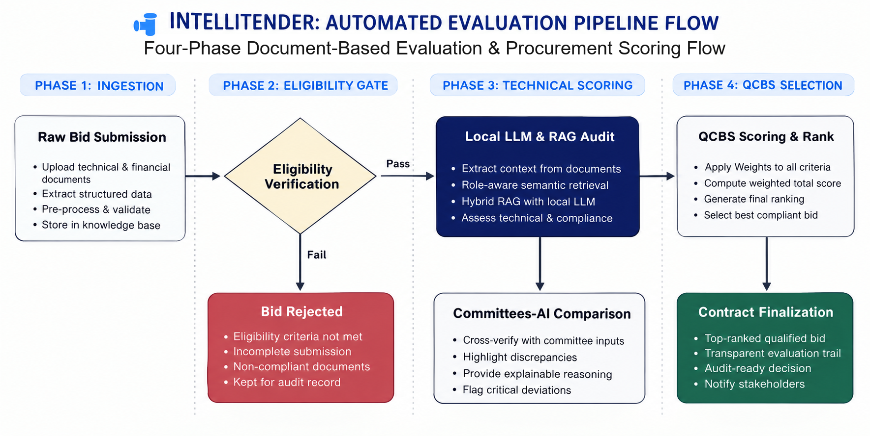
Fig. 3. Four-phase document-first evaluation pipeline: ingestion, eligibility gate, technical scoring, and QCBS selection.

A. Model Parameter Configurations
The evaluation uses a consumer-grade workstation (NVIDIA RTX 3050, 8 GB VRAM, and AMD Ryzen 5 5600G CPU). Table I separates runtime defaults used by bid scoring, milestone review, and chatbot generation from shared workstation settings. The defaults are read from the source code and can be overridden through environment variables.
The source implementation defines task-specific runtime defaults. Bid scoring uses the configured Qwen model with temperature 0.2 and an AI_SCORING_MAX_TOKENS default of 700; it parses the returned text as JSON and retries once with a stricter prompt if parsing fails. Milestone review uses temperature 0.2 and an AI_MILESTONE_MAX_TOKENS default of 2,200 with a JSON-object response format. Normal chatbot answers use temperature 0.2 and an LM_STUDIO_CHAT_MAX_TOKENS default of 1,200; a detailed milestone-chat path uses temperature 0.15. These are source-code defaults and may be changed by environment variables. Structured-output flags are also configurable, so the paper does not treat them as evidence of grammar-constrained decoding.

TABLE I. WORKSTATION MODEL PARAMETER SETTINGS
Task | Configured operational values
Bid scoring | Qwen3-4B-2507; temperature 0.2; AI_SCORING_MAX_TOKENS default 700; application JSON parsing and one retry; structured-output flag configurable and false by default.
Milestone review | Qwen3-4B-2507; temperature 0.2; AI_MILESTONE_MAX_TOKENS default 2,200; JSON-object response format.
Chatbot discussion | Normal final answer: temperature 0.2 and LM_STUDIO_CHAT_MAX_TOKENS default 1,200; detailed milestone-chat path: temperature 0.15.
Shared workstation | 16,384-token context (8,192-token fast run); 36 GPU-offload layers; batch size 512; top-p 0.90; min-p 0.05; repetition penalty 1.05.

B. Structured JSON Output Handling
To reduce structural formatting failures, the evaluator asks the local model for JSON, optionally requests JSON-object response formatting when enabled, parses the response, and retries when parsing fails. This is application-level output handling rather than grammar-constrained decoding. The evaluator expects a

The full schema is provided in Appendix A. The source implementation currently stores the warning object under the legacy key `genuityChecks`; this paper refers to its meaning as documentConsistencyChecks because it reports consistency warnings and confidence metadata, not authentication against an authoritative certificate registry. The main-paper field summary is:
Field | Purpose
eligibility | Pass/fail result and reasons for the eligibility gate.
criteriaScores | Criterion name, source document, maximum mark, awarded mark, rule type, and evidence.
commercialAnalysis | Stated and adjusted bid values, rationale, and commercial risks.
documentConsistencyChecks (source key: genuityChecks) | Document warnings and confidence metadata.
aiScores | Candidate technical, financial, and overall scores.
summary | Short human-readable evaluation summary.
rationale | Evidence-linked reasons supporting the candidate scores.

C. Recalculating Scores
The language model extracts evidence and proposes criterion-level marks in the validated JSON object. The backend then clamps each mark to its criterion maximum, sums marks, normalizes the technical score, applies QCBS weights, and calculates the final totals. Thus the model supplies evidence-linked candidate scores, while the backend performs numerical normalization, weighting, and final mathematical calculations; model-generated totals are never trusted without recomputation.
$T_{AI}=\frac{\sum_{i=1}^{n}{}a_{i}}{\sum_{i=1}^{n}{}m_{i}}×100$
In the equation above, a_i is the AI-awarded mark for criterion i, and M_i is the maximum available mark for criterion i. TechnicalScore is the normalized technical result on a 0-100 scale.

D. Commercial Evaluation & QCBS Selection
The system extracts and verifies bid values against the submitted commercial PDF. In Quality and Cost-Based Selection (QCBS) modes, the lowest eligible bid receives a financial score , and other bids are normalized proportionally:
$F_{j}=min\left(100,\frac{P_{min}}{P_{j}}×100\right)$
In the financial-score equation, P_min is the lowest valid eligible bid price and P_j is the price of bid j. F_j is capped at 100. Ineligible bids do not receive commercial marks unless the authorized procurement officer explicitly enables the documented override.
$O_{j}=T_{j}\left(\frac{W_{T}}{100}\right)+F_{j}\left(\frac{W_{F}}{100}\right)$
Here, T_j is the technical score for bid j, F_j is its normalized financial score, W_T is the technical weight, and W_F is the commercial weight. For the municipal case, the configured QCBS weights are W_T = 70 and W_F = 30, so the backend computes the weighted total after it has independently recalculated both component scores.

MILESTONE MONITORING & ASYNCHRONOUS AI REVIEW
When progress certificates or milestone checklists are submitted, the milestone service collects tender documents, contract and milestone dates, checklist state, progress reports, and attachment text. It compares planned and actual dates, checks reported checklist completion, searches tender clauses for quality or penalty conditions, and returns a structured report with timeline, observations, alerts, severity, penalty estimate, and clause/document signals. Reports are stored against the contract and milestone, and alerts are surfaced to authorized PO users. This is an implemented review workflow; the current study does not contain a multi-case milestone accuracy benchmark.
tdelay = tactual - tplanned
Here, t_planned is the planned completion time, t_actual is the recorded completion time, and t_delay is the signed delay. Positive values indicate lateness; negative values indicate early completion.

EXPERIMENTAL SETUP & WORKSTATION RESULTS
The prototype evaluated one controlled municipal tender (budget: INR 45,00,000; total available technical criteria: 1,050 marks) with three synthetic bid submissions. This is a proof-of-concept case study, not a statistically powered evaluation of procurement accuracy.
- Apex Infra Constructions Pvt. Ltd.: Bid of INR 43,97,280. Valid Class-A License (CEIG Pune), valid ISO 45001, two valid Proof of Works, and a complete project schedule.
- Pinnacle BuildTech Solutions Ltd.: Bid of INR 49,73,700. Valid Class-A Electrical License, valid ISO 45001, but only one valid Proof of Work (marks capped at 100/200) and a completely omitted project implementation schedule.
- TechNova Systems: Bid of INR 49,56,000. The submitted certificates listed "BuildPro Civil Infrastructures Pvt. Ltd." instead of "TechNova Systems," triggering an immediate name mismatch.

A. Scoring Breakdown & Clerical Error Auditing
TABLE II. TECHNICAL AND COMMERCIAL SCORE COMPARISON
For every eligible bidder and criterion, Gap G_i is defined as AI mark minus committee mark: G_i = AI_i - Committee_i. The totals are Apex: committee 1,035/1,050 = 98.57% and AI 1,050/1,050 = 100.00%, so G = +15; Pinnacle: committee 950/1,050 = 90.48% and AI 450/1,050 = 42.86%, so G = -500. Apex's +15 arises because the committee awarded 485/500 for a schedule that the bid evidence supports at 500/500. Pinnacle's -500 arises because the committee awarded 500/500 for a project schedule that was absent, whereas the tender rule assigns zero when the required evidence is missing. TechNova is excluded from these normalized totals because it failed the eligibility gate.
Bidder / Criterion | Max Marks | Committee Mark | AI Mark | Gap G_i (AI - Committee) | Compliance Evidence Verified in Bid Pack
Apex Infra
- Elec. License | 150 | 150.00 | 150.00 | 0.00 | CEIG Pune, valid until June 11, 2027
- ISO 45001 | 200 | 200.00 | 200.00 | 0.00 | IQMS Certification, valid until Feb 09, 2025
- Proof of Work | 200 | 200.00 | 200.00 | 0.00 | Mumbai Port Trust & Pillai College
- Project Schedule | 500 | 485.00 | 500.00 | +15.00 | Detailed work breakdown, scope compliant
Pinnacle BuildTech
- Elec. License | 150 | 150.00 | 150.00 | 0.00 | State Electricity Board, Valid to May 2028
- ISO 45001 | 200 | 200.00 | 200.00 | 0.00 | Verified (Civil & MEP, Valid to Aug 2026)
- Proof of Work | 200 | 100.00 | 100.00 | 0.00 | Capped due to single submission (Vertex Tech)
- Project Schedule | 500 | 500.00 | 0.00 | -500.00 | Absent. AI detected complete omission.
TechNova Systems
- Eligibility Gate | N/A | Failed | Failed | 0.00 | Identity mismatch: BuildPro Civil Certificates
Apex Infra total | 1,050 | 1,035 | 1,050 | +15 | Committee 98.57%; AI 100.00%
Pinnacle BuildTech total | 1,050 | 950 | 450 | -500 | Committee 90.48%; AI 42.86%

The evaluation shows how the local AI can act as an AI-assisted document-grounded verification layer. It is not an objective or infallible gate: retrieval, extraction, and interpretation errors remain possible and require human verification.

B. On-Device Workstation Telemetry
TABLE III. ON-DEVICE PERFORMANCE TELEMETRY (NVIDIA RTX 3050, 8 GB VRAM)
Evaluated Bidder | Evaluation Time | Processed Tokens | Throughput | Mean GPU Power | Total Energy | First-Token Latency
Apex Infra | 41.00 s | 11,799 tokens | 47.8 tok/s | 62.40 W | 2,048.20 J | 3.34 s
Pinnacle BuildTech | 21.00 s | 4,097 tokens | 55.5 tok/s | 63.40 W | 969.30 J | 2.03 s
TechNova Systems | 18.00 s | 4,513 tokens | 53.3 tok/s | 64.00 W | 918.30 J | 1.63 s

The cumulative AI execution time across the entire bidding queue was 1 minute 24 seconds (84 s), compared with 15 minutes 2 seconds (902 s) for the human committee's recorded portal review and submission-update work. The AI measurement includes the three queued bid-evaluation runs, including document preparation, local-model generation, backend validation, score recomputation, and persistence. The human measurement includes the committee's recorded portal work for reviewing the same three submissions and entering the results. The measurements are comparable at the workflow level but are not identical instrumentation scopes; they should therefore be interpreted as an administrative speed comparison, not a controlled end-to-end human-factors experiment. The speed-up factor is human time divided by AI time: (15 x 60 + 2) / 84 = 902 / 84 = 10.738, or approximately 10.7x.

DISCUSSION & WORKSTATION COMPUTE LIMITS
The main compute result is the measured local performance on the RTX 3050: the three queued evaluations completed in 84 seconds, with 47.8-55.5 tokens/s and approximately 62.4-64.0 W mean GPU power in the recorded run. The comparison with RTX 5080, H100, H200, and B200 is included only as contextual specification information; those cards were not tested in this study, and their theoretical bandwidth or compute values must not be read as measured IntelliTender performance. The paper therefore uses the local telemetry, rather than an unsupported cross-GPU efficiency claim, to characterize the prototype's workstation limits.

TABLE IV. CONTEXTUAL GPU SPECIFICATION COMPARISON (NOT MEASURED IN THIS STUDY)
GPU Card | VRAM (GB) | Bandwidth (TB/s) | Compute Ratio
RTX 3050 | 8 GB | 0.22 | 1$×$ (Baseline)
RTX 5080 | 16 GB | 1.00 | $∼$12.4$×$
H100 | 80 GB | 3.35 | $∼$27.2$×$
H200 | 141 GB | 4.80 | $∼$27.2$×$
B200 | 180 GB | 8.00 | $∼$61.8$×$

Datacenter accelerators generally provide more memory and bandwidth than the tested consumer GPU, but this observation is contextual and does not establish an energy or throughput ranking because no cross-hardware experiment was performed. For the present study, the practical limit is the RTX 3050's 8 GB VRAM: larger local models may require quantization, reduced context, or CPU/PCIe offloading, which can reduce throughput. These constraints motivate the use of a compact local model while preserving document privacy.
Models larger than the available 8 GB VRAM may require quantization, reduced context, or CPU/PCIe offloading, which can reduce throughput. This observation is an engineering constraint of the evaluated workstation, not a measured comparison with RTX 5080, H100, H200, or B200 hardware.

ADVANTAGES, LIMITATIONS & ETHICS
The system consolidates tendering, bid auditing, and progress tracking into a unified local dashboard. However, several critical boundaries should be emphasized.
- Small Dataset: The controlled prototype evaluates only three synthetic bidder submissions; findings cannot yet be generalized to enterprise, multi-hundred-bid procurement networks.
- No Authentic Documents: The certificate files used in our risk evaluations were generated as suspicious sample documents without authentic government signatures, seals, or validations, serving only to test risk-detection capabilities.
- Mandatory Human-in-the-Loop: System outputs serve as decision support [6]. Final awards, compliance exceptions, and legal verifications must remain with authorized human officials [6, 8].

CONCLUSION & FUTURE WORK
This paper presents IntelliTender as a proof-of-concept for locally deployed, document-grounded AI assistance in procurement workflows. The evaluated case used one synthetic municipal tender, three synthetic bid submissions, and one recorded queue run on an RTX 3050 workstation. The study demonstrated: (1) role-scoped retrieval and workflow access, (2) hybrid document search combining dense similarity with lexical and metadata signals, (3) schema parsing and one-retry handling for invalid bid JSON, (4) deterministic backend recomputation of criterion and QCBS scores, and (5) detection of a missing project schedule that had received 500 committee marks. The measured AI queue time was 84 seconds versus 902 seconds of recorded committee portal work, but the timing scopes were not identical and no general productivity claim is made. The 89.89% value is withdrawn, and the 75.48% agreement measure remains provisional because the case lacks independently reviewed ground truth. The results therefore support the central claim that IntelliTender demonstrates the feasibility of combining local LLM inference, hybrid document retrieval, structured output validation, deterministic scoring, and a human decision boundary. Larger tenders, repeated runs, labeled retrieval benchmarks, JSON reliability trials, ablation studies, and milestone outcome data remain necessary before effectiveness or accuracy claims can be generalized.

B. Reproducible Experimental Methodology
Dataset and units of analysis. The case study contains one municipal tender with a budget of INR 4,500,000, four technical criteria totaling 1,050 marks, and three synthetic bid submissions: Apex Infra Constructions, Pinnacle BuildTech Solutions, and TechNova Systems. The criterion-level unit is one bidder-criterion pair; the retrieval unit is one document chunk; the milestone unit is one submitted milestone record. The source description specifies paragraph chunks of approximately 1,200 characters with 180-character overlap, but the original run did not preserve the final chunk count. The chunk count should therefore be exported from the index in every replication rather than inferred from the document count.
Evaluation procedure. Each eligible bid is processed through the same eligibility gate, evidence retrieval, criterion scoring, backend score recomputation, and commercial normalization. TechNova is evaluated at the eligibility gate because its certificates name a different company. The reported timing uses the three queue entries shown in the telemetry table. The current manuscript contains one recorded evaluation run; repeated runs are required for a variance estimate because Qwen sampling is not mathematically deterministic even at low temperature.
Independent reference assessment. Committee marks are not treated as ground truth because the committee record contains the 500-mark schedule error. A defensible reference set should be constructed by two evaluators who independently apply the published tender rules to the tender notice and bid evidence, record the evidence location for every criterion, and resolve disagreements through a documented adjudication. Until that double-review procedure is completed, the reference used here is provisional and rule-derived from the evidence summarized in Table 2. Accordingly, the paper reports agreement with the reference assessment rather than accuracy.
Agreement metric. Let M_i be the maximum mark for criterion instance i, a_i the compared assessment, and g_i the reference mark. The weighted normalized agreement is A = 100(1 - sum_i |a_i - g_i| / sum_i M_i). For the available table, the absolute differences are 15 marks for Apex and 500 marks for Pinnacle, while the maximum marks across the two eligible bids sum to 2,100. Thus A = 100(1 - 515/2100) = 75.48%. This calculation is transparent but provisional because the reference has not been independently double-reviewed. It must not be generalized from one tender and three synthetic submissions.
C. Retrieval Evaluation and Hybrid-Score Ablation
Retrieval should be evaluated separately from generation. For each query, evaluators should label the relevant tender-document chunks before viewing system rankings. Report Recall@k = relevant chunks retrieved in the top k divided by all relevant chunks, Precision@k = relevant chunks retrieved in the top k divided by k, MRR as the reciprocal rank of the first relevant chunk, and nDCG@k for graded relevance. Use the same query set for BM25-only, BGE-M3-only, and the proposed hybrid method. Query types should include exact identifiers and values, eligibility questions, criterion evidence questions, and milestone-status questions. The original run did not preserve relevance labels or ranked retrieval outputs, so no retrieval improvement percentage is claimed in this paper.
The proposed document score can be written as S = w_d S_cosine + w_b S_BM25 + w_p S_phrase + w_c C_terms + B_source + B_authority. The coefficients reported in the implementation are w_d, w_b, w_p, and w_c for the dense, lexical, phrase, and coverage terms, with source and authority boosts of +0.7 and +0.4. Because the manuscript does not document a held-out tuning set, these coefficients should be treated as engineering settings rather than learned optimal weights. The ablation should remove one component at a time: dense similarity, BM25, phrase matching, term coverage, source weighting, and authority weighting. Compare each variant with the same labeled queries and report paired changes in Recall@k, MRR, and nDCG@k.
D. Quantitative JSON Reliability Evaluation
JSON reliability is evaluated independently of semantic scoring. For N evaluation requests, valid-JSON rate is V/N, retry rate is R/N, and failed-evaluation rate is F/N, where V is the number valid on the first accepted attempt, R is the number requiring at least one retry, and F is the number still invalid after the retry budget. The required comparison is prompt-only, structured-output enabled, schema-validation without retry, and schema-validation plus retry. The original manuscript describes the handling logic but does not contain the four-condition request log; therefore it reports no invented reliability percentages. Future runs should fix the prompt, model, temperature, and retry budget and publish the complete numerator and denominator for each condition.
E. Quantitative Milestone-Monitoring Evaluation
Milestone monitoring should be evaluated with the same discipline as bid scoring. For each milestone, record planned completion date t_planned, actual completion date t_actual, checklist items, supporting evidence, AI severity, human severity, and alert latency. Delay is t_delay = t_actual - t_planned. As a reproducible test case, a milestone planned for day 30 and completed on day 37 has a measured delay of 7 days; the system should display the 7-day value, retrieve the associated checklist or certificate, and create an alert according to a threshold declared before testing. Report mean absolute delay error, severity agreement, alert precision and recall, and median alert latency over multiple logged milestones. The current paper contains the delay formula and workflow but no preserved milestone trial, so the case study does not claim a measured milestone-monitoring accuracy.
F. Human-in-the-Loop Decision Boundary
The operational boundary is explicit: retrieval produces candidate evidence, the local model produces a structured recommendation, the interface displays the evidence and rationale, an authorized human verifies the material facts, the human records the final decision, and the system stores an audit log. The AI may flag missing schedules, identity mismatches, or delayed milestones, but it cannot award a contract, waive a tender rule, or certify legal compliance. This boundary also limits the interpretation of the 500-mark discrepancy: it is an audit finding for human review, not proof that the model is objective.

Appendix A. Full Structured Output Schema
{
"type": "object", "additionalProperties": false,
"required": ["eligibility", "criteriaScores", "commercialAnalysis", "genuityChecks", "aiScores", "summary", "rationale"],
"properties": {
"eligibility": {"type": "object", "additionalProperties": false, "required": ["passed", "reasons"], "properties": {"passed": {"type": "boolean"}, "reasons": {"type": "array", "items": {"type": "string"}, "maxItems": 4}}},
"criteriaScores": {"type": "array", "items": {"type": "object", "additionalProperties": false, "required": ["criterion", "documentLabel", "maxMarks", "awardedMarks", "ruleType", "evidence"], "properties": {"criterion": {"type": "string"}, "documentLabel": {"type": "string"}, "maxMarks": {"type": "number"}, "awardedMarks": {"type": "number"}, "ruleType": {"type": "string", "enum": ["binary", "ratio", "numeric", "textual"]}, "evidence": {"type": "array", "items": {"type": "string"}, "maxItems": 1}}}},
"commercialAnalysis": {"type": "object", "additionalProperties": false, "required": ["statedValue", "adjustedValue", "rationale", "risks"], "properties": {"statedValue": {"type": ["number", "null"]}, "adjustedValue": {"type": ["number", "null"]}, "rationale": {"type": "string"}, "risks": {"type": "array", "items": {"type": "string"}, "maxItems": 3}}},
"genuityChecks": {"type": "object", "additionalProperties": false, "required": ["warnings", "confidence"], "properties": {"warnings": {"type": "array", "items": {"type": "string"}}, "confidence": {"type": ["number", "null"]}}},
"aiScores": {"type": "object", "additionalProperties": false, "required": ["technicalScore", "financialScore", "overallScore"], "properties": {"technicalScore": {"type": ["number", "null"]}, "financialScore": {"type": ["number", "null"]}, "overallScore": {"type": ["number", "null"]}}},
"summary": {"type": "string"}, "rationale": {"type": "array", "items": {"type": "string"}, "maxItems": 3}
}
}
The schema below is the implementation-compatible representation. The `genuityChecks` key is retained for compatibility; semantically it contains document-consistency warnings and confidence metadata, not registry authentication.
The schema below is the implementation-compatible representation. The `genuityChecks` key is retained for compatibility; semantically it contains document-consistency warnings and confidence metadata, not registry authentication.
The schema below is the implementation-compatible representation. The `genuityChecks` key is retained for compatibility; semantically it contains document-consistency warnings and confidence metadata, not registry authentication.
The schema below is the implementation-compatible representation. The `genuityChecks` key is retained for compatibility; semantically it contains document-consistency warnings and confidence metadata, not registry authentication.
Positioning statement. IntelliTender is presented here as a proof-of-concept for locally deployed, document-grounded AI assistance in procurement workflows, not as a fully validated autonomous tender evaluation system. Human officials retain authority over eligibility exceptions, score acceptance, award decisions, and legal verification.

REFERENCES
[1] P. Lewis et al., "Retrieval-Augmented Generation for Knowledge-Intensive NLP Tasks," in Proc. Neural Information Processing Systems (NeurIPS), 2020.
[2] J. Chen et al., "M3-Embedding: Multi-linguality, multi-functionality, multi-granularity text embeddings through self-knowledge distillation," arXiv:2402.05172, 2024.
[3] S. Robertson and H. Zaragoza, "The Probabilistic Relevance Framework: BM25 and Beyond," Found. Trends Inf. Retr., vol. 3, no. 4, pp. 333-389, 2009.
[4] D. Edge et al., "From Local to Global: A Graph RAG Approach to Query-Focused Summarization," arXiv:2404.16130, 2024.
[5] C. da Silva Bezerra et al., "Study for applying artificial intelligence to the analysis and construction of public procurement notices," Revista de Gestão e Secretariado, vol. 16, no. 2, 2025.
[6] H. R. F. Araújo et al., "Detection of anomalous proposals in governmental bidding processes: A machine learning-based approach," in Proc. LASDiGov, 2024.
[7] A. Asai, M. Gardner, and H. Hajishirzi, "Evidentiality-guided Generation for Knowledge-Intensive NLP Tasks," in Proc. North American Chapter of the Association for Computational Linguistics (NAACL), pp. 2226-2243, 2022.
[8] Y. Hong, C. Li, J. Zhang, and Y. Shao, "FG-RAG: Enhancing Query-Focused Summarization with Context-Aware Fine-Grained Graph RAG," arXiv:2504.07103, 2025.
[9] Y. Hong, C. Li, J. Zhang, and Y. Shao, "Context-Aware Fine-Grained Graph RAG for Query-Focused Summarization," in Proc. ACM International Conference on Information and Knowledge Management (CIKM), 2025.
[10] J. Pérez-Iglesias, J. R. Pérez-Agüera, V. Fresno-Fernández, and Y. Z. Feinstein, "Integrating the Probabilistic Models BM25/BM25F into Lucene," arXiv:0911.5046, 2009.
[11] S. Robertson, "BM25 and all that—a look back," in Proc. ACM SIGIR Conference on Research and Development in Information Retrieval, 2025.
[12] S. Robertson, H. Zaragoza, and M. J. Taylor, "Simple BM25 extension to multiple weighted fields," in Proc. ACM SIGIR Conference on Research and Development in Information Retrieval, pp. 42-49, 2004.
[13] B. Shao and Y. Chen, "Multi-granularity for knowledge distillation," arXiv:2108.06681, 2021.
[14] Y. Zhao, B. Hu, P. Minervini, P. Stenetorp, and S. Riedel, "An Efficient Memory-Augmented Transformer for Knowledge-Intensive NLP Tasks," arXiv:2210.16773, 2022.

