Exoplanet Vetting on Kepler Light Curves: From Windowed CNNs and Attention-MIL to Real-Data Mamba-2 State-Space Models
Capstone Project–II | Project Report | Semester VII | Academic Year 2026–27
Vivekanand Education Society’s Institute of Technology (An Autonomous Institute Affiliated to the University of Mumbai), Department of Computer Engineering
Submitted in partial fulfilment of the requirements for the Bachelor of Engineering (B.E.) Degree in Computer Engineering
Submitted by: Sakshi Bhansali – D17A/7; Shreya Gokhale – D17A/19; Srushti Mahadik – D17A/40; Rochelle Ann Teddy – D17A/50
Project Mentor: Mrs.Pallavi Saindane - Assistant Professor

Certificate
This is to certify that Sakshi Bhansali, Shreya Gokhale, Srushti Mahadik, Rochelle Ann Teddy of Fourth Year Computer Engineering, studying in Vivekanand Education Society’s Institute of Technology, affiliated to the University of Mumbai, have satisfactorily completed the project on “[Exact approved title of the project]” as a part of their coursework of Capstone Project–II for Semester VII under the guidance of their mentor [Prof. Name] in the year 2026–27.
This project report entitled “[Title]” by [Author names] is approved for the degree of Bachelor of Engineering (Computer Engineering).
Programme Outcomes | Grade
PO1, PO2, PO3, PO4, PO5, PO6, PO7, PO8, PO9, PO10, PO11, PSO1, PSO2
Date:
Project Guide:

Project Report Approval
For B.E. (Computer Engineering). This project report entitled “[Title]” by [Author names] is approved for the degree of Bachelor of Engineering (Computer Engineering).
Internal Examiner: ____________________
External Examiner: ____________________
Head of the Department: ____________________
Principal: ____________________
Date:
Place:

Declaration
We declare that this written submission represents our ideas in our own words and where others’ ideas or words have been included, we have adequately cited and referenced the original sources. We also declare that we have adhered to all principles of academic honesty and integrity and have not misrepresented or fabricated or falsified any idea/data/fact/source in our submission. We understand that any violation of the above will be cause for disciplinary action by the Institute and can also evoke penal action from the sources which have thus not been properly cited or from whom proper permission has not been taken when needed.
(Signature) ____________________ (Sakshi Bhansali 07)
(Signature) ____________________ (Shreya Gokhale 19)
(Signature) ____________________ (Srushti Mahadik 40)
(Signature) ____________________ (Rochelle Ann Teddy 50)
Date:

Acknowledgement
We are thankful to our college, Vivekanand Education Society’s Institute of Technology, for considering our project and extending help at all stages of our work.
It gives us immense pleasure to express our deep and sincere gratitude to our project guide, [Name and Designation], for her/his kind help, valuable advice and guidance during the development of the project synopsis and the project itself.
We are deeply indebted to our Principal, Dr. (Mrs.) J. M. Nair, and the Head of the Computer Department, Dr. (Mrs.) Nupur Giri, for giving us this valuable opportunity to do this project. We express our heartfelt thanks for their assistance, without which it would have been difficult to finish this project report successfully.
We convey our deep sense of gratitude to all teaching and non-teaching staff for their constant encouragement, support and selfless help throughout the project work. We also thank the Department of Computer Engineering for its help and suggestions.
We wish to express our profound thanks to all those who helped us in gathering information about the project. Our families too have provided moral support and encouragement several times.

Course Outcomes and CO–PO–PSO Mapping
Course Outcome | Description
CO1 | Implement and integrate all modules of the proposed system effectively.
CO2 | Perform testing, debugging, validation, and performance optimization of the developed solution.
CO3 | Analyze project outcomes using appropriate engineering tools and metrics.
CO4 | Demonstrate deployment readiness, usability, security, scalability, and sustainability considerations.
CO5 | Analyze, interpret, and present research outcomes effectively using appropriate research methodologies, analytical tools, and presentation techniques.
CO6 | Present and defend the complete project professionally through demonstrations, presentations, and comprehensive technical documentation.

CO | PO1 | PO2 | PO3 | PO4 | PO5 | PO6 | PO7 | PO8 | PO9 | PO10 | PO11 | PSO1 | PSO2
CO1 | 2 | 3 | 3 | – | 3 | – | – | – | 3 | – | 2 | 3 | 3
CO2 | 2 | 3 | 2 | 3 | 3 | – | – | – | 2 | – | 2 | 3 | 2
CO3 | 2 | 3 | 2 | 3 | 3 | – | – | – | – | 2 | 2 | 3 | 2
CO4 | 2 | 2 | 3 | 2 | 3 | 2 | 3 | 2 | – | – | 3 | 3 | 3
CO5 | 2 | 3 | – | 3 | 3 | – | – | 2 | – | 3 | 2 | 2 | 2
CO6 | – | – | – | – | 2 | – | – | 2 | 3 | 3 | 2 | 2 | 2
Mapping scale: 3 = High correlation; 2 = Moderate correlation; 1 = Low correlation; – = No direct correlation.

Table of Contents
Sr. No. | Section | Page No.
1 | Abstract | 7
2 | Chapter 1: Introduction | 7-9
3 | Chapter 2: Literature Survey | 10-13
4 | Chapter 3: Requirement Gathering for the Proposed System | 13-16
5 | Chapter 4: Proposed Design | 16-19
6 | Chapter 5: Implementation of the Proposed System | 19-21
7 | Chapter 6: Testing of the Proposed System | 21-23
8 | Chapter 7: Results and Discussion | 23-40
9 | Chapter 8: Conclusion | 40-41
10 | References | 41
11 | Appendix – I: Project Evidence and Supporting Documents | 42-43

List of Figures
Figure No. | Figure Description | Page No.
4.1 | End-to-end pipeline and system block diagram | 16
4.4 | Project Scheduling and Tracking | 18
5.1 | Stage I pipeline (windowed 1D CNN)
5.2 | Stage II architecture (WindowCNN with AttentionMIL)
5.3 | Experimental lineage of the Mamba-2 study
5.4 | Mamba-2 sequence classifier used in V5
7.1 | User interface screenshots (upload, preprocessing, intermediate and final results)
7.2 | CNN+AttentionMIL test ranking metrics across experiments
7.3 | Test ROC and precision–recall curves (V5 ensembles, NA2 HGB, length-only)
7.4 | Seed-wise test performance of the Mamba-2 variants

List of Tables
Table No. | Table Description | Page No.
1.1 | SDG alignment
2.1 | Related works
2.2 | Comparison with existing approaches
3.1 | Hardware, software and tools
6.1 | Test case scenarios
7.1 | Stage I KIC-level performance
7.2 | CNN+AttentionMIL experiment matrix
7.3 | Preliminary Mamba-2 versions (V1–V4-B)
7.4 | Threshold-independent V5 test performance
7.5 | Summary-statistic baselines
7.6 | Paired-bootstrap differences against NA2 HGB
7.7 | Threshold-dependent metrics
7.8 | Paired injection test
7.9 | Summary of modelling stages
7.10 | Sustainability targets
7.11 | Sustainability rubric
A.1 | Per-seed threshold metrics

List of Abbreviations
Abbreviation | Full form
AP | Average Precision
AUC | Area Under the Curve
BLS | Box Least Squares
CNN | Convolutional Neural Network
FITS | Flexible Image Transport System
HGB | Histogram Gradient Boosting
KIC | Kepler Input Catalog
MAD | Median Absolute Deviation
MCC | Matthews Correlation Coefficient
MIL | Multiple-Instance Learning
NPZ | NumPy compressed archive
PDCSAP | Pre-search Data Conditioning Simple Aperture Photometry
PR-AUC | Precision–Recall Area Under the Curve
ROC | Receiver Operating Characteristic
SAP | Simple Aperture Photometry
SSM | State-Space Model

Abstract
The transit method detects planets as small, temporary dips in stellar brightness, and automated classification of light curves can help prioritise targets for manual inspection. Kepler light curves are difficult to model because stars have very long and unequal observation spans, labels are weak at the sub-sequence level, and synthetic augmentation can silently introduce a provenance signal that a classifier exploits instead of transit morphology. This project builds a reproducible star-level pipeline and studies three modelling stages on one frozen split of Kepler Input Catalog identifiers: a memory-efficient windowed one-dimensional convolutional neural network, a window-level network with attention-based multiple-instance learning, and Mamba-2 state-space models on whole stitched sequences. A web interface lets a user upload light-curve files, prepares the data in the form each model expects, and displays intermediate and final results. In the window-based experiments the number of windows per star mattered most; 32 windows gave the best ranking, with ROC-AUC 0.701 and PR-AUC 0.422 for one seed. Preliminary Mamba-2 versions trained on real and synthetically injected sequences exposed a source shortcut, with real-versus-injected ROC-AUC of 1.0. The final real-data-only models reach ensemble ROC-AUC 0.7065 (flux) and 0.7172 (flux plus time gap) on 635 held-out targets, but a histogram gradient-boosting baseline on summary statistics performs better (ROC-AUC 0.7774, average precision 0.4990), with paired-bootstrap intervals excluding zero. A paired injection test shows that apparent recovery is largely explained by parents already scored positive. The work supports a feasibility conclusion and contributes a methodology of star-level isolation, source probes, feature baselines and paired injection analysis.
Keywords: Kepler light curves, exoplanet vetting, multiple-instance learning, Mamba-2 state-space model, source shortcut, feature baseline

Chapter 1: Introduction

1.1 Introduction
A planetary transit appears as a small, temporary dip in the brightness of a star when a planet passes in front of it. The Kepler mission recorded photometric time series for a very large number of stars, and convolutional networks have been shown to learn transit-related structure from such series [1]–[3]. Automated classification can rank planet-like signals and reduce manual inspection effort, which is the application domain of this project.
This project consolidates three stages of work on a common data foundation: a memory-efficient one-dimensional CNN over overlapping windows, a window-level CNN with attention-based multiple-instance learning (AttentionMIL), and Mamba-2 state-space models that operate on full stitched sequences. All stages share one frozen, star-level split of Kepler Input Catalog (KIC) identifiers. On top of the trained models, the project provides a web interface where a user uploads light-curve data, which is processed into the representation each model expects and then scored, with intermediate and final results displayed.
Throughout this report, host classification means separating labelled planet-host stars from non-host stars. Transit detection is reserved for experiments that directly establish sensitivity to transit signals.

1.2 Motivation
Three difficulties motivate the project. First, Kepler stars have very long and highly unequal observation spans, so full light curves do not fit a fixed-size input and the complete set of windows can exceed memory. Second, positive labels are weak at the sub-sequence level: a star is labelled as a host, but the window containing the transit is not identified. Third, synthetic augmentation by transit injection can introduce a provenance signal that a classifier learns instead of transit morphology, producing scores that look strong but are not scientifically meaningful.
A practical motivation is to provide a transparent tool in which a user can see how raw data becomes model input and how a score is produced, rather than receiving an unexplained number.

1.3 Problem Definition
Given a Kepler light curve for a star identified by its KIC number, classify whether the star is a labelled planet host or a non-host, using models that are trained and evaluated at the star level without leakage between partitions. The system must additionally (i) accept user-uploaded light-curve files (for example FITS or NPZ), (ii) transform them into the inputs expected by each model, and (iii) present intermediate and final outputs.
Target users: students and researchers who wish to rank Kepler targets or study the behaviour of sequence models on photometric data.
Scope: host classification on Kepler light curves. The project does not claim planet confirmation, and a high score does not confirm a planet.
Intended outcome: a reproducible pipeline, controlled model comparisons including a feature-based baseline, a documented diagnosis of the source shortcut, and a working upload-and-inference interface.

1.4 Existing Systems
Convolutional networks have been applied to identify and classify transit signals in Kepler data [1], with later work showing that scientific domain knowledge improves transit classification [2]. Related CNN-based classification has been applied to candidates from the Next Generation Transit Survey [3] and to rapid classification of TESS candidates [9]. One-dimensional CNNs have also been used to compute transiting-exoplanet parameters [8]. More recent studies apply machine learning to Kepler and TESS candidate vetting and characterisation, including comparative analyses on Kepler data [4], validation of TESS candidates [5], fuzzy and explainable vetting of Kepler candidates [6], and conditional flow matching with XGBoost [7]. Selective state-space models such as Mamba and Mamba-2 provide linear-time sequence modelling [11], [12].

1.5 Lacunae in Existing Systems
The following gaps are the ones this project addresses; they are stated as gaps in what is evaluated here, not as unsupported claims about the cited works.
- Windowed models discard long-range context and depend on weak window labels; the effect of the per-star window budget is rarely treated as an experimental variable.
- Synthetic injections are widely useful, but a classifier can learn to separate injected from real curves. This project demonstrates the effect, with a real-versus-injected probe reaching ROC-AUC 1.0.
- Headline scores are often reported without a simple feature-based baseline, so the value added by a deep sequence model is unclear.
- Injection recovery is often reported as a raw rate, which is inflated when the uninjected parent is already scored positive.

1.6 Relevance of the Project
The project is relevant to researchers who rank or vet Kepler targets and to students learning how to evaluate machine-learning claims on astronomical time series. Its main contribution is methodological: star-level isolation, representation ablation, source-aware diagnostics, feature baselines and paired injection analysis. The interface makes the preprocessing and model stages visible to the user.

1.7 Alignment with the United Nations Sustainable Development Goals
Only goals with a genuine connection to the project are listed. The connections below are design intent or expected contribution; no broad SDG progress is claimed for a prototype.
Table 1.1: SDG alignment
SDG No. and Name | Relevant SDG Target | Project Component / Objective | Expected or Demonstrated Contribution | Indicator / Evidence
SDG 9: Industry, Innovation and Infrastructure | Target 9.5: enhance scientific research and upgrade technological capabilities | Reproducible machine-learning pipeline for astronomical light curves with documented baselines | Expected: supports scientific research through reusable, audited methodology | Frozen splits, SHA-256 hashed artefacts, per-seed manifests (Section 8 of the paper; Chapter 7)
SDG 4: Quality Education | Target 4.4: increase the number of people with relevant technical skills | Interface that exposes preprocessing and model stages | Expected: transparent tool for learning how model inputs are prepared | Qualitative; no user study conducted

Chapter 2: Literature Survey

2.1 Brief Overview of the Literature Survey
The survey covers three areas: (i) CNN-based classification and vetting of Kepler and TESS candidates, (ii) recent machine-learning approaches to candidate vetting and parameter estimation, and (iii) long-sequence state-space models and the transit-modelling tool used for synthetic injection. Sources are the papers referenced in this report. Table 2.1 is summarised at the level of each work’s stated title and scope; entries should be checked against the full texts before final submission.

2.2 Related Works / Research Papers Referred
Table 2.1: Related works
Paper / citation | Method / approach | Key findings (as stated in the title/scope) | Inference for this project
Shallue and Vanderburg, 2018 [1] | Deep learning (CNN) on Kepler light curves | Identification of exoplanets, including a five-planet resonant chain around Kepler-80 and an eighth planet around Kepler-90 | Establishes that CNNs can learn transit structure from Kepler photometry
Ansdell et al., 2018 [2] | CNN with scientific domain knowledge | Domain knowledge improves transit classification | Input design and representation affect results, which this project tests directly
Chaushev et al., 2019 [3] | CNN classification of candidates | Applied to the Next Generation Transit Survey | CNN vetting transfers across surveys
Osborn et al., 2020 [9] | CNN classification of TESS candidates | Rapid classification of TESS planet candidates | Supports CNN use for large candidate sets
Iglesias Álvarez et al., 2024 [8] | 1D CNN | Computing transiting-exoplanet parameters | 1D convolution is a suitable backbone for light-curve windows
Karimi et al., 2025 [4] | Comparative machine learning | Exoplanet detection using Kepler data | Motivates comparison against conventional classifiers
Huang and Jiang, 2025 [5] | Machine learning | Validating TESS candidates and identifying planets in the habitable zone | Illustrates current vetting studies
Marín Díaz, 2025 [6] | Fuzzy and explainable AI | Interpretable vetting of Kepler candidates | Supports the need for transparent outputs
Fiscale et al., 2025 [7] | Conditional flow matching with XGBoost | Detection of exoplanets in transit light curves | Shows boosted-tree models used alongside neural methods
Gu and Dao, 2023 [11]; Dao and Gu, 2024 [12] | Selective state-space models (Mamba, Mamba-2) | Linear-time sequence modelling | Allows whole-sequence modelling without windowing
Kreidberg, 2015 [10] | batman transit model | Transit light-curve calculation in Python | Used to create controlled synthetic injections

2.3 Patent Search
Patent search details are not part of the supplied project material and must not be invented. Complete this section with: search terms and databases used (European Patent Office Espacenet; US patent search), patent titles and numbers, jurisdiction, link, date checked and relevance to the project. Do not claim freedom to operate without qualified legal review.
Search terms | Database / link | Patent title and number | Date checked | Relevance
Exoplanet light curve classification, machine learning | Google Patents | Light Curve Automatic Classification Method and System Based on Multimodal Machine Learning – CN116342920A | 24/08/2026 | Relevant to automated light-curve classification using ML.
Exoplanet detection, transfer learning,1D CNN | Google Patents | An Exoplanet Light Variation Signal Classification Method Based on Transfer Learning – CN116226714B | 07/09/2026 | Relevant to deep-learning-based classification of astronomical time-series data.
Transit method, exoplanet detection | Google Patents | Demonstration Device of Searching Extrasolar Planet by Transit Method – CN104599584A | 21/09/2026 | Related to the transit-based exoplanet detection principle.

2.4 Inference Drawn
The literature shows that CNNs and boosted-tree methods are established for light-curve classification, and that state-space models offer a route to whole-sequence modelling. It does not remove three practical issues that this project addresses: how much of each star should be presented to the model, how to prevent provenance shortcuts when synthetic data is used, and how to establish whether a sequence model adds value over a simple summary-statistic classifier. The project responds with controlled window-budget experiments, a source probe, real-data-only training and an explicit feature baseline.

2.5 Comparison with Existing Systems
Table 2.2: Comparison with existing approaches
System / paper | Features / method | Strengths | Limitations | Difference in proposed work
CNN-based vetting [1]–[3], [9] | Fixed-size CNN input from light curves | Established, effective at learning transit structure | Fixed input size requires binning or windowing | Gap-aware stitching and windowing with star-level splits and an explicit window-budget ablation
Feature-based and boosted-tree methods [4], [7] | Summary features with conventional classifiers | Simple and strong | May be omitted as a reference when evaluating deep models | HGB on flux summary statistics is used as a mandatory baseline and is the best model tested
Proposed Stage II | WindowCNN with AttentionMIL | Handles weak labels at the star level | Sensitive to the window cap and to seed | Window budget varied one factor at a time over several seeds
Proposed Stage III | Mamba-2 on full stitched sequences | No windowing; uses long-range context | Needs long-sequence batching; did not beat the baseline | Real-data-only training, three seeds, ensembles, paired bootstrap and paired injection test

2.6 Feasibility Analysis
a. Technical feasibility. The data are public Kepler products retrieved with Lightkurve, and stellar parameters for injection come from the NASA Exoplanet Archive Kepler DR25 table. The pipeline is demonstrably feasible: the Mamba-2 classifier has about 69 thousand parameters, and batches are capped at 4 samples and 524,288 padded timesteps so that very long stars fit in memory. Stage I streams per-star shards with tf.data so the full window set is never held in RAM.
b. Economic and financial feasibility. The work uses open data and open-source libraries.
Cloud Storage (Google) - worth Rs. 1,300/ month
c. Cost-effectiveness. Cost is reduced by gap-aware windowing with a per-star window cap, a small model, a single frozen split reused by all stages, and cached feature tables.
d. Operational feasibility and risk mitigation.
Risk | Mitigation applied
Leakage between train and test through near-duplicate overlapping windows | Splits are always made by KIC before windowing
Provenance shortcut from synthetic injection | Source-identification probe; real-data-only final design
Label conflicts | Labels reconciled against injection ground truth; conflicting KICs excluded
Seed-dependent results | Three seeds per configuration and ensembles
Irreproducible runs | Configuration, seeds, manifests and SHA-256 hashes stored
e. Environmental and sustainability feasibility. Compute demand is limited by the small model, window cap and memory-aware batching. Energy was not measured (see Section 7.7).
f. Legal, ethical and privacy feasibility. The project relies exclusively on publicly available astronomical data obtained from NASA's Kepler mission archive (MAST) and the NASA Exoplanet Archive, subject to their respective data-use and acknowledgement guidelines. No human subjects, personal information or sensitive data are involved. The application requires users to enter only a Kepler Input Catalog (KIC) identifier, which is used to retrieve the corresponding light-curve data from public archives. No personal files are uploaded or collected. Therefore, the project presents minimal legal, ethical and privacy concerns, provided appropriate data attribution and responsible handling of user queries are maintained.

2.7 Expected Outcomes / Deliverables
- A reproducible KIC-level pipeline with audited labels and frozen splits.
- Controlled CNN and CNN+AttentionMIL ablations.
- A record of four preliminary Mamba-2 versions and the diagnosis of the source shortcut.
- A real-data-only, three-seed Mamba-2 study benchmarked against summary-statistic baselines with paired-bootstrap intervals and a paired injection test.
- A web interface for uploading data and viewing intermediate and final results.

Chapter 3: Requirement Gathering for the Proposed System

3.1 Introduction to Requirement Gathering
The stakeholders are the project team and mentor, who need a reproducible and defensible experimental record, and end users (students and researchers) who want to upload a light curve and see how it is processed and scored. Requirements were derived from the experimental pipeline of Chapters 4 and 5 and from the intended upload-and-inference workflow of the interface: a user uploads data in a supported format (for example FITS or NPZ); the system processes and prepares it into the input each model expects; the prepared input is passed to the models; and intermediate and final results are displayed.

3.2 Functional Requirements
ID | Requirement
FR-01 | The system shall accept an uploaded light-curve file in FITS or NPZ format (additional formats only where the parser supports them).
FR-02 | The system shall standardise each upload to time, flux, flux error, quality flags and cadence number, preferring PDCSAP flux and falling back to SAP flux.
FR-03 | The system shall remove non-finite entries, sort arrays by time, and reject inputs with fewer than ten valid points.
FR-04 | The system shall perform gap-aware stitching: segments are joined only if the temporal gap is at most g times the median cadence, larger gaps are kept as segment boundaries, and no interpolation is made across them.
FR-05 | The system shall apply Savitzky–Golay detrending (window 101, order 2) exactly once and shall reuse the processed flux downstream without second filtering.
FR-06 | For the windowed models, the system shall cut each segment into 1,024-sample windows with stride 512 so that no window crosses a segment boundary.
FR-07 | For the AttentionMIL model, the system shall form a bag of at most 32 windows per star.
FR-08 | For the Mamba-2 models, the system shall build the V5-A input (median-centred flux scaled by 1000) or the V5-B input (the same plus the time gap between consecutive samples).
FR-09 | The system shall run the selected model(s) and, for Mamba-2, the three seeds and their ensemble, and compute a host score.
FR-10 | The system shall display intermediate results of each processing stage (for example the raw and processed light curve, segmentation, windows, model inputs).
FR-11 | The system shall display the final host score together with the validation-selected decision threshold and the resulting label.
FR-12 | The system shall state that scores are not calibrated probabilities and do not confirm a planet.
FR-13 | The system shall report a clear error when an upload cannot be parsed or fails validation.

3.3 Non-Functional Requirements
Attribute | Requirement
Correctness / leakage control | Training, validation and test partitions are made by KIC; test data are not used for checkpoint or threshold selection.
Reproducibility | Every run records configuration, seed, preprocessing flags, split and batch-plan manifests, and SHA-256 hashes of key artefacts.
Memory efficiency | Batches are capped at 4 samples and 524,288 padded timesteps; Stage I streams per-star shards rather than holding all windows in memory.
Robustness | Appended right-padding must not change the logits of valid positions (checked by an invariance test).
Usability | The interface exposes intermediate results so the user can follow the data from upload to score.
Performance (interface) | After a user enters a KIC ID, fetching and preprocessing the light-curve data and generating the prediction takes approximately 90–120 seconds. No file upload is required.
Privacy | No personal files are uploaded or stored. Users enter only a KIC ID, which is used to retrieve publicly available astronomical data for prediction.

3.4 Hardware, Software, Technologies and Tools Utilized
Table 3.1: Hardware, software and tools
Category | Tool / specification | Purpose / version
Hardware | Standard Laptop, 8GB RAM | Running and demonstrating the application
Cloud computing | Google Colab with NVIDIA T4 GPU | Model training and evaluation
Software | Windows; Google Colab | Local development and cloud-based execution
Languages / frameworks | Python; TensorFlow (tf.data streaming, Stage I); Mamba-2 implementation [library and version]; scikit-learn [14] | Models, training, baselines
Data and astronomy tools | Lightkurve; batman [10]; NASA Exoplanet Archive Kepler DR25 table | Light-curve retrieval; synthetic injection; stellar parameters
Optimisation | AdamW [13] | Mamba-2 training
Version control / logging | [Tool]; SHA-256 hashing | Traceability of artefacts
Bracketed entries are not stated in the supplied material and must be completed from the actual environment.

3.5 Constraints
- Labels reflect the supplied catalogue; a high score does not confirm a planet.
- The dataset index lists 6,969 unique KIC identifiers; this is an index count, not the number of successfully acquired targets. The modelling cohorts are smaller: 4,504 real/control KICs for the CNN seed-123 run (a subset of the 4,565-KIC frozen split restricted by processed-data availability) and 4,253 real sequences for V5 (2,971/647/635).
- Synthetic injections are controlled examples, not natural planets.
- Stages use different gap factors (3.0 for the baseline CNN, 2.5 later) and splits (60/20/20 and 70/15/15), so absolute numbers are not directly comparable across stages.
- Only public astronomical data are used; no personal data are involved.

Chapter 4: Proposed Design

4.1 Block Diagram of the System
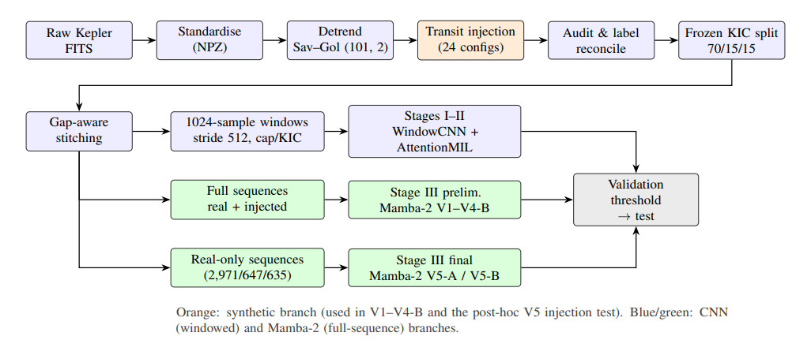
Figure 4.1: End-to-end pipeline and system block diagram
4.2 Modular Design of the System
Module | Responsibility | Input | Output
M1: Ingestion and standardisation | Parse FITS/NPZ, choose flux column, remove non-finite values, sort by time | Uploaded or archive file | Standardised arrays (time, flux, flux error, quality, cadence)
M2: Preprocessing | Savitzky–Golay detrending, gap-aware stitching, segment boundaries | Standardised arrays | Processed flux and stitched sequence
M3: Windowing / bagging | 1,024-sample windows, stride 512, cap of 32 windows per KIC | Stitched segments | Window set / bag
M4: Windowed models | WindowCNN, AttentionMIL, baseline 1D CNN | Windows | Star-level score
M5: Sequence models | Mamba-2 V5-A and V5-B | Centred flux (plus time gap) | Host score per seed and ensemble
M6: Decision and reporting | Apply validation-selected threshold; assemble results | Scores | Label, scores and diagnostics
M7: Interface | Upload, progress, display of intermediate and final results | User file | Visual output

4.3 Detailed Design
Stage I – 1D CNN baseline (Figure 5.1). Three Conv1D blocks (32/64/128 filters, kernels 7/7/5), each with batch normalisation and max-pooling, followed by global average pooling, a 64-unit dense layer, dropout 0.3 and a sigmoid output. Window probabilities are aggregated to the star by mean or maximum.
Stage II – WindowCNN with AttentionMIL (Figure 5.2). A WindowCNN maps each 1×1024 window to a 128-dimensional embedding through four Conv1D+BatchNorm+ReLU layers (channels 1→32→64→128→128, kernels 11/9/7/5, two max-pools), adaptive average pooling and dropout 0.25. An attention head (128→64 with tanh, →1) produces softmax weights a_k, the weighted sum z = Σ a_k h_k is passed through a 128→64→1 classifier with sigmoid output. Prediction is made at the KIC, the same unit as the split.
Stage III – Mamba-2 (Figure 5.4). Per-timestep features are projected to d_model = 64, followed by two Mamba-2 blocks (d_state = 64, d_conv = 4, expand 2), layer normalisation, masked mean-pooling over valid positions and a linear head with two logits (about 69 thousand parameters). The architecture is identical for V5-A (one channel) and V5-B (two channels).
Baselines. Weighted logistic regression and histogram gradient boosting on three summary-statistic feature sets: NA1 (23 features), NA2 (31) and NA3 (24), plus a length-only diagnostic.

4.4 Project Scheduling and Tracking
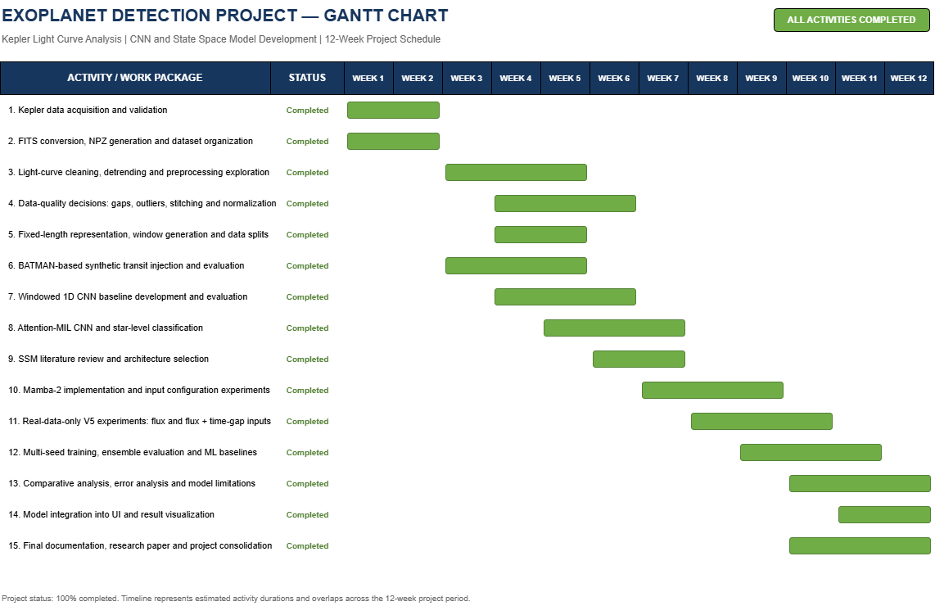
Phase | Planned | Actual | Notes
Data acquisition, standardisation, detrending | ✓ | ✓ | Lightkurve retrieval with retry/resume and manifest
Stage I: windowed 1D CNN | ✓ | ✓ | Memory-efficient streaming
Stage II: CNN + AttentionMIL ablations | ✓ | ✓ | Window cap, normalisation, quality, outlier filter
Stage III: Mamba-2 V1–V4-B | ✓ | ✓ | Source shortcut diagnosed
Stage III: V5 real-only study and baselines | ✓ | ✓ | Three seeds, bootstrap, injection test
Interface development | ✓ | ✓ | Model integration, preprocessing, inference and result visualization.
Testing, documentation, paper | ✓ | ✓ | Model comparison, error analysis, limitations, experimental findings and project documentation.

4.5 Sustainability-by-Design Decisions
- Bounded memory and compute: gap-aware windowing with a per-star cap, per-star shard streaming and a memory-aware batch plan (4 samples, 524,288 padded timesteps, length-bucket ratio 1.15) avoid oversized runs. Trade-off: long stars are handled through batching rules rather than simply truncating.
- Small model: the Mamba-2 classifier has about 69 thousand parameters, which limits training cost. Trade-off: capacity is modest, and it did not beat the feature baseline.
- Reuse instead of recomputation: one frozen split, cached feature tables and stored checkpoints avoid repeated runs.
- Avoiding wasted experiments: the source probe and feature baselines expose unproductive designs early.

Chapter 5: Implementation of the Proposed System

5.1 Methodology Employed for Development
Development was iterative and diagnosis-driven. Stage I established a memory-efficient windowed CNN. Stage II treated each KIC as a bag of windows and varied the window cap, median/MAD normalisation, quality filtering and outlier filtering one at a time under a fixed rule (same frozen split, same architecture, explicit seed and preprocessing flags). Stage III moved to full sequences: versions V1–V4-B used real plus synthetically injected sequences and exposed a source shortcut, and V5 was designed to remove it by training on real data only, repeating each input configuration over three seeds, forming ensembles, benchmarking against summary-statistic classifiers, and using injections only as a post-hoc probe. The upload interface was then built around the resulting preprocessing and models.
Figure 5.3: Experimental lineage of the Mamba-2 study (insert Fig. 5 of the paper): V1 smoke test → V2 (flux, flux error, Δt) → V3 (source-aware loss; source shortcut found) → V4-A (centred flux) and V4-B (centred flux plus Δt; mixed roster) → V5-A / V5-B (real-only, three seeds).

5.2 Algorithms and Flowcharts for Modules Developed
Algorithm 1: Standardisation and gap-aware stitching
for each product of a KIC:
read time, flux (PDCSAP, else SAP), flux_err, quality, cadence
drop non-finite entries; sort by time
if fewer than 10 valid points: discard
concatenate observations in time order
start a new segment where gap > g * median cadence (g = 3.0 baseline CNN, 2.5 later)
never interpolate across a segment boundary
flux_processed = SavitzkyGolay(flux, window=101, order=2) # applied once
Algorithm 2: Windowing
for each segment of length L >= 1024:
N = floor((L - 1024) / 512) + 1
window i = samples [512*i, 512*i + 1024)
each window inherits the star label (weak label)
# the split is made by KIC BEFORE windowing
Algorithm 3: AttentionMIL forward pass
bag = up to 32 windows of one KIC
h_k = WindowCNN(x_k) # 128-d embedding
e_k = w2 . tanh(W1 h_k) # 128 -> 64 -> 1
a = softmax(e)
z = sum_k a_k * h_k
score = sigmoid(MLP_128-64-1(z)) # KIC-level
loss: BCE with positive weight = (#negative train KICs) / (#positive train KICs)
Algorithm 4: Mamba-2 V5 training and selection
x_t = 1000 * (f_t - median(f)) # V5-A
x_t = [1000 * (f_t - median(f)), dt_t], dt_0 = 0 # V5-B
model: Linear(C->64) -> 2 x Mamba2 -> LayerNorm -> masked mean-pool -> Linear(64->2)
train 10 epochs, AdamW (lr 1e-3, wd 1e-4), clip grad norm 1.0, class weights [1, 3]
keep checkpoint with highest validation ROC-AUC (strict improvement)
threshold = argmax validation MCC (ties: balanced accuracy, then closeness to 0.50)
evaluate test set once, after all runs are finished
ensemble = mean of class-1 probabilities over seeds 42, 43, 44
Algorithm 5: Paired injection test
for each valid injection (positive depth, realised transit) from a test parent KIC:
compare parent score s_p and injected score s_i against the frozen threshold
recovered = s_i >= threshold
new crossing = s_p < threshold and s_i >= threshold (negative parents)
delta score = s_i - s_p, averaged with equal weight per parent, bootstrap over parents
Inference flow in the interface. Upload → validate (FR-01–FR-03) → stitch and detrend (FR-04, FR-05) → build model input (FR-06–FR-08) → score (FR-09) → display intermediate and final results with the frozen threshold (FR-10–FR-12).

5.3 Dataset Sources and Utilization
Item | Description
Light curves | Kepler products retrieved with Lightkurve into KIC-specific directories, with retry/resume logic and a manifest of file sizes and SHA-256 hashes; standardised to NPZ (time, flux, flux error, quality, cadence number)
Source | NASA MAST – Kepler Mission Data; NASA Exoplanet Archive – KOI DR25. (Open Source and available)
Index size | 6,969 unique KIC identifiers (index count, not the number acquired)
Stellar parameters | NASA Exoplanet Archive, Kepler DR25 table (used for injection)
Synthetic injections | batman [10]; radii {1.5, 2, 3} R⊕, periods {2, 5, 10, 20} d, impact parameters {0, 0.5}; 24 configurations; seed 42; circular orbits
Label audit | Index labels reconciled against injection ground truth; KICs with conflicting labels excluded before splitting
Frozen split (CNN/Mamba comparison) | Stratified 70/15/15 by KIC (seed 42); 30 KICs with NaN flux errors removed in the Savitzky–Golay version
Stage I split | Stratified 60/20/20 by KIC (seed 42)
Stage II cohort | 4,504 real/control KICs for seed 123 (3,152 train / 672 validation / 680 test); 4,565-KIC frozen split
Preliminary Mamba-2 plan | 7,288 sequences (5,122/1,101/1,065) from 4,535 KICs, real plus injected
V5 plan | Real sequences only: 2,971 train / 647 validation / 635 test; 155 test positives (24.41%)
Known limitation: duplicate timestamps across concatenated segments are not guaranteed to be removed.

Chapter 6: Testing of the Proposed System

6.1 Introduction to Testing
Testing has two objectives: to verify that the data pipeline and models are free of leakage and shortcut artefacts, and to verify that the upload-and-inference interface behaves correctly. The scientific tests were run as part of the experiments reported in the paper; interface tests are listed with their status so that execution evidence can be attached.

6.2 Types of Tests Considered
- Data validation tests: label audit, minimum-length rule, removal of non-finite entries.
- Leakage tests: KIC-level partitioning so that a real curve and all of its injected variants remain in one partition.
- Model validation tests: source-identification probe, right-padding invariance, length-only diagnostic, null-control injections.
- Statistical validation: comparison with a feature baseline using paired bootstrap resampling of test targets.
- Robustness tests: repetition over three seeds, paired injection test.
- Interface tests: file-format handling, error handling, correct display of intermediate and final results.

6.3 Test Case Scenarios
Table 6.1: Test case scenarios
Test ID | Module / requirement | Input / precondition | Expected result | Actual result | Status / evidence
TC-01 | Label audit and split (M1/M2) | Index labels vs. injection ground truth | Conflicting KICs excluded; each KIC in one partition | Conflicting KICs excluded before splitting; partitioning by KIC | Pass by design; split manifests
TC-02 | Mamba-2 masking (M5) | Planned batch with appended right-padding | Logits of valid positions unchanged | Invariance check passed on a planned batch | Pass; to be re-validated per installed implementation
TC-03 | Source probe (V3) | Summary statistics, real vs. injected | ROC-AUC near 0.5 if no shortcut | ROC-AUC 1.000 | Fail for V3; shortcut diagnosed and motivated V5
TC-04 | Null-control injections (V4) | 18 injections with no realised transit | Scored negative | All 18 scored positive; injected scores above real (0.687 vs. 0.558 for V4-B) | Fail; residual provenance sensitivity
TC-05 | Length-only diagnostic (V5) | Sequence length alone | Near chance if length does not explain signal | ROC-AUC 0.5372 | Pass (close to chance)
TC-06 | Baseline comparison (V5) | Paired bootstrap on 635 test targets | Mamba-2 ≥ baseline if it adds value | All intervals exclude zero in favour of NA2 HGB | Baseline better; see Table 7.6
TC-07 | Paired injection test (V5) | 302 valid injections from 20 test parents | Newly crossing injections if sensitive to transits | 11 of 235 (V5-A) and 3 of 235 (V5-B) new crossings | Limited sensitivity; see Table 7.8
TC-08 | Interface upload | Valid FITS file | Preprocessing and scoring complete | [to be recorded] | [screenshot / log]
TC-09 | Interface upload | Valid NPZ file | Preprocessing and scoring complete | [to be recorded] | [screenshot / log]
TC-10 | Interface validation | File with fewer than ten valid points | Clear rejection message | [to be recorded] | [screenshot / log]
TC-11 | Interface validation | Unsupported or corrupt file | Clear error message | [to be recorded] | [screenshot / log]
TC-12 | Interface output | Any valid upload | Intermediate results, score, threshold and disclaimer shown | [to be recorded] | [screenshot / log]

6.4 Inference Drawn from Test Cases
The scientific tests were useful mainly because they failed informatively. The source probe and null-control checks showed that mixed real and injected rosters can produce scores that reflect provenance, and this led to the real-data-only V5 design. The length-only diagnostic shows that sequence length alone does not explain the signal, although it does not exclude confounding by other observational or noise properties. The baseline comparison and paired injection test limit the claims that can be made. Interface test cases TC-08 to TC-12 must be executed and their evidence attached before submission; no result is asserted for them here.

Chapter 7: Results and Discussion

7.1 User Interface Screenshots for Respective Modules
Figure 7.1: User interface screenshots
- Landing Page

- Dashboard
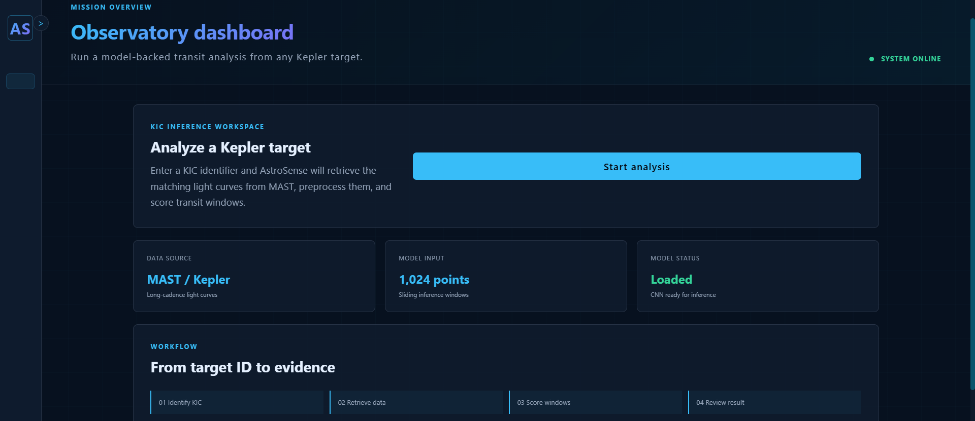
- Insert the KIC ID that you want to analyse
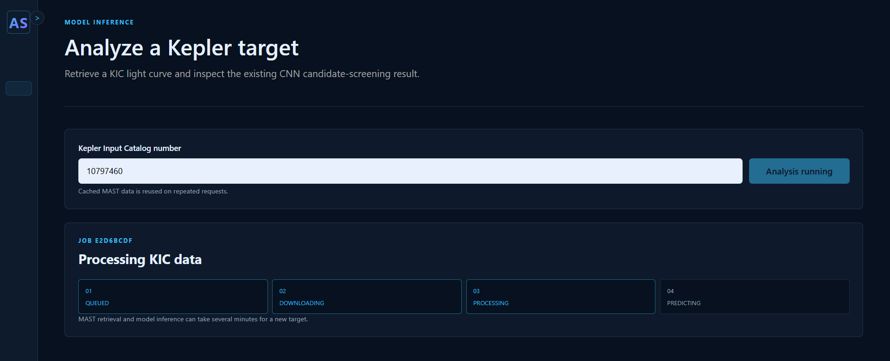
- Preprocessing view: standardised arrays, detrending and gap-aware stitching, with segment boundaries shown.
- Model-input view: the windows or sequence prepared for the selected model (windows of 1,024 samples; centred flux, optionally with time gap).
- Results view: the host score from each model with the validation-selected threshold, the resulting label and the statement that scores are not calibrated probabilities and do not confirm a planet.
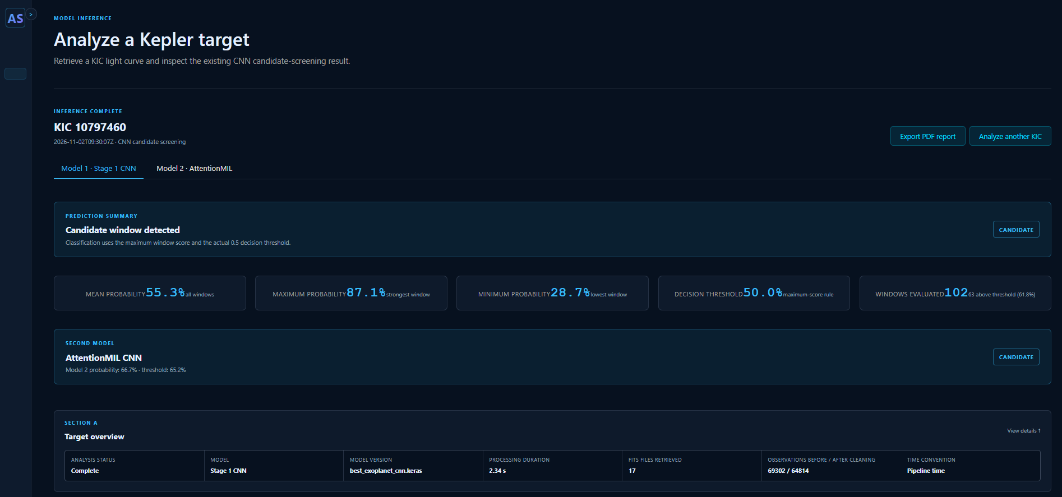
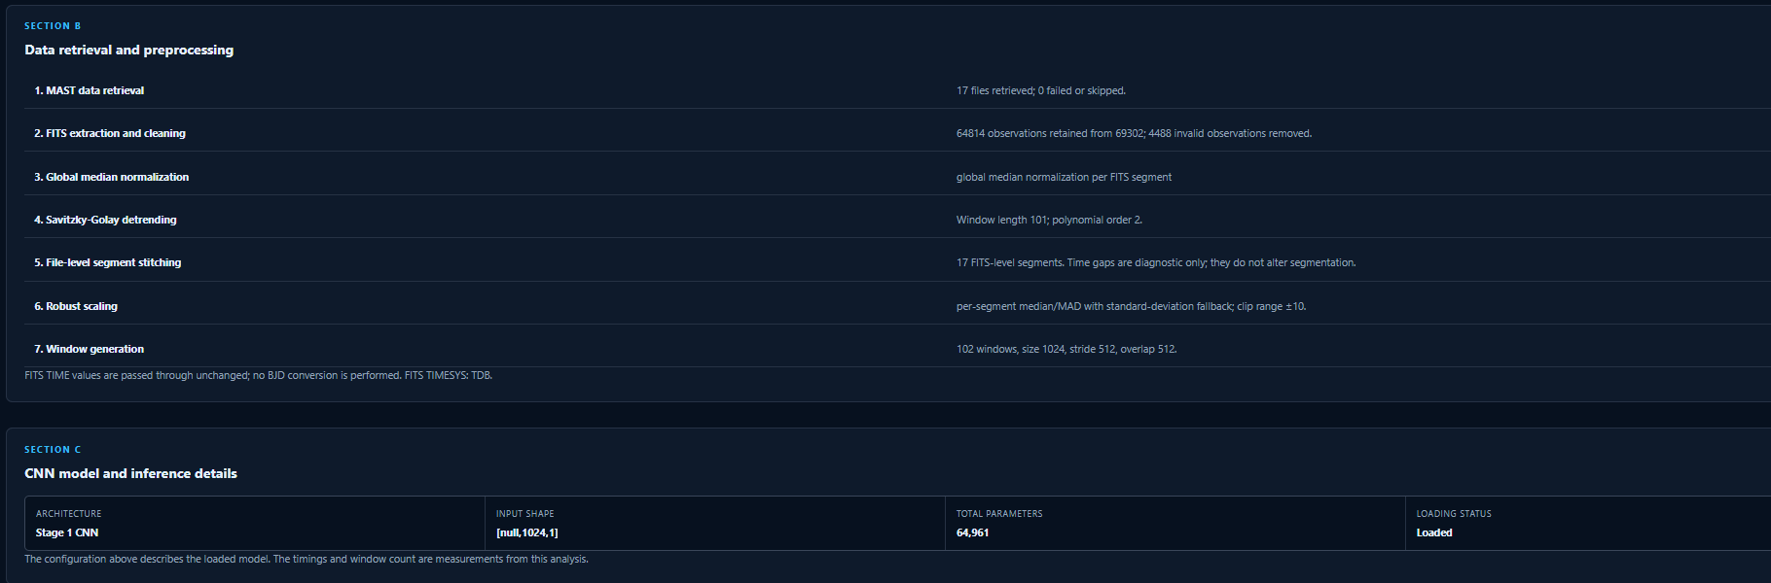
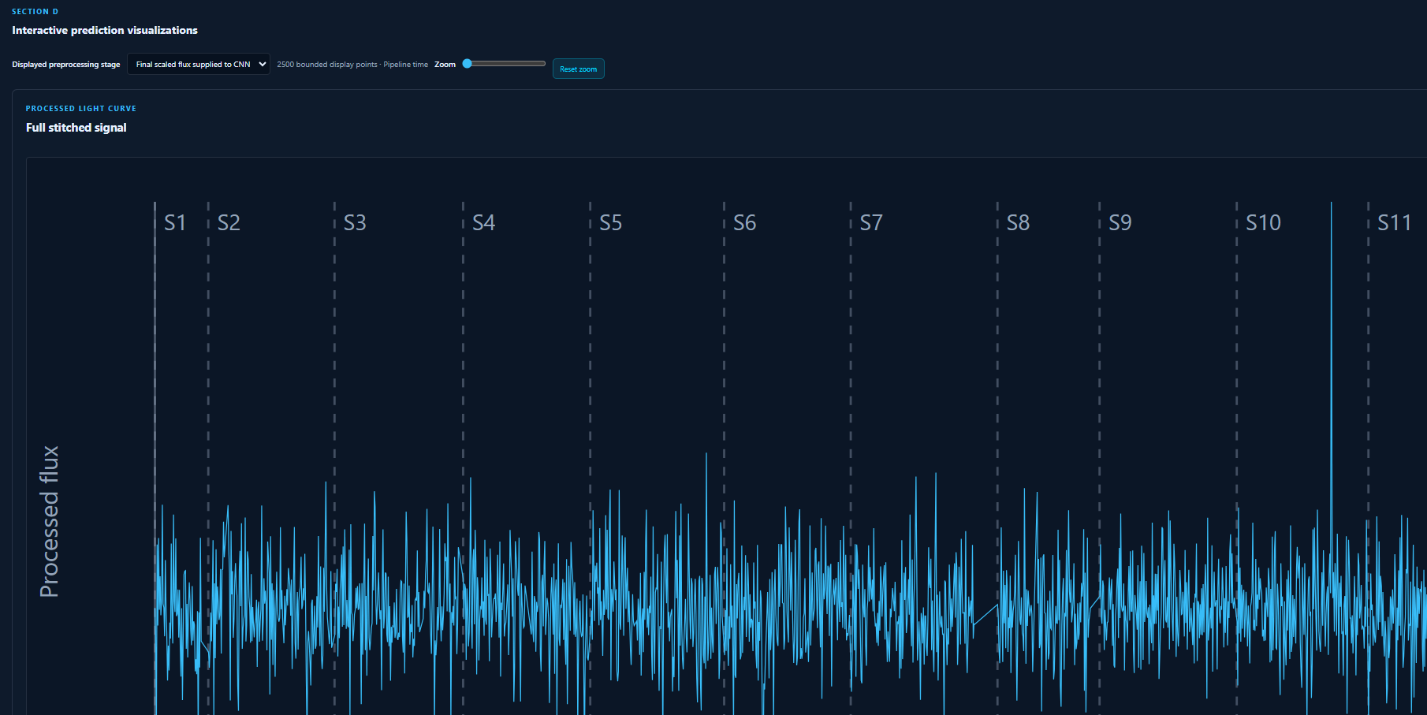
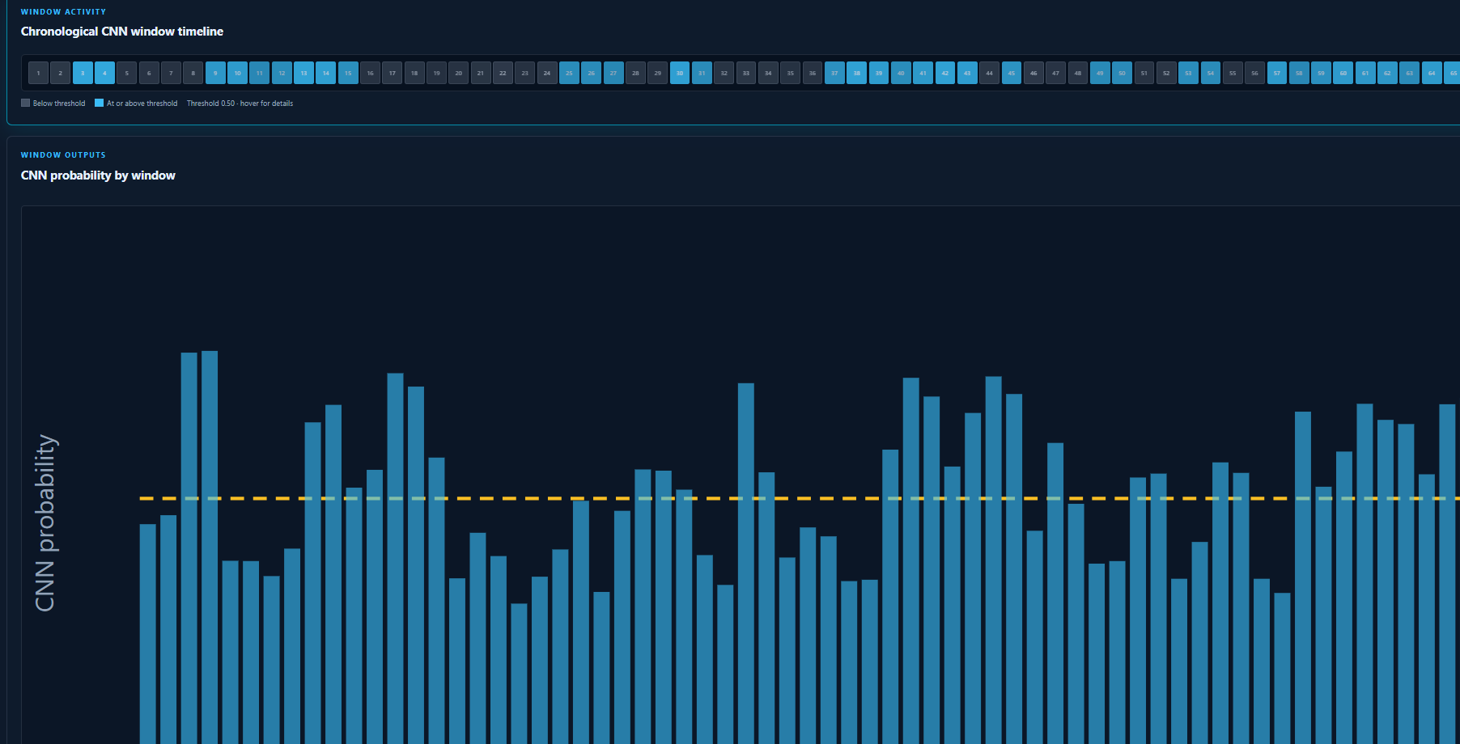
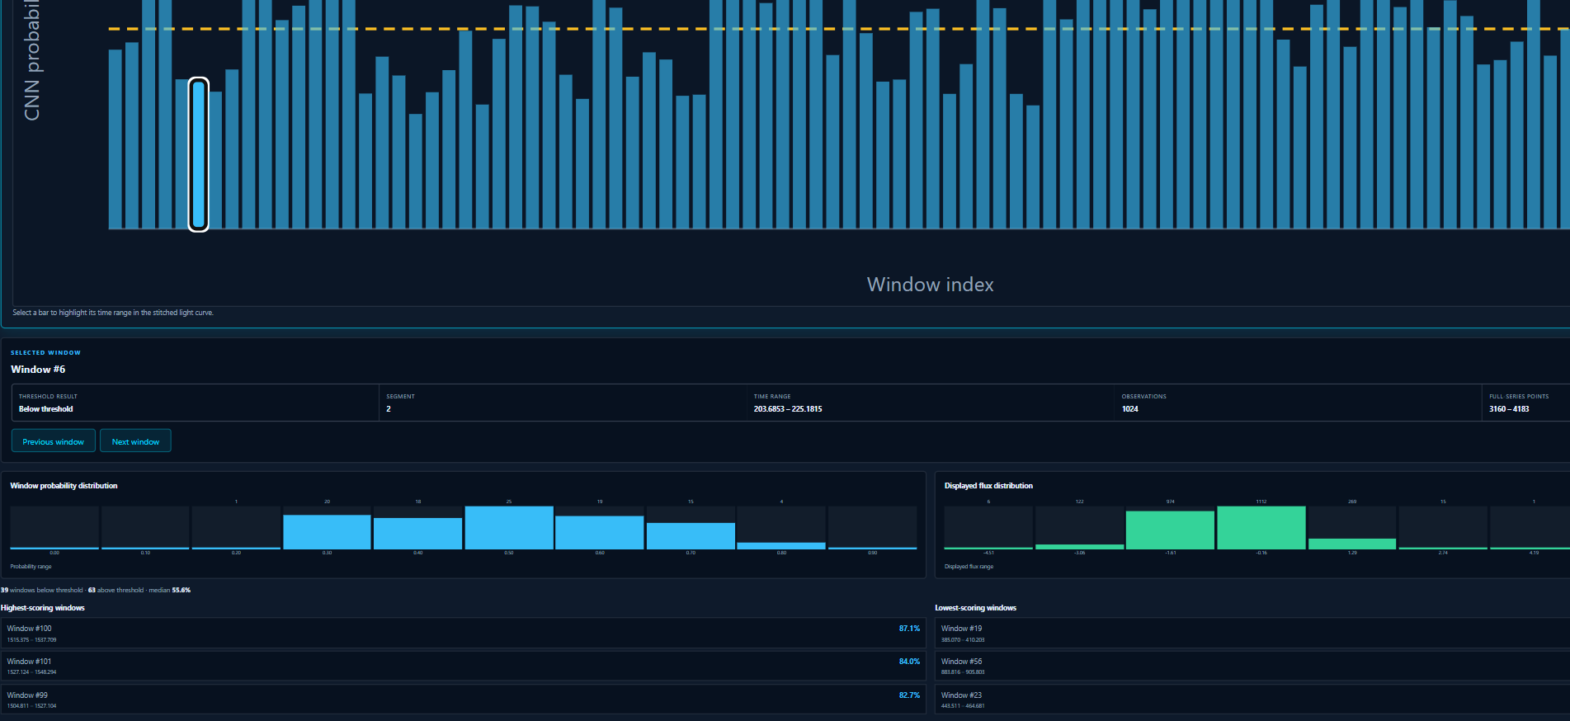
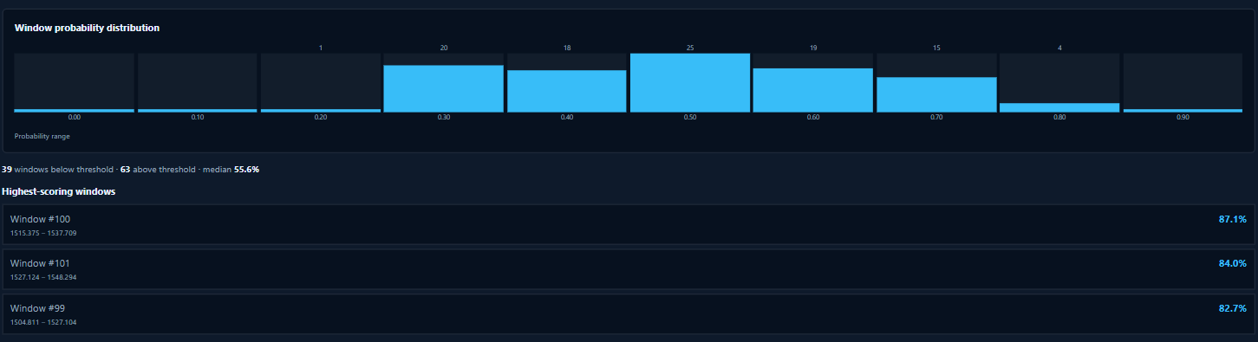
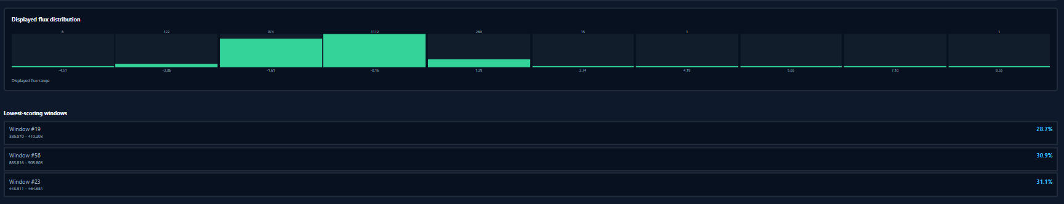
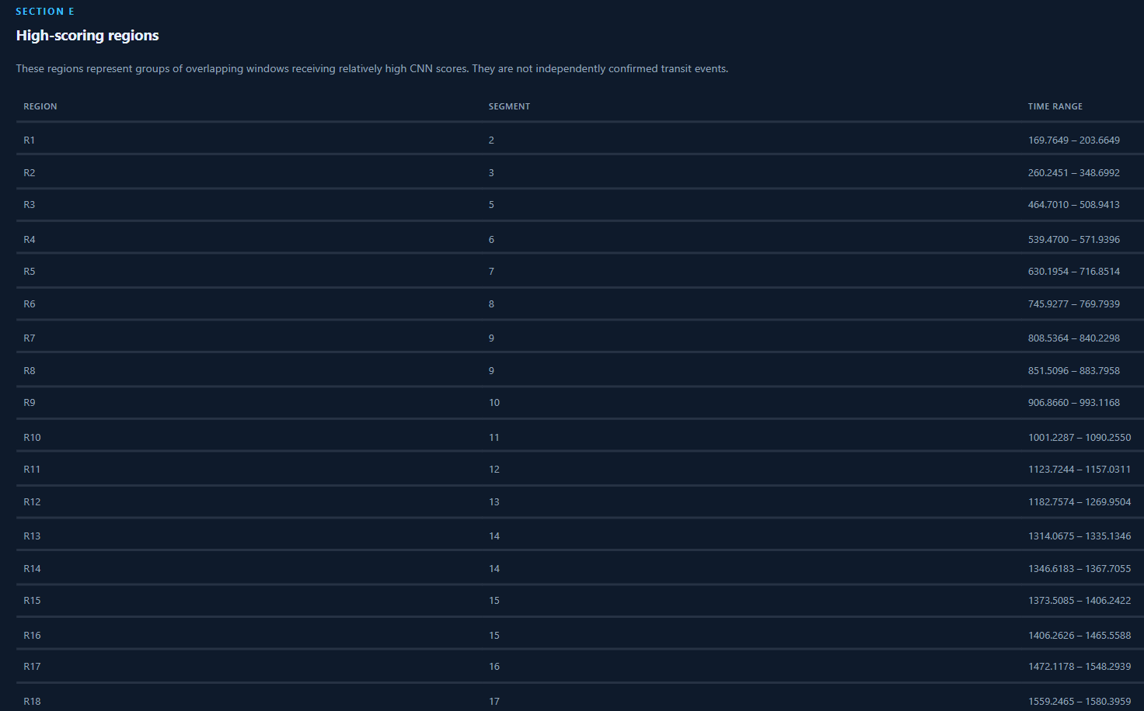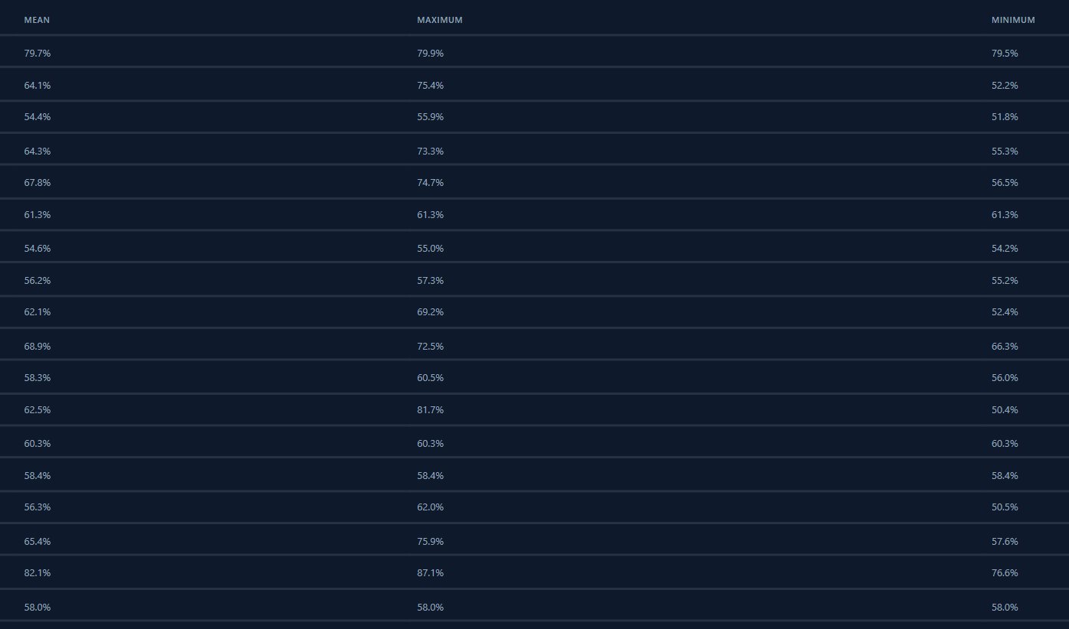
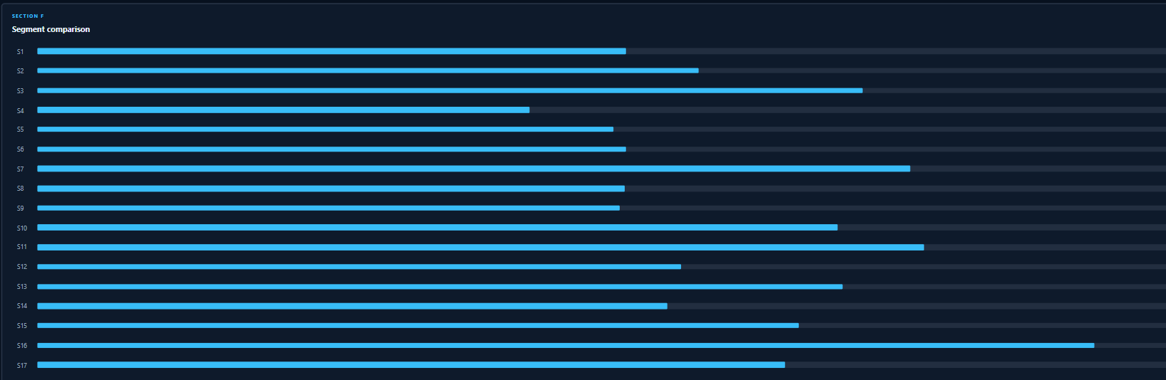
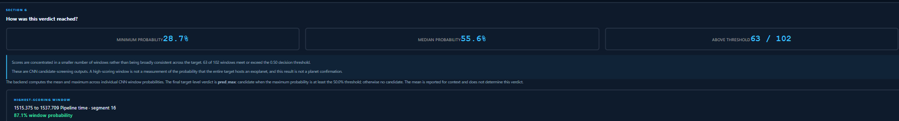
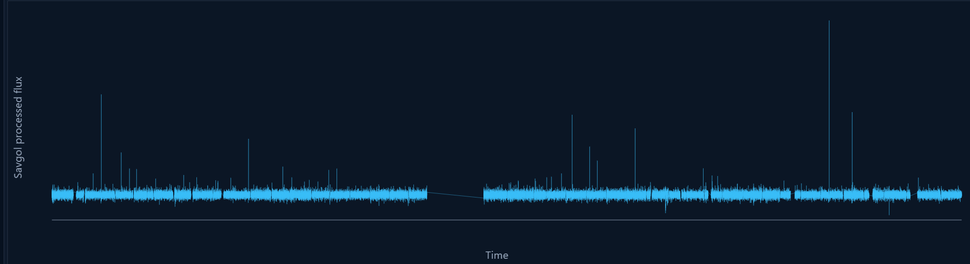
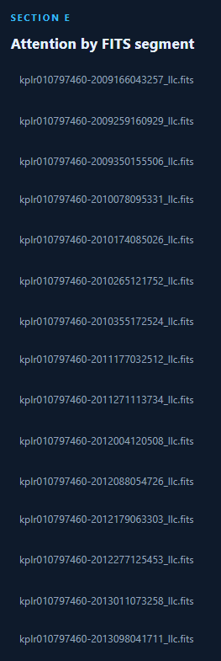
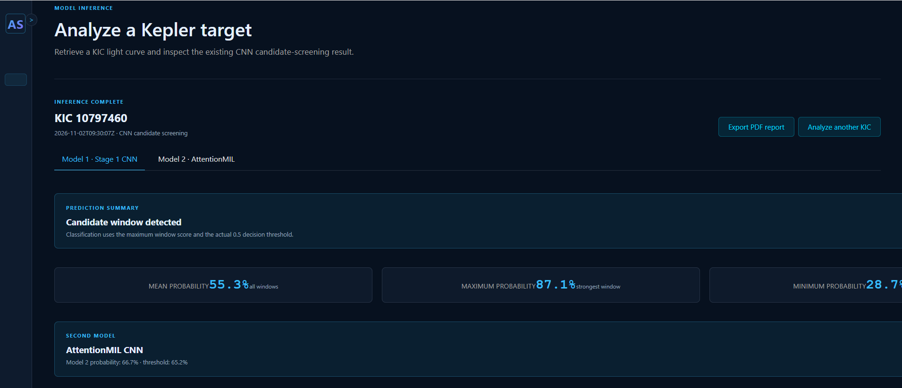
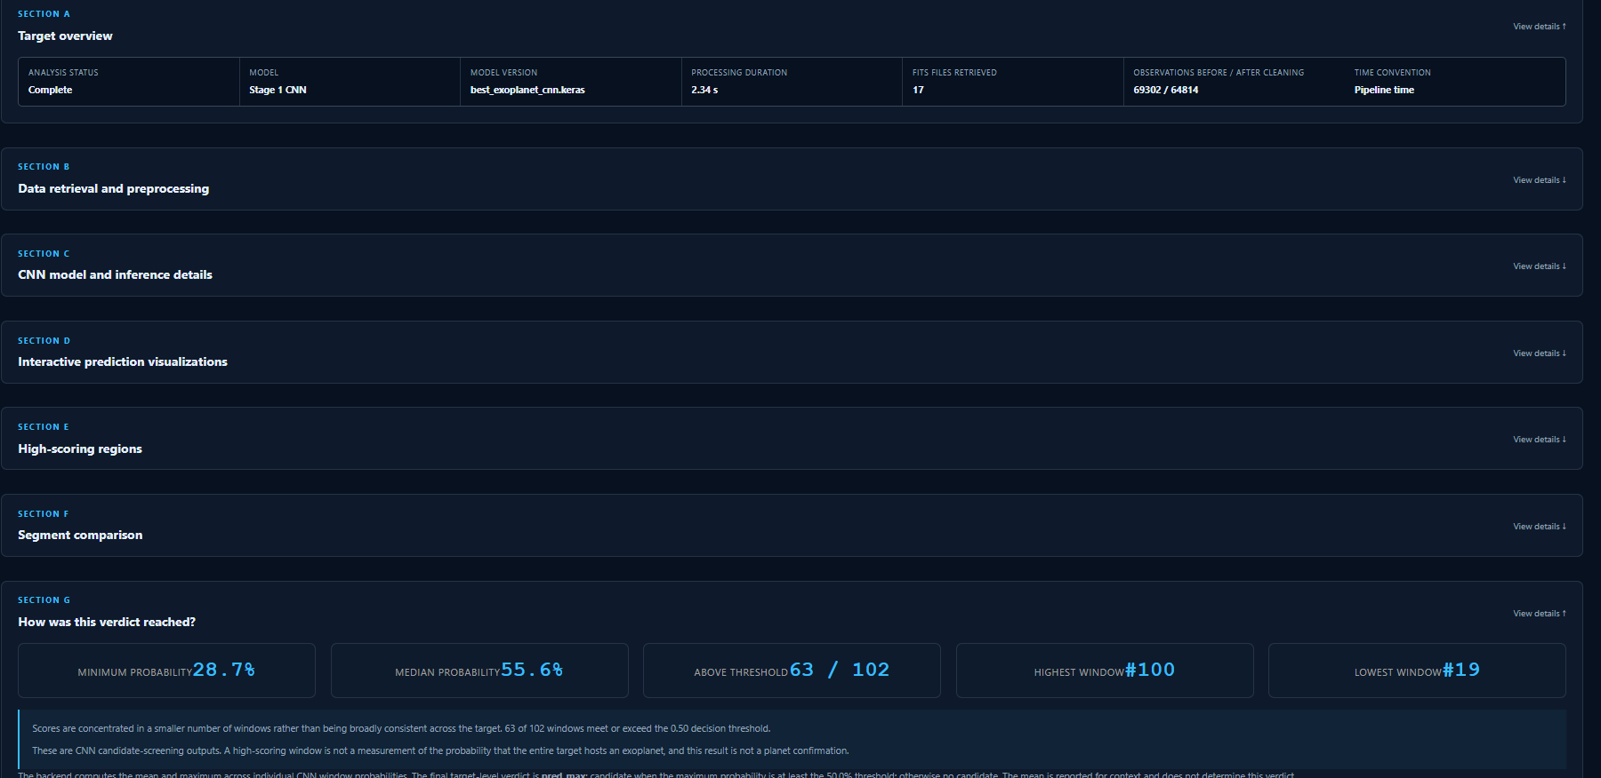
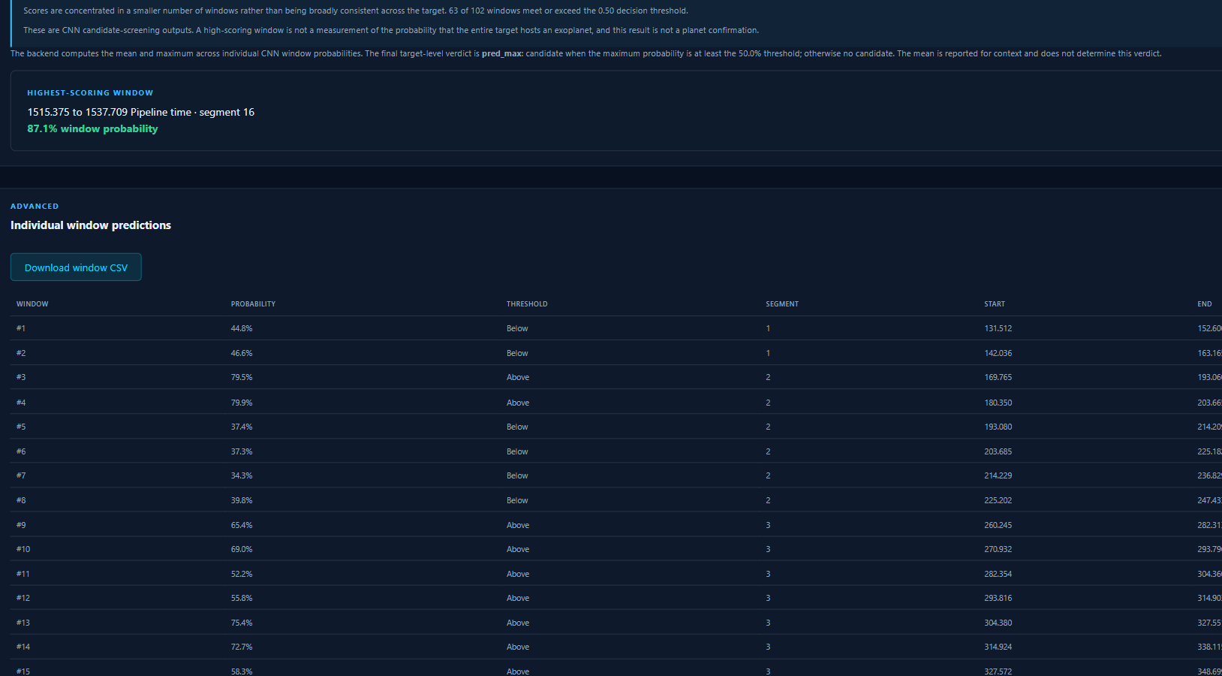

7.2 Performance Evaluation Measures
- ROC-AUC: probability that a random positive is scored above a random negative; threshold-independent.
- Average precision (AP / PR-AUC): area under the precision–recall curve computed with scikit-learn’s average precision (not a trapezoidal area); suited to imbalance. No-skill AP equals prevalence (0.2441 for the V5 test set).
- Precision, recall, specificity, F1, balanced accuracy, MCC: threshold-dependent metrics at the validation-selected threshold. Accuracy is not emphasised because it is misleading under class imbalance.
- Paired bootstrap: resampling of test targets (one KIC each) to give 95% confidence intervals on metric differences.
Protocol: thresholds are chosen on validation data, frozen, and applied once to the test set.

7.3 Input Parameters / Features Considered
Stage | Input / configuration | Rationale
Stage I | 1,024-sample windows, stride 512, gap factor 3.0, mean or maximum probability aggregation | Fixed-size input within memory limits
Stage II | Bags of up to 32 windows; window cap of 16, 32 or 64; median/MAD normalisation; quality==0 filter; local-MAD outlier filter | Test which presentation and preprocessing choices matter
V5-A | Median-centred flux × 1000 | Flux-only sequence model
V5-B | V5-A plus time gap Δt | Tests whether temporal sampling information helps
Baselines | NA1 (23 features), NA2 (31, adds dip features), NA3 (24, adds log sequence length) | Summary statistics as a necessary reference
Neither V5 variant uses flux error or the absolute flux level.

7.4 Graphical and Statistical Output
Stage I – windowed 1D CNN. Table 7.1 reports KIC-level performance on the real-only test dataset of 680 KICs, with window probabilities aggregated by mean or maximum. These are the paper’s updated values.
Table 7.1: KIC-level performance on the real-only test dataset (680 KICs)
Metric | Mean probability | Maximum probability
Accuracy | 68.24% | 47.21%
Precision | 44.88% | 33.77%
Recall | 73.51% | 97.84%
F1-score | 55.74% | 50.21%
ROC-AUC | 0.7990 | 0.7223
PR-AUC | 0.6387 | 0.4814
Mean aggregation ranks stars better than maximum aggregation. Maximum aggregation reaches high recall (97.84%) at low accuracy (47.21%), consistent with the observation that recall alone is uninformative. The paper additionally reports an earlier pilot of about 50 KICs with ROC-AUC 0.362 and AP 0.335, described as unsatisfactory (Table 7.9).
Stage II – CNN with AttentionMIL.
Table 7.2: CNN+AttentionMIL experiment matrix (test set, real/control KICs)
Exp. | Change | ROC-AUC | PR-AUC
A | 16 windows/KIC | 0.489 | 0.250
B (seed 42) | 32 windows/KIC | – | 0.327
B (seed 123) | 32 windows/KIC | 0.701 | 0.422
B (seed 456) | 32 windows/KIC | 0.656 | 0.389
C | 64 windows/KIC | 0.442 | 0.231
B QF | B + quality==0 | 0.606 | 0.298
B norm | B + median/MAD | no clear gain | no clear gain
B OUTLIER (s42) | B + local-MAD | 0.653 | 0.378
B OUTLIER (s123) | B + local-MAD | 0.545 | 0.279
B OUTLIER (s456) | B + local-MAD | 0.672 | 0.425
Figure 7.2: CNN+AttentionMIL test ranking metrics across experiments
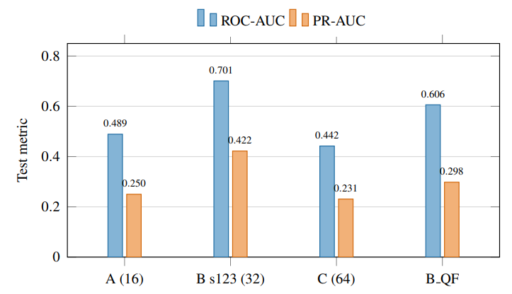
Key observations: 32 windows per KIC was the strongest budget tested. Experiment A reached recall of about 0.968 but specificity of only about 0.059, flagging nearly everything. Increasing to 64 windows degraded performance. For seed 123, median/MAD normalisation reduced AP from 0.4220 to 0.3202 and ROC-AUC from 0.7010 to 0.6394, so the unnormalised configuration was kept. The corrected local-MAD filter gave a mean AP of 0.361 (sample standard deviation 0.073) against 0.379 for baseline B, with strongly seed-dependent effects. In one failure case the validation negative mean score (about 0.134) exceeded the positive mean (about 0.039), indicating reversed ranking and not merely a thresholding problem.
Stage III – preliminary Mamba-2 versions (mixed real + injected roster).
Table 7.3: Preliminary Mamba-2 versions (V1–V4-B)
Ver. | Input | Loss | Whole-roster ROC-AUC | Whole-roster PR-AUC | Real recall | Real specificity | Injected recall
V1 | Smoke test | – | no detection metrics (training loss 0.5702) | – | – | – | –
V2 | f, σf, Δt | CE | not reported | – | 0.0387 | 0.9833 | 1.0000
V3 | f, σf, Δt | source-aware | 0.8861 | – | 0.0581 (thr. 0.50) | 0.9688 | 1.0000
V4-A | centred f | source-aware | 0.6285 | 0.6471 | 0.9806 (thr. 0.50) | 0.2396 | 0.8325
V4-B | centred f + Δt | source-aware | 0.6974 | 0.7774 | 0.9161 (thr. 0.50) | 0.2646 | 0.8228
The V3 source probe reached ROC-AUC 1.000, so its apparently strong whole-roster AUC reflected provenance. V4 could not be used as the final answer because its roster is 55% positive (585 of 1,065) whereas the real test set is 24.4% positive, all 18 null-control injections were scored positive, and no feature baseline existed.
Stage III – V5 real-data study.
Table 7.4: Threshold-independent test performance (635 real targets, 155 positive)
Model | ROC-AUC | AP
V5-A: mean across seeds | 0.7026 | 0.3830
V5-B: mean across seeds | 0.7079 | 0.4038
V5-A ensemble | 0.7065 | 0.3975
V5-B ensemble | 0.7172 | 0.4087
NA2: selected HGB baseline | 0.7774 | 0.4990
No-skill reference | 0.5000 | 0.2441
Table 7.5: Summary-statistic baselines
Set | Model | ROC-AUC | AP
Length only | LR | 0.5372 | 0.2774
NA1 flux summary | LR | 0.6849 | 0.3630
NA1 flux summary | HGB | 0.7726 | 0.4954
NA2 flux + dips | LR | 0.6833 | 0.3613
NA2 flux + dips | HGB (selected) | 0.7774 | 0.4990
NA3 flux + length | LR | 0.6912 | 0.3708
NA3 flux + length | HGB | 0.7788 | 0.4948
Figure 7.3: Test ROC and precision–recall curves
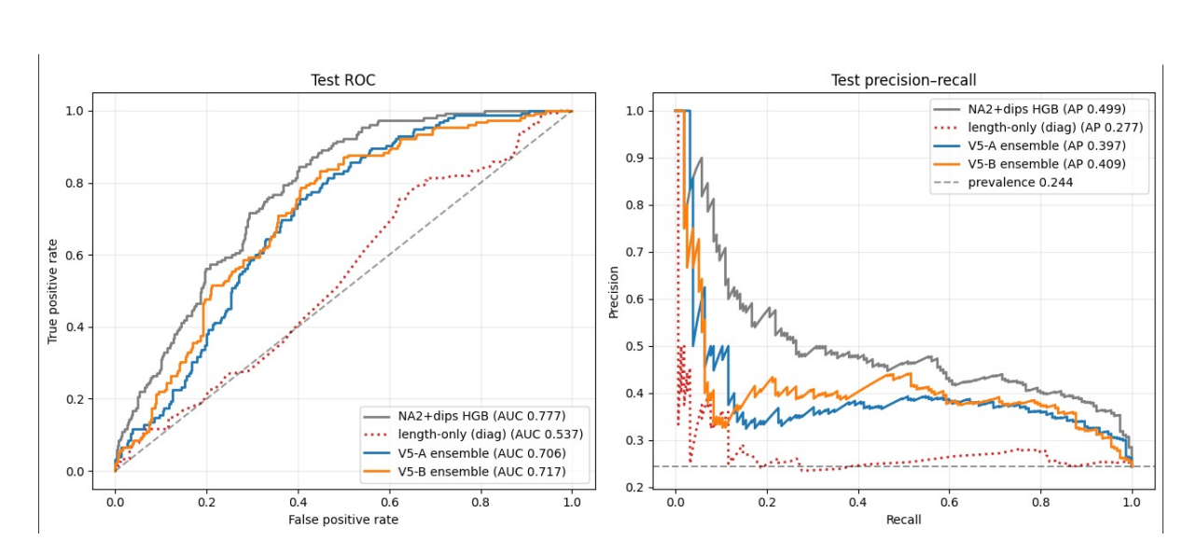
Figure 7.4: Seed-wise test performance of the Mamba-2 variants
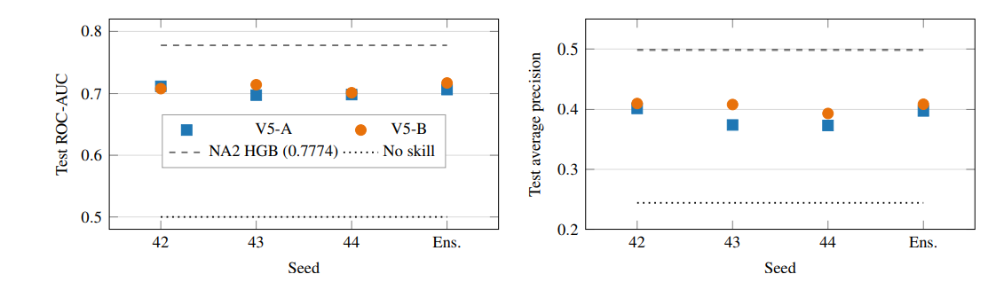
Table 7.6: Differences relative to NA2 HGB (Mamba-2 minus baseline), 95% paired-bootstrap intervals
Configuration | ΔROC-AUC [95% CI] | ΔAP [95% CI]
V5-A mean | −0.0748 [−0.1060, −0.0400] | −0.1160 [−0.1680, −0.0600]
V5-B mean | −0.0694 [−0.1025, −0.0346] | −0.0951 [−0.1491, −0.0372]
V5-A ensemble | −0.0709 [−0.1045, −0.0346] | −0.1015 [−0.1579, −0.0458]
V5-B ensemble | −0.0601 [−0.0957, −0.0231] | −0.0903 [−0.1456, −0.0315]
Table 7.7: Test metrics at validation-selected MCC thresholds (155 positive, 480 negative targets)
Metric | NA2 HGB | V5-A ens. | V5-B ens.
Selected threshold | 0.21 | 0.13 | 0.19
Balanced accuracy | 0.7012 | 0.6540 | 0.6595
Precision | 0.3605 | 0.3265 | 0.3366
Recall | 0.9419 | 0.9226 | 0.8774
F1-score | 0.5214 | 0.4823 | 0.4866
Specificity | 0.4604 | 0.3854 | 0.4417
MCC | 0.3596 | 0.2860 | 0.2849
TN / FP / FN / TP | 221 / 259 / 9 / 146 | 185 / 295 / 12 / 143 | 212 / 268 / 19 / 136
Table 7.8: Paired injection test (302 valid injections from 20 test parents; 235 from 15 negative parents)
Model | Threshold | Recovery (all) | Recovery (negative parents) | New crossings (rate)
V5-A seed 42 | 0.34 | 0.5232 | 0.4638 | 14 (0.0596)
V5-A seed 43 | 0.15 | 0.6556 | 0.6085 | 1 (0.0043)
V5-A seed 44 | 0.17 | 0.6722 | 0.6298 | 24 (0.1021)
V5-B seed 42 | 0.08 | 0.6656 | 0.6298 | 0 (0.0000)
V5-B seed 43 | 0.19 | 0.6556 | 0.6085 | 12 (0.0511)
V5-B seed 44 | 0.12 | 0.3311 | 0.2426 | 8 (0.0340)
V5-A ensemble | 0.13 | 0.7152 | 0.6851 | 11 (0.0468)
V5-B ensemble | 0.19 | 0.5662 | 0.5064 | 3 (0.0128)
The mean paired score change from parent to injected curve is slightly negative for both ensembles (−0.0252 and −0.0262). Per-seed score-change intervals are given in the paper (Table VIII).

7.5 Comparison of Results with Existing Systems
Table 7.9: Summary of modelling stages
Stage | Unit / input | Test population | ROC-AUC | AP | Key outcome
CNN (Stage I) pilot | Window, 1 channel; mean-probability KIC vote | Pilot, about 50 KICs | 0.362 | 0.335 | Unsatisfactory test performance
CNN (Stage I) real-only evaluation | Window, 1 channel; mean-probability KIC vote | Real-only, 680 KICs | 0.7990 | 0.6387 | Mean aggregation better than maximum
CNN+MIL (Stage II) | KIC bag of up to 32 windows | Real/control, 680 KICs | 0.701 / 0.656 (seed 123 / 456) | 0.422 / 0.389 | Window cap matters
Mamba-2 V3 | Full sequence, 3 channels | Mixed, 1,065 | 0.886 | – | Source shortcut (probe AUC 1.000)
Mamba-2 V4-B | Full sequence, flux + Δt | Mixed, 1,065 | 0.697 | 0.777 | Not comparable (55% positive)
Mamba-2 V5-A ensemble | Full sequence, flux | Real, 635 | 0.7065 | 0.3975 | Above chance; below HGB
Mamba-2 V5-B ensemble | Full sequence, flux + Δt | Real, 635 | 0.7172 | 0.4087 | Above chance; below HGB
NA2 HGB | 31 flux summary features | Real, 635 | 0.7774 | 0.4990 | Best model tested
Absolute numbers are not directly comparable across stages. The CNN results are on a real/control or real-only cohort with positive prevalence of roughly 27% (185 of 680 test KICs in the seed-123 split) and a 60/20/20 split; the V5 models are evaluated on the 635-target frozen test set (prevalence 24.4%) with a 70/15/15 split; the preliminary Mamba-2 versions use a mixed real + injected roster; and thresholds and metric definitions differ. Ranking within each family is nonetheless informative. The reviewed literature [1]–[9] reports results on different datasets and protocols, so no numerical comparison with published systems is made.

7.6 Inference Drawn
- Objectives met: a reproducible star-level pipeline, controlled ablations, a diagnosed source shortcut, a real-data-only Mamba-2 study with baselines, and an upload-and-inference interface.
- Window budget matters: how much of each star is presented to the model changed results more than architectural detail; normalisation and strict quality filtering did not help.
- Mamba-2 does not beat the feature baseline: both V5 variants and their ensembles are above chance but below the NA2 HGB classifier, with all paired-bootstrap intervals excluding zero. The V5-B minus V5-A gain (+0.0053 ROC-AUC, +0.0208 AP) is of the order of seed-to-seed standard deviation (0.0065 and 0.0053 for ROC-AUC), so no reliable benefit of Δt is established. Its apparent value on the mixed roster (+0.069 ROC-AUC in V4) shrank to +0.005 on real data.
- Specificity remains low: more than half of the 480 real negatives are classified positive by both ensembles (295 for V5-A, 268 for V5-B).
- Injection recovery is inflated: raw recovery of 71.5% (V5-A) and 56.6% (V5-B) falls to 11 and 3 newly crossing injections out of 235 once parents already scored positive are accounted for. The cohort covers 20 of 635 test targets, so the test supports moderate real-target ranking and not validated sensitivity to injected transits.
- Above-chance host classification does not establish sensitivity to transit morphology; the models may also use general variability, noise properties or other correlates of the labels.

7.7 Sustainability Impact Assessment and Rubric Justification

7.7.1 Scope, boundary and evidence
The boundary covers development and experimentation (data acquisition, preprocessing, model training and evaluation) and the inference interface. Hosting, long-term maintenance and hardware disposal are outside the supplied evidence. Data are public, and no personal data are processed. Energy, emissions and cloud-usage figures were not measured; statements about compute are limited to design facts (model size, batch cap, window cap).

7.7.2 Material sustainability topics
Dimension / topic | Project relevance and potential impact | Indicator / unit | Evidence source | Boundary / limitation
Environment: energy / compute | Material: repeated training across stages and seeds | Model size (about 69 thousand parameters), batch cap (524,288 padded timesteps), window cap (32) | Paper Sections V–VI | Energy (kWh) not measured
Environment: emissions / travel | Not material beyond compute | – | – | Not assessed
Environment: materials / waste | N/A: software project | – | – | Hardware end-of-life not assessed
Social: access / inclusion / usability | Interface lowers the barrier to inspecting preprocessing and scores | Task success, user feedback | Not applicable | No user study
Social: safety / well-being | Low direct risk; risk of over-interpreting scores | Disclaimer shown in results | Interface design | No ethics study required for public data
Governance: privacy / security / fairness | Public data; user uploads handled by the interface | Label audit, leakage controls, source probe | Paper Sections II, V | Upload handling and security not tested

7.7.3 Sustainability targets and progress
Topic / target | Baseline and date | Target / due date | Actual result | Status / corrective action
Reduce redundant compute | Single-run experiments | Reuse one frozen split, cached features and checkpoints | Achieved by design (frozen split, cached feature table, stored checkpoints) | Measure runtime/energy in future work
Reproducibility and integrity | No hashing | SHA-256 hashes of archive, plan, split and weights | Implemented for the Mamba-2 runs; hashing of the full dataset and batch plan listed as future work | Freeze and hash all artefacts
Accessibility / privacy of interface | Not established | [Define target] | [Not measured] | To be assessed

7.7.4 SDG alignment and evidence
The link to SDG 9 (target 9.5) is a design intent and expected contribution, supported by documented, reproducible methodology. The link to SDG 4 (target 4.4) is an expected contribution through a transparent interface. Neither is a demonstrated outcome, and no broad SDG progress is attributed to this prototype.

7.7.5 Sustainability assessment rubric
Provisional ratings are based only on evidence in this report and are subject to the mentor’s review. Weighted points = (rating ÷ 3) × weight.
Table 7.11: Sustainability rubric
Criterion | Weight | Rating (0–3) | Weighted points | Basis
A. Scope, materiality and baseline | 15% | 2 | 10.0 | Boundary and material topics stated; baseline for compute not measured
B. Environmental / resource impacts | 20% | 1 | 6.7 | Compute-saving design described; no quantified energy or emissions
C. Social value, inclusion and safety | 20% | 1 | 6.7 | Benefits stated; no user testing
D. Governance, privacy, security and ethics | 20% | 2 | 13.3 | Public data, label audit, leakage and shortcut controls tested; upload security untested
E. SDG linkage and measurable targets | 10% | 2 | 6.7 | Target-level mapping; expected vs. demonstrated impact distinguished; no measured indicator
F. Measurement, transparency and improvement | 15% | 3 | 15.0 | Seeds, manifests, hashes, limitations and future actions disclosed
Total | 100% |  | 58.3 / 100 | Falls in the “emerging” band (40–59)
The score can be improved by measuring training and inference energy, running a small usability study of the interface, and testing upload handling.

7.7.6 Evidence and limitations statement
Measured: model performance, leakage and shortcut diagnostics, seed-to-seed variation (paper tables and run manifests). Design facts, not measurements: model size, batch and window caps. Not assessed: energy, emissions, hardware life cycle, accessibility and user feedback on the interface. Expected outcomes are not described as achieved outcomes.

Chapter 8: Conclusion
Across a windowed CNN, a CNN with attention-based multiple-instance aggregation, and Mamba-2 sequence models, the dominant finding is methodological. How much of each star is presented to the model matters, while normalisation and strict quality filtering are not obvious improvements. The preliminary Mamba-2 versions show that an apparently excellent score can come from a provenance shortcut: a simple classifier reached ROC-AUC 1.0 in separating real from injected data. The real-data-only V5 experiments give a sober picture: flux-only and flux-plus-time-gap Mamba-2 models reach mean ROC-AUC 0.7026 and 0.7079 (ensembles 0.7065 and 0.7172) on 635 held-out targets, the time-gap feature has no statistically established benefit, and a histogram gradient-boosting classifier on flux summary statistics is better (ROC-AUC 0.7774, AP 0.4990). The paired injection test shows that headline recovery is largely driven by parents that are already scored positive. The results support a feasibility-study conclusion, not a claim of effective transit detection. The main contribution is the methodology: star-level isolation, representation ablation, source-aware diagnostics, feature baselines and paired injection analysis, together with an interface that exposes the data preparation and scoring steps to the user.

8.1 Limitations
- Synthetic injections do not reproduce eclipsing binaries, stellar variability or instrumental systematics. The V5 injection test covers only 20 of 635 test parents (15 negative).
- Host classification is not transit detection; feature importance, noise-matched controls and injection-strength analyses are still required.
- Preliminary-version metrics (V2–V4-B) were computed on a mixed roster and are not comparable with V5; V2 metrics are only partly available.
- Label and manifest integrity (duplicate KIC/configuration pairs, host vs. injected labels, segment coverage) must be cross-checked against actual NPZ contents; null-control counts (18 in V4 test logs, 14 in the V5 injection manifest for test parents) are not fully reconciled.
- CNN conclusions on the window cap rest on few runs; V5 uses three seeds per variant and thresholds and injection recovery vary by seed. The CNN cohort (4,504) is smaller than the frozen split (4,565), and gap factors and splits differ between stages.
- Duplicate timestamps across concatenated segments are not guaranteed to be removed.
- Masking is applied after the Mamba blocks; padding behaviour should be re-validated for each installed implementation.
- Scores are not calibrated probabilities; calibration was not analysed.
- The findings concern the tested configurations and baselines only and do not bound what state-space models can achieve on this task.

8.2 Future Scope
- Freeze and hash the dataset, split and batch plan.
- Document the bootstrap resampling unit, replicate count and interval construction, and report seed-matched tests of the Δt effect.
- Analyse feature importance and noise-matched controls to determine whether the learned signal relates to transit morphology.
- Extend the paired injection test beyond 20 parents and report response as a function of injection strength with parent-level uncertainty.
- Report calibration and real-only confusion matrices.
- Add a Box Least Squares transit-recovery reference alongside the CNN and HGB baselines and compare mean, maximum and top-k aggregation in the CNN.
- Evaluate the Hampel-style outlier filter.
- Develop temporally informative but demonstrably source-invariant sequence representations, always re-running the source-domain probe.

References
[1] C. J. Shallue and A. Vanderburg, “Identifying exoplanets with deep learning: A five-planet resonant chain around Kepler-80 and an eighth planet around Kepler-90,” The Astronomical Journal, vol. 155, no. 2, p. 94, 2018.
[2] M. Ansdell et al., “Scientific domain knowledge improves exoplanet transit classification with deep learning,” The Astrophysical Journal Letters, vol. 869, p. L7, 2018.
[3] A. Chaushev et al., “Classifying exoplanet candidates with convolutional neural networks: Application to the Next Generation Transit Survey,” Monthly Notices of the Royal Astronomical Society, vol. 488, no. 4, pp. 5232–5245, 2019.
[4] R. Karimi, M. Mousavi-Sadr, M. Haghighi, and F. Tabatabaei, “Machine learning for exoplanet detection: A comparative analysis using Kepler data,” arXiv:2508.09689, 2025, doi: 10.48550/arXiv.2508.09689.
[5] S. Huang and C. Jiang, “Machine learning for exoplanet discovery: Validating TESS candidates and identifying planets in the habitable zone,” arXiv:2512.00967, 2025, doi: 10.48550/arXiv.2512.00967.
[6] G. Marín Díaz, “FAS-XAI: Fuzzy and explainable AI for interpretable vetting of Kepler exoplanet candidates,” Mathematics, vol. 13, no. 23, p. 3796, 2025, doi: 10.3390/math13233796.
[7] S. Fiscale et al., “Detection of exoplanets in transit light curves with conditional flow matching and XGBoost,” Electronics, vol. 14, no. 9, p. 1738, 2025, doi: 10.3390/electronics14091738.
[8] S. Iglesias Álvarez et al., “Computing transiting exoplanet parameters with 1D convolutional neural networks,” Axioms, vol. 13, no. 2, p. 83, 2024, doi: 10.3390/axioms13020083.
[9] H. P. Osborn et al., “Rapid classification of TESS planet candidates with convolutional neural networks,” Astronomy & Astrophysics, 2020, doi: 10.48550/arXiv.1902.08544.
[10] L. Kreidberg, “batman: BAsic Transit Model cAlculatioN in Python,” Publications of the Astronomical Society of the Pacific, vol. 127, p. 1161, 2015.
[11] A. Gu and T. Dao, “Mamba: Linear-time sequence modeling with selective state spaces,” arXiv:2312.00752, 2023.
[12] T. Dao and A. Gu, “Transformers are SSMs: Generalized models and efficient algorithms through structured state space duality,” in Proc. Int. Conf. Mach. Learn. (ICML), 2024.
[13] I. Loshchilov and F. Hutter, “Decoupled weight decay regularization,” in Proc. Int. Conf. Learn. Represent. (ICLR), 2019.
[14] F. Pedregosa et al., “Scikit-learn: Machine learning in Python,” J. Mach. Learn. Res., vol. 12, pp. 2825–2830, 2011.
[15] B. W. Matthews, “Comparison of the predicted and observed secondary structure of T4 phage lysozyme,” Biochimica et Biophysica Acta, vol. 405, no. 2, pp. 442–451, 1975.

Appendix – I: Project Evidence and Supporting Documents

A. IPR / Research Publication Evidence
- Research paper: “Exoplanet Vetting on Kepler Light Curves: From Windowed CNNs and Attention-MIL to Real-Data Mamba-2 State-Space Models.” Status: [submitted / under review / accepted / published – state accurately]. Venue: [ ].
- Certificate of publication or presentation: [attach if applicable].
- Plagiarism report and AI-content detection report: [attach].
- Patent / IPR filing: [none, or state status as filed / published / granted / planned].

B. Project Competition / Award Certificates
[Attach, or write “Not applicable.”]

C. Progress Review Sheets
[Attach Progress Review Sheet 1 and Progress Review Sheet 2 in the prescribed format.]

D. Additional Supporting Material
Table A.1: Individual-seed test results at validation-selected MCC thresholds (635 test targets)
Variant | Seed | Thr. | ROC-AUC | AP | Prec. | Rec. | Spec. | MCC
V5-A | 42 | 0.34 | 0.7118 | 0.4017 | 0.3517 | 0.8645 | 0.4854 | 0.3068
V5-A | 43 | 0.15 | 0.6975 | 0.3741 | 0.3263 | 0.8968 | 0.4021 | 0.2732
V5-A | 44 | 0.17 | 0.6984 | 0.3733 | 0.3333 | 0.8839 | 0.4292 | 0.2814
V5-B | 42 | 0.08 | 0.7080 | 0.4099 | 0.3133 | 0.9097 | 0.3562 | 0.2514
V5-B | 43 | 0.19 | 0.7144 | 0.4082 | 0.3350 | 0.8839 | 0.4333 | 0.2846
V5-B | 44 | 0.12 | 0.7014 | 0.3933 | 0.3457 | 0.7806 | 0.5229 | 0.2622

E. Video Presentation
[Insert the video presentation folder link shared by the department and verify that it opens for authorised reviewers.]

