**Title:** Observing the logs/behaviour for varying values of Initial population (the hyperparameter settings go in this blank).

**Submitted By:**

**Name: Bhuvanchand**

**Email Address:  bhuvanchand.dasari.official@gmail.com**

**Log folder details:**

**Log folder name:Players_Data_initial_population_5**

**Log zip name:Players_Data_initial_population**

**Number of logs in directory: 2119**

**Hyperparameter Values:**

Mention all the values of hyperparameters used (write ‘default’ in case of default values)

 (d = default)

|  |  |  |
| --- | --- | --- |
| **S.No** | **Hyperparameter Name** | **Value** |
| 1 | initial_population | 5 |
| 2 | state_size | d |
| 3 | initial_energy | d |
| 4 | model_updates | d |
| 5 | speed | d |
| 6 | max_age | d |
| 7 | max_allowed_population | d |
| 8 | kill_type | d |
| 9 | sensory_radius | d |
| 10 | decay_rate | d |

**Visuals:**

All relevant graphs/ family trees/Visual Charts will come under this section.

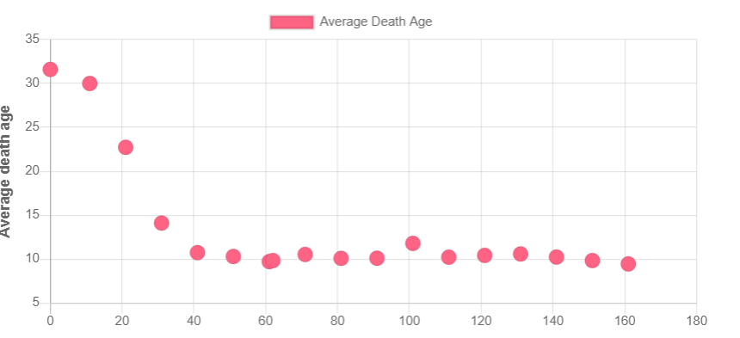

Average death age decreases up to 40th time step and reaches a stable and then stays constant rest of the time. Average death age after time step 40 is 10. Which is very low considering max life span is 90.

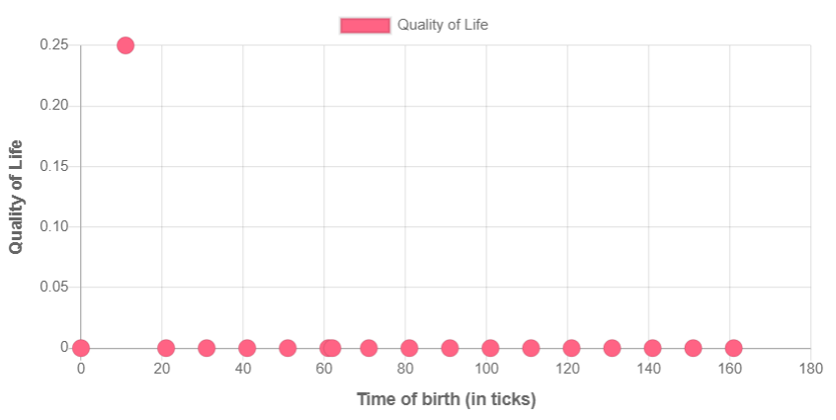

There is a exception in case of 11-6 agent which had quality of life 0.25. But there was no exceptional behaviour shown by the agent.

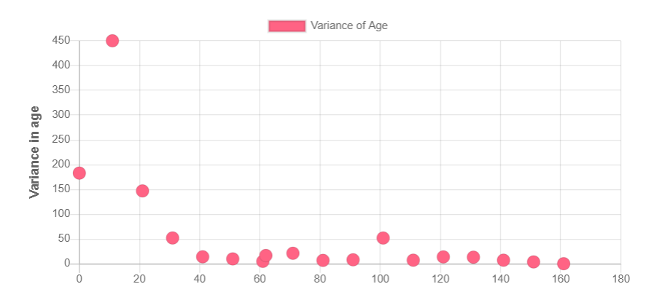

Due to above exception, variance at time step 11 is high. IN the rest of graph variance decreased up to time step 40 and then stayed constant which is near to zero referring majority of the agents die almost at the same age.

In the above graphs other agents didn’t show exception like agent 11-6 might be that agent 11-6 didn’t have any children.