**Title:** Observing the logs/behaviour for varying values of Initial population (the hyperparameter settings go in this blank).

**Submitted By:**

**Name: Bhuvanchand**

**Email Address:  bhuvanchand.dasari.official@gmail.com**

**Log folder details:**

**Log folder name:Players_Data_initial_population_10**

**Log zip name:Players_Data_initial_population**

**Number of logs in directory: 2037**

**Hyperparameter Values:**

Mention all the values of hyperparameters used (write ‘default’ in case of default values)

 (d = default)

|  |  |  |
| --- | --- | --- |
| **S.No** | **Hyperparameter Name** | **Value** |
| 1 | initial_population | 10 |
| 2 | state_size | d |
| 3 | initial_energy | d |
| 4 | model_updates | d |
| 5 | speed | d |
| 6 | max_age | d |
| 7 | max_allowed_population | d |
| 8 | kill_type | d |
| 9 | sensory_radius | d |
| 10 | decay_rate | d |

**Visuals:**

All relevant graphs/ family trees/Visual Charts will come under this section.

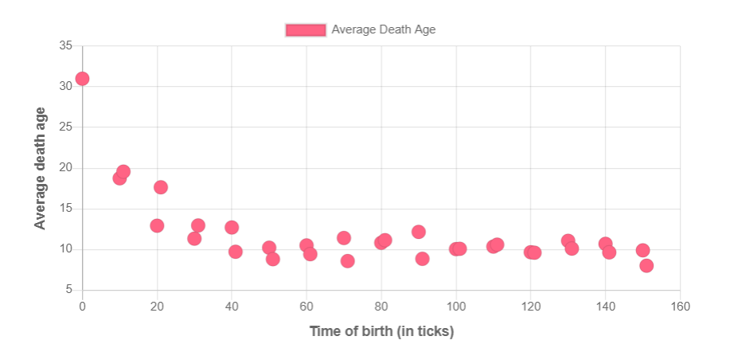

Average death age decreases up to 40th time step and reaches a stable and then stays constant rest of the time. Average death age after time step 40 is 10. Which is very low considering max life span is 90.

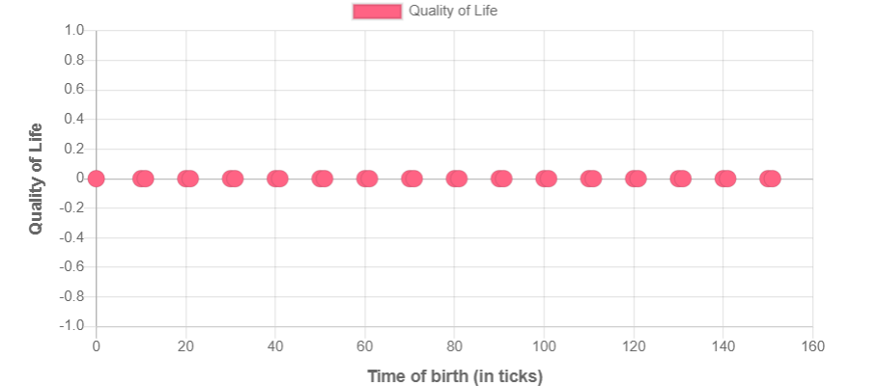

The quality of life all agent sis zero which signifies all the agents died early.

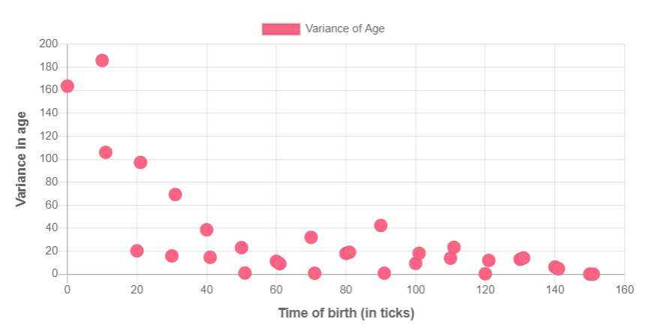

Agents at 10th time step seemed to die at different ages. But in the rest of graph variance decreased which signifies agents died almost at same ages.