**Title:** Observing the logs/behaviour for varying values of Initial population (the hyperparameter settings go in this blank).

**Submitted By:**

**Name: Bhuvanchand**

**Email Address:  bhuvanchand.dasari.official@gmail.com**

**Log folder details:**

**Log folder name:Players_Data_initial_population_20**

**Log zip name:Players_Data_initial_population**

**Number of logs in directory: 2010**

**Hyperparameter Values:**

Mention all the values of hyperparameters used (write ‘default’ in case of default values)

 (d = default)

|  |  |  |
| --- | --- | --- |
| **S.No** | **Hyperparameter Name** | **Value** |
| 1 | initial_population | 20 |
| 2 | state_size | d |
| 3 | initial_energy | d |
| 4 | model_updates | d |
| 5 | speed | d |
| 6 | max_age | d |
| 7 | max_allowed_population | d |
| 8 | kill_type | d |
| 9 | sensory_radius | d |
| 10 | decay_rate | d |

**Visuals:**

All relevant graphs/ family trees/Visual Charts will come under this section.

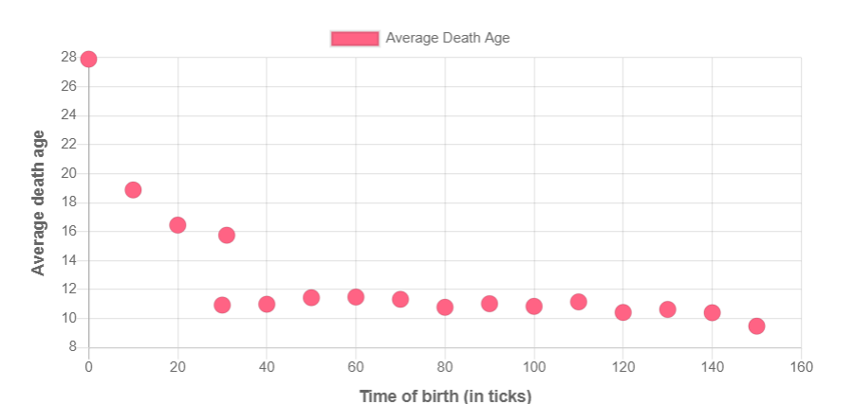

There is a sudden drop in avg death age at time step 30 signifying there are many deaths at 30th time step. One of the reason might be due to many agents are choosing asexual reproduction.

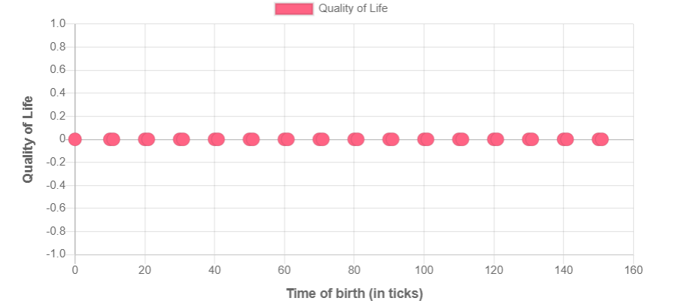

The quality of life all agent sis zero which signifies all the agents died early.

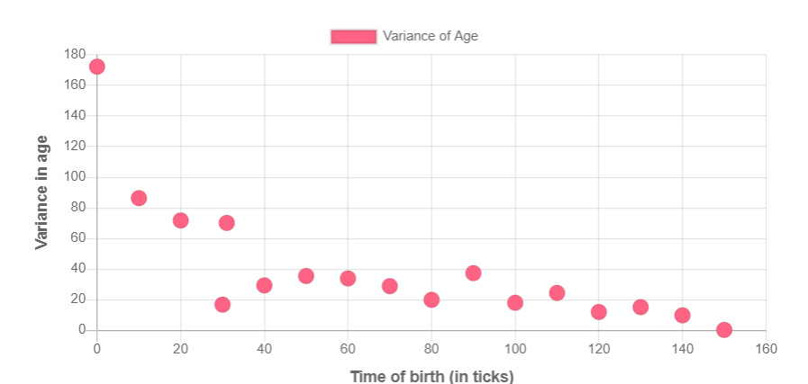

Variance is also showing similar trend like avg death age. Low variance signifies agent are dying at almost same time.

Summary from 3 reports.

New generation of agents after certain time only tend to asexually reproduce. There are not choosing any other action.