**Title:** Observing the logs/behaviour for varying values of 50 (the hyperparameter settings go in this blank).

**Submitted By:**

**Name:** SHIVAM GUPTA

**Email Address:**shivamguptasml@gmail.com

**Visuals:**

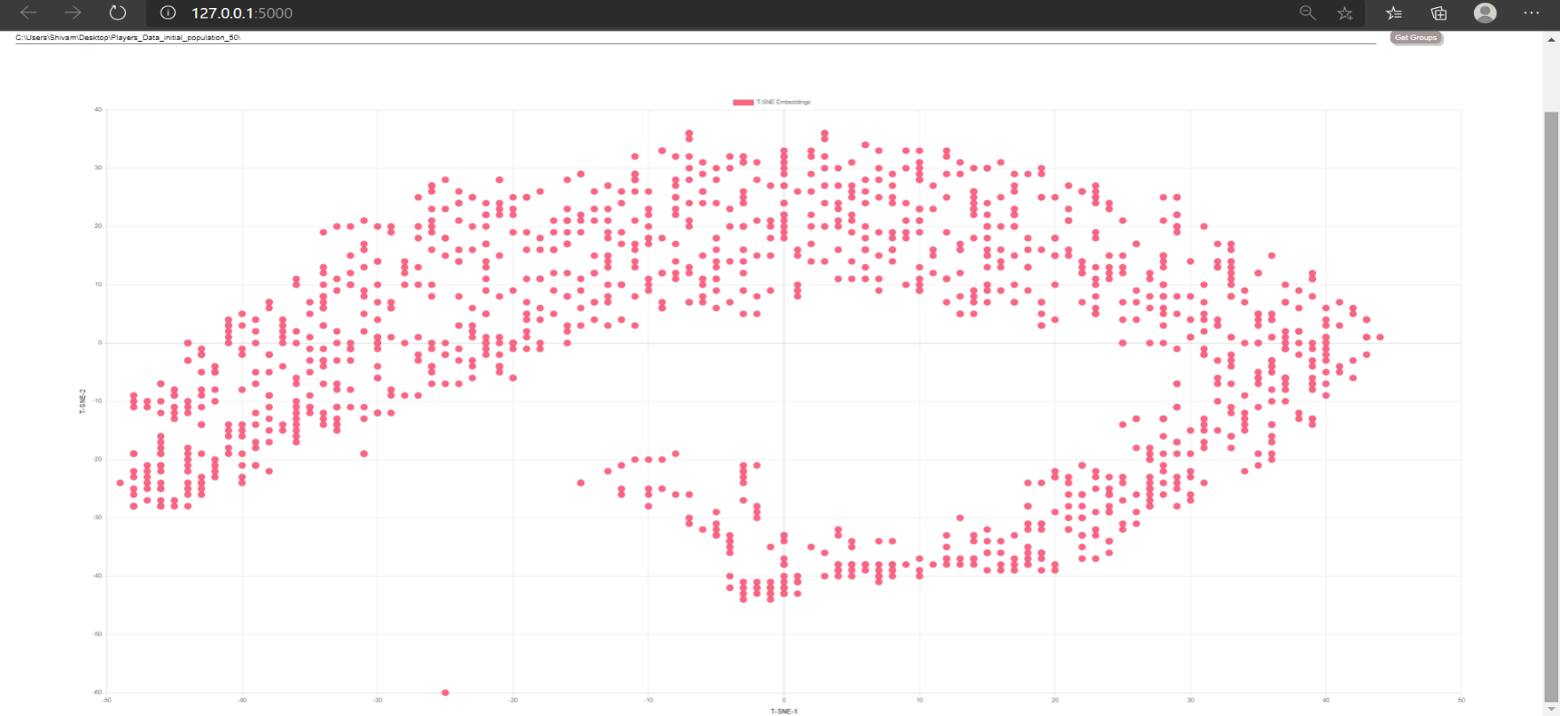

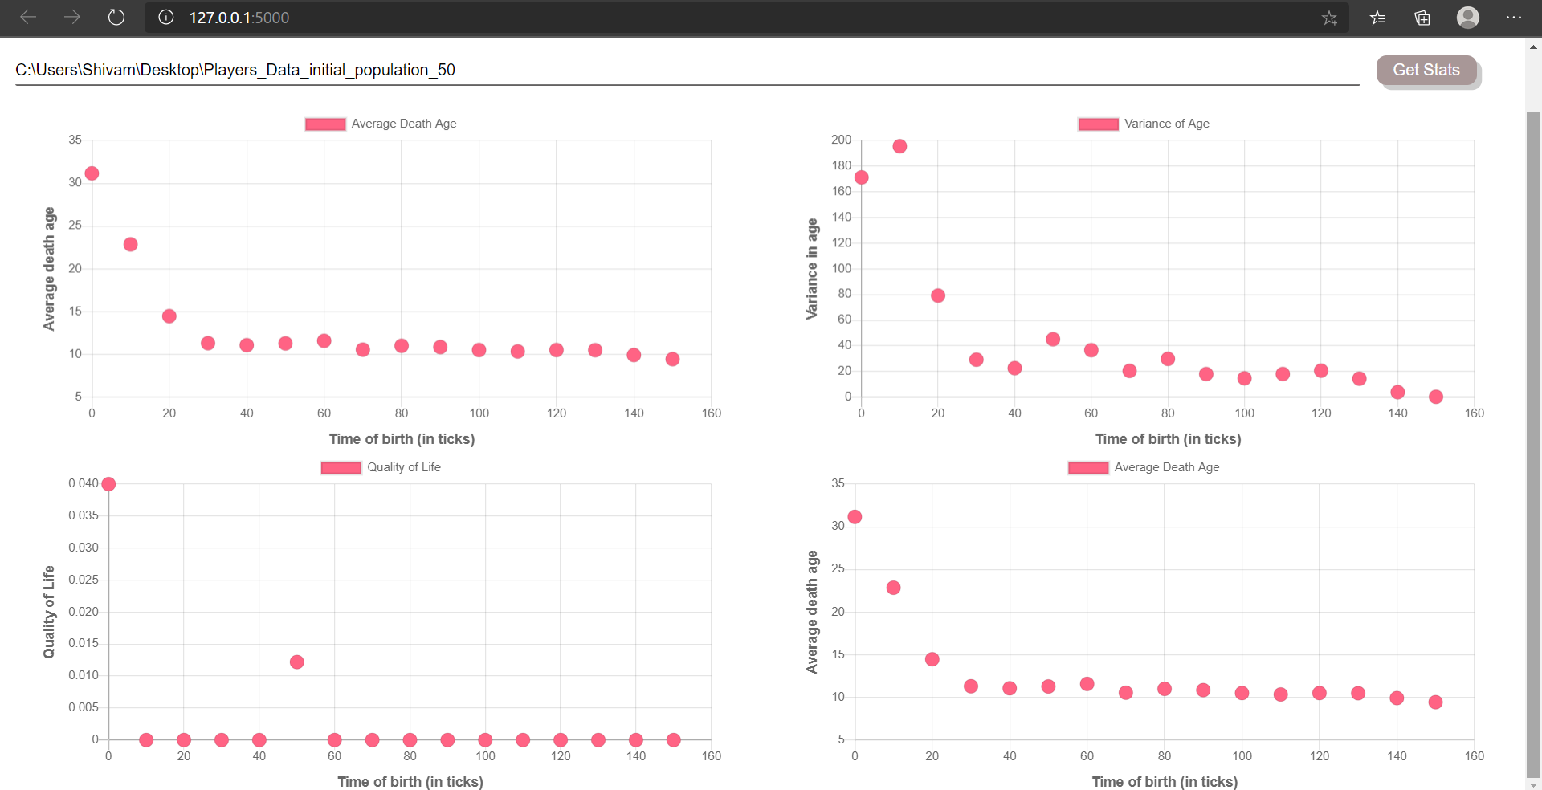

**Log folder details:**

**Log folder name:** Players_Data_initial_population_50

**Log zip name:** Players_Data_initial_population.zip

**Number of logs in directory:** 2080

**Hyperparameter Values:**

Mention all the values of hyperparameters used (write ‘default’ in case of default values)

|  |  |  |
| --- | --- | --- |
| **S.No** | **Hyperparameter Name** | **Value** |
| 1 | initial_population | 50 |
| 2 | state_size | Default |
| 3 | initial_energy | Default |
| 4 | model_updates | Default |
| 5 | speed | Default |
| 6 | max_age | Default |
| 7 | max_allowed_population | Default |
| 8 | kill_type | Default |
| 9 | sensory_radius | Default |
| 10 | decay_rate | Default |

**Observations:**

1. Average death age decreases steeply and then becomes constant.
2. Quality of life is constant except at time 0 and 50
3. After time 0-10 the variance age is very low
4. There is only one group as formation of a clear cluster is very difficult.

**Suggested Changes (If Any):**

1. Since the average death age and variance in age for different values of time of birth is different therefore, quality of life graph should also be varied.
2. The bias towards 0-10 time of birth can be reduced

**Conclusion:**

At these values there is only one complete cluster of points so it is difficult to differentiate between the organisms.