**Title:** Observing the logs/behaviour for varying values of 80 (the hyperparameter settings go in this blank).

**Submitted By:**

**Name:** SHIVAM GUPTA

**Email Address:**shivamguptasml@gmail.com

**Visuals:**

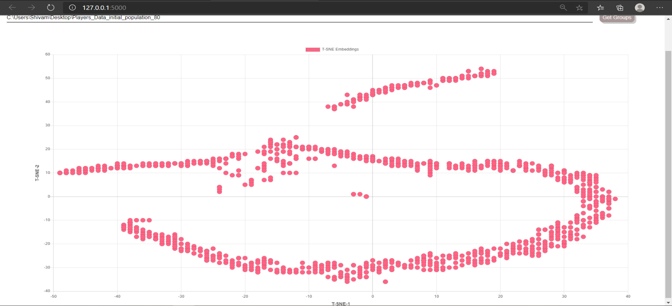

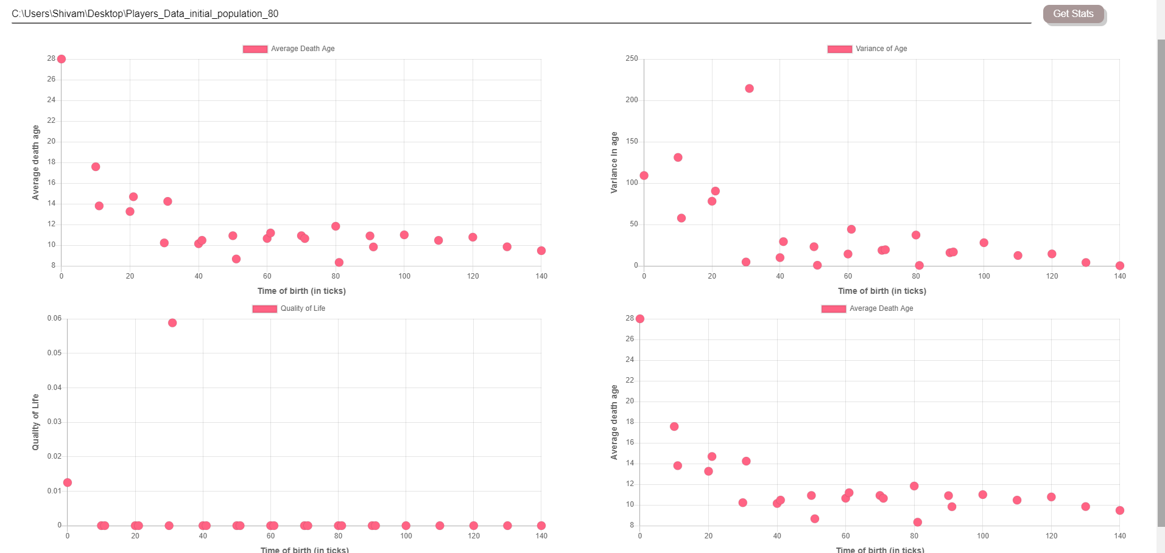

**Log folder details:**

**Log folder name:** Players_Data_initial_population_80

**Log zip name:** Players_Data_initial_population

**Number of logs in directory:** 2048

**Hyperparameter Values:**

Mention all the values of hyperparameters used (write ‘default’ in case of default values)

|  |  |  |
| --- | --- | --- |
| **S.No** | **Hyperparameter Name** | **Value** |
| 1 | initial_population | 80 |
| 2 | state_size | Default |
| 3 | initial_energy | Default |
| 4 | model_updates | Default |
| 5 | speed | Default |
| 6 | max_age | Default |
| 7 | max_allowed_population | Default |
| 8 | kill_type | Default |
| 9 | sensory_radius | Default |
| 10 | decay_rate | Default |

**Observations:**

1. Average death age remains between 8 and 18 except when at 0
2. Quality of life is constant except at time 0.
3. After time 0-30 the variance age is very low
4. There are 2 clusters.

One is U-Shaped between -40 and 40 at TSNE-2

The other one is above it.

**Suggested Changes (If Any):**

1. Since the average death age and variance in age for different values of time of birth is different therefore, quality of life graph should also be varied.

**Conclusion:**

The graphs were studied and observations were made and reported.