**Title:** Observing the logs/behaviour for varying values of 90 (the hyperparameter settings go in this blank).

**Submitted By:**

**Name:** SHIVAM GUPTA

**Email Address:**shivamguptasml@gmail.com

**Visuals:**

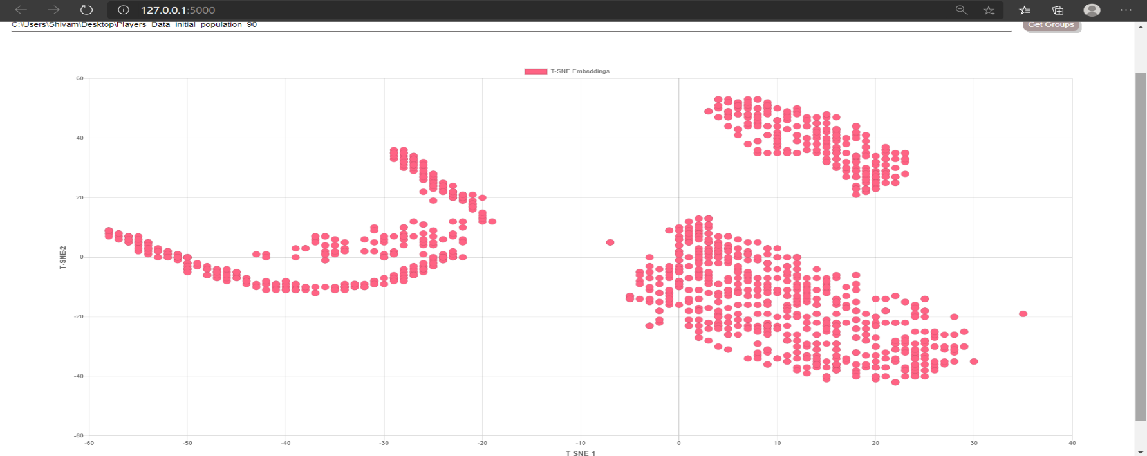 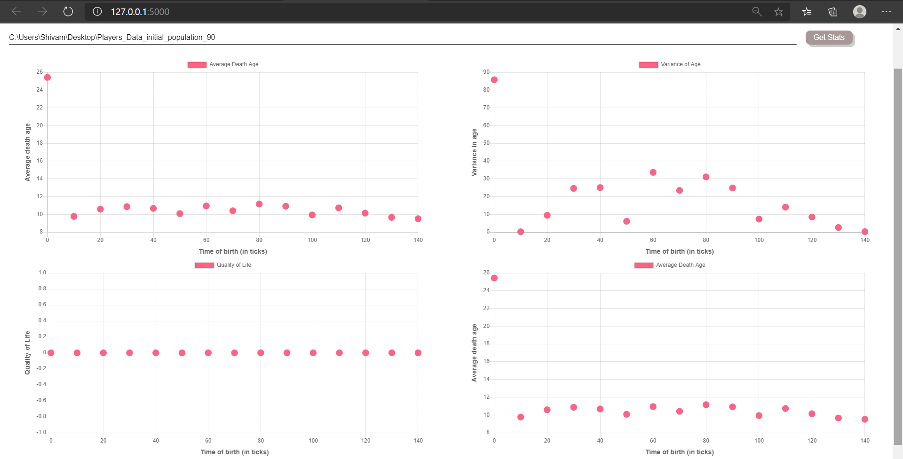

**Log folder details:**

**Log folder name:** Players_Data_initial_population_90

**Log zip name:** Players_Data_initial_population

**Number of logs in directory:** 2137

**Hyperparameter Values:**

Mention all the values of hyperparameters used (write ‘default’ in case of default values)

|  |  |  |
| --- | --- | --- |
| **S.No** | **Hyperparameter Name** | **Value** |
| 1 | initial_population | 90 |
| 2 | state_size | Default |
| 3 | initial_energy | Default |
| 4 | model_updates | Default |
| 5 | speed | Default |
| 6 | max_age | Default |
| 7 | max_allowed_population | Default |
| 8 | kill_type | Default |
| 9 | sensory_radius | Default |
| 10 | decay_rate | Default |

**Observations:**

1. Average death age remains constant between 8-12.
2. Quality of life is constant at 0.
3. After time 0-10 the variance age is very low.
4. There are 3 clear clusters or groups to differentiate between the findings.

**Suggested Changes (If Any):**

Irrespective of the Hyperparameter value Quality of life remains very close to 0 or 0 itself even when variance and death age is varied.

**Conclusion:**

There are 3 clear clusters or groups to differentiate between the findings and draw similarity.