

***3. Qualitative Risk Analysis***: Qualitative Risk Analysis is a simple and cost-effective way to manage project risks.

## What is Risk Analysis?

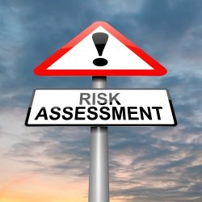

Once you have identified the risks that could affect your project, you need to determine which ones you will spend time and money on.

**Risk analysis** is the process of prioritizing risks based on the probability of the risk occurring and the impact it would have on the project.

There are two primary methods of risk analysis you can use on your project...

* Qualitative Risk Analysis
* Quantitative Risk Analysis

The main difference between these two methods of risk analysis is that **qualitative risk analysis** uses a relative or descriptive scale to measure the probability of occurrence whereas **quantitative risk analysis** uses a numerical scale.

For example, a qualitative analysis would use a scale of "Low, Medium, High" to indicate the likelihood of a risk event occurring.

A quantitative analysis will determine the probability of each risk event occurring. For example, Risk #1 has an 80% chance of occurring, Risk #2 has a 27% chance of occurring, and so on.

The rest of this article will focus on using **qualitative analysis** to prioritize and decide which risks your project should focus on.

## The Risk Assessment Matrix

A **Risk Assessment Matrix** (RAM) is a tool to help you determine which risks you need to develop a risk response for.

The first step in developing a RAM is to define the rating scales for likelihood and impact.

|  |  |  |
| --- | --- | --- |
| RATING | LIKELIHOOD | DESCRIPTION |
| 1 | Very Low | Highly unlikely to occur. May occur in exceptional situations. |
| 2 | Low | Most likely will not occur. Infrequent occurrence in past projects. |
| 3 | Moderate | Possible to occur. |
| 4 | High | Likely to occur. Has occurred in past projects. |
| 5 | Very High | Highly likely to occur. Has occurred in past projects and conditions exist for it to occur on this project. |

In a qualitative analysis, likelihood or probability is measured using a relative scale. Here's an example **Likelihood Scale** definition...

Here's an example Impact Scale definition...

|  |  |  |  |
| --- | --- | --- | --- |
| RATING | IMPACT | COST | SCHEDULE |
| 1 | Very Low | No increase in budget | No change to schedule |
| 2 | Low | < 5% increase in budget | < 1 week delay to schedule |
| 3 | Moderate | 5-10% increase in budget | 1 - 2 weeks delay to schedule |
| 4 | High | 10-20% increase in budget | 2 - 4 weeks delay to schedule |
| 5 | Very High | > 20% increase in budget | > 4 weeks delay to schedule |

Remember, these scales are very dependent on the specific details of your project.

For example, a "Low" likelihood of occurrence for one project may mean a risk event is unlikely to occur within the next 10 deployments. With another type of project "Low" may mean that a risk event is unlikely to occur within the next year.

The impact scale for your project could also include other considerations such as scope, political, and employee impacts.

With your rating scales prepared, you can create a Risk Assessment Matrix to help you categorize the Risk Level for each risk event.

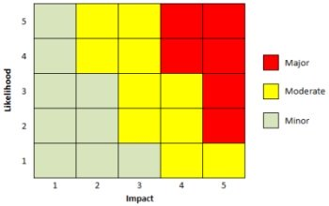Risk Assessment Matrix

For example, if a risk event has a Moderate Likelihood of occurring and a High impact, it would be considered a Moderate Risk using the RAM shown above.

## Qualitative Risk Assessment

Using your RAM and Rating Scales, you can then analyze the likelihood of each risk event occurring and its impact to determine what **Risk Level** it is at. This will give you the information you need to prioritize your list of [**project risks**](https://amzn.to/2INgRlw).

A qualitative risk assessment can also help you determine if there are any specific types or categories of risks that would require special attention or any risk events that need to be handled in the near-term.

The most challenging aspect of performing a qualitative risk analysis is defining your rating scales. But once that has been done, you can use them for the duration of the project to effectively manage your project's risks in a timely manner.

***4. Qualitative Risk Analysis:***

**Evaluating Risks Using Quantitative Risk Analysis**

Project managers should be prepared to perform different types of risk analysis. For many projects, the quicker qualitative risk assessment is all you need. But there are occasions when you will benefit from a quantitative risk analysis.

Let’s take a look at this type of analysis: What is it? Why should we perform it? When should it be performed? And how do we quantify risks?

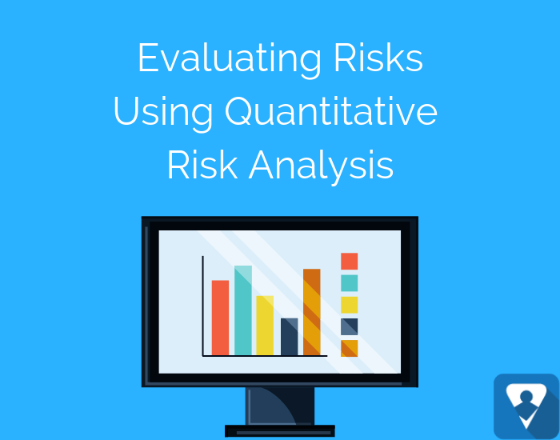

**What is Quantitative Risk Analysis?**

Qualitative risk analysis is a numeric estimate of the overall effect of risk on the project objectives such as cost and schedule objectives. The results provide insight into the likelihood of project success and is used to develop contingency reserves.

**Why Perform Quantitative Risk Analysis?**

Better Overall Project Risk Analysis

Individual risks are evaluated in the qualitative risk analysis. But the quantitative analysis allows us to evaluate the overall project risk from the individual risks.

Better Business Decisions

Business decisions are rarely made with all the information or data we desire. For more critical decisions, quantitative risk analysis provides more objective information and data than the qualitative analysis. Keep in mind: While the quantitative analysis is more objective, it is still an estimate. Wise project managers consider other factors in the decision-making process.

Better Estimates

A project manager estimated a project's duration at eight months with a cost of $300,000. The project actually took twelve months and cost $380,000. What happened?

The project manager did a Work Breakdown Structure (WBS) and estimated the work. However, the project manager failed to consider the potential impact of the risks (good and bad) on the schedule and budget.

**When to Perform Quantitative Risk Analysis?**

First, we [identify risks](https://projectriskcoach.com/7-ways-to-identify-risks/). Then we can evaluate the risks qualitatively and quantitatively.

Consider using Quantitative Risk Analysis for:

* Projects that require a Contingency Reserve for the schedule and budget.
* Large, complex projects that require Go/No Go decisions (the Go/No Go decision may occur multiple times in a project).
* Projects where upper management wants more detail about the probability of completing the project on schedule and within budget.

**What is the Difference Between Qualitative and Quantitative Risk Analysis?**

<https://www.youtube.com/watch?time_continue=3&v=TsEjoXL9CHI>



Quantitative Risk Assessment Tools & Techniques

Quantitative Risk Analysis tools and techniques include but are not limited to:

* **Three Point Estimate** – a technique that uses the optimistic, most likely, and pessimistic values to determine the best estimate.
* **Decision Tree Analysis** – a diagram that shows the implications of choosing one or other alternatives. [Click here to see an example.](https://www.mindtools.com/dectree.html)
* **Expected Monetary Value (EMV)** – a method used to establish the contingency reserves for a project budget and schedule.
* **Monte Carlo Analysis** – a technique that uses optimistic, most likely, and pessimistic estimates to determine the total project cost and project completion dates. For example, we could estimate the probability of completing a project at a cost of $20M. Or what is a company wanted to have an 80% probability of achieving its cost objectives. What is the cost to achieve 80%?
* **Sensitivity Analysis** – a technique used to determine which risks have the greatest impact on a project.
* **Fault Tree Analysis (FMEA)** – the analysis of a structured diagram which identifies elements that can cause system failure.

**Quantitative Risk Analysis Example**

Let’s look at a simple Expected Monetary Value (EMV) example:

Keep in mind that risks include both threats and opportunities. Threats have adverse impacts on cost. Opportunities are benefits that reduce cost. Expected Monetary Value = Probability x Impact.

|  |  |  |  |
| --- | --- | --- | --- |
| **Risk** | **Probability** | **Cost Impact** | **EMV** |
| A (Threat) | 20% | $100,000 | $20,000 |
| B (Opportunity) | 40% | ($10,000) | ($4,000) |
| C (Threat) | 30% | $50,000 | $15,000 |
| Total EMV |  |  | $31,000 |

Notice we subtracted the benefit of the Opportunity from the EMV. The Total EVM represents the project risk exposure and the amount of our Contingency Reserve.

<https://www.youtube.com/watch?time_continue=3&v=TsEjoXL9CHI>

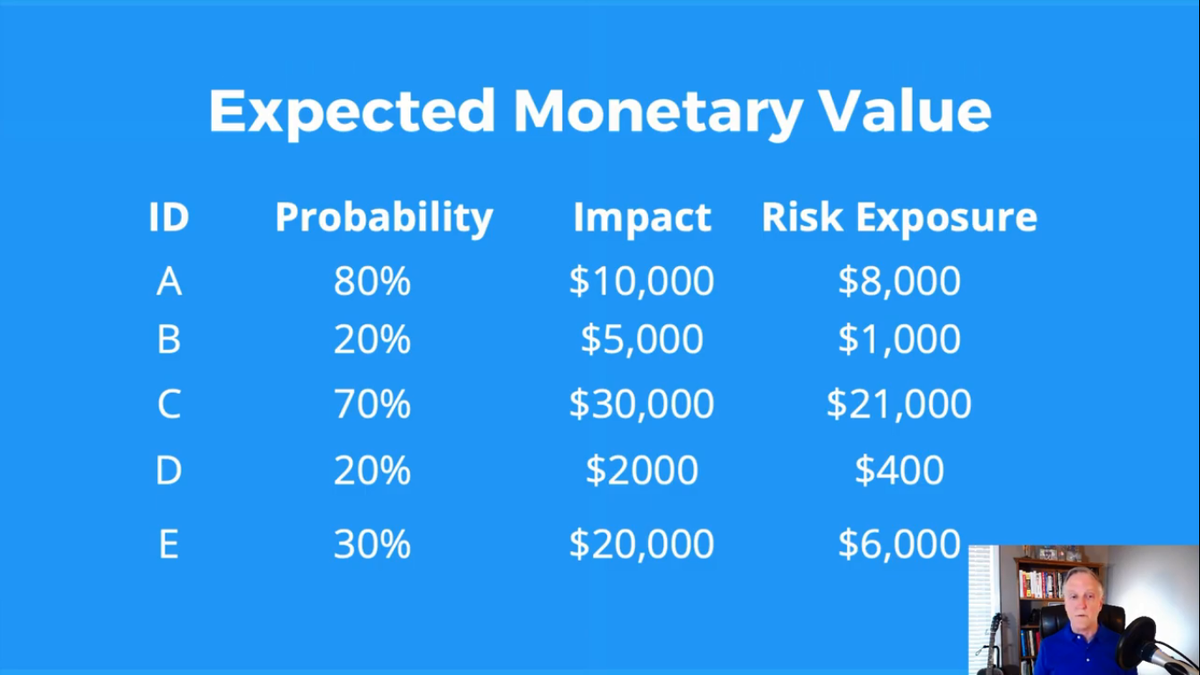

Once you've performed the Quantitative Risk Analysis, be sure to [update your risk register](https://projectriskcoach.com/how-to-build-a-risk-register/) with the additional risk information.