SOFTWARE ARCHITECTURE AND DESIGN SPECIFICATION
Project Management System

Version: 1.0
Status: In Progress

Field | Details
Project | Project Management System
Team | Team 11
Team Lead | Shivansh Sharma
Members | Shibi R Shetty; Sheetal S Bevinakatti; Shivanagouda I Patil
Date | October 2026

Revision History
Version | Date | Author | Change Summary
1.0 | October 2026 | Team 11 | Revised technology stack, diagram placement, UML sequence diagrams, and open issues.

Approvals
Role | Name | Signature / Date
Faculty / Instructor | Prof. M. Sheela Devi
Team Lead | Shivansh Sharma

1. Introduction

1.1 Purpose
This Software Architecture and Design Specification (SASD) describes the architecture, major components, design decisions, interfaces, security considerations, and implementation-oriented design of the Project Management System (PMS). It translates the approved Software Requirements Specification (SRS) into an architectural and design view that can guide development and testing.

1.2 Scope
The Project Management System is a web-based system intended to help teams plan, organize, execute, monitor, and report project work. The system covers user authentication, project management, task and issue management, Kanban boards, workflow management, estimation, sprint and milestone management, dashboards, notifications, collaboration, search and filtering, reporting, and activity logging.

1.3 Audience
This document is intended for the project development team, test engineers, team lead, product owner, faculty/instructors, and future maintainers of the system.

1.4 Definitions
Term | Definition
PMS | Project Management System.
RBAC | Role-Based Access Control; permissions are controlled according to user roles.
Kanban | A visual workflow board used to track tasks through different states.
Sprint | A fixed development period containing a defined set of work items.
Workflow | A defined sequence of task states and permitted transitions.
API | Application Programming Interface used for communication between software components.
SASD | Software Architecture and Design Specification.
SRS | Software Requirements Specification.
STP | Software Test Plan.

2. Document Overview

2.1 How to Use This Document
The document should be read from the system goals and stakeholders through the architecture, component responsibilities, architecture pattern, security, design flows, interfaces, and operational considerations. It is intended to be used together with the SRS and Software Test Plan. Architecture and design decisions should remain consistent with the approved requirements.

2.2 Related Documents
- Project Management System Requirements document.
- Project Management System Software Requirements Specification (SRS).
- Project Management System Software Test Plan (STP).
- Requirement Traceability Matrix (RTM), where maintained.

3. Architecture

3.1 Goals & Constraints
The architecture is intended to provide a maintainable, secure, reliable, usable, and scalable foundation for the PMS.
- Maintainability: separate presentation, application/business logic, and data responsibilities.
- Security: authenticate users and enforce role-based authorization.
- Reliability: handle invalid requests and failures without exposing sensitive information.
- Performance: support normal project, task, dashboard, search, and reporting operations with acceptable response times.
- Scalability: allow the system to support growth in users, projects, tasks, and activity records.
- Usability: provide clear interfaces for project, task, workflow, sprint, and reporting activities.
Constraints include adherence to the approved SRS, the team's selected technology stack, available development time, team size, and the requirement to maintain code, testing, version control, and CI/CD activities together during development.

3.2 Stakeholders & Concerns
Stakeholder | Primary Concerns
Admin | User/role management, security, system control.
Project Manager | Project planning, tasks, workflows, sprints, dashboards, and reports.
Team Member | Task execution, updates, collaboration, and visibility.
Product Owner | Requirement alignment, prioritization, and expected project outcomes.
Development Team | Modularity, maintainability, integration, and implementation feasibility.
Test Team | Functional correctness, integration, errors/boundary cases, and quality.
Faculty / Instructor | Compliance with project requirements, documentation, and demonstrable progress.

3.3 Component (UML) Diagram
The following architecture diagram shows the major PMS application components, selected technologies, PostgreSQL data store, source repository, and CI/CD flow.
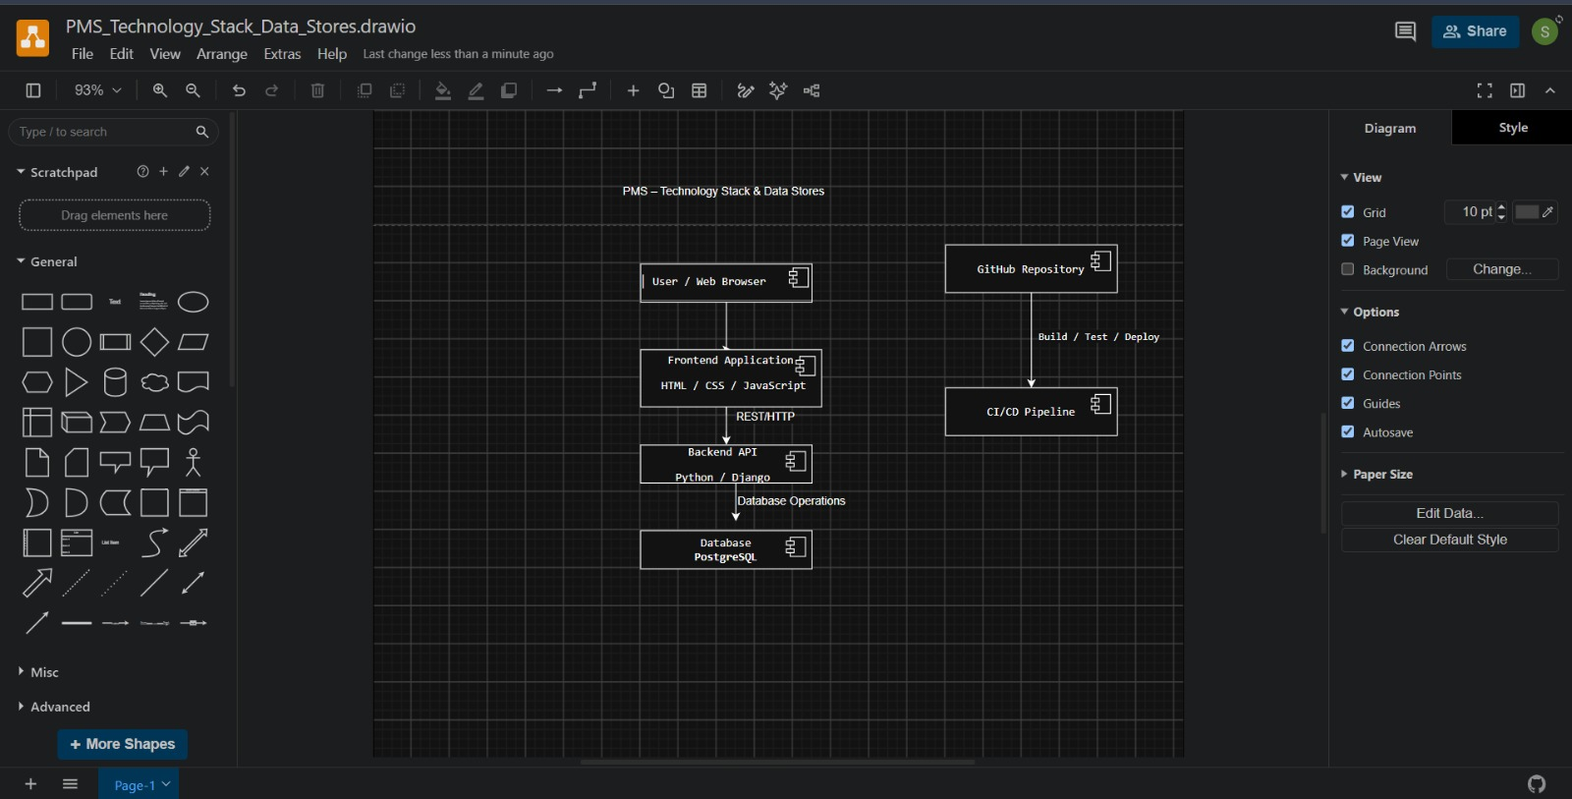
Figure 3.3.1 — PMS Technology Stack, Data Stores and CI/CD Architecture

3.4 Component Descriptions
Component | Responsibility
Presentation / Web UI | Provides screens for login, projects, tasks, Kanban, sprints, dashboards, search, reports, and collaboration.
Authentication & Authorization | Handles registration/login/logout and enforces role-based access.
Project Management | Creates, updates, archives/deletes projects and manages project membership.
Task / Issue Management | Creates, assigns, updates, and tracks tasks/issues and their details.
Workflow / Kanban | Manages workflow states, permitted transitions, and visual task movement.
Estimation | Stores and manages effort estimates for tasks.
Sprint / Milestone Management | Creates sprints/milestones and manages the associated backlog and progress.
Dashboard / Reporting | Provides project visibility, KPIs, charts, summaries, and reports.
Notification | Delivers relevant task/project notifications and reminders.
Collaboration | Supports comments and related collaboration information.
Search / Filter | Provides task/project search and filtering.
Activity Log | Records significant system and project activities for traceability.
Data Store | Persists users, projects, tasks, workflows, sprints, comments, attachments, and activity information.

3.5 Chosen Architecture Pattern and Rationale
A layered architecture is proposed for the Project Management System. The presentation layer handles user interaction, the application/API layer handles requests and orchestration, the business logic layer implements project rules, and the data access layer communicates with the database.
- Separation of concerns makes individual modules easier to develop and test.
- Changes in the user interface can be made with limited impact on business logic.
- Business rules such as workflow validation and role authorization can be centralized.
- The design supports unit and integration testing of individual components and their interactions.
- The structure is suitable for a student project while remaining extensible for future features.

3.6 Technology Stack & Data Stores
The selected technology stack and data stores for the Project Management System are:
Technology / Area | Selected Technology
Frontend | HTML / CSS / JavaScript
Backend | Python / Django
Database / Data Store | PostgreSQL
Version Control / Repository | Git / GitHub
CI/CD | GitHub Actions
The architecture uses a browser-based frontend communicating with the Python/Django backend through REST/HTTP. The backend performs database operations on PostgreSQL. Git/GitHub is used for source-code management, and GitHub Actions is used for automated build and test activities and deployment where configured.

3.7 Risks & Mitigations
Risk | Impact | Mitigation
Unauthorized access | High | Use authentication, role-based authorization, secure password handling, and authorization checks.
Invalid workflow transition | Medium | Validate transitions in the workflow/business-logic layer.
Data loss or database failure | High | Use database backup/recovery procedures and validate critical database operations.
Application/API failure | Medium | Use standardized error handling, logging, validation, and automated tests.
Poor performance as data grows | Medium | Use appropriate queries, indexing where required, pagination/filtering, and performance testing.
CI/CD failure | Medium | Run automated tests on repository changes and resolve build/test failures before continuing.
Requirement mismatch | Medium | Maintain traceability between SRS requirements, architecture components, implementation tasks, and tests.

3.8 Traceability to Requirements
Requirement | Primary Architecture / Design Area
FR1 – User Authentication | Authentication & Authorization component
FR2 – Project Management | Project Management component
FR3 – Task / Issue Management | Task / Issue Management component
FR4 – Kanban Board | Workflow / Kanban component
FR5 – Workflow Management | Workflow / Kanban component
FR6 – Estimation | Estimation component
FR7 – Sprint / Milestone Management | Sprint / Milestone component
FR8 – Visibility & Dashboard | Dashboard / Reporting component
FR9 – Notifications | Notification component
FR10 – Comments & Collaboration | Collaboration component
FR11 – Search & Filter | Search / Filter component
FR12 – Reporting | Dashboard / Reporting component
FR13 – Activity Log | Activity Log component

3.9 Security Architecture
Security is designed around authentication, authorization, secure handling of credentials, validation of user input, controlled access to project data, and activity traceability.
Threat / Concern | Mitigation
Spoofing / account takeover | Authentication, secure password handling, session/token controls, and appropriate login validation.
Unauthorized access | RBAC and authorization checks at protected operations.
Data tampering | Server-side validation and controlled update operations.
Information disclosure | Avoid sensitive information in responses/logs and protect communications using the selected secure transport mechanism.
Abuse / excessive requests | Input validation and appropriate request controls where needed.
Privilege escalation | Enforce permissions based on Admin, Project Manager, and Team Member roles.
Auditability | Maintain the activity log for significant project/system actions.

4. Design

4.1 Design Overview
The PMS design follows the selected layered architecture. User requests originate in the presentation layer and are handled by the application/API layer. Business rules are applied by the relevant service/module, and persistent information is stored through the data-access layer.
Core design modules include authentication and authorization, project management, task management, workflow/Kanban, estimation, sprint management, dashboard/reporting, notifications, collaboration, search/filter, and activity logging.

4.2 UML Sequence Diagrams
The following project-specific UML sequence diagrams model the two key PMS flows: (1) User Login / Authentication and (2) Project Manager creates a project and then creates/assigns a task.
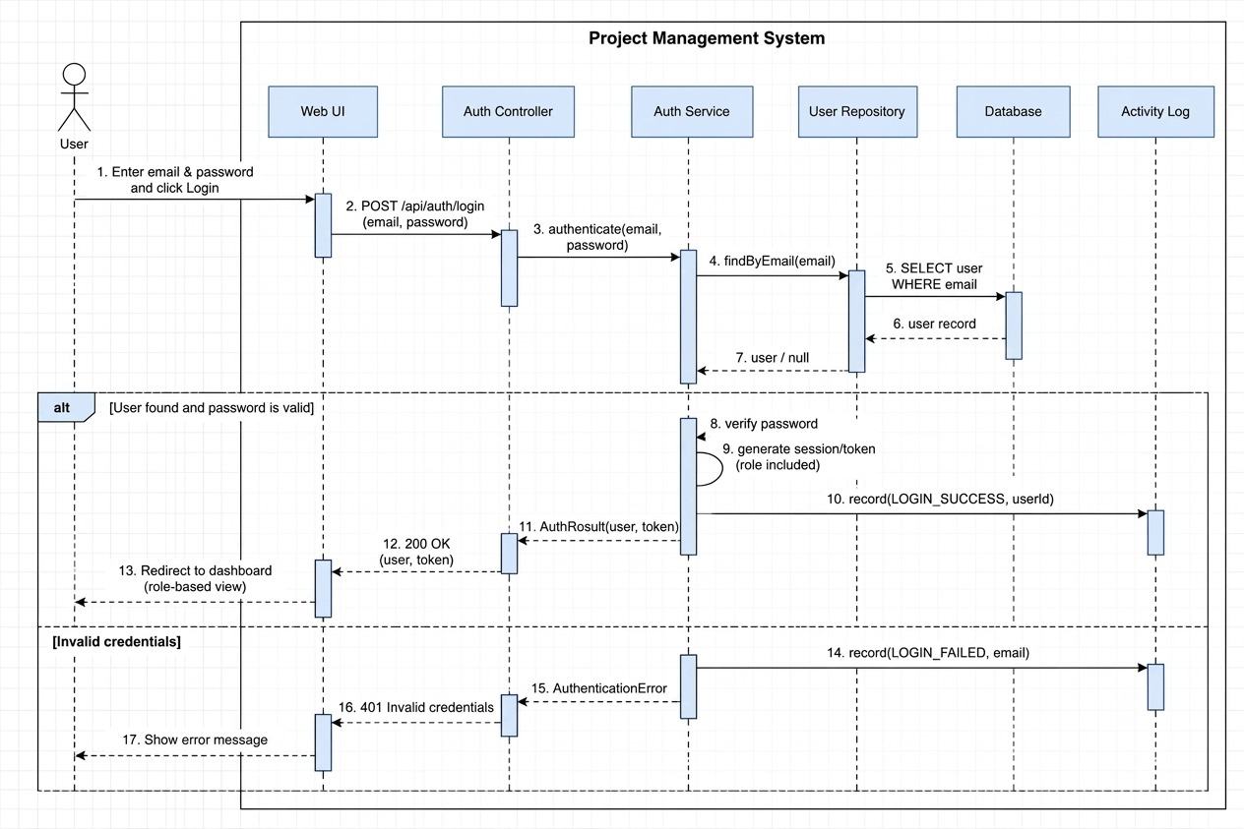
Figure 4.2.1 — User Login / Authentication Sequence
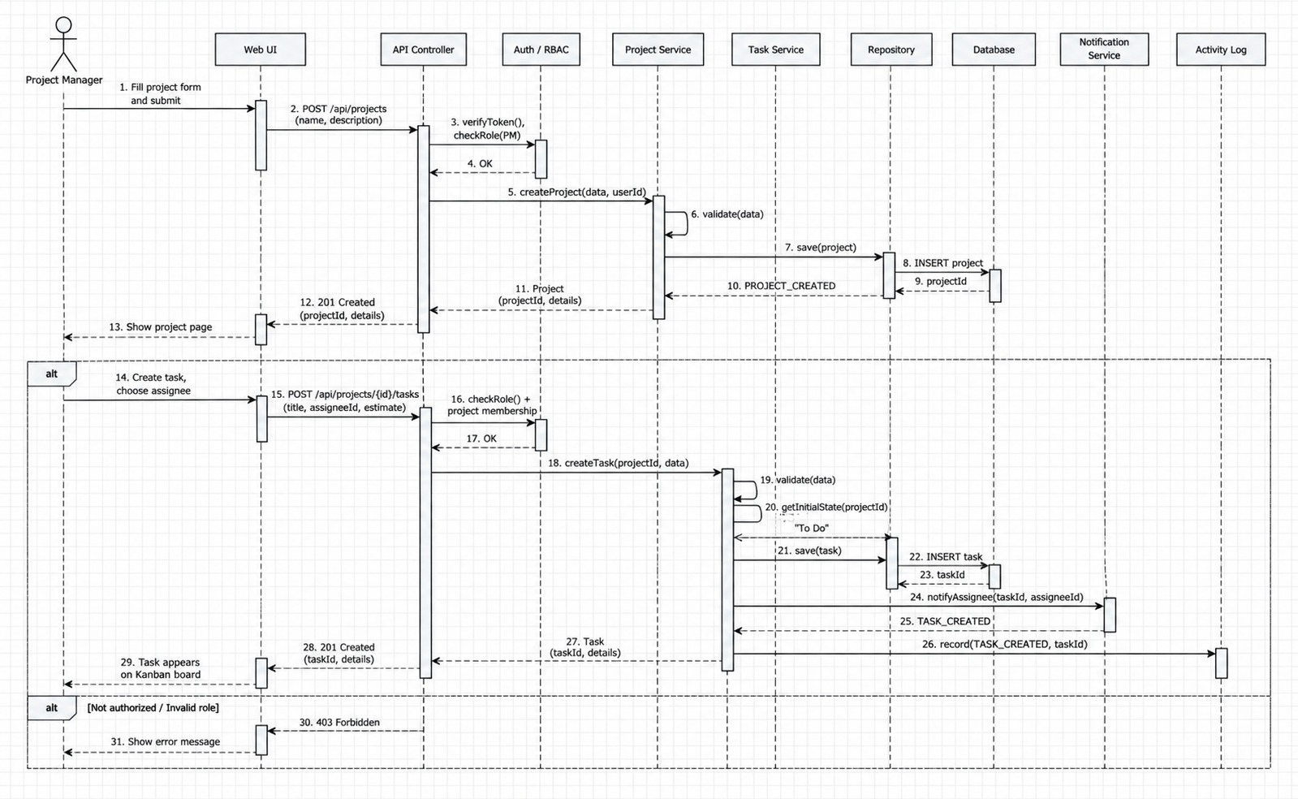
Figure 4.2.2 — Project Creation and Task Creation/Assignment Sequence

4.3 API Design
The PMS should expose clearly defined interfaces between the presentation layer and backend/application components. The following are design examples based on the approved PMS functions; final endpoint names and payloads should be aligned with the implementation.

4.3.1 Authentication API
Item | Definition
Endpoint | POST /api/auth/login
Purpose | Authenticate a registered user.
Request | email, password
Success | Authenticated user information and the selected authentication/session mechanism.
Errors | Invalid credentials; validation error; unauthorized access.

4.3.2 Project Creation API
Item | Definition
Endpoint | POST /api/projects
Purpose | Create a new project for an authorized user.
Request | Project name, description, and other approved project fields.
Success | Created project identifier and project details.
Errors | Validation error; unauthorized/forbidden request; persistence failure.
At least two implemented interfaces should be documented with the actual method, endpoint, request schema, response schema, authorization requirement, and error responses once the backend implementation is finalized.

4.4 Error Handling, Logging & Monitoring
The system should use consistent error handling so that invalid operations return clear, non-sensitive error messages. Validation should occur at the appropriate client and server boundaries, with server-side validation treated as authoritative.
- Authentication failures should not reveal sensitive credential information.
- Invalid task/project identifiers should return an appropriate not-found response.
- Unauthorized operations should return an appropriate authorization response.
- Invalid workflow transitions should be rejected by the business-logic layer.
- Database or internal failures should be logged for diagnosis without exposing sensitive details to users.
Logging should record useful diagnostic and audit information while avoiding passwords, tokens, or other sensitive values. Monitoring should focus on application errors, API failures, response times where available, authentication failures, and system availability.

4.5 UX Design
The PMS user interface should provide a consistent and understandable experience for the defined user roles.
- Login and registration interfaces should provide clear validation and error feedback.
- Project pages should clearly show project details, members, tasks, and progress.
- Task screens should make assignment, status, estimation, comments, and updates understandable.
- Kanban boards should clearly represent workflow states and permitted movement.
- Sprint views should expose sprint scope, backlog, and progress.
- Dashboards should present relevant project metrics in a concise visual form.
- Search and filter controls should provide clear feedback when no matching records are found.
- Interfaces should use readable text, consistent navigation, and appropriate validation/error feedback.

4.6 Open Issues & Next Steps
The following implementation and validation activities remain as the project progresses:
- Finalize API endpoints and request/response schemas after implementation decisions.
- Implement Sprint 1 features according to the Jira Sprint 1 backlog.
- Develop unit and integration tests alongside implementation.
- Configure and validate the CI/CD pipeline.
- Maintain requirement-to-design-to-test traceability as implementation progresses.
- Perform security, performance, usability, and system testing as appropriate before final release.

5. Appendices

5.1 Glossary
Term | Meaning
PMS | Project Management System.
SRS | Software Requirements Specification.
SASD | Software Architecture and Design Specification.
STP | Software Test Plan.
RBAC | Role-Based Access Control.
API | Application Programming Interface.
UML | Unified Modeling Language.
Kanban | Visual workflow method for tracking work.
Sprint | Fixed period for completing a defined set of project work.
Workflow | Sequence of states and permitted transitions for work items.
RTM | Requirement Traceability Matrix.
CI/CD | Continuous Integration / Continuous Delivery or Deployment.

5.2 References
- Project Management System Requirements document.
- Project Management System Software Requirements Specification (SRS).
- Project Management System Software Test Plan (STP).
- Project Management System Requirement Traceability Matrix (where applicable).
- Software Architecture and Design Specification guideline/template provided for the project.

5.3 Tools
Tool / Category | Purpose
Jira | Sprint planning, backlog management, task assignment, and project tracking.
Git / GitHub | Version control, collaboration, and source-code management.
GitHub Actions | CI/CD automation and automated test execution.
Draw.io / equivalent UML tool | Architecture and UML diagrams.
Postman / equivalent | API testing during backend development.
Selected IDE | Application development and debugging.

