Phase 2.5 — Practical Assignments (Week 3)
Week 3-Streams and Redirections

🎯 Assignment 1: File Descriptor Mastery
Create commands that:
- Redirect stdout only
- Redirect stderr only
- Merge both
- Separate both
Solution:
- Redirect only output (stdout):
- Redirect only errors (stderr):
- Merge output + errors:
- Separate both:
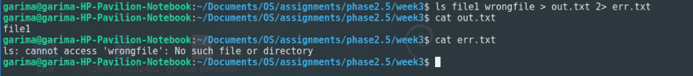
- error and observe:

🎯 Assignment 2: Pipeline Engineering
Given a messy log file:
Extract:
- Unique error messages
- Count occurrences
- Sort by frequency
Must use:
- grep
- sort
- uniq
- awk
solution:
- Step 1: Get only ERROR lines
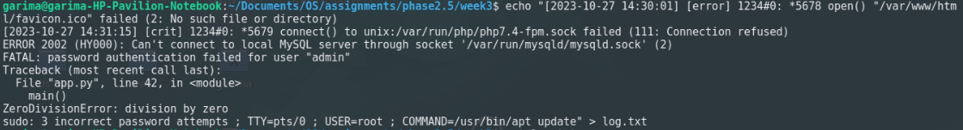
- Step 2: Unique errors
- Step 3: Count frequency
- Step 4: Sort by highest count
- Step 5: Clean output using awk

🎯 Assignment 3: Heredoc Script Input
Write a small script that:
- Accepts heredoc input
- Processes lines
Outputs structured results

- Script:
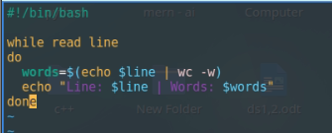
- Heredoc output:

