Phase 2.5 — Practical Assignments (Week 4)
Week 3-Text processing and Networking

🎯 Assignment 1: Log Analyzer
Given:
- /var/log/syslog or any large log
Extract:
- Errors from last hour
- Count per service
- Top 5 frequent issues
Must combine tools.
Solution
- errors from last 1 hour
- Count errors per service
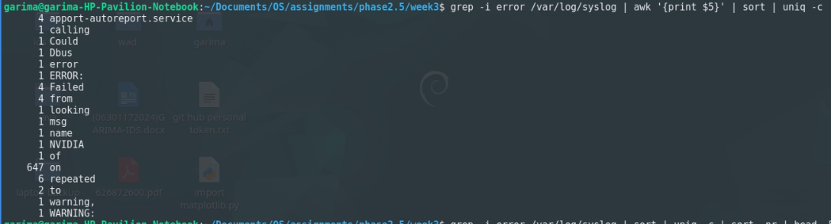
- Top 5 frequent issues
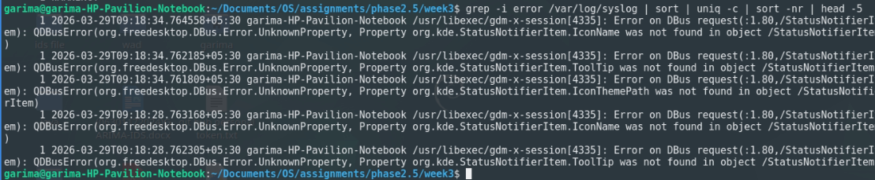

🎯 Assignment 2: Network Debugging Drill
Using:
- curl
- netstat / ss
- ping
Diagnose:
- Whether a port is open
- Whether a service is reachable
- Whether DNS resolves
Solution:
- Check if port is open
- Check service reachable
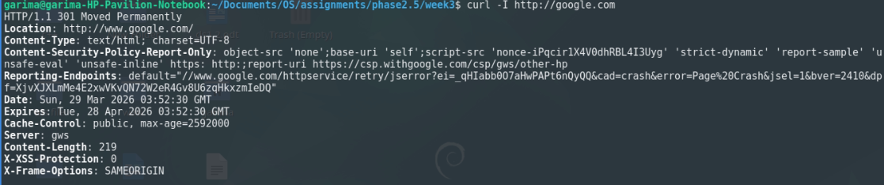
- Check DNS resolution
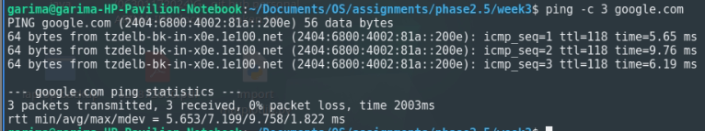

🎯 Assignment 3: Data Extraction Challenge
Given a CSV-like file:
- Extract column 2
- Filter rows
- Compute aggregate
Must use:
- awk
- cut
- grep
solution:

Example file: data.csv
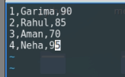
- Extract column 2
- Filter rows (marks > 80)
- Compute average marks

