Phase 2.5 — Practical Assignments(week 5)
Week 5 — Compilation & Automation

🎯 Assignment 1: GCC Deep Dive
- Compile a C program with:
  - Debug symbols
  - Warnings
- Generate object file separately.
- Link manually.
- Use ldd to inspect dependencies.
Explain:
- What is linked dynamically
- What is resolved at runtime
Solution:
- Compile with debug + warnings
- Create object file
- Manual linking
- Check dependencies
Dynamic linking: means your program doesn’t carry all the library code inside it; instead, it borrows it when it runs.
Runtime resolution: means that while the program is starting, the system finds those needed functions (like printf) and connects them so the program can work.

🎯 Assignment 2: Build Helper Script
Write a script that:
- Cleans build directory
- Compiles project
- Moves binary to bin/
- Prints success/failure based on exit code
Must use:
- set -e
- set -o pipefail
Functions
Solution:
- script:
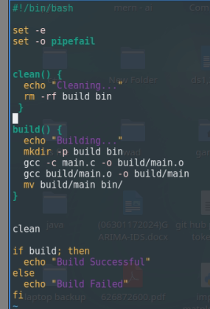
- output:

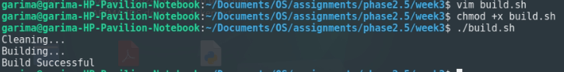

🎯 Assignment 3: Automated Backup Script
Script must:
- Accept directory argument
- Validate input
- Create timestamped archive
- Handle errors
Log actions
solution:
- Script:
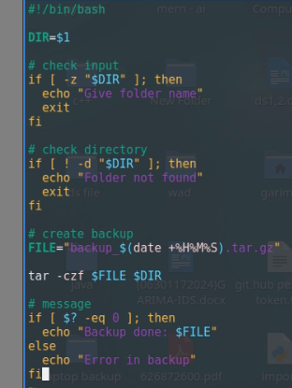
- Output:
