**Pump_Microscope-Dropbox:**

* **Pump_Code:**

Folder with 4 python scripts:

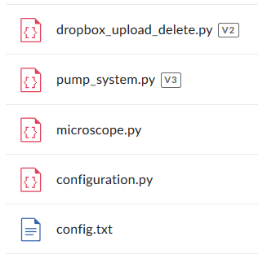

To execute the Pump System you need to copy this folder in your Raspberry Pi. Open a terminal and change to the directory corresponding to this folder. For instance, if you just copy this folder in “/home/pi”:

**cd Pump_Code**

In this test version, this code is not running automatically after boot. To execute the code you need to write in the terminal:

**python3 pump_system.py**

* **Installation.docx:**

Guide to install all libraries necessary to run all codes.

* **download_delete.py:**

Code to run in your personal computer and download from Dropbox all the files in an specific folder. It is possible to choose if you want to delete the files after download or if you want to keep the files in your dropbox account.

* **Versions used:**
  + **Raspbian Stretch with desktop – Version: June,2018**
  + **OpenCV 3.3.0**
  + **Python 3**
  + **Pi Camera 1.1.0**
  + **Dropbox Python Library: (**<https://dropbox-sdk-python.readthedocs.io/en/latest/>**) - October 14,2018**