THIS DOCUMENT FOLLOWS THE MAKING OF THE SENTRY WORKFLOW, AND SHOULD NOT BE CONSIDERED A GUIDE TO DEPLOYING SENTRY OR ITS PARTS. THIS ONLY INCLUDES THE PROCESS TO MAKING THE N8N WORKFLOW AND NOT THE PRIOR SETUP.

The inference engine aimed to be used for Project Sentry is Ollama, because it is easy to learn, and has tight integration with N8N.

WHY WE DIDN’T USE RAG
Vectorising data is compute intensive, therefore, instead of vectorising entire databases of CVEs, we opted to use live data fetching and injecting the fetched data into the LLM prompt using N8N. This is not only resource efficient, but provides the most up to date data as well. It is also the simplest solution, since we will be using ip-api for IP lookup anyway.
WHICH MODEL AND WHY
Since we are students, and don’t own powerful computers in terms of processing power, the LLM used in this project will be using an AI API service (Namely, OpenAI’s API service, using the GPT-5-Mini model), however the end product of ‘Sentry’ is aimed at being local-first and able to be deployed completely ‘on-prem’. In production, the best model size would be to use something 14B parameters and up, or using an api key by an AI provider (such as OpenAI), since larger models will be able to follow instructions much better.

Since the solution calls for a very specific system prompt in order to get the desired JSON format that will successfully be displayed in the dashboard, we have created one. We have uploaded the system prompt to the repository.

THE N8N WORKFLOW
Before setting up the workflow, credentials must be set up for Ollama (or your API key) and PostgreSQL. I will leave this process out since it is fairly straightforward. Firstly, a trigger node is needed. We opted for a schedule trigger, but a PostgreSQL event trigger would be more suitable. The trigger attaches to a node that executes a Postgres query.
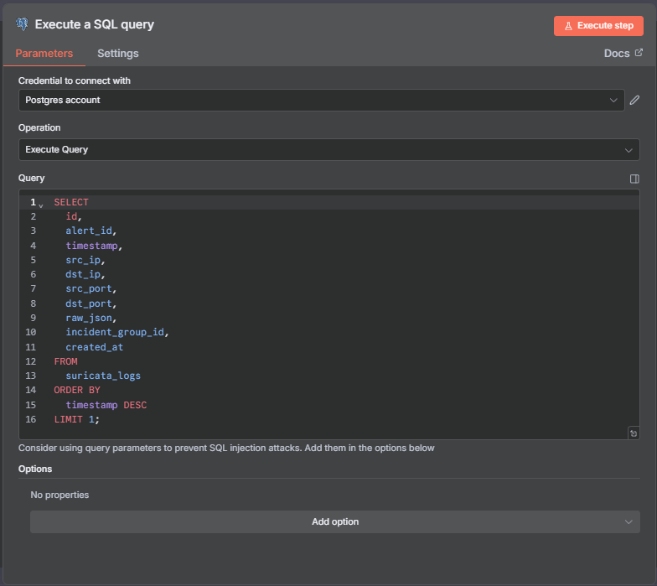
1 Postgres Query Node
Since the data in the database has already been digested (since Postgres is effective at parsing JSON data), it is easy to separate the data streams so that we can fetch extra enrichment information. First, the raw json must be turned from a json object to a string. This can be achieved using a ‘Edit Fields (Set)’ node set to manual mapping mode.
. 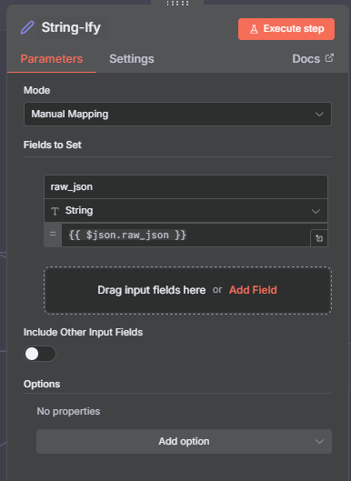
2 Edit Fields (Set) node.
The next data stream deals with doing the IP lookup. This is simply a HTTP Request node. Shown below is the configuration.
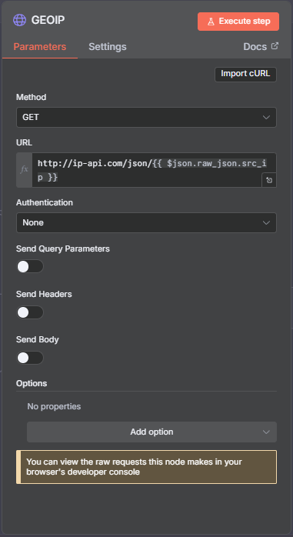
3 IP Lookup node
Lastly is the data stream for fetching CVE info. Since not every alert event may have a CVE attached, we need to use an If statement node.
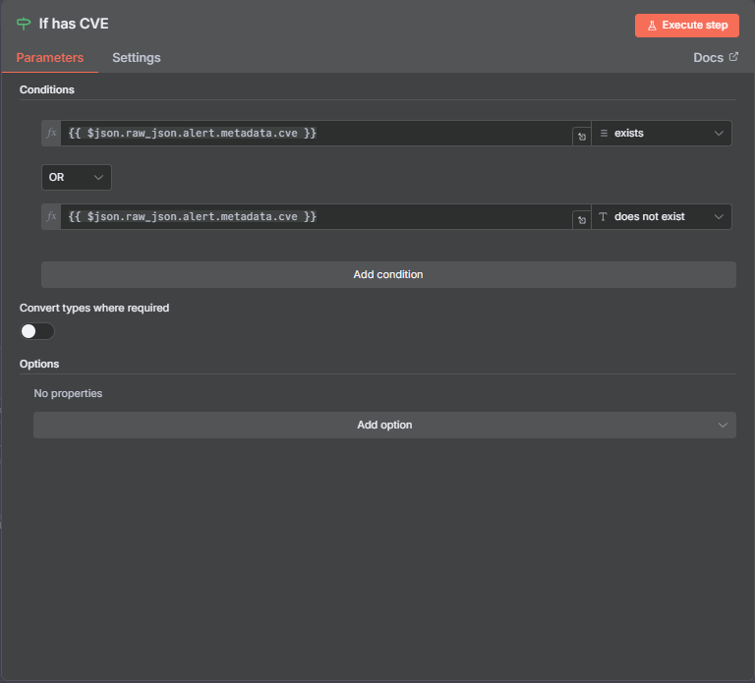
4 If Statement
By using the OR function, we can accommodate for situations where a CVE may not be present, where the workflow will simply send through an empty result, leading to an empty search query when fetching from the NVD API, which fails gracefully by producing a ‘null’ result and lets the workflow continue.
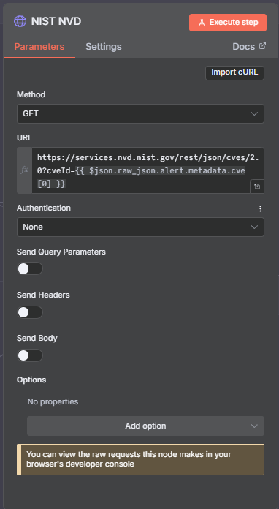
5 NIST NVD API HTTP Request Node
Now that the data streams are set up, we need to merge the streams. N8N allows for this by using a combination of Merge ‘Flow’ nodes, but in order to merge streams, a common key field is required. For this, we used the new ‘Data Tables’ feature in N8N, a feature that gives databases integrated into the N8N service. We used these similarly to how temp files are used in other programmes and applications, and found it to be the most effective way of solving the merged data streams problem. Data tables can be created from the home dashboard, set up only requiring you to add a column to pass the JSON objects into for merging. We have also made it so that once the LLM is done processing the data, the temp tables are cleared, reducing likelihood of a data leak (which is already low, as N8N sports robust security measures when implemented in a production setting [https, SSL based auth, etc]). Once all streams are merged, we can pass along the data to the LLM node. We used the OpenAI node for this demo (due to aforementioned compute restrictions), but the setup for Ollama is also similar, the only difference in being that a system prompt in the Ollama node is set up as an option instead of as an additional prompt as is in the OpenAI node.
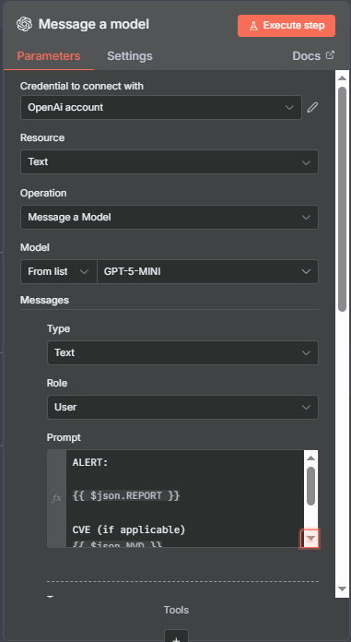
6 LLM Node Configuration; 1
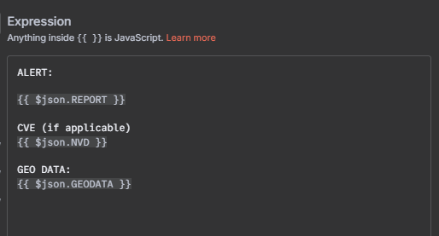
7 LLM Prompt
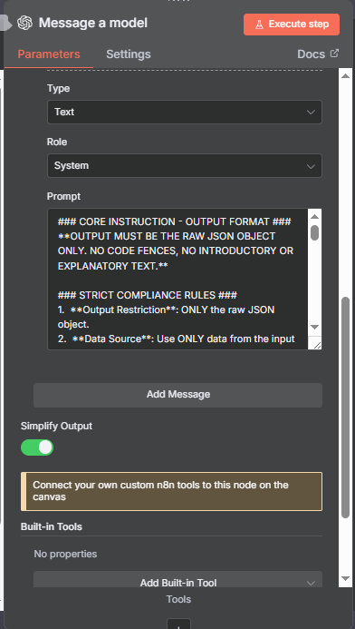
8 LLM Node Configuration; 2
Lastly is an HTTP Request node that sends a POST request to the Sentry dashboard using REST api, where the dashboard is hosted on the “WindowsHost” machine itself and not in docker, however it would be possible (and more production appropriate) to host it on a proper web server in docker (such as Apache or NGINX).
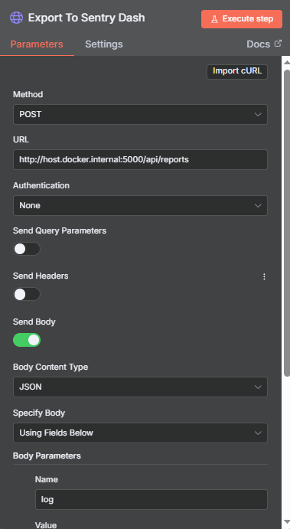
9 POST HTTP Request Node
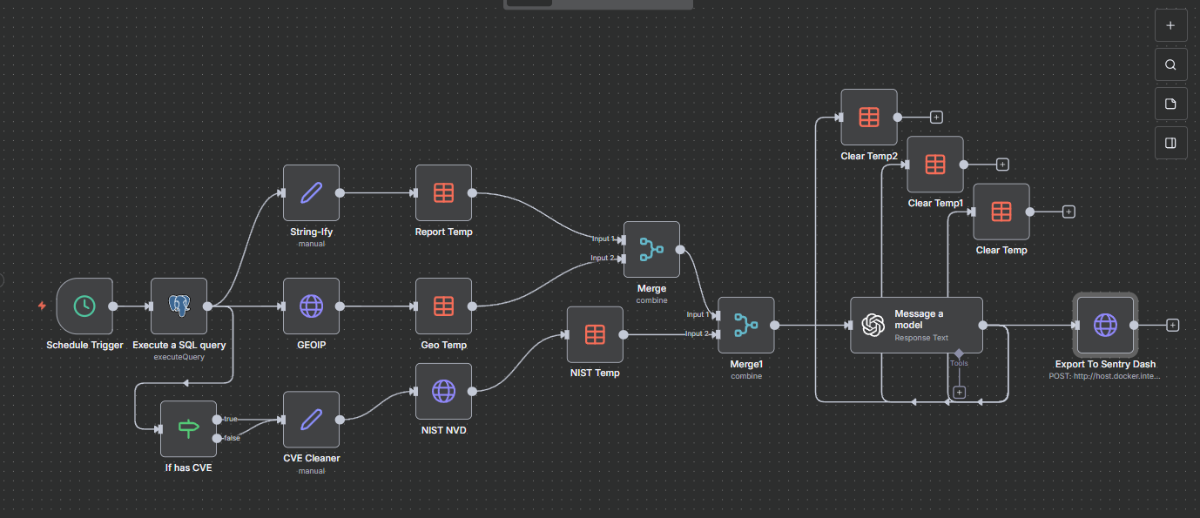
10 Final Workflow

THE DASHBOARD
The Sentry dashboard is a simple static HTML web app hosted locally using Python Flask. We opted for Python Flask as it is the simplest to use development server, although we recognise that this is not best practice, and it would be better to host the dashboard on a production ready web server. The script for the Flask web server and the HTML page itself has been submitted to the GitHub repository (along with the JSON store of the vulnerability reports we reproduced. Note that some of these were produced with sample Suricata alerts found online, since we were not able to reproduce the respective exploits).
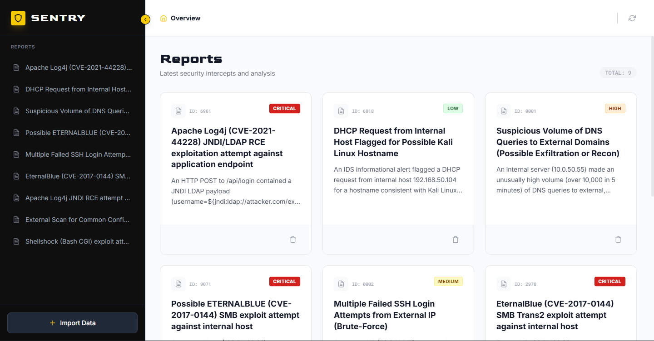
11 Sentry Dashboard

A query must be executed at least once to return the JSON object ‘blocks’ that we will be using in the rest of the nodes.

