THIS DOCUMENT FOLLOWS THE MAKING OF THE SENTRYSERVE1 VIRTUAL MACHINE, AND SHOULD NOT BE CONSIDERED A GUIDE TO DEPLOYING SENTRY OR ITS PARTS.
SentryServe1 is a virtual machine hosted in Hyper-V, running the Ubuntu Server 24.04.3 operating system. The VM is connected to my physical network by using a bridged (external) adapter. VM will also have an additional adapter for its own network (which clients will connect to. Think of it as a dual port router, one port for ‘WAN’ and one for LAN). This VM is going to be hosting the instances of:
- Suricata
- N8n
NOTE: n8n instance could possibly run on a different machine, but I left both to run on one machine to reduce ‘wiring’
It will also be serving the purpose of a network’s router + firewall, so it will also have the typical functions of ip routing, dhcp server, ufw, etc
It uses a static IP via DHCP reservation as I found that to be easiest. Security settings are mostly defaults, not edited since Linux is fairly secure by nature.
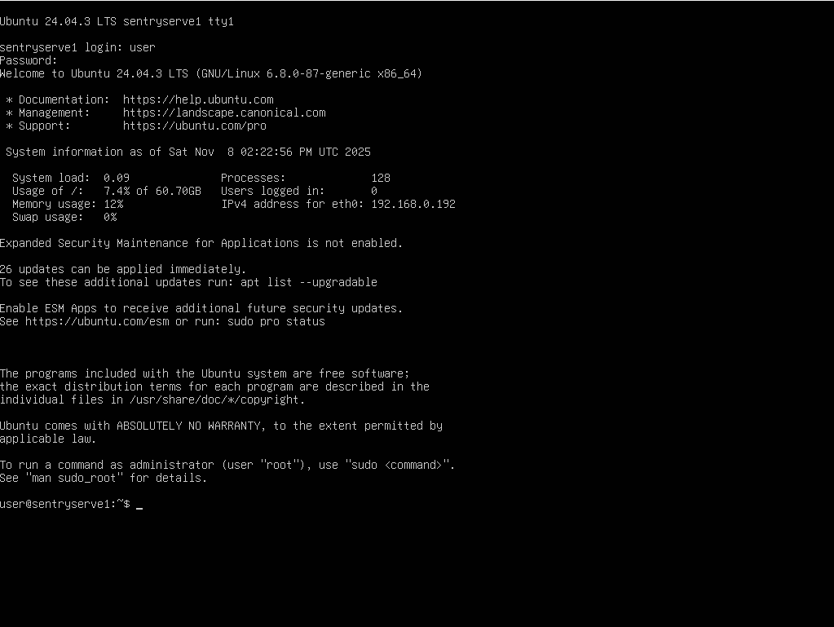
1 Initial Server Setup
INSTALLING DOCKER APPLICATIONS
Opted to run n8n instance in Docker since that’s the recommended way, and also is highly reproducible. Also installed Portainer to manage Docker containers in a GUI environment, using the Docker Compose file made by Portainer (found in their documentation - https://docs.portainer.io/start/install-ce/server/docker/linux#docker-compose).
Commands:
- sudo apt install -y docker.io docker-compose
- sudo docker pull portainer/portainer-ce:lts
- sudo docker compose up -d
- sudo docker pull n8nio/n8n
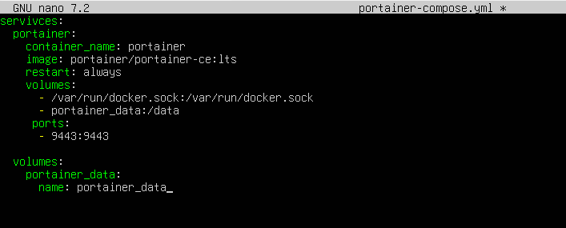
2 Portainer Compose yml
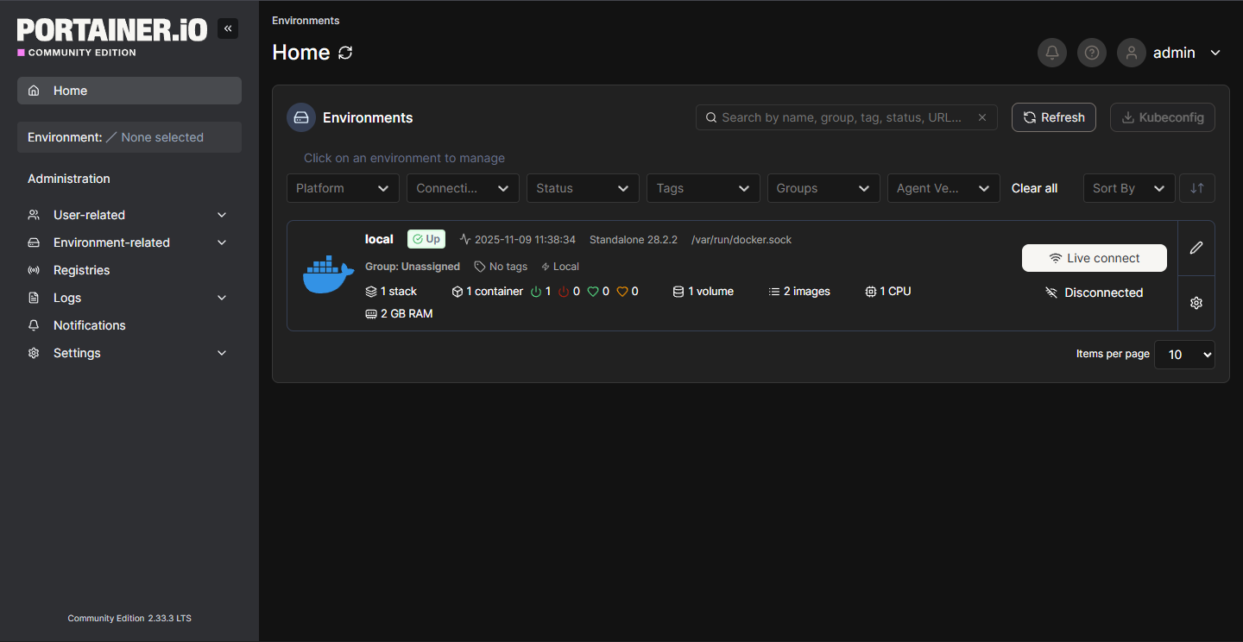
3 Portainer Running

Using docker compose for n8n as well so that I can create and mount volumes. Suricata IDS logs will be going here/will mount suricata log folder to container through compose file (the latter is preferred since it is probably best practice).
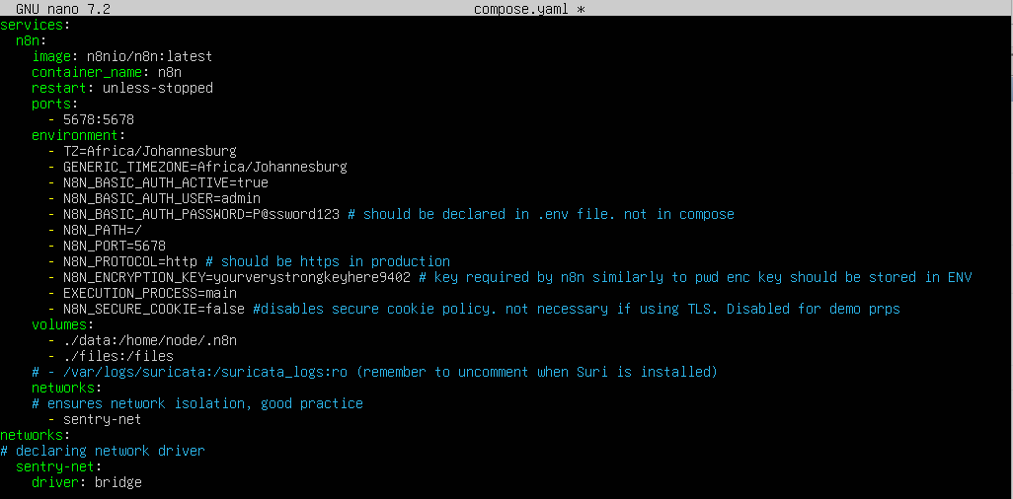
4 N8N Compose File

Must run ‘sudo chown -R 1000:1000 ./data’ so that n8n is able to modify data in the data folder.
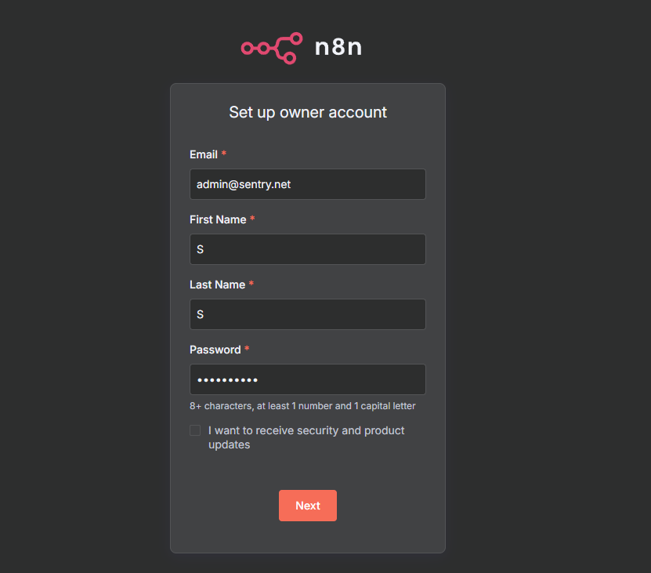
5 N8N First Time Setup
On the home screen, ill navigate to credentials to add the Ollama account we’ll be using for the n8n workflow. The ollama service is running on my physical machine (since ollama is compute intensive and I don’t want to run it in a VM or container).
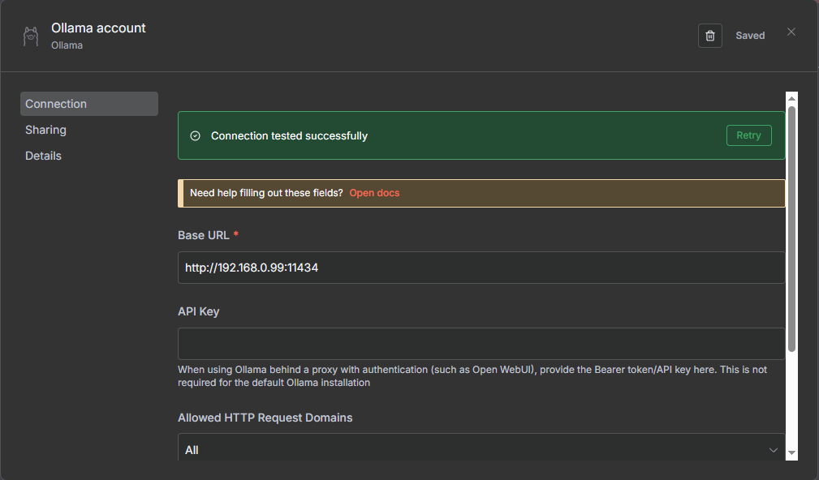
6 Adding the Ollama Credential

Now that n8n is set up, I need to start on configuring the ‘router’ functionality of the vm. The two net adapters are working like this:
- eth0 = 192.168.0.192
- eth1 = 192.168.5.1
eth1 will NAT traffic in the 192.168.5 LAN segment and forward it to the 192.168.0 LAN segment, from where it will go to my physical router
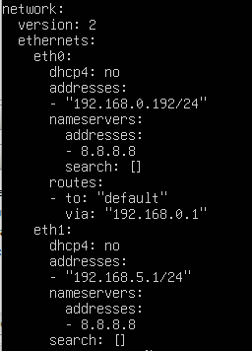
7 Netplan Config
I now need to enable ip forawarding, and configure NAT/Masquerade. IP forwarding is a kernel feature so I’ll find it in sysctl.conf
Commands:
- sudo nano /etc/sysctl.conf
- sudo sysctl -p (after making the change to the sysctl.conf file)
I’ll only be doing ipv4 so I’ll uncomment that line only.
I’ll add NAT rules using iptables
- sudo iptables -t nat -A POSTROUTING -o eth0 -j MASQUERADE
- sudo iptables -A FORWARD -i eth1 -o eth0 -j ACCEPT
- sudo iptables -A FORWARD -i eth0 -o eth1 -m state --state ESTABLISHED,RELATED -j ACCEPT
iptables rules are lost on reboot so I need to make them persistent. I’ll do this using the iptables-persistent package
- sudo apt install -y iptables-persistent
- sudo netfilter-persistent save (saves changes to ipv4 settings persistently)
For the actual DHCP server functionality I’ll be using ISC DHCP Server
- sudo apt install -y isc-dhcp-server
- sudo nano /etc/dhcp/dhcpd.conf (to edit the dhcp config)
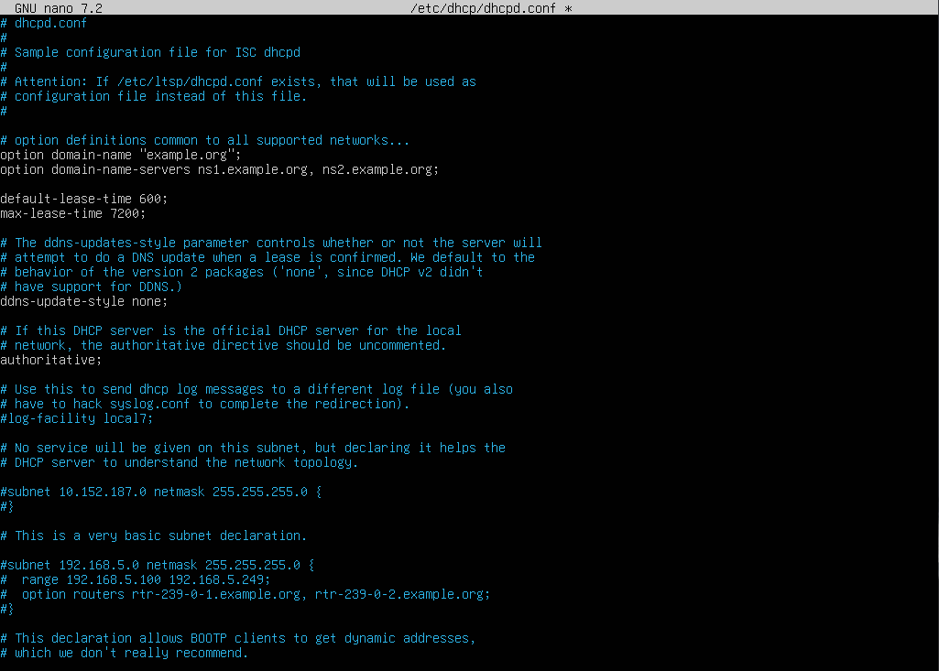
8 DHCPd config; 1
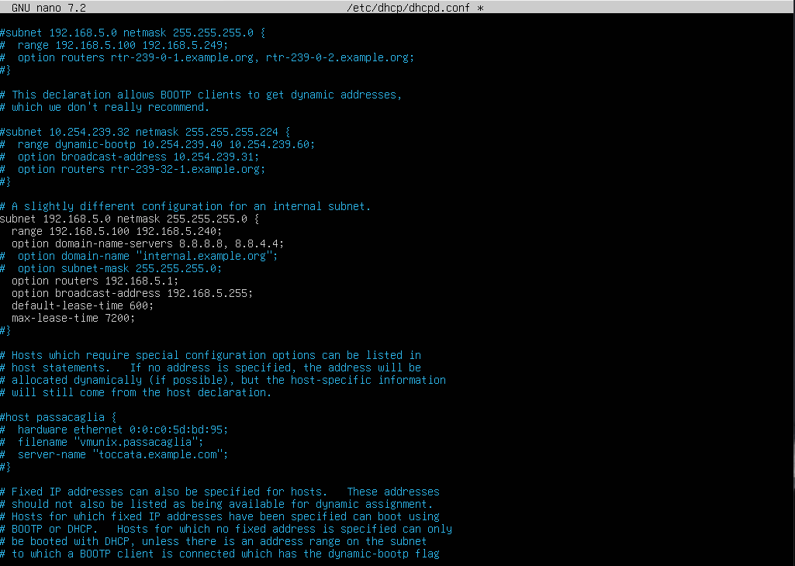
9 DHCPd config; 2
Next, I need to edit which interface ISC DHCP is active on by using:
- sudo nano /etc/default/isc-dhcp-server
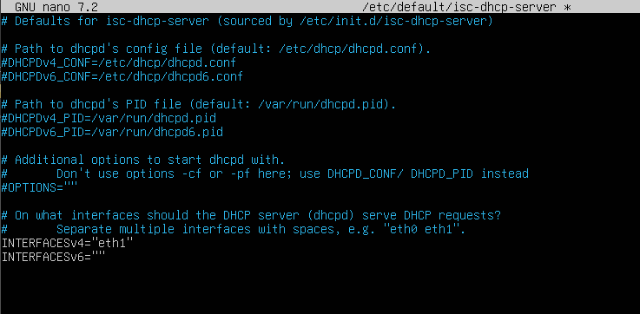
10 Interface Config
Use:
- sudo systemctl restart isc-dhcp-server
to start the DHCP server.
Also run:
- sudo systemctl enable isc-dhcp-server
so that the dhcp service runs on boot.
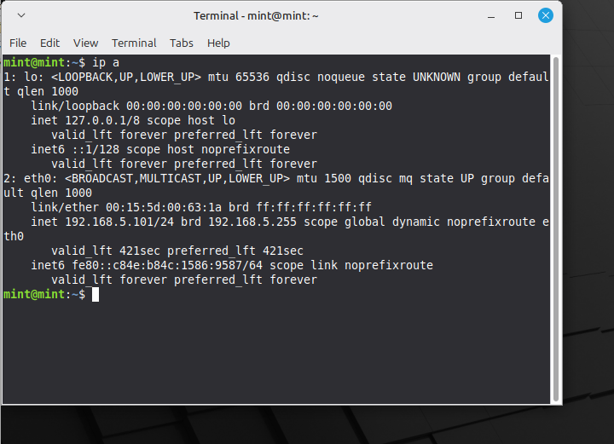
11 DHCP Working on A Linux Mint Client
AFTER EXTENSIVE TRYING TO MAKE INTERNET ACCESS WORK, I HAVE DECIDED TO SCRAP THIS AND BEGIN AGAIN FROM SCRATCH. SEE: SENTRYSERVE2

I missed to uncomment the closing curly bracket in the subnet portion. Corrected error but not documented.

