THIS DOCUMENT FOLLOWS THE MAKING OF THE SENTRYSERVE2 VIRTUAL MACHINE, AND SHOULD NOT BE CONSIDERED A GUIDE TO DEPLOYING SENTRY OR ITS PARTS.

Hyper-V Configuration
Two switches will be used.
- ‘WAN Switch’: External type network bridged to physical adaptor (Subnet: 192.168.0.0/24)
- ‘LAN Switch’: Internal type network switch for communication between server and clients. Will later be given an IP in network and sharing centre on host machine. (Subnet: 192.168.50.0/24)
Virtual Processors: 2
RAM allocation: 2048MB

Installed Ubuntu Server 24.03 as normal. Installed OpenSSH for easier management and a better terminal experience.
Making Server into a Gateway
The reason for adding router functionality is so that the lab setting is more realistic. In a production setting, it is likely that the router and firewall are two different devices, and in this case only the firewall would have to be set up with the Sentry workflow.
First, I’ll need to configure the interfaces. I’ll do this in the netplan config.
Command: sudo nano /etc/netplan/*.yaml
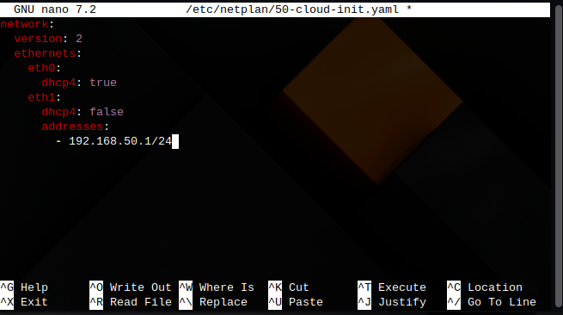
1 Netplan Interface Configuration
Then I need to enable IP forwarding, and NAT masquerading.
Commands:
- sudo nano /etc/sysctl.conf (to enable IP forwarding, uncomment net.ipv4.ip_forward=1)
  - sudo sysctl -p (to save and apply)
- sudo iptables -t nat -A POSTROUTING -o eth0 -j MASQUERADE
- sudo apt install iptables-persistent (allows iptables rules to be made permanent)
- sudo netfilter-persistent save (saves iptables rules)
To set up DHCP, this time I will use DNSMasq as it is simpler and more straightforward to setup.
Commands:
- sudo apt install dnsmasq
- sudo mv /etc/dnsmasq.conf /etc/dnsmasq.conf.bak (making a backup of the original config. Good practice)
- sudo nano /etc/dnsmasq.conf
- sudo systemctl restart dnsmasq (starting the dnsmasq service)
- sudo systemctl enable dnsmasq (enables start on boot)

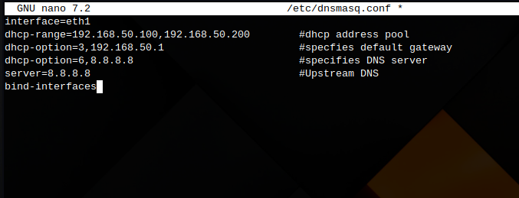
2 DNSMasq Configuration
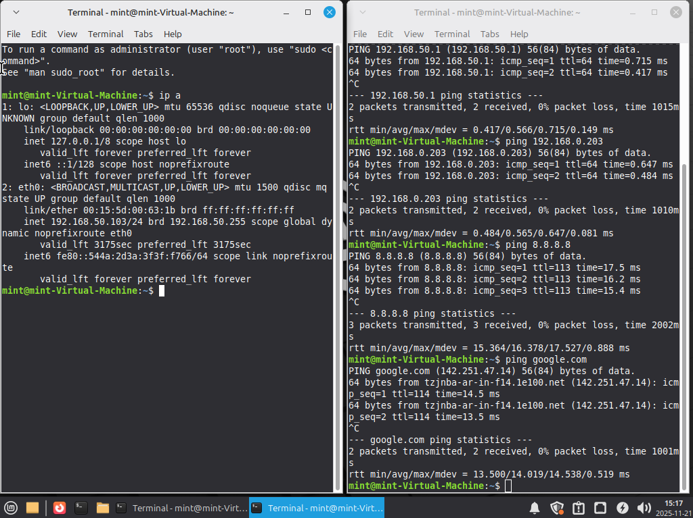
3 Client Successfully acquires IP Address and Internet Connection

INSTALLING AND CONFIGURING SURICATA
I can finally install Suricata, by using the following commands,
- sudo add-apt-repository ppa:oisf/suricata-stable (to add the repository)
- sudo apt update
- sudo apt install suricata
Next, I need to configure the interfaces.
Commands:
- sudo nano /etc/suricata/suricata.yaml
In the config file I need to find the ‘af-packet’ section, where you can pick which interface Suricata will read traffic on. This will get changed to ‘eth1’, which is the ‘LAN’ interface. Next I need to load the rules that Suricata will use.
Commands:
- sudo suricata-update
This command will download and unpack the ‘Emerging Threats Open’ ruleset.
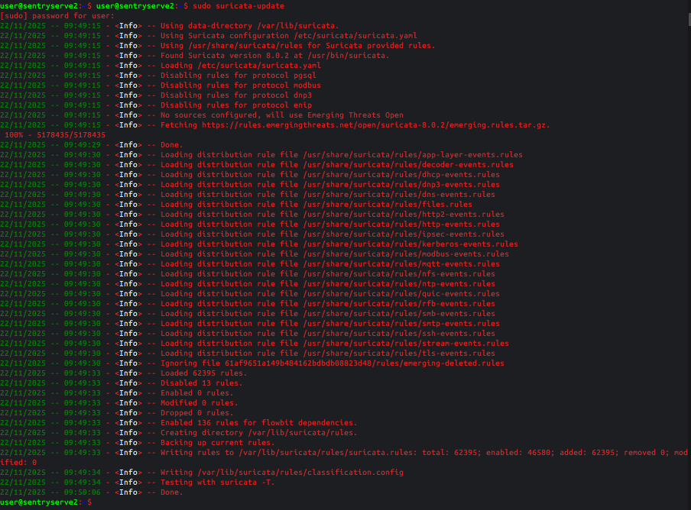
4 Loading the Ruleset
Once the rules are downloaded, may need to point to the rules file in the config.
Command:
- sudo nano /etc/suricata/suricata.yaml
Scroll down to the ‘rule-files:’ section and add the file path. It is already there by default.
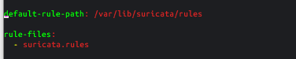
5 Rule path
Suricata needs to be restarted with systemctl once rules are loaded.

To test that Suricata is working, I have a Kali machine connected to the LAN network. We can tail the ‘fast.log’ file in /var/log/suricata to see the alert, and use curl in Kali to test.
Commands:
- sudo tail -f /var/log/suricata/fast.log
- curl http://testmynids.org/uid/index.html (sends back a uid tag that looks like a root command)
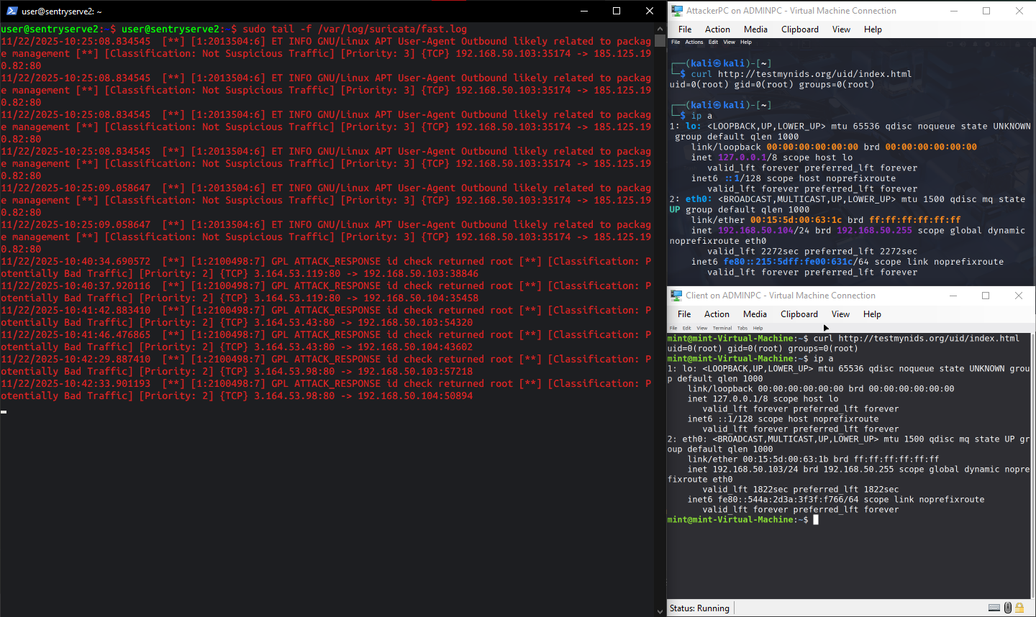
6 Verifying Suricata is working

DEPLOYING N8N
Even though the recommended method of deploying n8n is to do so via Docker, I will opt for a native installation for SentryServe2 since a native install will mitigate the possibilities of new networking issues, Docker’s NAT related issues (which are surprisingly common), and possible iptables rule issues. Native n8n deployements require NPM (Node Package Manager). For that I will run:
Commands:
- sudo apt install npm
- curl -o- https://raw.githubusercontent.com/nvm-sh/nvm/v0.39.7/install.sh | bash (installs Node version manager)
- sudo npm install n8n -g
- nvm install –lts (installs latest version of NodeJS)
- export N8N_HOST="0.0.0.0" && export N8N_LISTEN_ADDRESS="0.0.0.0" (sets N8N environment variables)
- sudo iptables -I INPUT -p tcp --dport 5678 -j ACCEPT (firewall exception)
- sudo netfilter-persistent save (saves firewall rule)
- n8n (runs the n8n instance)

I cannot figure out why N8N does not work, therefore, this part of the server will instead be ran on the same machine running Ollama, i.e. the Windows Host.
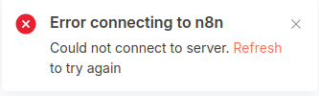
7 Error Message

New course of action: Run N8N on Windows Host machine. SentryServe2 will remain in place, since Suricata is running on it. A log shipper will send logs from SentryServe2 to WindowsHost’s N8N instance.

LOGSHIPPER: PYTHON MICROSERVICE
Since the microservice for shipping logs to WindowsHost uses Python, I need to install the dependencies:
- sudo apt update
- sudo apt install python3-full python3-venv
- mkdir ~/logpusher && cd ~/logpusher
- python3 -m venv ~/sentryenv (not required anymore)
- Permissions Commands:
  - sudo groupadd suricata-readers
  - sudo usermod -a -G suricata-readers $USER
  - sudo chgrp suricata-readers /var/log/suricata/eve.json
  - sudo chmod g+r /var/log/suricata/eve.json
  - sudo chgrp suricata-readers /var/log/suricata/
  - sudo chgrp suricata-readers /var/log/suricata/eve.json
  - sudo chmod g+rx /var/log/suricata/
  - sudo chmod g+r /var/log/suricata/eve.json
- source ~/sentryenv/bin/activate (activates virtual environment)
- sudo apt install python3-psycopg2 python3-watchdog
python file added to repository.
Need to remove constraint from DB to allow incident grouping.
- docker exec -it postgres psql -U admin -d sentry_db
- ALTER TABLE suricata_logs DROP CONSTRAINT suricata_logs_alert_id_key;
Making it a system service:
- sudo nano /etc/systemd/system/logparser.service (makes the system file)
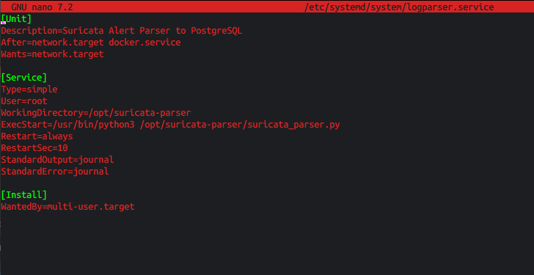
- sudo mkdir -p /opt/logparser
- sudo cp logparser.py /opt/logparser/
- sudo chmod +x /opt/logparser/logparser.py
- sudo systemctl daemon-reload
- sudo systemctl enable logparser
- sudo systemctl start logparser
The JSON objects from eve.json are now being shipped to postgres.

