THIS DOCUMENT FOLLOWS THE SET UP OF THE ‘WINDOWSHOST’ SYSTEM, AND SHOULD NOT BE CONSIDERED A GUIDE TO DEPLOYING SENTRY OR ITS PARTS.

AdminPC, or ‘WindowsHost’ (as it will be referred to further) is the host system for the Sentry project as a whole. It is running Windows 10 Professional. As mentioned in the SentryServe1 and SentryServe2 documents, it is running Hyper-V as well so that I can set up the virtual environments.

INSTALLING OLLAMA
Ollama can easily be installed from the website (https://ollama.com/download/windows), and can be downloaded and installed like any other windows application.
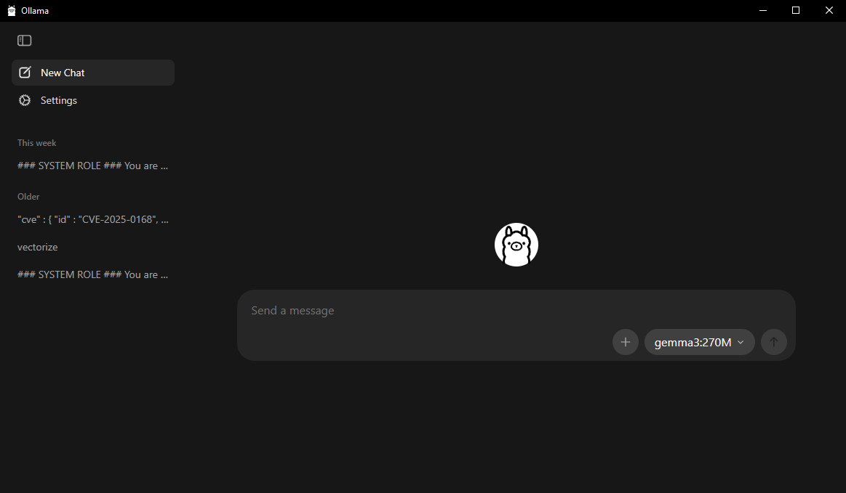
1 Ollama Intereface
The only setup that must be done for ollama is that it must be exposed to the network. This can just be done through the gui, in the settings menu.
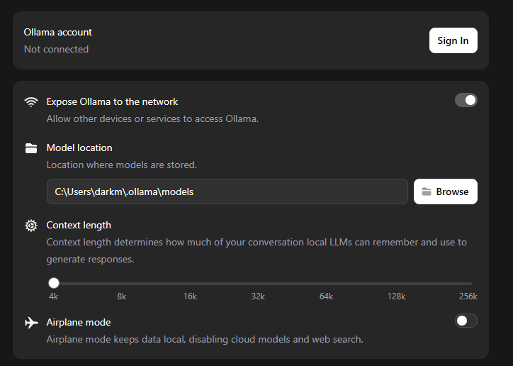
2 Exposing Ollama to the Network

DEPLOYING N8N IN DOCKER DESKTOP
Docker Desktop is a version of Docker made for Windows and Mac which makes it easy to pull, configure and deploy docker containers. The desktop installation is fairly straightforward and can be found on the docker website. The only dependencies for Docker Desktop on Windows is enabling Hyper-V and WSL2. I will be using a Docker-Compose file.
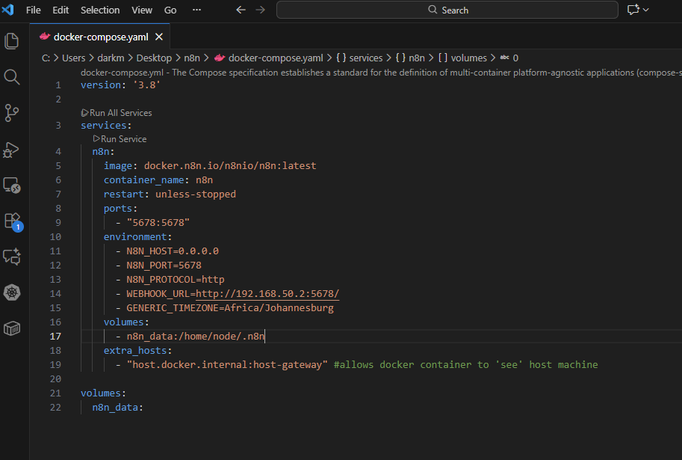
3 Compose File
Docker Desktop has a built in terminal, which I will use for convenience.
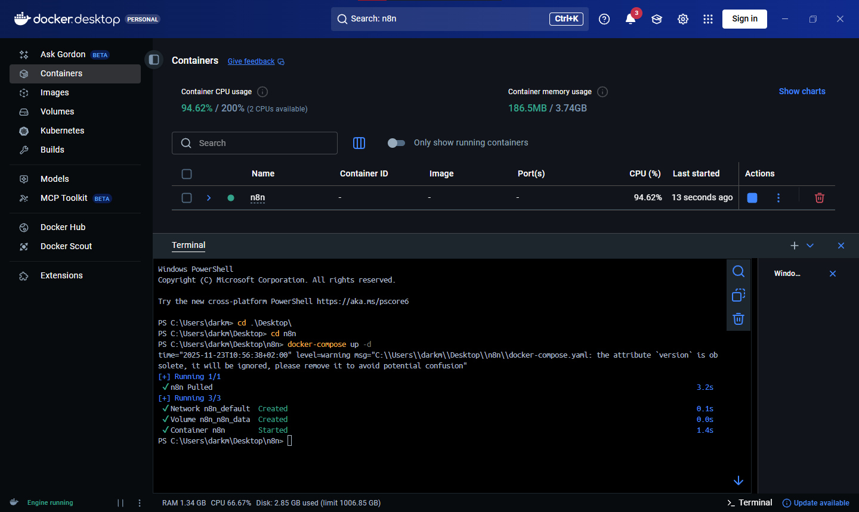
4 n8n running in Docker Desktop
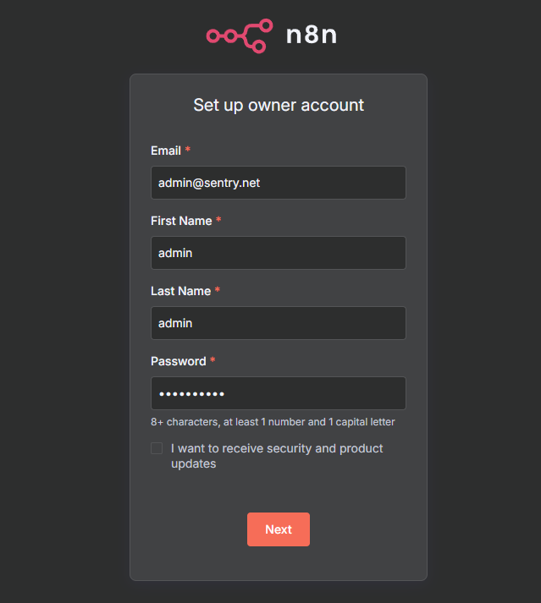
5 N8N First Login Screen
I’ll fill this form with placeholder information (note to self: password=Frosted11!)
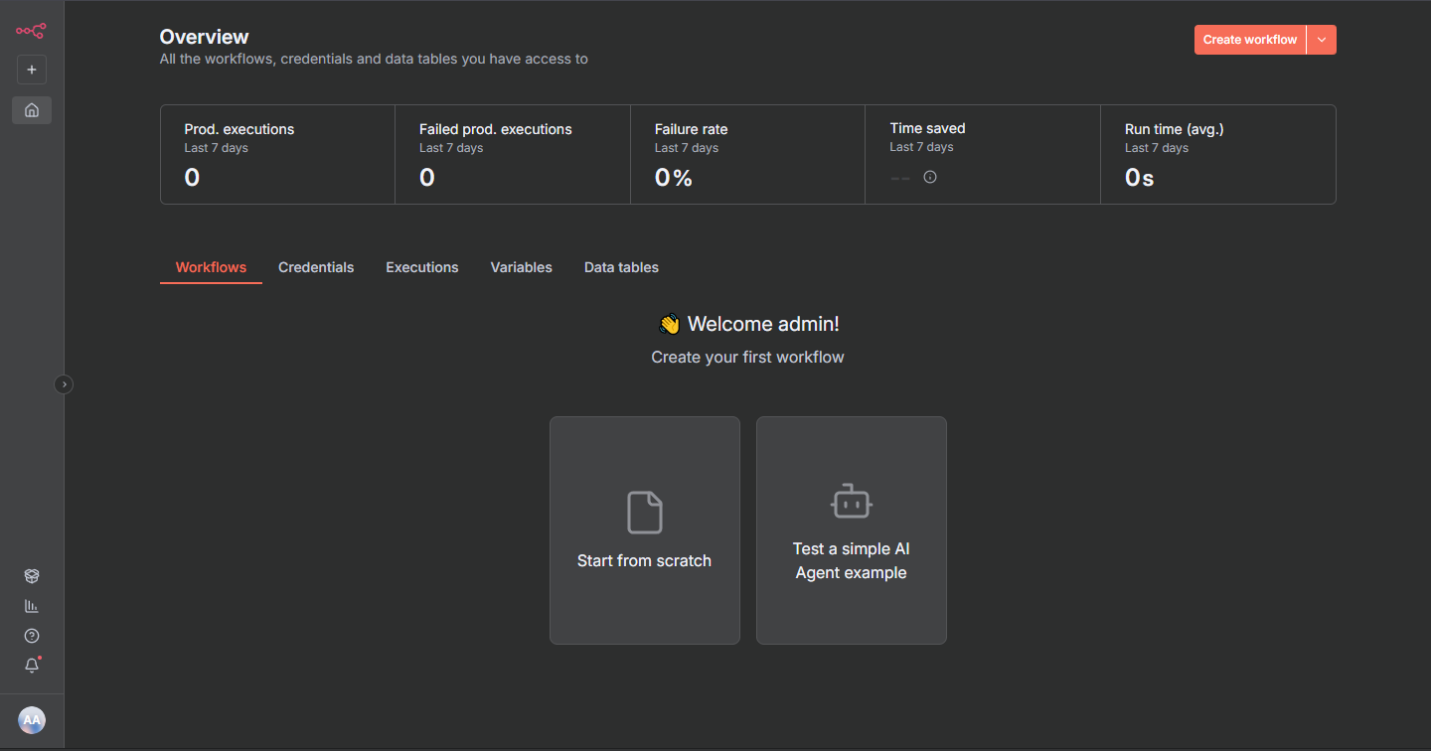
6 N8N Interface
To add the Ollama instance to the workflow, I’ll add the credential in the ‘Credentials’ tab. I can search for the ‘Ollama’ app in the search bar then I can add the details.
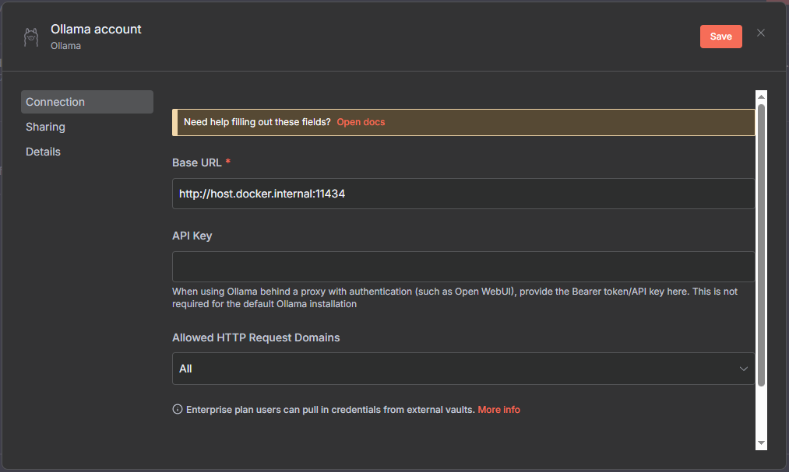
7 Adding Ollama Credential
A CRUCIAL part of the set up is that the base URL MUST be ‘host.docker.internal’, since localhost will point to the container itself. Once that is done, I can press save.
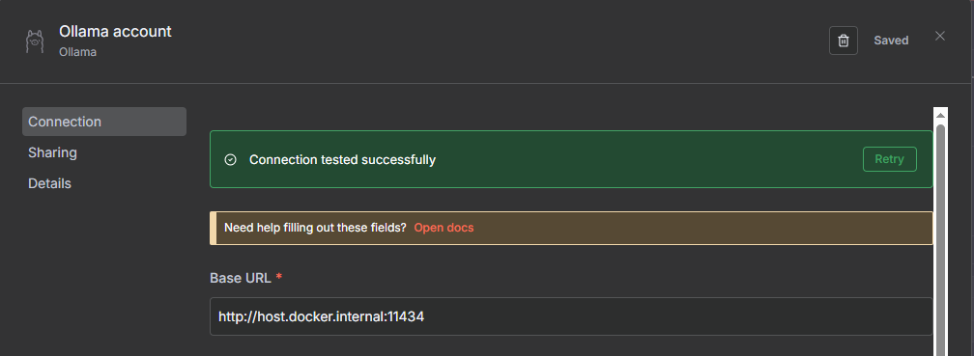
8 N8N Successfully Interfaced With Ollama
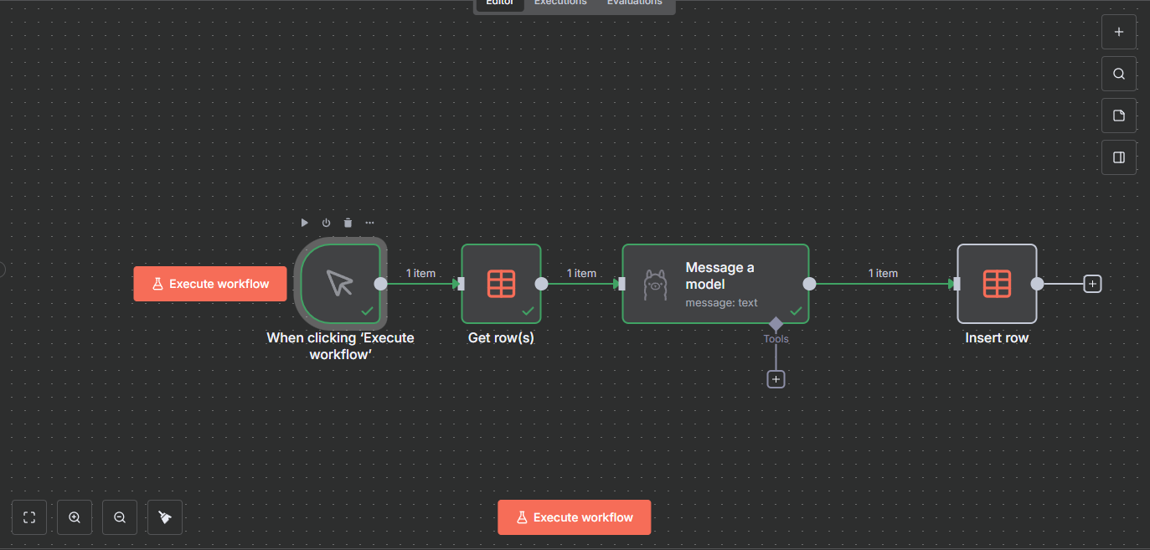
9 A demo workflow in N8N
Above is a workflow that I have made to verify the functionality of n8n. When the workflow is executed, N8N fetches data from a data table (in this case, I have loaded a sample suricata log into the data table), passes it to the Ollama node, which sends the log to Ollama along with a system prompt instructing it its role and instructions. Ollama then parses the log and outputs JSON code, which gets sent to another data table.
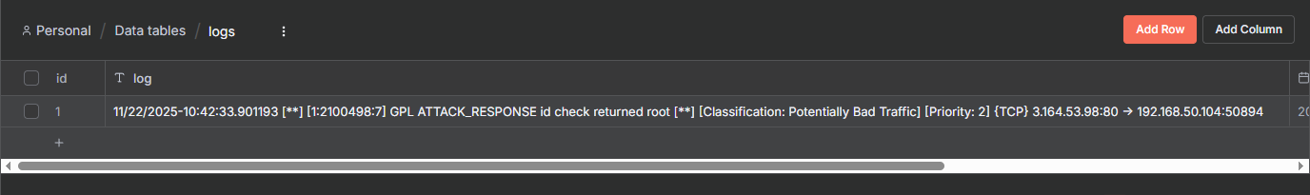
10 Logs Data Table
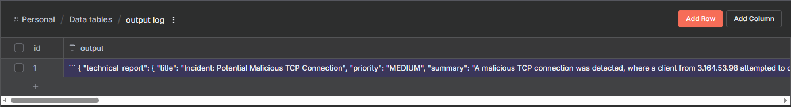
11 Output Log Data Table

Once the project is fully configured this process will be automated.

SOLUTION FOR RECEIVING LOGS FROM SENTRYSERVE2
In order to receive logs, I will be using a simple workflow as follows:
SentryServe2: Logshipper >> WindowsHost >> Python script running on WH parses logs >> Send parsed and/or aggregated logs to PostgreSQL Database >> N8N interfaces with PostgreSQL DB hosted on WH >> N8N fetches enrichment data (geoip, whois, etc) and Ollama model able to read from PostgreSQL DB

First, I will deploy PostgreSQL. This will be done in Docker, using Docker Compose.
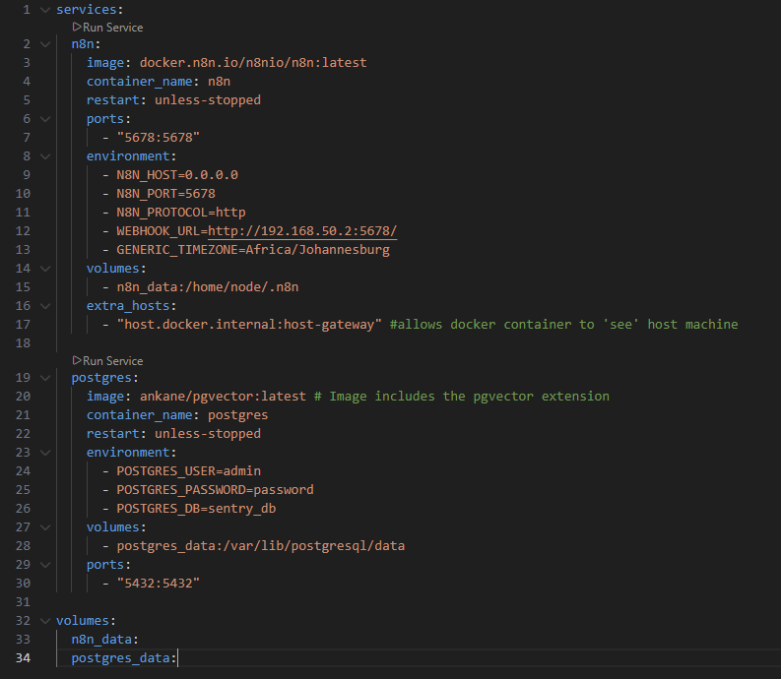
12 Compose File with PostgreSQL

Once the containers are up we need to configure the database which will be done through the terminal (i.e. PowerShell). I’ll connect to the container with the following command
- docker exec -it postgres psql -U admin sentry_db
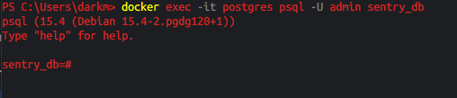
13 In PostgreSQL

- CREATE TABLE suricata_logs ( id SERIAL PRIMARY KEY, alert_id VARCHAR(50) UNIQUE, timestamp TIMESTAMP WITH TIME ZONE, src_ip INET, dst_ip INET, src_port INTEGER, dst_port INTEGER, raw_json JSONB NOT NULL, incident_group_id UUID, created_at TIMESTAMP WITH TIME ZONE DEFAULT NOW() ); (creates the tables for suricata logs)

- CREATE TABLE security_knowledge ( id SERIAL PRIMARY KEY, title TEXT, content TEXT NOT NULL, source_url TEXT, embedding VECTOR(512) ); (dimensions set to 512, a good balance for the embeddinggemma:306M model I have chosen) (No Need to make vector store. RAG not used in final workflow)

- sql\q (exits PostgreSQL interface)

PYTHON LOGSHIPPER
Python script uploaded to github repository.
CREATING THE N8N WORKFLOW. CONTINUED IN DOCUMENT: MAKINGOFSENTRYFLOW.DOCX

Why we didn’t use RAG: Vectorising data is compute intensive, therefore, we opted to use live data fetching and injecting the fetched data into the LLM prompt using N8N.

