In order for the code to work properly you need to set up a few things first:

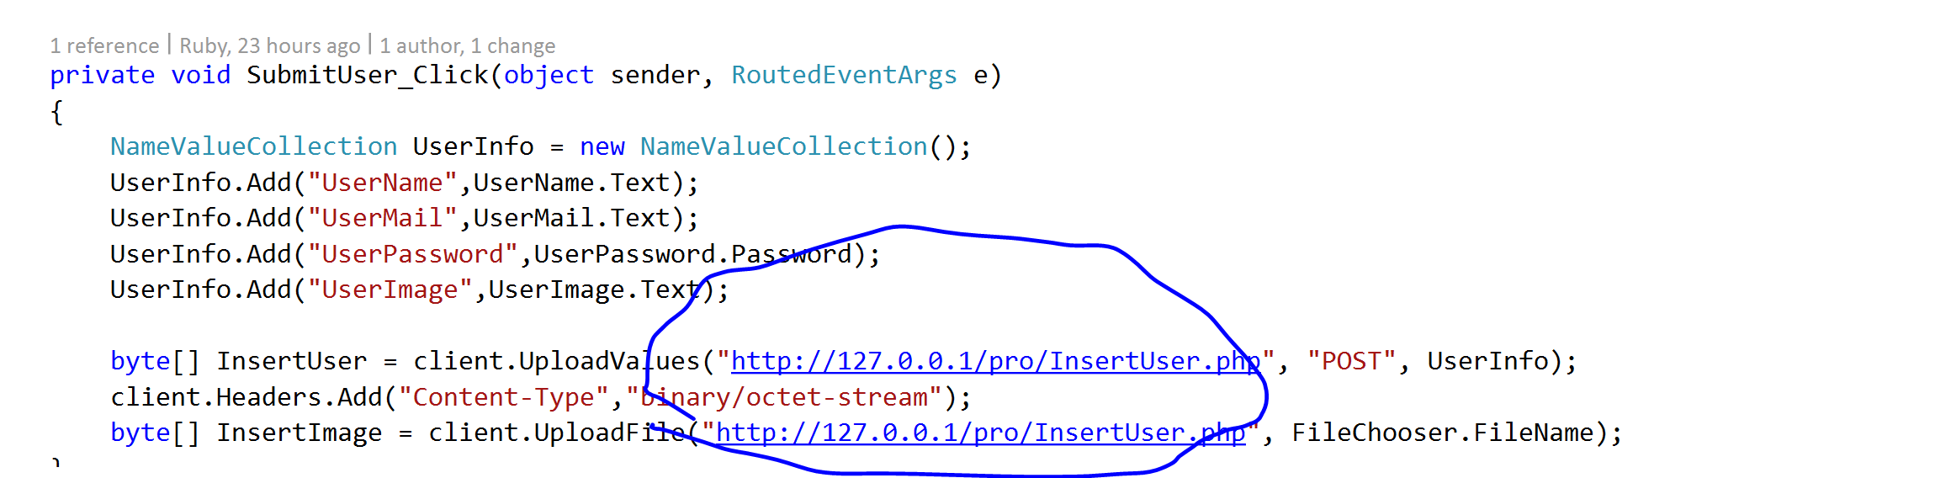

Make sure that this address is where your php files are located , this is the way we send the request to our php.

2.

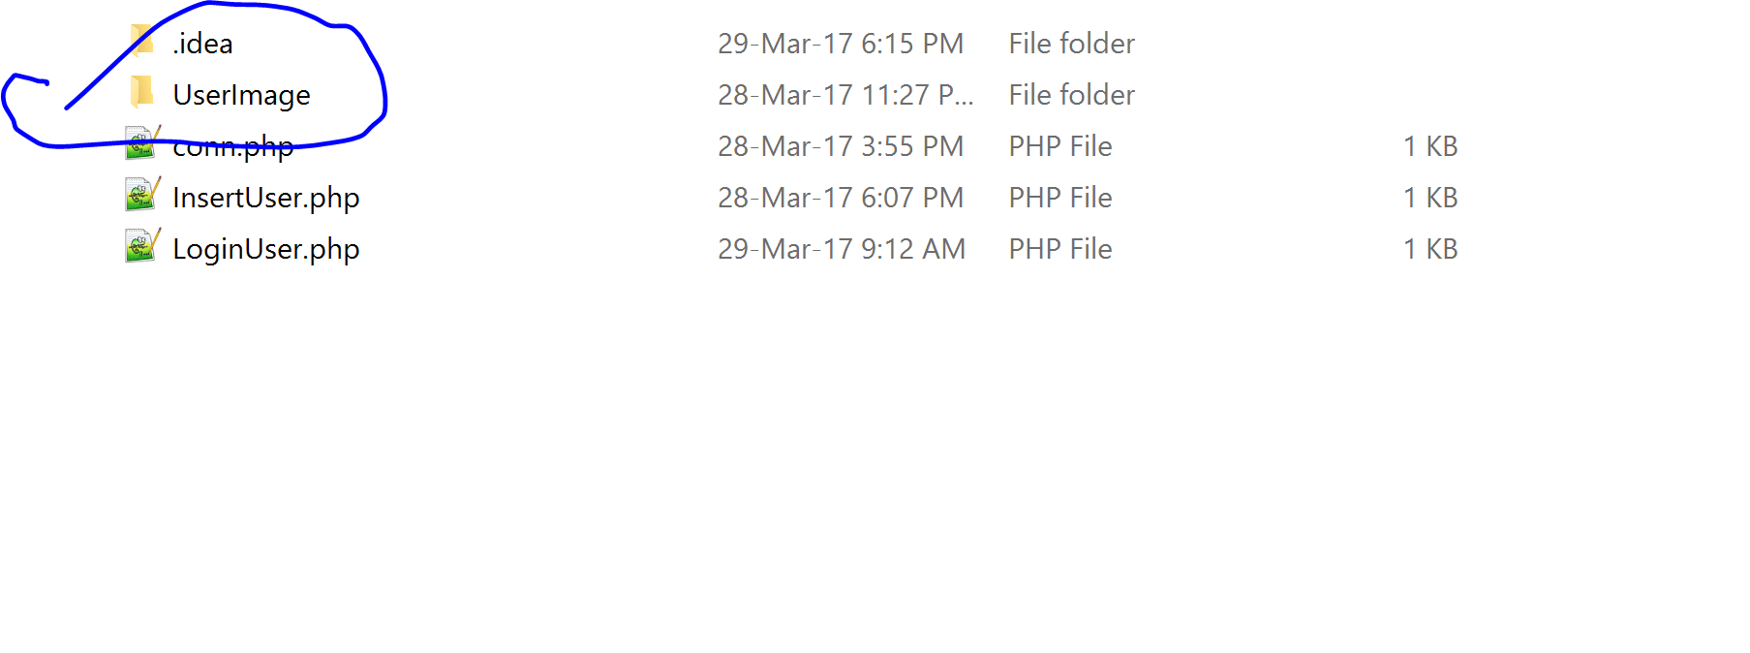

Make sure you open a new file named” UserImage” where your php is located. (this is for saving all the users pictures).