

NORTH SOUTH UNIVERSITY

CSE 327

Project Report

Project Topic: Online Booking System

Section: 04

**Submitted By:**

* Shaon Kumar Das (1812613042)
* Pinaki Ranjan Das (1813087642)
* Abdul Hannan Anik (1812091042)

**Submitted To:**

A K M Bahalul Haque (ABH3)

**GitHub Link**: <https://github.com/Project-TripzoBD/TripzoBD>

Table of Contents

|  |  |
| --- | --- |
| **CONTENT** | **Page No:** |
| Introduction | 03 |
| 01: Project Description  1.1: Project Overview  1.2: The purpose of the project  1.3: Goals of the Project | 03-04 |
| 02: Requirements  2.1: Functional Requirements  2.2: Non-Functional Requirements  2.3: Performance Requirements  2.4: Security Requirements | 04-05 |
| 03: Activities  3.1: User Activities  3.2: Admin Activities | 05 |
| 04: Designs  4.1: Use Case Diagram  4.2: Sequence Diagram  4.3: Class Diagram | 06-10 |
| 05: Development  5.1: User Application  5.2: Admin Application | 11-15 |
| 06: Testing | 15-17 |
| Conclusion | 18 |
| References | 18 |

**Introduction**

An Online Reservation System is a software you can use for managing reservations for your service. Basically, an online reservation system allows a potential customer to book and pay for a service directly through an app or website. That means from the moment a customer decides they want to book a slot for your service to choosing a date, picking a time, and paying for the booking and everything is handled online! It greatly reduces the workload on your staff and removes the opportunity for double bookings.

We know that mobile applications are very important in every aspect of human endeavour. Mobile and mobile applications have made our lives a lot easier. In this project we have developed an Online booking system using Android. The Online Booking System is an Android application that allows user check ticket availability, buy ticket and pay via online. But now we are able to complete the bus ticket booking system. In future we will extend our project and we will add hotel booking, flight ticket booking, and tour package. This system is an online bus ticket reservation system established for all home / office users. Users can use this system to make online bus ticket reservations via the Internet. Users can be use this program directly on their mobile after install it.

**Project Description**

**1.1: Project Overview:**

We have developed an Online booking system using Android. But now we are able to complete the bus ticket booking system. In future we will extend our project and we will add hotel booking, flight ticket booking, and tour package. In this project, the Passenger can books tickets, and pay through online. We have tried to make the project very easy so that people can use it easily. This project have a simple login system and easy payment method.

**1.2: The Purpose of the Project:**

We now live in a world where almost everything is practically inseparable from the internet, businesses topping the list. It's now crucial that every business has a recognizable online presence, no matter its sector. Not only does modern technology help businesses get found online, but it also helps them easily convert visits into revenue through an online booking system. A booking system can help you do way more than just passively accept bookings and payments online. Reservation technology has evolved to the point that it’s become a central hub for managing every aspect of your business, from marketing to distribution to operations. We have done this project keeping in mind the welfare of the people.

**1.3: Goals of the Project:**

Our main goal is for people to be able to book tickets at home. In future we will make more responsive UI, protect it by our own security and enhance security. We will extend our project and we will add hotel booking, flight ticket booking, and tour package in one app. People can enjoy all kind of booking in one app and will be helpful for everyone.

**Requirements**

**2.1: Functional Requirements:**

Functional requirements define the specific functions that the system performs, along with the data operated on by the functions. The functional requirements are presented in scenarios that depict an operational system from the perspective of its end users. Included are one or more examples of all system features and an enumeration of all the specific requirements associated with these features.

* The system shall incorporate mechanism to authenticate its users.
* The system shall verify and validate all user input and should notify in case of error detection and should help the user in error correction.
* The system shall allow sharing of files in the system.
* The system shall allow quick messages to be exchanged without face-to-face interaction.

**2.2: Non-Functional Requirement:**

Non-functional requirements address aspects of the system other than the specific functions it performs. These aspects include system performance, costs, and such general system characteristics as reliability, security, and portability. The non-functional requirements also address aspects of the system development process and operational personnel.

* The system shall be user friendly and consistent.
* The system shall provide attractive graphical interface for the user.
* The system shall allow developer access to installed environment.
* The system shall target customer base.

**2.3: Performance Requirements:**

Performance requirements typically comprise a set of criteria which stipulate how things should perform or the standards that they must achieve in a specific set of circumstances.

* The system shall a fast opening.
* The system shall light weight.
* The system shall bug free.

**2.4: Security Requirements:**

A security requirement is a goal set out for an application at its inception. Every application fits a need or a requirement.

* The system shall safe personal data.
* The system shall secure payment.
* The system shall two step verification.

**Activities**

**3.1 User Activities**

The most common activities carried out by user are illustrated bellow:

* The user can search for the seat.
* The user can sign up/do registration with the system.
* The registered user can login to the proposed system.
* The user can check for the available seat.
* The user can also do payment for the seat on the proposed system.
* The user can print ticket on the system.

**3.2 Admin Activities**

* The administrator can add Bus Company.
* The administrator can add schedule.
* The administrator can add fare.
* The administrator can send notification.

**Designs**

**4.1: Use Case Diagram**

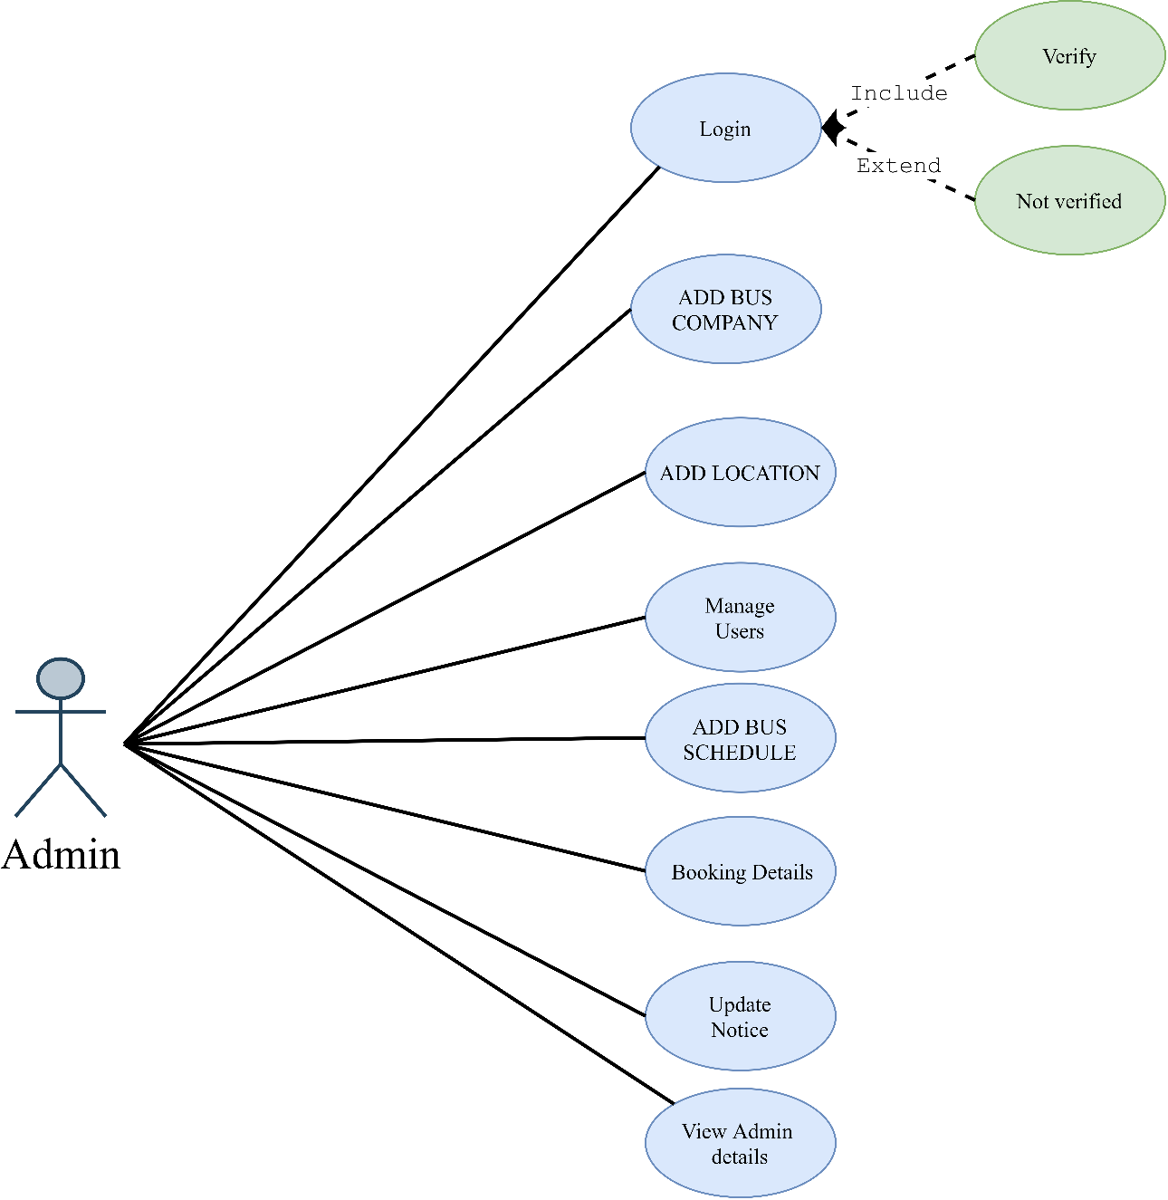

*Figure 1: Admin Use Case Diagram*

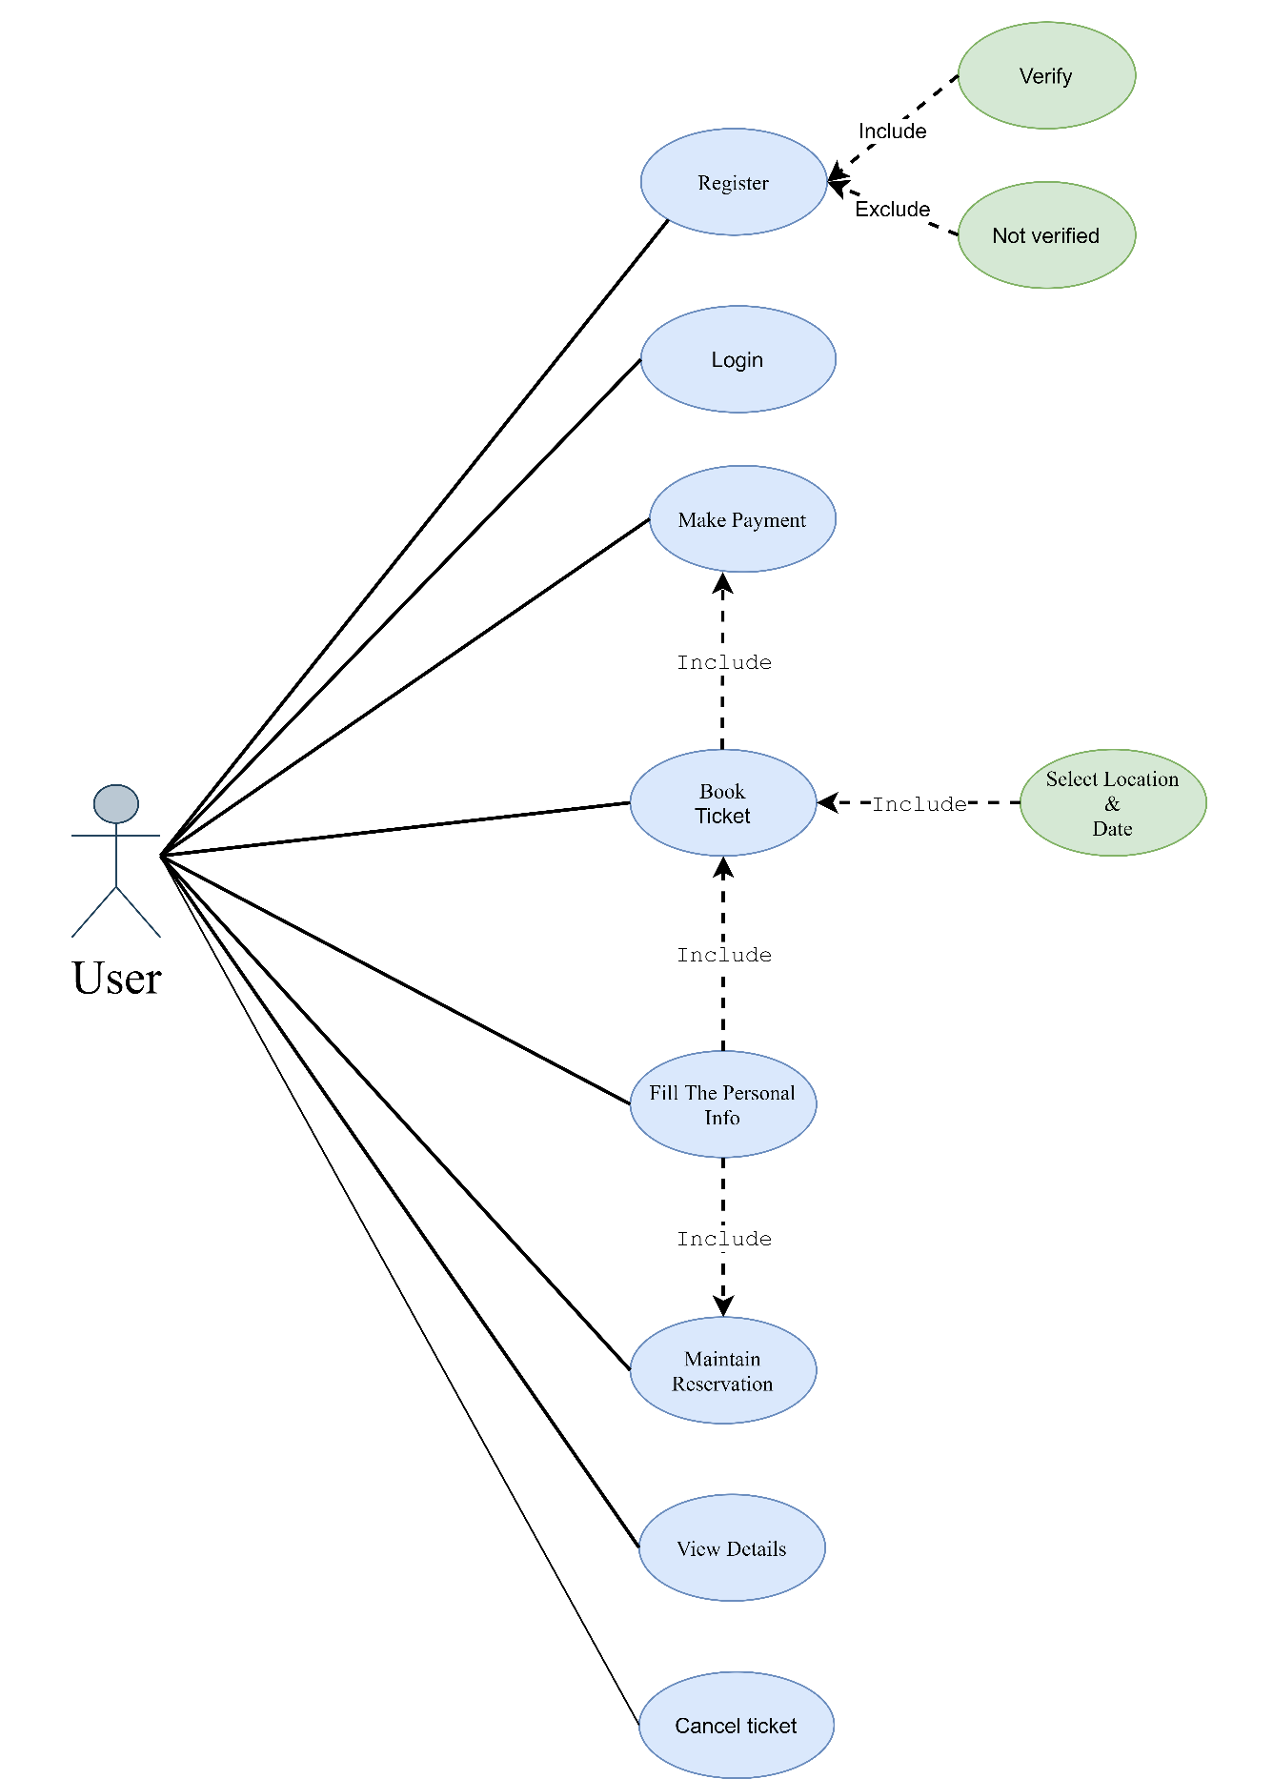

*Figure 2: User Use Case Diagram*

**4.2: Sequence Diagram**

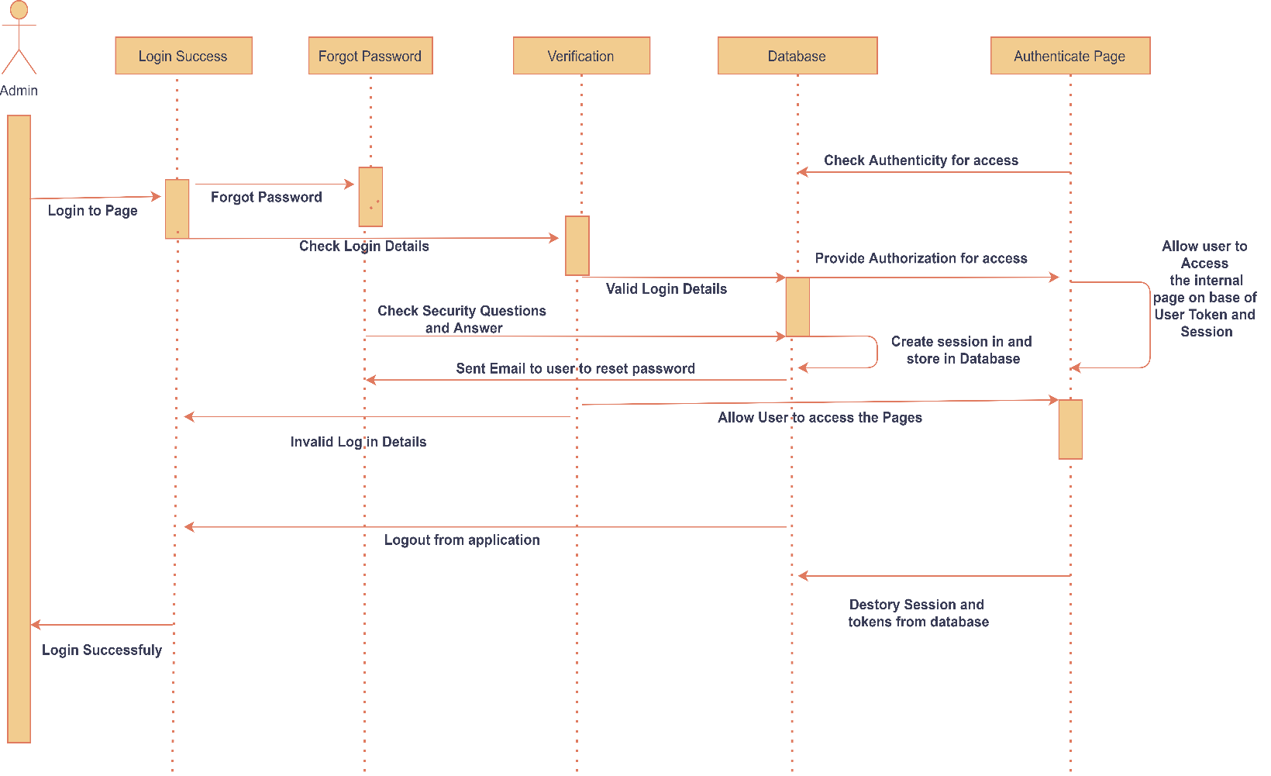

*Figure 3: Sequence Diagram for Login*

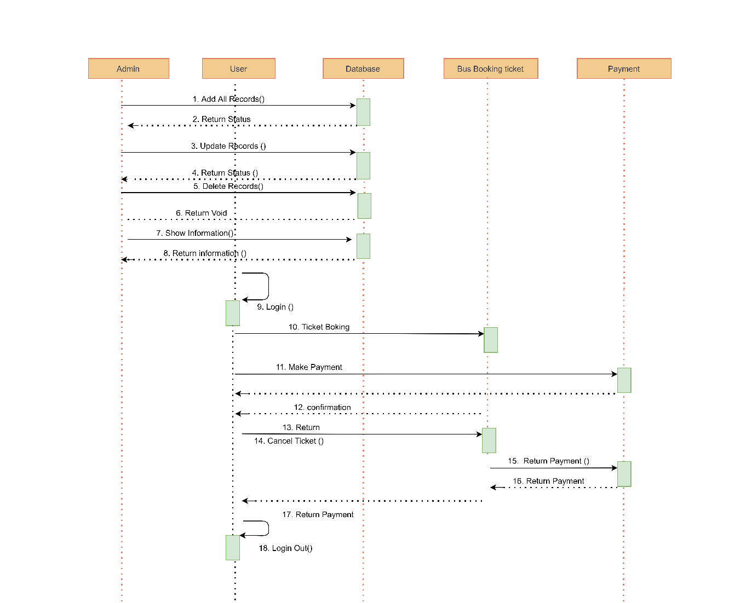

*Figure 4: Sequence Diagram*

**4.3: Class Diagram**

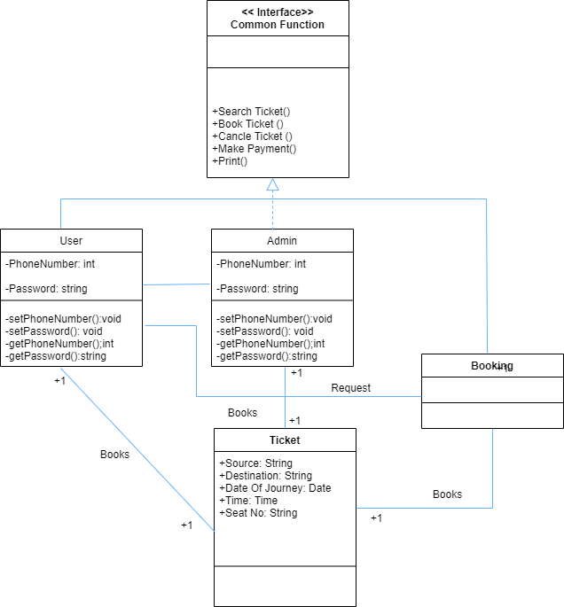

*Figure 5: Class Diagram*

**Development**

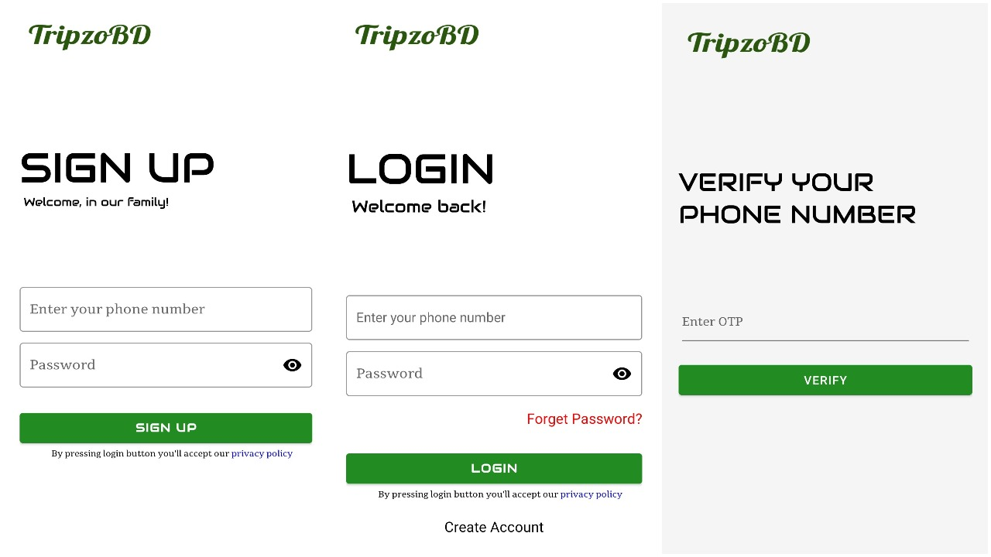**5.1 User Application**

This is Login and Register page of user application which is developed by Abdul Hannan Anik.

For login and registration, phone number and password needed. After input valid information in registration page, user automatically gone in “verify your phone number” page. User will get 6-digit code for verification. After completed verification, user can get full access in application.

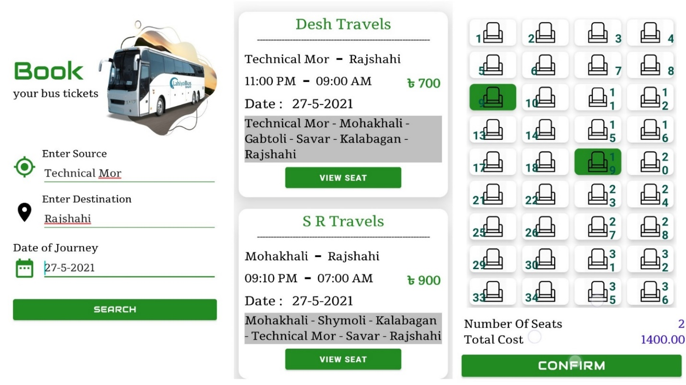

All this are ticket booking steps of user application. After login, user can see “Book you bus tickets” page where there are options available to select boarding point, dropping point and journey date. Then the next page, user see all buses list which is available. Both of this are developed by Abdul Hannan Anik. User can choose seat on his/her own choice by clicking “view seat” button. Some parts of this feature have been developed by Abdul Hannan Anik and some parts have been developed by Shaon Kumar Das.

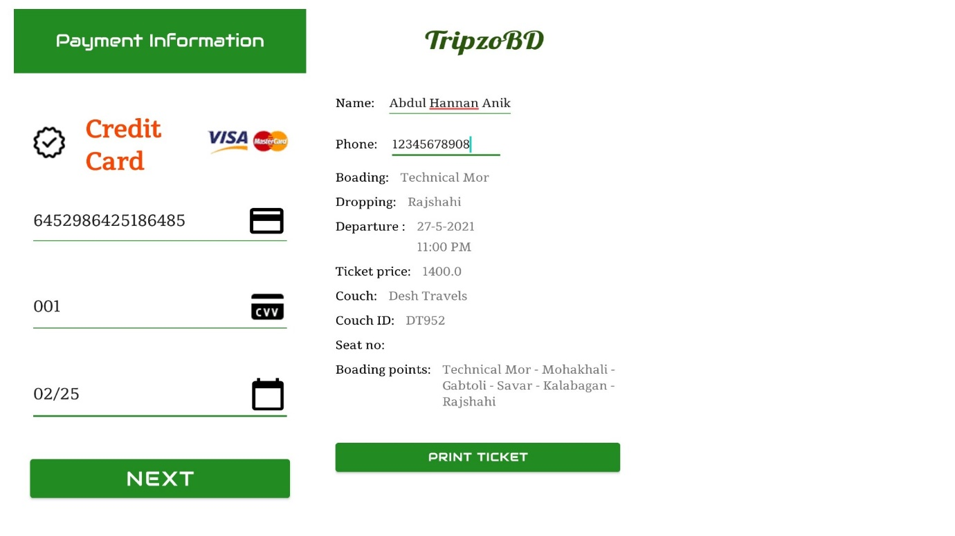

In user application, payment system and print ticket feature available which is developed by Shaon Kumar Das. At present only credit card payment gateway available. After completed payment, user can print ticket where user need to input name and phone number.

**5.2 Admin Application**

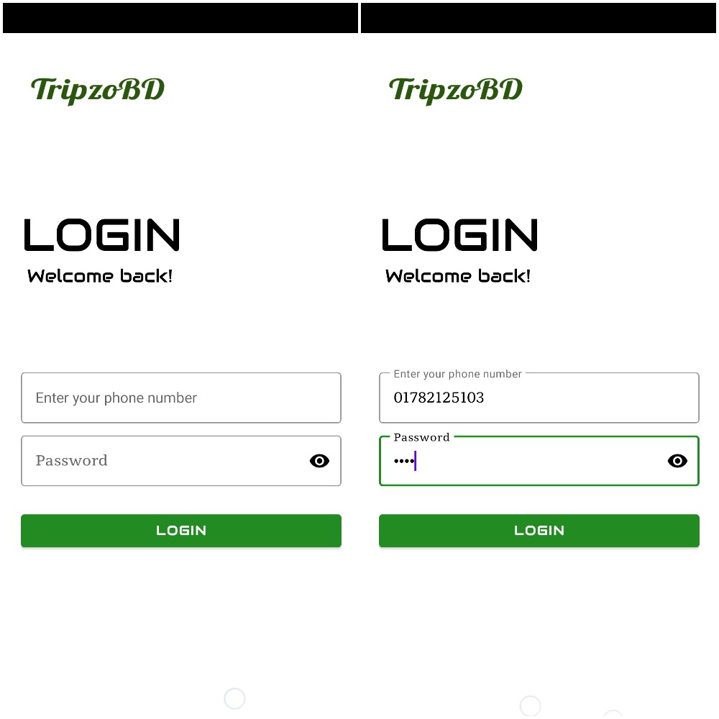

This is the Login page for Admin portal where admin can access application by input valid phone number and password. In this application, there is no option for admin registration. Admin information inserted in database manually.

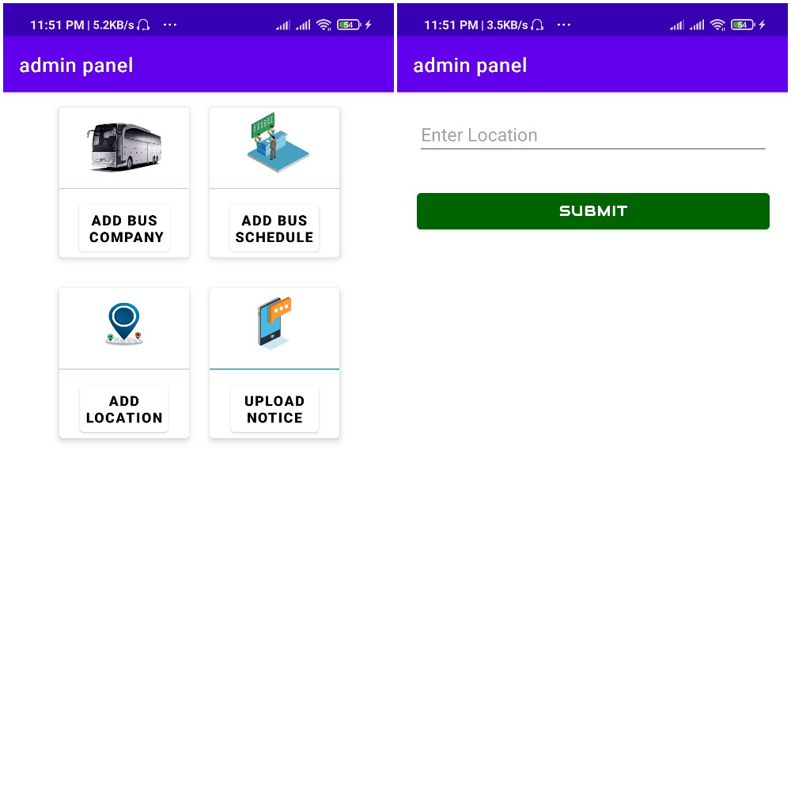

After Login admin can see admin portal where Admin can add bus company, add bus schedule, add location and can send notice by upload notice.

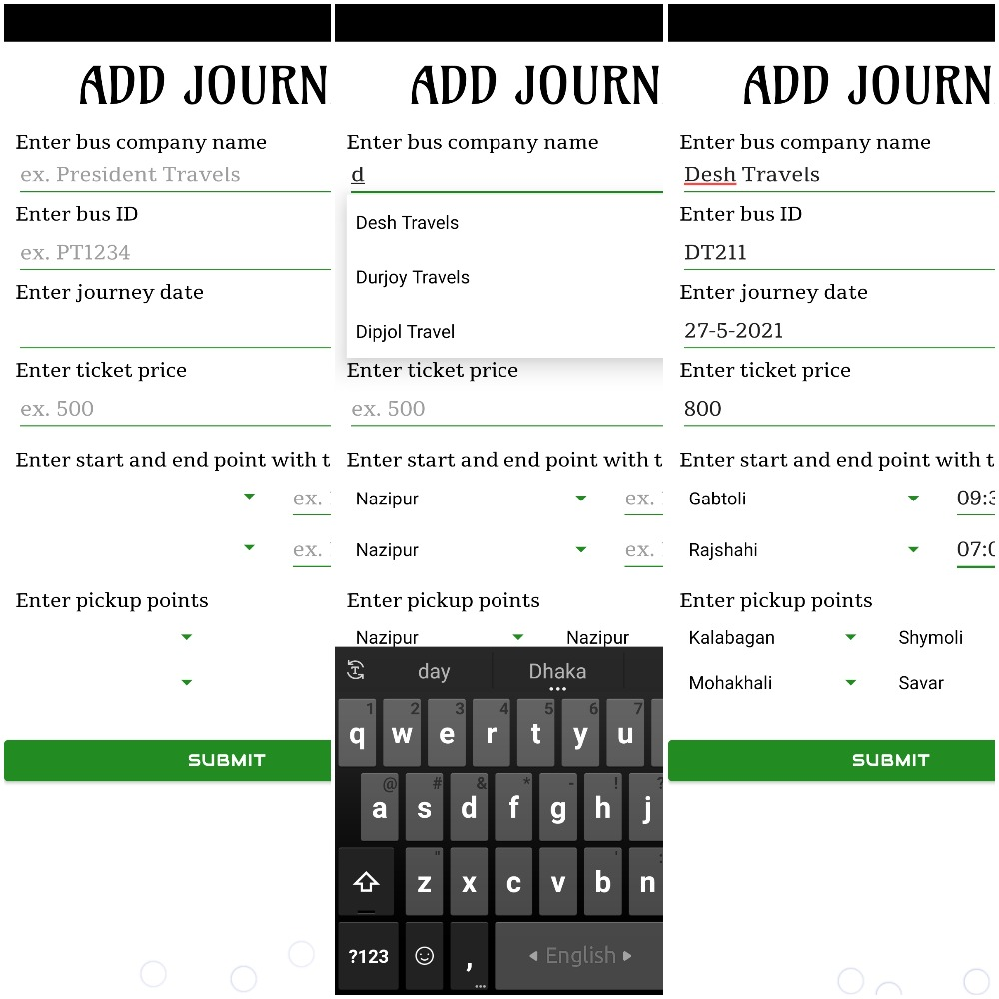

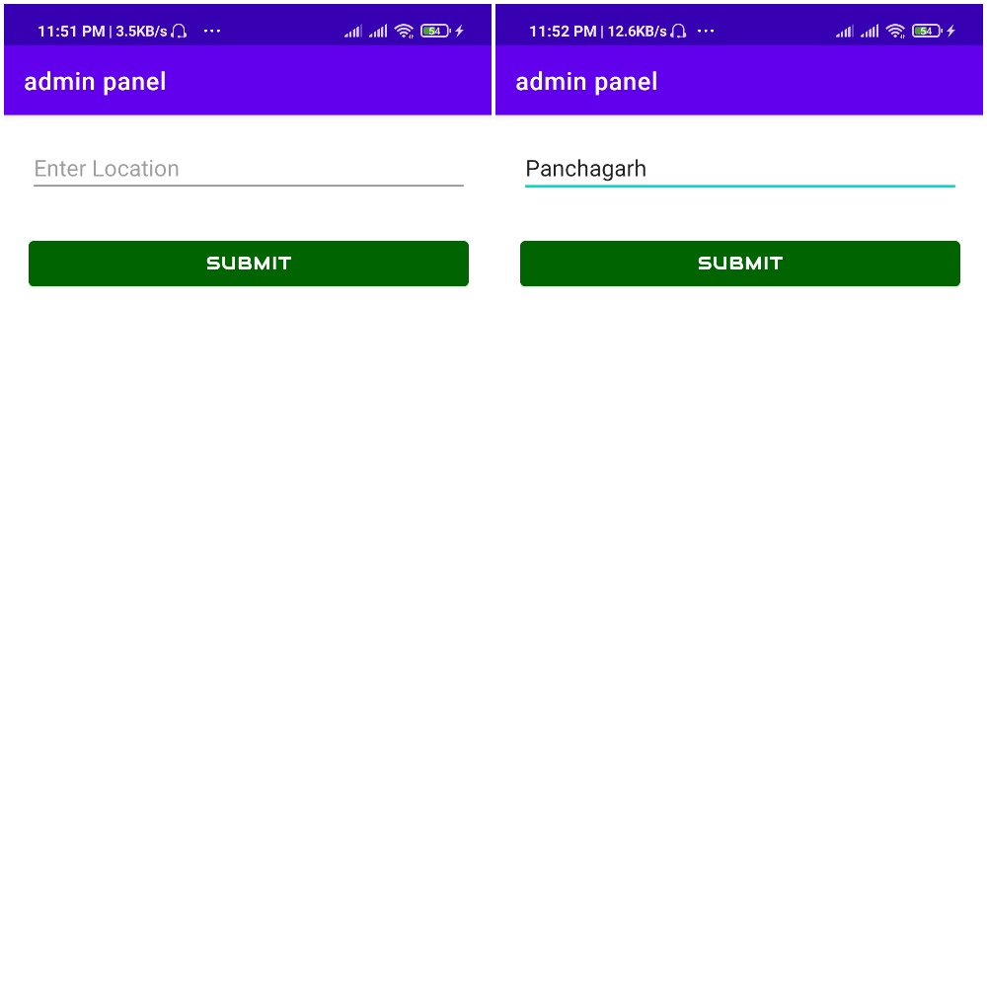This is Journey Feature, Here Admin can add Bus Company Name, Bus ID, journey Date, Ticket Price, and Pickup Points with time.

In this feature Admin can add Location which is directly inserted in database.

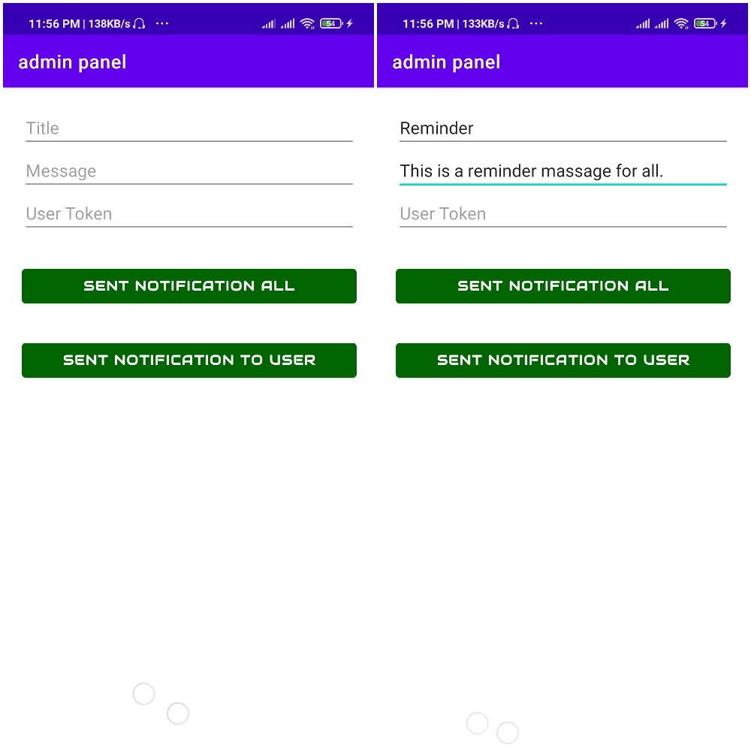

In this Feature admin can send message to all User and Admins.

All features about admin are developed by Pinaki Ranjan Das.

**Testing**

|  |  |  |  |  |  |  |  |
| --- | --- | --- | --- | --- | --- | --- | --- |
| Test Case ID | Test Case Description | Test Step | Test Data | Post Conditional | Expected Result | Actual  Result | Status |
| Test_Login_01 | Enter a valid Phone Number & password | 1.Enter valid Phone Number  2. Enter Valid Password  3. Click Login Button | Phone Number: 01782125103  Pass: 2222 | User should be able to see home page | Successfully login | Popup message show Login Error | Fail |
| Test_Login_02 | Enter a valid Phone Number & invalid password | 1.Enter valid Phone Number  2. Enter invalid Password  3. Click Login Button | Phone Number: 01782125103  Pass: XXXX | Error message  ” Phone Number and Password does not match” | A Popup message box show an error “Wrong password” | Popup message show Login Error | Fail |
| Test_Login_03 | Enter an invalid Phone Number & valid password | 1.Enter invalid Phone Number  2. Enter valid Password  3. Click Login Button | Phone Number: 02782125103  Pass: 2222 | Error message  “User not found” | A Popup message box show an error  “User not found” | A Popup message box show an error  “User not found” | Pass |
| Test_Login_04 | Enter a valid Phone Number & password | 1.Enter valid Phone Number  2. Enter Valid Password  3. Click Login Button | Phone Number: 01782125103  Pass: 2222 | User should be able to see home page | Successfully login | Login successfully & go to next page | Pass |
| Test_Login_05 | Enter a valid Phone Number & invalid password | 1.Enter valid Phone Number  2. Enter invalid Password  3. Click Login Button | Phone Number: 01782125103  Pass: XXXX | Error message  ” Phone Number and Password does not match” | A Popup message box show an error “Wrong password” | Showing Wrong password | Pass |
| Test_  viewbuslist_1 | Enter starting, ending point and select date | 1. Enter starting point  2. Enter ending point  3.Select date  4.Click Search button | Starting point: Malibagh  Ending point: Savar  Date: 27-04-2021 | User should be able to see details and after click confirm button, user should not see any available buses | Do not show any buses | Do not show any buses | Pass |
| Test_  viewbuslist_2 | Enter starting, ending point and select date | 1. Enter starting point  2. Enter ending point  3.Select date  4.Click Search button | Starting point: Mohakhali  Ending point: Savar  Date: 27-04-2021 | User should be able to see details and after click confirm button, user can see all available buses | Successfully  Show available buses | Do not show any buses | Fail |
| Test_  viewbuslist_3 | Enter starting, ending point and select date | 1. Enter starting point  2. Enter ending point  3.Select date  4.Click Search button | Starting point: Shymoli  Ending point: Savar  Date: 02-05-2021 | User should be able to see details and after click confirm button, user can see all available buses | Successfully  Show available buses | Do not show any buses | Fail |
| Test_  viewbuslist_4 | Enter starting, ending point and select date | 1. Enter starting point  2. Enter ending point  3.Select date  4.Click Search button | Starting point: Mohakhali  Ending point: Savar  Date: 03-05-2021 | User should be able to see details and after click confirm button, user can see all available buses | Successfully  Show available buses | Show available buses | Pass |
| Test_  viewbuslist_5 | Enter starting, ending point and select date | 1. Enter starting point  2. Enter ending point  3.Select date  4.Click Search button | Starting point: Shymoli  Ending point: Savar  Date: 03-05-2021 | User should be able to see details and after click confirm button, user can see all available buses | Successfully  Show available buses | Show available buses | Pass |

**Conclusion**

The main aim of this project was to put what we learnt in our Software engineering class into practice. The software we created in this project can be improved. This is especially because we had to create it within a limited time. With more time, the software can be improved to include security and different types of uses. This is the first step in making the project. We have a future plan to extend the project and update the existing features.

**References**

|  |  |
| --- | --- |
| [1] | How to Write Test Cases: Sample Template with Examples. <https://www.guru99.com/test-case.html> |
| [2] | Creating Entity Relationship Diagrams using Draw.io  <https://www.youtube.com/watch?v=lAtCySGDD48> |
| [3] | MOBILE – BASED BUS TICKETING SYSTEM IN IRAQ  <https://www.researchgate.net/publication/315801024_MOBILE_-_BASED_BUS_TICKETING_SYSTEM_IN_IRAQ> |
| [4] | ANDROID MOBILE APPLICATION FOR ONLINE BUS BOOKING SYSTEM  <https://www.ftms.edu.my/journals/pdf/IJISE/Apr2018/34-56.pdf> |
| [5] | Online Bus Ticket Reservation System  <https://www.researchgate.net/publication/326468848_Online_Bus_Ticket_Reservation_System> |