Allure

Test Report

Test Session Summary

|  |  |
| --- | --- |
| Start: Sat Apr 11 22:40:30 2020 End: Sat Apr 11 23:24:09 2020 Duration: 0:43:39.248000  broken: 1 (2.50%) failed: 5 (12.50%) skipped: 0 (0.00%) passed: 34 (85.00%) |  |

Test Results

Test Results 1

Blacklist button checking - broken 3

Liked tracks clicking - failed 4

Popular tracks clicking - failed 6

Signs up with 999 age - failed 8

Signs up with female gender - failed 10

Signs up with wrong name format - failed 12

About clicking - passed 14

Download button checking - passed 16

Facebook Button Checking - passed 18

Home clicking - passed 20

Login clicking - passed 22

Login correctly - passed 24

Login with no password & email - passed 26

Login with no email - passed 28

Login with no password - passed 30

Login with wrong email - passed 32

Login with wrong email format - passed 34

Login with wrong password - passed 36

Logout clicking - passed 38

Love button checking - passed 40

Minimize button checking - passed 42

New releases clicking - passed 44

Next button checking - passed 46

Play button checking - passed 48

Previous button checking - passed 50

Recommended tracks clicking - passed 52

Repeat button checking - passed 54

Search clicking - passed 56

Share button checking - passed 58

Sign up clicking - passed 60

Sign up correctly - passed 62

Signs up with -ve age - passed 64

Signs up with 0 age - passed 66

Signs up with existing email - passed 68

Signs up with no age - passed 70

Signs up with no email - passed 72

Signs up with no name - passed 74

Signs up with no password - passed 76

Signs up with wrong email format - passed 78

checking the artist button - passed 80

Manual Testing Report 84

# Blacklist button checking - broken

Checking that the Blacklist button is visible

## Details

AttributeError: 'NoneType' object has no attribute 'click'

|  |
| --- |
| self = <Mobile_Testing.Tests.test_player.TestPlayer object at 0x10ebcb5e0>, setup = None   @allure.severity(allure.severity_level.BLOCKER)  @allure.story("Player Page Tests")  @allure.sub_suite("Blacklist button checking")  @allure.title("Blacklist button checking")  @allure.description("Checking that the Blacklist button is visible")  @pytest.mark.Do  @pytest.mark.Player  @pytest.mark.Test10  def test_case_10(self, setup):  """  Checks that Blacklist button is visible and enabled  """  ap = AuthenticationPage(self.driver)  ap.click_signin_button()  lp = LoginPage(self.driver)  lp.do_the_login(Constants.correct_credentials["email"], Constants.correct_credentials["password"])  hp = HomePage(self.driver)  time.sleep(10)  hp.click_recommended_tracks()  time.sleep(2) > Helper.find_element_by_xpath(self.driver, Constants.first_song_playlist).click() E AttributeError: 'NoneType' object has no attribute 'click'  Mobile_Testing/Tests/test_player.py:373: AttributeError |

## Test Setup

[Fixture] setup

## Test Body

No test body information available.

## Test Teardown

[Fixture] setup::0

# Liked tracks clicking - failed

Liked tracks clicking and check that it works

## Details

AssertionError: assert False

|  |
| --- |
| self = <Mobile_Testing.Tests.test_home.TestHome object at 0x104ab71f0>, setup = None   @allure.severity(allure.severity_level.BLOCKER)  @allure.story("Home Page Tests")  @allure.sub_suite("Liked tracks clicking")  @allure.title("Liked tracks clicking")  @allure.description("Liked tracks clicking and check that it works")  @pytest.mark.Do  @pytest.mark.HomePage  @pytest.mark.Test3  def test_case_3(self, setup):  """  checking the Liked tracks works  """  ap = AuthenticationPage(self.driver)  ap.click_signin_button()  lp = LoginPage(self.driver)  lp.do_the_login(Constants.correct_credentials["email"], Constants.correct_credentials["password"])  hp = HomePage(self.driver)  time.sleep(10)  hp.click_liked_tracks_button()  if Helper.element_exists_by_id(self.driver, HomePage.about_button_id):  print(self.driver.current_activity)  Helper.report_allure(self.driver, "Home page test failed") > assert False E assert False  Mobile_Testing/Tests/test_home.py:135: AssertionError |

## Test Setup

[Fixture] setup

## Test Body

[Attachment] Home page test failed

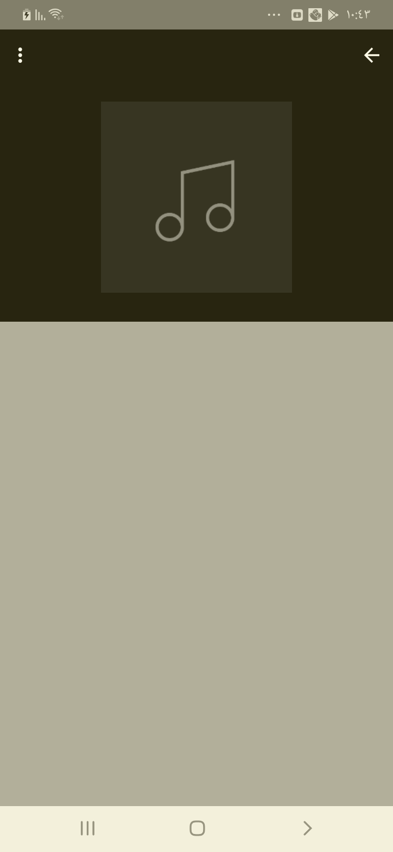

[Attachment] stdout

## Test Teardown

[Fixture] setup::0

# Popular tracks clicking - failed

Popular tracks clicking and check that it works

## Details

AssertionError: assert False

|  |
| --- |
| self = <Mobile_Testing.Tests.test_home.TestHome object at 0x104a8edf0>, setup = None   @allure.severity(allure.severity_level.BLOCKER)  @allure.story("Home Page Tests")  @allure.sub_suite("Popular tracks clicking")  @allure.title("Popular tracks clicking")  @allure.description("Popular tracks clicking and check that it works")  @pytest.mark.Do  @pytest.mark.HomePage  @pytest.mark.Test4  def test_case_4(self, setup):  """  checking the Popular tracks works  """  ap = AuthenticationPage(self.driver)  ap.click_signin_button()  lp = LoginPage(self.driver)  lp.do_the_login(Constants.correct_credentials["email"], Constants.correct_credentials["password"])  hp = HomePage(self.driver)  time.sleep(10)  hp.click_popular_tracks_button()  if Helper.element_exists_by_id(self.driver, HomePage.about_button_id):  print(self.driver.current_activity)  Helper.report_allure(self.driver, "Home page test failed") > assert False E assert False  Mobile_Testing/Tests/test_home.py:163: AssertionError |

## Test Setup

[Fixture] setup

## Test Body

[Attachment] Home page test failed

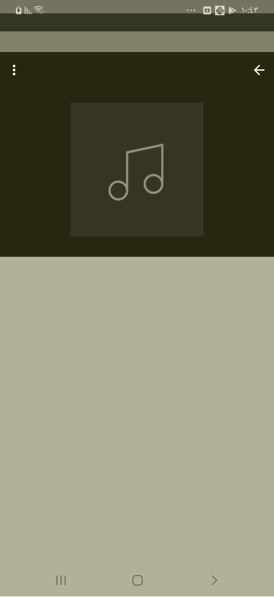

[Attachment] stdout

## Test Teardown

[Fixture] setup::0

# Signs up with 999 age - failed

Signs up with 999 age with ,,,999, M

## Details

AssertionError: assert False

|  |
| --- |
| self = <Mobile_Testing.Tests.test_signup.TestSignup object at 0x104ab7b50>, setup = None   @allure.severity(allure.severity_level.BLOCKER)  @allure.story("Signup Tests")  @allure.sub_suite("Sign up with 999 age ")  @allure.title("Signs up with 999 age ")  @allure.description("Signs up with 999 age with " + name + ","  + email + "," + password+",999, M")  @pytest.mark.Do  @pytest.mark.Signup  @pytest.mark.Test12  def test_case_12(self, setup):  """  Signs up with 999 age  """  ap = AuthenticationPage(self.driver)  ap.click_signup_button()  sp = SignupPage(self.driver)  sp.do_the_signup(self.name, self.email, self.password, "999", "M")  if Helper.element_exists_by_id(self.driver, HomePage.logout_button_id):  print(self.driver.current_activity)  Helper.report_allure(self.driver, "Sign up test Failed") > assert False E assert False  Mobile_Testing/Tests/test_signup.py:388: AssertionError |

## Test Setup

[Fixture] setup

## Test Body

[Attachment] Sign up test Failed

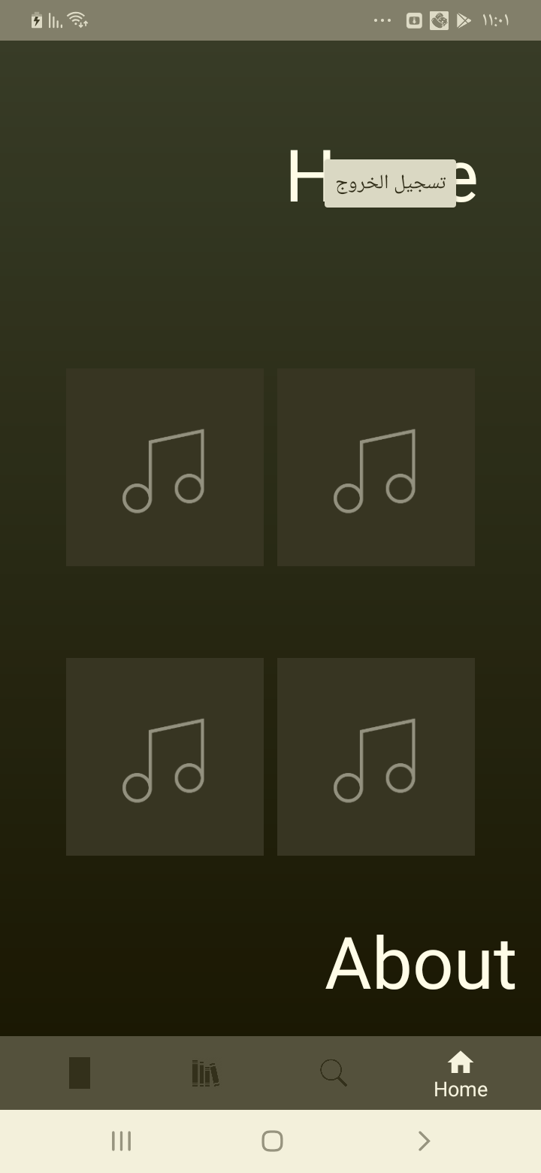

[Attachment] stdout

## Test Teardown

[Fixture] setup::0

# Signs up with female gender - failed

Signs up with female gender format with ,,,21, F

## Details

AssertionError: assert False

|  |
| --- |
| self = <Mobile_Testing.Tests.test_signup.TestSignup object at 0x104bfe700>, setup = None   @allure.severity(allure.severity_level.BLOCKER)  @allure.story("Signup Tests")  @allure.sub_suite("Sign up with female gender ")  @allure.title("Signs up with female gender ")  @allure.description("Signs up with female gender format with " + name + ","  + email + "," + password+",21, F")  @pytest.mark.Do  @pytest.mark.Signup  @pytest.mark.Test7  def test_case_7(self, setup):  """  Signs up with female gender  """  ap = AuthenticationPage(self.driver)  ap.click_signup_button()  sp = SignupPage(self.driver)  sp.do_the_signup(self.name, self.email, self.password, "21", "F")  if Helper.element_exists_by_id(self.driver, HomePage.logout_button_id):  Helper.report_allure(self.driver, "Sign up test Passed")  assert True  else:  print(self.driver.current_activity)  Helper.report_allure(self.driver, "Sign up test Failed") > assert False E assert False  Mobile_Testing/Tests/test_signup.py:260: AssertionError |

## Test Setup

[Fixture] setup

## Test Body

[Attachment] Sign up test Failed

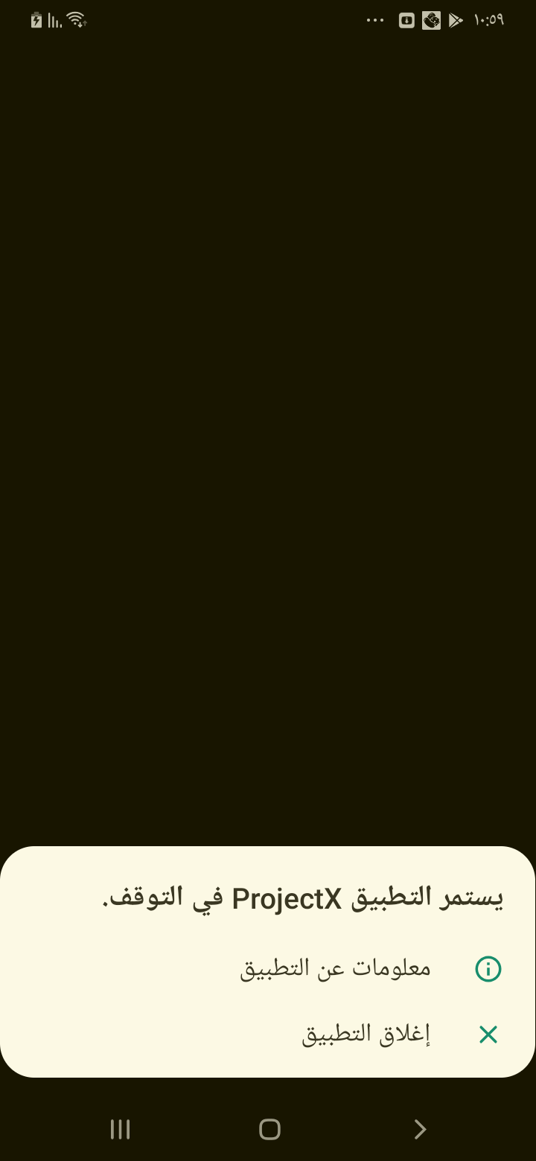

[Attachment] stdout

## Test Teardown

[Fixture] setup::0

# Signs up with wrong name format - failed

Signs up with wrong name format with @!@!#!@,,,21, M

## Details

AssertionError: assert False

|  |
| --- |
| self = <Mobile_Testing.Tests.test_signup.TestSignup object at 0x104d40f40>, setup = None   @allure.severity(allure.severity_level.BLOCKER)  @allure.story("Signup Tests")  @allure.sub_suite("Sign up with wrong name format")  @allure.title("Signs up with wrong name format")  @allure.description("Signs up with wrong name format with " + "@!@!#!@" + ","  + email + "," + password+",21, M")  @pytest.mark.Do  @pytest.mark.Signup  @pytest.mark.Test8  def test_case_8(self, setup):  """  Signs up with wrong name format  """  ap = AuthenticationPage(self.driver)  ap.click_signup_button()  sp = SignupPage(self.driver)  sp.do_the_signup("@!@#!@", self.email, self.password, "21", "M")  if Helper.element_exists_by_id(self.driver, HomePage.logout_button_id):  print(self.driver.current_activity)  Helper.report_allure(self.driver, "Sign up test Failed") > assert False E assert False  Mobile_Testing/Tests/test_signup.py:283: AssertionError |

## Test Setup

[Fixture] setup

## Test Body

[Attachment] Sign up test Failed

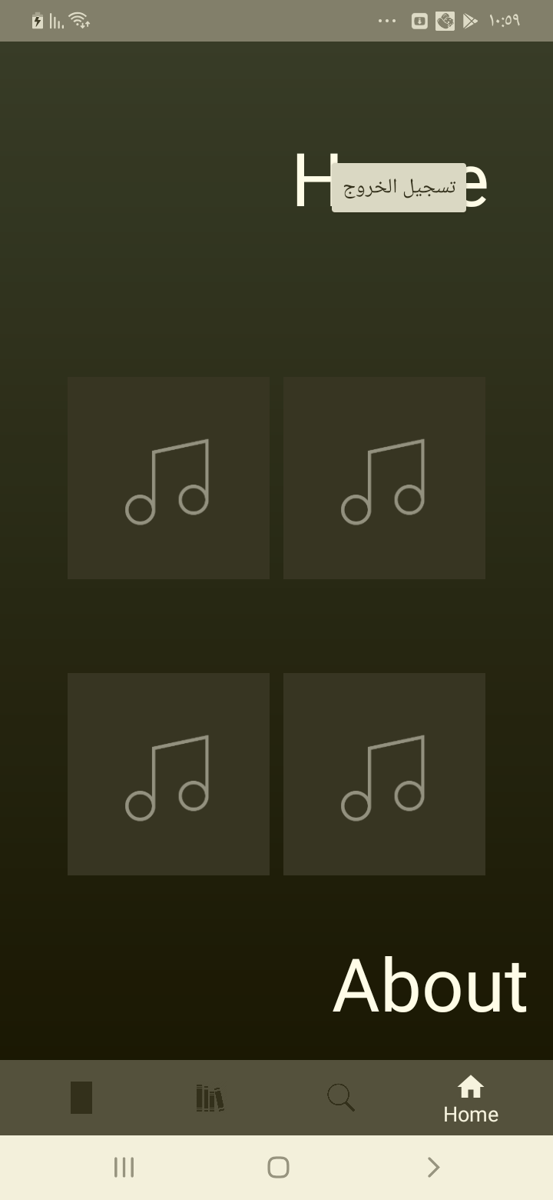

[Attachment] stdout

## Test Teardown

[Fixture] setup::0

# About clicking - passed

About clicking and check that it works

## Test Setup

[Fixture] setup

## Test Body

[Attachment] Home page test passed

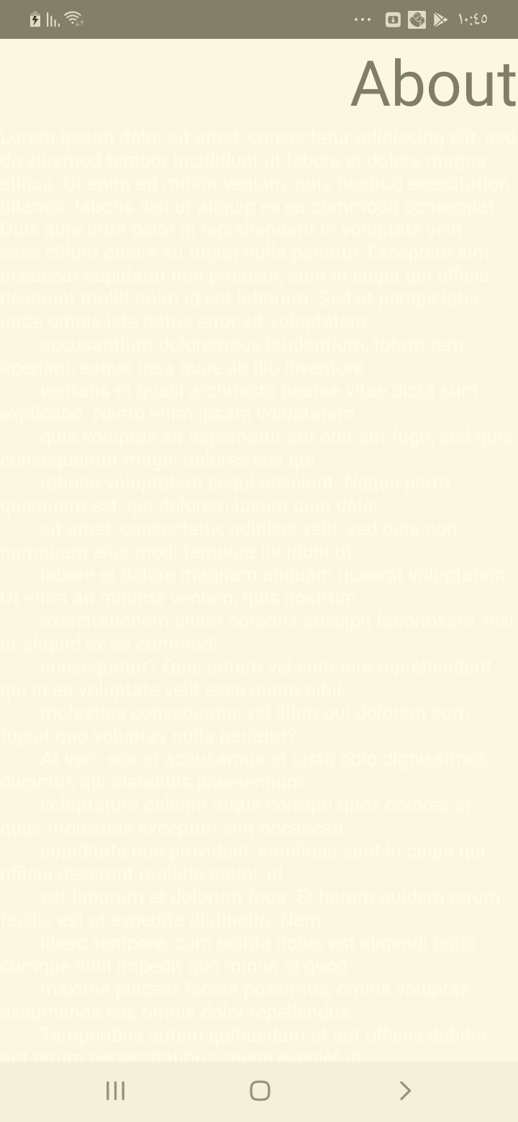

## Test Teardown

[Fixture] setup::0

# Download button checking - passed

Checking that the Download button is visible

## Test Setup

[Fixture] setup

## Test Body

[Attachment] Player page test passed

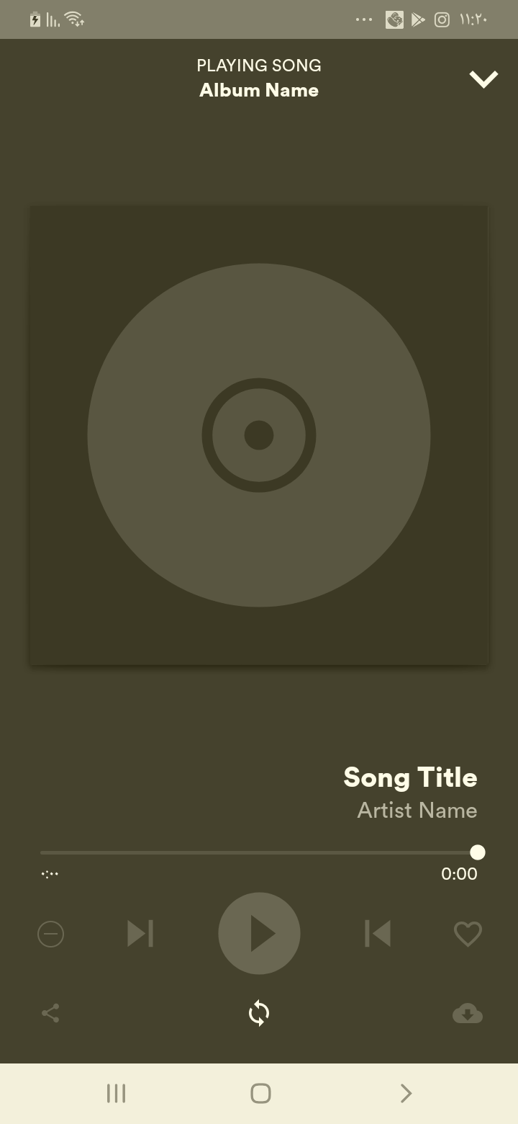

## Test Teardown

[Fixture] setup::0

# Facebook Button Checking - passed

Checking the Facebook button is available

## Test Setup

[Fixture] setup

## Test Body

[Attachment] Facebook Page available

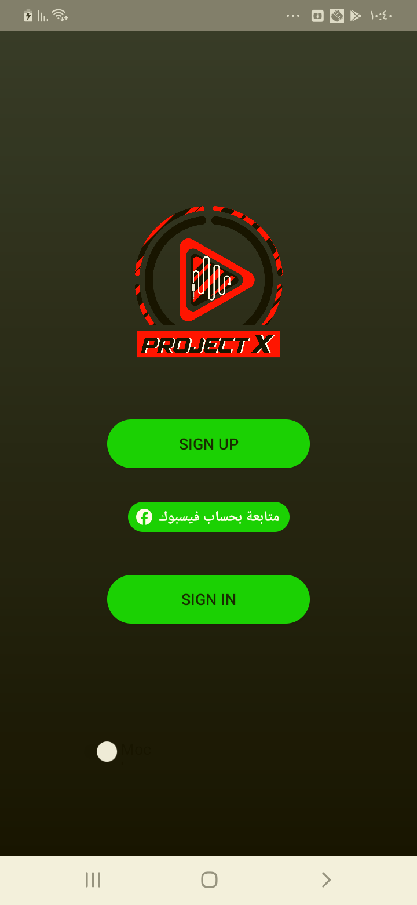

## Test Teardown

[Fixture] setup::0

# Home clicking - passed

Home clicking and check that it works

## Test Setup

[Fixture] setup

## Test Body

[Attachment] Home page test passed

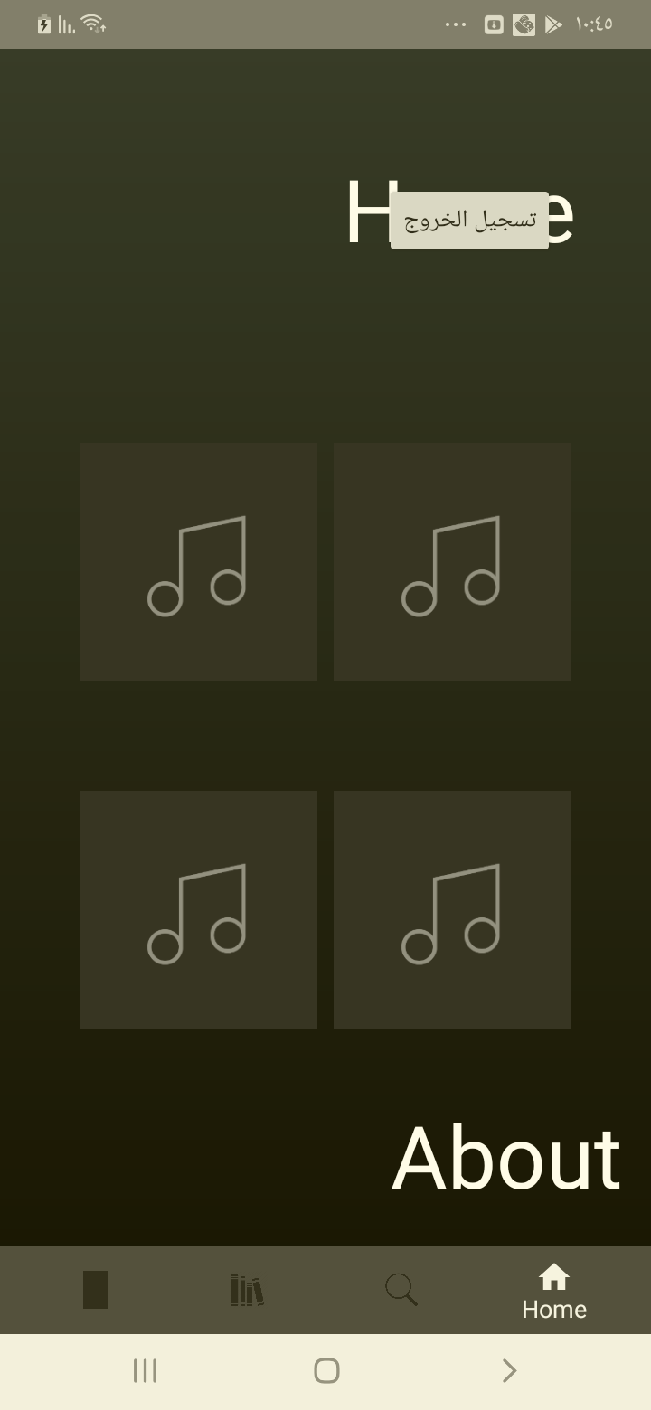

## Test Teardown

[Fixture] setup::0

# Login clicking - passed

Clicking the Login button

## Test Setup

[Fixture] setup

## Test Body

[Attachment] Login Page entered

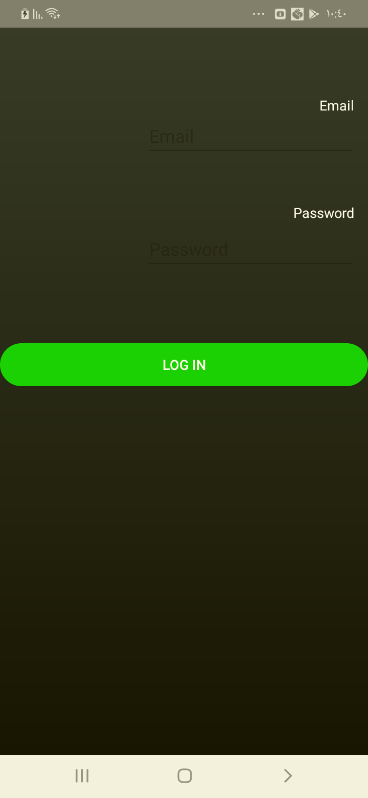

## Test Teardown

[Fixture] setup::0

# Login correctly - passed

Logging in with correct format with abdallah@gmail.com, 123456

## Test Setup

[Fixture] setup

## Test Body

[Attachment] Login test passed

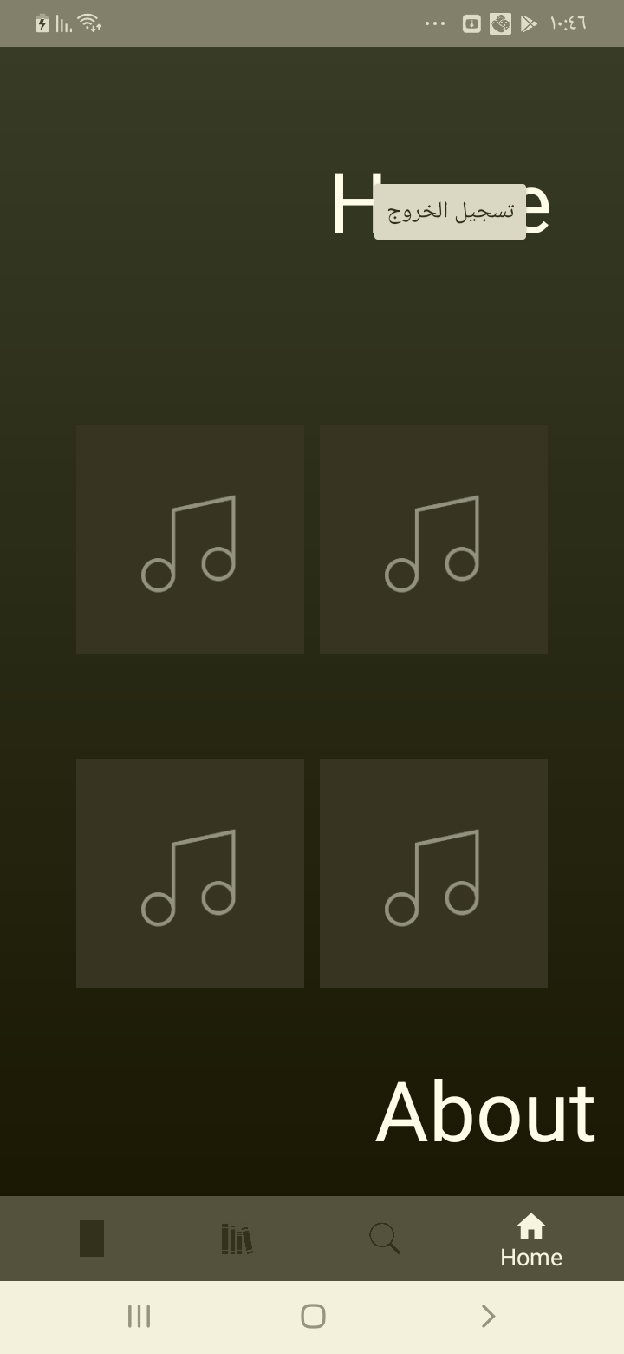

## Test Teardown

[Fixture] setup::0

# Login with no password & email - passed

Logging in with no password & email with ,

## Test Setup

[Fixture] setup

## Test Body

[Attachment] Login test passed

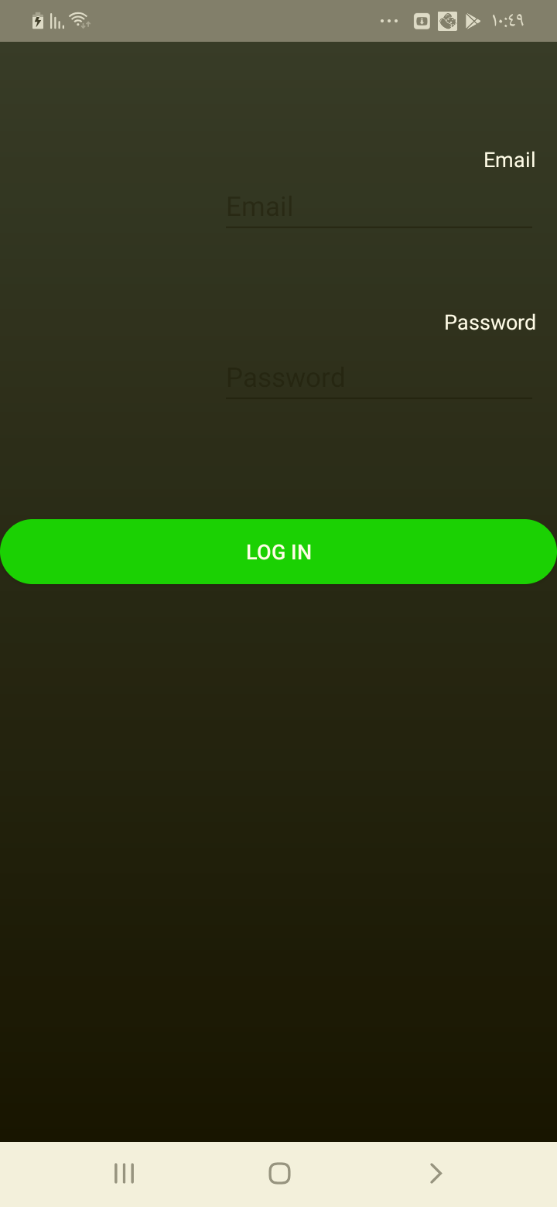

## Test Teardown

[Fixture] setup::0

# Login with no email - passed

Logging in with no email with , Kimo2010

## Test Setup

[Fixture] setup

## Test Body

[Attachment] Login test passed

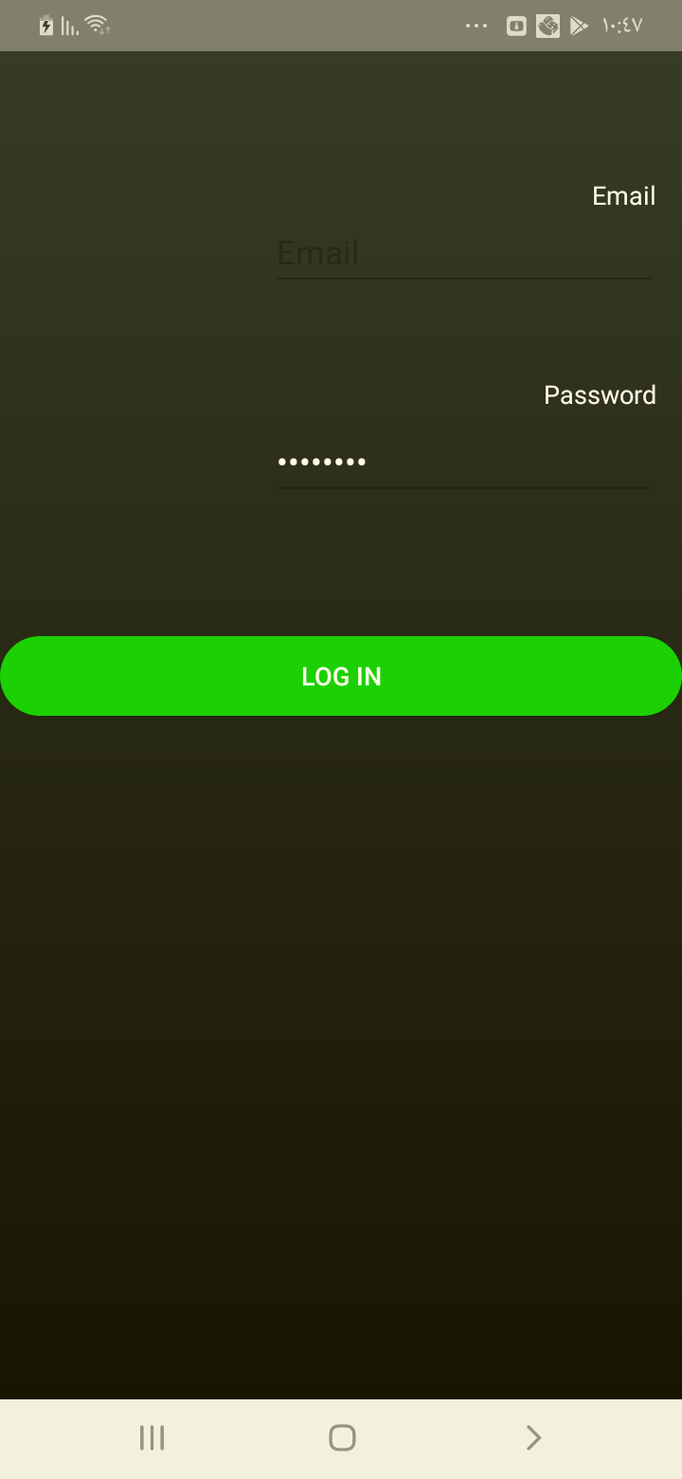

## Test Teardown

[Fixture] setup::0

# Login with no password - passed

Logging in with no password with kamelmohsenkamel@gmail.com,

## Test Setup

[Fixture] setup

## Test Body

[Attachment] Login test passed

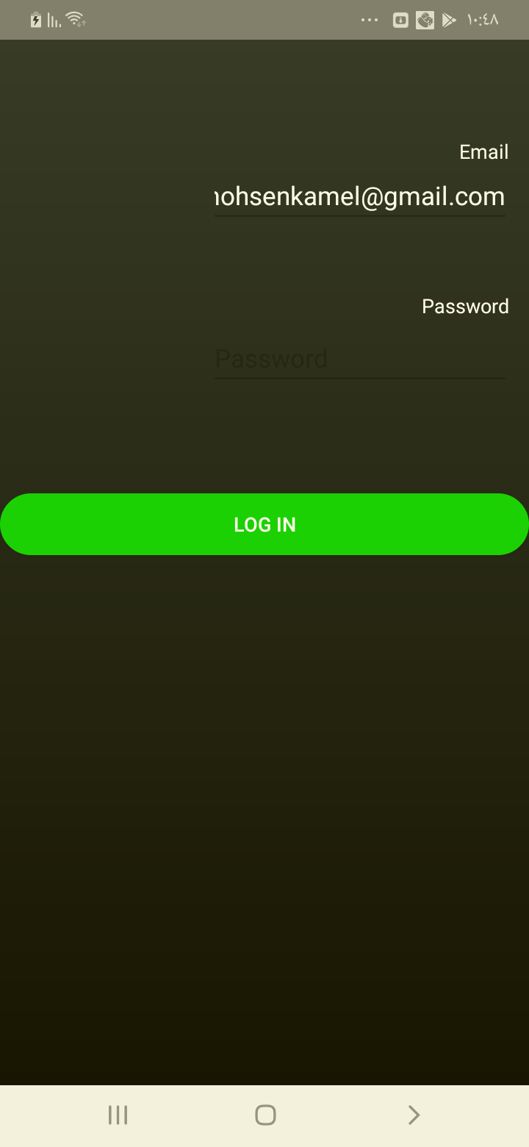

## Test Teardown

[Fixture] setup::0

# Login with wrong email - passed

Logging in with wrong email with kamelmohsenkamel99@gmail.com, Kimo2010

## Test Setup

[Fixture] setup

## Test Body

[Attachment] Login test passed

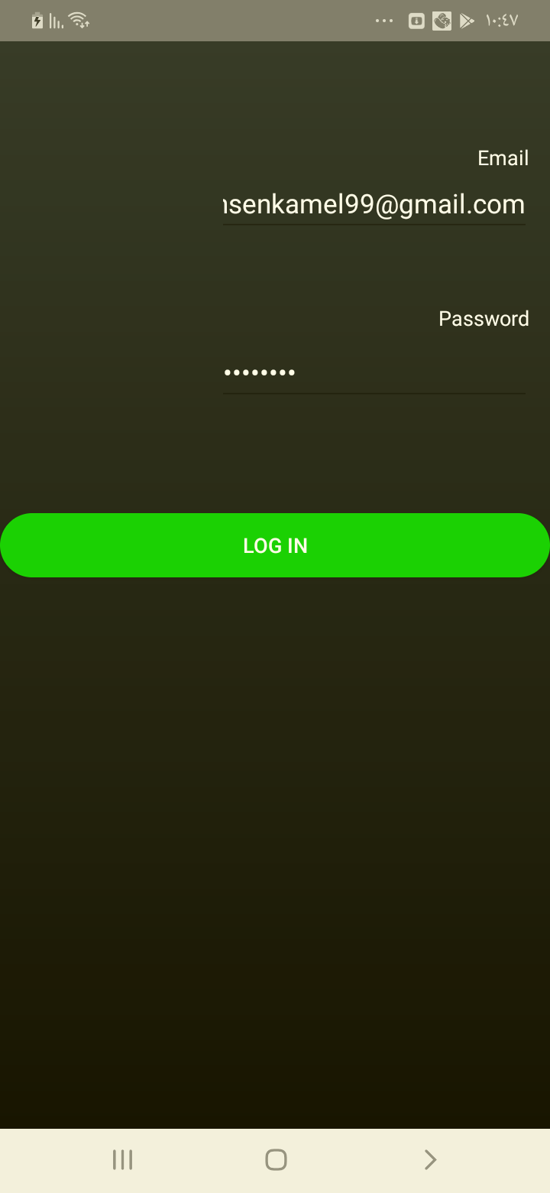

## Test Teardown

[Fixture] setup::0

# Login with wrong email format - passed

Logging in with wrong email format with kamelmohsenkamelgmail.com, Kimo2010

## Test Setup

[Fixture] setup

## Test Body

[Attachment] Login test passed

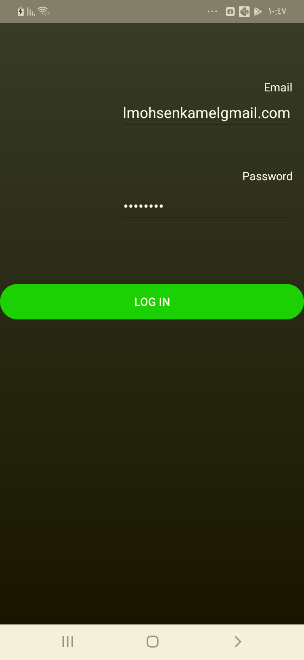

## Test Teardown

[Fixture] setup::0

# Login with wrong password - passed

Logging in with wrong password with kamelmohsenkamel@gmail.com, !@#!@#1

## Test Setup

[Fixture] setup

## Test Body

[Attachment] Login test passed

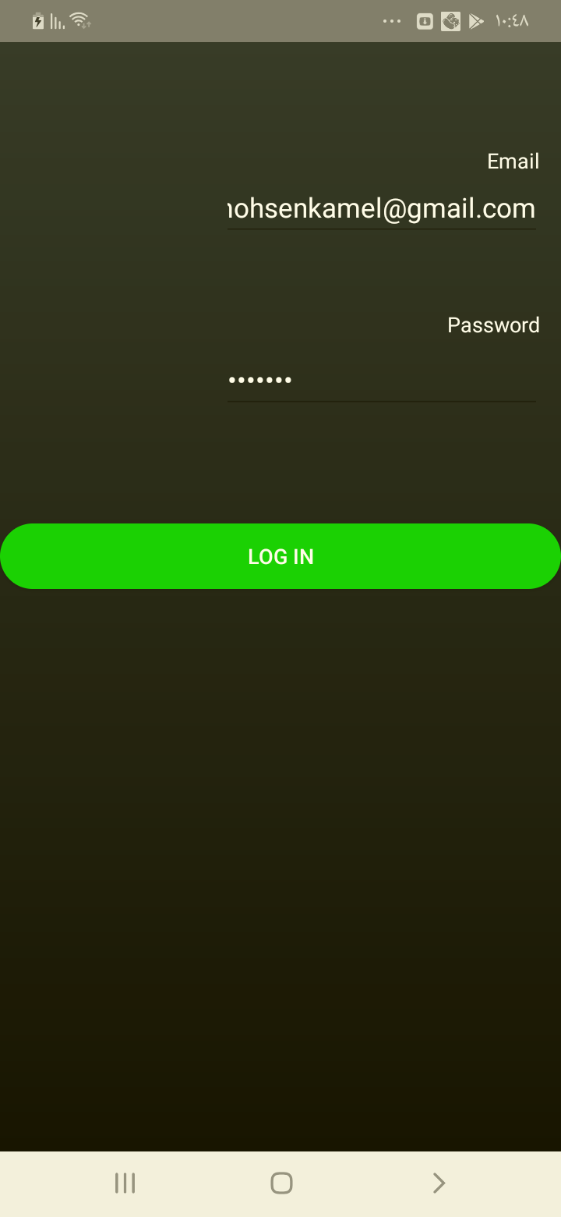

## Test Teardown

[Fixture] setup::0

# Logout clicking - passed

Logout clicking and check that it works

## Test Setup

[Fixture] setup

## Test Body

[Attachment] Home page test passed

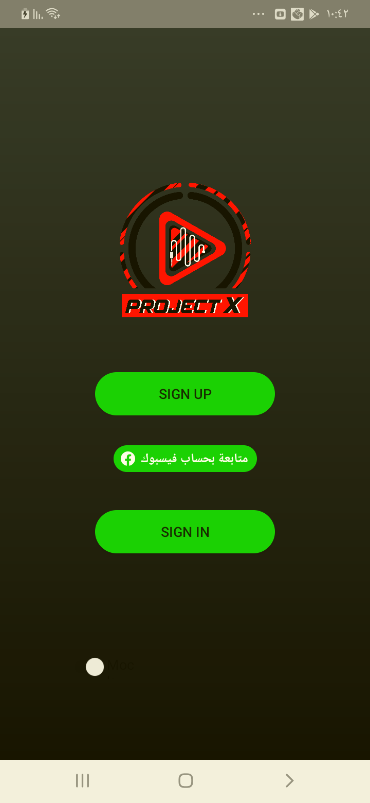

## Test Teardown

[Fixture] setup::0

# Love button checking - passed

Checking that the Love button is visible

## Test Setup

[Fixture] setup

## Test Body

[Attachment] Player page test passed

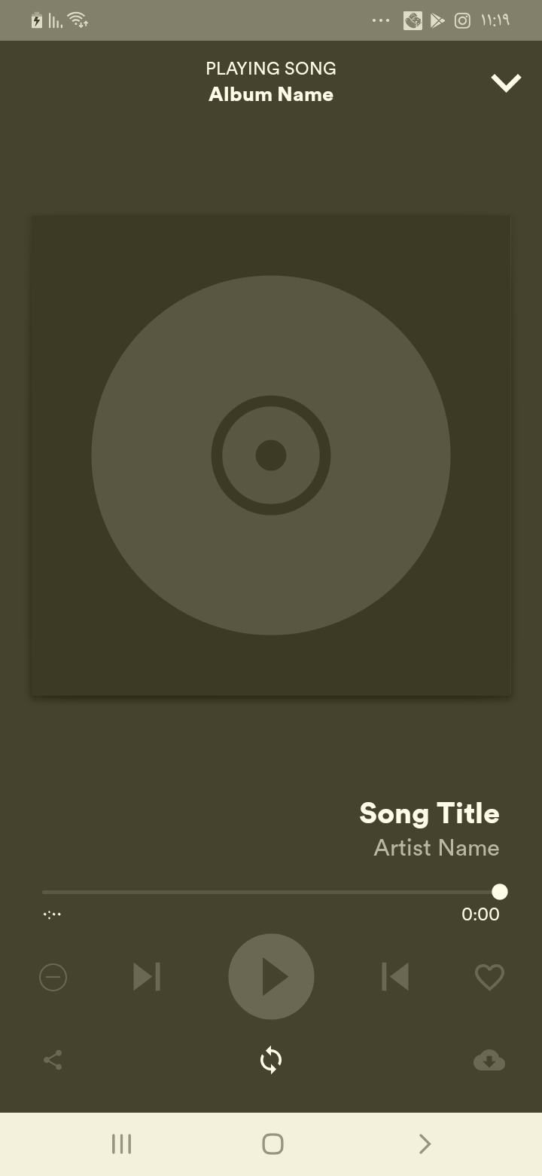

## Test Teardown

[Fixture] setup::0

# Minimize button checking - passed

Checking that the Minimize button is visible

## Test Setup

[Fixture] setup

## Test Body

[Attachment] Player page test passed

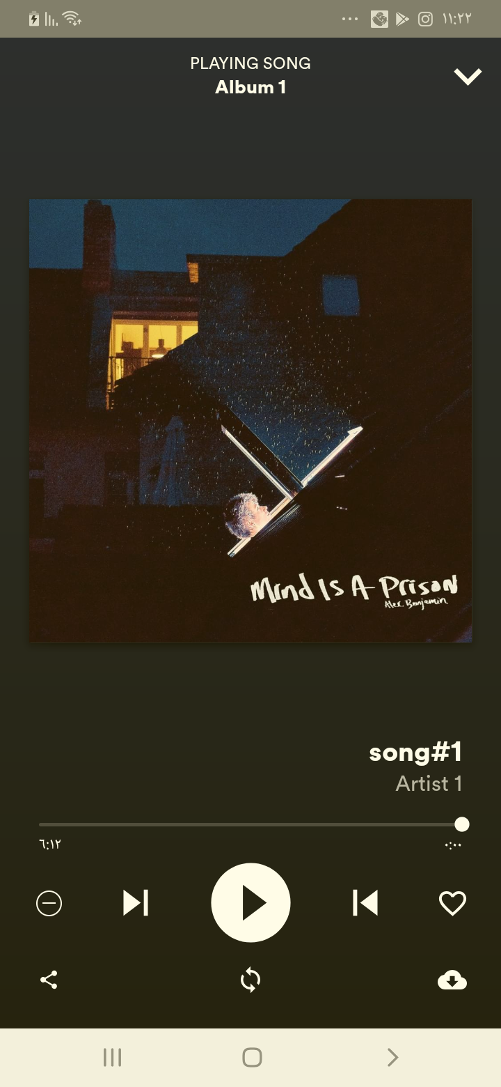

## Test Teardown

[Fixture] setup::0

# New releases clicking - passed

New releases clicking and check that it works

## Test Setup

[Fixture] setup

## Test Body

[Attachment] Home page test passed

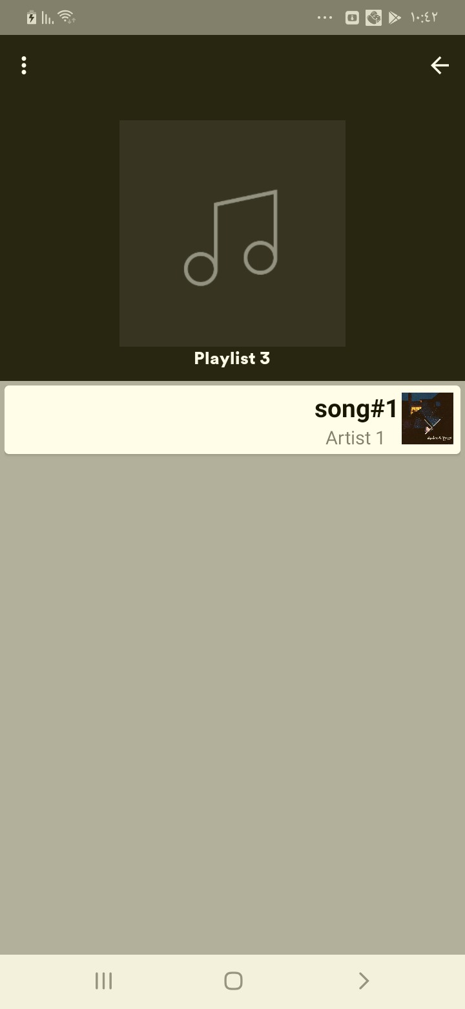

## Test Teardown

[Fixture] setup::0

# Next button checking - passed

Checking that the Next button is visible

## Test Setup

[Fixture] setup

## Test Body

[Attachment] Player page test passed



## Test Teardown

[Fixture] setup::0

# Play button checking - passed

Checking that the Play button is visible

## Test Setup

[Fixture] setup

## Test Body

[Attachment] Player page test passed

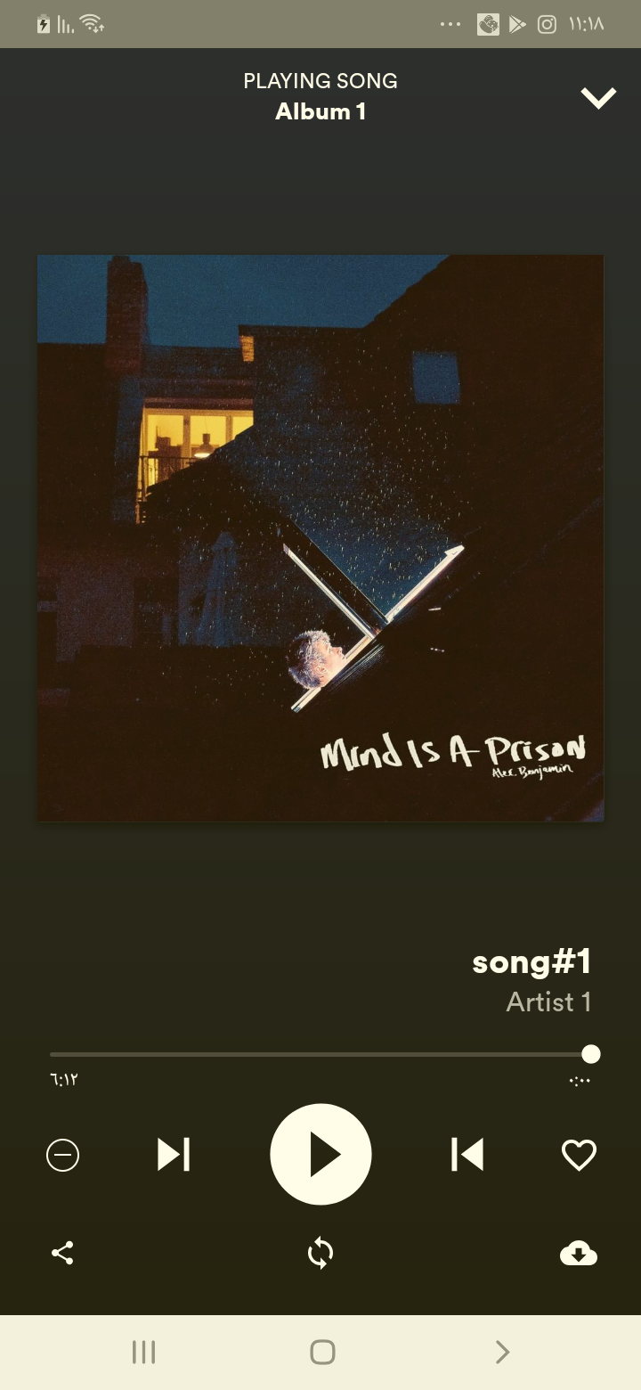

## Test Teardown

[Fixture] setup::0

# Previous button checking - passed

Checking that the Previous button is visible

## Test Setup

[Fixture] setup

## Test Body

[Attachment] Player page test passed



## Test Teardown

[Fixture] setup::0

# Recommended tracks clicking - passed

Recommended tracks clicking and check that it works

## Test Setup

[Fixture] setup

## Test Body

[Attachment] Home page test passed

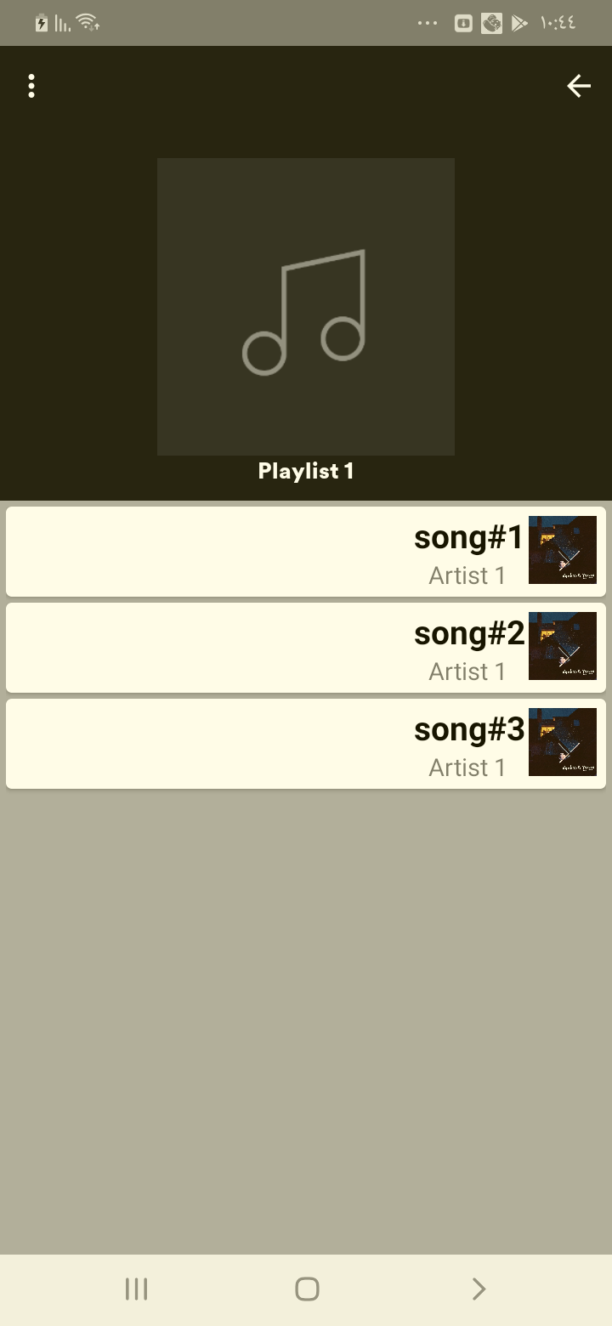

## Test Teardown

[Fixture] setup::0

# Repeat button checking - passed

Checking that the repeat button is visible

## Test Setup

[Fixture] setup

## Test Body

[Attachment] Player page test passed

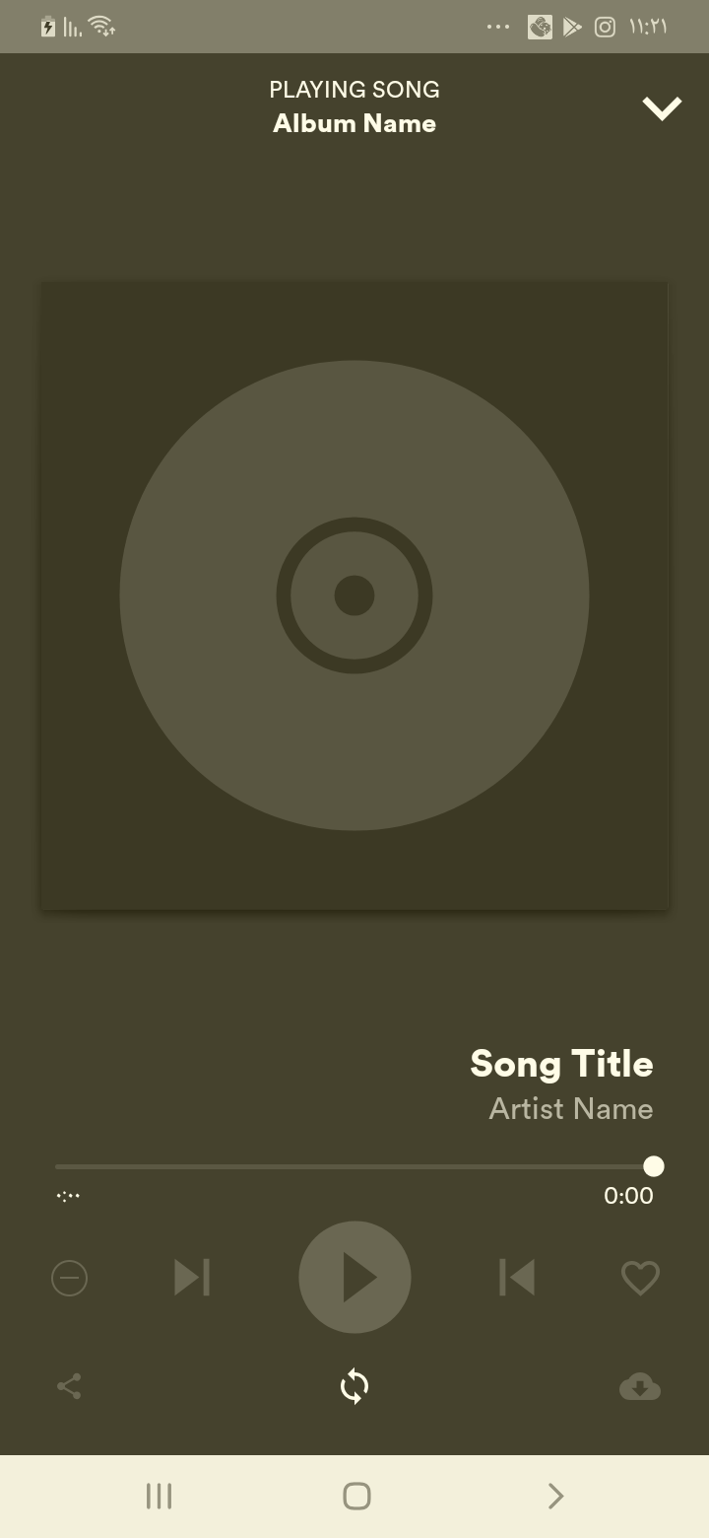

## Test Teardown

[Fixture] setup::0

# Search clicking - passed

Search clicking and check that it works

## Test Setup

[Fixture] setup

## Test Body

[Attachment] Home page test passed

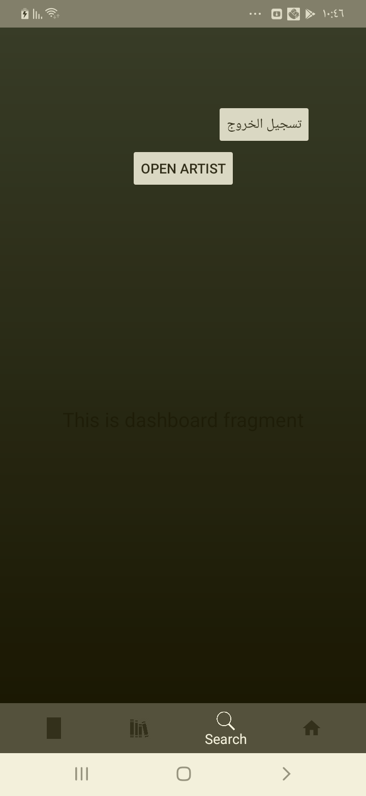

## Test Teardown

[Fixture] setup::0

# Share button checking - passed

Checking that the Share button is visible

## Test Setup

[Fixture] setup

## Test Body

[Attachment] Player page test passed

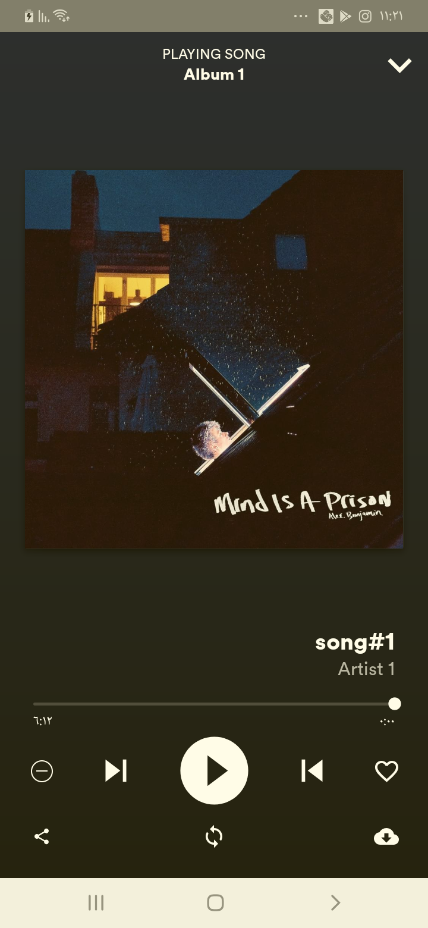

## Test Teardown

[Fixture] setup::0

# Sign up clicking - passed

Clicking the sign up button

## Test Setup

[Fixture] setup

## Test Body

[Attachment] Sign up Page entered

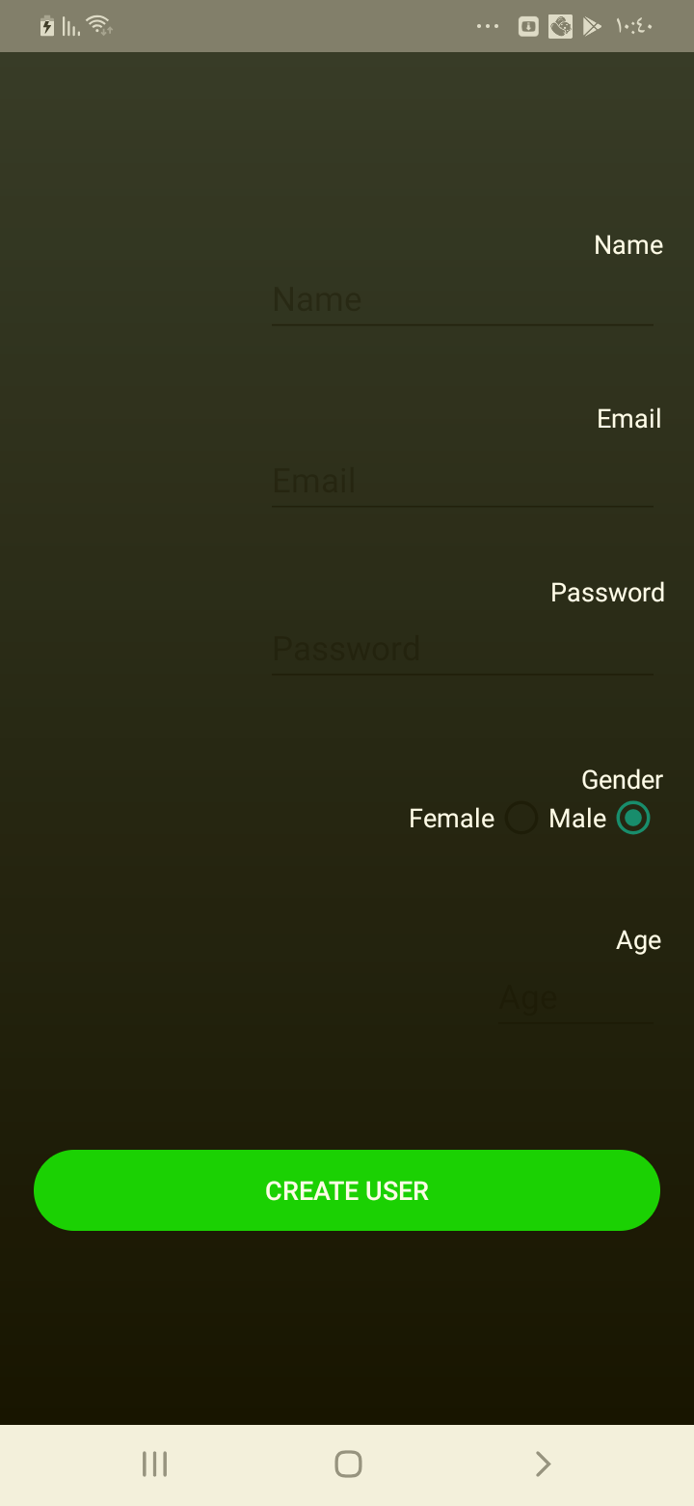

## Test Teardown

[Fixture] setup::0

# Sign up correctly - passed

Signing up with correct format with ,,,22,M

## Test Setup

[Fixture] setup

## Test Body

[Attachment] Sign up test Passed

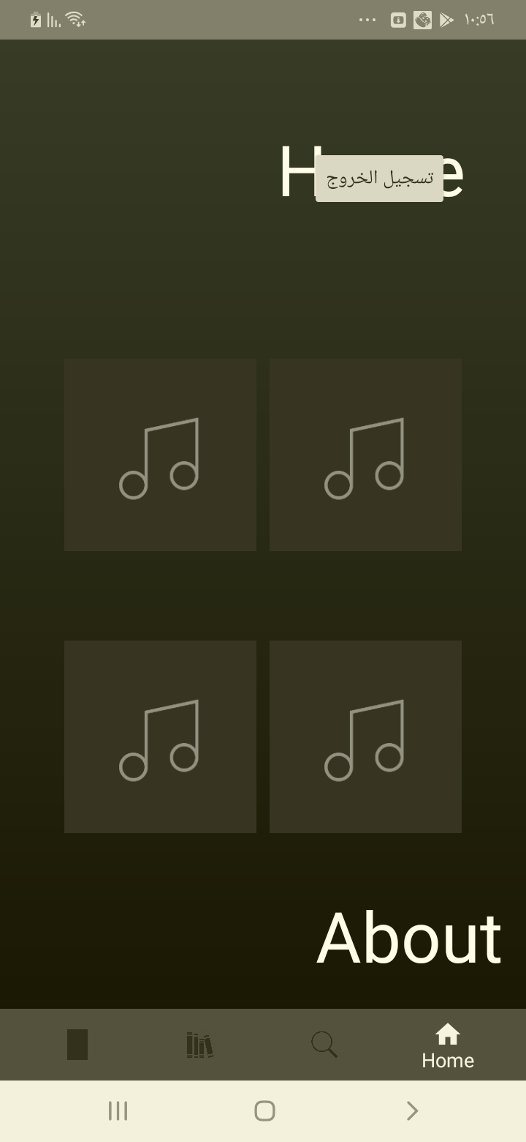

## Test Teardown

[Fixture] setup::0

# Signs up with -ve age - passed

Signs up with -ve age with ,,,-21, M

## Test Setup

[Fixture] setup

## Test Body

[Attachment] Sign up test Passed

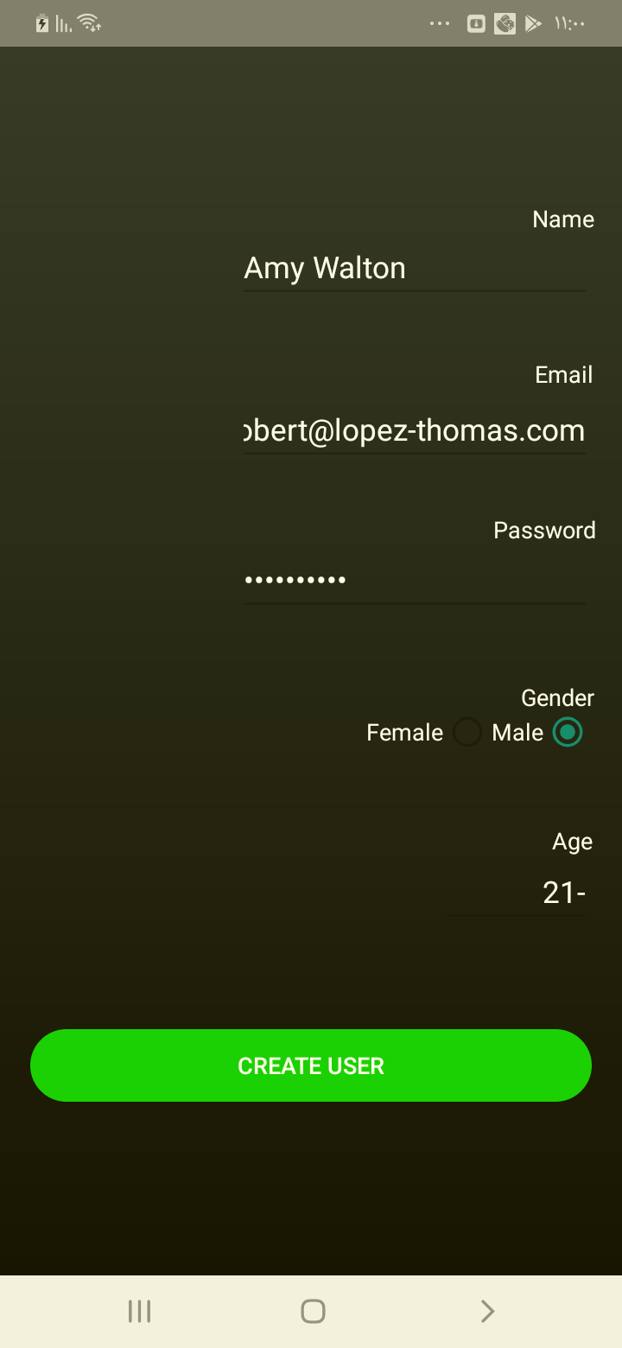

## Test Teardown

[Fixture] setup::0

# Signs up with 0 age - passed

Signs up with 0 age with ,,,0, M

## Test Setup

[Fixture] setup

## Test Body

[Attachment] Sign up test Passed

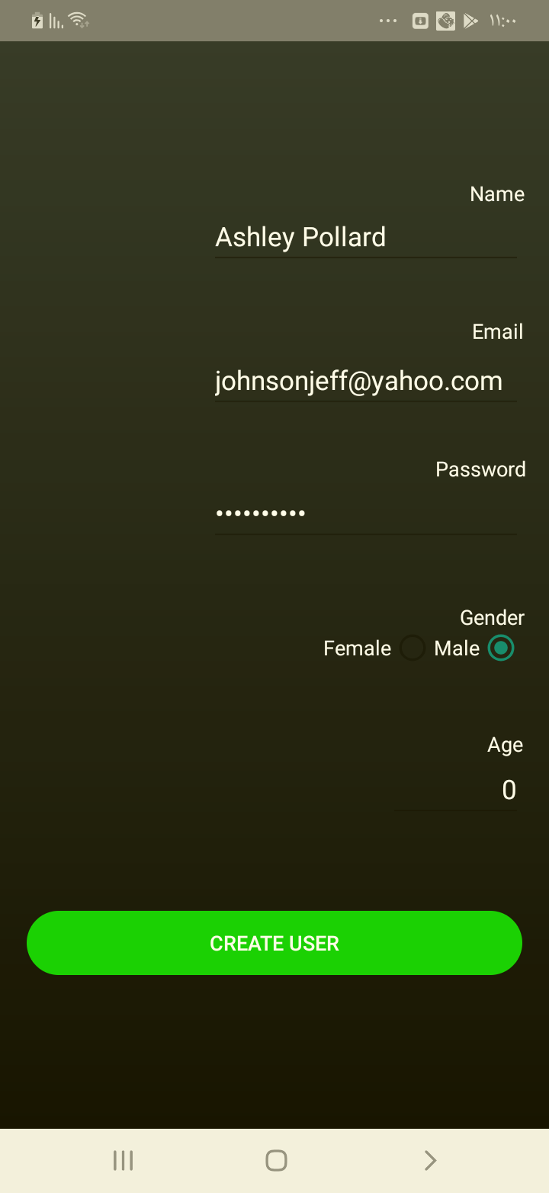

## Test Teardown

[Fixture] setup::0

# Signs up with existing email - passed

Signs up with same email format with ,abdallah@gmail.com,123456,22, M

## Test Setup

[Fixture] setup

## Test Body

[Attachment] Sign up test Passed

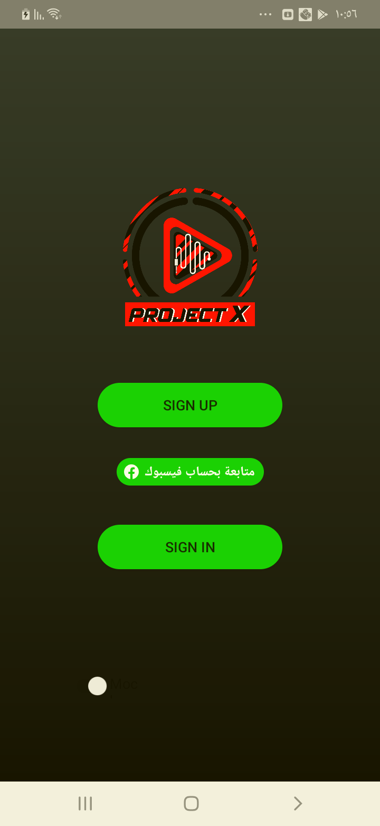

## Test Teardown

[Fixture] setup::0

# Signs up with no age - passed

Signs up with no age format with ,,,, M

## Test Setup

[Fixture] setup

## Test Body

[Attachment] Sign up test Passed

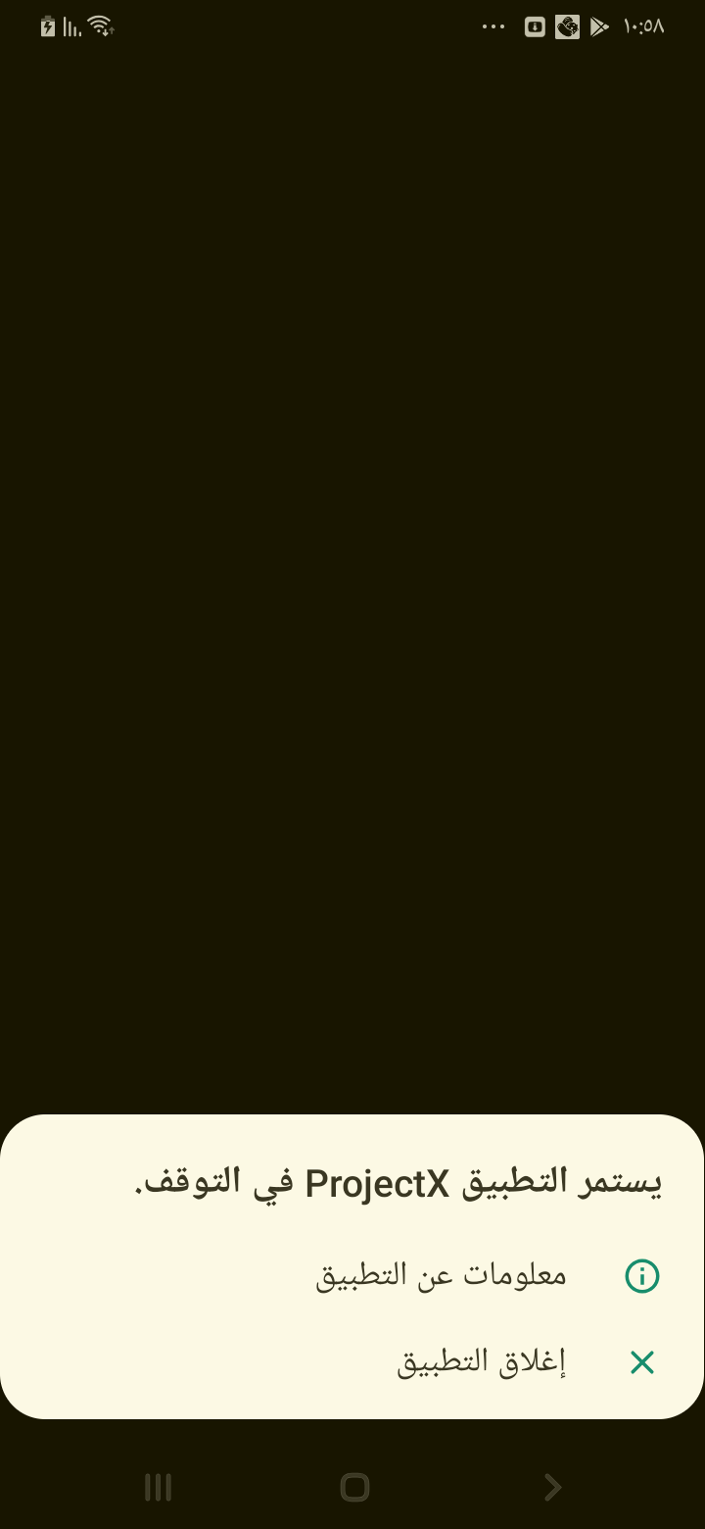

## Test Teardown

[Fixture] setup::0

# Signs up with no email - passed

Signs up with no email format with , ,,22, M

## Test Setup

[Fixture] setup

## Test Body

[Attachment] Sign up test Passed

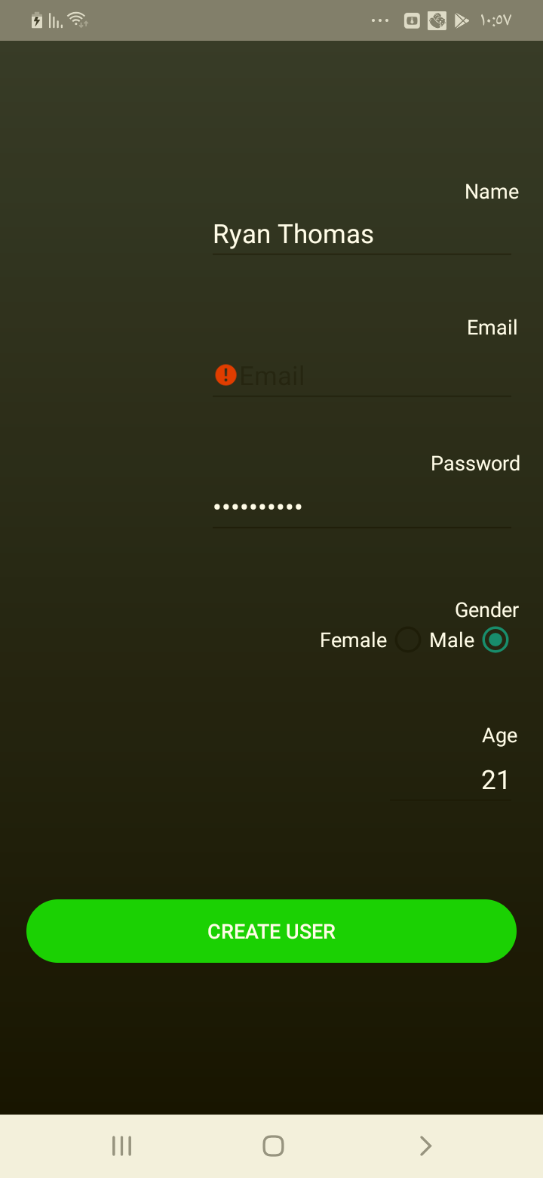

## Test Teardown

[Fixture] setup::0

# Signs up with no name - passed

Signs up with no name format with ,,,22, M

## Test Setup

[Fixture] setup

## Test Body

[Attachment] Sign up test Passed

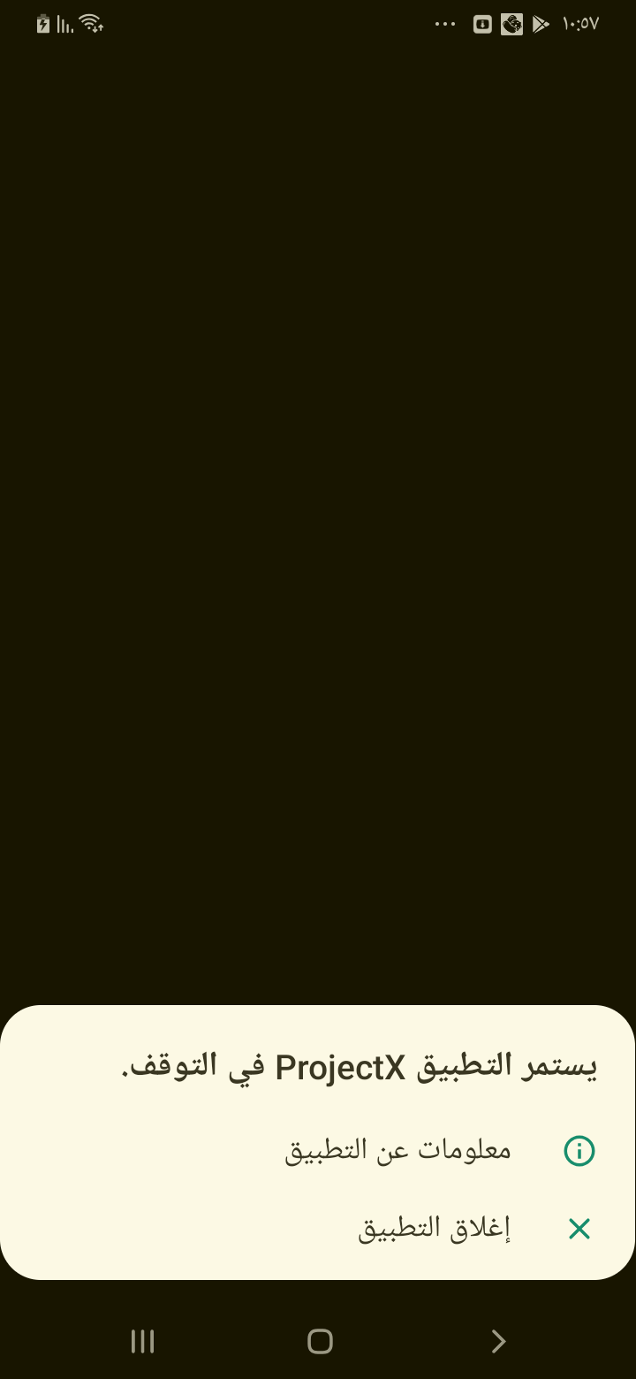

## Test Teardown

[Fixture] setup::0

# Signs up with no password - passed

Signs up with no password format with ,, ,22, M

## Test Setup

[Fixture] setup

## Test Body

[Attachment] Sign up test Passed

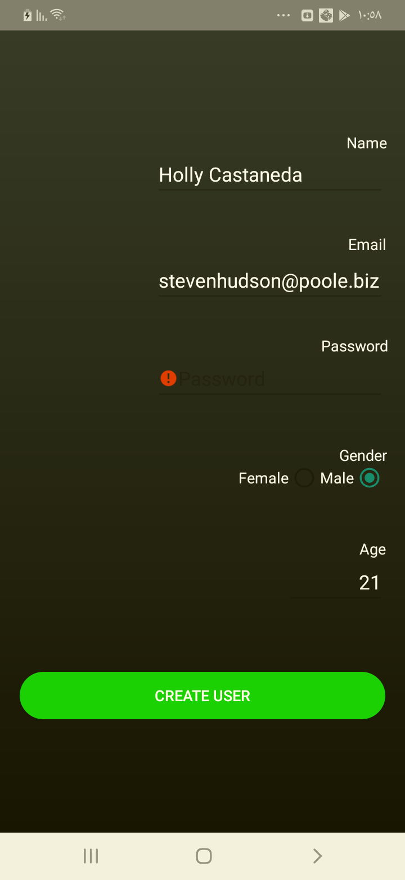

## Test Teardown

[Fixture] setup::0

# Signs up with wrong email format - passed

Signs up with wrong email format with ,,,21, M

## Test Setup

[Fixture] setup

## Test Body

[Attachment] Sign up test Passed

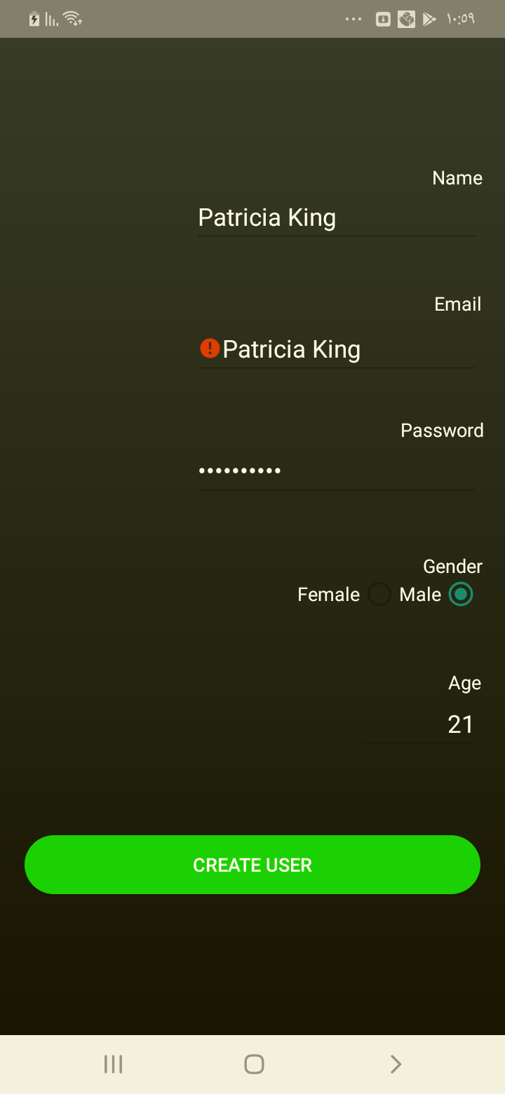

## Test Teardown

[Fixture] setup::0

# checking the artist button - passed

checking the artist button

## Test Setup

[Fixture] setup

## Test Body

[Attachment] Extra test1 passed

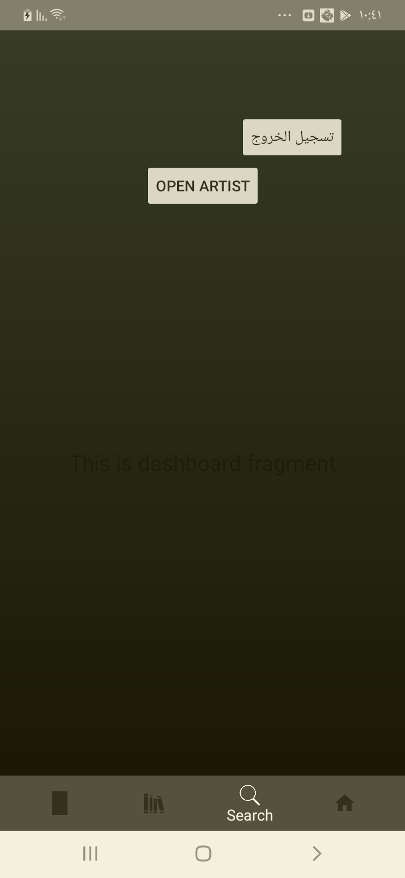

[Attachment] Extra test2 passed

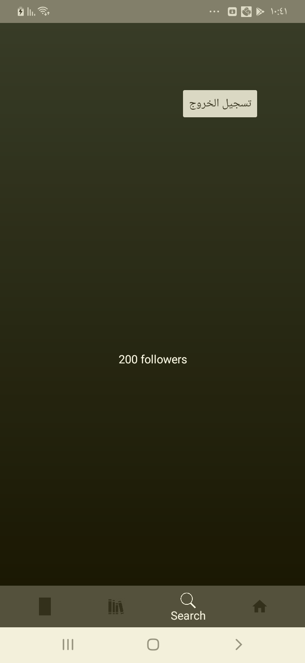

[Attachment] Extra test3 passed

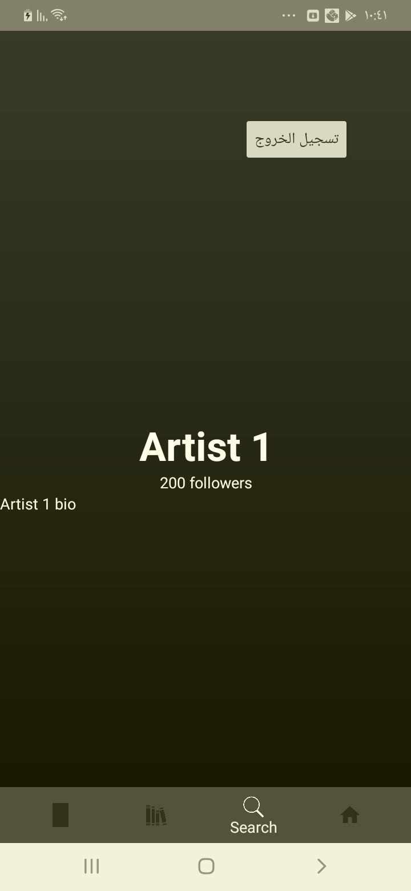

## Test Teardown

[Fixture] setup::0

# Manual Testing Report

**1-First Regarding the Automated tests it was inconsestant and crashed in many cases and that test cases are (Regardless of the failed test/tests )**

**Signup testcases :**

* Signup with No name entered
* Signup with No age entered
* Signup with already registered email
* Signup with wrong name format i.e:“!@!@#!@#“
* Signup with large age number i.e : “999“

**2-Before running the app I had to add Clear text explicit enable line to support android 9+**

**3-Loading sometime takes huge time and the the user keeps on getting no network connection even though the buttouns are visible and clickable, I think it would be great to add loading effect in that time to increase convenince.**

**4-Logout button out of place**

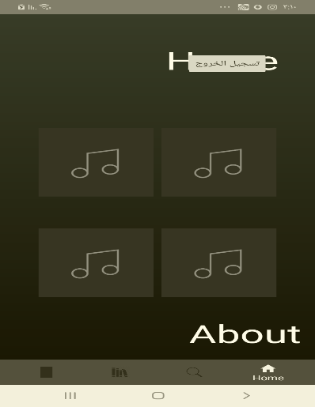

**5-Artist picture stays on the backgroung after going back from artist bio:**

**To reproduce the issue**

* **Login to the app**
* **Click search**
* **Click open artist**
* **Click artist picture**
* **Click artist bio**
* **Click back button(on the phone)**
* **Click home button (on the app)**

**6- Only the play , share , next , previous button are functional in the music player**

**7- Song keeps on playing after logout**

**8-Login Error message doesnot appear, it would be great to show a message saying chaeck entered data**