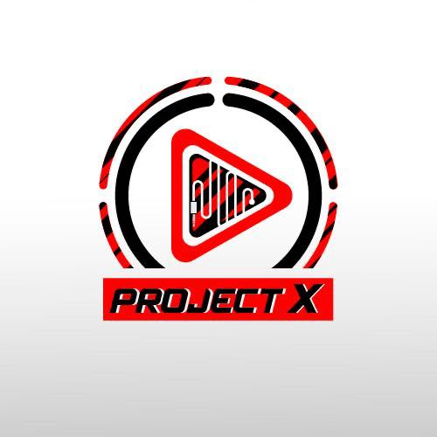

Login

Test Report

Test Session Summary

|  |  |
| --- | --- |
| Start: Thu Jun 11 20:28:30 2020 End: Thu Jun 11 20:31:35 2020 Duration: 0:03:04.776000  broken: 0 (0.00%) failed: 0 (0.00%) skipped: 0 (0.00%) passed: 4 (100.00%) |  |

Test Results

# Checking first album - passed

Checking first album exists and is click-able

## Test Setup

[Fixture] setup

## Test Body

[Attachment] first album exists

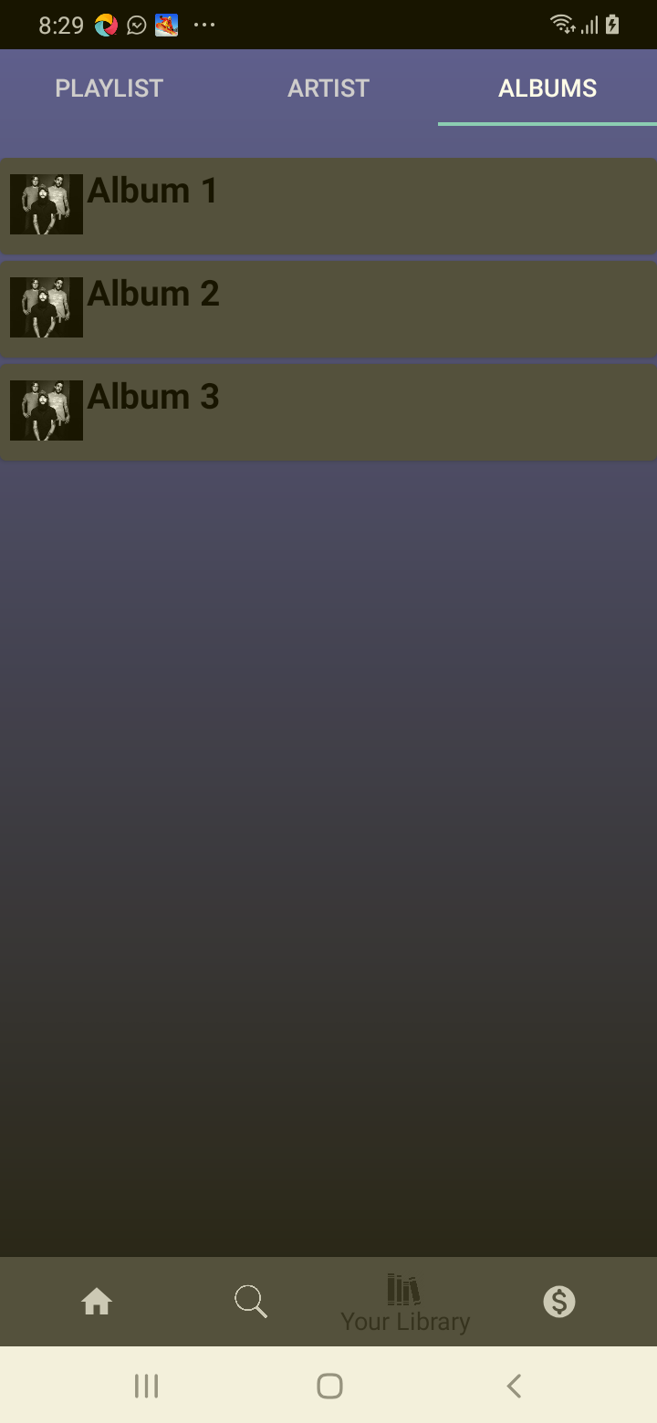

## Test Teardown

[Fixture] setup::0

# Checking first song - passed

Checking first song exists and is click-able

## Test Setup

[Fixture] setup

## Test Body

[Attachment] first song exists

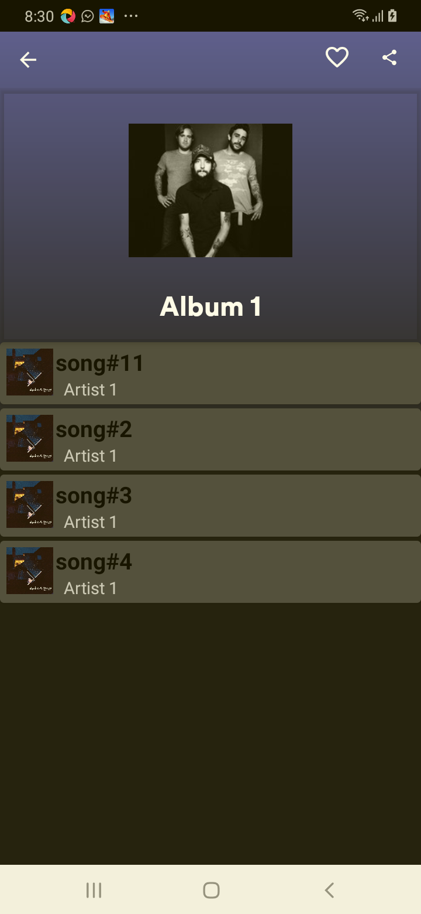

## Test Teardown

[Fixture] setup::0

# Checking like - passed

Checking like exists and is click-able

## Test Setup

[Fixture] setup

## Test Body

[Attachment] like exists

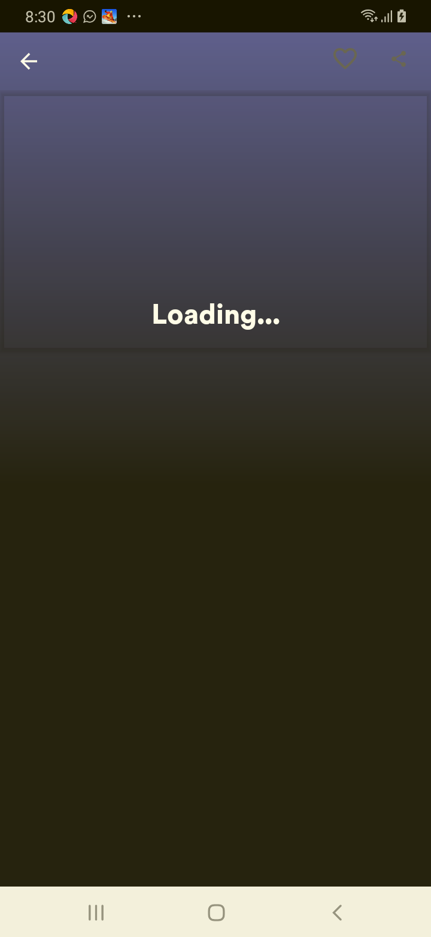

## Test Teardown

[Fixture] setup::0

# Checking share - passed

Checking share exists and is click-able

## Test Setup

[Fixture] setup

## Test Body

[Attachment] share exists

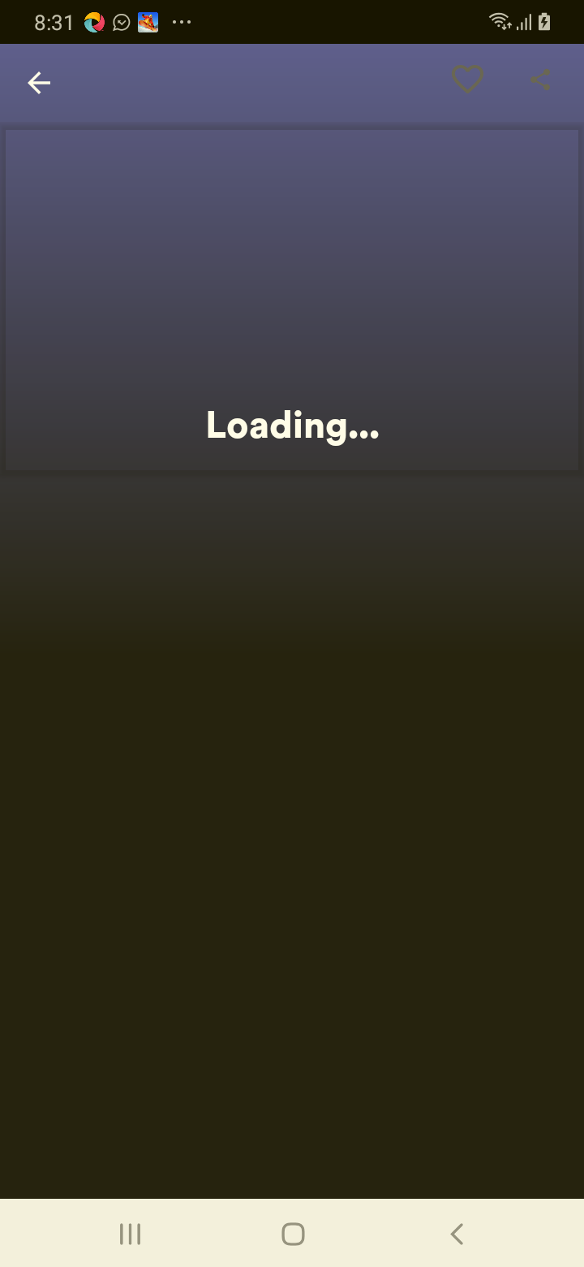

## Test Teardown

[Fixture] setup::0