

Mobile

Test Report

Test Session Summary

|  |  |
| --- | --- |
| Start: Thu Jun 11 07:14:56 2020 End: Thu Jun 11 07:32:49 2020 Duration: 0:17:52.207000  broken: 0 (0.00%) failed: 1 (3.70%) skipped: 0 (0.00%) passed: 26 (96.30%) |  |

Test Results

# Checking premium family box - failed

Checking premium family box exists

## Details

AssertionError: assert False

|  |
| --- |
| self = <test_premium.TestPremium object at 0x10c51d5e0>, setup = None   @allure.severity(allure.severity_level.CRITICAL)  @allure.story("Premium Tests")  @allure.sub_suite("Checking premium family box")  @allure.title("Checking premium family box")  @allure.description("Checking premium family box exists")  @pytest.mark.Do  @pytest.mark.Premium  @pytest.mark.Test9  def test_case_9(self, setup):  """  Checks that the premium family box exists  """  ap = AuthenticationPage(self.driver)  ap.click_signin_button()  lp = LoginPage(self.driver)  lp.do_the_login(Constants.correct_credentials["email"], Constants.correct_credentials["password"])  time.sleep(10)  hp = HomePage(self.driver)  hp.click_premium_button()  pp = PremiumPage(self.driver)  time.sleep(10)  if pp.premium_family_box():  Helper.report_allure(self.driver, "premium family box exists")  assert True  else:  print(self.driver.current_activity)  Helper.report_allure(self.driver, "premium family box does not exists") > assert False E assert False  Mobile_Testing/Tests/test_premium.py:337: AssertionError |

## Test Setup

[Fixture] setup

## Test Body

[Attachment] premium family box does not exists

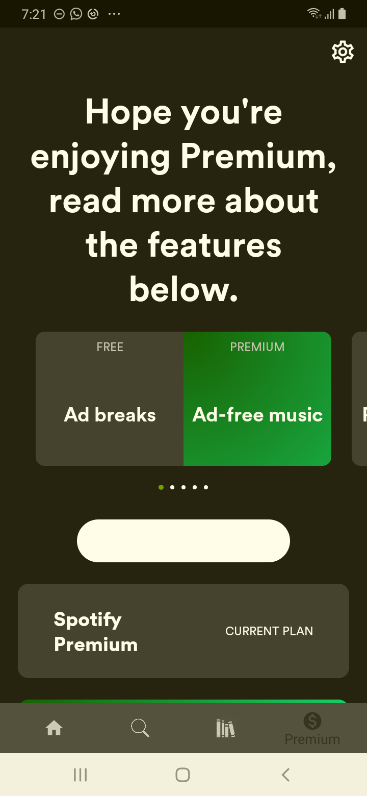

[Attachment] stdout

## Test Teardown

[Fixture] setup::0

# Checking delete track - passed

Checking delete track exists

## Test Setup

[Fixture] setup

## Test Body

[Attachment] delete track exists

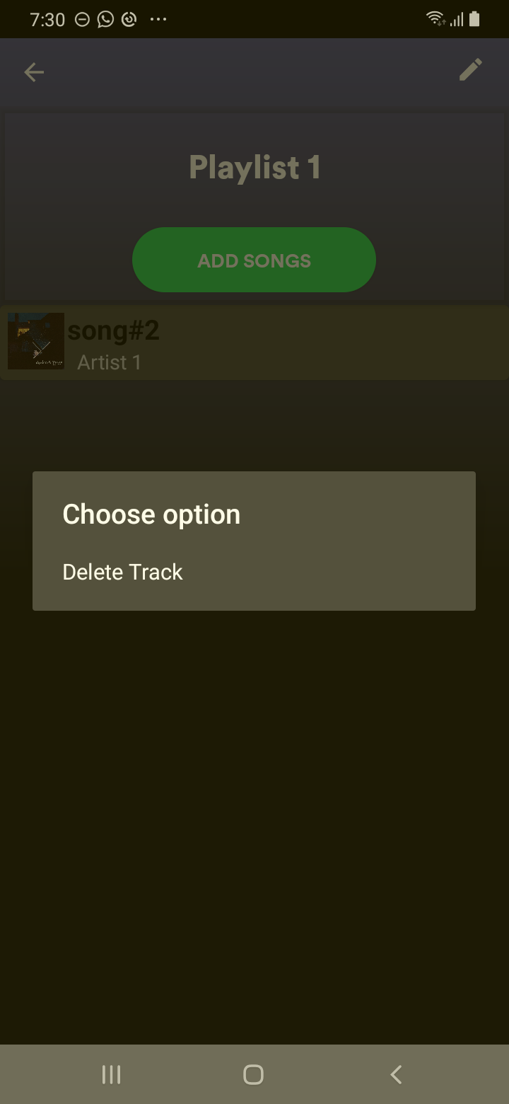

## Test Teardown

[Fixture] setup::0

# Checking rename - passed

Checking rename exists

## Test Setup

[Fixture] setup

## Test Body

[Attachment] rename exists

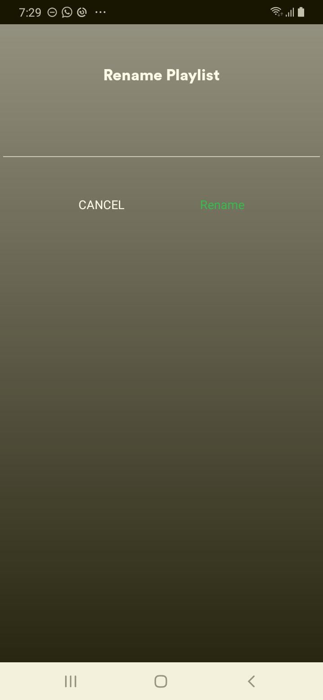

## Test Teardown

[Fixture] setup::0

# Checking ad breaks | ad free music box - passed

Checking ad breaks | ad free music box exists

## Test Setup

[Fixture] setup

## Test Body

[Attachment] break box exists

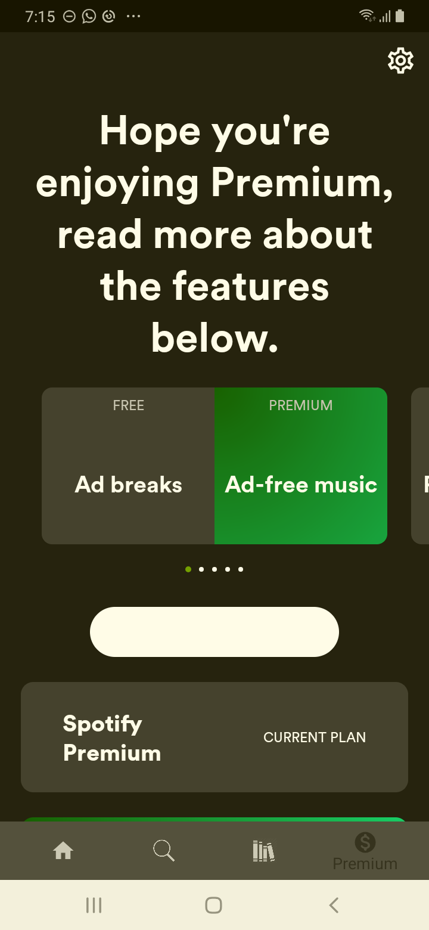

## Test Teardown

[Fixture] setup::0

# Checking cancel button - passed

Checking cancel button exists

## Test Setup

[Fixture] setup

## Test Body

[Attachment] cancel button exist

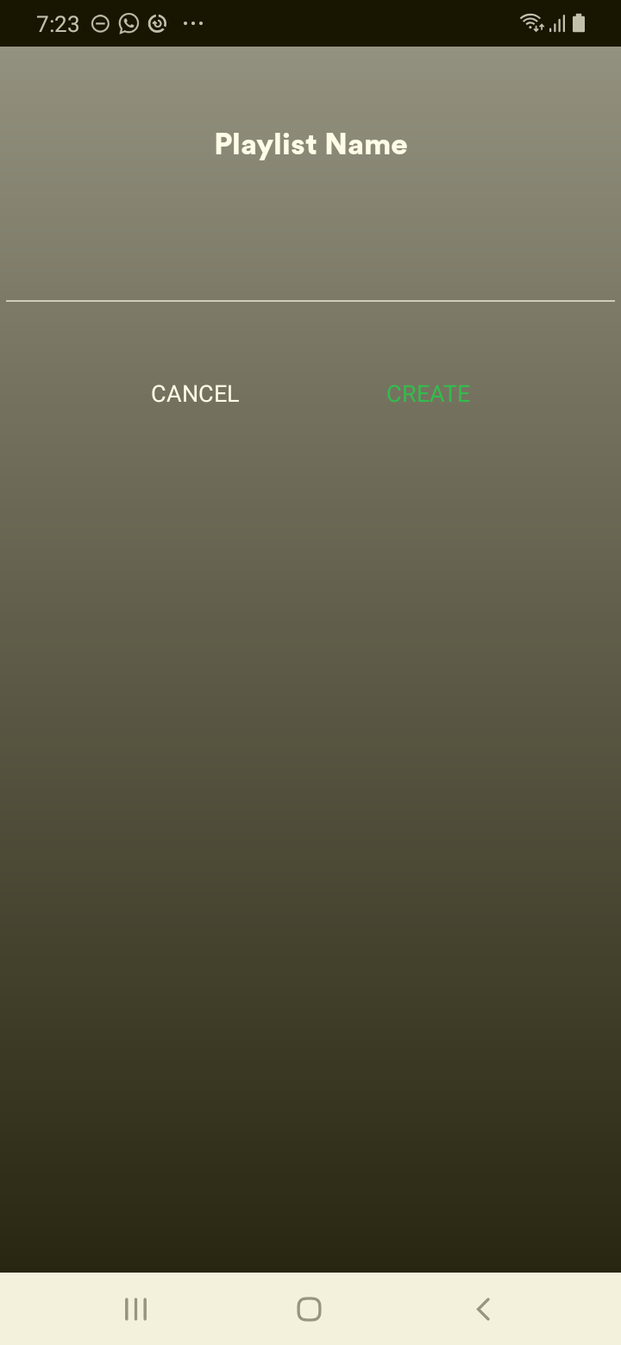

## Test Teardown

[Fixture] setup::0

# Checking cancel rename - passed

Checking cancel rename exists

## Test Setup

[Fixture] setup

## Test Body

[Attachment] cancel rename exists

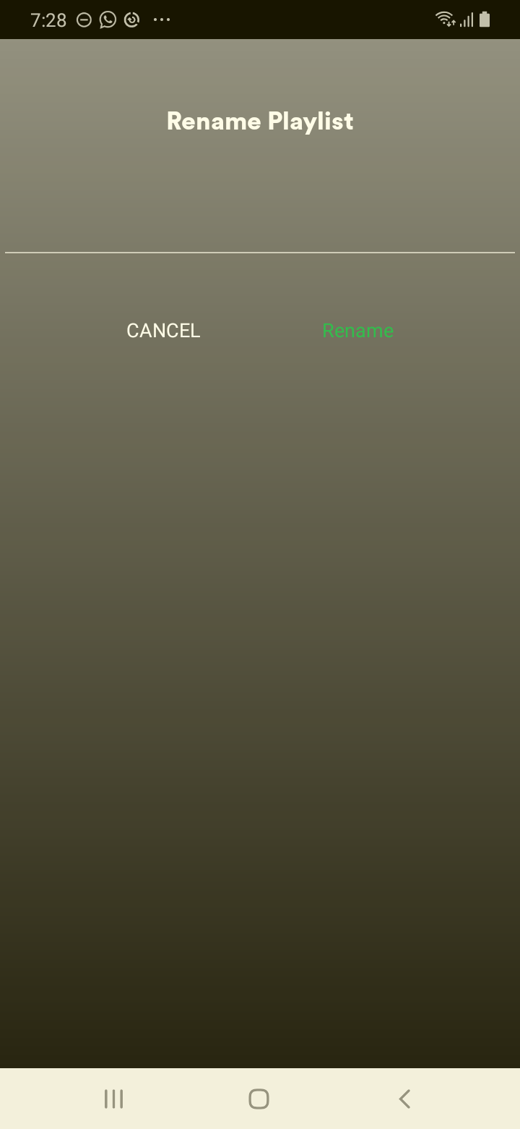

## Test Teardown

[Fixture] setup::0

# Checking create playlist - passed

Checking create playlist

## Test Setup

[Fixture] setup

## Test Body

[Attachment] Creation done

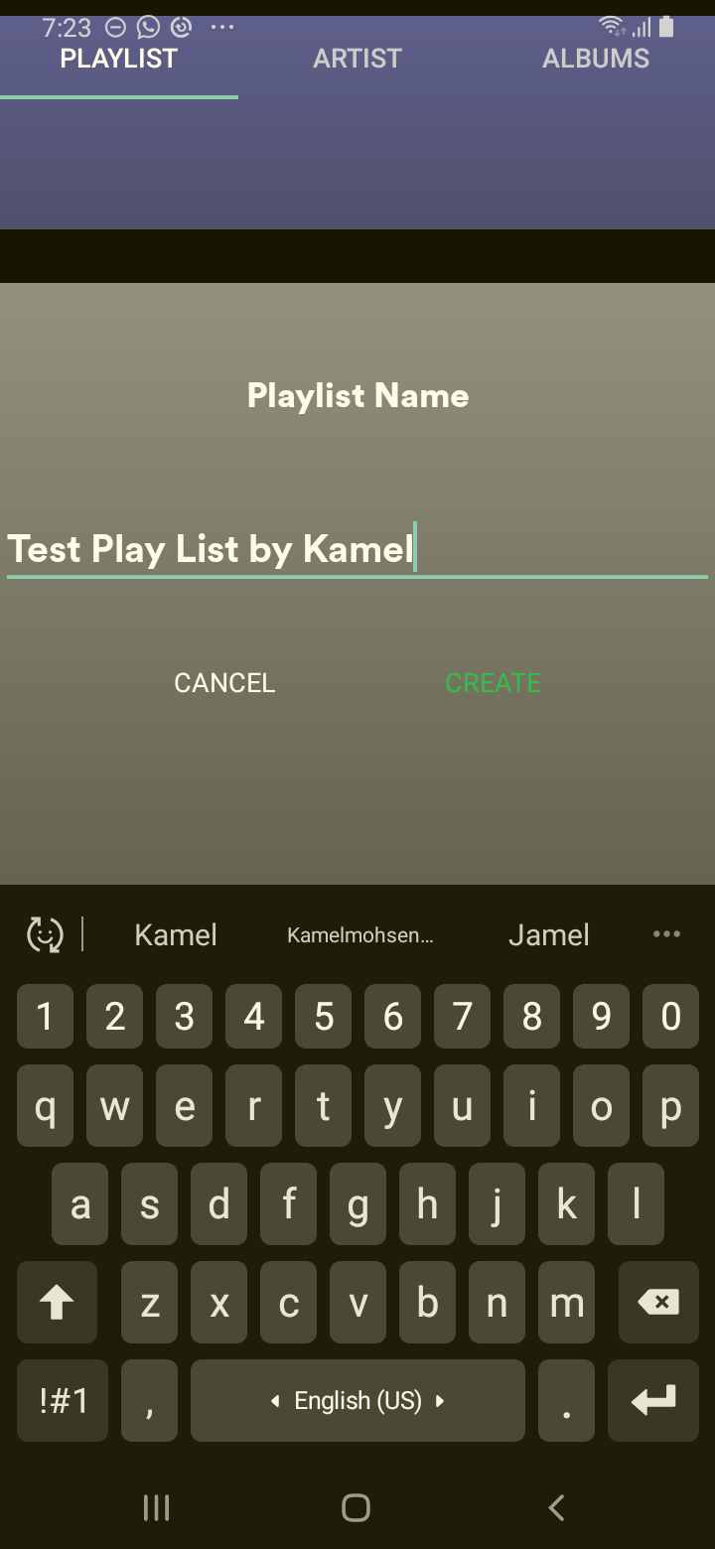

## Test Teardown

[Fixture] setup::0

# Checking create playlist button - passed

Checking create playlist button exists

## Test Setup

[Fixture] setup

## Test Body

[Attachment] create button exist

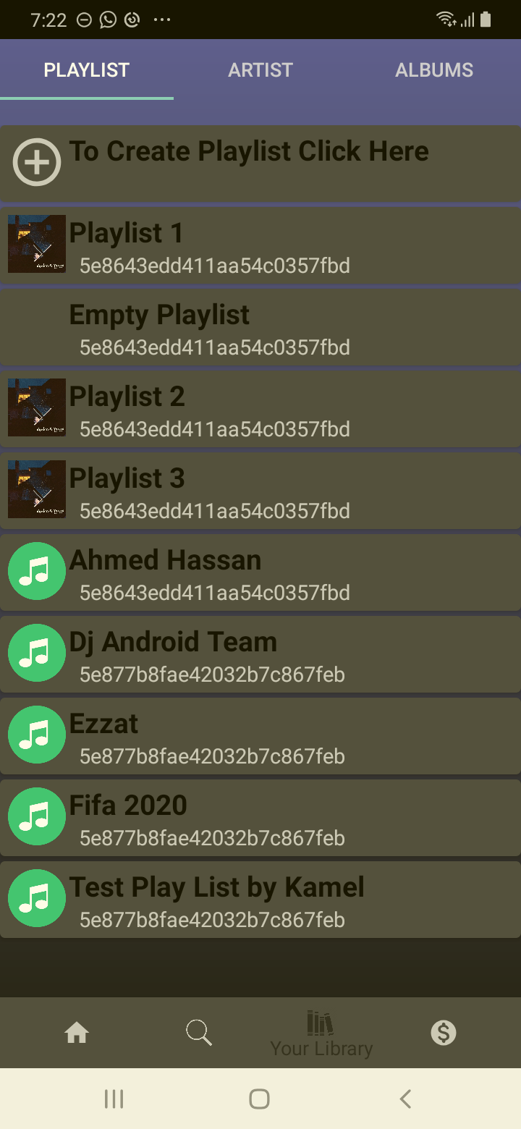

## Test Teardown

[Fixture] setup::0

# Checking first album - passed

Checking first album exists and is click-able

## Test Setup

[Fixture] setup

## Test Body

[Attachment] first album exists

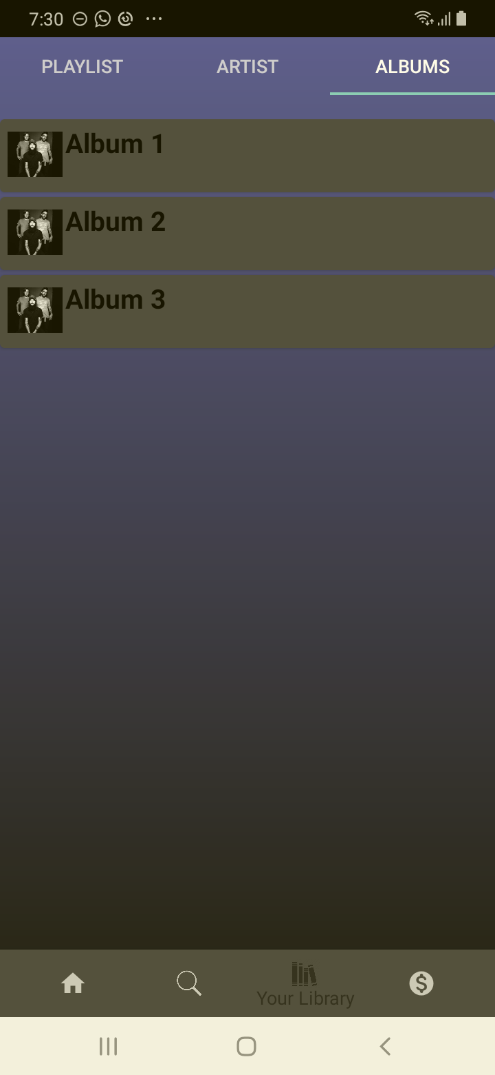

## Test Teardown

[Fixture] setup::0

# Checking first song - passed

Checking first song exists and is click-able

## Test Setup

[Fixture] setup

## Test Body

[Attachment] first song exists

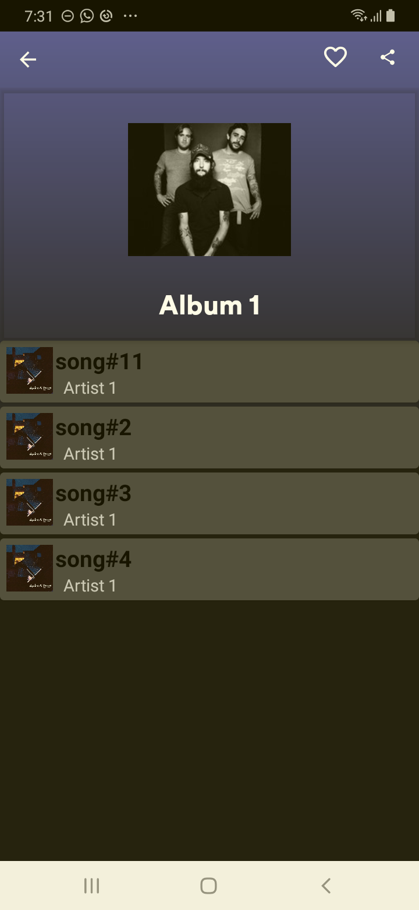

## Test Teardown

[Fixture] setup::0

# Checking first song in edit playlist - passed

Checking first song in edit exists

## Test Setup

[Fixture] setup

## Test Body

[Attachment] first song in edit exists

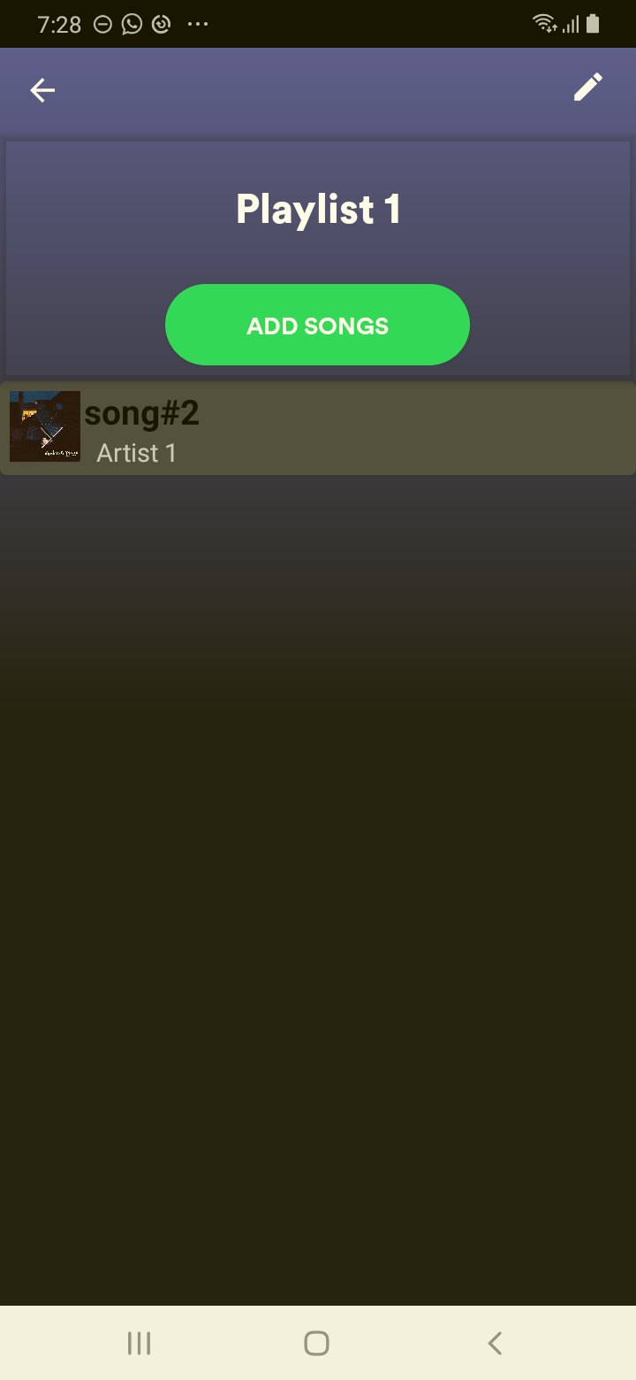

## Test Teardown

[Fixture] setup::0

# Checking free box - passed

Checking free box exists

## Test Setup

[Fixture] setup

## Test Body

[Attachment] free box exists

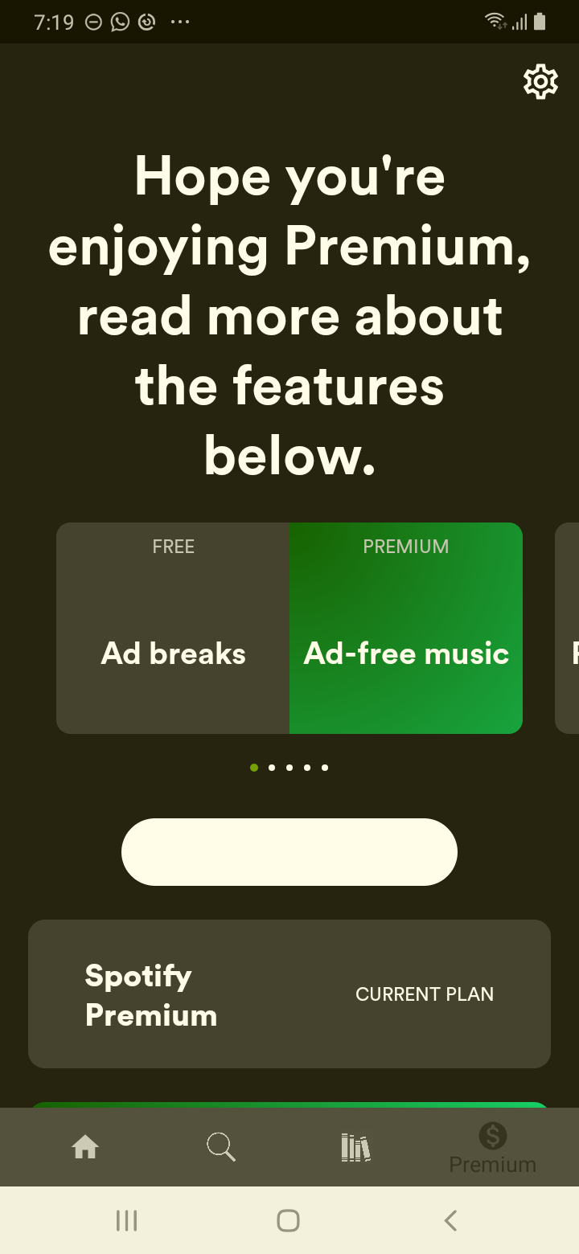

## Test Teardown

[Fixture] setup::0

# Checking get premium button - passed

Checking get premium button exists

## Test Setup

[Fixture] setup

## Test Body

[Attachment] get premium button exists

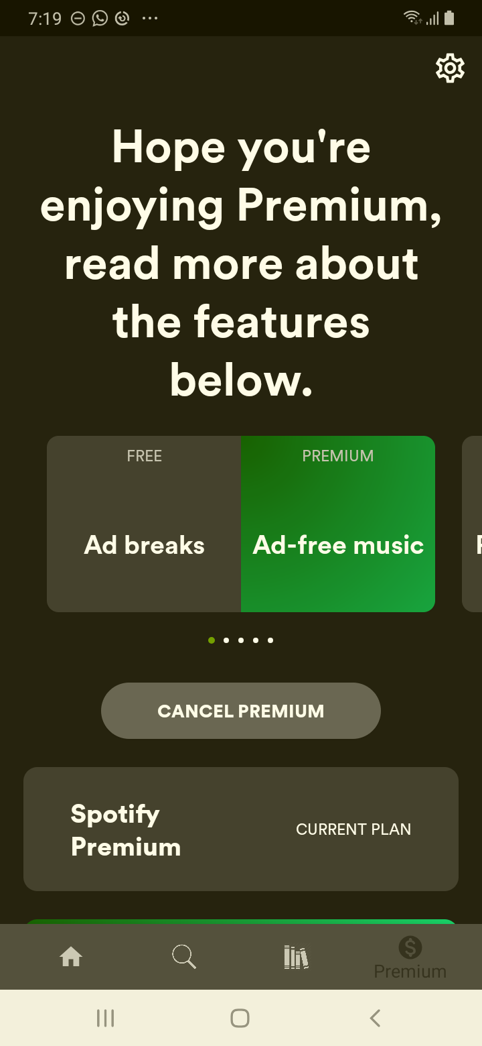

## Test Teardown

[Fixture] setup::0

# Checking high audio quality box - passed

Checking high audio quality exists

## Test Setup

[Fixture] setup

## Test Body

[Attachment] high audio quality box exists

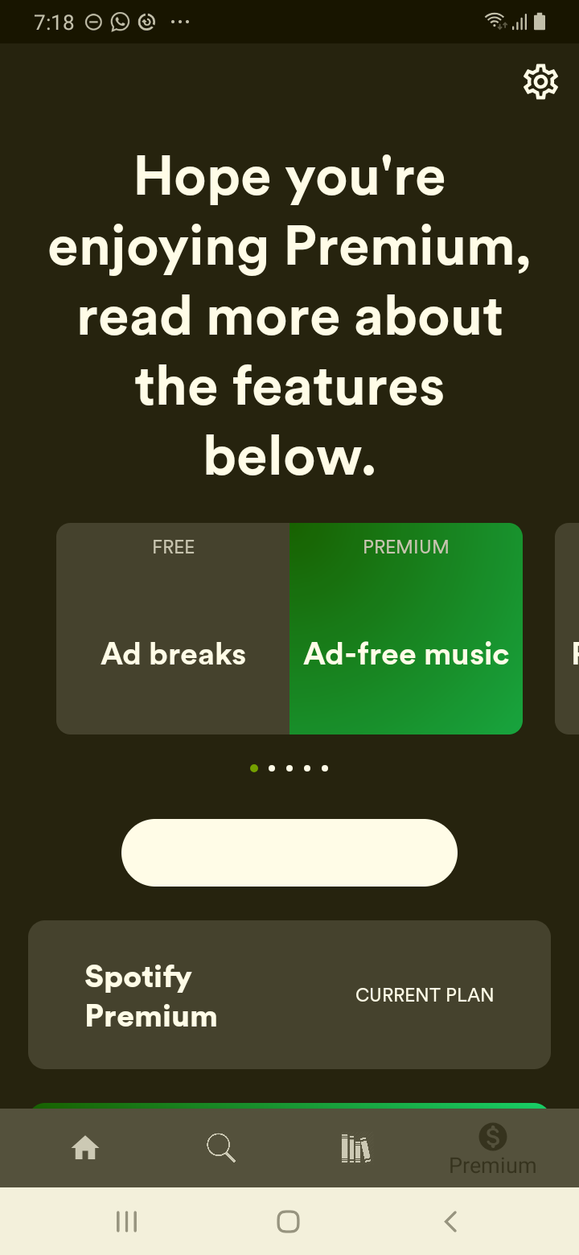

## Test Teardown

[Fixture] setup::0

# Checking like - passed

Checking like exists and is click-able

## Test Setup

[Fixture] setup

## Test Body

[Attachment] like exists

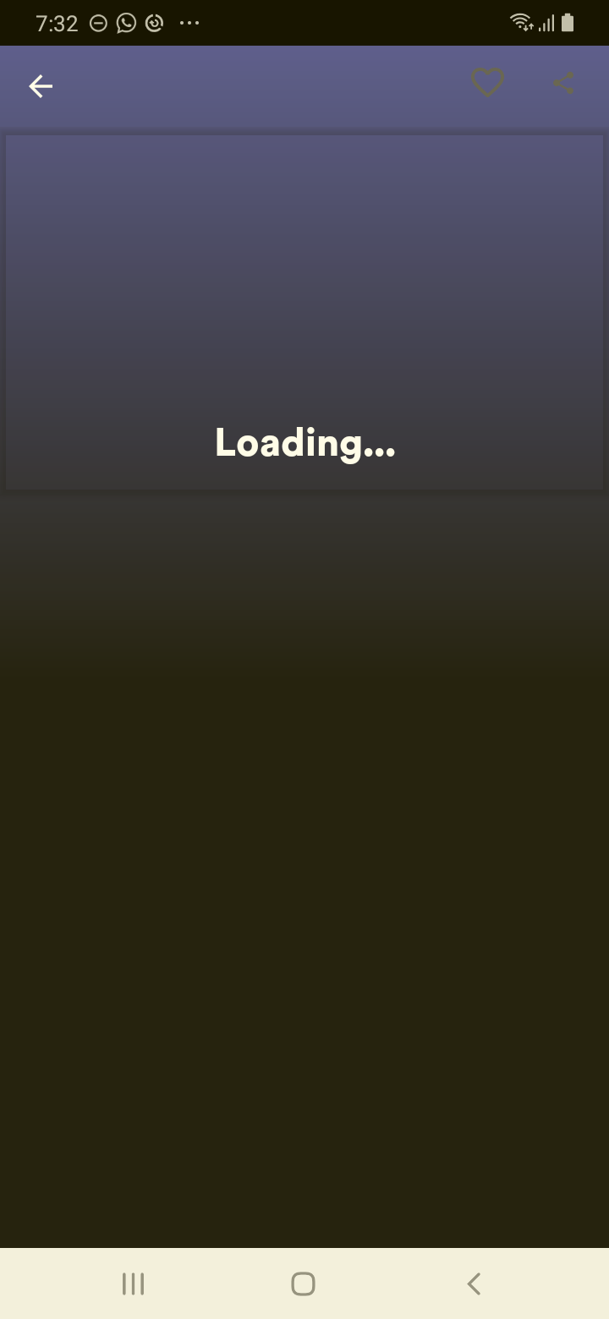

## Test Teardown

[Fixture] setup::0

# Checking offline listening box - passed

Checking offline listening exists

## Test Setup

[Fixture] setup

## Test Body

[Attachment] offline listening box exists

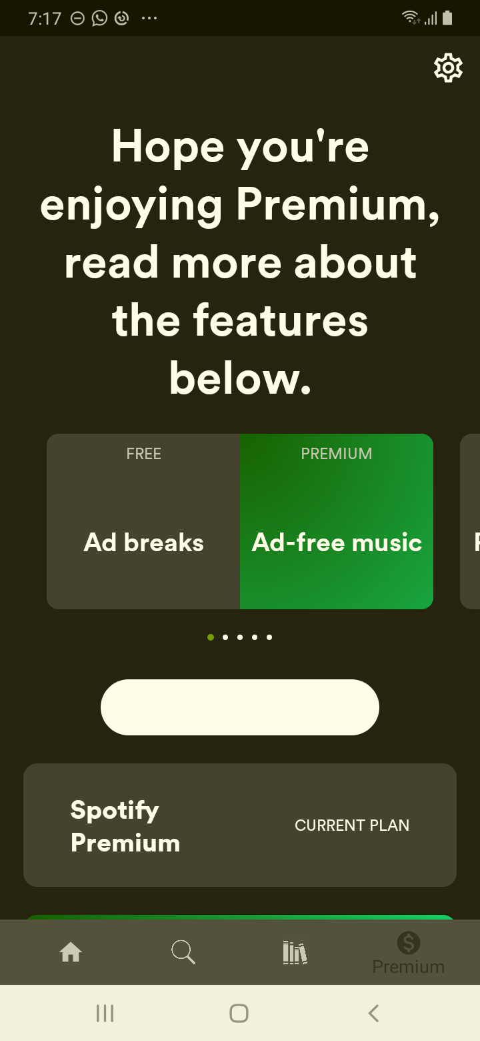

## Test Teardown

[Fixture] setup::0

# Checking play in shuffle box - passed

Checking play in shuffle box exists

## Test Setup

[Fixture] setup

## Test Body

[Attachment] play in shuffle box exists

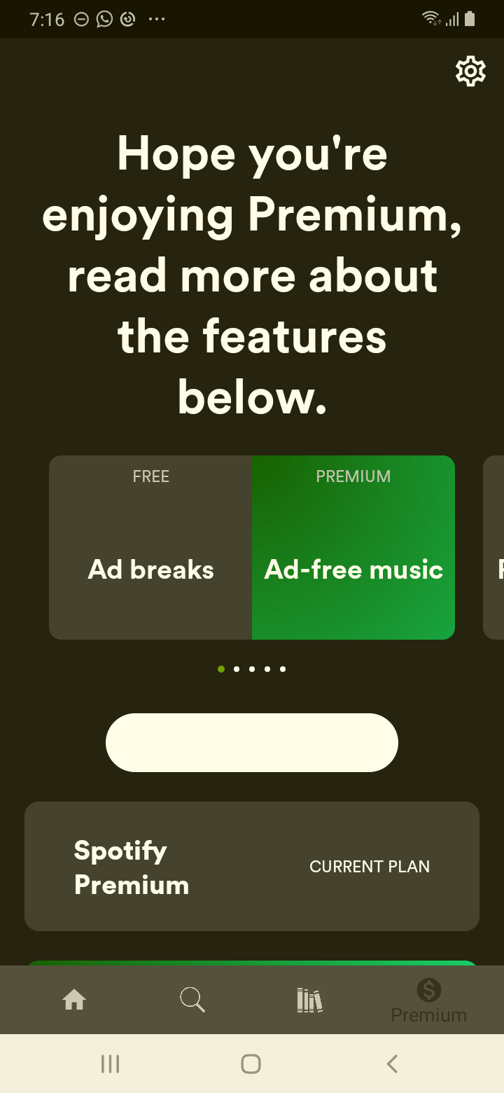

## Test Teardown

[Fixture] setup::0

# Checking premium individual box - passed

Checking premium individual box exists

## Test Setup

[Fixture] setup

## Test Body

[Attachment] premium individual box exists

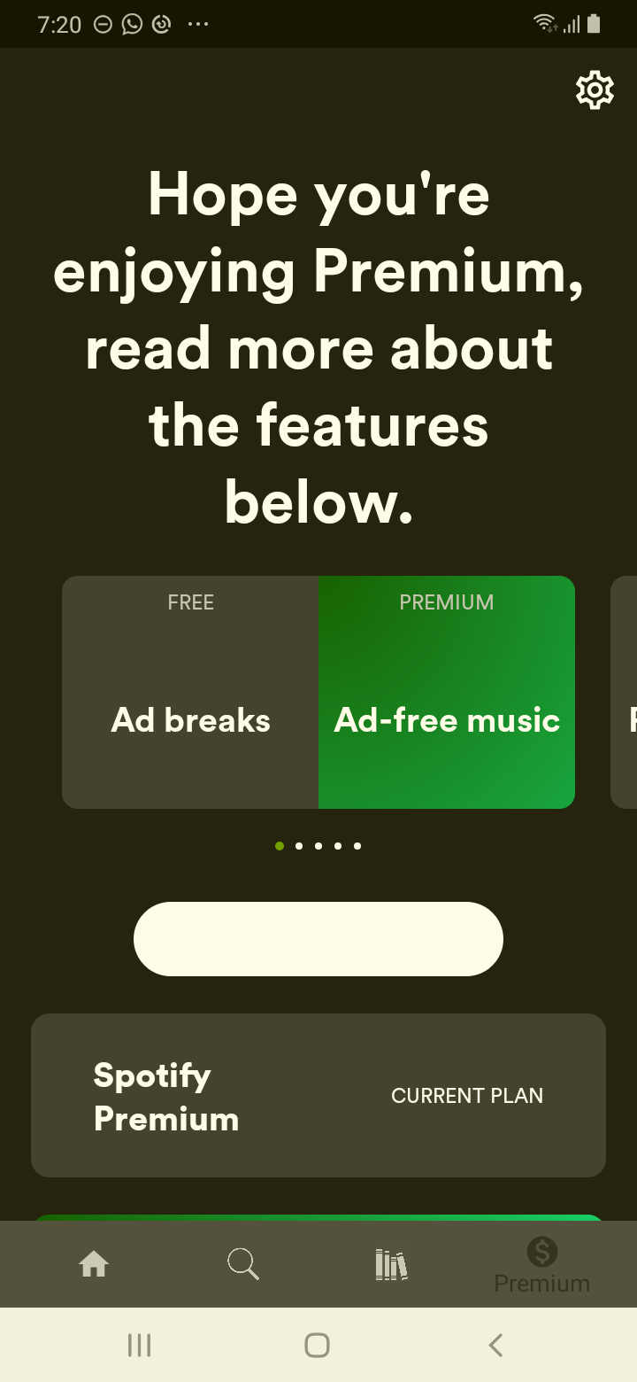

## Test Teardown

[Fixture] setup::0

# Checking save button - passed

Checking save button exists

## Test Setup

[Fixture] setup

## Test Body

[Attachment] save button exist

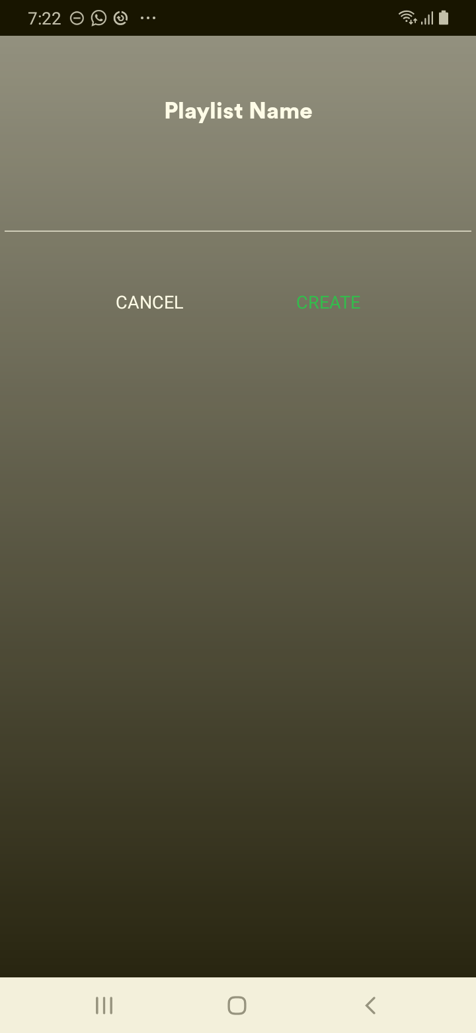

## Test Teardown

[Fixture] setup::0

# Checking share - passed

Checking share exists and is click-able

## Test Setup

[Fixture] setup

## Test Body

[Attachment] share exists



## Test Teardown

[Fixture] setup::0

# Checking the add song - passed

Checking the add song exists

## Test Setup

[Fixture] setup

## Test Body

[Attachment] add song exists

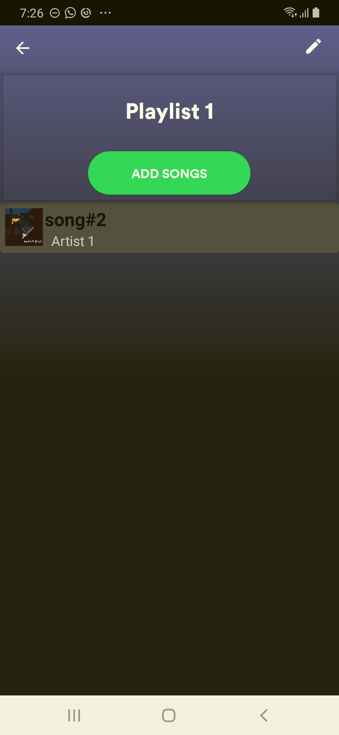

## Test Teardown

[Fixture] setup::0

# Checking the edit - passed

Checking the edit exists

## Test Setup

[Fixture] setup

## Test Body

[Attachment] edit exists

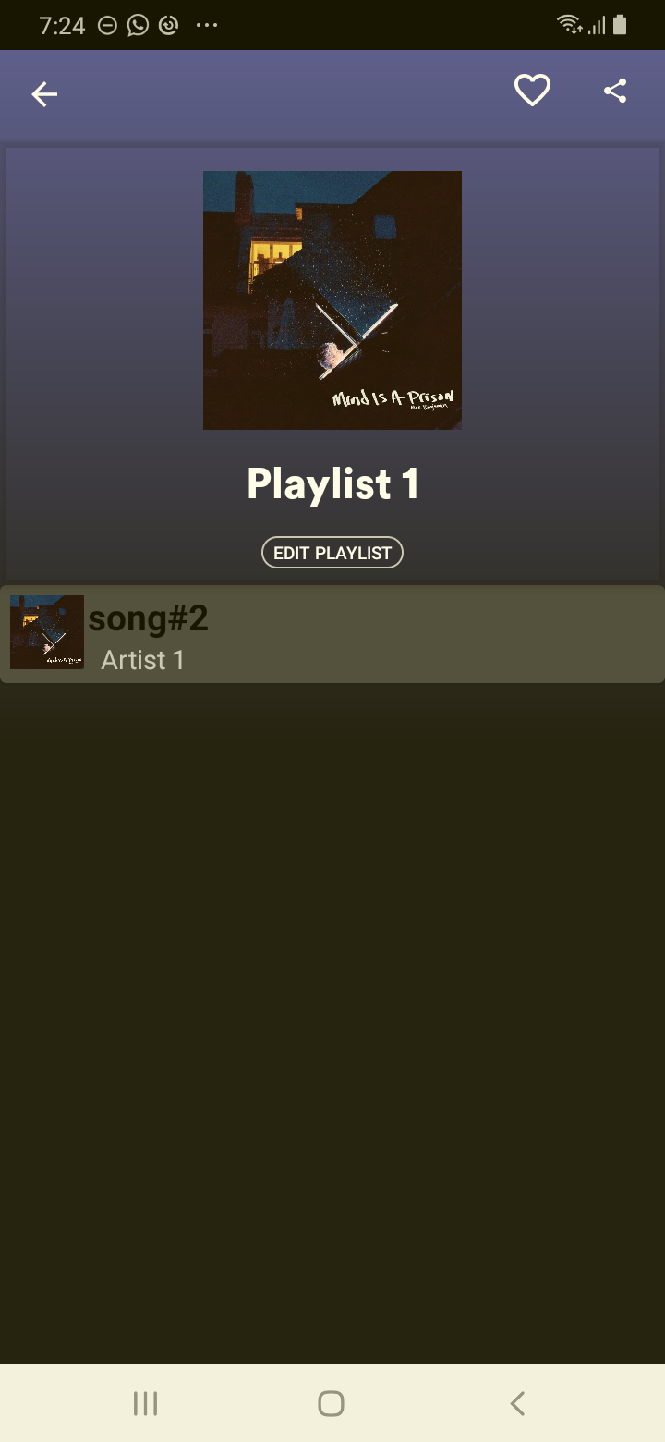

## Test Teardown

[Fixture] setup::0

# Checking the edit playlist - passed

Checking the edit playlist exists

## Test Setup

[Fixture] setup

## Test Body

[Attachment] edit playlist exists

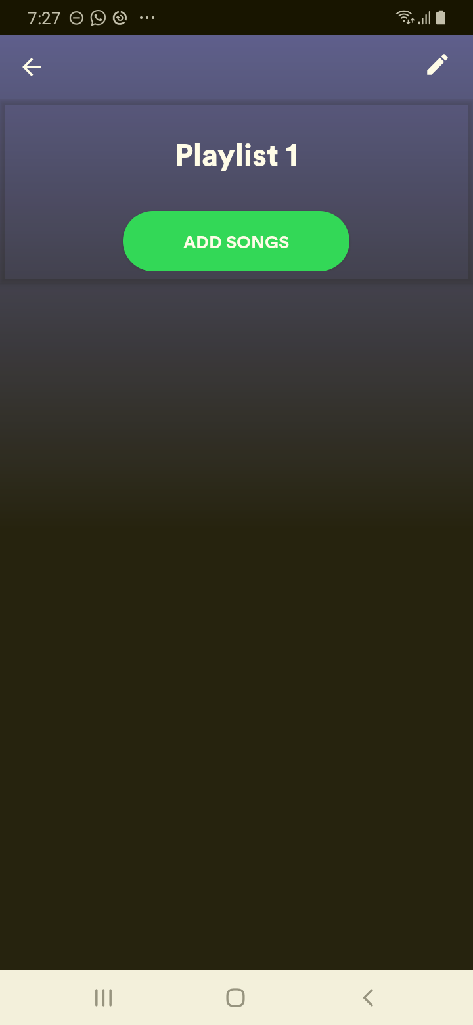

## Test Teardown

[Fixture] setup::0

# Checking the first playlist - passed

Checking the first playlist exists

## Test Setup

[Fixture] setup

## Test Body

[Attachment] first play list exists

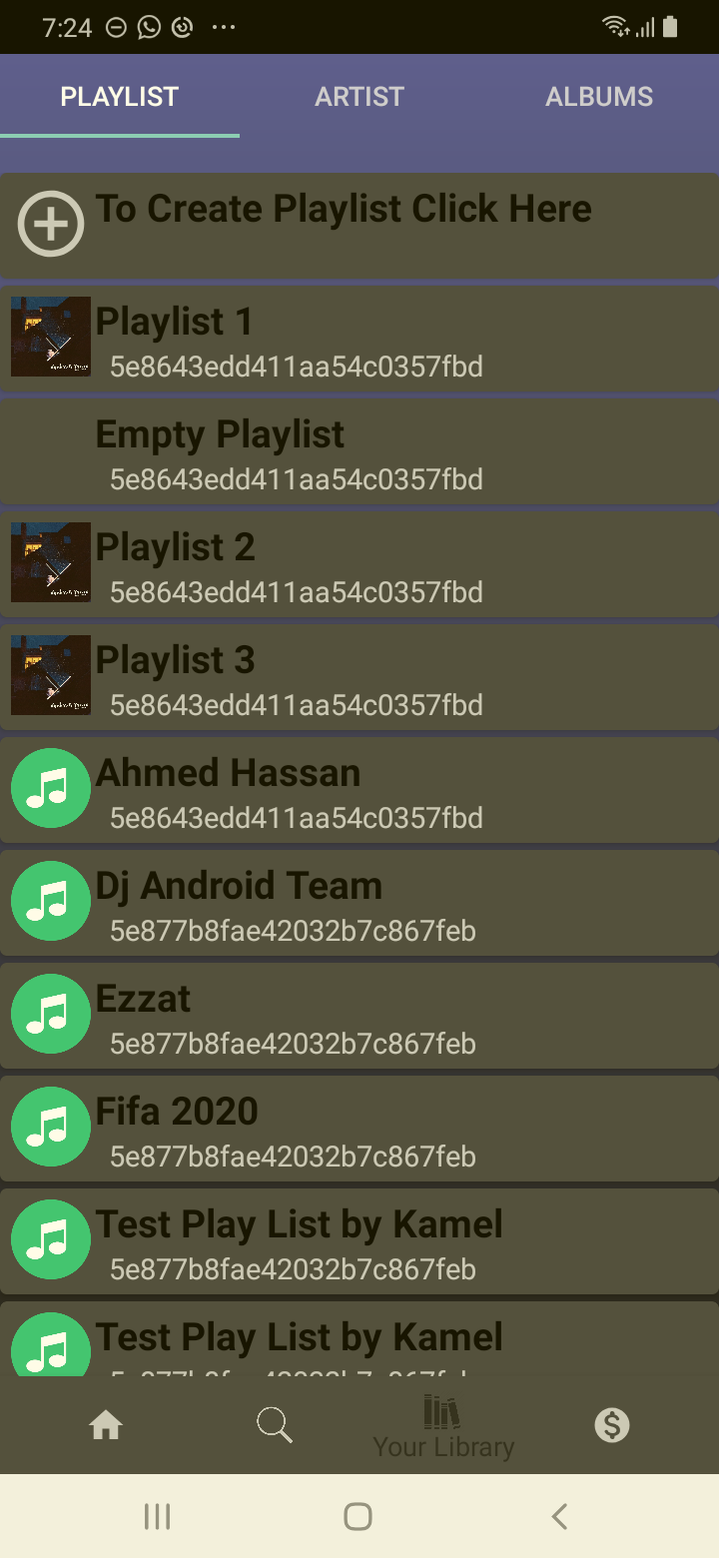

## Test Teardown

[Fixture] setup::0

# Checking the like - passed

Checking the like exists

## Test Setup

[Fixture] setup

## Test Body

[Attachment] like exists

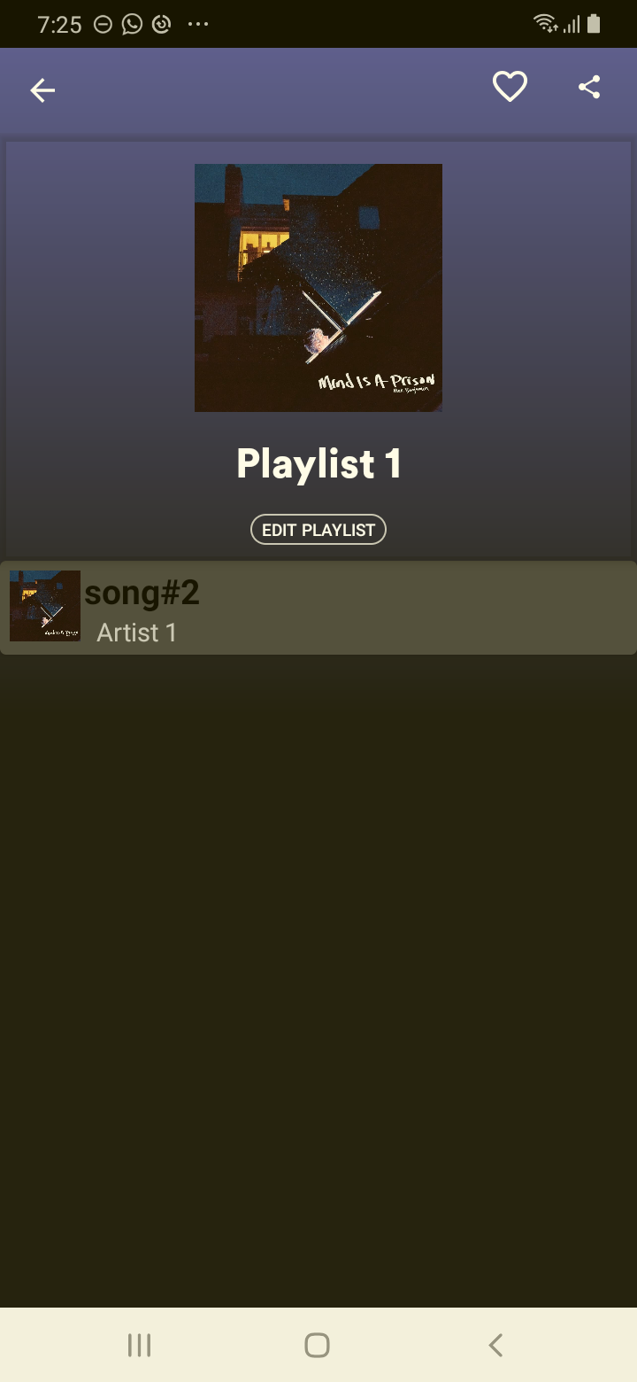

## Test Teardown

[Fixture] setup::0

# Checking the share - passed

Checking the share exists

## Test Setup

[Fixture] setup

## Test Body

[Attachment] share exists

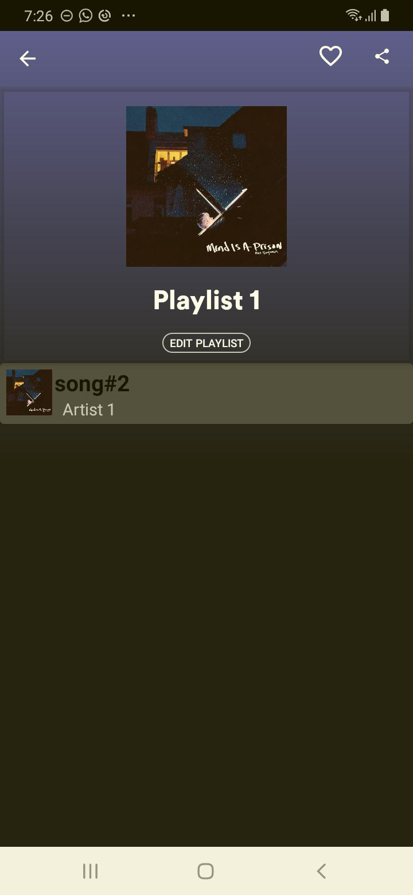

## Test Teardown

[Fixture] setup::0

# Checking unlimited skips box - passed

Checking unlimited skips exists

## Test Setup

[Fixture] setup

## Test Body

[Attachment] unlimited skips box exists



## Test Teardown

[Fixture] setup::0