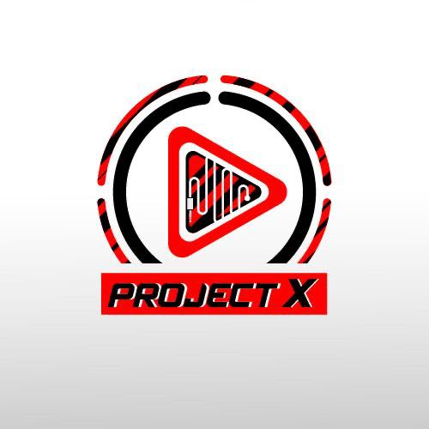

Login

Test Report

Test Session Summary

|  |  |
| --- | --- |
| Start: Thu Jun 11 07:21:38 2020 End: Thu Jun 11 07:30:13 2020 Duration: 0:08:34.809000  broken: 0 (0.00%) failed: 0 (0.00%) skipped: 0 (0.00%) passed: 14 (100.00%) |  |

Test Results

# Checking delete track - passed

Checking delete track exists

## Test Setup

[Fixture] setup

## Test Body

[Attachment] delete track exists

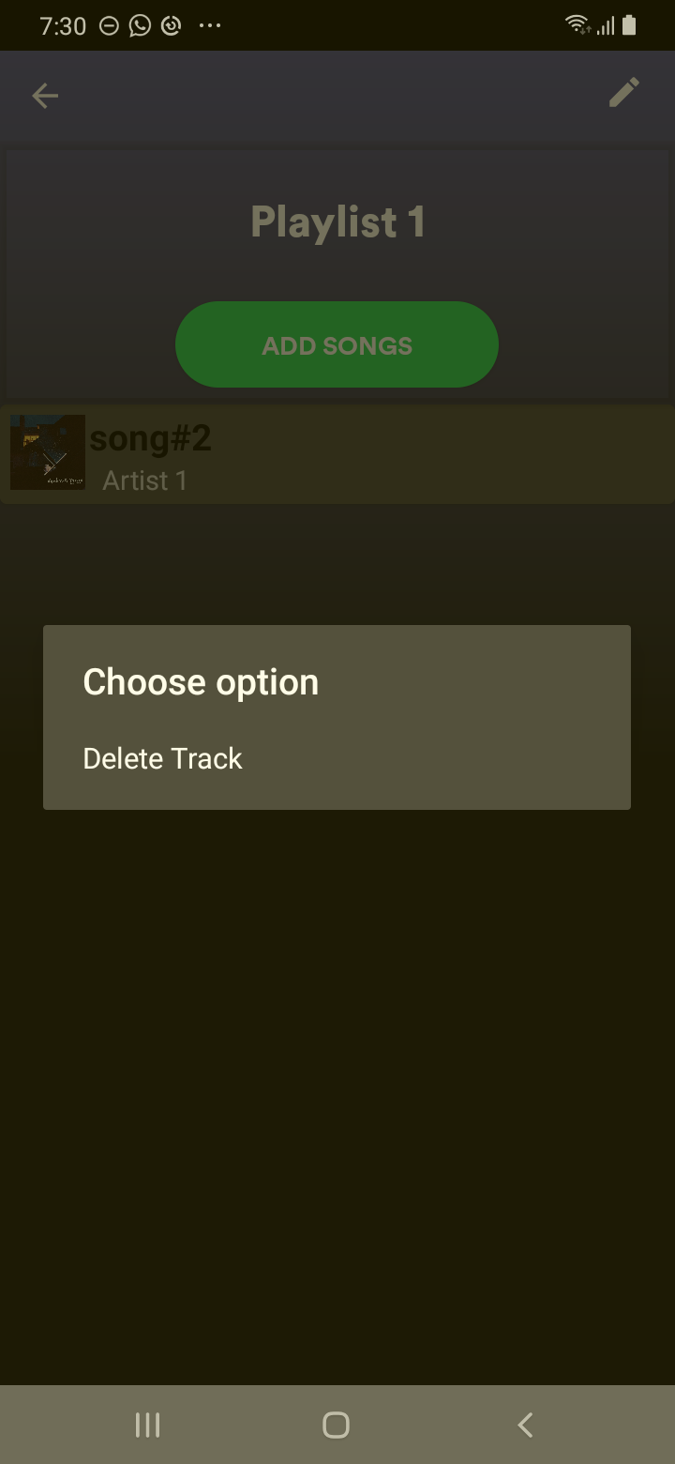

## Test Teardown

[Fixture] setup::0

# Checking rename - passed

Checking rename exists

## Test Setup

[Fixture] setup

## Test Body

[Attachment] rename exists

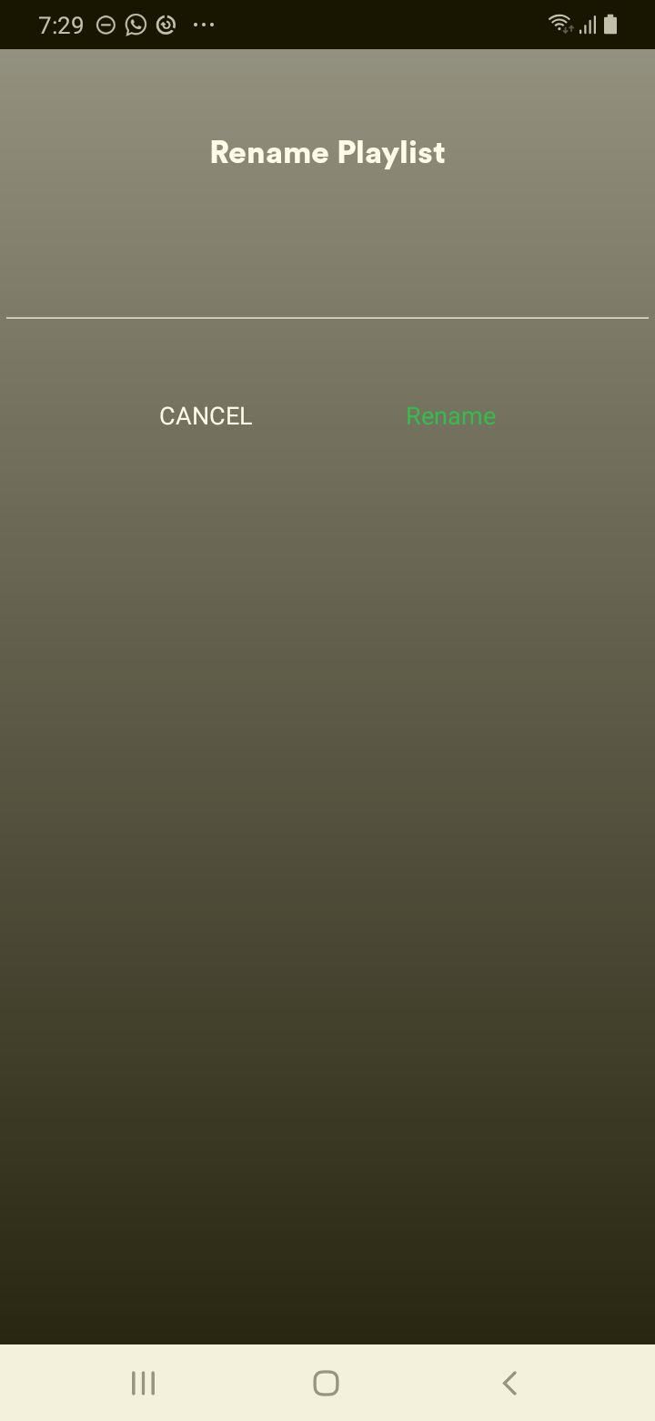

## Test Teardown

[Fixture] setup::0

# Checking cancel button - passed

Checking cancel button exists

## Test Setup

[Fixture] setup

## Test Body

[Attachment] cancel button exist

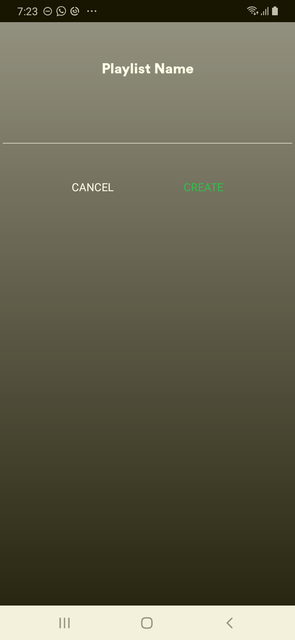

## Test Teardown

[Fixture] setup::0

# Checking cancel rename - passed

Checking cancel rename exists

## Test Setup

[Fixture] setup

## Test Body

[Attachment] cancel rename exists

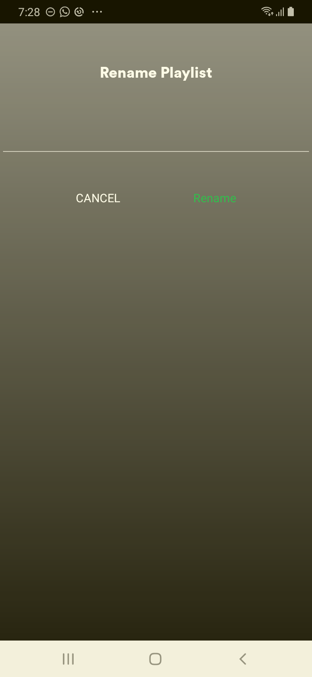

## Test Teardown

[Fixture] setup::0

# Checking create playlist - passed

Checking create playlist

## Test Setup

[Fixture] setup

## Test Body

[Attachment] Creation done

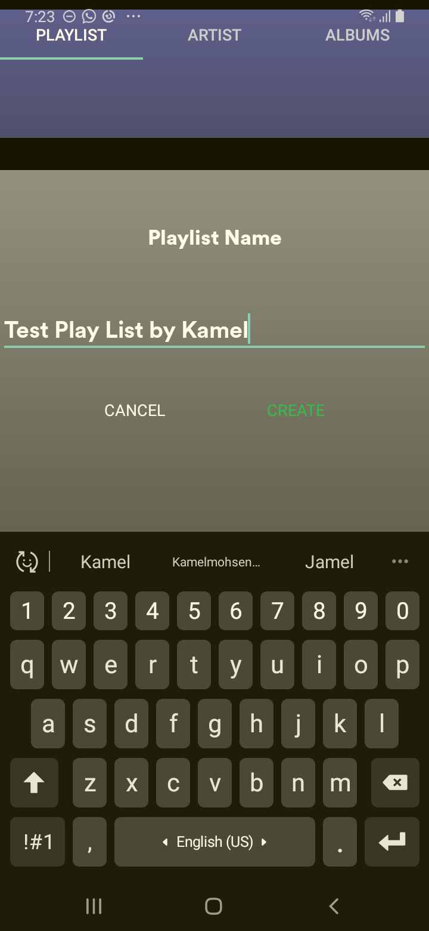

## Test Teardown

[Fixture] setup::0

# Checking create playlist button - passed

Checking create playlist button exists

## Test Setup

[Fixture] setup

## Test Body

[Attachment] create button exist

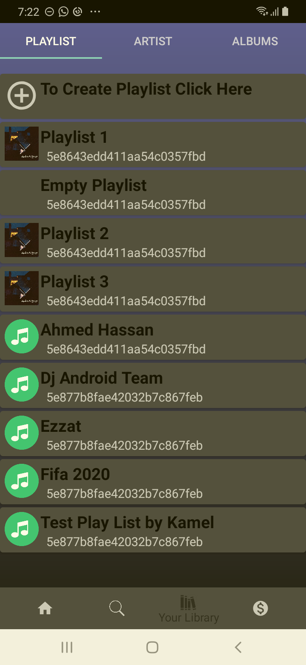

## Test Teardown

[Fixture] setup::0

# Checking first song in edit playlist - passed

Checking first song in edit exists

## Test Setup

[Fixture] setup

## Test Body

[Attachment] first song in edit exists

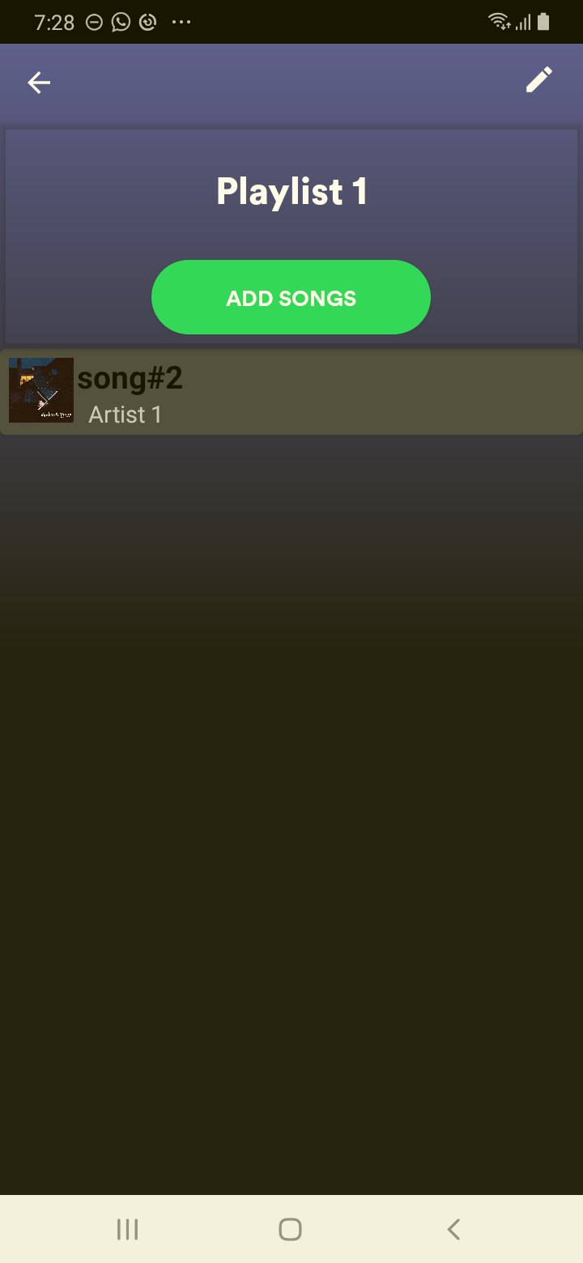

## Test Teardown

[Fixture] setup::0

# Checking save button - passed

Checking save button exists

## Test Setup

[Fixture] setup

## Test Body

[Attachment] save button exist

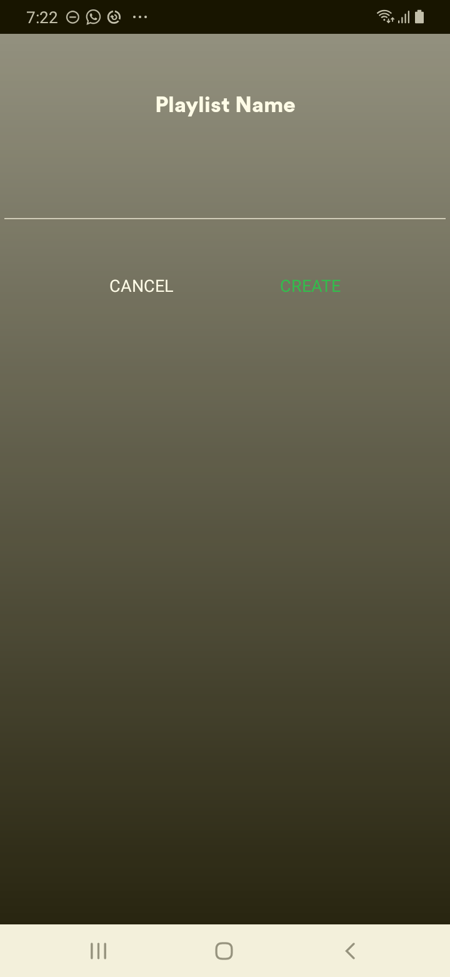

## Test Teardown

[Fixture] setup::0

# Checking the add song - passed

Checking the add song exists

## Test Setup

[Fixture] setup

## Test Body

[Attachment] add song exists

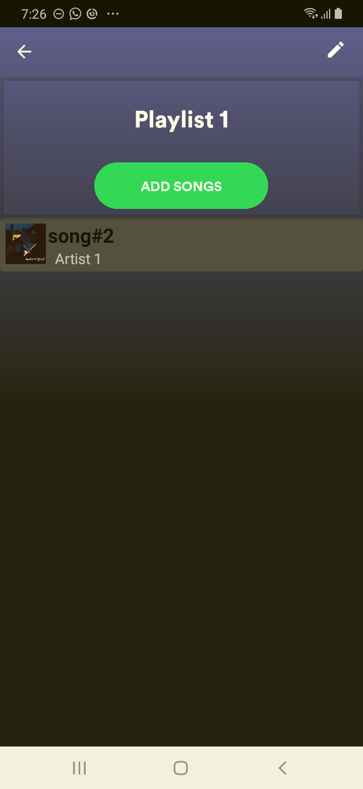

## Test Teardown

[Fixture] setup::0

# Checking the edit - passed

Checking the edit exists

## Test Setup

[Fixture] setup

## Test Body

[Attachment] edit exists

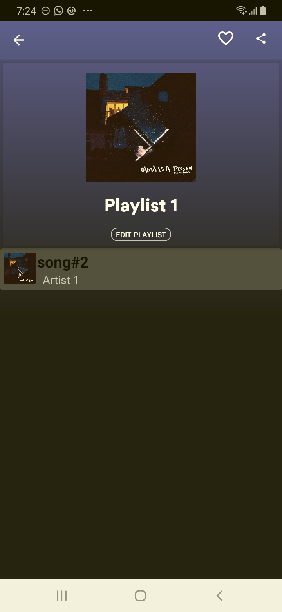

## Test Teardown

[Fixture] setup::0

# Checking the edit playlist - passed

Checking the edit playlist exists

## Test Setup

[Fixture] setup

## Test Body

[Attachment] edit playlist exists

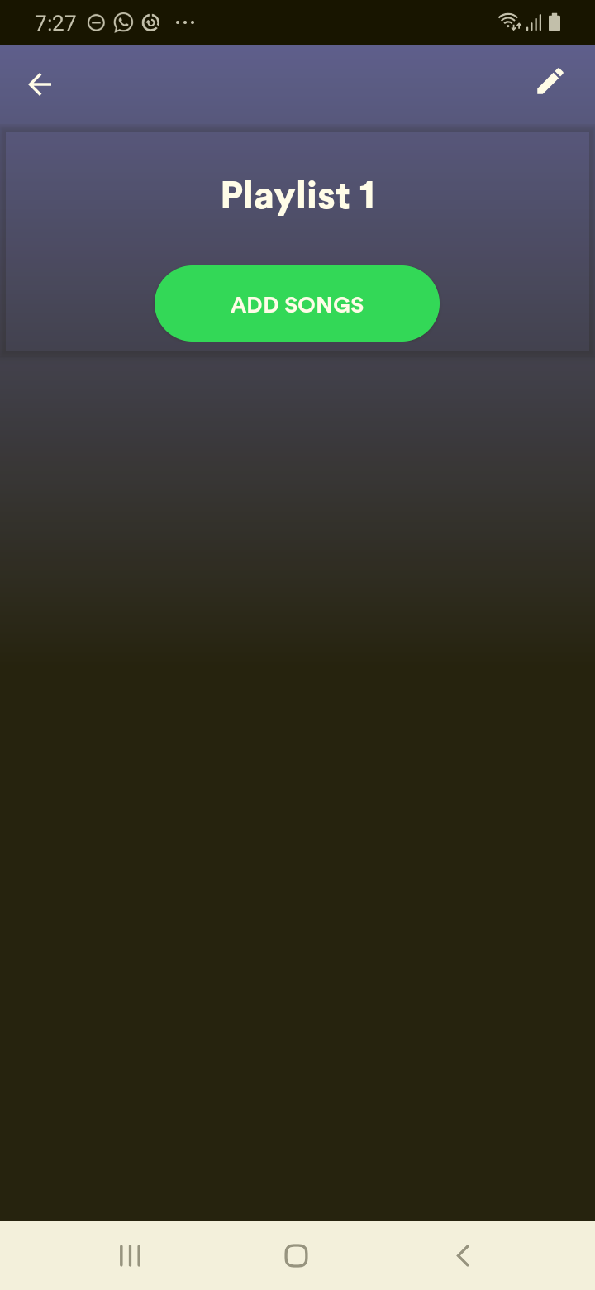

## Test Teardown

[Fixture] setup::0

# Checking the first playlist - passed

Checking the first playlist exists

## Test Setup

[Fixture] setup

## Test Body

[Attachment] first play list exists

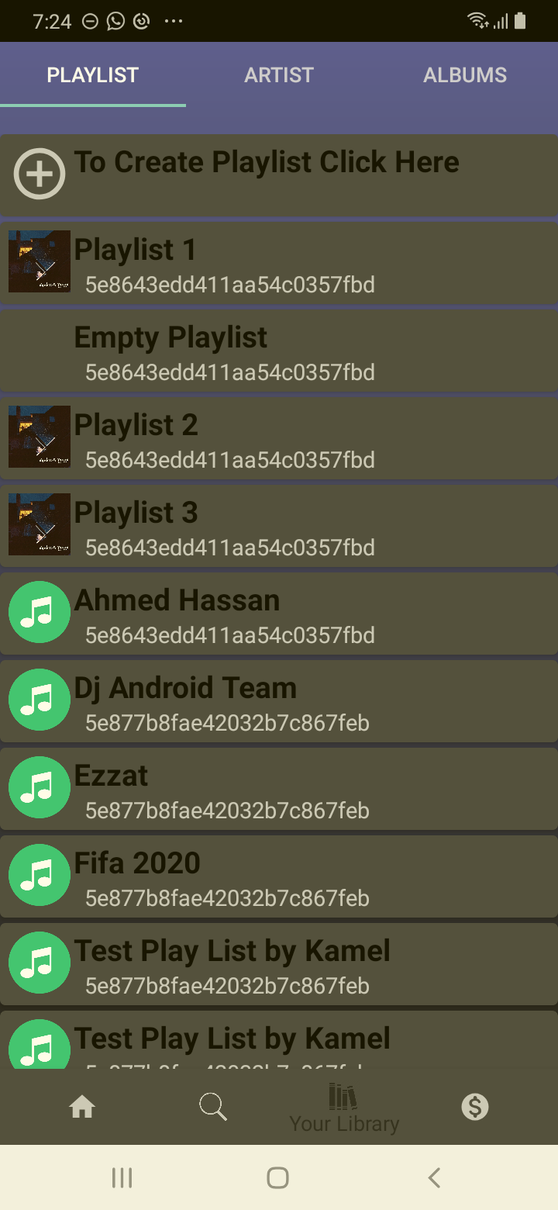

## Test Teardown

[Fixture] setup::0

# Checking the like - passed

Checking the like exists

## Test Setup

[Fixture] setup

## Test Body

[Attachment] like exists

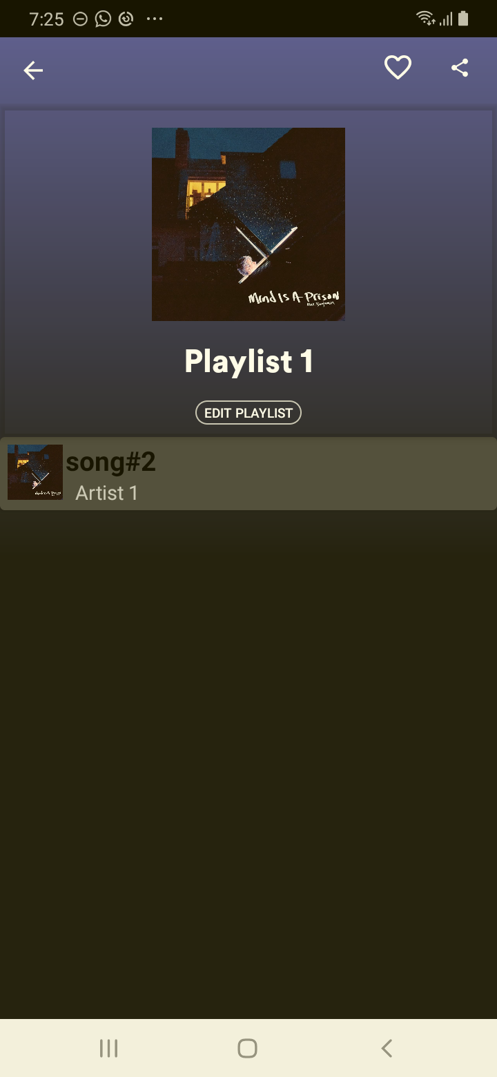

## Test Teardown

[Fixture] setup::0

# Checking the share - passed

Checking the share exists

## Test Setup

[Fixture] setup

## Test Body

[Attachment] share exists

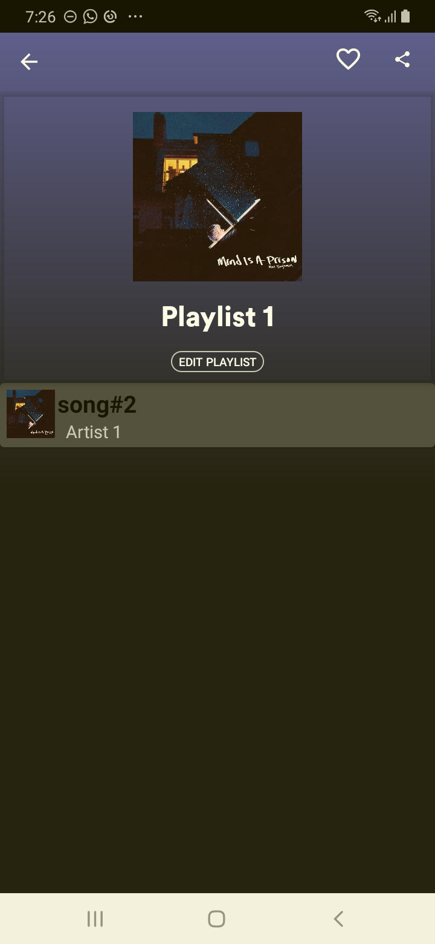

## Test Teardown

[Fixture] setup::0