

Login

Test Report

Test Session Summary

|  |  |
| --- | --- |
| Start: Thu Jun 11 20:31:37 2020 End: Thu Jun 11 20:50:23 2020 Duration: 0:18:45.787000  broken: 0 (0.00%) failed: 12 (57.14%) skipped: 0 (0.00%) passed: 9 (42.86%) |  |

Test Results

# changes the user email to !@!#@ email - failed

changes the user email to !@!#@ email

## Details

AssertionError: assert False

|  |
| --- |
| self = <test_profile.TestProfile object at 0x10d185a00>, setup = None   @allure.severity(allure.severity_level.CRITICAL)  @allure.story("Profile Tests")  @allure.sub_suite("changes the user email to !@!#@ email")  @allure.title("changes the user email to !@!#@ email")  @allure.description("changes the user email to !@!#@ email")  @pytest.mark.Do  @pytest.mark.Profile  @pytest.mark.Test19  def test_case_19(self, setup):  """  changes the user email to !@!#@ email  """  ap = AuthenticationPage(self.driver)  ap.click_signin_button()  lp = LoginPage(self.driver)  lp.do_the_login(Constants.correct_credentials["email"], Constants.correct_credentials["password"])  hp = HomePage(self.driver)  hp.click_premium_button()    pp = PremiumPage(self.driver)  if not pp.enter_profile():  print(self.driver.current_activity)  Helper.report_allure(self.driver, "failed to test change the user email to !@!#@ email")  assert False  pp = ProfilePage(self.driver)  pp.check_edit_profile_button()    if not pp.change_the_email("!@!#@ ","or"):  Helper.report_allure(self.driver, "Passed")  assert True  else:  pp.change_the_email("abdallah@gmail.com", "re")  print(self.driver.current_activity)  Helper.report_allure(self.driver, "failed to test change the user email to !@!#@ email") > assert False E assert False  Mobile_Testing/Tests/test_profile.py:780: AssertionError |

## Test Setup

[Fixture] setup

## Test Body

[Attachment] failed to test change the user email to !@!#@ email

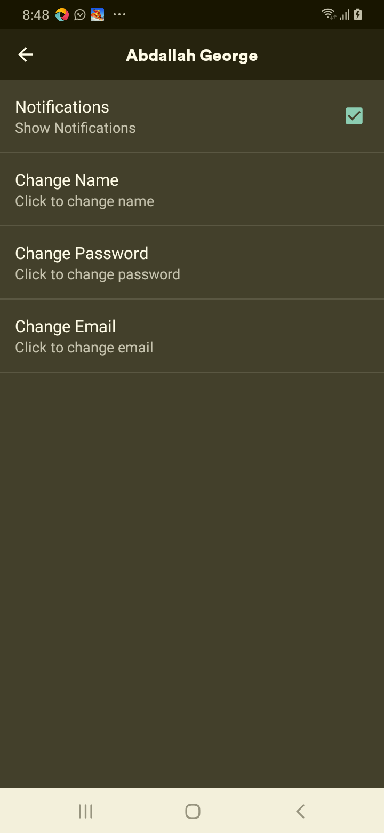

[Attachment] stdout

## Test Teardown

[Fixture] setup::0

# changes the user email to empty email - failed

changes the user email to empty email

## Details

AssertionError: assert False

|  |
| --- |
| self = <test_profile.TestProfile object at 0x10d2c87c0>, setup = None   @allure.severity(allure.severity_level.CRITICAL)  @allure.story("Profile Tests")  @allure.sub_suite("changes the user email to empty email")  @allure.title("changes the user email to empty email")  @allure.description("changes the user email to empty email")  @pytest.mark.Do  @pytest.mark.Profile  @pytest.mark.Test18  def test_case_18(self, setup):  """  changes the user email to empty email  """  ap = AuthenticationPage(self.driver)  ap.click_signin_button()  lp = LoginPage(self.driver)  lp.do_the_login(Constants.correct_credentials["email"], Constants.correct_credentials["password"])  hp = HomePage(self.driver)  hp.click_premium_button()    pp = PremiumPage(self.driver)  if not pp.enter_profile():  print(self.driver.current_activity)  Helper.report_allure(self.driver, "failed to test change the user email to empty email")  assert False  pp = ProfilePage(self.driver)  pp.check_edit_profile_button()    if not pp.change_the_email("", "or"):  Helper.report_allure(self.driver, "Passed")  assert True  else:  pp.change_the_email("abdallah@gmail.com", "re")  print(self.driver.current_activity)  Helper.report_allure(self.driver, "failed to test change the user email to empty email") > assert False E assert False  Mobile_Testing/Tests/test_profile.py:743: AssertionError |

## Test Setup

[Fixture] setup

## Test Body

[Attachment] failed to test change the user email to empty email

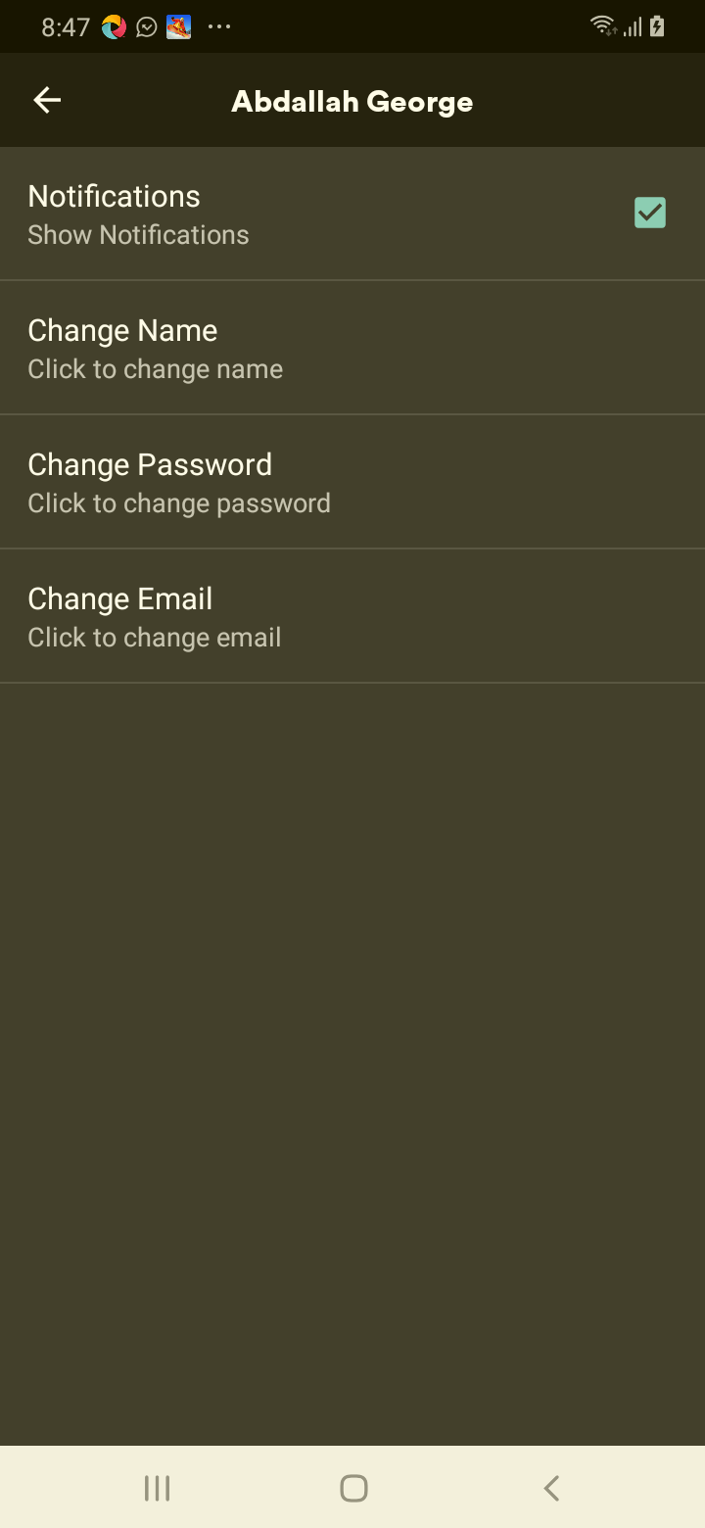

[Attachment] stdout

## Test Teardown

[Fixture] setup::0

# changes the user email to numbers email - failed

changes the user email to numbers email

## Details

AssertionError: assert False

|  |
| --- |
| self = <test_profile.TestProfile object at 0x10d3c6d30>, setup = None   @allure.severity(allure.severity_level.CRITICAL)  @allure.story("Profile Tests")  @allure.sub_suite("changes the user email to numbers email")  @allure.title("changes the user email to numbers email")  @allure.description("changes the user email to numbers email")  @pytest.mark.Do  @pytest.mark.Profile  @pytest.mark.Test21  def test_case_21(self, setup):  """  changes the user email to numbers email  """  ap = AuthenticationPage(self.driver)  ap.click_signin_button()  lp = LoginPage(self.driver)  lp.do_the_login(Constants.correct_credentials["email"], Constants.correct_credentials["password"])  hp = HomePage(self.driver)  hp.click_premium_button()    pp = PremiumPage(self.driver)  if not pp.enter_profile():  print(self.driver.current_activity)  Helper.report_allure(self.driver, "failed to test change the user email to numbers email")  assert False  pp = ProfilePage(self.driver)  pp.check_edit_profile_button()    if not pp.change_the_email("1234567", "or"):  Helper.report_allure(self.driver, "Passed")  assert True  else:  pp.change_the_email("abdallah@gmail.com", "re")  print(self.driver.current_activity)  Helper.report_allure(self.driver, "failed to test change the user email to numbers email") > assert False E assert False  Mobile_Testing/Tests/test_profile.py:854: AssertionError |

## Test Setup

[Fixture] setup

## Test Body

[Attachment] failed to test change the user email to numbers email

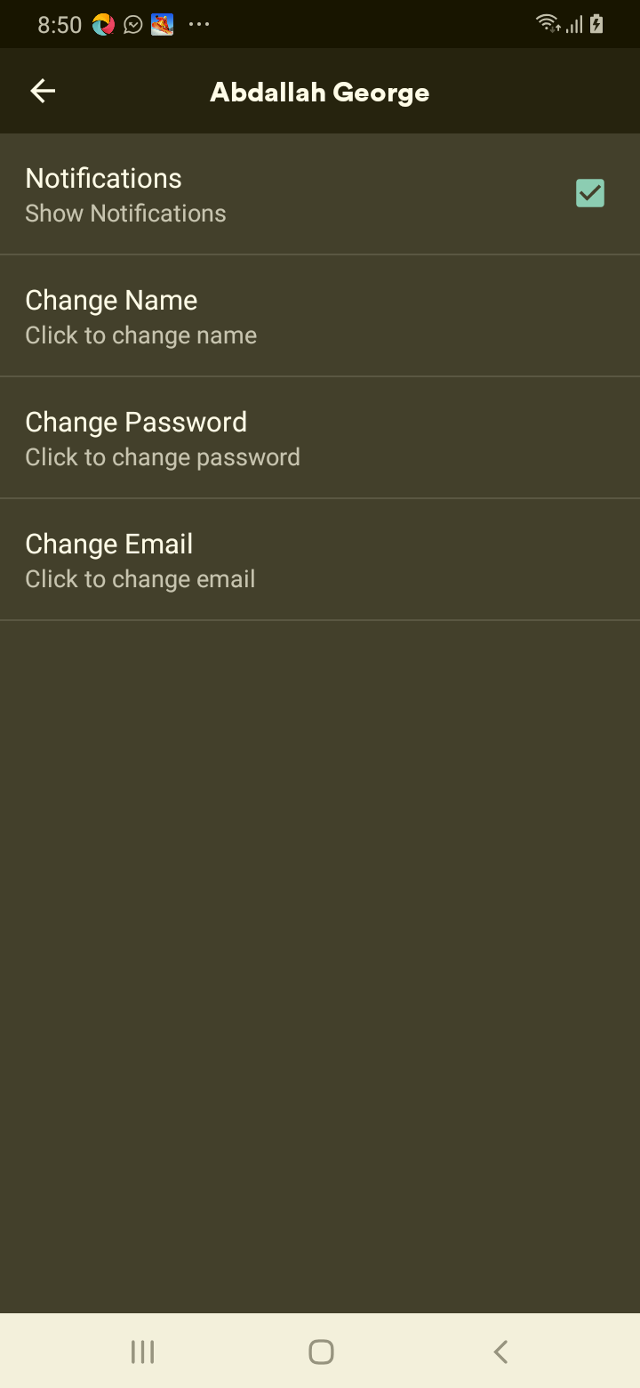

[Attachment] stdout

## Test Teardown

[Fixture] setup::0

# changes the user email to spaces email - failed

changes the user email to spaces email

## Details

AssertionError: assert False

|  |
| --- |
| self = <test_profile.TestProfile object at 0x10bff3b50>, setup = None   @allure.severity(allure.severity_level.CRITICAL)  @allure.story("Profile Tests")  @allure.sub_suite("changes the user email to spaces email")  @allure.title("changes the user email to spaces email")  @allure.description("changes the user email to spaces email")  @pytest.mark.Do  @pytest.mark.Profile  @pytest.mark.Test20  def test_case_20(self, setup):  """  changes the user email to spaces email  """  ap = AuthenticationPage(self.driver)  ap.click_signin_button()  lp = LoginPage(self.driver)  lp.do_the_login(Constants.correct_credentials["email"], Constants.correct_credentials["password"])  hp = HomePage(self.driver)  hp.click_premium_button()    pp = PremiumPage(self.driver)  if not pp.enter_profile():  print(self.driver.current_activity)  Helper.report_allure(self.driver, "failed to test change the user email to spaces email")  assert False  pp = ProfilePage(self.driver)  pp.check_edit_profile_button()    if not pp.change_the_email(" ", "or"):  Helper.report_allure(self.driver, "Passed")  assert True  else:  pp.change_the_email("abdallah@gmail.com", "re")  print(self.driver.current_activity)  Helper.report_allure(self.driver, "failed to test change the user email to spaces email") > assert False E assert False  Mobile_Testing/Tests/test_profile.py:817: AssertionError |

## Test Setup

[Fixture] setup

## Test Body

[Attachment] failed to test change the user email to spaces email

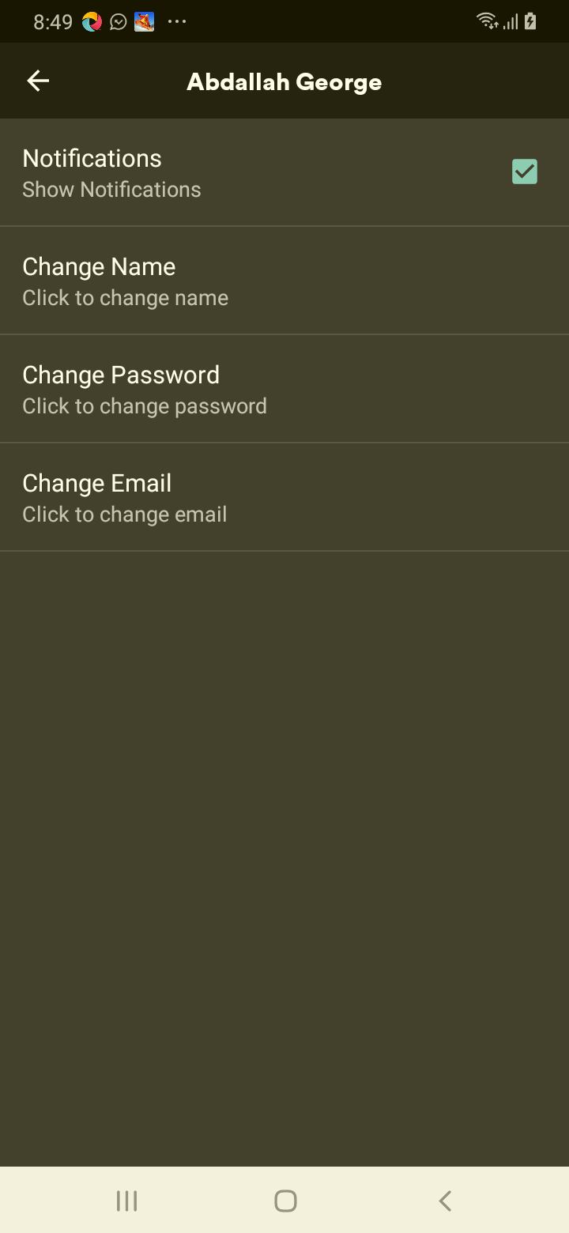

[Attachment] stdout

## Test Teardown

[Fixture] setup::0

# changes the user name to !@!#@ name - failed

changes the user name to !@!#@ name

## Details

AssertionError: assert False

|  |
| --- |
| self = <test_profile.TestProfile object at 0x10d17be50>, setup = None   @allure.severity(allure.severity_level.CRITICAL)  @allure.story("Profile Tests")  @allure.sub_suite("changes the user name to !@!#@ name")  @allure.title("changes the user name to !@!#@ name")  @allure.description("changes the user name to !@!#@ name")  @pytest.mark.Do  @pytest.mark.Profile  @pytest.mark.Test9  def test_case_9(self, setup):  """  changes the user name to !@!#@ name  """  ap = AuthenticationPage(self.driver)  ap.click_signin_button()  lp = LoginPage(self.driver)  lp.do_the_login(Constants.correct_credentials["email"], Constants.correct_credentials["password"])  hp = HomePage(self.driver)  hp.click_premium_button()    pp = PremiumPage(self.driver)  if not pp.enter_profile():  print(self.driver.current_activity)  Helper.report_allure(self.driver, "failed to test change the user name to !@!#@ name")  assert False  pp = ProfilePage(self.driver)  pp.check_edit_profile_button()    if not pp.change_name("!@!#@", "or"):  Helper.report_allure(self.driver, "Passed")  assert True  else:  pp.change_name("Abdallah George", "re")  print(self.driver.current_activity)  Helper.report_allure(self.driver, "failed to test changes the user name to !@!#@ name") > assert False E assert False  Mobile_Testing/Tests/test_profile.py:412: AssertionError |

## Test Setup

[Fixture] setup

## Test Body

[Attachment] failed to test changes the user name to !@!#@ name

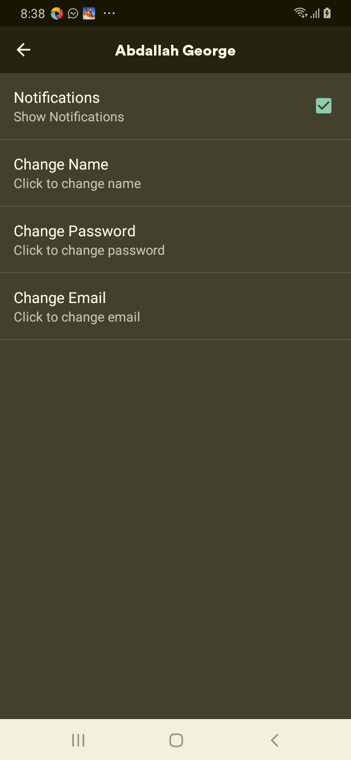

[Attachment] stdout

## Test Teardown

[Fixture] setup::0

# changes the user name to empty name - failed

changes the user name to empty name

## Details

AssertionError: assert False

|  |
| --- |
| self = <test_profile.TestProfile object at 0x10d185670>, setup = None   @allure.severity(allure.severity_level.CRITICAL)  @allure.story("Profile Tests")  @allure.sub_suite("changes the user name to empty name")  @allure.title("changes the user name to empty name")  @allure.description("changes the user name to empty name")  @pytest.mark.Do  @pytest.mark.Profile  @pytest.mark.Test8  def test_case_8(self, setup):  """  changes the user name to empty name  """  ap = AuthenticationPage(self.driver)  ap.click_signin_button()  lp = LoginPage(self.driver)  lp.do_the_login(Constants.correct_credentials["email"], Constants.correct_credentials["password"])  hp = HomePage(self.driver)  hp.click_premium_button()    pp = PremiumPage(self.driver)  if not pp.enter_profile():  print(self.driver.current_activity)  Helper.report_allure(self.driver, "failed to test change the user name to empty name")  assert False  pp = ProfilePage(self.driver)  pp.check_edit_profile_button()    if not pp.change_name("", "or"):  Helper.report_allure(self.driver, "Passed")  assert True  else:  pp.change_name("Abdallah George", "re")  print(self.driver.current_activity)  Helper.report_allure(self.driver, "failed to test changes the user name to empty name") > assert False E assert False  Mobile_Testing/Tests/test_profile.py:375: AssertionError |

## Test Setup

[Fixture] setup

## Test Body

[Attachment] failed to test changes the user name to empty name

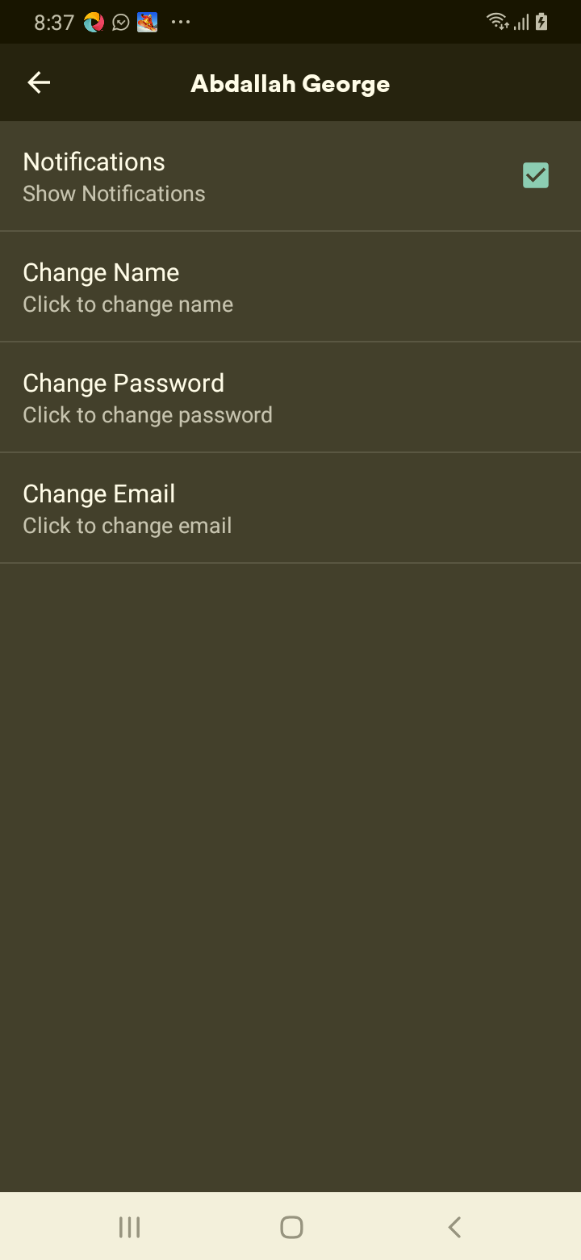

[Attachment] stdout

## Test Teardown

[Fixture] setup::0

# changes the user name to name + characters name - failed

changes the user name to name + characters name

## Details

AssertionError: assert False

|  |
| --- |
| self = <test_profile.TestProfile object at 0x10d18b8e0>, setup = None   @allure.severity(allure.severity_level.CRITICAL)  @allure.story("Profile Tests")  @allure.sub_suite("changes the user name to name + characters name")  @allure.title("changes the user name to name + characters name")  @allure.description("changes the user name to name + characters name")  @pytest.mark.Do  @pytest.mark.Profile  @pytest.mark.Test12  def test_case_12(self, setup):  """  changes the user name to name + characters name  """  ap = AuthenticationPage(self.driver)  ap.click_signin_button()  lp = LoginPage(self.driver)  lp.do_the_login(Constants.correct_credentials["email"], Constants.correct_credentials["password"])  hp = HomePage(self.driver)  hp.click_premium_button()    pp = PremiumPage(self.driver)  if not pp.enter_profile():  print(self.driver.current_activity)  Helper.report_allure(self.driver, "failed to test change the user name to name + characters name")  assert False  pp = ProfilePage(self.driver)  pp.check_edit_profile_button()    if not pp.change_name("kamel12345_!@#!@$", "or"):  Helper.report_allure(self.driver, "Passed")  assert True  else:  pp.change_name("Abdallah George", "re")  print(self.driver.current_activity)  Helper.report_allure(self.driver, "failed to test changes the user name to name + characters name") > assert False E assert False  Mobile_Testing/Tests/test_profile.py:523: AssertionError |

## Test Setup

[Fixture] setup

## Test Body

[Attachment] failed to test changes the user name to name + characters name

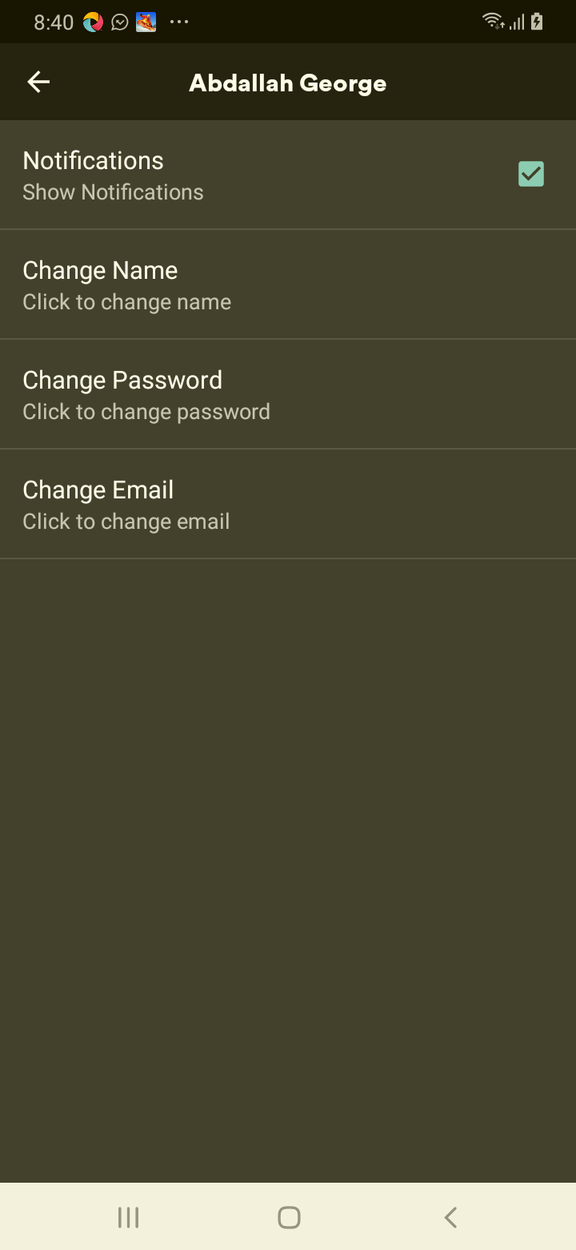

[Attachment] stdout

## Test Teardown

[Fixture] setup::0

# changes the user name to numbers name - failed

changes the user name to numbers name

## Details

AssertionError: assert False

|  |
| --- |
| self = <test_profile.TestProfile object at 0x10d18f370>, setup = None   @allure.severity(allure.severity_level.CRITICAL)  @allure.story("Profile Tests")  @allure.sub_suite("changes the user name to numbers name")  @allure.title("changes the user name to numbers name")  @allure.description("changes the user name to numbers name")  @pytest.mark.Do  @pytest.mark.Profile  @pytest.mark.Test11  def test_case_11(self, setup):  """  changes the user name to numbers name  """  ap = AuthenticationPage(self.driver)  ap.click_signin_button()  lp = LoginPage(self.driver)  lp.do_the_login(Constants.correct_credentials["email"], Constants.correct_credentials["password"])  hp = HomePage(self.driver)  hp.click_premium_button()    pp = PremiumPage(self.driver)  if not pp.enter_profile():  print(self.driver.current_activity)  Helper.report_allure(self.driver, "failed to test change the user name to numbers name")  assert False  pp = ProfilePage(self.driver)  pp.check_edit_profile_button()    if not pp.change_name("12345", "or"):  Helper.report_allure(self.driver, "Passed")  assert True  else:  pp.change_name("Abdallah George", "re")  print(self.driver.current_activity)  Helper.report_allure(self.driver, "failed to test changes the user name to numbers name") > assert False E assert False  Mobile_Testing/Tests/test_profile.py:486: AssertionError |

## Test Setup

[Fixture] setup

## Test Body

[Attachment] failed to test changes the user name to numbers name

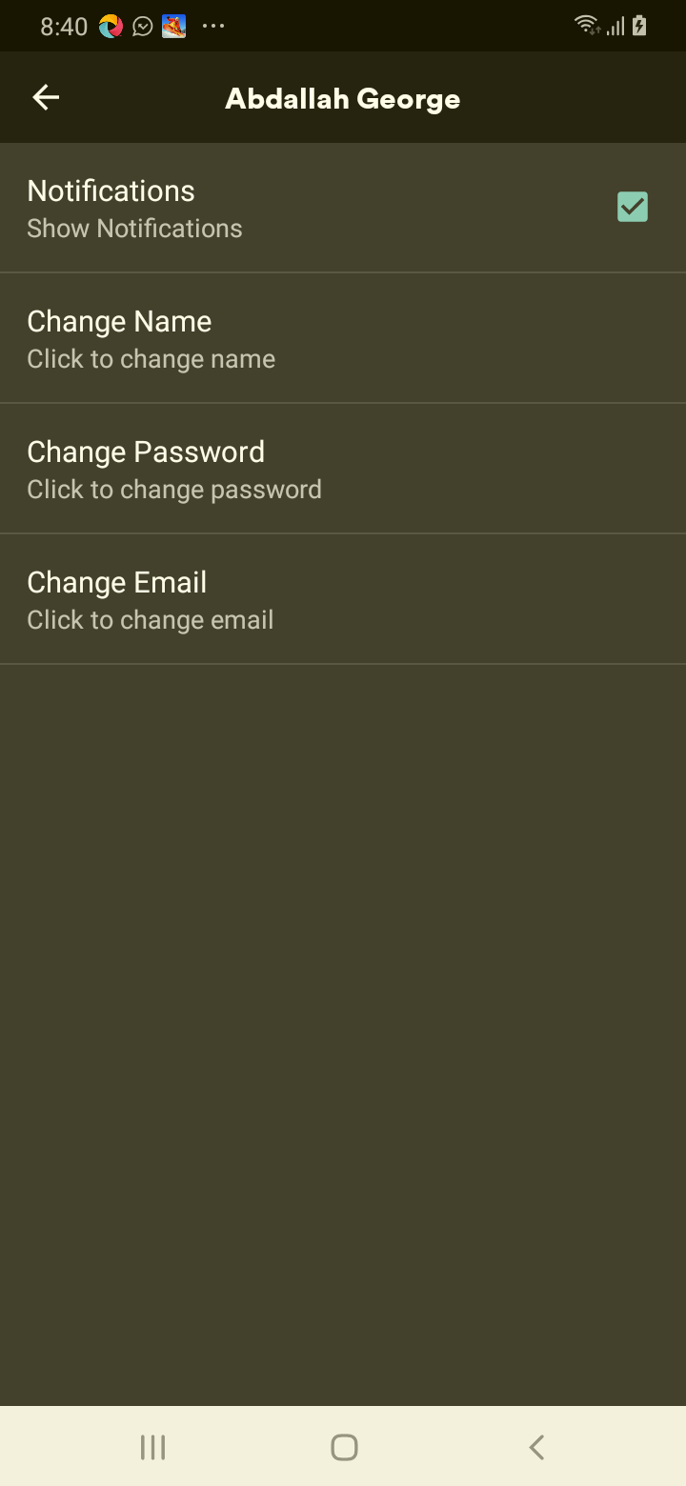

[Attachment] stdout

## Test Teardown

[Fixture] setup::0

# changes the user name to spaces name - failed

changes the user name to spaces name

## Details

AssertionError: assert False

|  |
| --- |
| self = <test_profile.TestProfile object at 0x10d18bd60>, setup = None   @allure.severity(allure.severity_level.CRITICAL)  @allure.story("Profile Tests")  @allure.sub_suite("changes the user name to spaces name")  @allure.title("changes the user name to spaces name")  @allure.description("changes the user name to spaces name")  @pytest.mark.Do  @pytest.mark.Profile  @pytest.mark.Test10  def test_case_10(self, setup):  """  changes the user name to spaces name  """  ap = AuthenticationPage(self.driver)  ap.click_signin_button()  lp = LoginPage(self.driver)  lp.do_the_login(Constants.correct_credentials["email"], Constants.correct_credentials["password"])  hp = HomePage(self.driver)  hp.click_premium_button()    pp = PremiumPage(self.driver)  if not pp.enter_profile():  print(self.driver.current_activity)  Helper.report_allure(self.driver, "failed to test change the user name to spaces name")  assert False  pp = ProfilePage(self.driver)  pp.check_edit_profile_button()    if not pp.change_name(" ", "or"):  Helper.report_allure(self.driver, "Passed")  assert True  else:  pp.change_name("Abdallah George", "re")  print(self.driver.current_activity)  Helper.report_allure(self.driver, "failed to test changes the user name to spaces name") > assert False E assert False  Mobile_Testing/Tests/test_profile.py:449: AssertionError |

## Test Setup

[Fixture] setup

## Test Body

[Attachment] failed to test changes the user name to spaces name

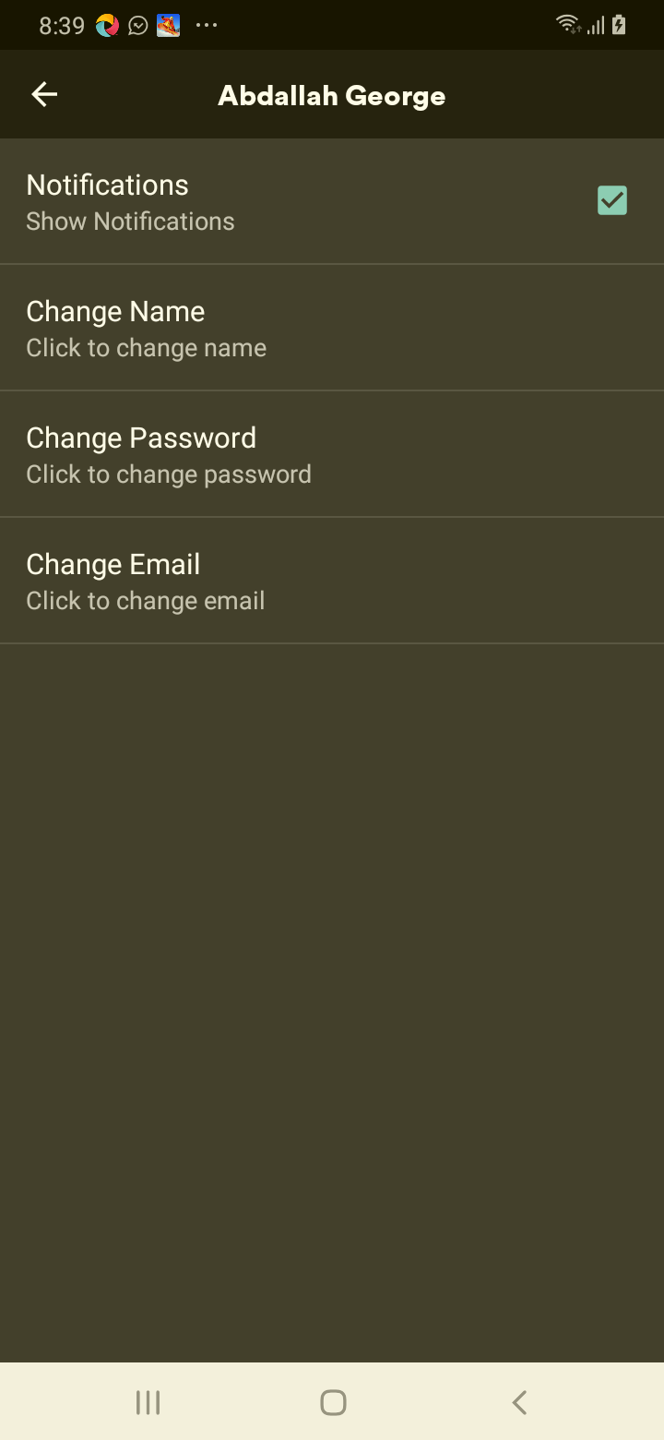

[Attachment] stdout

## Test Teardown

[Fixture] setup::0

# changes the user password to !@!#@ password - failed

changes the user password to !@!#@ password

## Details

AssertionError: assert False

|  |
| --- |
| self = <test_profile.TestProfile object at 0x10d185790>, setup = None   @allure.severity(allure.severity_level.CRITICAL)  @allure.story("Profile Tests")  @allure.sub_suite("changes the user password to !@!#@ password")  @allure.title("changes the user password to !@!#@ password")  @allure.description("changes the user password to !@!#@ password")  @pytest.mark.Do  @pytest.mark.Profile  @pytest.mark.Test15  def test_case_15(self, setup):  """  changes the user password to !@!#@ password  """  ap = AuthenticationPage(self.driver)  ap.click_signin_button()  lp = LoginPage(self.driver)  lp.do_the_login(Constants.correct_credentials["email"], Constants.correct_credentials["password"])  hp = HomePage(self.driver)  hp.click_premium_button()    pp = PremiumPage(self.driver)  if not pp.enter_profile():  print(self.driver.current_activity)  Helper.report_allure(self.driver, "failed to test change the user password to !@!#@ password") > assert False E assert False  Mobile_Testing/Tests/test_profile.py:622: AssertionError |

## Test Setup

[Fixture] setup

## Test Body

[Attachment] failed to test change the user password to !@!#@ password

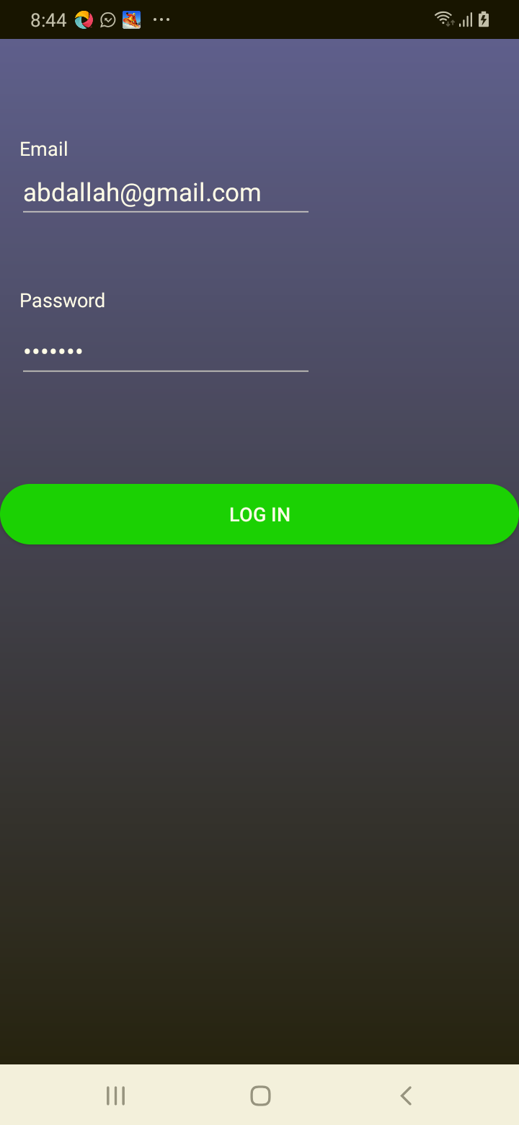

[Attachment] stdout

## Test Teardown

[Fixture] setup::0

# changes the user password to empty password - failed

changes the user password to empty password

## Details

AssertionError: assert False

|  |
| --- |
| self = <test_profile.TestProfile object at 0x10d349940>, setup = None   @allure.severity(allure.severity_level.CRITICAL)  @allure.story("Profile Tests")  @allure.sub_suite("changes the user password to empty password")  @allure.title("changes the user password to empty password")  @allure.description("changes the user password to empty password")  @pytest.mark.Do  @pytest.mark.Profile  @pytest.mark.Test14  def test_case_14(self, setup):  """  changes the user password to empty password  """  ap = AuthenticationPage(self.driver)  ap.click_signin_button()  lp = LoginPage(self.driver)  lp.do_the_login(Constants.correct_credentials["email"], Constants.correct_credentials["password"])  hp = HomePage(self.driver)  hp.click_premium_button()    pp = PremiumPage(self.driver)  if not pp.enter_profile():  print(self.driver.current_activity)  Helper.report_allure(self.driver, "failed to test change the user password to empty password") > assert False E assert False  Mobile_Testing/Tests/test_profile.py:585: AssertionError |

## Test Setup

[Fixture] setup

## Test Body

[Attachment] failed to test change the user password to empty password

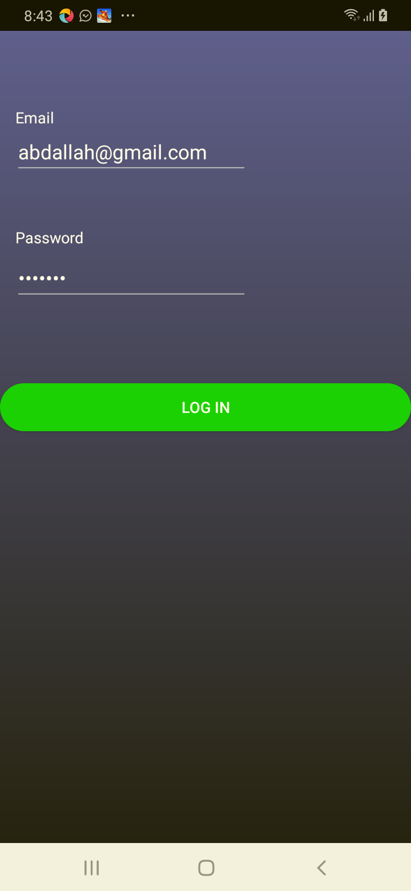

[Attachment] stdout

## Test Teardown

[Fixture] setup::0

# changes the user password to spaces password - failed

changes the user password to spaces password

## Details

AssertionError: assert False

|  |
| --- |
| self = <test_profile.TestProfile object at 0x10d2ece80>, setup = None   @allure.severity(allure.severity_level.CRITICAL)  @allure.story("Profile Tests")  @allure.sub_suite("changes the user password to spaces password")  @allure.title("changes the user password to spaces password")  @allure.description("changes the user password to spaces password")  @pytest.mark.Do  @pytest.mark.Profile  @pytest.mark.Test16  def test_case_16(self, setup):  """  changes the user password to spaces password  """  ap = AuthenticationPage(self.driver)  ap.click_signin_button()  lp = LoginPage(self.driver)  lp.do_the_login(Constants.correct_credentials["email"], Constants.correct_credentials["password"])  hp = HomePage(self.driver)  hp.click_premium_button()    pp = PremiumPage(self.driver)  if not pp.enter_profile():  print(self.driver.current_activity)  Helper.report_allure(self.driver, "failed to test change the user password to spaces password") > assert False E assert False  Mobile_Testing/Tests/test_profile.py:659: AssertionError |

## Test Setup

[Fixture] setup

## Test Body

[Attachment] failed to test change the user password to spaces password

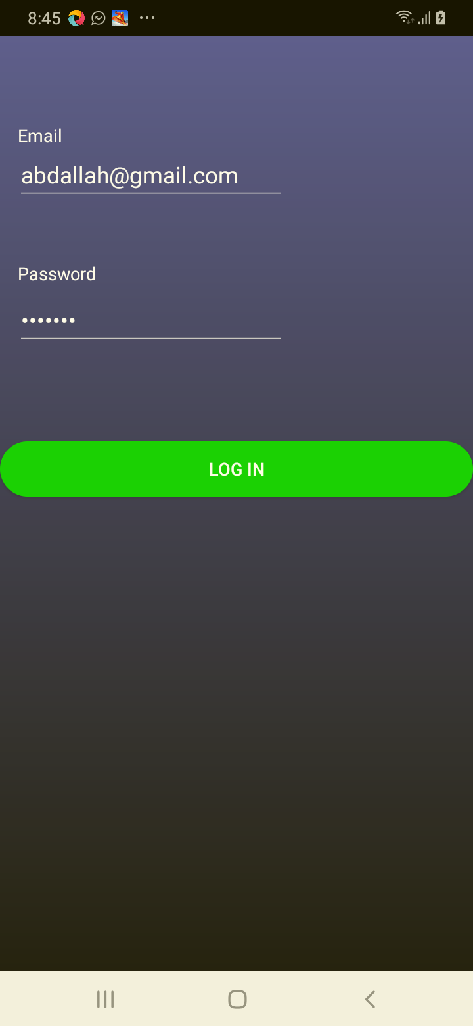

[Attachment] stdout

## Test Teardown

[Fixture] setup::0

# changes the user email to correct email - passed

changes the user email to correct email

## Test Setup

[Fixture] setup

## Test Body

[Attachment] Passed

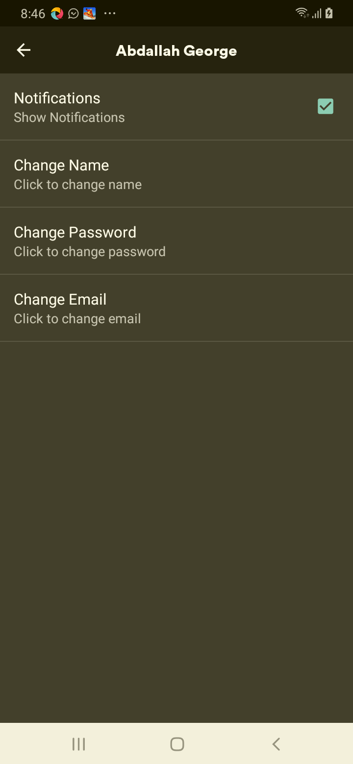

## Test Teardown

[Fixture] setup::0

# changes the user name to correct name - passed

changes the user name to correct name

## Test Setup

[Fixture] setup

## Test Body

[Attachment] Passed

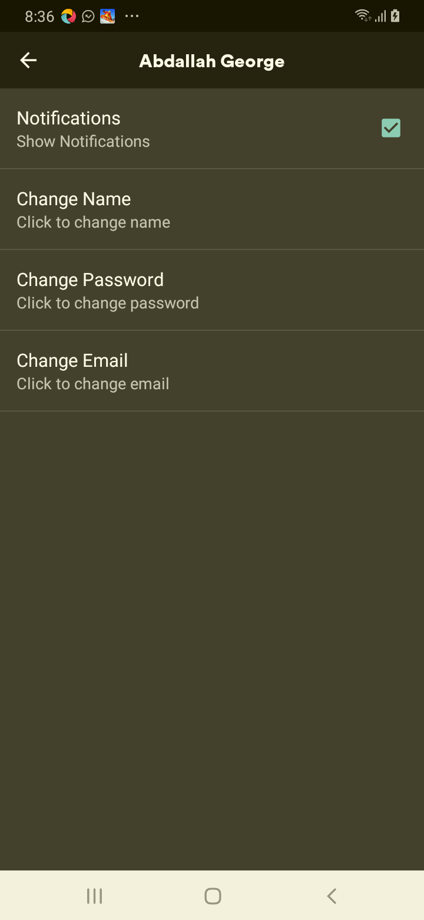

## Test Teardown

[Fixture] setup::0

# changes the user password to correct password - passed

changes the user password to correct password

## Test Setup

[Fixture] setup

## Test Body

[Attachment] Passed

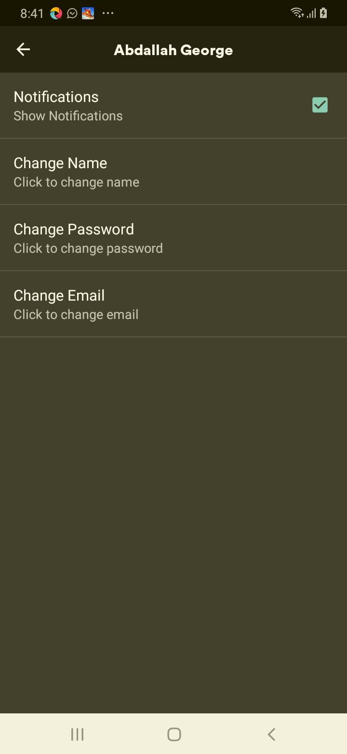

## Test Teardown

[Fixture] setup::0

# checks change email button - passed

checks change email button

## Test Setup

[Fixture] setup

## Test Body

[Attachment] Passed

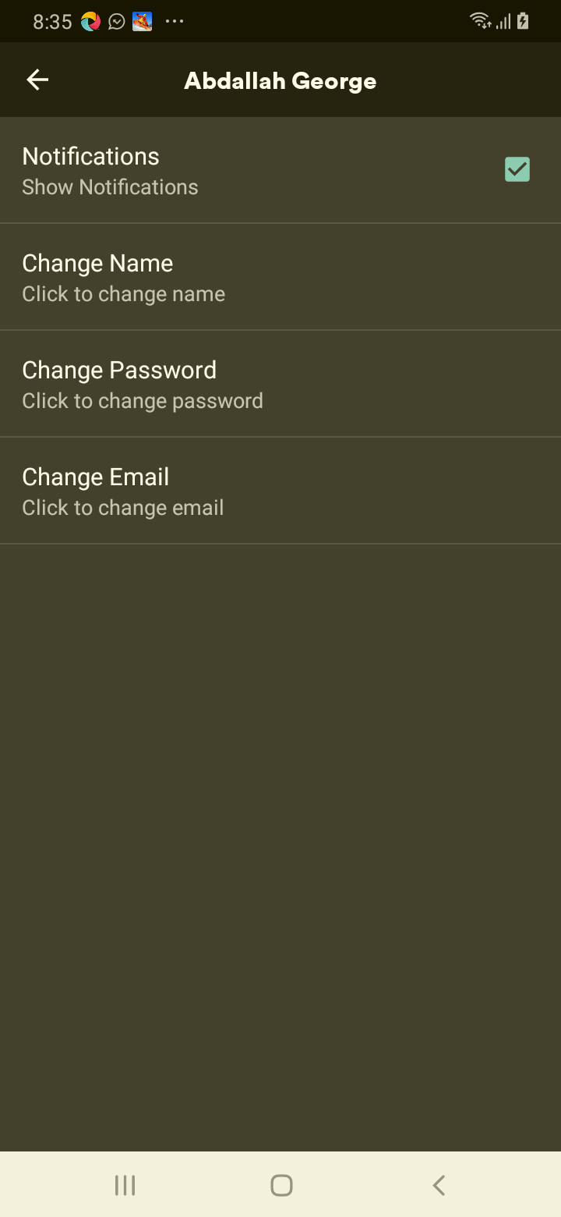

## Test Teardown

[Fixture] setup::0

# checks change password button - passed

checks change password button

## Test Setup

[Fixture] setup

## Test Body

[Attachment] Passed

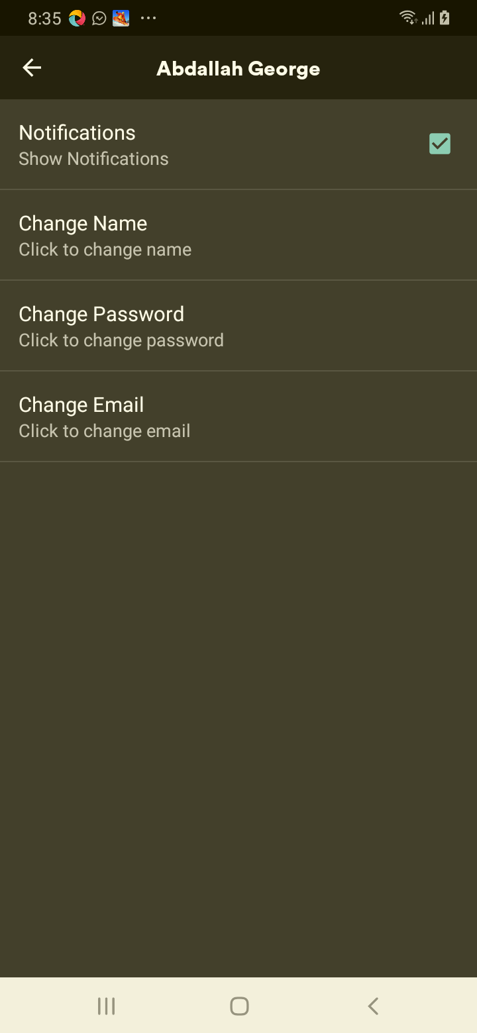

## Test Teardown

[Fixture] setup::0

# checks change user name button - passed

checks change user name button

## Test Setup

[Fixture] setup

## Test Body

[Attachment] Passed

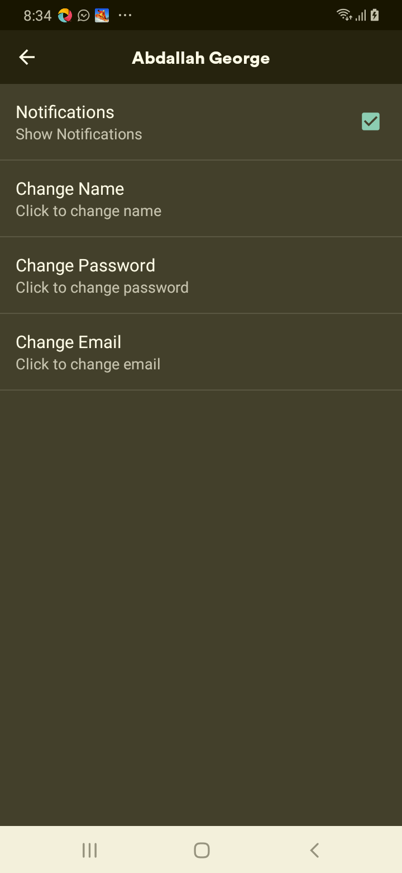

## Test Teardown

[Fixture] setup::0

# checks the edit profile exists - passed

checks the edit profile exists

## Test Setup

[Fixture] setup

## Test Body

[Attachment] Passed

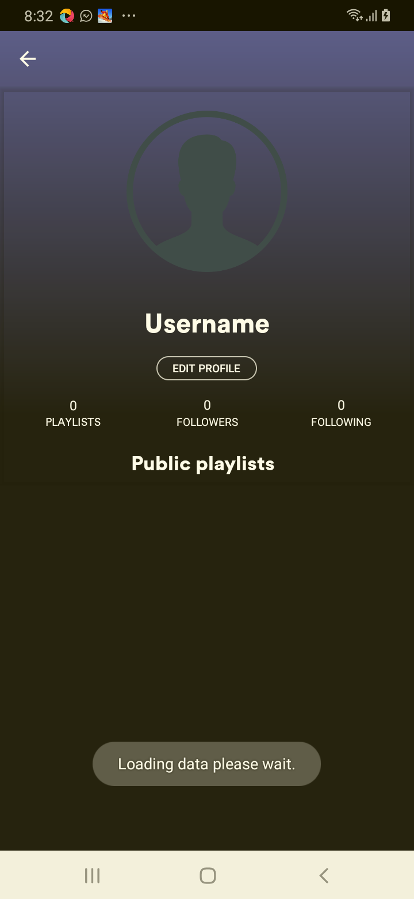

## Test Teardown

[Fixture] setup::0

# checks the first playlist exists - passed

checks the first playlist exists

## Test Setup

[Fixture] setup

## Test Body

[Attachment] Passed

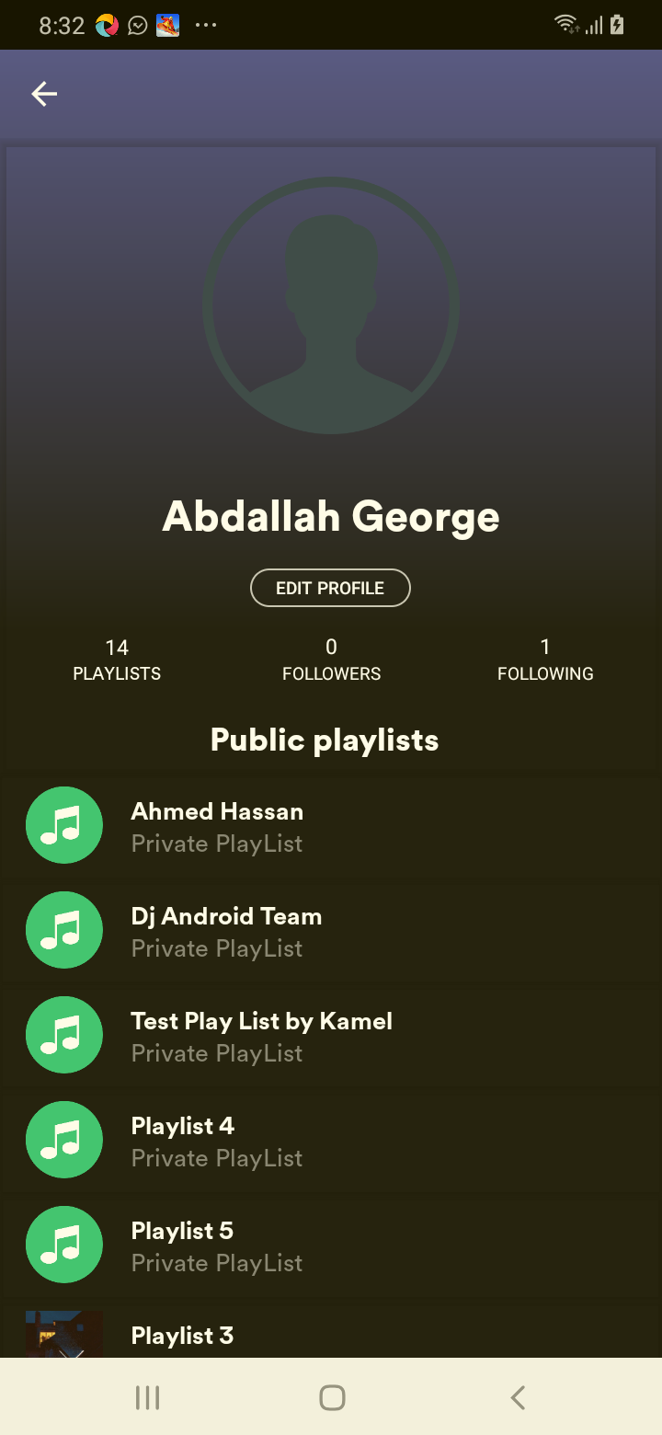

## Test Teardown

[Fixture] setup::0

# checks the notifications checkbox is clickable - passed

checks the notifications checkbox is clickable

## Test Setup

[Fixture] setup

## Test Body

[Attachment] Passed

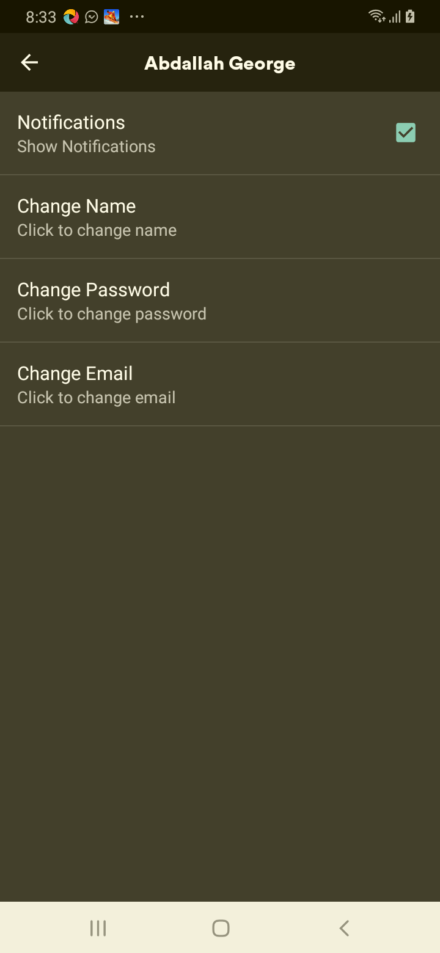

## Test Teardown

[Fixture] setup::0