

Authentication

Test Report

Test Session Summary

|  |  |
| --- | --- |
| Start: Mon Apr 13 06:10:21 2020 End: Mon Apr 13 06:11:07 2020 Duration: 0:00:46.644000  broken: 0 (0.00%) failed: 0 (0.00%) skipped: 0 (0.00%) passed: 3 (100.00%) |  |

Test Results

# Facebook Button Checking - passed

Checking the Facebook button is available

## Test Setup

[Fixture] setup

## Test Body

[Attachment] Facebook Page available

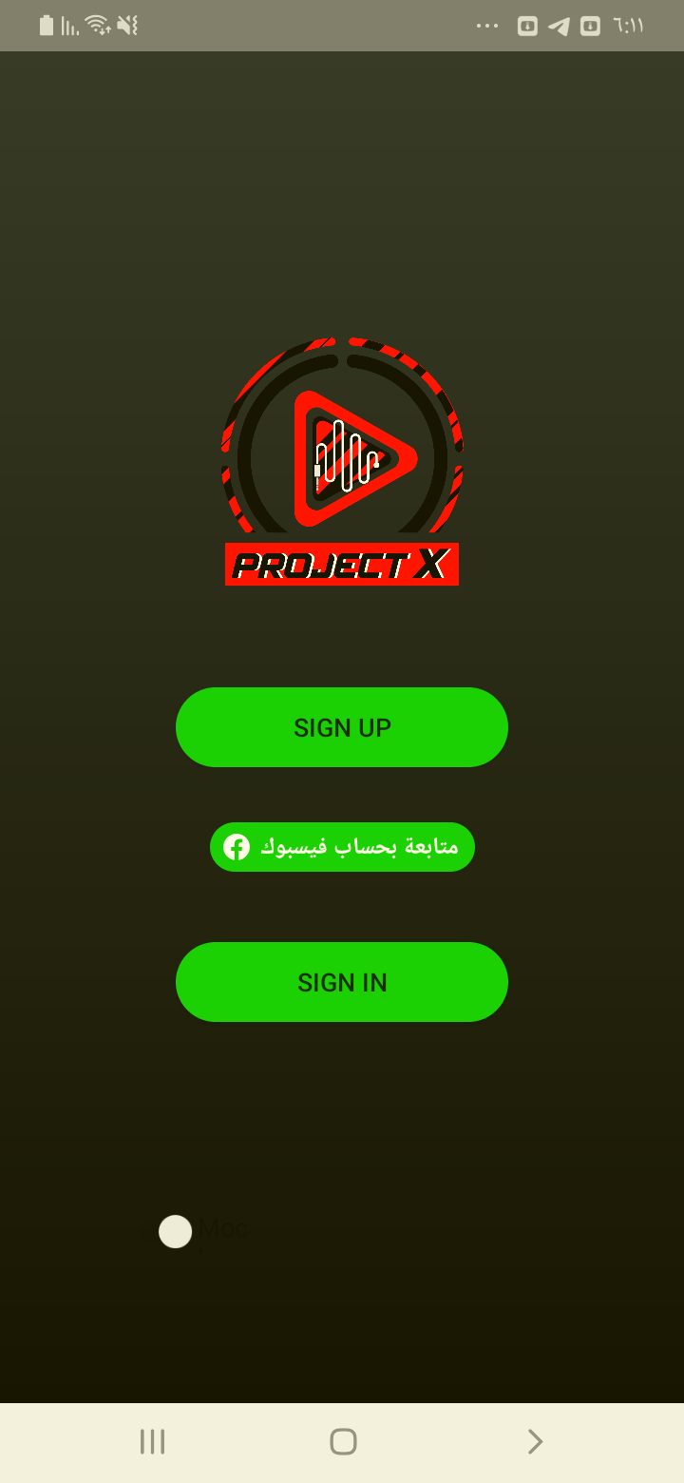

## Test Teardown

[Fixture] setup::0

# Login clicking - passed

Clicking the Login button

## Test Setup

[Fixture] setup

## Test Body

[Attachment] Login Page entered

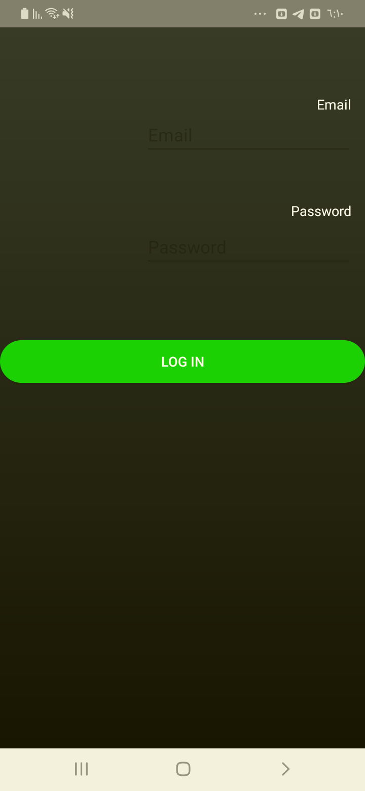

## Test Teardown

[Fixture] setup::0

# Sign up clicking - passed

Clicking the sign up button

## Test Setup

[Fixture] setup

## Test Body

[Attachment] Sign up Page entered

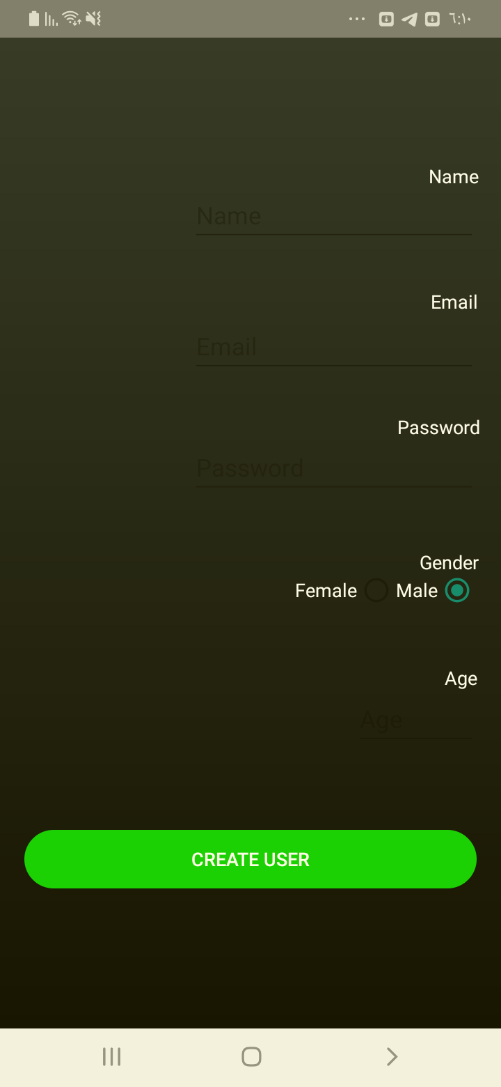

## Test Teardown

[Fixture] setup::0