

Home

Test Report

Test Session Summary

|  |  |
| --- | --- |
| Start: Mon Apr 13 06:11:44 2020 End: Mon Apr 13 06:15:35 2020 Duration: 0:03:51.437000  broken: 0 (0.00%) failed: 4 (50.00%) skipped: 0 (0.00%) passed: 4 (50.00%) |  |

Test Results

# Liked tracks clicking - failed

Liked tracks clicking and check that it works

## Details

AssertionError: assert False

|  |
| --- |
| self = <Mobile_Testing.Tests.test_home.TestHome object at 0x110427970>, setup = None   @allure.severity(allure.severity_level.BLOCKER)  @allure.story("Home Page Tests")  @allure.sub_suite("Liked tracks clicking")  @allure.title("Liked tracks clicking")  @allure.description("Liked tracks clicking and check that it works")  @pytest.mark.Do  @pytest.mark.HomePage  @pytest.mark.Test3  def test_case_3(self, setup):  """  checking the Liked tracks works  """  ap = AuthenticationPage(self.driver)  ap.click_signin_button()  lp = LoginPage(self.driver)  lp.do_the_login(Constants.correct_credentials["email"], Constants.correct_credentials["password"])  hp = HomePage(self.driver)  time.sleep(10)  hp.click_liked_tracks_button()  if Helper.element_exists_by_id(self.driver, HomePage.about_button_id):  print(self.driver.current_activity)  Helper.report_allure(self.driver, "Home page test failed") > assert False E assert False  Mobile_Testing/Tests/test_home.py:140: AssertionError |

## Test Setup

[Fixture] setup

## Test Body

[Attachment] Home page test failed

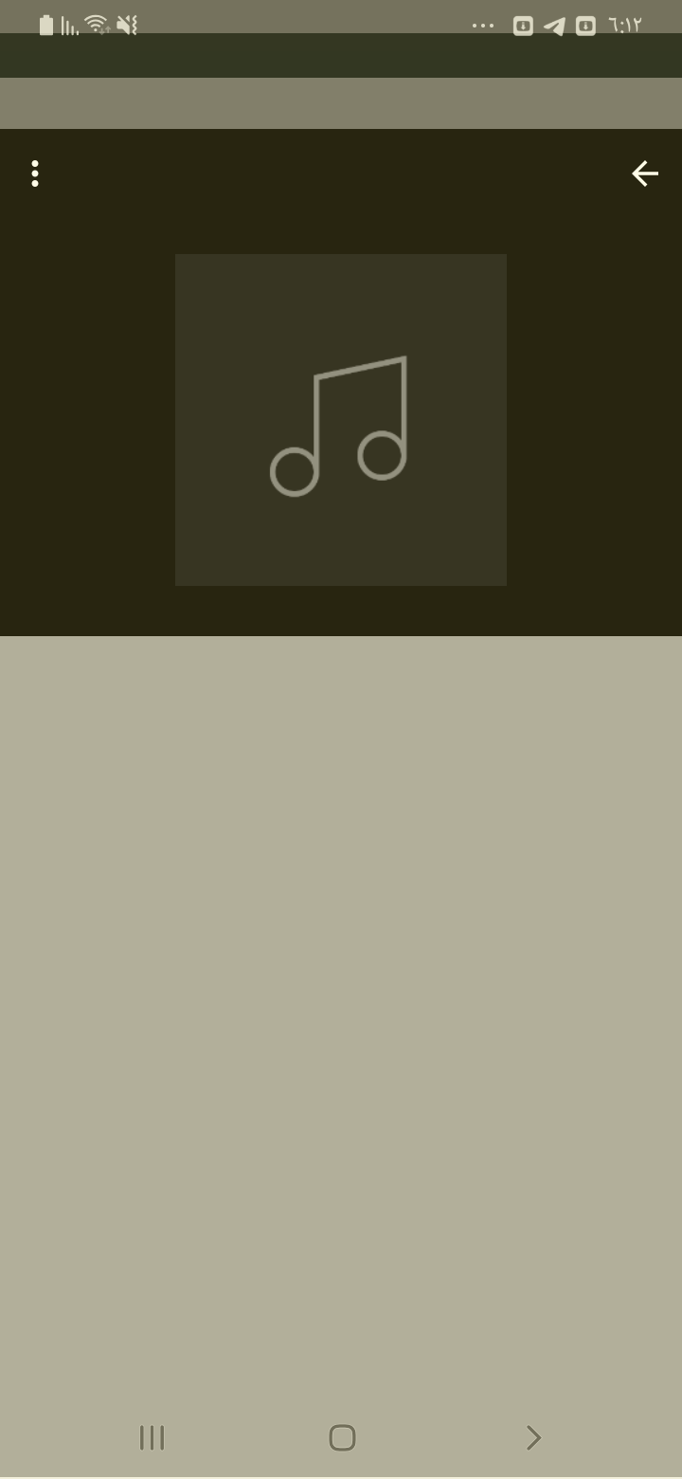

[Attachment] stdout

## Test Teardown

[Fixture] setup::0

# New releases clicking - failed

New releases clicking and check that it works

## Details

AssertionError: assert False

|  |
| --- |
| self = <Mobile_Testing.Tests.test_home.TestHome object at 0x1103adf70>, setup = None   @allure.severity(allure.severity_level.BLOCKER)  @allure.story("Home Page Tests")  @allure.sub_suite("New releases clicking")  @allure.title("New releases clicking")  @allure.description("New releases clicking and check that it works")  @pytest.mark.Do  @pytest.mark.HomePage  @pytest.mark.Test2  def test_case_2(self, setup):  """  checking the New releases works  """  ap = AuthenticationPage(self.driver)  ap.click_signin_button()  lp = LoginPage(self.driver)  lp.do_the_login(Constants.correct_credentials["email"], Constants.correct_credentials["password"])  hp = HomePage(self.driver)  time.sleep(10)  hp.click_new_releases_button()  if Helper.element_exists_by_id(self.driver, HomePage.about_button_id):  print(self.driver.current_activity)  Helper.report_allure(self.driver, "Home page test failed") > assert False E assert False  Mobile_Testing/Tests/test_home.py:111: AssertionError |

## Test Setup

[Fixture] setup

## Test Body

[Attachment] Home page test failed

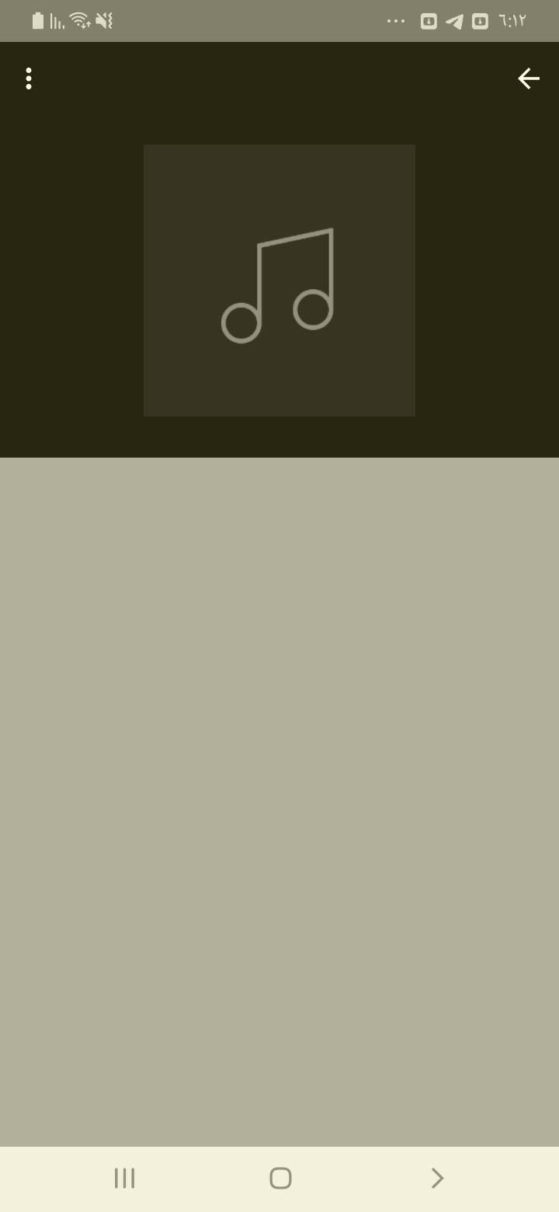

[Attachment] stdout

## Test Teardown

[Fixture] setup::0

# Popular tracks clicking - failed

Popular tracks clicking and check that it works

## Details

AssertionError: assert False

|  |
| --- |
| self = <Mobile_Testing.Tests.test_home.TestHome object at 0x11045dc40>, setup = None   @allure.severity(allure.severity_level.BLOCKER)  @allure.story("Home Page Tests")  @allure.sub_suite("Popular tracks clicking")  @allure.title("Popular tracks clicking")  @allure.description("Popular tracks clicking and check that it works")  @pytest.mark.Do  @pytest.mark.HomePage  @pytest.mark.Test4  def test_case_4(self, setup):  """  checking the Popular tracks works  """  ap = AuthenticationPage(self.driver)  ap.click_signin_button()  lp = LoginPage(self.driver)  lp.do_the_login(Constants.correct_credentials["email"], Constants.correct_credentials["password"])  hp = HomePage(self.driver)  time.sleep(10)  hp.click_popular_tracks_button()  if Helper.element_exists_by_id(self.driver, HomePage.about_button_id):  print(self.driver.current_activity)  Helper.report_allure(self.driver, "Home page test failed") > assert False E assert False  Mobile_Testing/Tests/test_home.py:169: AssertionError |

## Test Setup

[Fixture] setup

## Test Body

[Attachment] Home page test failed

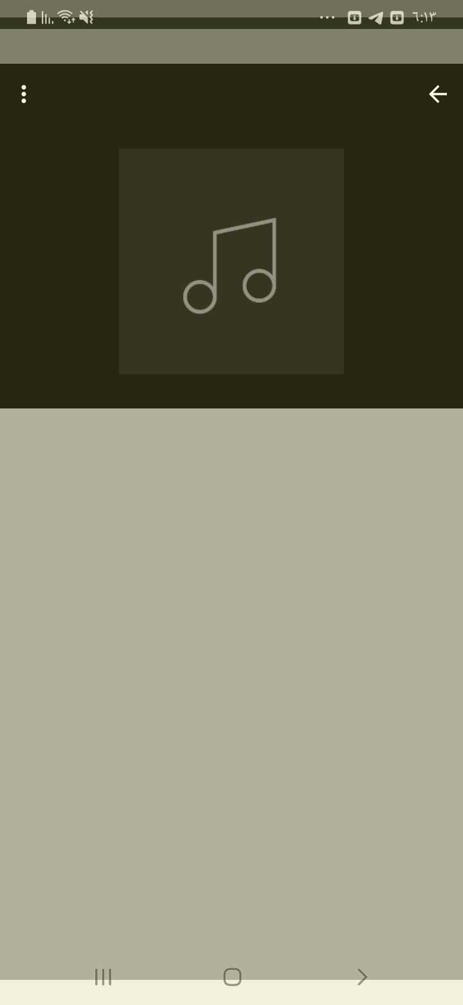

[Attachment] stdout

## Test Teardown

[Fixture] setup::0

# Recommended tracks clicking - failed

Recommended tracks clicking and check that it works

## Details

AssertionError: assert False

|  |
| --- |
| self = <Mobile_Testing.Tests.test_home.TestHome object at 0x1104d8d60>, setup = None   @allure.severity(allure.severity_level.BLOCKER)  @allure.story("Home Page Tests")  @allure.sub_suite("Recommended tracks clicking")  @allure.title("Recommended tracks clicking")  @allure.description("Recommended tracks clicking and check that it works")  @pytest.mark.Do  @pytest.mark.HomePage  @pytest.mark.Test5  def test_case_5(self, setup):  """  checking the Recommended tracks works  """  ap = AuthenticationPage(self.driver)  ap.click_signin_button()  lp = LoginPage(self.driver)  lp.do_the_login(Constants.correct_credentials["email"], Constants.correct_credentials["password"])  hp = HomePage(self.driver)  time.sleep(10)  hp.click_recommended_tracks()  if Helper.element_exists_by_id(self.driver, HomePage.about_button_id):  print(self.driver.current_activity)  Helper.report_allure(self.driver, "Home page test failed") > assert False E assert False  Mobile_Testing/Tests/test_home.py:198: AssertionError |

## Test Setup

[Fixture] setup

## Test Body

[Attachment] Home page test failed

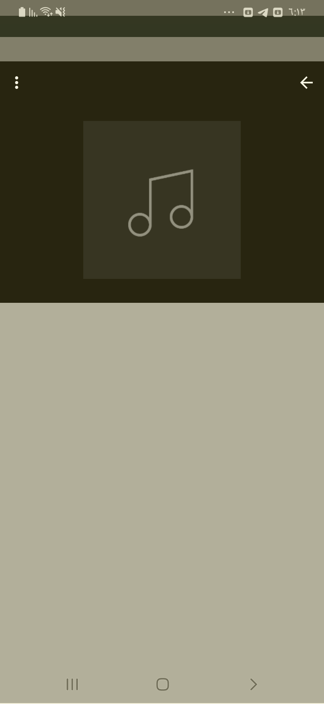

[Attachment] stdout

## Test Teardown

[Fixture] setup::0

# About clicking - passed

About clicking and check that it works

## Test Setup

[Fixture] setup

## Test Body

[Attachment] Home page test passed

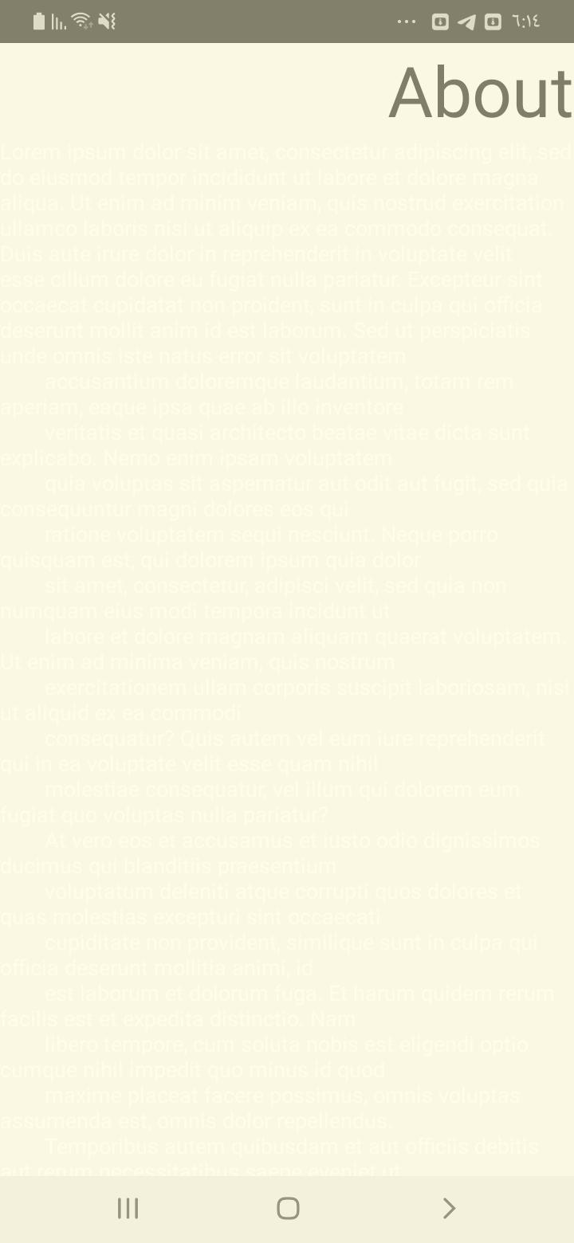

## Test Teardown

[Fixture] setup::0

# Home clicking - passed

Home clicking and check that it works

## Test Setup

[Fixture] setup

## Test Body

[Attachment] Home page test passed

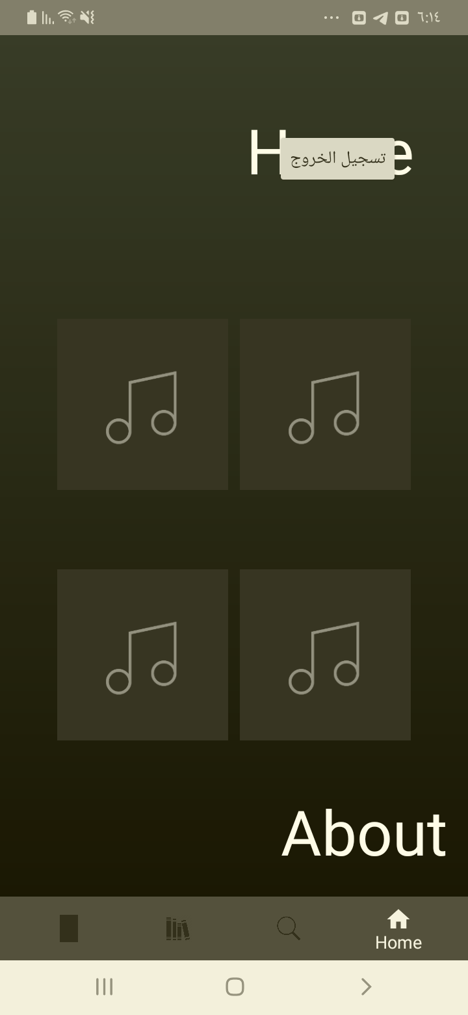

## Test Teardown

[Fixture] setup::0

# Logout clicking - passed

Logout clicking and check that it works

## Test Setup

[Fixture] setup

## Test Body

[Attachment] Home page test passed

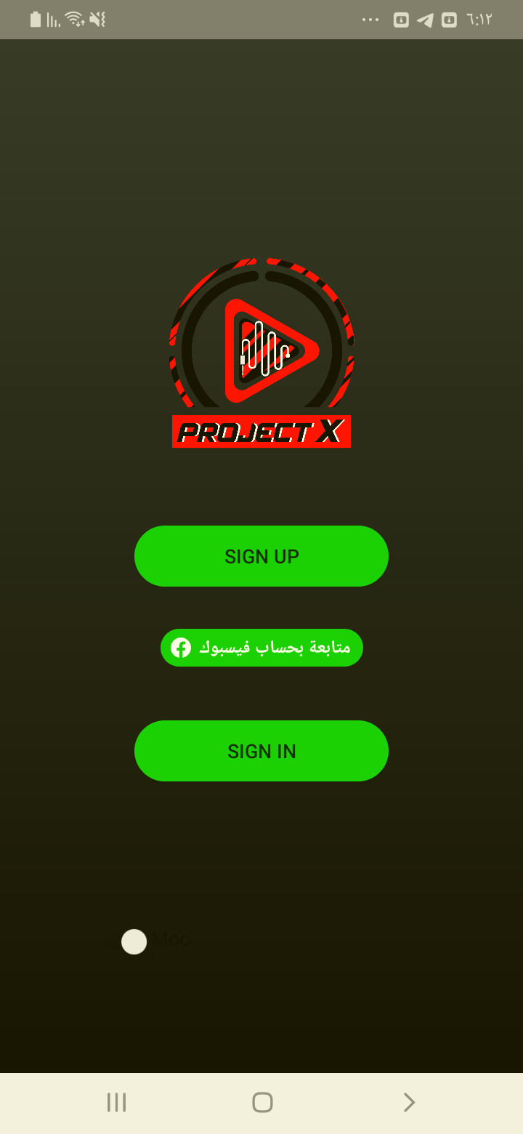

## Test Teardown

[Fixture] setup::0

# Search clicking - passed

Search clicking and check that it works

## Test Setup

[Fixture] setup

## Test Body

[Attachment] Home page test passed

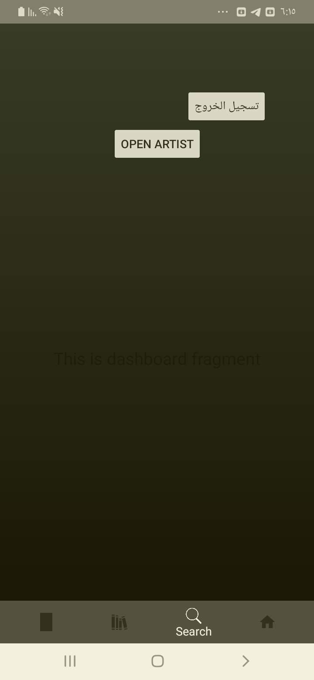

## Test Teardown

[Fixture] setup::0