

Login

Test Report

Test Session Summary

|  |  |
| --- | --- |
| Start: Mon Apr 13 06:07:37 2020 End: Mon Apr 13 06:10:19 2020 Duration: 0:02:42.845000  broken: 0 (0.00%) failed: 0 (0.00%) skipped: 0 (0.00%) passed: 7 (100.00%) |  |

Test Results

# Login correctly - passed

Logging in with correct format with abdallah@gmail.com, 1234567

## Test Setup

[Fixture] setup

## Test Body

[Attachment] Login test passed

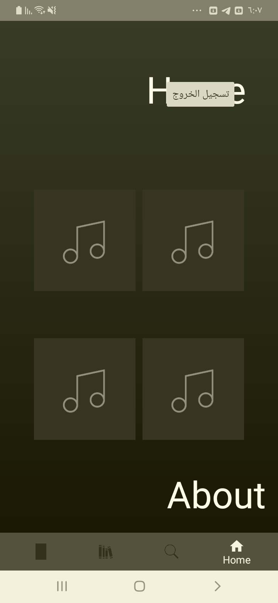

## Test Teardown

[Fixture] setup::0

# Login with no password & email - passed

Logging in with no password & email with ,

## Test Setup

[Fixture] setup

## Test Body

[Attachment] Login test passed

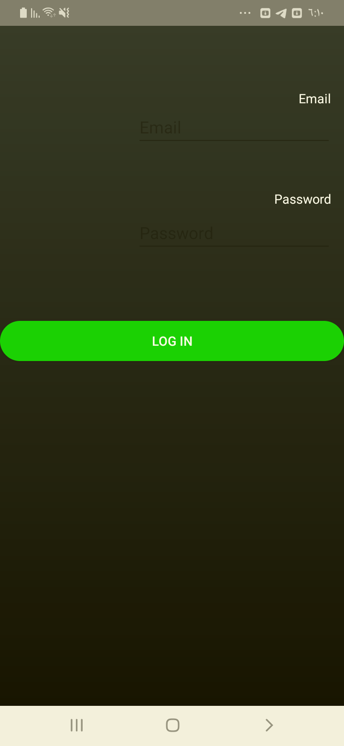

## Test Teardown

[Fixture] setup::0

# Login with no email - passed

Logging in with no email with , Kimo2010

## Test Setup

[Fixture] setup

## Test Body

[Attachment] Login test passed

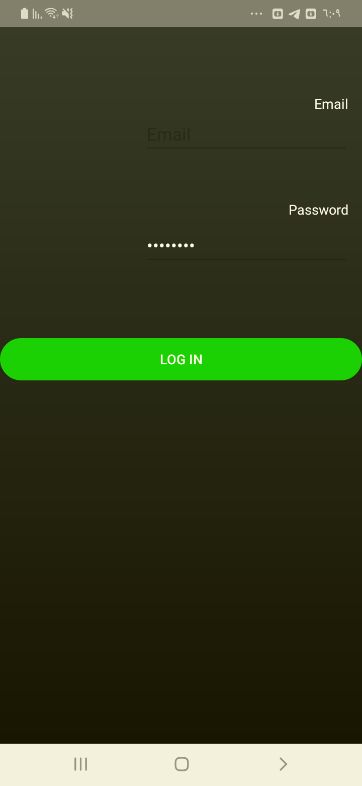

## Test Teardown

[Fixture] setup::0

# Login with no password - passed

Logging in with no password with kamelmohsenkamel@gmail.com,

## Test Setup

[Fixture] setup

## Test Body

[Attachment] Login test passed

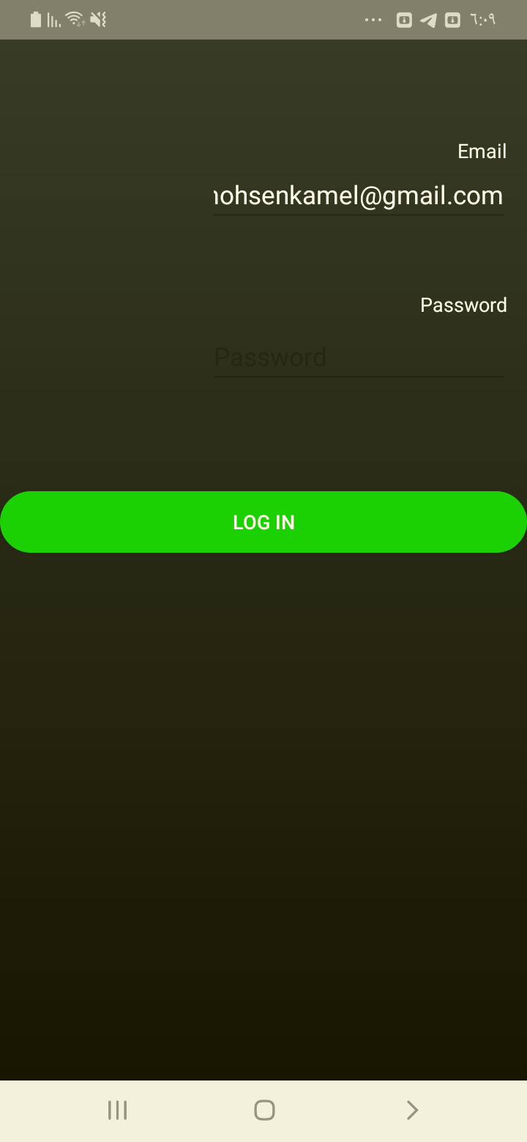

## Test Teardown

[Fixture] setup::0

# Login with wrong email - passed

Logging in with wrong email with kamelmohsenkamel99@gmail.com, Kimo2010

## Test Setup

[Fixture] setup

## Test Body

[Attachment] Login test passed

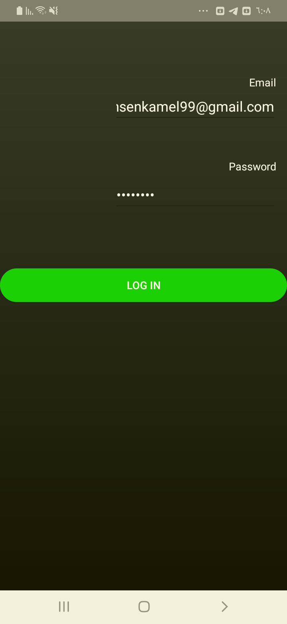

## Test Teardown

[Fixture] setup::0

# Login with wrong email format - passed

Logging in with wrong email format with kamelmohsenkamelgmail.com, Kimo2010

## Test Setup

[Fixture] setup

## Test Body

[Attachment] Login test passed

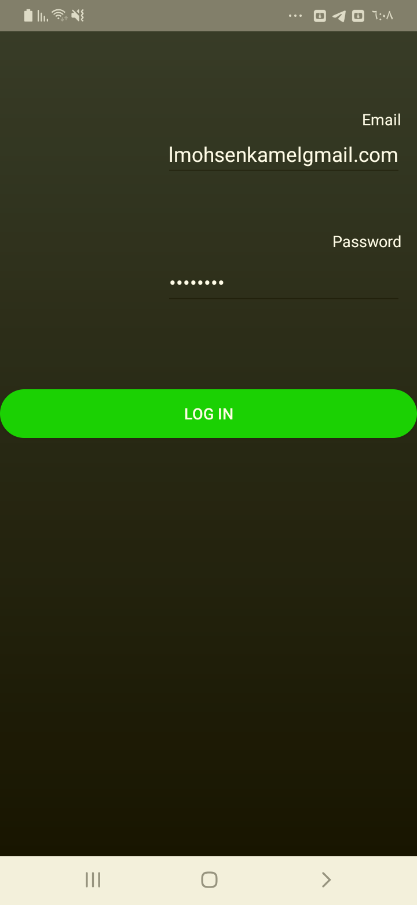

## Test Teardown

[Fixture] setup::0

# Login with wrong password - passed

Logging in with wrong password with kamelmohsenkamel@gmail.com, !@#!@#1

## Test Setup

[Fixture] setup

## Test Body

[Attachment] Login test passed

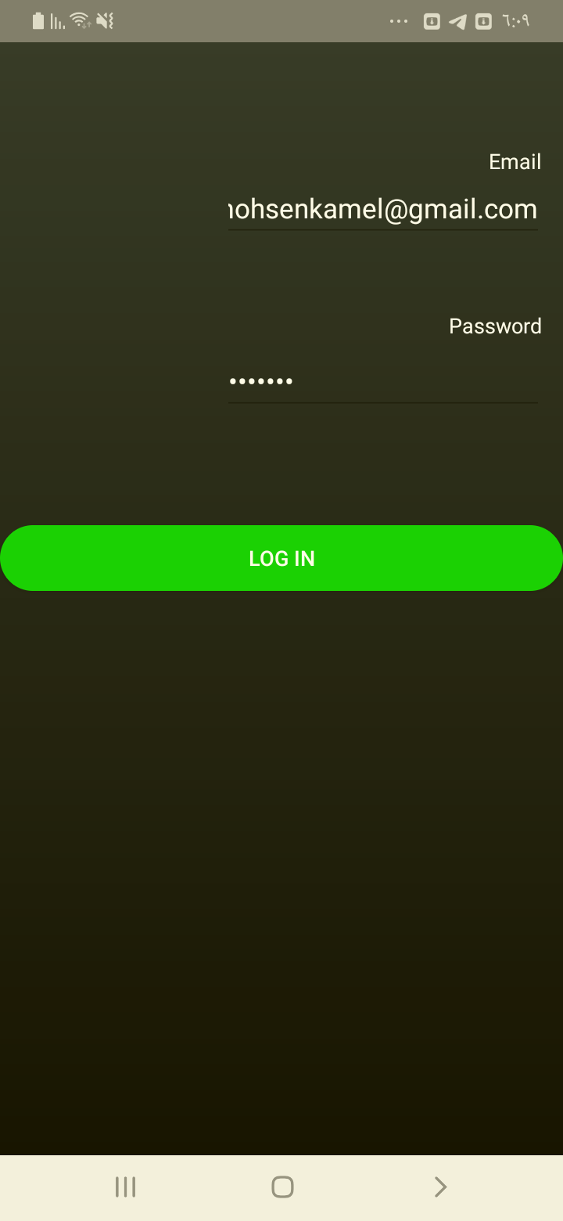

## Test Teardown

[Fixture] setup::0