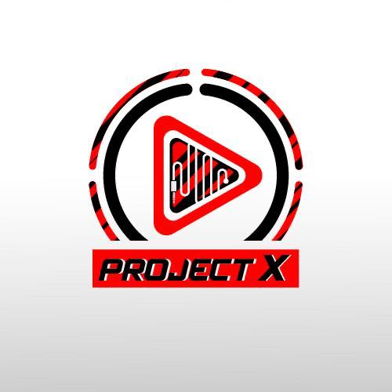

Player

Test Report

Test Session Summary

|  |  |
| --- | --- |
| Start: Mon Apr 13 06:15:36 2020 End: Mon Apr 13 06:21:11 2020 Duration: 0:05:35.102000  broken: 0 (0.00%) failed: 0 (0.00%) skipped: 0 (0.00%) passed: 9 (100.00%) |  |

Test Results

# Blacklist button checking - passed

Checking that the Blacklist button is visible

## Test Setup

[Fixture] setup

## Test Body

[Attachment] Player page test passed

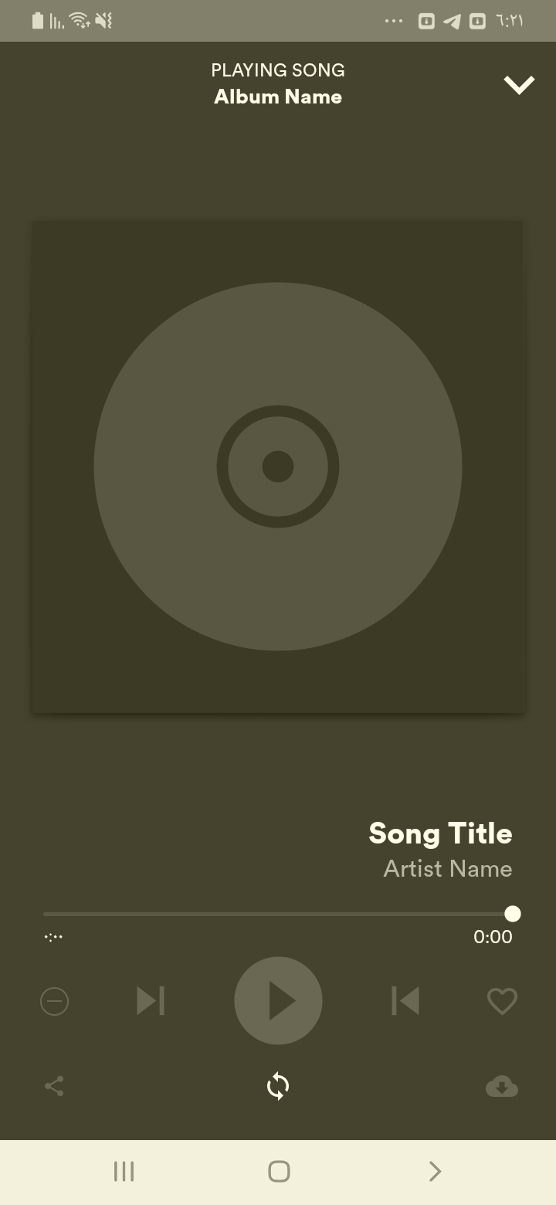

## Test Teardown

[Fixture] setup::0

# Download button checking - passed

Checking that the Download button is visible

## Test Setup

[Fixture] setup

## Test Body

[Attachment] Player page test passed

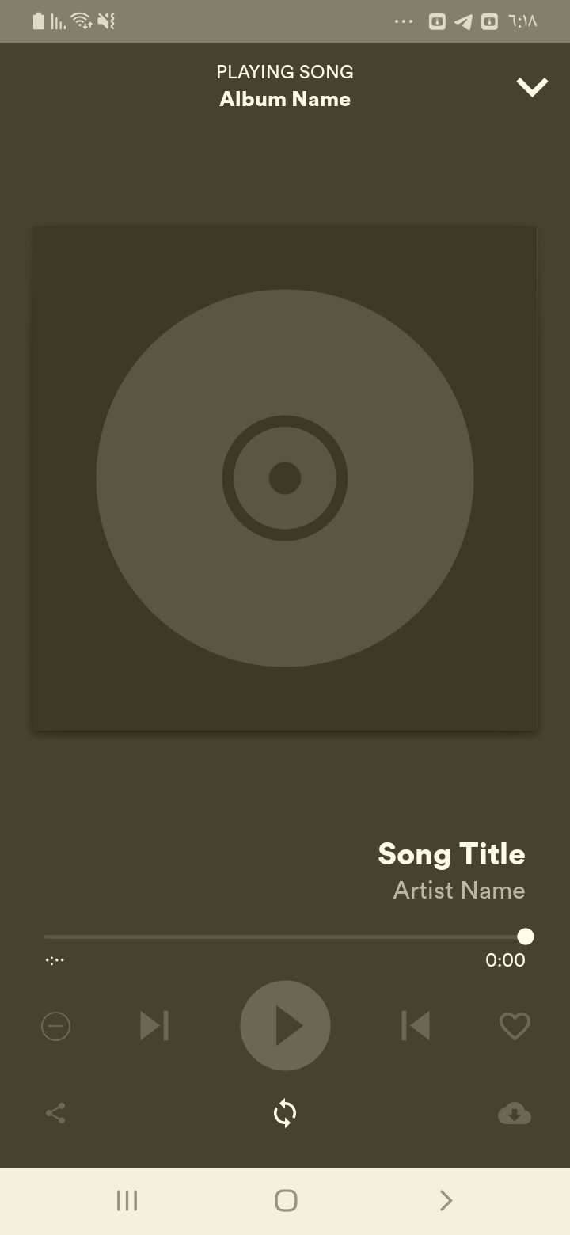

## Test Teardown

[Fixture] setup::0

# Love button checking - passed

Checking that the Love button is visible

## Test Setup

[Fixture] setup

## Test Body

[Attachment] Player page test passed

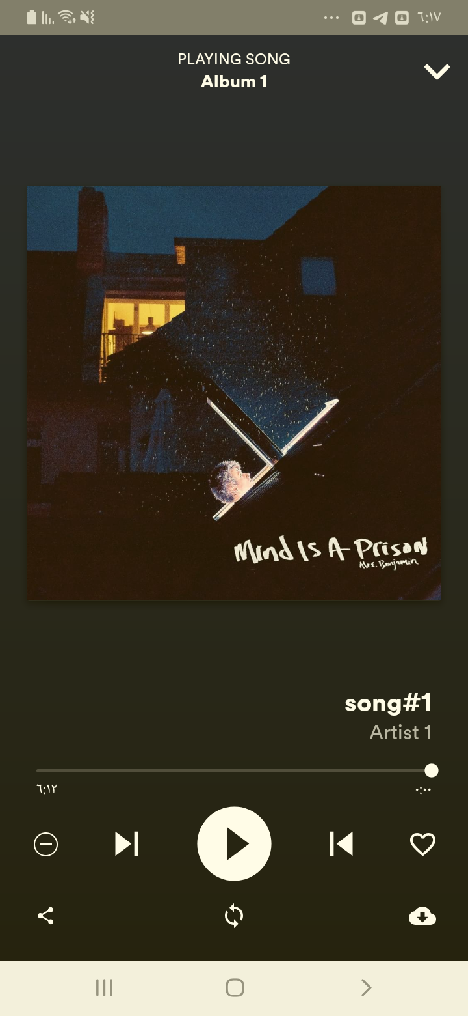

## Test Teardown

[Fixture] setup::0

# Minimize button checking - passed

Checking that the Minimize button is visible

## Test Setup

[Fixture] setup

## Test Body

[Attachment] Player page test passed

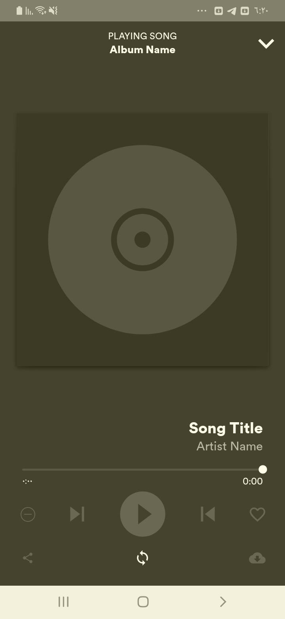

## Test Teardown

[Fixture] setup::0

# Next button checking - passed

Checking that the Next button is visible

## Test Setup

[Fixture] setup

## Test Body

[Attachment] Player page test passed



## Test Teardown

[Fixture] setup::0

# Play button checking - passed

Checking that the Play button is visible

## Test Setup

[Fixture] setup

## Test Body

[Attachment] Player page test passed

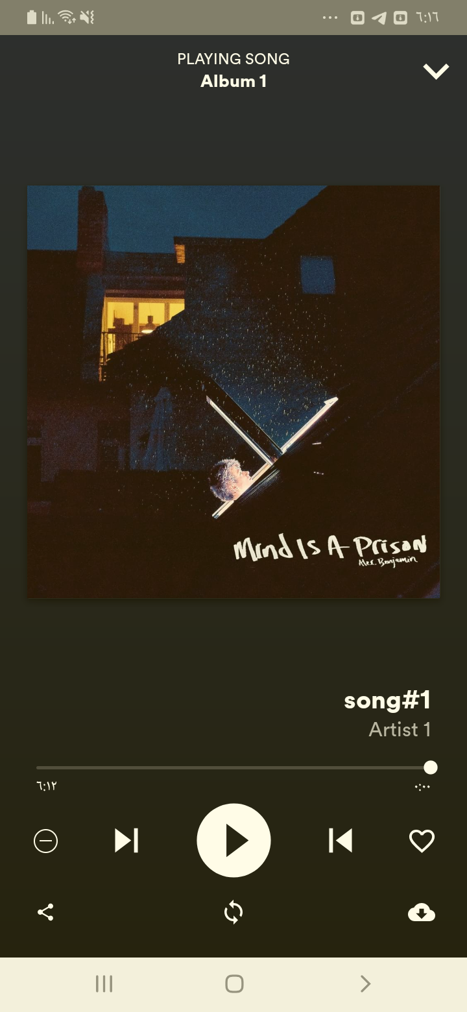

## Test Teardown

[Fixture] setup::0

# Previous button checking - passed

Checking that the Previous button is visible

## Test Setup

[Fixture] setup

## Test Body

[Attachment] Player page test passed

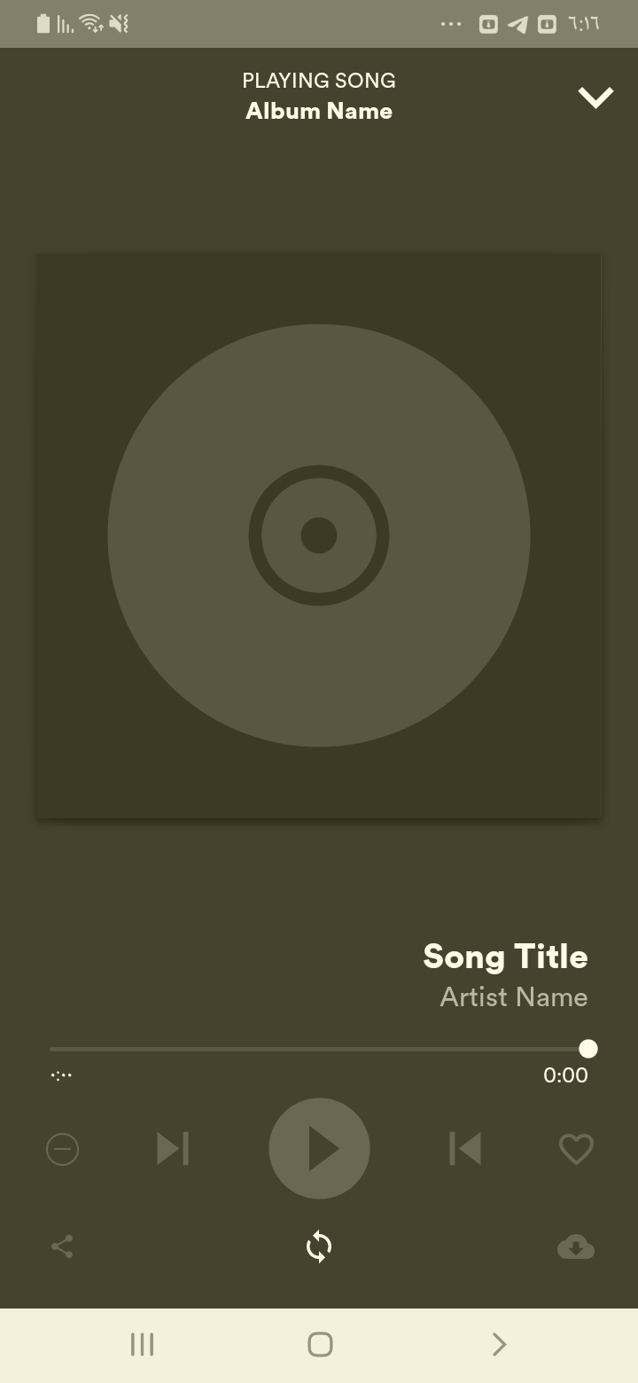

## Test Teardown

[Fixture] setup::0

# Repeat button checking - passed

Checking that the repeat button is visible

## Test Setup

[Fixture] setup

## Test Body

[Attachment] Player page test passed



## Test Teardown

[Fixture] setup::0

# Share button checking - passed

Checking that the Share button is visible

## Test Setup

[Fixture] setup

## Test Body

[Attachment] Player page test passed

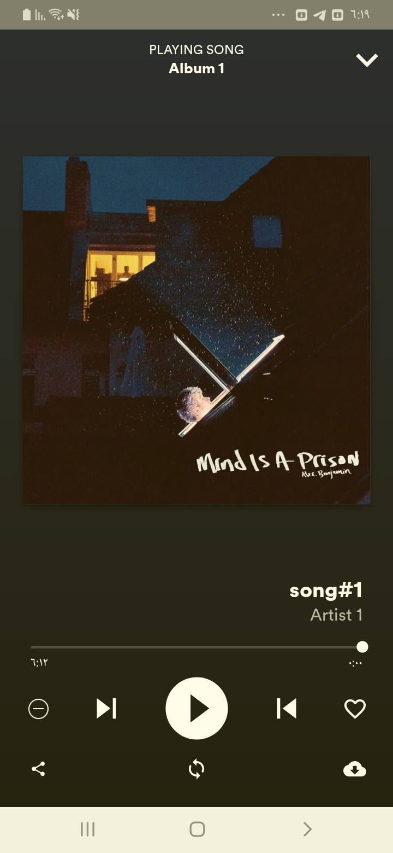

## Test Teardown

[Fixture] setup::0