

Signup

Test Report

Test Session Summary

|  |  |
| --- | --- |
| Start: Mon Apr 13 06:21:13 2020 End: Mon Apr 13 06:26:26 2020 Duration: 0:05:12.657000  broken: 0 (0.00%) failed: 3 (25.00%) skipped: 0 (0.00%) passed: 9 (75.00%) |  |

Test Results

# Sign up correctly - failed

Signing up with correct format

## Details

AssertionError: assert False

|  |
| --- |
| self = <Mobile_Testing.Tests.test_signup.TestSignup object at 0x10fc98bb0>, setup = None   @allure.severity(allure.severity_level.BLOCKER)  @allure.story("Signup Tests")  @allure.sub_suite("Sign up correctly")  @allure.title("Sign up correctly")  @allure.description("Signing up with correct format ")  @pytest.mark.Do  @pytest.mark.Signup  @pytest.mark.Test1  def test_case_1(self, setup):  """  Signs up correctly  """  ap = AuthenticationPage(self.driver)  ap.click_signup_button()  sp = SignupPage(self.driver)  sp.do_the_signup(self.name, self.email, self.password, "22", "M")  if Helper.element_exists_by_id(self.driver, HomePage.logout_button_id):  Helper.report_allure(self.driver, "Sign up test Passed")  assert True  else:  print(self.driver.current_activity)  Helper.report_allure(self.driver, "Sign up test Failed") > assert False E assert False  Mobile_Testing/Tests/test_signup.py:103: AssertionError |

## Test Setup

[Fixture] setup

## Test Body

[Attachment] Sign up test Failed

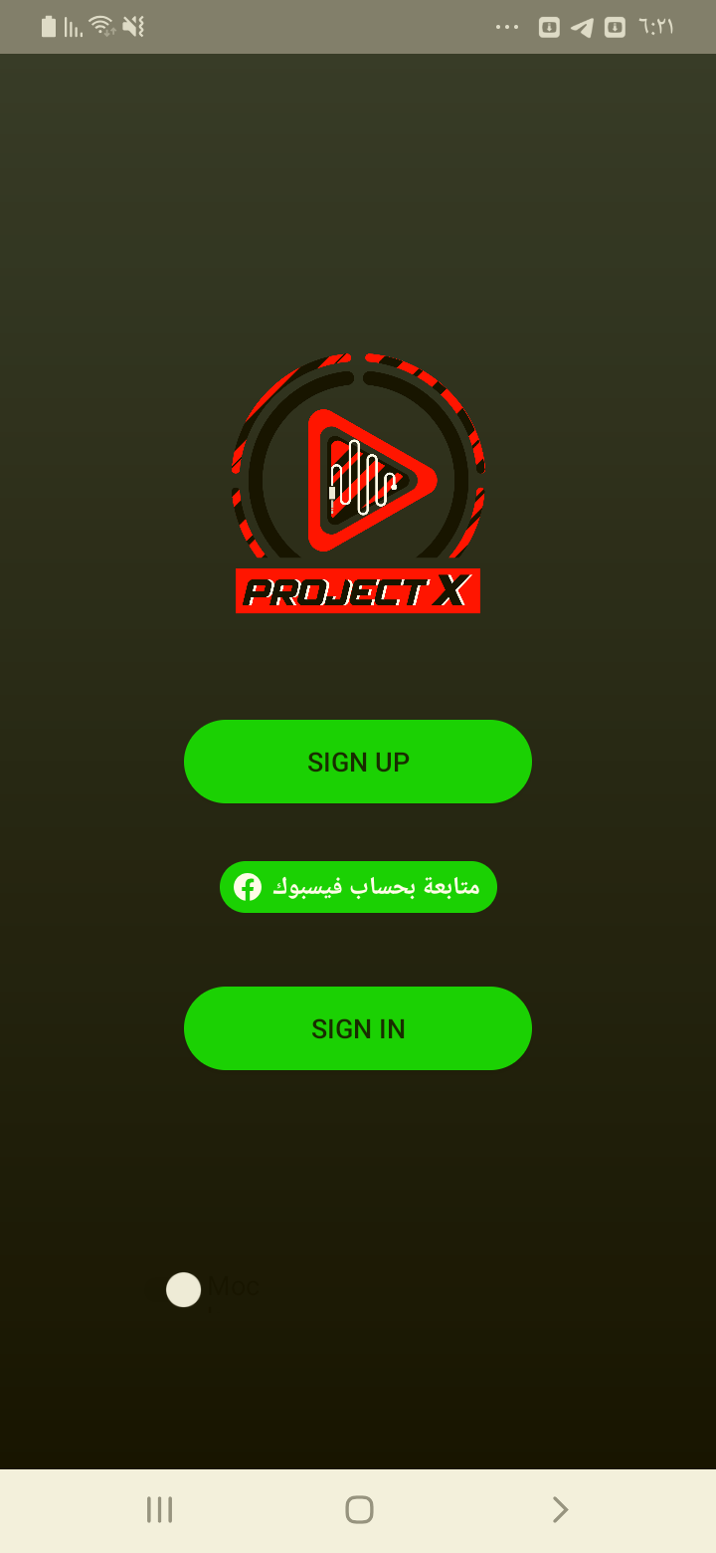

[Attachment] stdout

## Test Teardown

[Fixture] setup::0

# Signs up with 999 age - failed

Signs up with 999 age

## Details

AssertionError: assert False

|  |
| --- |
| self = <Mobile_Testing.Tests.test_signup.TestSignup object at 0x10fd815b0>, setup = None   @allure.severity(allure.severity_level.BLOCKER)  @allure.story("Signup Tests")  @allure.sub_suite("Sign up with 999 age ")  @allure.title("Signs up with 999 age ")  @allure.description("Signs up with 999 age")  @pytest.mark.Do  @pytest.mark.Signup  @pytest.mark.Test12  def test_case_12(self, setup):  """  Signs up with 999 age  """  ap = AuthenticationPage(self.driver)  ap.click_signup_button()  sp = SignupPage(self.driver)  sp.do_the_signup(self.name, self.email, self.password, "999", "M")  if Helper.element_exists_by_id(self.driver, HomePage.logout_button_id):  print(self.driver.current_activity)  Helper.report_allure(self.driver, "Sign up test Failed") > assert False E assert False  Mobile_Testing/Tests/test_signup.py:376: AssertionError |

## Test Setup

[Fixture] setup

## Test Body

[Attachment] Sign up test Failed

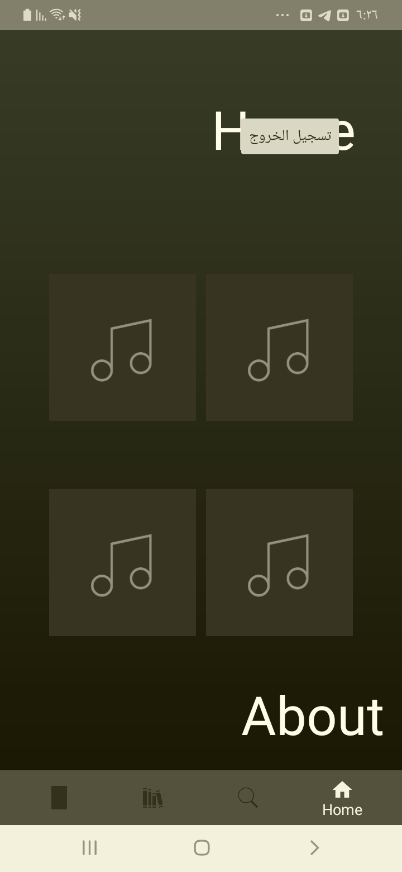

[Attachment] stdout

## Test Teardown

[Fixture] setup::0

# Signs up with wrong name format - failed

Signs up with wrong name format

## Details

AssertionError: assert False

|  |
| --- |
| self = <Mobile_Testing.Tests.test_signup.TestSignup object at 0x10fd81af0>, setup = None   @allure.severity(allure.severity_level.BLOCKER)  @allure.story("Signup Tests")  @allure.sub_suite("Sign up with wrong name format")  @allure.title("Signs up with wrong name format")  @allure.description("Signs up with wrong name format")  @pytest.mark.Do  @pytest.mark.Signup  @pytest.mark.Test8  def test_case_8(self, setup):  """  Signs up with wrong name format  """  ap = AuthenticationPage(self.driver)  ap.click_signup_button()  sp = SignupPage(self.driver)  sp.do_the_signup("@!@#!@", self.email, self.password, "21", "M")  if Helper.element_exists_by_id(self.driver, HomePage.logout_button_id):  print(self.driver.current_activity)  Helper.report_allure(self.driver, "Sign up test Failed") > assert False E assert False  Mobile_Testing/Tests/test_signup.py:276: AssertionError |

## Test Setup

[Fixture] setup

## Test Body

[Attachment] Sign up test Failed

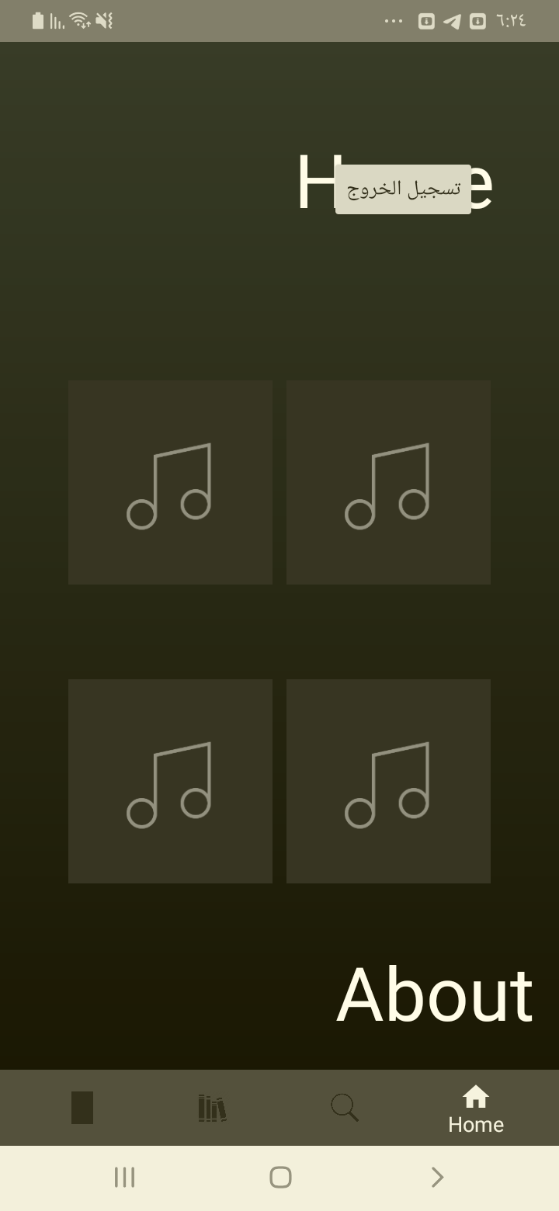

[Attachment] stdout

## Test Teardown

[Fixture] setup::0

# Signs up with -ve age - passed

Signs up with -ve age

## Test Setup

[Fixture] setup

## Test Body

[Attachment] Sign up test Passed

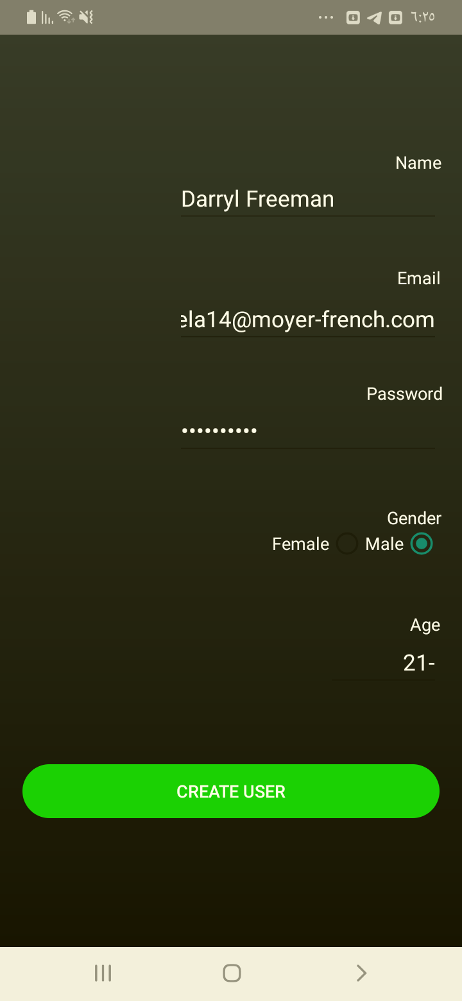

## Test Teardown

[Fixture] setup::0

# Signs up with 0 age - passed

Signs up with 0 age

## Test Setup

[Fixture] setup

## Test Body

[Attachment] Sign up test Passed

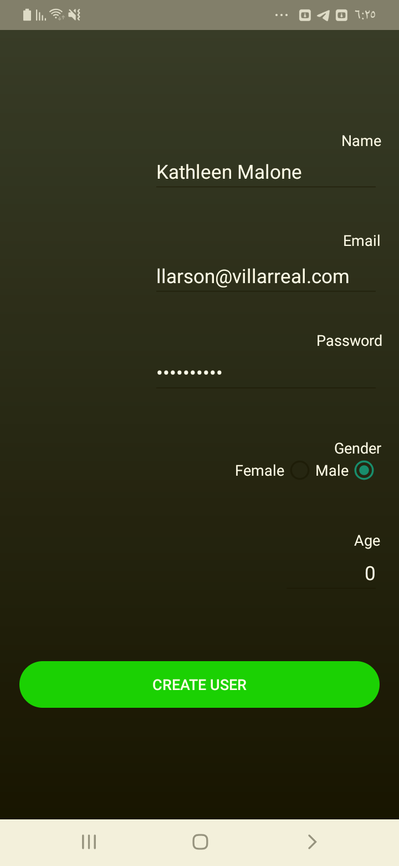

## Test Teardown

[Fixture] setup::0

# Signs up with existing email - passed

Signs up with existing email

## Test Setup

[Fixture] setup

## Test Body

[Attachment] Sign up test Passed

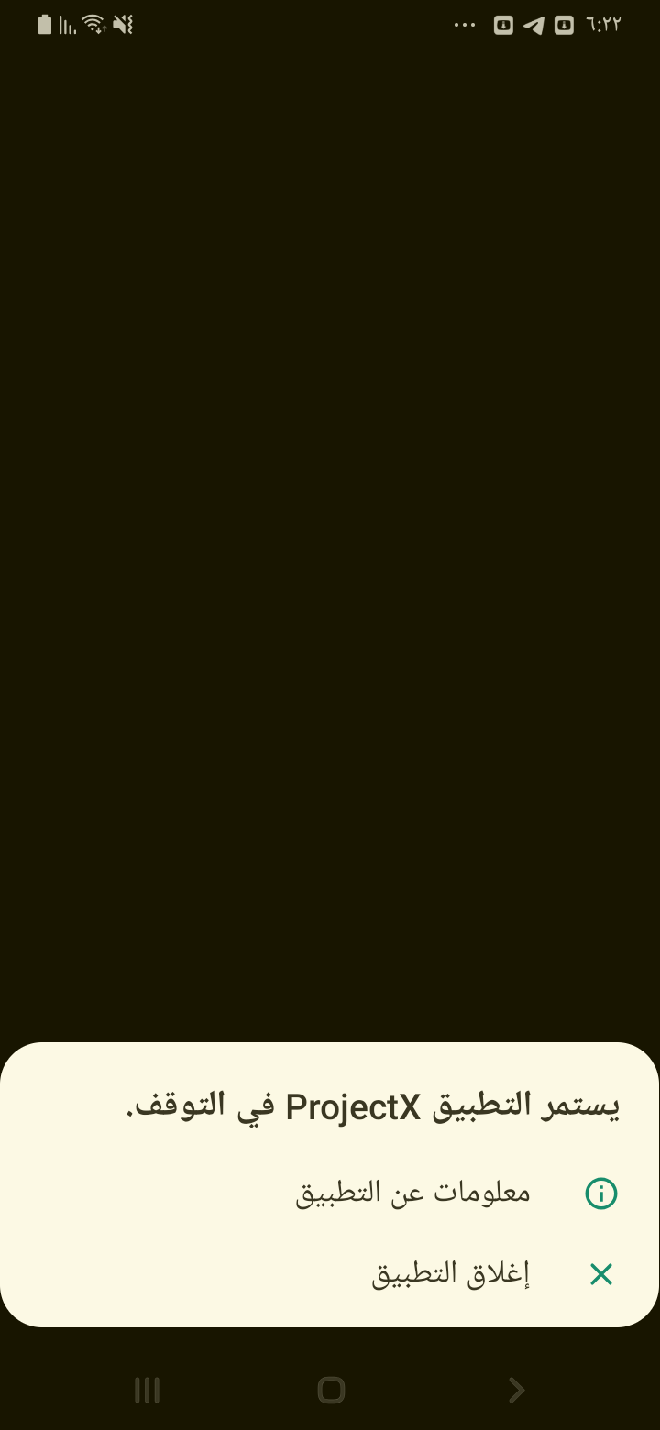

## Test Teardown

[Fixture] setup::0

# Signs up with female gender - passed

Signs up with female

## Test Setup

[Fixture] setup

## Test Body

[Attachment] Sign up test Passed



## Test Teardown

[Fixture] setup::0

# Signs up with no age - passed

Signs up with no age

## Test Setup

[Fixture] setup

## Test Body

[Attachment] Sign up test Passed

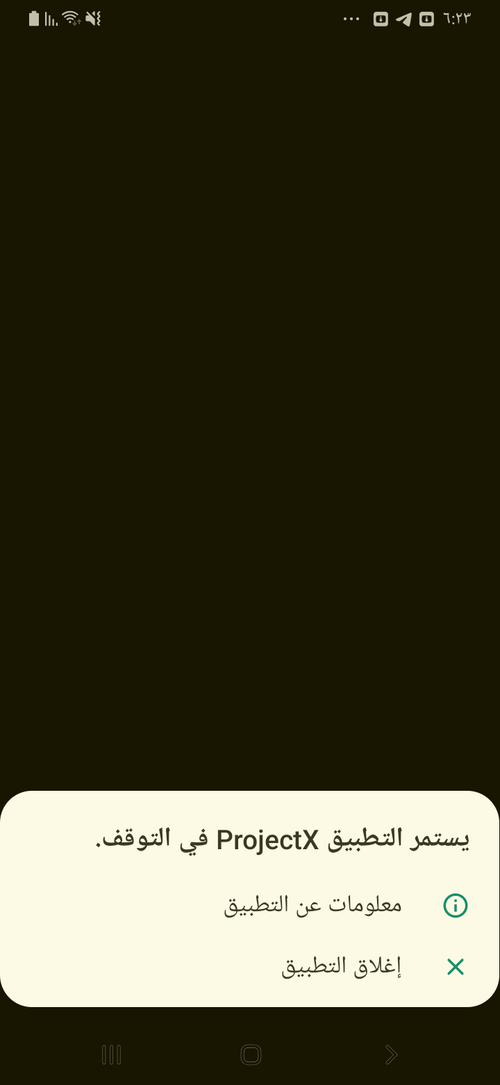

## Test Teardown

[Fixture] setup::0

# Signs up with no email - passed

Signs up with no email

## Test Setup

[Fixture] setup

## Test Body

[Attachment] Sign up test Passed

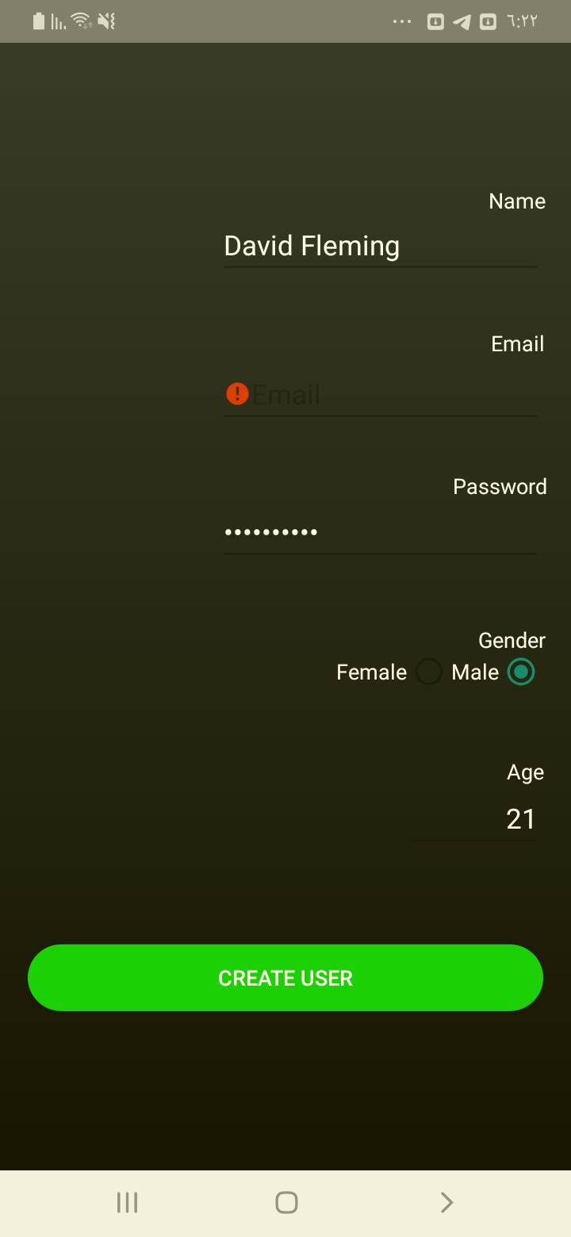

## Test Teardown

[Fixture] setup::0

# Signs up with no name - passed

Signs up with no name

## Test Setup

[Fixture] setup

## Test Body

[Attachment] Sign up test Passed

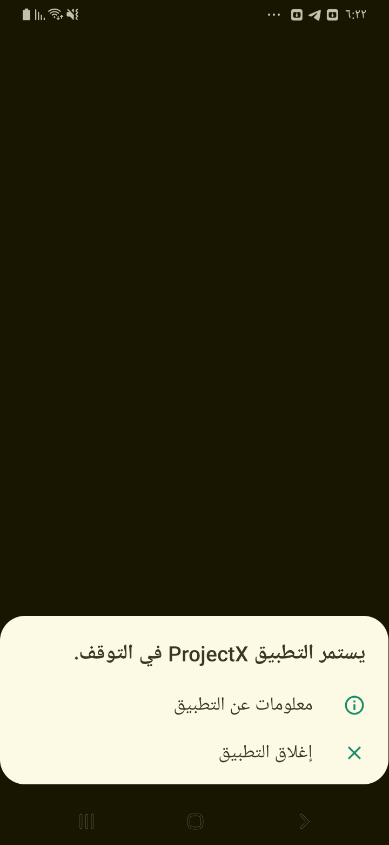

## Test Teardown

[Fixture] setup::0

# Signs up with no password - passed

Signs up with no password

## Test Setup

[Fixture] setup

## Test Body

[Attachment] Sign up test Passed

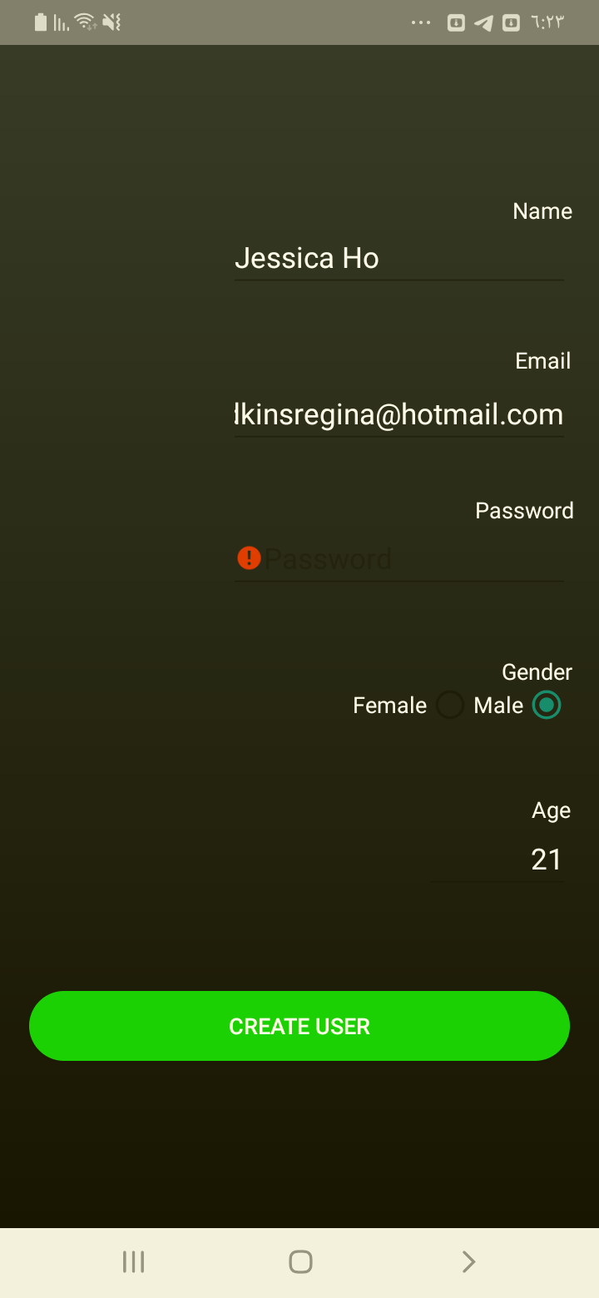

## Test Teardown

[Fixture] setup::0

# Signs up with wrong email format - passed

Signs up with wrong email format

## Test Setup

[Fixture] setup

## Test Body

[Attachment] Sign up test Passed

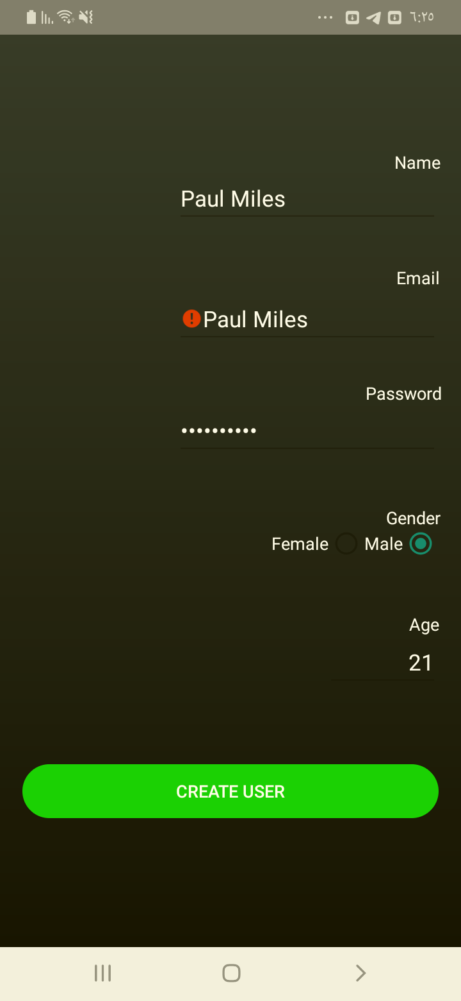

## Test Teardown

[Fixture] setup::0