

Extra

Test Report

Test Session Summary

|  |  |
| --- | --- |
| Start: Mon Apr 13 06:11:08 2020 End: Mon Apr 13 06:11:43 2020 Duration: 0:00:34.418000  broken: 0 (0.00%) failed: 0 (0.00%) skipped: 0 (0.00%) passed: 1 (100.00%) |  |

Test Results

# checking the artist button - passed

checking the artist button

## Test Setup

[Fixture] setup

## Test Body

[Attachment] Extra test1 passed

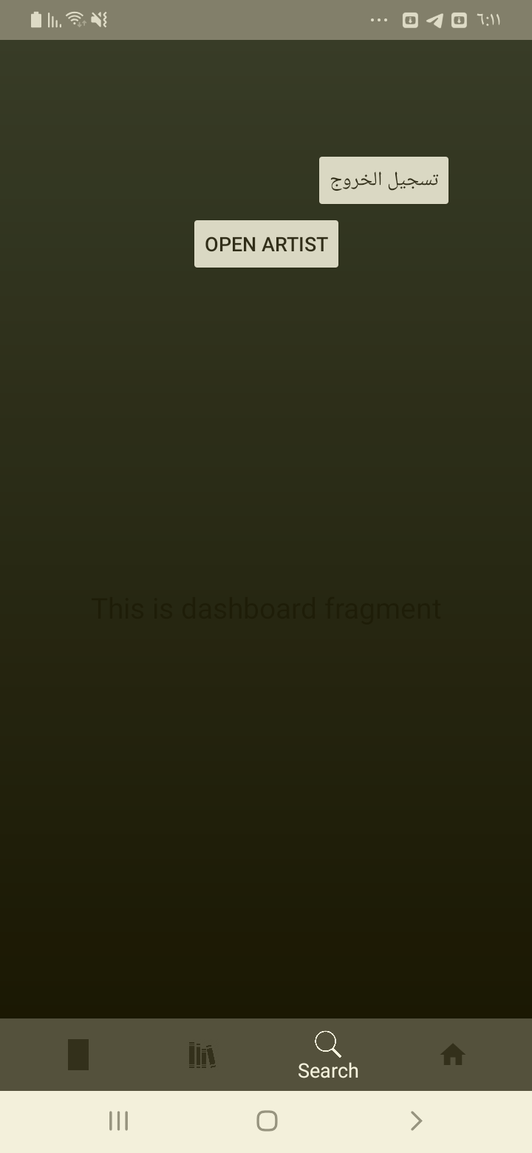

[Attachment] Extra test2 passed

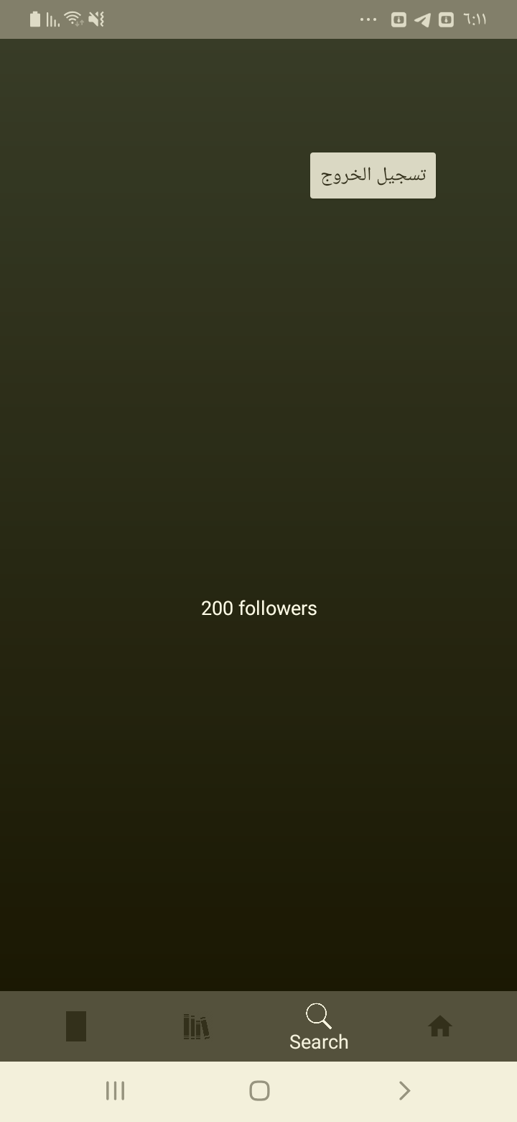

[Attachment] Extra test3 passed

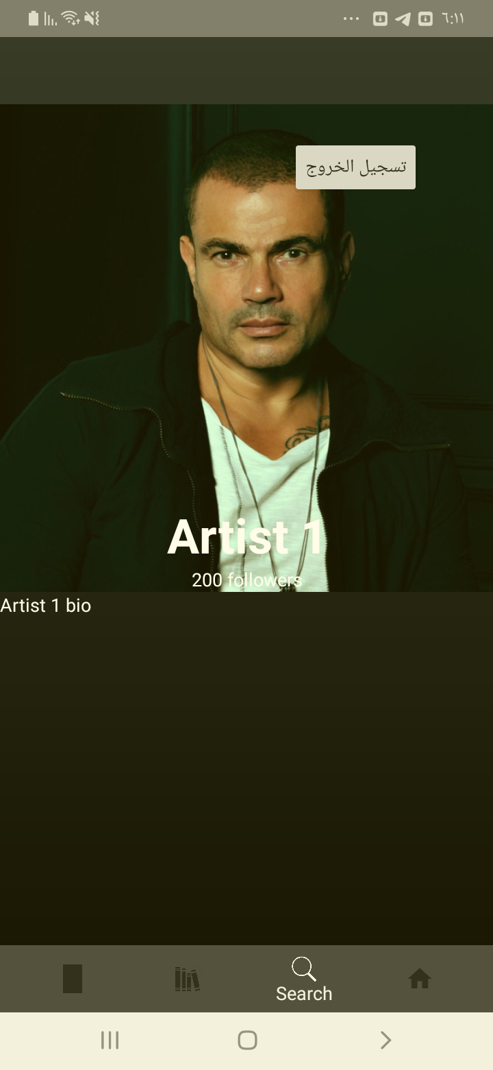

## Test Teardown

[Fixture] setup::0