

Account Overview

Test Report

Test Session Summary

|  |  |
| --- | --- |
| Start: Mon Apr 13 07:41:18 2020 End: Mon Apr 13 07:42:07 2020 Duration: 0:00:48.490000  broken: 0 (0.00%) failed: 0 (0.00%) skipped: 0 (0.00%) passed: 14 (100.00%) |  |

Test Results

# Check right information - passed

Check user information and signing in with the following credentials email : test_projectX@hotmail.com & password:

## Test Setup

[Fixture] setup_check_information

## Test Body

[Attachment] SUCCESS: All information is correct

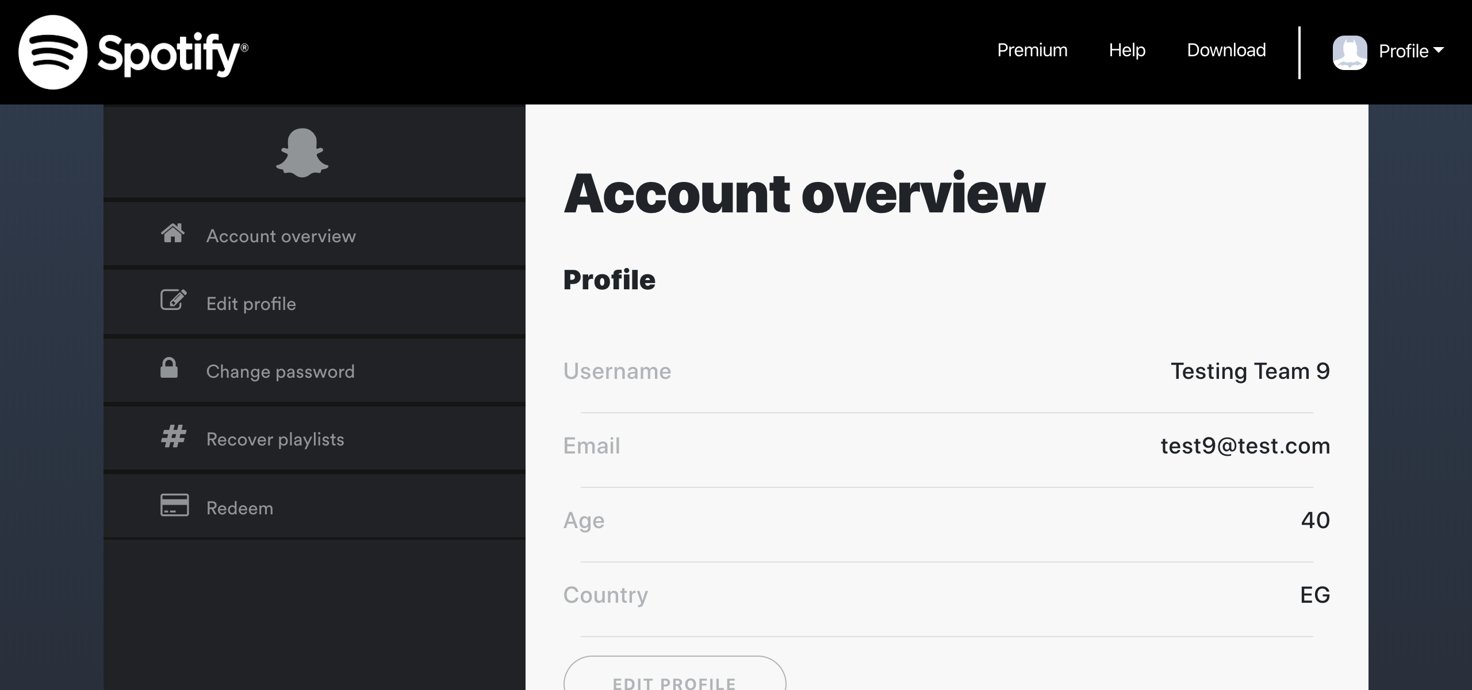

[Attachment] stdout

## Test Teardown

[Fixture] setup_check_information::0

# Clicking Download link - passed

Clicking Download link

## Test Setup

[Fixture] setup

## Test Body

[Attachment] Download functional

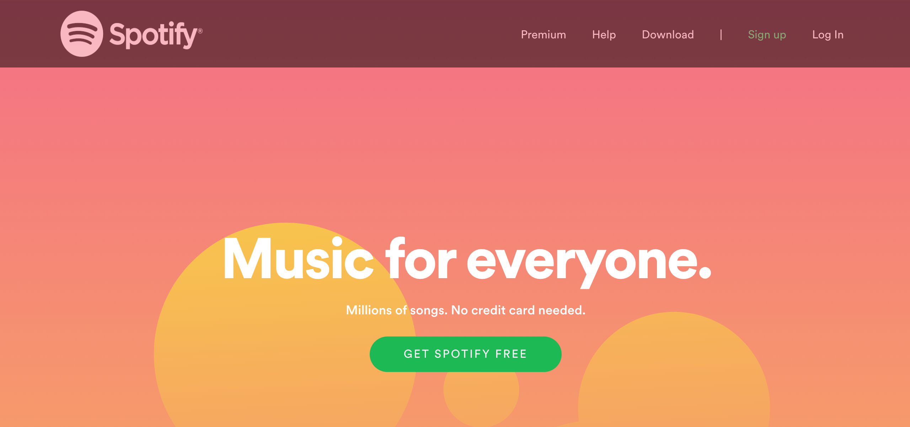

## Test Teardown

[Fixture] setup::0

# Clicking account link - passed

Clicking account link

## Test Setup

[Fixture] setup

## Test Body

[Attachment] Account link functional



## Test Teardown

[Fixture] setup::0

# Clicking account overview link - passed

Clicking account overview link

## Test Setup

[Fixture] setup

## Test Body

[Attachment] Account Overview link functional

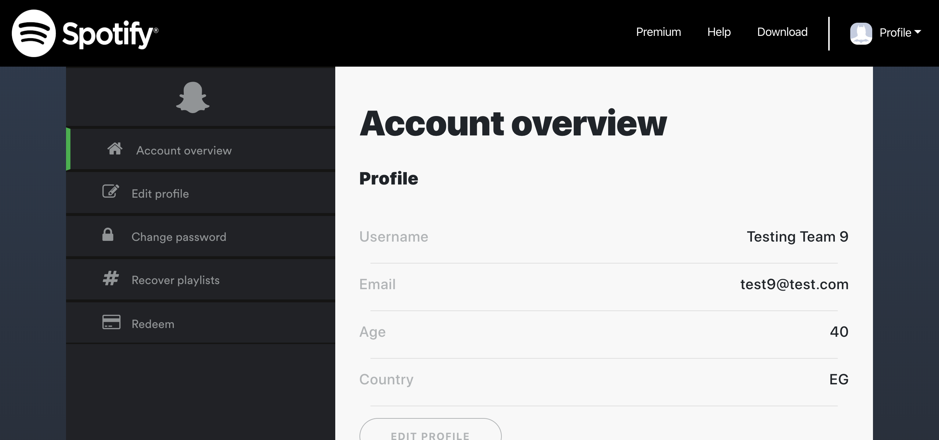

## Test Teardown

[Fixture] setup::0

# Clicking change password link - passed

Clicking change password link

## Test Setup

[Fixture] setup

## Test Body

[Attachment] Change Password link functional

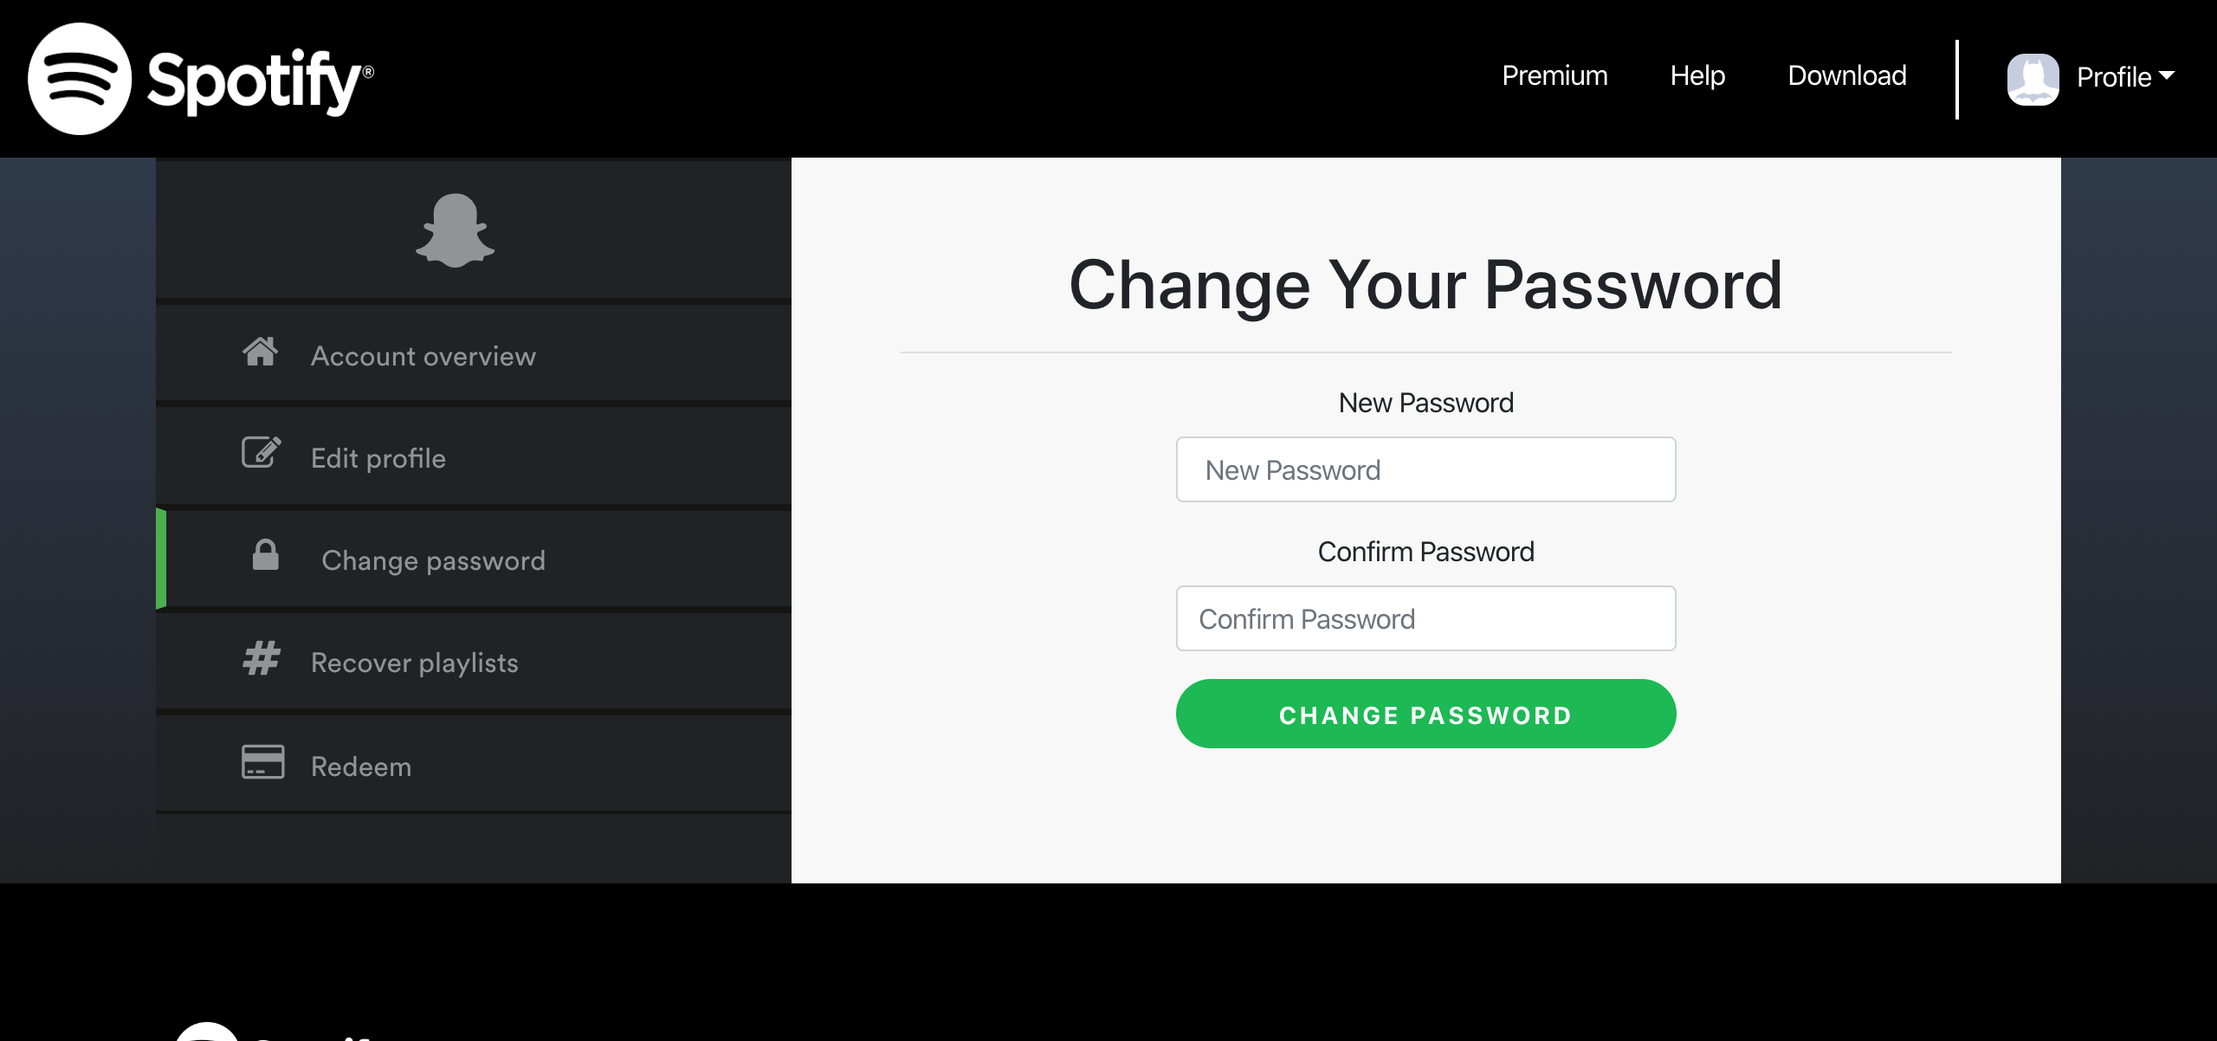

## Test Teardown

[Fixture] setup::0

# Clicking edit profile button - passed

Clicking edit profile button

## Test Setup

[Fixture] setup

## Test Body

[Attachment] edit profile button functional

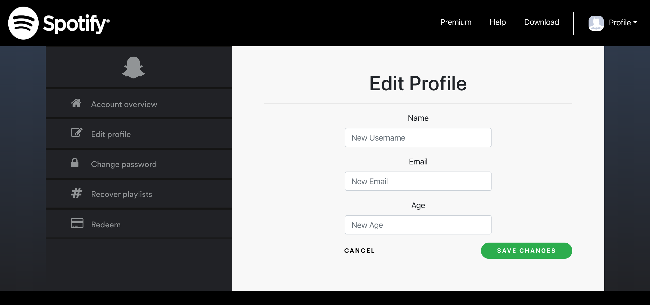

## Test Teardown

[Fixture] setup::0

# Clicking edit profile link - passed

Clicking edit profile link

## Test Setup

[Fixture] setup

## Test Body

[Attachment] Edit Profile link functional

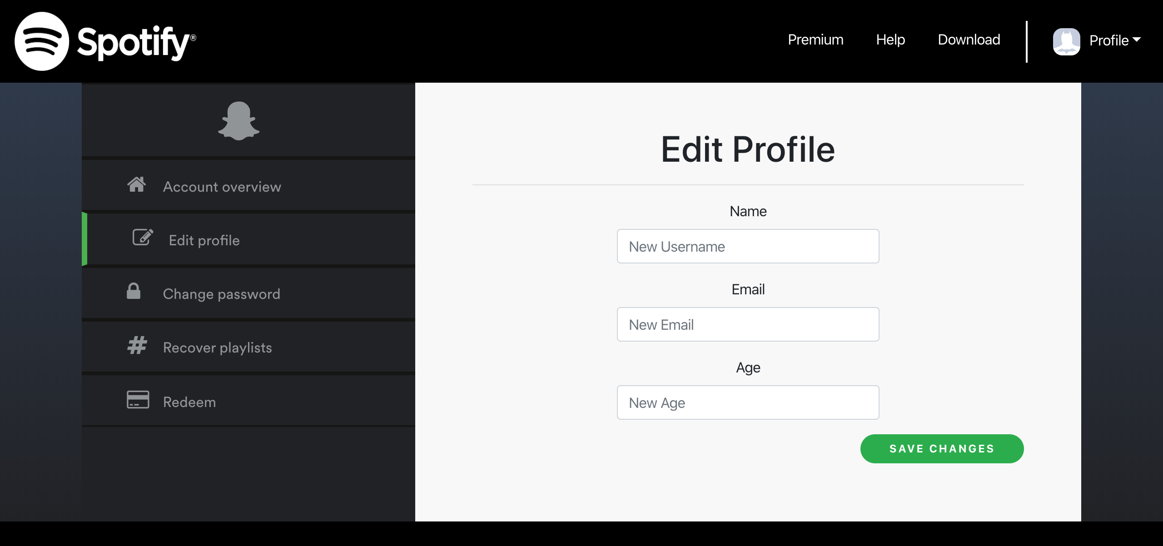

## Test Teardown

[Fixture] setup::0

# Clicking help link - passed

Clicking help link

## Test Setup

[Fixture] setup

## Test Body

[Attachment] Help link functional

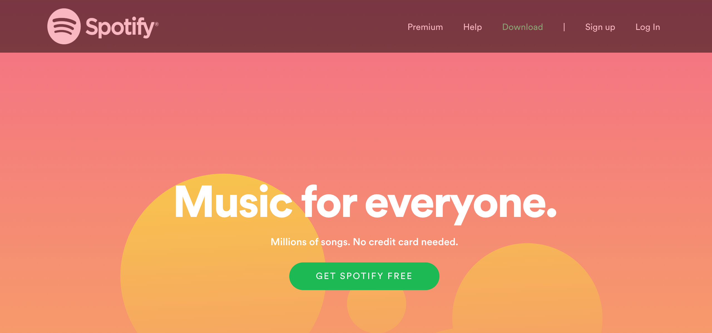

## Test Teardown

[Fixture] setup::0

# Clicking join premium button - passed

Clicking join premium button

## Test Setup

[Fixture] setup

## Test Body

[Attachment] join premium button functional

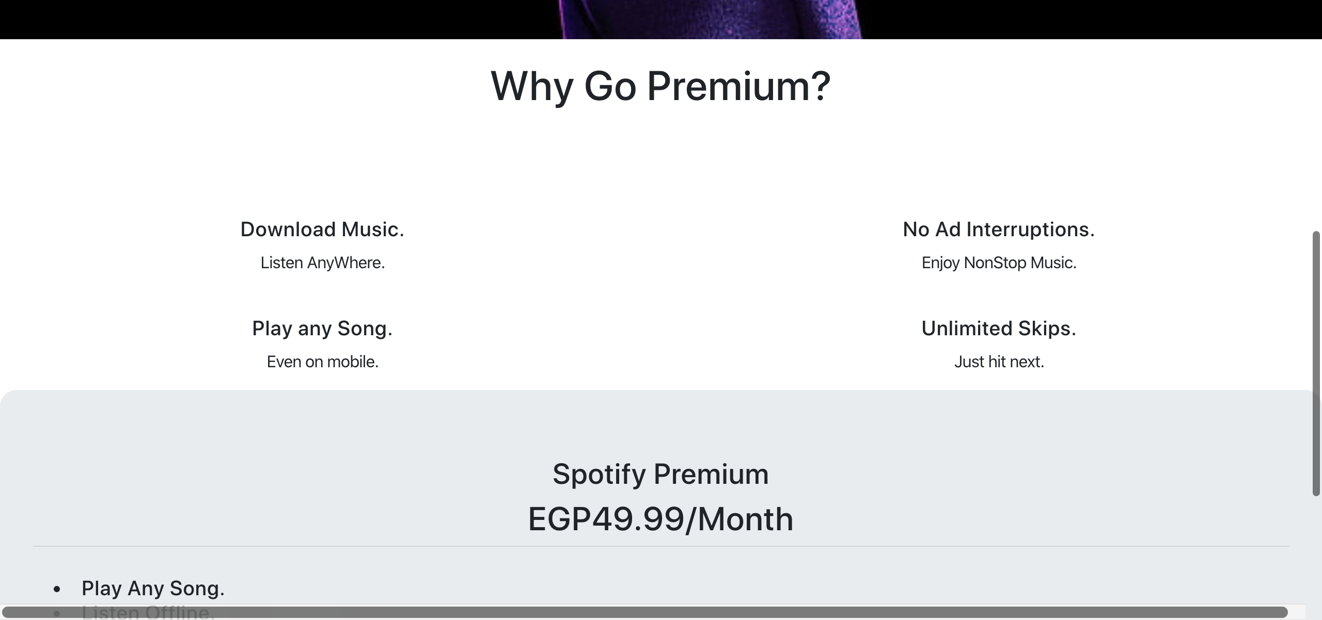

## Test Teardown

[Fixture] setup::0

# Clicking logout link - passed

Clicking logout link

## Test Setup

[Fixture] setup

## Test Body

[Attachment] Logout link functional

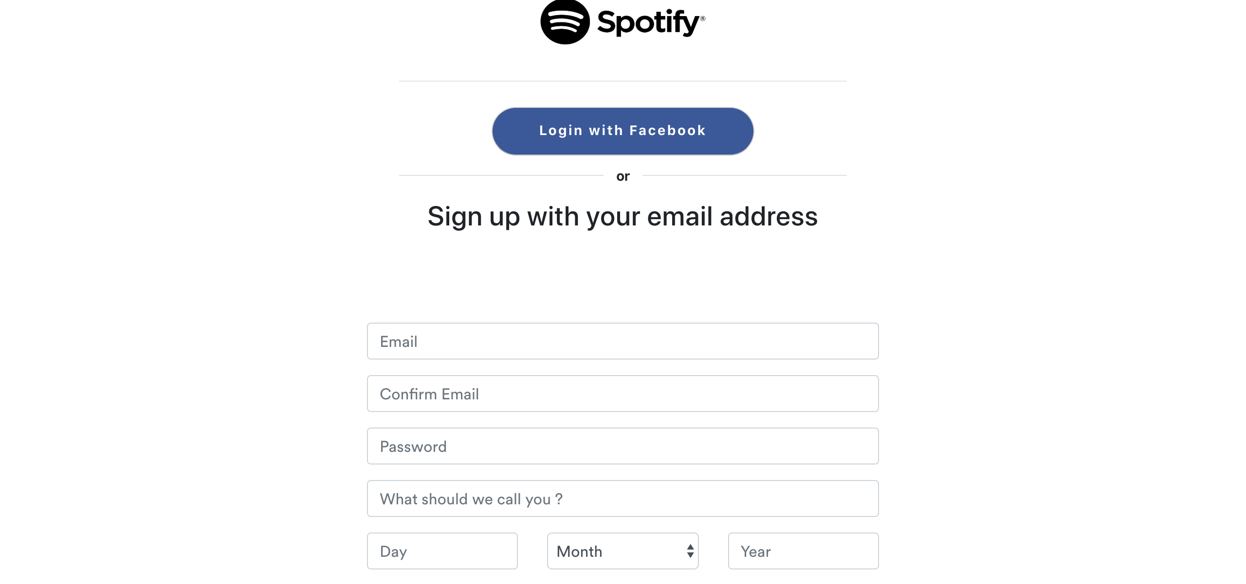

## Test Teardown

[Fixture] setup::0

# Clicking premium link - passed

Clicking premium link

## Test Setup

[Fixture] setup

## Test Body

[Attachment] Premium link functional

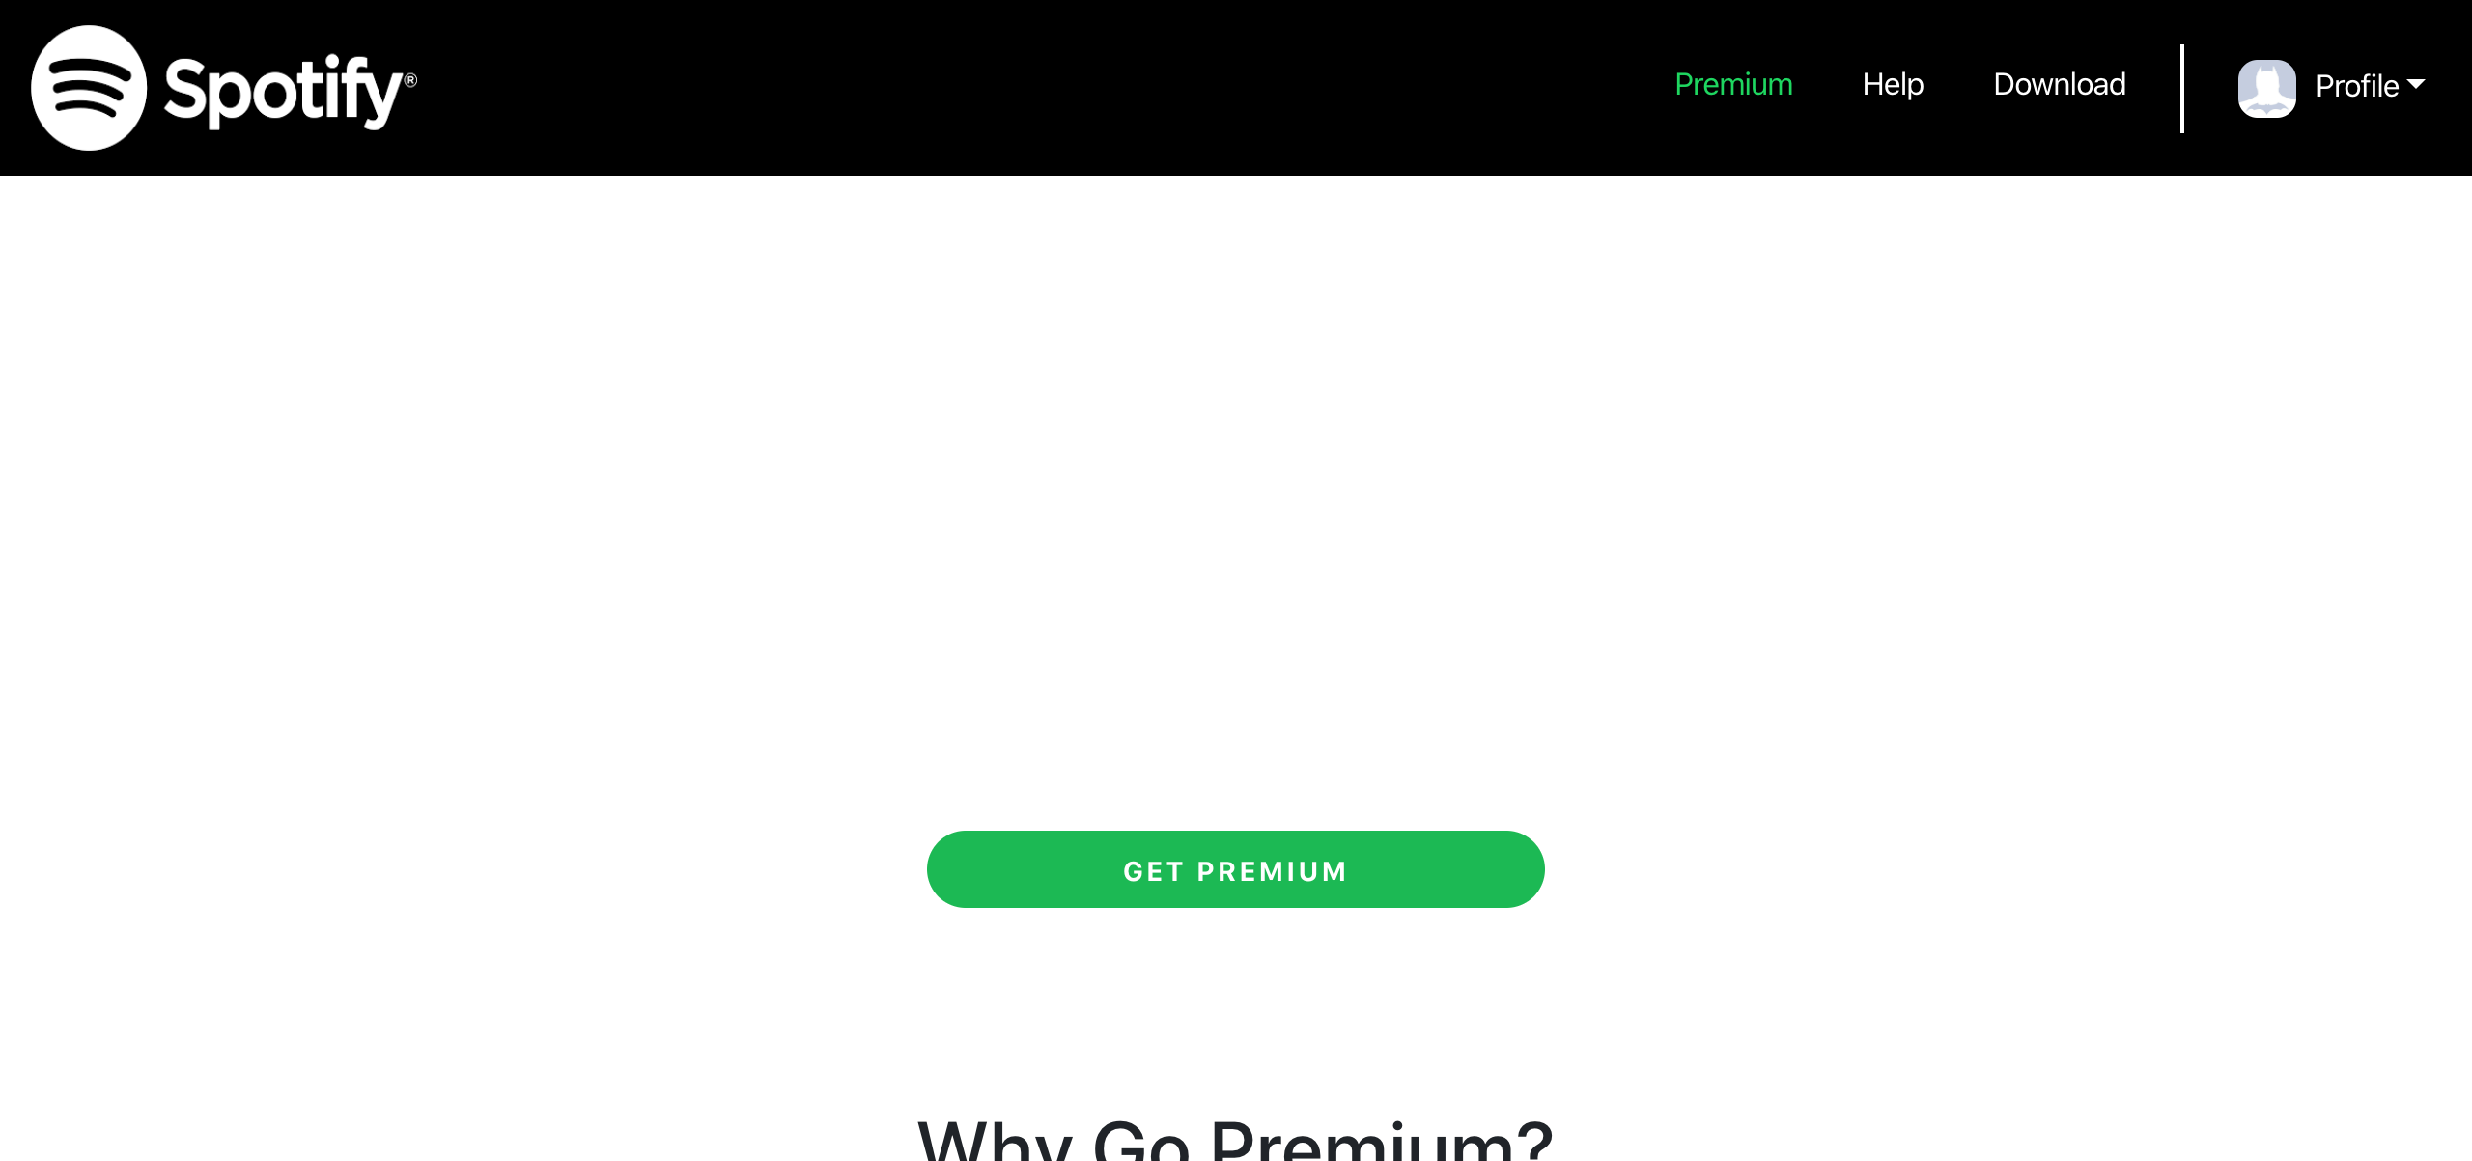

## Test Teardown

[Fixture] setup::0

# Clicking recover playlists link - passed

Clicking recover playlists link

## Test Setup

[Fixture] setup

## Test Body

[Attachment] Recover Playlists link functional

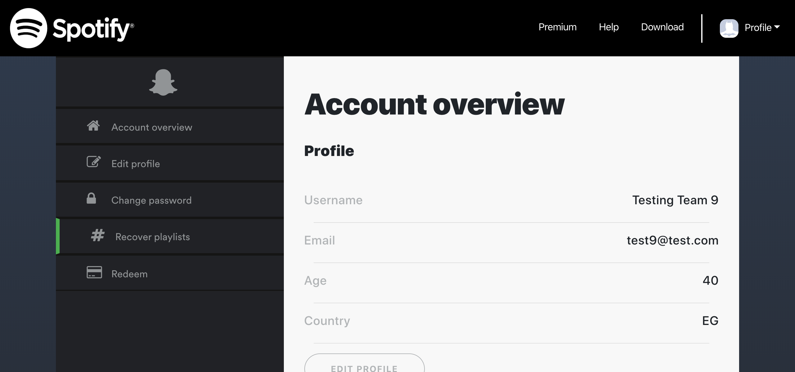

## Test Teardown

[Fixture] setup::0

# Clicking redeem link - passed

Clicking redeem link

## Test Setup

[Fixture] setup

## Test Body

[Attachment] Redeem link functional

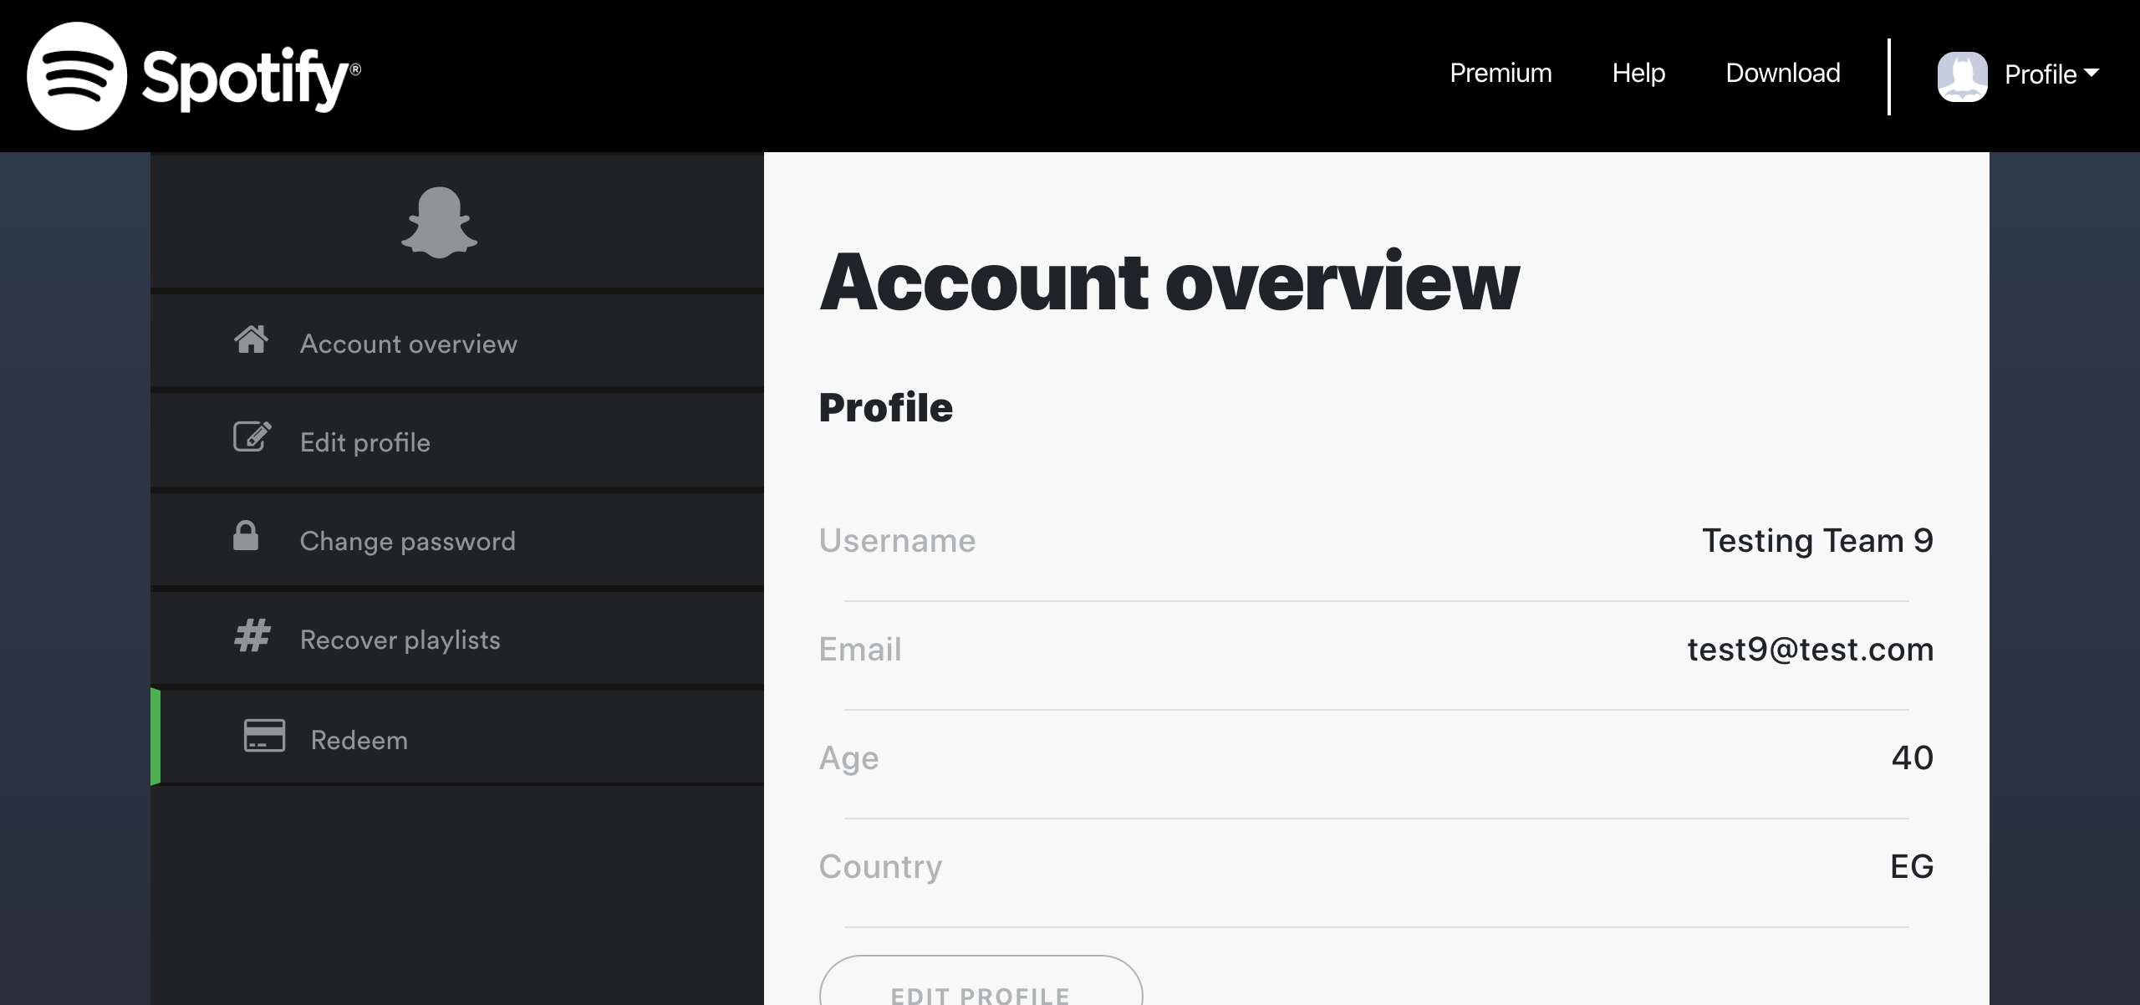

## Test Teardown

[Fixture] setup::0

# Clicking sign out button - passed

Clicking sign out button

## Test Setup

[Fixture] setup_final

## Test Body

[Attachment] sign out button functional

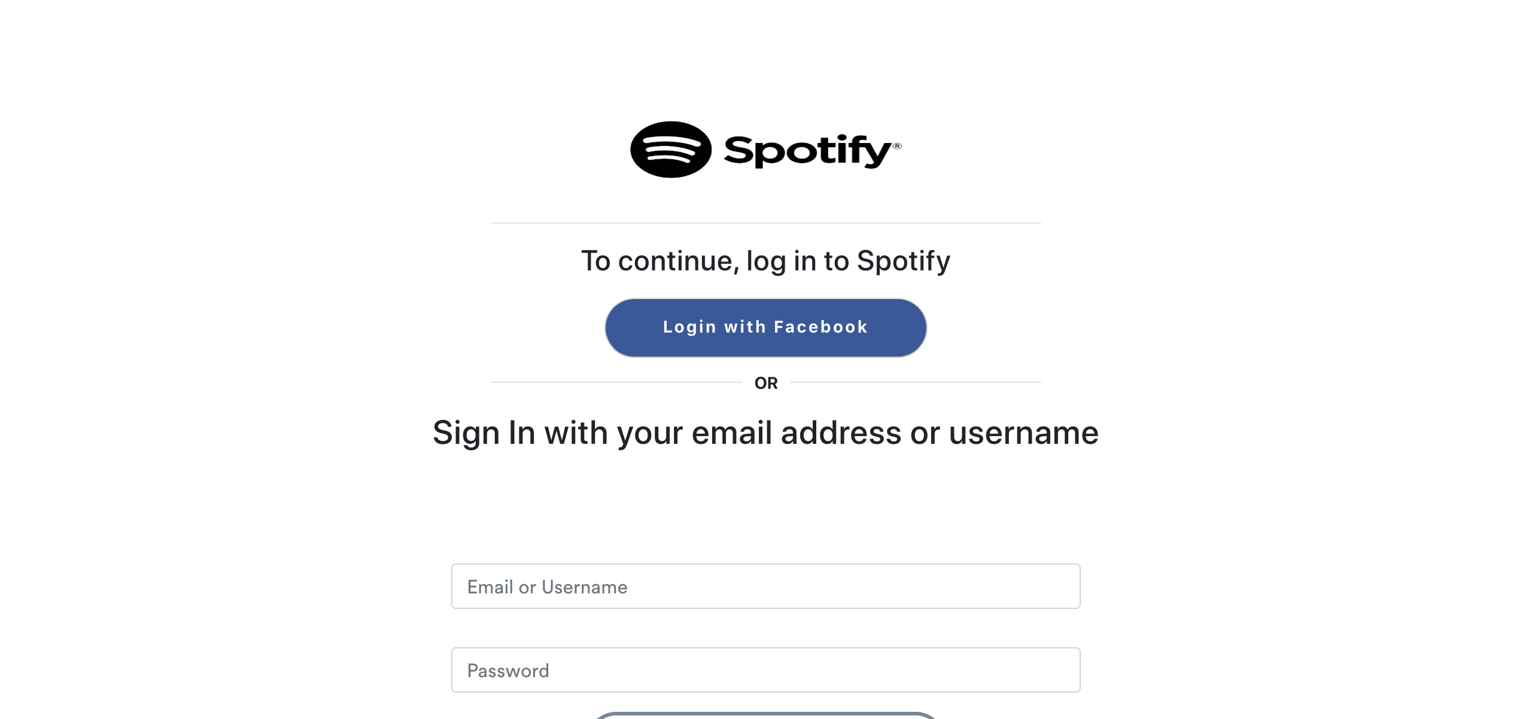

## Test Teardown

[Fixture] setup_final::0