

Logged Out

Test Report

Test Session Summary

|  |  |
| --- | --- |
| Start: Mon Apr 13 07:44:40 2020 End: Mon Apr 13 07:44:53 2020 Duration: 0:00:12.735000  broken: 0 (0.00%) failed: 1 (33.33%) skipped: 0 (0.00%) passed: 2 (66.67%) |  |

Test Results

# Testing Premium Button - failed

Testing Premium Button

## Details

AssertionError: assert False

|  |
| --- |
| self = <Web_Testing.Tests.test_loggedOutHome.TestLoggedOutHome object at 0x10cd9a0d0> setup_final = None   @allure.severity(allure.severity_level.BLOCKER)  @allure.story("Premium Button")  @allure.title("Testing Premium Button")  @allure.description("Testing Premium Button")  @pytest.mark.Do  @pytest.mark.LoggedOutHome  def test_case_3(self, setup_final):  logged_out_home = LoggedOutHome(self.driver)  logged_out_home.click_premium()  time.sleep(2)  if str(self.driver.current_url).find('premium') != -1:  WebHelper().report_allure("Premium button working", self.driver)  assert True  else:  WebHelper().report_allure("Premium button failed", self.driver) > assert False E assert False  Web_Testing/Tests/test_loggedOutHome.py:93: AssertionError |

## Test Setup

[Fixture] setup_final

## Test Body

[Attachment] Premium button failed

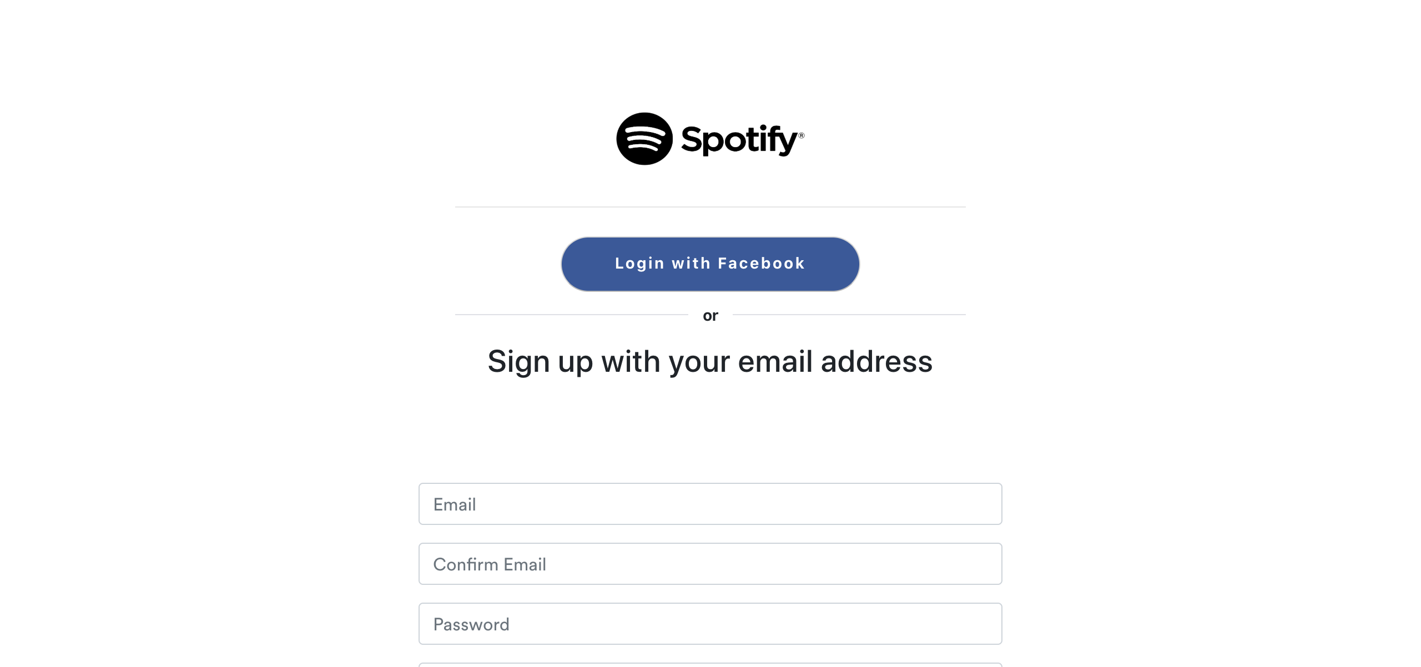

## Test Teardown

[Fixture] setup_final::0

# Testing Login Button - passed

Testing Login Button

## Test Setup

[Fixture] setup

## Test Body

[Attachment] Login button working

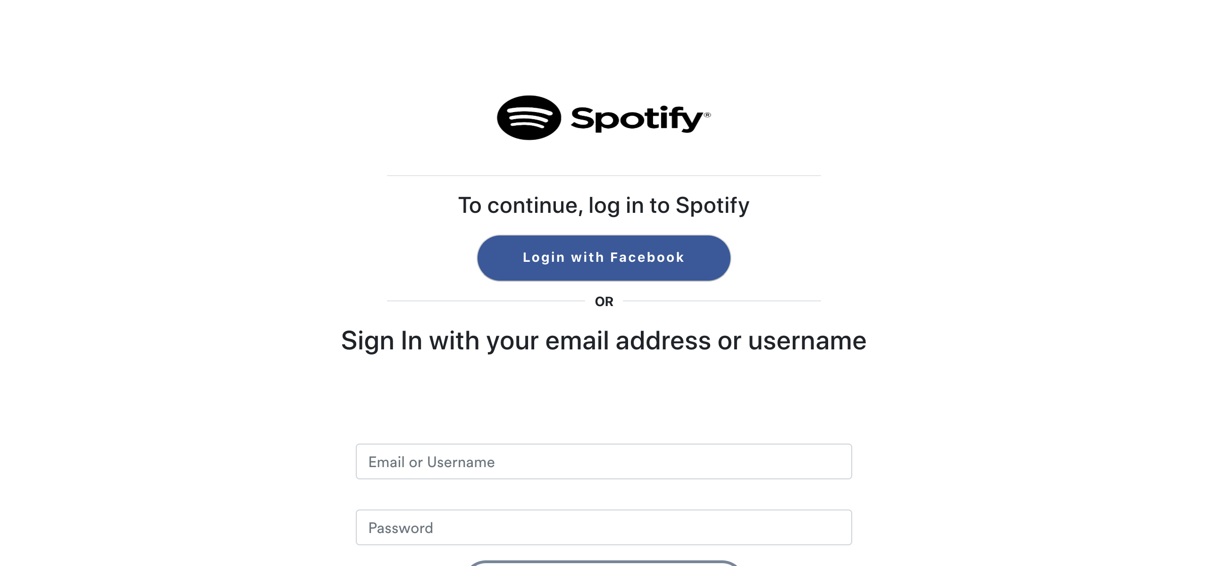

## Test Teardown

[Fixture] setup::0

# Testing Sign up Button - passed

Testing Sign up button

## Test Setup

[Fixture] setup

## Test Body

[Attachment] Signup button working



## Test Teardown

[Fixture] setup::0