

Your Library

Test Report

Test Session Summary

|  |  |
| --- | --- |
| Start: Mon Apr 13 07:50:42 2020 End: Mon Apr 13 07:51:45 2020 Duration: 0:01:02.170000  broken: 1 (25.00%) failed: 1 (25.00%) skipped: 0 (0.00%) passed: 2 (50.00%) |  |

Test Results

# Liked Songs Play Button with empty playlist - broken

Testing Your Library Liked Songs Play Button with empty playlist

## Details

AttributeError: 'NoneType' object has no attribute 'click'

|  |
| --- |
| self = <Web_Testing.Tests.test_yourLibrary.TestWebPlayerLibrary object at 0x1109ac850> setup_final = None   @allure.severity(allure.severity_level.BLOCKER)  @allure.story("Testing Your Library Liked Songs Play Button with empty playlist")  @allure.title("Liked Songs Play Button with empty playlist")  @allure.description("Testing Your Library Liked Songs Play Button with empty playlist")  @pytest.mark.Do  @pytest.mark.YourLibrary  def test_case_4(self, setup_final):  web_player_home = WebPlayerHome(self.driver)  web_player_home.click_logout()  time.sleep(2)  web_player_home.click_login()  time.sleep(3)  lp = LoginPage(self.driver)  lp.login_to_spotify("abdallah@gmail.com", "123456")  time.sleep(3)  self.driver.get(self.helper.base_url + "webplayer/home")  time.sleep(3)  web_player_home = WebPlayerHome(self.driver) > web_player_home.click_your_library()  Web_Testing/Tests/test_yourLibrary.py:138:  _ _ _ _ _ _ _ _ _ _ _ _ _ _ _ _ _ _ _ _ _ _ _ _ _ _ _ _ _ _ _ _ _ _ _ _ _ _ _ _   self = <Web_Testing.Pages.WebPlayerHome.WebPlayerHome object at 0x1109b05b0>   def click_your_library(self):  """  Clicks Your Library button in web player menu  """ > (self.find_element_by_xpath("/html/body/div/div/div/div/div[1]/div/div/div[1]/div/button")).click() E AttributeError: 'NoneType' object has no attribute 'click'  Web_Testing/Pages/WebPlayerMenu.py:96: AttributeError |

## Test Setup

[Fixture] setup_final

## Test Body

[Attachment] stdout

## Test Teardown

[Fixture] setup_final::0

# Clicking Liked Songs Card text - failed

Clicking on the Liked Songs Text in the card in Your Library Page

## Details

AssertionError: assert False

|  |
| --- |
| self = <Web_Testing.Tests.test_yourLibrary.TestWebPlayerLibrary object at 0x11092d040> setup = None   @allure.severity(allure.severity_level.BLOCKER)  @allure.story("Clicking on the Liked Songs Text in the card in Your Library Page")  @allure.title("Clicking Liked Songs Card text")  @allure.description("Clicking on the Liked Songs Text in the card in Your Library Page")  @pytest.mark.Do  @pytest.mark.YourLibrary  def test_case_3(self, setup):  time.sleep(2)  web_player_home = WebPlayerHome(self.driver)  web_player_home.click_your_library()  time.sleep(2)  web_player_library = WebPlayerLibrary(self.driver)  web_player_library.click_liked_songs_txt()  if self.helper.url_has("webplayer/likedplay"):  self.helper.report_allure("SUCCESS: The Liked Songs Card button in your Library page is functional")  assert True  else:  self.helper.report_allure("FAILURE: The Liked Songs Card button in your Library page is not functional") > assert False E assert False  Web_Testing/Tests/test_yourLibrary.py:117: AssertionError |

## Test Setup

[Fixture] setup

## Test Body

[Attachment] FAILURE: The Liked Songs Card button in your Library page is not functional

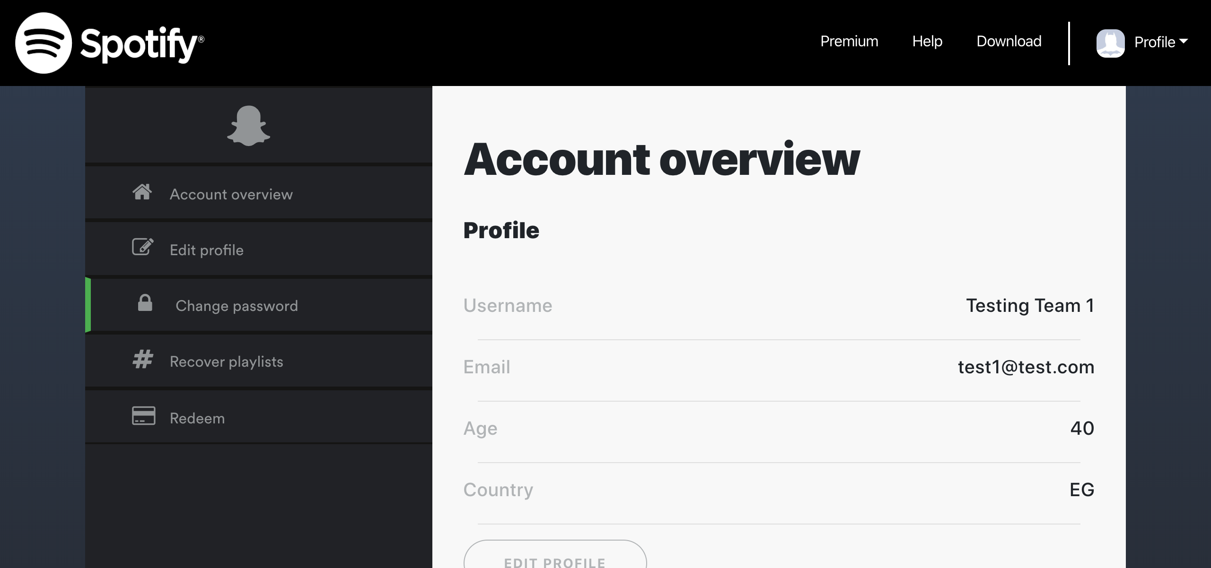

## Test Teardown

[Fixture] setup::0

# Liked Songs Play Button - passed

Testing Your Library Liked Songs Play Button

## Test Setup

[Fixture] setup_initial

## Test Body

[Attachment] SUCCESS: Your Library Liked songs cards are functional

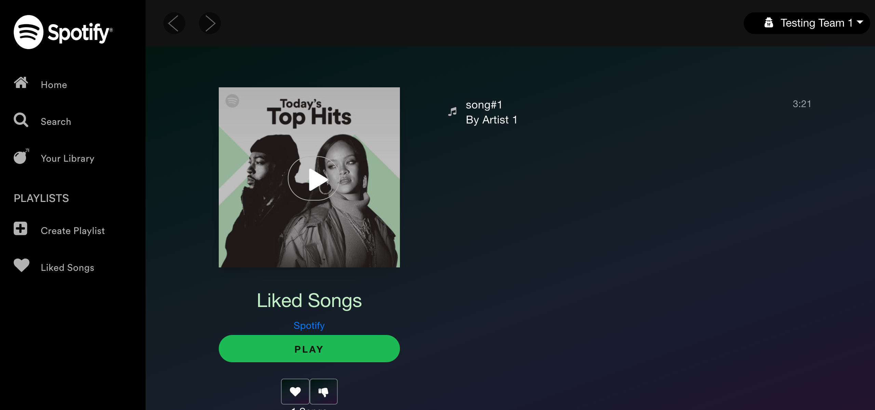

[Attachment] stdout

## Test Teardown

[Fixture] setup_initial::0

# Playlists cards - passed

Testing Your Library Playlists cards

## Test Setup

[Fixture] setup

## Test Body

[Attachment] ERROR: Playlist name is not the same as the card name. Card name = Playlist 3  
Playlist, Playlist name = Playlist 3

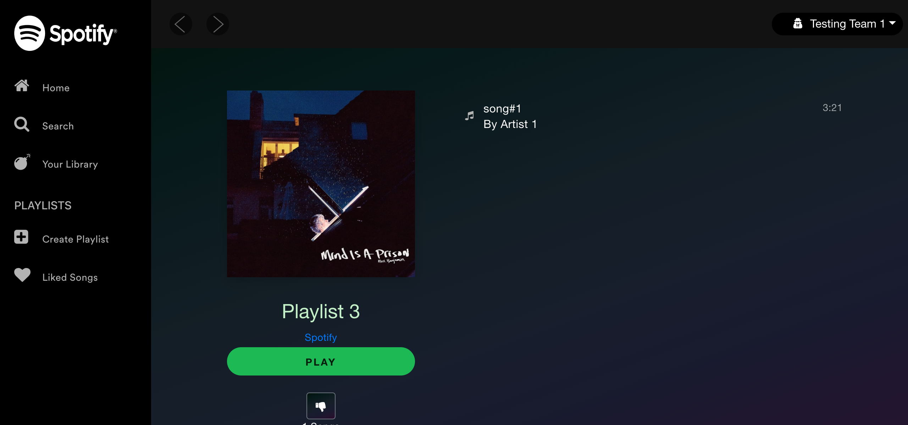

[Attachment] SUCCESS: Your Library page playlist cards are functional



## Test Teardown

[Fixture] setup::0