Allure

Test Report

Test Session Summary

|  |  |
| --- | --- |
| Start: Wed Mar 25 06:39:00 2020 End: Wed Mar 25 06:39:41 2020 Duration: 0:00:41.416000  broken: 0 (0.00%) failed: 8 (100.00%) skipped: 0 (0.00%) passed: 0 (0.00%) |  |

Test Results

# Clicking Download link - failed

Clicking Download link

## Details

AssertionError

|  |
| --- |
| self = <Web_Testing.Tests.test_premium.TestPremium object at 0x000001B2DA5E7A88>, setup = None   @allure.severity(allure.severity_level.BLOCKER)  @allure.story("Premium tests")  @allure.sub_suite("Clicking Download link")  @allure.title("Clicking Download link")  @allure.description("Clicking Download link")  @pytest.mark.Do  @pytest.mark.Premium  def test_case_3(self, setup):  pp = PremiumPage(self.driver) > pp.click_download_link()  Web_Testing\Tests\test_premium.py:82:  _ _ _ _ _ _ _ _ _ _ _ _ _ _ _ _ _ _ _ _ _ _ _ _ _ _ _ _ _ _ _ _ _ _ _ _ _ _ _ _ _ _ _ _ _ _ _ _ _ _ _ _ _ _ _ _ _ _ _ _  self = <Web_Testing.Pages.premium.PremiumPage object at 0x000001B2DA68AE88>   def click_download_link(self):  if helper().element_exists_by_xpath(self.driver, self.spotify_logo):  helper().find_element_by_xpath(self.driver, self.download_link).click()  else:  helper().report_allure(self.driver, "Not Found") > assert False E AssertionError  Web_Testing\Pages\premium.py:54: AssertionError |

## Test Setup

[Fixture] setup

## Test Body

[Attachment] Not Found

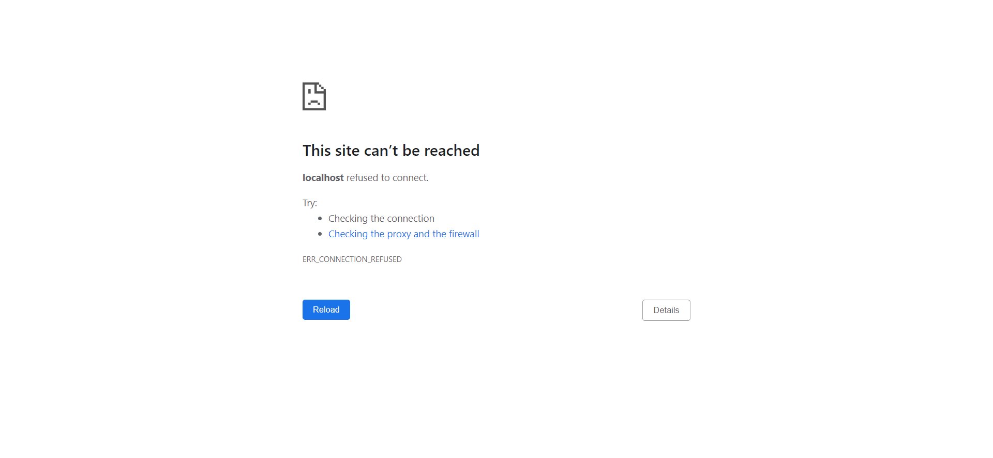

## Test Teardown

[Fixture] setup::0

# Clicking account link - failed

Clicking account link

## Details

AssertionError

|  |
| --- |
| self = <Web_Testing.Tests.test_premium.TestPremium object at 0x000001B2DA679708>, setup = None   @allure.severity(allure.severity_level.BLOCKER)  @allure.story("Premium tests")  @allure.sub_suite("Clicking account link")  @allure.title("Clicking account link")  @allure.description("Clicking account link")  @pytest.mark.Do  @pytest.mark.Premium  def test_case_2(self, setup):  pp = PremiumPage(self.driver) > pp.click_profile_link()  Web_Testing\Tests\test_premium.py:64:  _ _ _ _ _ _ _ _ _ _ _ _ _ _ _ _ _ _ _ _ _ _ _ _ _ _ _ _ _ _ _ _ _ _ _ _ _ _ _ _ _ _ _ _ _ _ _ _ _ _ _ _ _ _ _ _ _ _ _ _  self = <Web_Testing.Pages.premium.PremiumPage object at 0x000001B2DA679A88>   def click_profile_link(self):  if helper().element_exists_by_xpath(self.driver, self.spotify_logo):  helper().find_element_by_xpath(self.driver, self.profile_link).click()  else:  helper().report_allure(self.driver, "Not Found") > assert False E AssertionError  Web_Testing\Pages\premium.py:47: AssertionError |

## Test Setup

[Fixture] setup

## Test Body

[Attachment] Not Found



## Test Teardown

[Fixture] setup::0

# Clicking get premium link - failed

Clicking get premium link

## Details

AssertionError: assert False

|  |
| --- |
| self = <Web_Testing.Tests.test_premium.TestPremium object at 0x000001B2DA6C1948>, setup_final = None   @allure.severity(allure.severity_level.BLOCKER)  @allure.story("Premium tests")  @allure.sub_suite("Clicking get premium link")  @allure.title("Clicking get premium link")  @allure.description("Clicking get premium link")  @pytest.mark.Do  @pytest.mark.Premium  def test_case_8(self, setup_final):  pp = PremiumPage(self.driver)  pp.get_premium_button  if self.driver.current_url == "http://localhost:3000/getpremium":  assert True  else:  helper().report_allure(self.driver, "Premium button not functional") > assert False E assert False  Web_Testing\Tests\test_premium.py:174: AssertionError |

## Test Setup

[Fixture] setup_final

## Test Body

[Attachment] Premium button not functional



## Test Teardown

[Fixture] setup_final::0

# Clicking help link - failed

Clicking help link

## Details

AssertionError

|  |
| --- |
| self = <Web_Testing.Tests.test_premium.TestPremium object at 0x000001B2DA622E88>, setup = None   @allure.severity(allure.severity_level.BLOCKER)  @allure.story("Premium tests")  @allure.sub_suite("Clicking help link")  @allure.title("Clicking help link")  @allure.description("Clicking help link")  @pytest.mark.Do  @pytest.mark.Premium  def test_case_4(self, setup):  pp = PremiumPage(self.driver) > pp.click_help_link()  Web_Testing\Tests\test_premium.py:99:  _ _ _ _ _ _ _ _ _ _ _ _ _ _ _ _ _ _ _ _ _ _ _ _ _ _ _ _ _ _ _ _ _ _ _ _ _ _ _ _ _ _ _ _ _ _ _ _ _ _ _ _ _ _ _ _ _ _ _ _  self = <Web_Testing.Pages.premium.PremiumPage object at 0x000001B2DA622D48>   def click_help_link(self):  if helper().element_exists_by_xpath(self.driver, self.spotify_logo):  helper().find_element_by_xpath(self.driver, self.help_link).click()  else:  helper().report_allure(self.driver, "Not Found") > assert False E AssertionError  Web_Testing\Pages\premium.py:61: AssertionError |

## Test Setup

[Fixture] setup

## Test Body

[Attachment] Not Found



## Test Teardown

[Fixture] setup::0

# Clicking home link - failed

Clicking home link

## Details

AssertionError

|  |
| --- |
| self = <Web_Testing.Tests.test_premium.TestPremium object at 0x000001B2DA6955C8>, setup = None   @allure.severity(allure.severity_level.BLOCKER)  @allure.story("Premium tests")  @allure.sub_suite("Clicking home link")  @allure.title("Clicking home link")  @allure.description("Clicking home link")  @pytest.mark.Do  @pytest.mark.Premium  def test_case_5(self, setup):  pp = PremiumPage(self.driver) > pp.click_home_link()  Web_Testing\Tests\test_premium.py:116:  _ _ _ _ _ _ _ _ _ _ _ _ _ _ _ _ _ _ _ _ _ _ _ _ _ _ _ _ _ _ _ _ _ _ _ _ _ _ _ _ _ _ _ _ _ _ _ _ _ _ _ _ _ _ _ _ _ _ _ _  self = <Web_Testing.Pages.premium.PremiumPage object at 0x000001B2DA695588>   def click_home_link(self):  if helper().element_exists_by_xpath(self.driver, self.spotify_logo):  helper().find_element_by_xpath(self.driver, self.home_link).click()  else:  helper().report_allure(self.driver, "Not Found") > assert False E AssertionError  Web_Testing\Pages\premium.py:68: AssertionError |

## Test Setup

[Fixture] setup

## Test Body

[Attachment] Not Found



## Test Teardown

[Fixture] setup::0

# Clicking logout link - failed

Clicking logout link

## Details

AssertionError

|  |
| --- |
| self = <Web_Testing.Tests.test_premium.TestPremium object at 0x000001B2DA6CFB88>, setup = None   @allure.severity(allure.severity_level.BLOCKER)  @allure.story("Premium tests")  @allure.sub_suite("Clicking logout link")  @allure.title("Clicking logout link")  @allure.description("Clicking logout link")  @pytest.mark.Do  @pytest.mark.Premium  def test_case_6(self, setup):  pp = PremiumPage(self.driver) > pp.click_profile_link()  Web_Testing\Tests\test_premium.py:133:  _ _ _ _ _ _ _ _ _ _ _ _ _ _ _ _ _ _ _ _ _ _ _ _ _ _ _ _ _ _ _ _ _ _ _ _ _ _ _ _ _ _ _ _ _ _ _ _ _ _ _ _ _ _ _ _ _ _ _ _  self = <Web_Testing.Pages.premium.PremiumPage object at 0x000001B2DA6CFBC8>   def click_profile_link(self):  if helper().element_exists_by_xpath(self.driver, self.spotify_logo):  helper().find_element_by_xpath(self.driver, self.profile_link).click()  else:  helper().report_allure(self.driver, "Not Found") > assert False E AssertionError  Web_Testing\Pages\premium.py:47: AssertionError |

## Test Setup

[Fixture] setup

## Test Body

[Attachment] Not Found



## Test Teardown

[Fixture] setup::0

# Clicking profile link - failed

Clicking profile link

## Details

AssertionError

|  |
| --- |
| self = <Web_Testing.Tests.test_premium.TestPremium object at 0x000001B2DA6C65C8>, setup = None   @allure.severity(allure.severity_level.BLOCKER)  @allure.story("Premium tests")  @allure.sub_suite("Clicking profile link")  @allure.title("Clicking profile link")  @allure.description("Clicking profile link")  @pytest.mark.Do  @pytest.mark.Premium  def test_case_7(self, setup):  pp = PremiumPage(self.driver) > pp.click_profile_link()  Web_Testing\Tests\test_premium.py:151:  _ _ _ _ _ _ _ _ _ _ _ _ _ _ _ _ _ _ _ _ _ _ _ _ _ _ _ _ _ _ _ _ _ _ _ _ _ _ _ _ _ _ _ _ _ _ _ _ _ _ _ _ _ _ _ _ _ _ _ _  self = <Web_Testing.Pages.premium.PremiumPage object at 0x000001B2DA6C6A08>   def click_profile_link(self):  if helper().element_exists_by_xpath(self.driver, self.spotify_logo):  helper().find_element_by_xpath(self.driver, self.profile_link).click()  else:  helper().report_allure(self.driver, "Not Found") > assert False E AssertionError  Web_Testing\Pages\premium.py:47: AssertionError |

## Test Setup

[Fixture] setup

## Test Body

[Attachment] Not Found



## Test Teardown

[Fixture] setup::0

# Spotify logo - failed

Spotify logo

## Details

AssertionError

|  |
| --- |
| self = <Web_Testing.Tests.test_premium.TestPremium object at 0x000001B2DA610BC8>, setup = None   @allure.severity(allure.severity_level.BLOCKER)  @allure.story("Premium tests")  @allure.sub_suite("Spotify logo")  @allure.title("Spotify logo")  @allure.description("Spotify logo")  @pytest.mark.Do  @pytest.mark.Premium  def test_case_1(self, setup):  pp = PremiumPage(self.driver)   > pp.click_spotify_logo()  Web_Testing\Tests\test_premium.py:47:  _ _ _ _ _ _ _ _ _ _ _ _ _ _ _ _ _ _ _ _ _ _ _ _ _ _ _ _ _ _ _ _ _ _ _ _ _ _ _ _ _ _ _ _ _ _ _ _ _ _ _ _ _ _ _ _ _ _ _ _  self = <Web_Testing.Pages.premium.PremiumPage object at 0x000001B2DA610EC8>   def click_spotify_logo(self):  if helper().element_exists_by_xpath(self.driver, self.spotify_logo):  helper().find_element_by_xpath(self.driver, self.spotify_logo).click()  else:  helper().report_allure(self.driver, "Not Found") > assert False E AssertionError  Web_Testing\Pages\premium.py:25: AssertionError |

## Test Setup

[Fixture] setup

## Test Body

[Attachment] Not Found



## Test Teardown

[Fixture] setup::0