**CS/SE 6362 - Advanced Software Architecture & Design**

**(User Manual – KWIC System)**

**February 28th , 2013**

Submitted to:

**Dr. LAWRENCE CHUNG**

Associate Professor,

Department of Computer Science – Software Engineering,

The University of Texas at Dallas,

Richardson, TX-75080

Submitted by:

**THE DEVELOPERS LOOP**

# Team Website:

# <http://kwicsystem.appspot.com/Project-KWIC.html>

VERSION HISTORY

|  |  |  |  |
| --- | --- | --- | --- |
| **Version** | **Changes** | **Date** | **Author(s)** |
| 1.0 | User Manual – Phase I (Interim) | 02/22/2013 | Team |
| 1.1 | User Manual – Phase I (Final) | 02/27/2013 | Team |
|  |  |  |  |
|  |  |  |  |
|  |  |  |  |
|  |  |  |  |
|  |  |  |  |
|  |  |  |  |

TABLE OF CONTENTS

**Introduction 4**

**User Start Guide 5**

**Trouble Shooting 7**

**Customer Support…………………………………………………………………………………………………… 8**

**References 8**

INTRODUCTION

The purpose of this project is to architect and implement/prototype KWIC (Keyword in Context) index system, a simple web search engine that will use KWIC.

The project will be carried out in two phases:-

* Phase I
* Phase II

During phase I, we’ll architect KWIC, an indexing system; for this purpose, we are required to use an Object-Oriented architectural style. During implementation, we will build a Java applet or an equivalent. The applet will be accessible through the team’s web page.

As per customer specifications, “The KWIC (Key Word in Context) index system shall accept an ordered set of lines, where each line is an ordered set of words, and each word is an ordered set of characters. Any line shall be ``circularly shifted" by repeatedly removing the first word and appending it at the end of the line. The KWIC index system shall output a listing of all circular shifts of all lines in ascending alphabetical order.”

During phase II, we’ll architect and prototype Trex, a simple web search engine that “shall accept a list of keywords and return a list of URLs whose descriptions contain any of the given keywords.”

USER START GUIDE – KWIC SYSTEM

**Thank you for choosing the KWIC System by The Developers Loop.**

The following steps below will help you get started.

1. To get started, ctrl + click this <http://kwicsystem.appspot.com/Project-KWIC.html> **or** copy/paste the link into a web browser. The homepage of the KWIC system should appear (picture below).

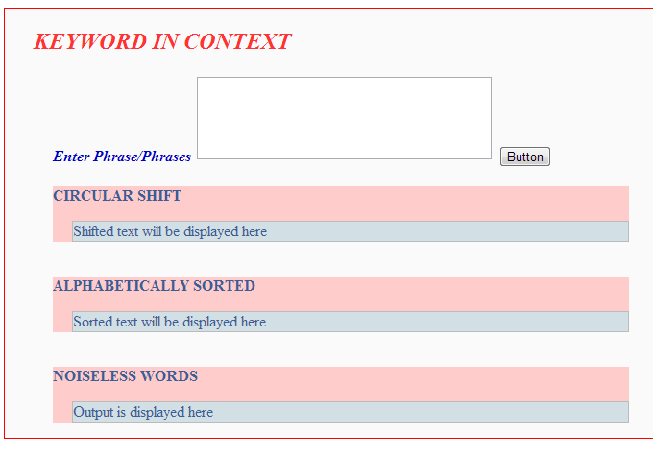

1. Place you mouse’s cursor onto the first dialogue box and click the left mouse button once. A vertical line, blinking at the left most section of the input dialogue box should be visible (picture below).

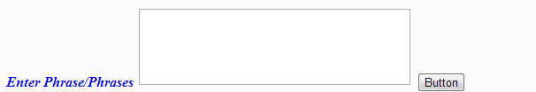

1. Using the keyboard or mouse, type in or copy/paste an ordered set of lines.

The set of lines should appear in the input dialogue box (picture below).

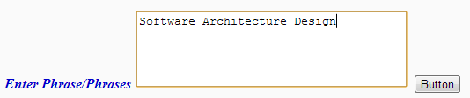

1. After you have entered the desired data, press the  on the right hand side of the dialog box in order to perform the desired function.
2. The circular shifts, sorted text and noiseless wrods should be printed dynamically in the dialogue box below (picture below).

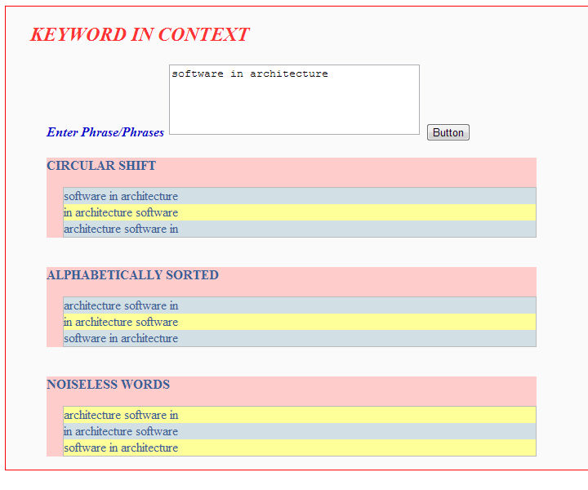

1. To generate another list, please re-enter the text in the input window and repeat steps 2 through 4.

KWIC SYSTEM TROUBLESHOOTING

Q1. The KWIC System is not seen when visiting the website.

A1. Make sure the latest version of Web browsers (Chrome/Firefox/Internet Explorer) is installed. The software can be downloaded from their website at,

* (Mozilla) <http://mozilla-firefox.todownload.com/>
* (Chrome) <https://www.google.com/intl/en/chrome/>
* (Internet Explorer) <http://windows.microsoft.com/en-us/internet-explorer/download-ie>

Q2. The blinking vertical line is not seen when clicking on the input dialogue box.

A2. Please make sure the mouse is properly connected to the computer and has the correct software installed. Refer to the mouse’s user manual for more details.

Q3. The lines/words do not appear in the input dialogue box when typed.

A3. Please make sure the keyboard is properly connected to the computer and has the correct software installed. Refer to the keyboard’s user manual for more details.

Q4. There is no response after the input is entered.

A4. Please make sure you are entering the text in the correct field. Please also refer to previous troubleshooter questions for more help.

Q5. No results appear on the bottom dialogue box.

A5. Please refer to previous question and answer.

CUSTOMER SUPPORT

If you have any questions or want to leave a comment, please contact our customer service center by email at tdl_se6362@googlegroups.com.

**Thank you for choosing The Developers Loop - KWIC System for all your line sorting needs.**

REFERENCES

* 1. KWIC **-** Manning, C. D., Schütze, H.: "Foundations of Statistical Natural Language Processing", p.35. The MIT Press, 1999.
  2. [*Advanced Indexing and Abstracting Practices*](http://books.google.co.uk/books?id=nIUkl7bLzYUC&pg=PA41&dq=Andrea+Crestadoro#v=onepage&q=Andrea%20Crestadoro&f=false)
  3. User_Manual_Fountain_Heads_KWIC_Phase_1_Interim_Version_1.0.docx (<https://docs.google.com/viewer?a=v&pid=sites&srcid=ZGVmYXVsdGRvbWFpbnxmb3VudGFpbmhlYWRzYXNhZHxneDo3NmQ5YWNiM2YyZjBiNWNj>)