CS/SE 6362 - Advanced Software Architecture & Design
Architecture Document (KWIC)
February 28th , 2013

Submitted to:

Dr. LAWRENCE CHUNG
Associate Professor,
Department of Computer Science – Software Engineering,
The University of Texas at Dallas,
Richardson, TX-75080

Mr. Owolabi Legunsen
Teaching Assistant

Submitted by:

DEVELOPERS LOOP

Team Website:
http://kwicsystem.appspot.com/Project-KWIC.html

TEAM AGREEMENT
By signing my name below, I hereby agree and possess no dispute regarding my contribution to the project, through my attendance in team meetings, and the roles and responsibilities that I fulfilled during the current phase.

NAME | NET ID | SIGNATURE
Archana Jaganathan | axj124030@utdallas.edu
Arunkumar Manickam | axm126230@utdallas.edu
Ashwin K Mishra | axm123931@utdallas.edu
Giridharan Subramanian | gxs123330@utdallas.edu
Hariprasad Natarajan | hxn121330@utdallas.edu
Sindhu P Manjari | sxp127530@utdallas.edu
Thyagaraj Vuppulapati | txv120830@utdallas.edu
Vignesh Sridhar | vxs120630@utdallas.edu
Vishnuvaradhan L | vxl121330@utdallas.edu
Prasanna Venkatesh Venkatasamy | pxv120830@utdallas.edu
Rekha Muthulakshmi Nachadalingam | rxn121330@utdallas.edu
Sriram Sridharan | sxs108821@utdallas.edu

Acknowledgement
This document reuses some of the structure, formatting, and content - revised or adapted for the current project from Team Fountain Heads project for Fall 2012 Advanced Software Architecture and Design course and other documents mentioned under references.

REVISION HISTORY

Version | Changes | Date | Author(s)
1.0 | Architecture Document - Phase 1 (Interim) | 02/15/2013 | Team
2.0 | Architecture Document - Phase 1 (Interim) | 02/21/2013 | Team
3.0 | Architecture Document - Phase 1 (Interim) | 02/26/2013 | Team
4.0 | Architecture Document - Phase 1 | 03/19/2013 | Team

Table of Contents
Team Website: 1
http://kwicsystem.appspot.com/Project-KWIC.html 1
TEAM AGREEMENT 2
REVISION HISTORY 4
1. INTRODUCTION 7
1.1. About the KWIC System 7
1.2. Purpose of the System 7
1.3 Scope 7
1.4 Definitions, Acronyms and Abbreviation 8
2 PROJECT ORGANIZATION 8
3 SOFTWARE ARCHITECTURE DESIGNS 8
3.3 Shared Data Design 9
3.3.1 Introduction 9
3.3.2 Design Diagram 9
3.3.3 Architecture Style 9
3.3.4 Components / Elements Processes and Data 10
3.4 Implicit Invocation Design 11
3.4.1 INTRODUCTION 11
3.4.2 Design Diagram 12
3.4.3 Architectural Style 12
3.4.4 Components / Elements: Objects and Data 12
3.5 Abstract Data Type Design 14
3.5.1 Introduction 14
3.5.2 Design Diagram 14
3.5.3 Architectural Style 15
3.5.4 Components / Elements: Objects and Data 15
3.6 Pipes and Filters Design 16
3.6.1 Introduction 16
3.6.2 Architectural Style 17
3.6.3 Components / Elements: Filters 17
4. Our Architecture Design 19
5. References 20
6. Appendix 20

1. INTRODUCTION

About the KWIC System

KWIC (Key Word In Context) index system provides an easier way to search for a piece of data long list of lines, such as book titles, or online documentation entries. It is widely used for a web search engines, the “permuted” indexing for the Unix Man pages. The system accepts an ordered set of lines, each line is an ordered set of word, and each word is an ordered set of characters. Any line may be ‘circularly shifted’ by repeatedly removing the first word and appending it at the end of line. The output is a listing of all circular shifts of all lines in alphabetical order.”
The primary purpose of the project is to complete a fully functioning KWIC index system and hence use it through a web search engine. We will first introduce briefly the whole lifecycle and the requirement specification. Then the following four different architectural solutions to KWIC will be described in detail:
- Shared data style
- Implicit invocation style
- Abstract Data Type (ADT), or Object-Oriented Style
- Pipes and filters Style

We will describe the style, components, glue, constraints, pattern of the four alternatives, analyze the advantages and disadvantages of each of them based mainly on nonfunctional requirements and use finally the object-oriented architecture style for implementation. The resulted java applet and all documentations will be accessible through our web page.

Purpose of the System
This document details about the architectural perspective of the KWIC system developed by our team. Multiple architectural views are presented here in order to highlight particular aspects of the system. It is intended to capture and convey significant architectural decisions undertaken in order to provide a sound foundation to the system. This document helps to figure out what the system constraints are and generalize them, to list what design goals are to be achieved and sharpen them.

Scope
This Software Architecture Document provides an architectural overview of the KWIC System. This document serves as a complete high-level architectural specification of the KWIC system. It helps in understanding the system constraints rather than dwelling more on the system domain details.

Definitions, Acronyms and Abbreviation

Circular shift: Operation in which a line’s first word is removed and appended to the end of the line.
Line: An ordered set of words.
Word: An ordered set of characters.

PROJECT ORGANIZATION

Team members assumed the following roles for analysis and design.
Team Members | Role
Ashwin K Mishra  Thyagaraj Vuppulapati  Rekha Muthulakshmi Nachadalingam | Requirement Engineer
Sindhu P Manjari  Giridharan Subramanian  Sriram Sridharan | Architect
Vishnuvaradhan L  Vignesh Sridhar | Development Engineer
Archana Jaganathan  Arunkumar Manickam | Quality Assurance Engineer
Hariprasad Natarajan  Prasanna Venkatesh Venkatasamy | Project Manager

SOFTWARE ARCHITECTURE DESIGNS

There are many different architectural styles available for designing a software system. A few examples of these styles are: Shared Data Model, Abstract Data Type Structure, Implicit Invocation and Pipe and Filter. There are distinctive advantages and disadvantages with each of these styles. In designing the software architecture for the KWIC system, we considered some of the above mentioned styles in order to choose the most suitable style for this system which offers the best tradeoff between non-functional requirements for the system, such as, reliability, performance, modifiable, complexity, portability, and re-usability. When designing a system it is highly desirable to create a system that is reliable, with a high level of performance, which is highly modifiable, with the least level of complexity, which is portable to other systems, and where its components are reusable in other systems.
In order to effectively select the most appropriate architectural style we will discuss the potential KWIC system’s design in each style and analyze the tradeoff of these different designs.

Shared Data Design

Introduction

The computational components are coordinated as subroutines by main program through them in turn. Data is communicated between the components through shared storage. Interaction between computational components and shared data is an unconfined read write protocol.

Design Diagram

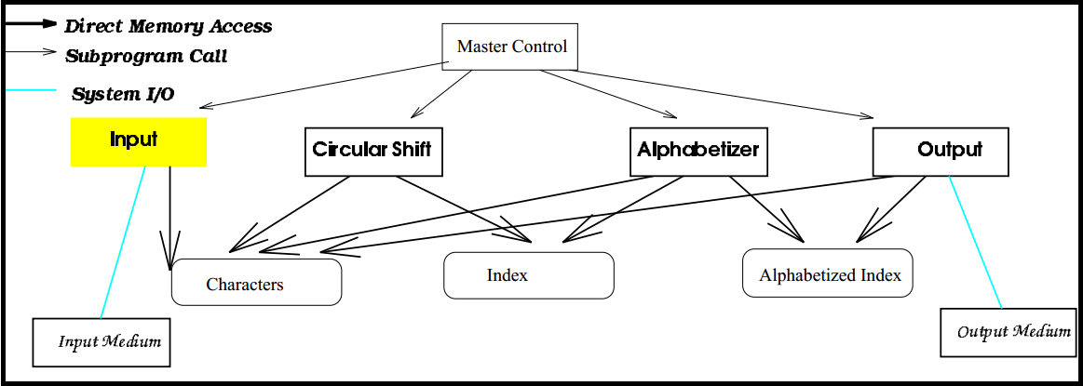

Architecture Style

When using shared data connectors, components operate concurrently on the same data space, as in blackboard systems or multiuser databases. Usually, some blocking scheme prevents concurrent writes to the same data.

Components / Elements Processes and Data

Module Input
Operational read Reads data from the input medium.
Operation store Stores data lines as packet “Charaters” in main memory.

Module Circular Shift
Operation readChar Read packet characters from “Characters”
Operation prepare Record into “Index” the starting index of the lines and offset for each word from the starting position, and conduct a virtual circular shift.

Module Alphabetizer
Opeartion readChar Read packet characters from “Characters”
Operation readIndex Read recorded index from “Index”
Operation alphabetize Converts index to an alphabetized index by listing by listing the circular shifts alphabetically. The result is stored in “Alphabetized Index”

Module Output
Operation readChar Read packed characters from “Characters”
Operation readIndex Read index from “Alphabetized Index”
Operation print List all the circular shifts using “Characters” and “Alphabetized Index”

Module Master Control
Operation main Batch mode, control the sequencing among four modules

Connections / Glues
- Direct Memory Access: The single means of component interaction is through a set of global data. This helps in managing the time and memory efficiently as it avoids the copying of data every time a module is being used separately.
- Procedure Call: One module can access another module by acquiring an instance of that module and invoke the corresponding method/procedure.
- System I/O: This means Input and Output come from outside medium.

Constraints
- Data is communicated between the components through shared storage.
- Special efforts need to be dedicated to data access synchronization.

Advantages
- Performance – This model offers the best efficiency as we use data sharing and not data duplication.

Disadvantages
- Modifiability – In this model, there is strong coupling between the components. The input of one component is highly dependent of the output of other components before it. If the storage data structure is modified, it affects at least one other component, potentially all of the system’s components.
- Enhance ability – Every time a new component is included, it comes along with a new data structure for which redesigning of the system is essential. This causes obvious difficulty and loss of time.
- Reusability – Since all the components being used are highly inter-dependent, the chances of using them in other systems is very less.

Implicit Invocation Design

INTRODUCTION

Implicit Invocation uses a form of component integration based on shared data. However, there are two important differences. First, the interface to the data is more abstract. Rather than exposing the storage formats to the computing modules, this solution access data abstractly. Second, computations are invoked implicitly as data is modified. Thus interaction is based on an “active data” model.

Design Diagram

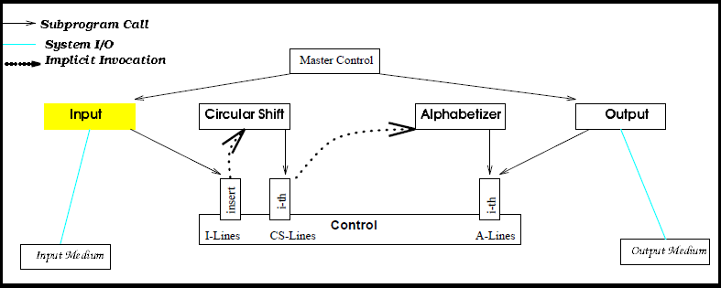

Architectural Style

- The connection between components is based on the following idea:

Every individual component has the ability to announce or broadcast an event.
- Other components in the system can register an interest in an event by associating a procedure with the event.

- As soon as the event is announced, the system qill be quick enough to invoke al the procedures associated with the event. Thus, an event announcement “implicitly” causes the invocation of procedures in other components

Components / Elements: Objects and Data

Module Input
Operation read reads data lines from input medium through operation insert, a new line to the line buffer, “I-Lines” and then announces the event of completion of input.

Module Circular Shift
This module registers an interest in the event of completion of input by associating procedure I-th with it. When completion of input is announced, the Control routine invokes procedure I-th. After completion of I-th, module Circular Shift announces the event of completion of circular shift. Procedure I-th: Reads I-lines produced by module “Input” as the input, produces shifted lines and stores them in a separate abstract line buffer, CS- Lines.
Module Alphabetical Shift
This module registers an interest in the event of completion of noise elimination by associating procedure (3rd) I-th with it. When completion of noise elimination is announced, the control routine invokes procedure I-th.
Procedure I-th: Reads the noise eliminated shifted line from CS-lines, alphabetizes these lines in non-decreasing order, and stores them in a separate abstract line buffer, A-lines.
Module Output
This module reads the alphabetized shifted lines from line buffer, A-lines, created by Module Alphabetical Shift and displays the result to the output medium.
Module Master Control
This module explicitly invokes input and output through procedure calls.
Connections / Glues
- Implicit Invocation: The procedures associated with the module are implicitly invoked when the module broadcasts an event.
- Subprogram Call: One module can access procedures in other modules through this routine. Arrow directions in the diagram indicate that the calling module hands control to the called module, and after called procedure finishes its job, control is returned to the calling procedure.
- System I/O: This is Input from outside medium or Output to the outside medium.

Constraint
Computations are invoked implicitly as events are announced.
Advantages
- Modifiability – Since the components are loosely coupled and data is kept in the control, the model is quite modifiable.
- Enhance ability – Inclusion of new components is possible without affecting any existing components.
- Re-usability – Since the components rely on external events, they are loosely coupled and can be reused by other systems.

Disadvantages
- Performance – This style tend to perform slower because it must wait for events to be triggered. It tends also tends to use more space than Shared Data model and the ADT model.

Abstract Data Type Design

Introduction

In ADT architecture design, the system can be viewed as a collection of ADT objects. Each ADT includes data objects, operations on data objects and essential properties of operations algebraic equations. Each ADT object also provides interfaces for other objects in the system, the communications can be achieved by sending message or passing parameters. An object is responsible for preserving the integrity of its representation that is hidden from other object. So data is no longer directly shared by the process components. Instead, each module provides interface, other components access data only by invoking that interface (information hiding).

Design Diagram

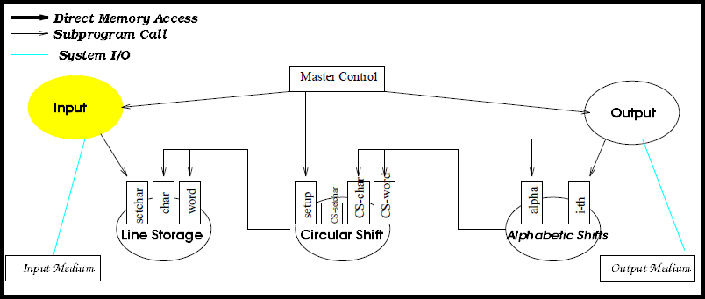

Architectural Style

Components in the main program with subroutines type of decomposition often use shared data storage. Decisions about data representations, then, are a mutual property of the components that use the data. We may also try to make those decisions locally rather than globally. In that case, the user does not get direct access to the data structures, but is offered an interface. The data can only be accessed through appropriate procedure or method calls.

Components / Elements: Objects and Data

Module Input
Operation read Read input string lines from the input medium, for example, the text panel of the applet.
Operation store Stores data lines.

Module Line Storage
This module will create will create a vector to store the original input line. Base on the value of parameters, the original line will be before being stored:
- If case is sensitive, all the characters in the input lines will be converted into lower case, otherwise they remain the same.
- If no noise word is allowed, the word "a", "an", "and", "the", "of" and "or" will be extracted from the original string line.

Module Circular Shift
This module creates a circular shift for multiple string lines. Circular Shift means repeatedly removing the first word and appending it at the end of the line until a circular is reached.

Module Alphabetic Shifts
This module creates alphabetized lines of the circular shifts and save the result in a vector. Strings are compared lexicographically and the comparison is based on the Unicode value of each character in the strings. The character sequence represented by this String object is compared lexicographically to the character sequence represented by the argument string.

Module Output
This module gets a vector, which contains the output lines in alphabetical order and prints them in the output text area line by line.

Module Master Control
This module makes procedure calls to all other modules.
Connections / Glues
- Procedure Call: The procedure call is made through acquiring an instance of one module and invokes the corresponding methods/procedures.
- System I/O: This is Input/output from outside medium.

Constraint
- Because of the information hiding of abstract data type, other components can only access data by invoking the corresponding interfaces.

Advantages
- Modifiability – Since the components are loosely coupled and data is kept in the control, the model is quite modifiable.
- Enhance ability – Inclusion of new components is possible without affecting any existing components.
- Re-usability – Since the components rely on external events, they are loosely coupled and can be reused by other systems.

Disadvantages
- Performance – This style tend to perform slower than Shared Data Model due to reconstruction.

Pipes and Filters Design

Introduction

A very simple, yet powerful architecture, that is also very robust. It consists of any number of components (filters) that transform or filter data, before passing it on via connectors (pipes) to other components. The filters are all working at the same time. The architecture is often used as a simple sequence, but it may also be used for very complex structures.
The filter transforms or filters the data it receives via the pipes with which it is connected. A filter can have any number of input pipes and any number of output pipes.
The pipe is the connector that passes data from one filter to the next. It is a directional stream of data that is usually implemented by a data buffer to store all data, until the next filter has time to process it.

Design Diagram
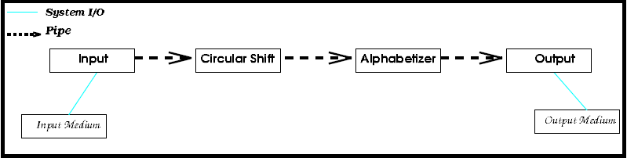

Architectural Style

This model architects the system into a set of sequential components. Each component does a local transformation to the input stream of data and produce output steam of data. Each glue serves as a conduit for the data stream, transmitting outputs of one filter to the inputs of another.

Components / Elements: Filters

Filter Input Reads inputs from input media, processes and stores the data in a return pipe.
Filter Circular Shift Reads input lines from an input pipe, creates and outputs circular shifts.
Filter Alphabetizer Reads circular shifts, creates and outputs
Filter Output Read alphabetized lines and writes data to the output medium.

Connections / Glues
- Pipes: The only path that component can communicate with each other and sharing data.
- System I/O: This is Input from outside medium or Output to the outside medium.

Constraint
- Each filter can run whenever it has data to compute on.
- Control is distributed.
- Filters are independent entities, not sharing states with others.
- Process does not know the entity of their upstream and upstream processes.

Advantages
- Modifiable – Modifying a component does not affect other components, as long as the output is the same as before. The internal data representation is not known to other components; therefore changing the implementation of a component does not affect any other component.
- Enhance ability – We are able to add or remove components with ease.
- Reusability – Since each component is a distinct part of the system, the components can be used by other systems.

Disadvantages
- Enhance ability – It is difficult to implement an interactive system using Pipe and Filter.
- Performance – In this design each component will replicate the data from its input to its output. Therefore it uses much more space than most other styles.

OUR ARCHITECTURE DESIGN
Our system is based on Pipe & Filters Architecture style with Shared Data concept. The following table gives the overview of the tradeoffs.

Tradeoff Analysis | Shared Data | ADT | Implicit Invocation | Pipe and Filter
Modifiability (algorithm) | - | + | - | + +
Modifiability (data Rep) | - - | + | + + | + +
Enhance-ability | + - | + + - | + + | + -
Performance (Space) | + + | + | - | - -
Performance (Response Time) | + | + | - | -
Reusability | - - | + | + | + +
Intuitiveness | - | + | + - | +

Based on the functional requirements of the KWIC system listed first with well-defined input and output we evaluated and carefully weighed each of them for further enhancement of our project in the search engine. There are total of five modules presented in this system. They are Input, Line Storage, Circular Shift, Alphabetizer and Output. Each of these modules contains procedures and functions. Based on functions performed by the system and data flow, all interactions between components or modules within same architecture style were decided by the designer.

The major non-functional requirements that make our analysis are the enhance-ability, reusability and performance. We used these to narrow down the best option of our design.

We must not only focus on their functional requirements but also their nonfunctional requirements. Generally, the latter is much more important when we compare different software architectures because from there we would know the advantages and disadvantages of the architectural styles, which would help us to select one best matches the requirements.

Nowadays, software development becomes more and more expensive due to the increasing complexity of software systems and the high cost of software maintainability. Therefore, the reusability (supported by Pipe & Filters), modifiable, maintainability and enhance-ability (supported by both Pipe & Filters and Shared Data) of the system are regarded as with the highest priority among the above several architecture design concerns.

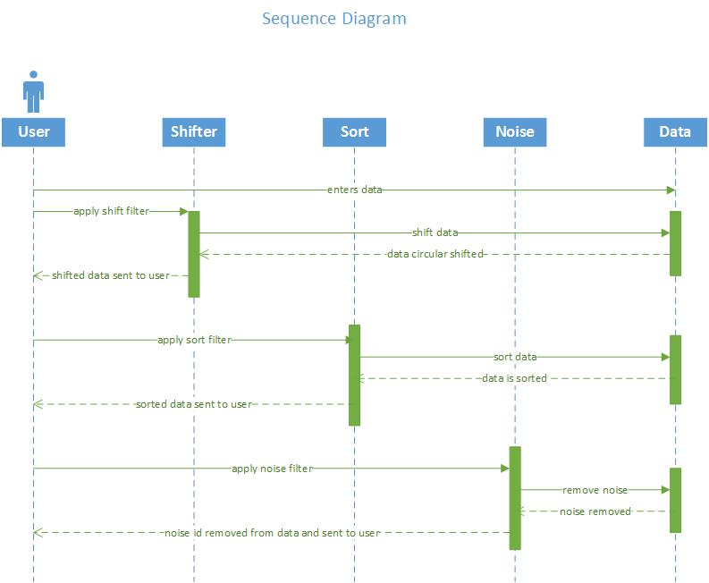

REFERENCES
1.Dr. Lawrence Chung. Software Architecture.[Online] 2005
http:/ /www.utdallas.edu/~chung/SA/syllabus.htm
2. Team Fountain Heads. [Online]Fall 2012
https://sites.google.com/site/fountainheadsasad

3. Wikipedia
http://en.wikipedia.org

APPENDIX
Appendix A: List of Architectural Specifications
I-FR Specification
Requirement ID | Architectural specification ID | Explanation
FR1 | AR1 | Module input accepts all valid unicode characters
FR4 | AR2 | Module input verifies all the inputs
FR3, FR6 | AR3 | Module Circular Shift constructs circular shift of each line
FR7 | AR4 | Module Circular Shift excludes circular shift of punctuation
FR2 | AR5 | Input medium accepts keyboard entry and copy/pasted inputs
FR5 | AR6 | Module Output outputs results to display screen
FR8 | AR15 | Module Alphabetizer does the sorting
NFR1 | AR7 | A sound User Manual and good GUI makes the product easily Understandable
NFR2 | AR8 | Anybody can use the system via internet and the system is non-platform specific
NFR3 | AR9 | The system can accept updates without problems
NFR4 | AR10 | The modules of the system can be easily reused because of fewer assumptions
NFR5 | AR11 | The system responses quickly and correctly
NFR6 | AR12 | The GUI design is simple to use and a help function helps user
NFR7 | AR13 | The system responses in two minutes
NFR8 | AR14 | The system is modular to be easily maintained

