Project interim report

---Yuxiao Zhou

**Project overview**

My project will go to be a system called “Health arrangement”. This app should be working as not only an information-sharing platform between patients and hospitals but also can help people to organize their health. To be more specific, patients allowed to arrange their appointment with doctors, get some health advice from our app and get their health report every day.

**Summary of work to date**

Here is the project plan from begin to now Which I wrote in the proposal:

|  |  |
| --- | --- |
| Time and date | Work and aim |
| Before 11/11/19 | Searching a similar app in the UK and also look for the APIs of hospitals. |
| 11/11/19-07/12/19 | Complete the first draft of the prototype by proto.io |
| 08/12/19-12/12/19 | Show the prototype to random people and record their feedback about the design and the virtual function. |
| 13/12/19-31/12/19 | Complete the second draft of the prototype by proto.io(Base on the users' feedback) |
| 01/01/20-13/01/20 | Show the newest prototype to doctors and patients in the hospital and record the feedback. The improve to the final version of the prototype |

*1*.

According to this plan, I search for some similar websites and apps in the UK For example, **doctap** (www.doctap.co.uk) is a website to get the patient feeling better as quickly. safely and painlessly as possible. And also **LondonDoctorsClinic** (londondoctorsclinic.co.uk).

The most common things are that they all offer GP appointments service near London and they all have their own combine hospital location which means they can only provide help from these hospitals.

So in conclusion, the selection of patient is limit on one website. The idea of my project is that the patient can select any hospital at any time if it is available.

*2.*

After confirming the ideal, I am starting to build my prototype by proto.io.Unfortunately, there are some changes from beginning to now:

The tool I used for prototyping. In the project plan, I wrote “I will build my prototype by proto.io”, but when I first day back to China, the free trial of the proto.io is ended and I had no time for downloading the project. So I have to use another app and rebuild the prototype.

The new app is called MockPlus. I will provide the screenshot of two prototypes below(only home page the details will be described after)

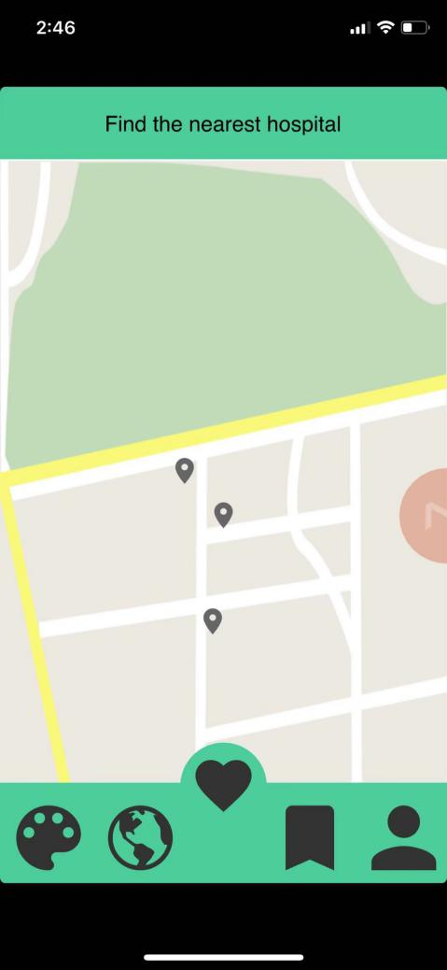 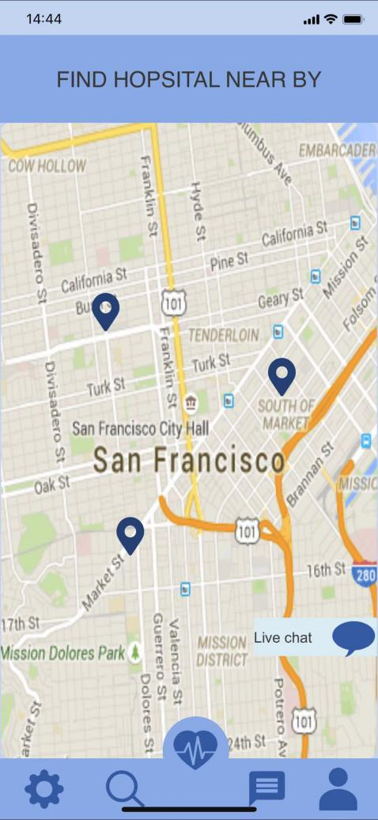

As you can see there are lots of deference in UI style but the main function remained the same.

I have not uploaded those two versions of prototype onto the gitlab due to reason that I am not currently in the UK So I could not log in into gitlab.doc.ac.uk. Those two versions of the prototype will be upload when I get back to the UK.

*3.*

After that, I am planning to make a table that I can record the users' feedback. Here is the newest record table:

|  |  |  |  |  |
| --- | --- | --- | --- | --- |
| Gender(性别) | Age(年龄) | Occupation(职业) | Date(日期) | Feedback(反馈) |
| Male | 53 | Doctors | 12.17 | 不够直观，许多地方显得过于复杂(Not straight forward, some function is too complex) |
| Female | 46 | Doctors | 12.17 | 年纪大的人可能看不清楚字体(old people could not be easy to read) |
| Male | 24 | Graduate students | 12.19 | 整体ui颜色不太好(colour of UI design is not well) |
| Male | 15 | Middle school students | 12.19 | 交互性不是很强，虽然功能还行但是不够吸引人(Interactivity is not strong, although the function went well, this app is not attractive enough) |
| female | 26 | Nurses | 12.21 | 整体不错但是能不能加一点功能(Great in whole but can we add more functions?) |
| Female | 46 | Nurse practitioners | 12.21 | 不用做的很花哨，因为面向人群不同所以整体ui最好简洁(UI seems to gaudy to me. ) |
| Male | 35 | Doctors | 12.21 | 我觉得挺好  (Great in total) |
| Male | 18 | Patients | 12.22 | 不够好玩可以增加一点内容  (Not fun enough could add some content) |
| Male | 8 | Patients | 12.22 | 我觉得不够方便  (Not convenient) |
| Female | unknown | Patients | 12.22 | 如果医院后台没刷新会怎么样  (What happens if the hospital doesn't refresh backstage) |
| Male | 35 | Family members of patients | 12.28 | 可以有一个可以直接买药的功能  (could add a function link to the Pharmacy) |
| Female | 54 | Family members of patients | 12.29 | 有没有是视屏可以看  (any videos for the health advice) |

To see more specific record including a weekly update, please check the end of the report.

According to the feedback, the new function and the new option are:

1. Adding UI style selection.

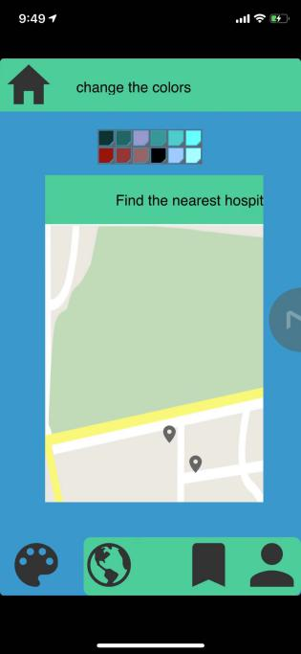As the graph from prototype.Users are able to select colors for their app and in the box below, users are able to the changes after select colors.

1. Adding health advice function.

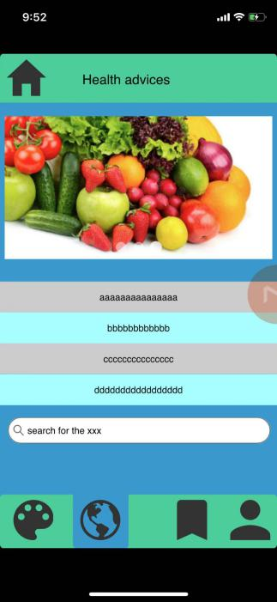As the graph from the prototype. Users can search articles, videos, graphs about how to keep your health

**Evaluation**

I believe I have met my milestone well. But there are some changes after doing the test plan I add more functions and more options for users. That makes my app become more reliable to patients, not only an app that helps patients booking their appointment but also an app that can help everyone to keep their health. I think my prototype is working well and do show the all function and design to our users. If my final work is as same as my prototype I will say that is a successful project. From this prototype design and testing, I have learnt that **Always thinking for your users** is important thinking during the program design. Only users know what our app feel like, we should hear from our clients.

**Revised project plan**

Same as the one wrote in proposal, My whole project plan will not change.

|  |  |
| --- | --- |
| Time and date | Work and aim |
| 14/01/20-28/01/20 | Complete the main method front-end of the app which is the patients' arrangement function |
| 29/01/20-12/02/20 | Building the back-end of the main method which completes by MySQL |
| 13/02/20-27/02/20 | Connect the front-end and the back-end by PHP and test the working result. |
| 28/02/20-13/03/20 | Check the error and working result. Test plan needed. (test plan aim to record the result of each test for each version of the app ). The first will be using dummy data to check the users' information is stored in to correct database and should be no conflict with doctor database. |
| 14/02/20-27/03/20 | Improving the main function to reach the achieve. Record each change of code and testing. |
| 28/03/20-11/04/20 | Complete the homepage of the app including the login-in system. Besides, create a database and check the data is accurate. Testing by the dummy data and record the result |
| 12/04/20-28/04/20 | Complete the function for the hospital checking. My purpose is our database and APIs can provide the correct information of hospital to our users. Testing by dummy data and record the result |
| 29/04/20-13/05-20 | Link each function to complete the app. Testing by Android simulator and record the result(in this step the point is to check the speed and the accuracy) |
| 14/05/20-22/05/20 | Final improvement and ready for showcase. |

**Repository Link**

<https://yzhou003.tumblr.com/>

Ps: I can not do this in China weekly, I will update my weekly blog after I back to the UK.

Here is the feedback record table with a weekly record(will update to the Tumblr when I back)  *Prototype feedback record*

*12.15*

*After I finish my 1st  version of prototype,I plan to show this to the random people in the local hospital nearby and record their feedback.(because I am doing this test in China So it will translate to eng.ver in report).*

|  |  |  |  |  |
| --- | --- | --- | --- | --- |
| *Gender(性别)* | *Age(年龄)* | *Occupation(职业)* | *Date(日期)* | *Feedback(反馈)* |

*12.20*

*Unlucky,I had run a temperature for 5 days. But I still have some record from my parent and my cousins.*

|  |  |  |  |  |
| --- | --- | --- | --- | --- |
| *Gender(性别)* | *Age(年龄)* | *Occupation(职业)* | *Date(日期)* | *Feedback(反馈)* |
| *男* | *53* | *医生* | *12.17* | *不够直观，许多地方显得过于复杂* |
| *女* | *46* | *医生* | *12.17* | *年纪大的人可能看不清楚字体* |
| *女* | *24* | *研究生在读* | *12.19* | *整体ui颜色不太好* |
| *男* | *15* | *初中生* | *12.19* | *交互性不是很强，虽然功能还行但是不够吸引人* |

*In addition, by asking the programmer in hospital, they give me some advice about using other app for prototype which they are using.(the free trail of the proto.io is end.)*

*So after almost rebuild the prototype. The 2nd version of prototype is coming out.*

*12.27*

*A week past, I asked few patient and doctor to try my 2nd version of prototype.*

*It is difficult for explaining, but the result was went well.*

|  |  |  |  |  |
| --- | --- | --- | --- | --- |
| *Gender(性别)* | *Age(年龄)* | *Occupation(职业)* | *Date(日期)* | *Feedback(反馈)* |
| *男* | *53* | *医生* | *12.17* | *不够直观，许多地方显得过于复杂* |
| *女* | *46* | *医生* | *12.17* | *年纪大的人可能看不清楚字体* |
| *女* | *24* | *研究生在读* | *12.19* | *整体ui颜色不太好* |
| *男* | *15* | *初中生* | *12.19* | *交互性不是很强，虽然功能还行但是不够吸引人* |
| *女* | *26* | *护士* | *12.21* | *整体不错但是能不能加一点功能* |
| *女* | *46* | *护师* | *12.22* | *不用做的很花哨，因为面向人群不同所以整体ui最好简洁* |
| *男* | *35* | *医生* | *12.22* | *我觉得挺好* |
| *男* | *18* | *病人* | *12.23* | *不够好玩可以增加一点内容* |
| *男* | *8* | *病人* | *12.25* | *我觉得不够方便* |
| *女* | *未透露* | *病人* | *12.26* | *如果医院后台没刷新会怎么样* |

*1.3*

*Happy new year and happy new feedback(Because none want to welcome 2020 in hospital, I could only get the feedback in 28th 29th 2nd ).*

|  |  |  |  |  |
| --- | --- | --- | --- | --- |
| *Gender(性别)* | *Age(年龄)* | *Occupation(职业)* | *Date(日期)* | *Feedback(反馈)* |
| *男* | *53* | *医生* | *12.17* | *不够直观，许多地方显得过于复杂* |
| *女* | *46* | *医生* | *12.17* | *年纪大的人可能看不清楚字体* |
| *女* | *24* | *研究生在读* | *12.19* | *整体ui颜色不太好* |
| *男* | *15* | *初中生* | *12.19* | *交互性不是很强，虽然功能还行但是不够吸引人* |
| *女* | *26* | *护士* | *12.21* | *整体不错但是能不能加一点功能* |
| *女* | *46* | *护师* | *12.21* | *不用做的很花哨，因为面向人群不同所以整体ui最好简洁* |
| *男* | *35* | *医生* | *12.21* | *我觉得挺好* |
| *男* | *18* | *病人* | *12.22* | *不够好玩可以增加一点内容* |
| *男* | *8* | *病人* | *12.22* | *我觉得不够方便* |
| *女* | *未透露* | *病人* | *12.22* | *如果医院后台没刷新会怎么样* |
| *男* | *35* | *病人家属* | *12.28* | *可以有一个可以直接买药的功能* |
| *女* | *54* | *病人家属* | *12.29* | *有没有是视屏可以看* |

*1.8*

*The final version of the prototype is finish , ready for coding.*

*(there are more function that i think i will add in but not in this version)*