**Project specification---------Health Appointment**

Author: Yuxiao Zhou

1. **Work overview**

My project will go to be a system called “Health appointment”. This app should be working as an information-sharing platform between patients and hospitals. To be more specific, with this app patient can arrange an appointment with doctors by their phone.

By this app, My users can arrange appointment base on their condition. They can select when they can go to the hospitals, which hospital they are willing to go to and which doctor they are willing to ask for medical help. There will be a function add to this software. For example, if patients do not have a specific quest, System will match them with available doctors. What’s more, patients can also get information about the hospital. Not only the address and the phone number of the hospital but also including how long they will wait to see the doctors.

Talk about technology, first of all, is the database, I would like to use the database to store our users’ information including name, age and some request information the hospital need. Secondly, Java, PHP, CSS will be my main-use technique to build this app.

1. ***Users requirement***

My app is going to publish to all the age gaps. Users should able to using their phone and knowing which department they will go to. Besides, the main users’ requirement will be users should be able to link to the internet so they can track the process of their appointment.

1. **Technologies and Materials**

Our software will be published on Android mainly based on the App. MySQL will provide help with our back-end to store user data. PHP will link our front-end with a back-end to produce an interactive app to users. The language we chose is Java as many developers do. For the function inside the app, we will use APIs to give the information of hospital to users, including address, phone number and the average waiting time to our users, aim to help patients to select a hospital.

Their lots of similar APP that can be an example of my APP (the image below). In China, this kind of APP is popular between hospital and patients.

1. ***Motivation research***

The thing that inspires me to choose this project is the time I am working as a volunteer in a local hospital in China. I spend lots of time in helping the patient to arrange an appointment with doctors in a different department. I found that even we have machines for patients paying their fees and arrange their appointment, most of them including young and olds will ask for help with that. I ask the IT department for help and they show me a demon which can only be run by WeChat(a Chinese social 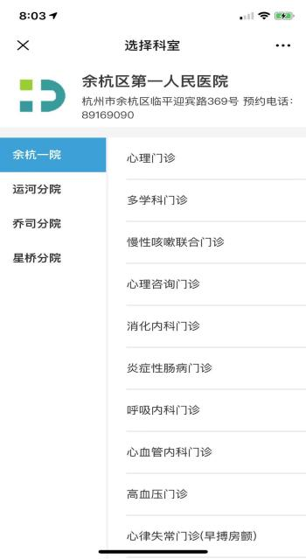media similar to Whatsapp) the home page will show right side and I simply transfer to the hand-drawing prototype, the image will show below.

In this image, the red-dash area is the name and the label of one hospital, the blue cross means the departments and the black cross means the hospital name if they have a branch.

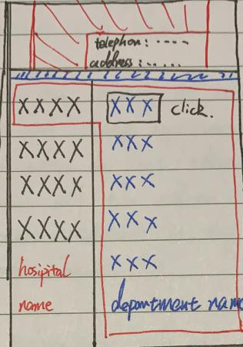

1. ***Existing knowledge:***

The existing knowledge could be the summary of my module especially

Database and Java. As I mentioned, Database will be the main technology I work with the existing knowledge in the database will support me to develop this APP

1. ***New knowledge:***

The main problem I am going to face is Constrained Optimization(CSPs). For example, Doctor A only available on Wednesday afternoon from 2pm-4pm in hospital B. Patient C arrange an appointment with Doctor A in hospital B on Thursday morning by our app. Here will be a conflict. By search form Wikipedia I found that CSPs is a popular topic in AI and Operations Research because the laws in their formulas provide a common basis for analyzing and solving many seemingly unrelated problems. Inside my app, CSPs will be the main topic about the match up patients and doctors.

1. ***Timeline and milestones:***

The table shows the timeline briefly.

|  |  |
| --- | --- |
| Time and date | Work and aim |
| 11/11/19- 13/01/20 | Prototyping |
| 14/01/20-27/03/20 | Supported Building and draft write up |
| 28/03/20-22/05/20 | Free Building and draft write up |
| 26/05/20-05/06/20 | Showcase |

To be more specific, I will provide another table for the prototyping step first.

|  |  |
| --- | --- |
| Time and date | Work and aim |
| Before 11/11/19 | Searching a similar app in the UK and also look for the APIs of hospitals. |
| 11/11/19-07/12/19 | Complete the first draft of the prototype by proto.io |
| 08/12/19-12/12/19 | Show the prototype to random people and record their feedback about the design and the virtual function. |
| 13/12/19-31/12/19 | Complete the second draft of the prototype by proto.io(Base on the users' feedback) |
| 01/01/20-13/01/20 | Show the newest prototype to doctors and patients in the hospital and record the feedback. The improve to the final version of the prototype |

Then. I will provide a table for the supported building step.

|  |  |
| --- | --- |
| Time and date | Work and aim |
| 14/01/20-28/01/20 | Complete the main method front-end of the app which is the patients' arrangement function |
| 29/01/20-12/02/20 | Building the back-end of the main method which completes by MySQL |
| 13/02/20-27/02/20 | Connect the front-end and the back-end by PHP and test the working result. |
| 28/02/20-13/02/20 | Check the error and working result. Test plan needed. (test plan aim to record the result of each test for each version of the app ). The first will be using dummy data to check the users' information is stored in to correct database and should be no conflict with doctor database. |
| 14/02/20-27/03/20 | Improving the main function to reach the achieve. Record each change of code and testing. |

During this step, I will do some research and gain new knowledge about the scheduling problem and CSP on the internet.

The free building step will provide the following:

|  |  |
| --- | --- |
| Time and date | Work and aim |
| 28/03/20-11/04/20 | Complete the homepage of the app including the login-in system. Besides, create a database and check the data is accurate. Testing by the dummy data and record the result |
| 12/04/20-28/04/20 | Complete the function for the hospital checking. My purpose is our database and APIs can provide the correct information of hospital to our users. Testing by dummy data and record the result |
| 29/04/20-13/05-20 | Link each function to complete the app. Testing by Android simulator and record the result(in this step the point is to check the speed and the accuracy) |
| 14/05/20-22/05/20 | Final improvement and ready for showcase. |

During Christmas, I will back to China and I would like to show my first version of the app to the hospital and looking for some advice. In this project, I would like to provide 2 types of product-----doctor’s version and patient’s version. Patient’s version is the app I will provide as the final version. Doctor’s version will show the situation of the “database” which means doctors can check the number of patient waiting and how many appointments they are going to attend. Also, I am hoping I can add more functionality to the doctor’s version. For example, doctors can edit their information including the time available, address available and the patients’ number available.

1. ***“Final version”:***

I expect to see users give me feedback which would be very valuable for me to improve my product. If everything goes smoothly, I will keep improving my system according to user habits. I may not define a “final” version for my App because I believe that there would be continuous changing demands for users, so I will keep releasing better versions to keep my App up to date.

1. ***Project repo***

My working record will be published

on my Tumblr <https://yzhou003.tumblr.com/> weekly.