integrationflow

# Technical Specification Document for iFlow ‘integrationflow’

1.1 Purpose
The purpose of the iFlow ‘integrationflow’ is to automate the process of retrieving unread emails from a Gmail inbox and sending the contents as an email attachment to a specified recipient. The integration flow is triggered by a scheduled event that polls the Gmail inbox at regular intervals. The expected outcome is to ensure that any unread emails are processed and forwarded, thereby facilitating efficient communication and data handling.

Business Problem
The business problem addressed by this integration flow is the need for timely processing of unread emails. In many organizations, important information may be buried in unread emails, leading to delays in response and decision-making. This flow automates the retrieval and forwarding of such emails, ensuring that critical information is not overlooked.

Trigger
The trigger for this integration flow is a scheduled event that occurs daily. The flow is configured to poll the Gmail inbox for unread emails every minute, ensuring that any new emails are processed promptly.

Outcome
The expected outcome of this integration flow is the successful retrieval of unread emails and their forwarding to a designated recipient. This not only improves communication efficiency but also ensures that important information is disseminated without manual intervention.

1.2 Scope

Inclusions
- Polling of unread emails from the Gmail inbox.
- Sending of email contents as attachments to a specified recipient.
- Use of IMAP for retrieving emails and SMTP for sending emails.

Exclusions
- Processing of read emails.
- Handling of email attachments beyond the specified format.
- Any manual intervention in the email retrieval and sending process.

Endpoints
- Sender Endpoint: Gmail IMAP server (imap.gmail.com:993)
- Receiver Endpoint: Gmail SMTP server (smtp.gmail.com)

Transformations
- The email content is transformed into an attachment format before being sent to the recipient.

Constraints
- The integration flow is limited to processing unread emails only.
- The flow must adhere to the security protocols of Gmail, including authentication and encryption.

2.1 Integration Components
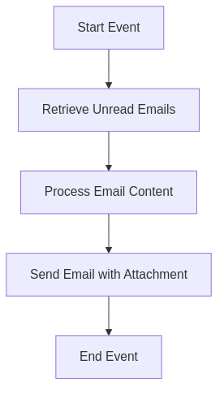
Integration Architecture

2.2 Integration Components
Component Type | Name | Description
Adapter | IMAP Adapter | Used to connect to the Gmail inbox and retrieve unread emails.
Adapter | SMTP Adapter | Used to send emails to the specified recipient.
Script | Groovy Script 1 | Processes the email content and prepares it for sending as an attachment.
Content Modifier | Content Modifier 1 | Modifies the email content before sending.
Content Modifier | Content Modifier 2 | Further enriches the email content if necessary.

3.1 Scenario Description

Step-by-Step Message Lifecycle
- Start Event: The integration flow is triggered by a scheduled event that occurs every minute.
- Retrieve Unread Emails: The IMAP adapter connects to the Gmail inbox and retrieves unread emails based on the specified criteria.
- Process Email Content: The Groovy script processes the retrieved email content, preparing it for sending. This may include formatting the content and creating an attachment.
- Content Modification: The first content modifier enriches the email content, while the second content modifier may add additional headers or properties as required.
- Send Email with Attachment: The SMTP adapter sends the processed email content as an attachment to the specified recipient.
- End Event: The integration flow concludes after the email has been sent successfully.
This document provides a comprehensive overview of the iFlow ‘integrationflow’, detailing its purpose, scope, integration components, and message lifecycle. The automation of email processing through this integration flow enhances operational efficiency and ensures timely communication.

