APACHE_POI_LIBRARIES
Technical Specification Document
Author: | github-actions
Date: | 2026-01-07
Version: | 1.0

Table of Contents
1. Introduction
1.1 Purpose
1.2 Scope
2. Integration Overview
2.1 Integration Architecture
2.2 Integration Components
3. Integration Scenarios
3.1 Scenario Description
3.2 Data Flows
3.3 Security Requirements
4. Error Handling
5. Testing Validation

1. Introduction

1.1 Purpose
The purpose of the Apache POI Libraries iFlow is to facilitate the reading and writing of Microsoft Excel and Word files within SAP Cloud Platform Integration (CPI), enabling seamless integration with these file formats for data exchange in various processes.

1.2 Scope
This iFlow supports scenarios where data needs to be extracted from Excel or Word documents, processed, and subsequently sent to different systems or transformed into different formats for further use.

2. Integration Overview

2.1 Integration Architecture
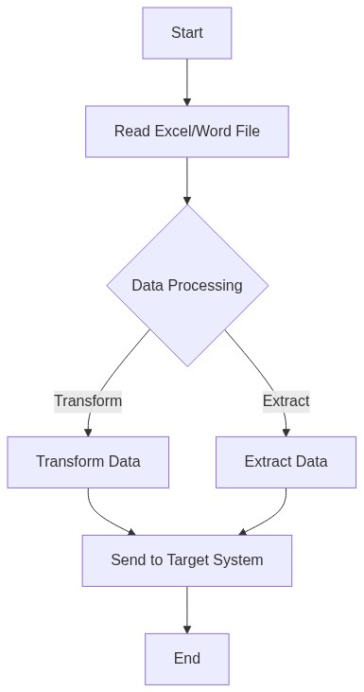

2.2 Integration Components
Component | Value
Content Modifier | Used for altering message content before processing.
Groovy Script | Applied for advanced data manipulation using Groovy scripting.
Apache POI Library | Library used for reading and writing Excel and Word documents.
Sender Adapter | Facilitates receiving files from SAP or external sources.
Receiver Adapter | Used for pushing processed data to target systems.

3. Integration Scenarios

3.1 Scenario Description
The iFlow reads Excel or Word files received from a sender adapter, processes the content using the Apache POI library to extract or transform data as required, and then routes the modified data to designated target systems.

3.2 Data Flows
Source Field | Target Field | Logic
Column Data in Excel/Word | Target Field in External System | Map Excel/Word column headers to appropriate fields based on predefined mapping rules.

3.3 Security Requirements
Utilizes standard SAP CPI security protocols for data transmission, including message encryption and secure communications over HTTPS. Access control is maintained using user roles and authorization settings.

4. Error Handling and Logging
Includes error handling mechanisms such as message logging, alerts for failed processes, and retry attempts for transient errors through integration with SAP CPI's error management framework.

5. Testing Validation
The iFlow can be tested using the SAP CPI monitoring tools to check message processing, transformation correctness, and integration points. Test cases should encompass various document formats, edge cases in data processing, and performance under load.

