CPI-Mail-Reader_3
Technical Specification Document
Author: | github-actions
Date: | 2026-01-07
Version: | 1.0

Table of Contents
1. Introduction
1.1 Purpose
1.2 Scope
2. Integration Overview
2.1 Integration Architecture
2.2 Integration Components
3. Integration Scenarios
3.1 Scenario Description
3.2 Data Flows
3.3 Security Requirements
4. Error Handling
5. Testing Validation

1. Introduction

1.1 Purpose
The purpose of the CPI-Mail-Reader_3 iFlow is to automate the process of reading emails from a specified mailbox, extracting relevant data, and processing it for further integration or actions within the SAP ecosystem.

1.2 Scope
The scope of this iFlow includes connecting to an email server, retrieving emails that meet certain criteria, parsing email content, and integrating the extracted data with SAP applications or third-party systems for downstream processing.

2. Integration Overview

2.1 Integration Architecture
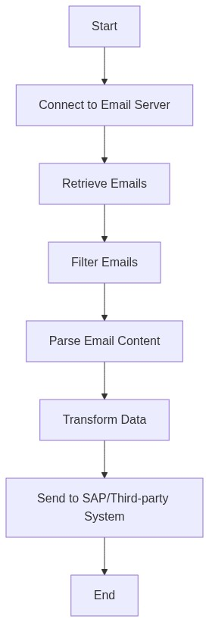

2.2 Integration Components
Component | Value
Email Connector | SAP CPI Email Connector for retrieving emails.
Message Transformation | Transformation logic to convert email data into a suitable format.
Error Handling Framework | Error handling mechanisms to manage failures in email retrieval and processing.
Logging | Logging components to monitor the flow and capture relevant events.

3. Integration Scenarios

3.1 Scenario Description
In this scenario, the iFlow connects to an email service to read incoming emails as they arrive. It leverages predefined filters to extract only those emails that contain specific information, such as purchase orders. The email contents are then parsed and transformed into a format compatible with the receiving SAP system, such as SAP S/4HANA or any other external system. Finally, the data is pushed to the target system for processing.

3.2 Data Flows
Source Field | Target Field | Logic
Email Body | Purchase Order Entity | Extract relevant fields (e.g., PO number, item details) using regex or parsing techniques.
Email Subject | Document Title | Map the email subject directly if it contains relevant metadata.
Email Attachments | Attachment Storage | Upload attachments to specified storage solution using its API.

3.3 Security Requirements
The iFlow implements OAuth for secure connections to the email server and ensures that sensitive data, such as credentials, are stored securely in the CPI credentials store.

4. Error Handling and Logging
The iFlow utilizes a comprehensive error handling strategy that includes retry mechanisms for transient errors, notification of failures via email or logging, and a dead-letter queue for permanently failed messages.

5. Testing Validation
The testing strategy includes unit testing of each component, integration testing to validate end-to-end flows, and user acceptance testing (UAT) to ensure that the implemented solution meets the business requirements.

