docs
Technical Specification Document
Author: | github-actions
Date: | 2026-01-07
Version: | 1.0

Table of Contents
1. Introduction
1.1 Purpose
1.2 Scope
2. Integration Overview
2.1 Integration Architecture
2.2 Integration Components
3. Integration Scenarios
3.1 Scenario Description
3.2 Data Flows
3.3 Security Requirements
4. Error Handling
5. Testing Validation

1. Introduction

1.1 Purpose
The iFlow is designed to integrate various systems and facilitate the seamless transfer of data between them using SAP Cloud Platform Integration (CPI). It enables data synchronization, transformation, and processing in real-time or batch modes.

1.2 Scope
The integration flow connects on-premise and cloud applications, ensuring that data consistency is maintained across different platforms. It encompasses data extraction, transformation, and loading (ETL) processes, catering to both business and technical requirements.

2. Integration Overview

2.1 Integration Architecture
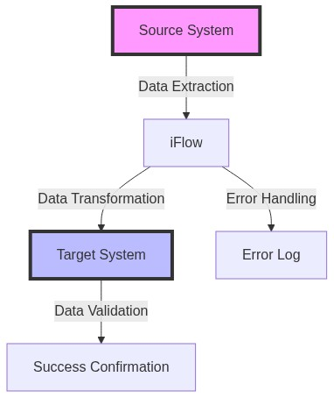

2.2 Integration Components
Component | Value
connectors | [{'name': 'HTTP_AAA', 'type': 'HTTP'}]
data_mappings | [{'name': 'Mapping1', 'type': 'XSLT'}]
error_handling | Error handling component to capture and log errors during data processing.

3. Integration Scenarios

3.1 Scenario Description
This iFlow integrates data from an on-premise ERP system to a cloud-based CRM system. It captures customer data updates and ensures that both systems are synchronized with real-time updates while also managing error handling processes.

3.2 Data Flows
Source Field | Target Field | Logic
Source System | Target System | Extract customer records, transform data format, and validate required fields.

3.3 Security Requirements
The iFlow uses OAuth 2.0 for secure authentication between the on-premise system and the cloud services. Data encryption is enforced for all data in transit to ensure confidentiality.

4. Error Handling and Logging
The iFlow includes a dedicated error handling path that captures exceptions, logs detailed error messages, and sends notifications to administrators for failed transactions.

5. Testing Validation
Unit tests are conducted to validate each component of the iFlow. Integration tests are performed to ensure end-to-end functionality, including testing with different scenarios to handle exceptions and validate successful data transmission.

