Experiment No :- 10

Name :- Shahidraja Shaikh

Roll :- 18CO56

Sub :- WDL

Aim :- Design a Web application using Laravel Framework.

1 -> **Inserting into database**

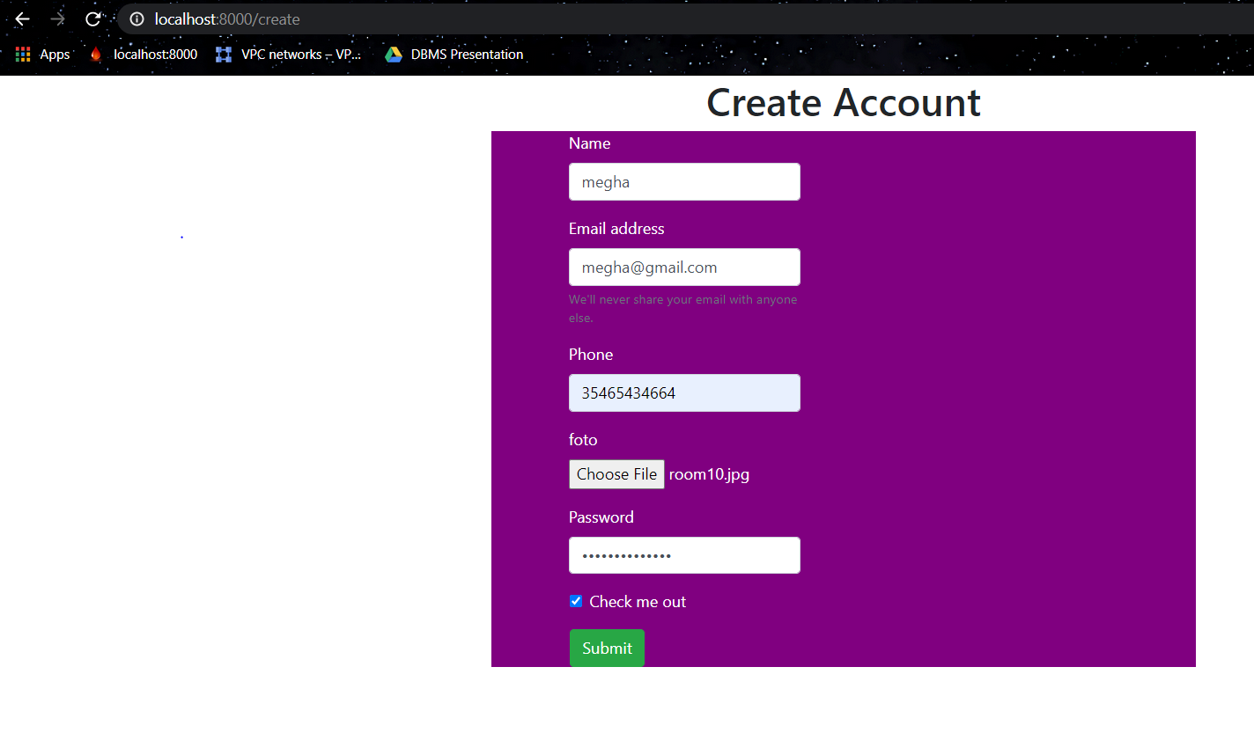

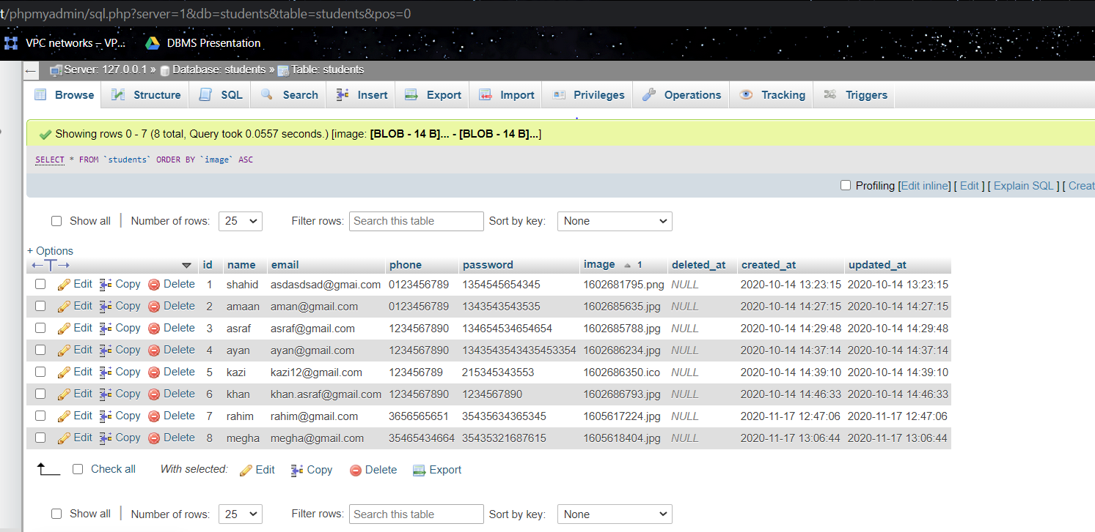

2 -> **Showing the Stored data**

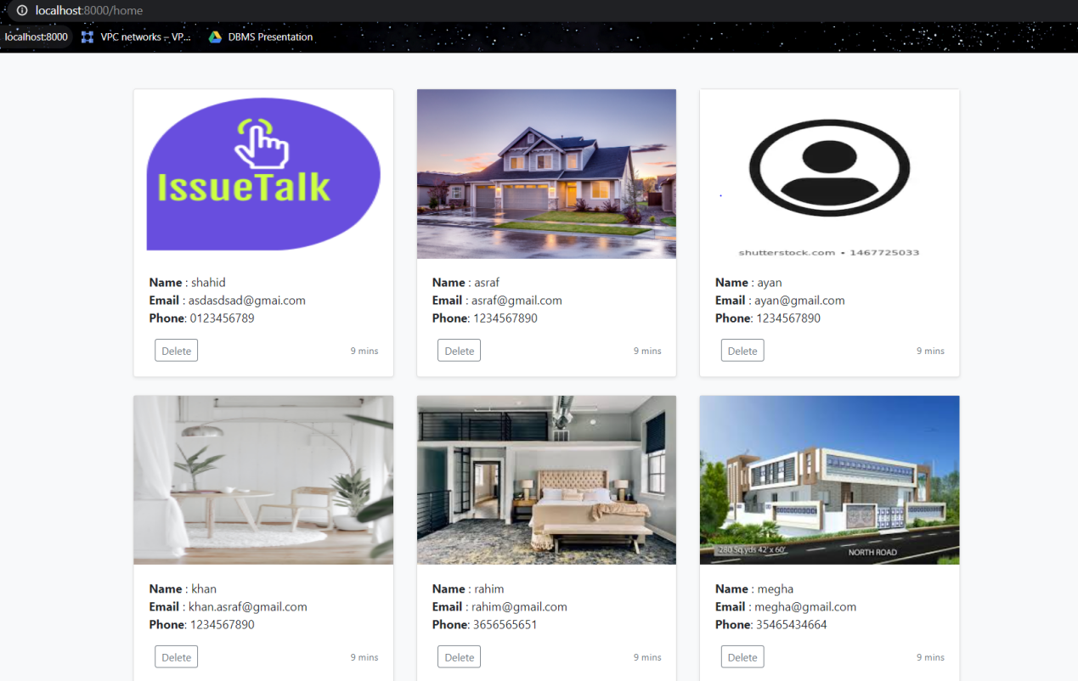

3 -> **Deleting the data from database**

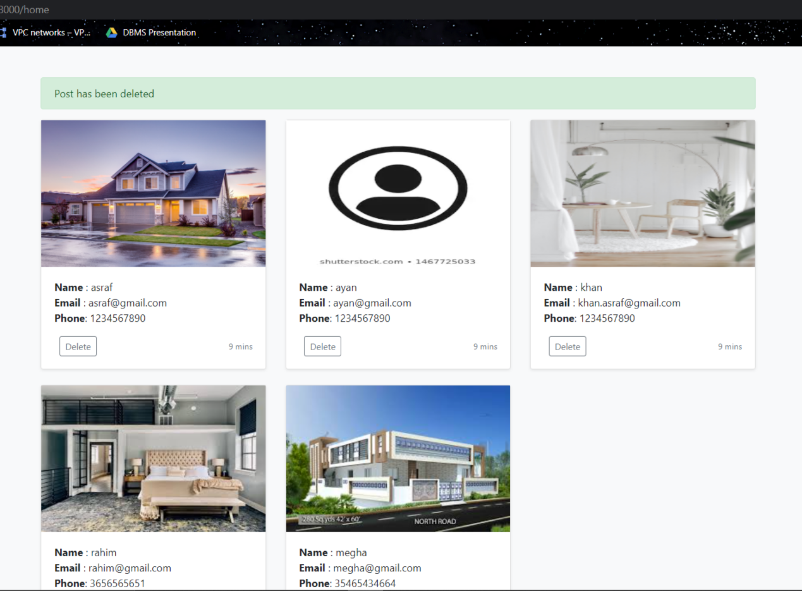

**Database After deletion**

