**WJA Comparison Tool v1.0**

**October 16, 2013**

**Jacob Butterfield**

**Introduction**

The purpose of this tool is to simplify the process of comparing expected and actual results from an EprInjector test scenario. It does this by comparing the EprInjector Activity Summary spreadsheet created by the Scalable Test Framework Console with the Exported Devices file generated by Web Jetadmin. Because an EprInjector test scenario could include hundreds of devices, this tool will save testers a great deal of time.

**Steps to Use**

Start by creating an EprInjector Scenario. For this example, we’ll set up a simple scenario like the one seen below:

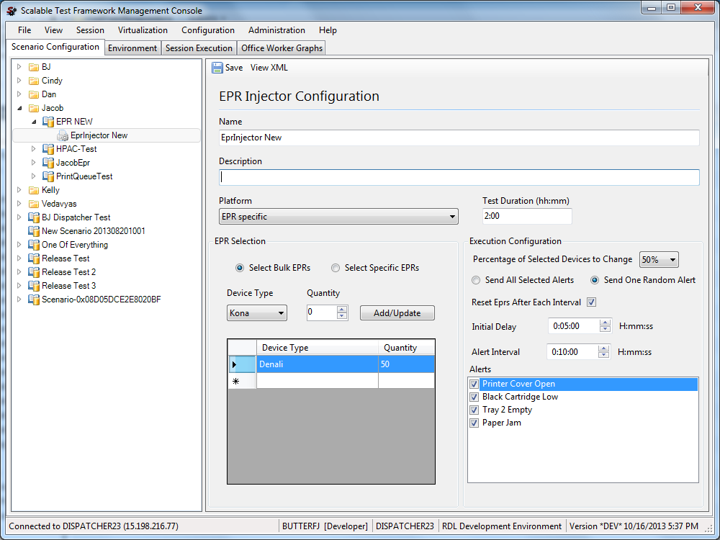

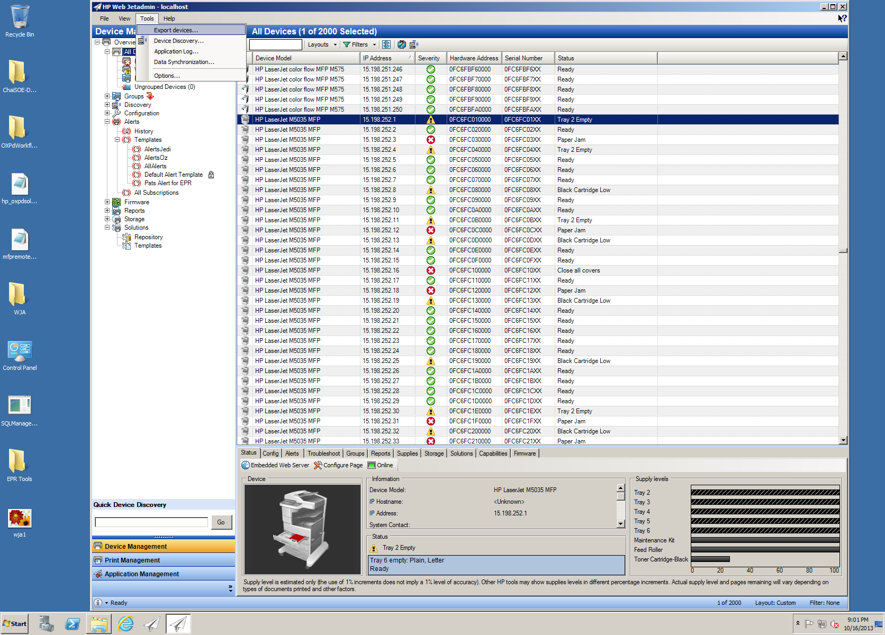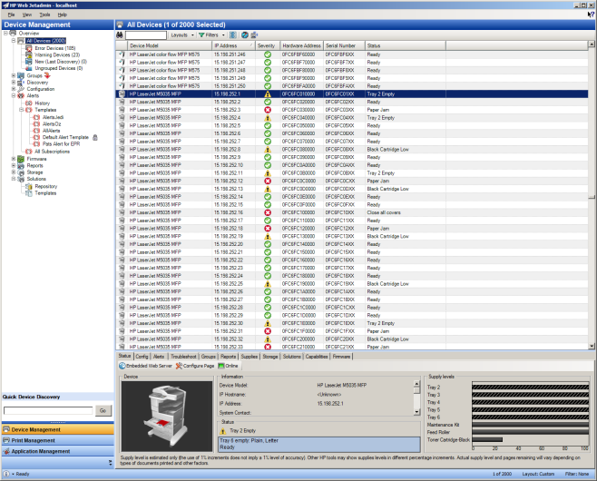Once the test has started and alerts have been sent, we can generate an Export Devices file from Web Jetadmin. This report can be generated at any time during the test; however, one should allow Web Jetadmin sufficient time to detect changes in the devices. Web Jetadmin works by polling the devices that are currently displayed on the screen. In a large test, the tester should scroll through the list of devices in order for their new states to be detected before generating the Export Devices file. Once the tester has allowed Web Jetadmin to detect changes, the report is ready to be generated. This report can be created by selecting Tools -> Export devices… from the toolbar. When the report is generated, Web Jetadmin takes a snapshot of all of its current data and exports it to a csv or an xml file.

In this first window, we select which columns of data we want included in the report. By default, Web Jetadmin includes the Device Model, the IP Hostname and the IP Address. In order to compare the state each device, we need to add the Status of each device to our report also. To do this, scroll down the Available Columns list and add a column for Status to the Selected Columns list. The “Status” column in Web Jetadmin displays the current state of the device. Now that the “Status” column is added, select “Next.”

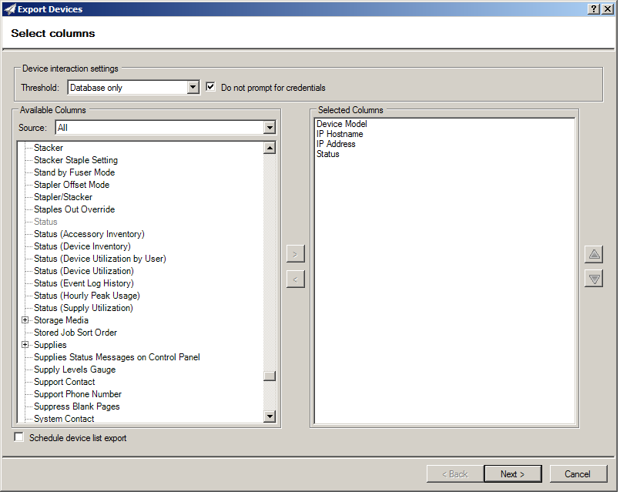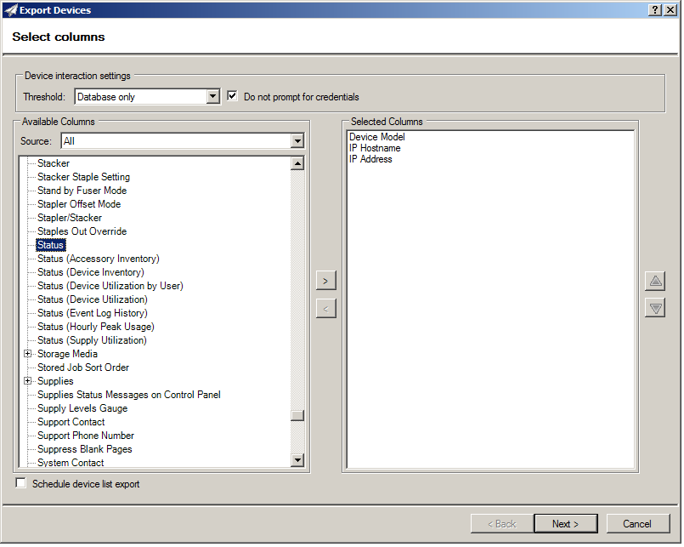

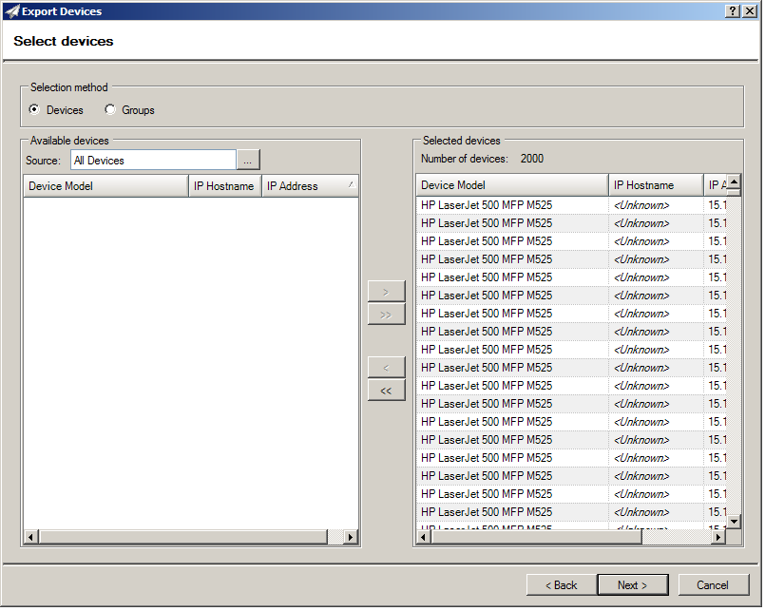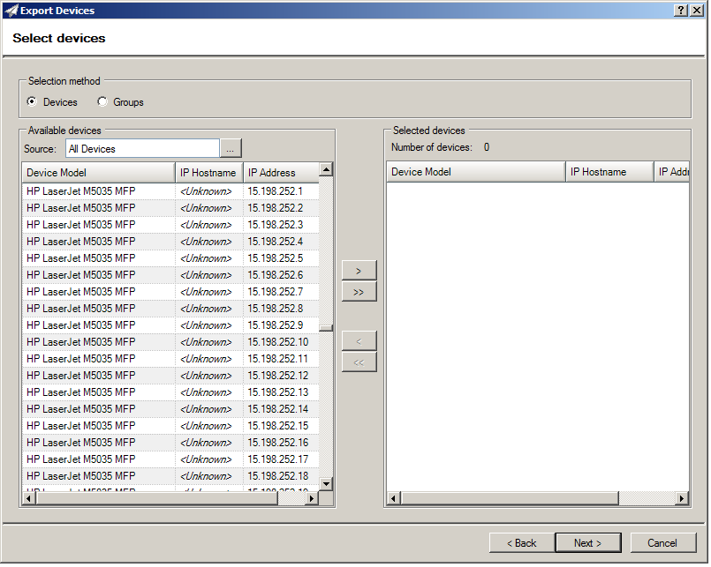This next window allows us to choose which devices we want to include in a report. Because Web Jetadmin generates these reports quickly, we’ll just select the option to add all of the devices to the report. This way we are guaranteed to get the devices affected by the Epr Injector. To add all of the devices to the report, just hit the button labeled “>>” between the Available Devices table and the Selected devices table. Once all of the devices are added to the report, select “Next.”

The next window asks us what kind of file we want exported and where we want it. The Web Jetadmin Comparison tool requires that we export a csv file. If Web Jetadmin is configured correctly, the tester can email the report to himself or they can simply export the file locally and copy it later. In this example we’ll save it locally. The tester can also enter in a unique name for the file; perhaps the date of the test or the tester’s name. By default the file is named HP Web Jetadmin Exported Devices. Once a name has 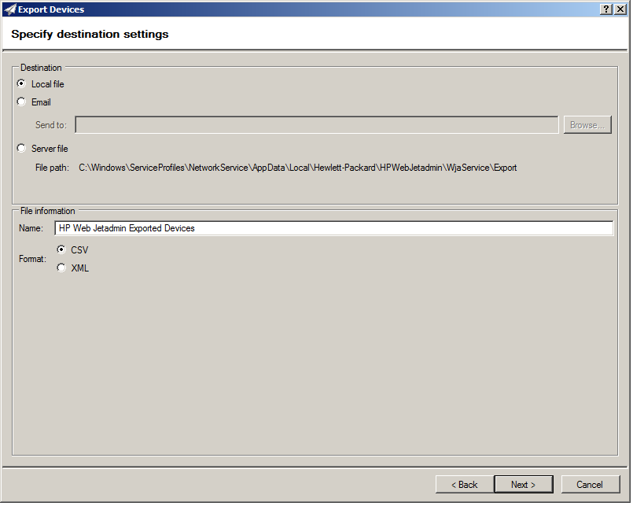been entered, we can hit “Next.”

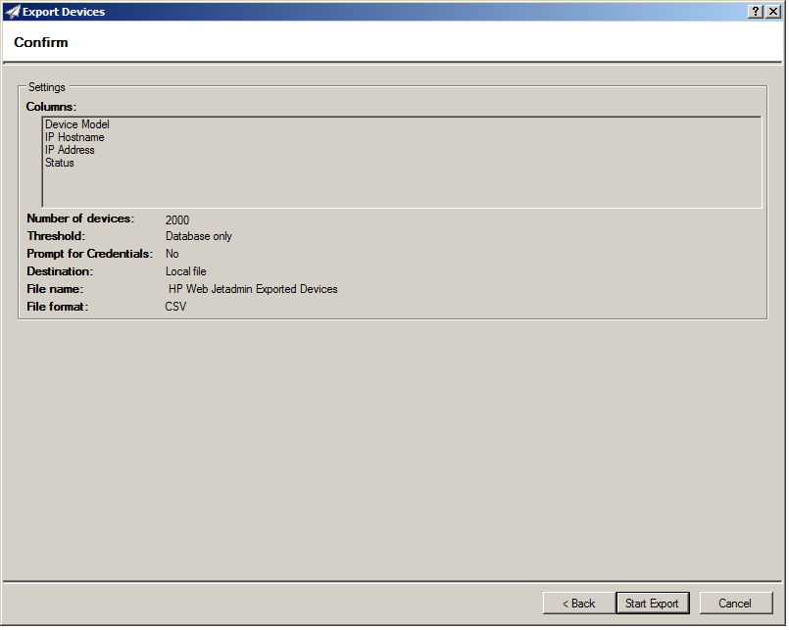The next window is a summary of the Export Devices file. The tester should review this window to make sure that it is configured correctly before exporting it. To review, first we need to export the IP Address and Status columns (the other columns are not necessary). Next, the Number of devices should be the total number of devices currently monitored by Web Jetadmin (in this case 2000). Finally, review the File name and Destination, and make sure the file is a CSV. Once reviewed, hit “Start Export.”

Once started, Web Jetadmin will start working on the export, after a while we are prompted to choose a location and confirm the name for the file for the file. We verify that everything is correct and hit "Save". Once saved, Web Jetadmin informs us if the export was successful. Warnings can generally be ignored (they have to do with exporting columns that we’re not interested in). Now we have the Web Jetadmin report saved to the desktop. If Web Jetadmin is running from a virtual machine, we can copy it to our local directory. Alternatively, we could have it emailed to us.

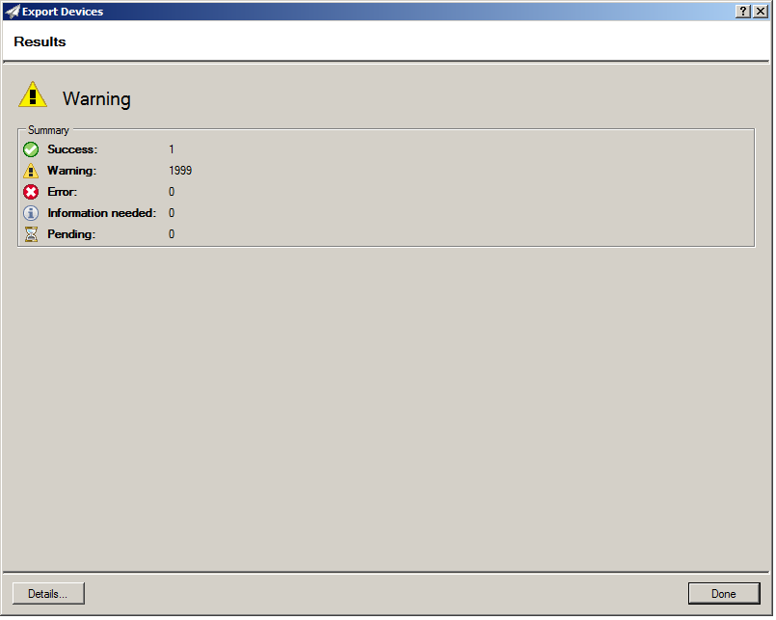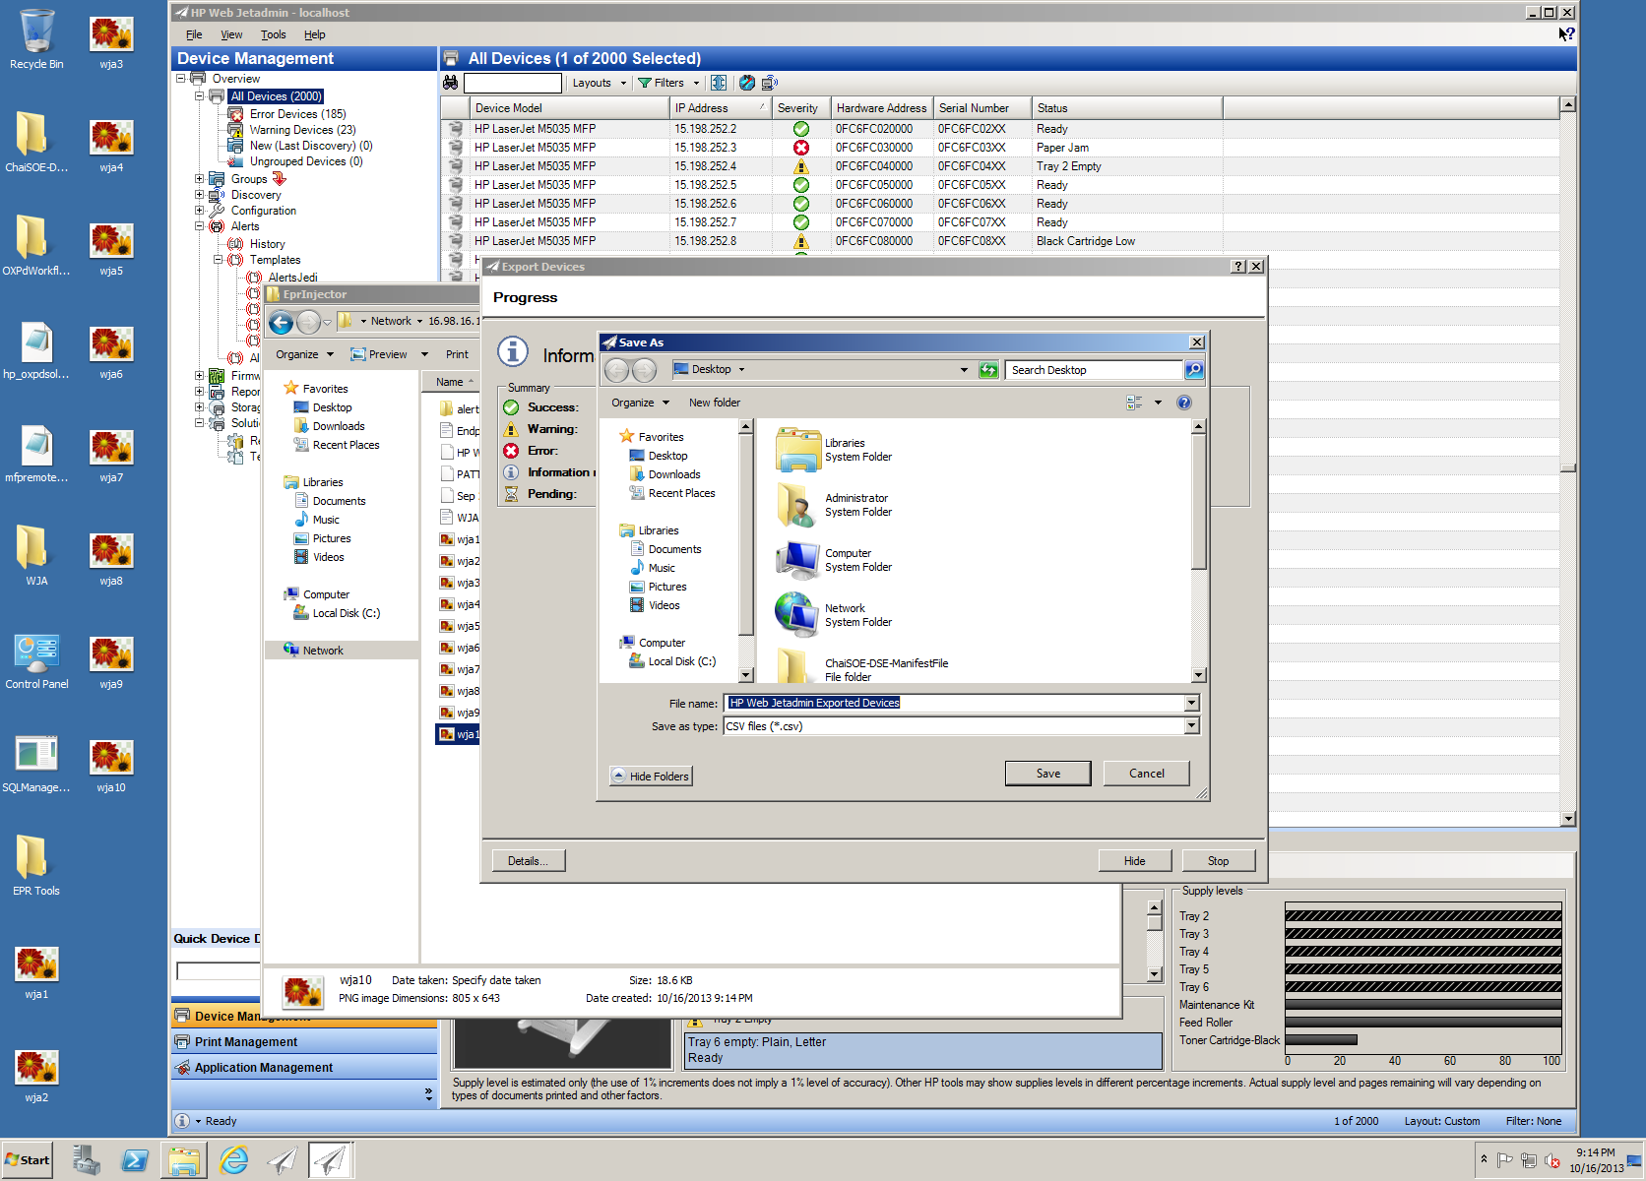

Now that we have the Web Jetadmin report, we need to get that Activity Summary from the STF Console. This report represents each individual Epr Injection activity, sorting them by the IP address of the Endpoint Responder and listing the state that was injected (Ready, Black Cartridge Low, etc). Therefore, the report generated by the STF Console provides the expected results, while the Web Jetadmin report gives the actual results.

The activity log file can be accessed from the STF Admin Console by selecting Session -> Session Reports from the tool bar. In the window that appears, select "Activity Summary" as the template, then select the Epr Injector session from the grid. Select "Create Report" at the bottom of the window and save the file.

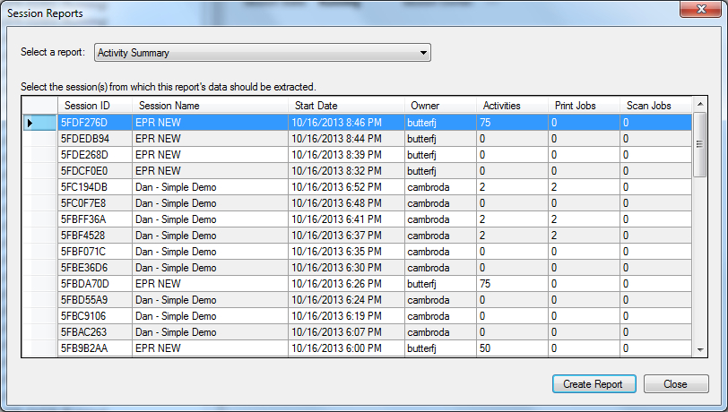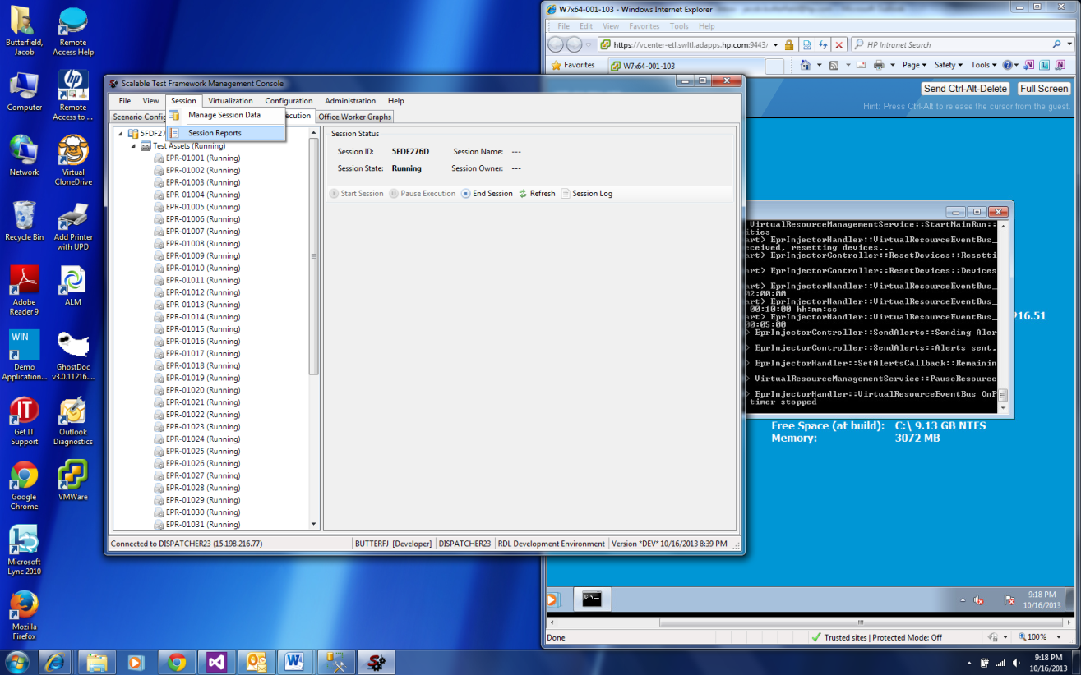

Now that we have both files, we are ready to compare them using the Web Jetadmin Comparison Tool. First we need to select the Web Jetadmin Exported Devices report. To do this, we’ll click on the button labeled “…” next to the WJA report textbox. In the explorer window that appears we’ll browse to the location of the report and select it. We will select the Activity Summary in the same manner.

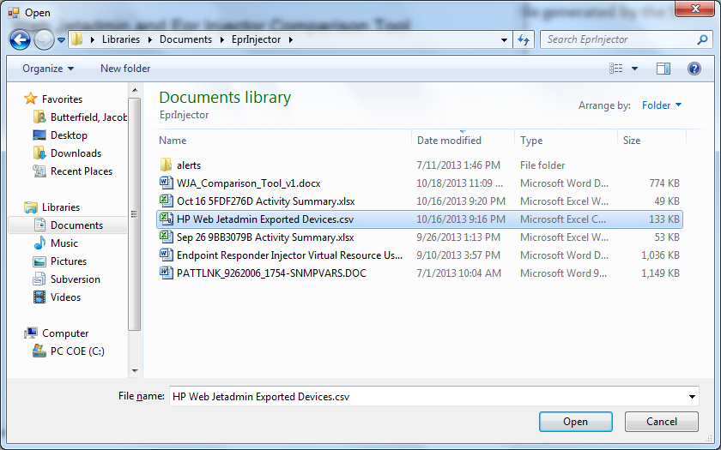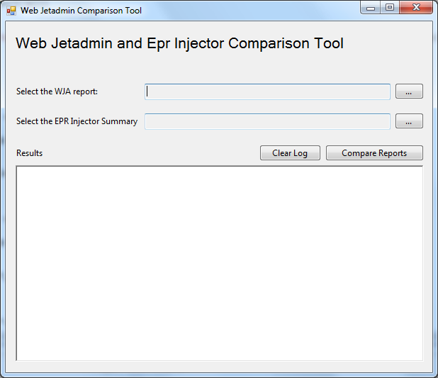

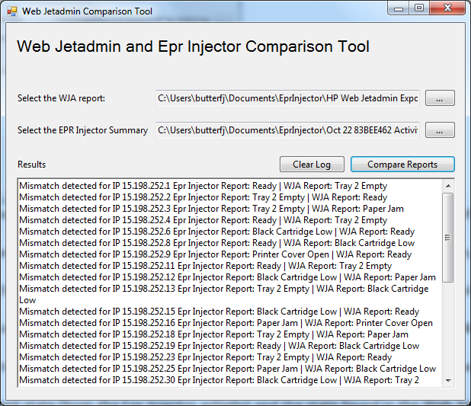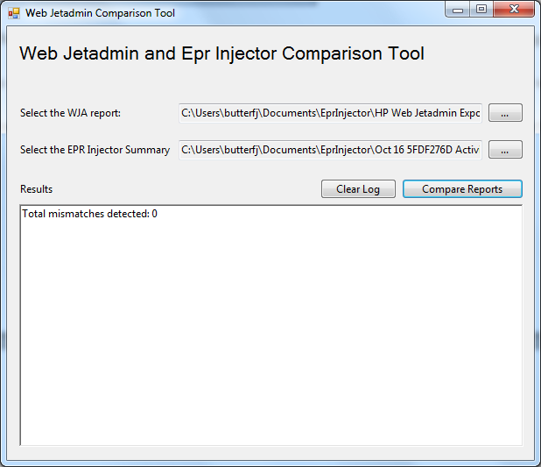Now that both reports have been entered, we’ll select the button labeled “Compare Reports.” The results will be logged in the textbox labeled “Results.” In our comparison, there were no mismatches detected, this means that Web Jetadmin caught every alert sent by the Epr Injector. When mismatches are detected, the IP address of the endpoint responder will be logged with its expected state and actual state.

**How It Works**

The tool works by going through the EPR Injector activity summary and getting the LATEST state injected into each endpoint responder. This means that if the test has multiple iterations, the tool will only use the LAST state for each endpoint responder. From there the tool will take the collection of unique endpoint responders found in the Activity Summary and compare them to the Web Jetadmin Exported Devices by their statuses. When a discrepancy is found, a line is output to the logger by IP address that gives the expected state (from the Epr Injector activity) and the state found in the Web Jetadmin report.

**Troubleshooting**

A few errors are likely to occur if this guide is not followed properly. Whenever an error is encountered in the input file, an error will be logged to the console. If a column is missing from a report, it will be logged to the console. If only a few are found or if a number of states from the Web Jetadmin report say ready, the user may have exported the Web Jetadmin report too soon, meaning that WJA did not finish detecting the state all of the devices. In this case, we may want to generate another report from WJA with current data. Also, it’s possible that we confused the two reports, so we should double check to make sure that the Web Jetadmin report was selected first.

