- Our story

Every freshman knows ModCon can be the most horrible abomination ever to disgrace the Earth. More than one breadboard has been flung across AC414 with an accompanying 'circuits hate me!' Living on the edge of a spiral of knowledge is tough, and professors sometimes forget how little we know. We in SoftDesign think that a lot of that pain can be avoided with help from some good software.
We thought of a few ways of alleviating this miserable plight. One, which we liked initially,was compiling a database that would contain all of the information about ModCon one would need, such as op-amp diagrams, oscilloscope tips, resistor bar translation, and so on. We would then connect that database to a UI that would be simple enough for frustrated, emotional freshmen. However, the idea of building our project on data gathering was not enough Software or enough Design for any of us. We decided to focus on our second idea, a circuit simulator.
We moved on to the idea of making a circuit simulator that could handle just about anything we could throw at it: resistors, capacitors, op-amps, accelerometers, you name it, we got it. It was at that point that we decided upon our current GUI, a drag-and-drop interface that looked real. This kind of program would mirror what a student would be doing in the real world, and help that student identify errors in their circuit, predict behavior, and hint at broken components. We realized that one of the most signficant challenges would be the circuit calculations, which can be absurdly complicated and exponentially increase in difficulty with the number of components involved. After discussion with Allen, we realized that those calculations, too, are not really software design—they are just math and electrical engineering. As such, we decided to recruit third-party software to do our calculations for us, freeing us from horrible math and allowing us to do mostly work on the GUI and creating a rich spectrum of circuit components.
That's our project's story in a nutshell. The next decisions we made were on our class structure, essentially answering the question 'How the hell do we code a breadboard?' The next section gives the highlights of our discussions on how we can code the class structure.

- UML Diagram
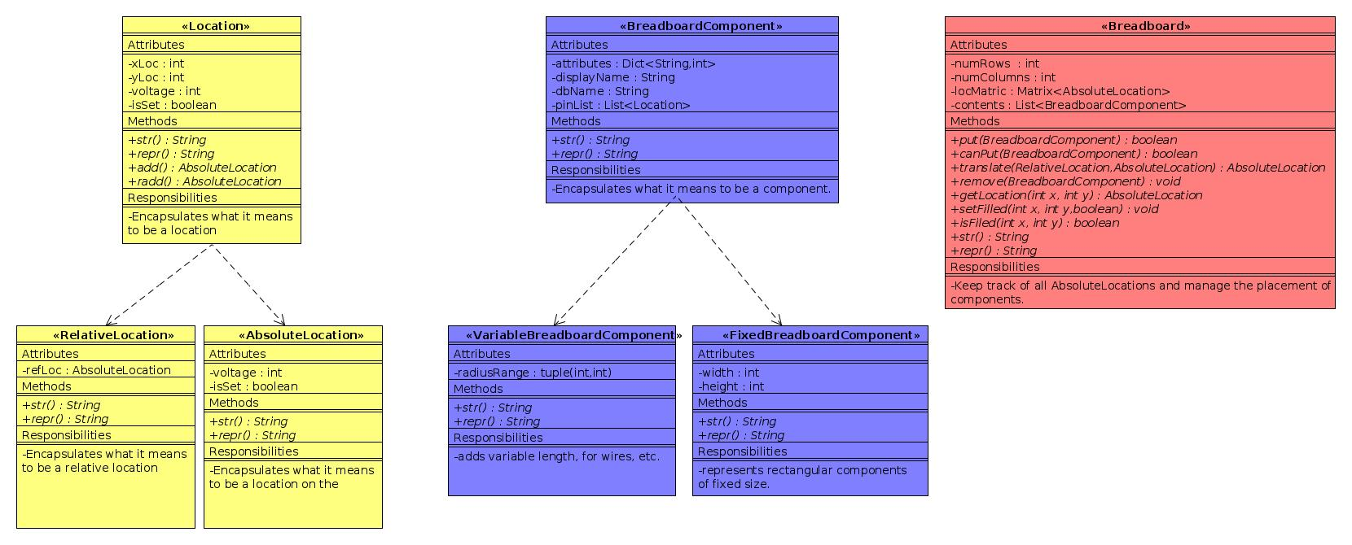
- Development plan

We have accomplished a considerable amount so far and have a solid plan for the future. We have settled on a concrete, realistic goal: we want a user-friendly ModCon and RWM circuit simulator. We have also settled on a minimum deliverable, which is a drag-and-drop interface that is able to check if a circuit is closed. This minimum deliverable would be able to handle drag resistors, capacitors, and wires onto a full-sized breadboard. A better program would incorporate other components such as op-amps, LEDs, inductors, and speakers, plus provide a host of other functions such as error analysis and AC simulation.
We have decided that our actual circuit calculations should be done by third-party software, and we did a considerable amount of research on simulation programs such as Spice, LTSpice, and GnuCap. Eventually, we settled on GnuCap because we feel it is the most useful. We are currently researching how that program works and are working on the interface between our Python code and
GnuCap. In the future we will continue our understanding of GnuCap and design an interface that is compatible with our class and object structure.
As for our Python code, we decided on a class structure with three major classes: Breadboard, BreadboardComponent, and Location. Unsurprisingly, the Breadboard class will consist of a matrix of Locations on which BreadboardComponents can be placed. Locations are split into Absolute and Relative, the latter of which regards position relative to some reference, for example one master pin on a component. We also decided to have two major subclasses within components, which are variable and fixed. These two represent the different types of component a budding EE would experience, fixed-size components, like an op-amp or other printed silicon, and variable-sized components, like a resistor that can easily be cut and bent into different lengths. All components are placed on the breadboard at a reference Location, and the other pin Location are either decided by geometry (in the case of fixed-size) or user input to another. Future work in the class and object definitions will involve making versatile, GUI-friendly decisions that allow for easy manipulation of components.
Finally, we also decided on a simple GUI that focuses on dragging-and-dropping components from one part of a screen (a toolbox) onto the breadboard. The coding for that will be done for WX widget. Our goal is to make it realistic looking and easy to understand, meeting our users' needs. The future of the GUI is research on WX widget and coding a program that is accessible. We will most likely do a lot of testing to ensure that the program runs without bugs and is clear.
Since this work is split into three distinct groups, we are splitting into subteams. The GUI is being tackled by Cory and Margaret-Ann (henceforward called 'Mann'). Dan will take the lead on class and object definitions, and Brittany and Noam will focus on researching GnuCap and designing and ideal interface.
One might wonder how this split in the team will lead to compartmenting and poor communication. To fight this, we have scheduled many meetings in which we will have open discussions such that every person will always be up to speed on what the other groups have done. We will make all major decisions as a team. Furthermore, all files are easily accessible by everyone from the shared Git repository and a Dropbox, and all codes will be heavily commented. We are all committed to understanding the whole project and will actively fight being segmented.

