Minch's Magic Storey Land Design Proposal
<projectProposal>
Members:
Dan Kearney, Margaret-Ann Seger, Cory Dolphin, Noam Rubin, Brittany Strachota
Project:
Breadboard Emulator which will provide an easy-to-use UI for introductory circuit building and analysis. The key feature that distinguishes our project from Simulink/ LabView is the fact that connections are implicit to the breadboard itself, rather than manually created such as in Simulink. Hence we will only be dealing with components (resistors, opAmps, wires etc.). Our goal for the project is to create a lasting usable tool for beginning circuit designers. One important component of this goal is to create an easily expendable framework. We intend to collaborate with Brad Minch and Brian Storey.
Minimum deliverable:
We would like to have, at minimum, a drag and drop interface to check if a given circuit is closed or not.
Maximum deliverable:
A clean, intuitive user interface which provides users the ability to virtually build and analyze circuits; providing information regarding frequency response of the system, error calculations, and oscilloscope capabilities. An indication of whether we have succeeded in the maximum deliverable would be the ability of this software to aid in the correct completion of all of the labs from ModCon 1.
First Step:
We need to learn spice, as we intend to use spice to aid us in the circuit analysis aspect of this project. Next, we need to design our basic objects and class structures, as well as decide how we want objects to interact with each other.
Biggest Problem:
We foresee difficulties in meshing our code with spice code that we will need to analyze the circuitry.
</projectProposal>

<designProposal>
- Our story
Many of the difficulties freshmen ModCon students face are wrapped up in the issues relating to the building, planning and debugging of breadboard circuits. In an attempt to enhance freshmen's experience and learning in ModCon, we aim to alleviate the issues many freshmen face, allowing them to concentrate on the elements even more fundamental to ModCon: modeling, controlling, and building circuits, properly.
Our idea is to make a very simple circuit simulator that can handle all of the circuits that freshmen are asked to complete. It would differ from popular programs such as LTSpice, Spice, pSpice, etc, by incorporating the fundamental connections present on a breadboard, and providing a simple, clean, and easy to use interface that is useful for ModCon. In this vein, we plan to design using our knowledge of ModCon and in collaboration with Brad Minch and Brian Storey, aiming to understand what they see as areas where there could be improvement.
That's our project's story in a nutshell. The next decisions we made were on our class structure, essentially answering the question 'How the hell do we code a breadboard?' The next section gives the highlights of our discussions on how we can code the class structure.

- UML Diagram
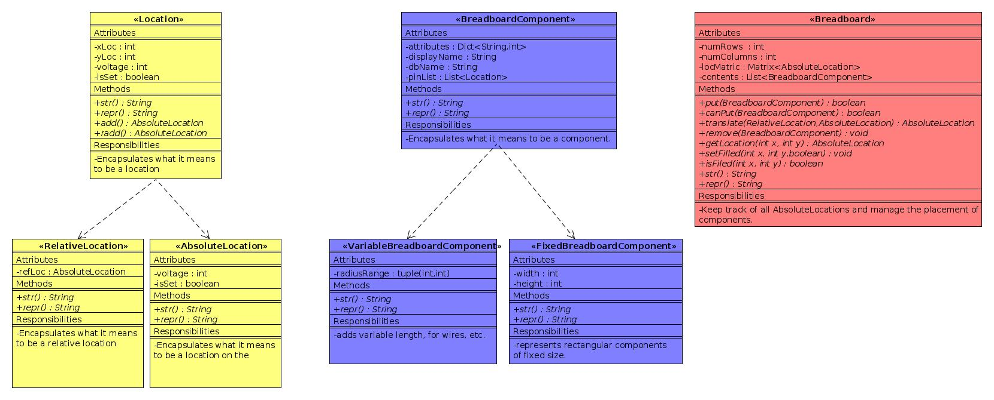
- Development plan

We have accomplished a considerable amount so far and have a solid plan for the future. We have settled on a concrete, realistic goal: we want a user-friendly ModCon and RWM circuit simulator. We have also settled on a minimum deliverable, which is a drag-and-drop interface that is able to check if a circuit is closed. This minimum deliverable would be able to handle drag resistors, capacitors, and wires onto a full-sized breadboard. A better program would incorporate other components such as op-amps, LEDs, inductors, and speakers, plus provide a host of other functions such as error analysis and AC simulation.
We have decided that our actual circuit calculations should be done by third-party software, and we did a considerable amount of research on simulation programs such as Spice, LTSpice, and GnuCap. Eventually, we settled on GnuCap because we feel it is the most useful. We are currently researching how that program works and are working on the interface between our Python code and
GnuCap. In the future we will continue our understanding of GnuCap and design an interface that is compatible with our class and object structure.
As for our Python code, we decided on a class structure with three major classes: Breadboard, BreadboardComponent, and Location. Unsurprisingly, the Breadboard class will consist of a matrix of Locations on which BreadboardComponents can be placed. Locations are split into Absolute and Relative, the latter of which regards position relative to some reference, for example one master pin on a component. We also decided to have two major subclasses within components, which are variable and fixed. These two represent the different types of component a budding EE would experience, fixed-size components, like an op-amp or other printed silicon, and variable-sized components, like a resistor that can easily be cut and bent into different lengths. All components are placed on the breadboard at a reference Location, and the other pin Location are either decided by geometry (in the case of fixed-size) or user input to another. Future work in the class and object definitions will involve making versatile, GUI-friendly decisions that allow for easy manipulation of components.
Finally, we also decided on a simple GUI that focuses on dragging-and-dropping components from one part of a screen (a toolbox) onto the breadboard. The coding for that will be done for WX widget. Our goal is to make it realistic looking and easy to understand, meeting our users' needs. The future of the GUI is research on WX widget and coding a program that is accessible. We will most likely do a lot of testing to ensure that the program runs without bugs and is clear.
Since this work is split into three distinct groups, we are splitting into subteams. The GUI is being tackled by Cory and Margaret-Ann (henceforward called 'Mann'). Dan will take the lead on class and object definitions, and Brittany and Noam will focus on researching GnuCap and designing and ideal interface.
One might wonder how this split in the team will lead to compartmenting and poor communication. To fight this, we have scheduled many meetings in which we will have open discussions such that every person will always be up to speed on what the other groups have done. We will make all major decisions as a team. Furthermore, all files are easily accessible by everyone from the shared Git repository and a Dropbox, and all codes will be heavily commented. We are all committed to understanding the whole project and will actively fight being segmented.
</designProposal>

