 

## VEHICLE DETECTOR

##### A MINI PROJECT REPORT

***Submitted by***

**Kumaran KM (211418104132) Naveen S R (211418104172)**

**Pradeish C (211418104196)**

***in partial fulfillment for the award of the degree of***

**BACHELOR OF ENGINEERING**

**IN**

##### COMPUTER SCIENCE AND ENGINEERING PANIMALAR ENGINEERING COLLEGE, CHENNAI - 600123.

**ANNA UNIVERSITY: CHENNAI 600 025**

**APRIL 2021**

**BONAFIDE CERTIFICATE**

**Certified that this project report “VEHICLE DETECTOR”** is the bonafide work of “**KUMARAM KM (211418104132), NAVEEN S R (211418104172),**

**PRADEISH C (211418104196)”** who carried out the project work under my supervision.

##### SIGNATURE SIGNATURE

**Dr.S.MURUGAVALLI,M.E.,Ph.D., MR.S.SUBBURAJ,M.E HEAD OF THE DEPARTMENT ASSISTANT PROFESSOR** DEPARTMENT OF CSE, DEPARTMENT OF CSE,

PANIMALAR ENGINEERING COLLEGE PANIMALAR ENGINEERING COLLEGE NAZARATHPETTAI, NAZARATHPETTAI,

POONAMALLEE, POONAMALLEE,

CHENNAI-600 123. CHENNAI-600 123.

##### Certified that the above candidates were examined in the Anna University Mini Project Examination held on...........................

**INTERNAL EXAMINER EXTERNAL EXAMINER**

**ACKNOWLEDGEMENT**

We express our deep gratitude to our respected Secretary and Correspondent **Dr.P.CHINNADURAI, M.A., Ph.D**. for his kind words and enthusiastic motivation, which inspired us a lot in completing this project.

We would like to extend our heartfelt and sincere thanks to our Directors **Tmt.C.VIJAYARAJESWARI, Thiru.C.SAKTHIKUMAR, M.E.,** and

**Tmt. SARANYASREE SAKTHIKUMAR B.E., M.B.A.,** for providing us with the necessary facilities for the completion of this project.

We also express our gratitude to our Principal **Dr.K.MANI, M.E., Ph.D**. for his timely concern and encouragement provided to us throughout the course.

We thank the HOD of the CSE Department, **Dr. S.MURUGAVALLI, M.E., Ph.D.** for the support extended throughout the project.

We would like to thank our **Project Guide Mr.S.SUBBURAJ, M.E.**, and all the faculty members of the Department of CSE for their advice and suggestions for the successful completion of the project.

### KUMARAN KM NAVEEN S R PRADEISH C

**ABSTRACT**

Vehicle Detector is an application that helps the owners to track their vehicle when they get lost by using the vehicle’s unique information. Our main goal is to provide the owners with a searching facility across the city using a Public Camera, GPS, and mobile capturing technique without raising the complaint to the cop. In this system, the user can share their vehicle’s identity and it will be stored on the user database. When the vehicle gets lost, the owner can ping on this platform about the vehicle lost. On the other side, data gets fetched and stored on a common database. If the information in both of these databases gets matched, the user/owner will receive a notification with an exact location, or else they can wait until it gets found. If there are any vehicle server vehicle issues successes or fraudulent information, then this whole system is taken care of by the admin. Hence this platform made the owners find the vehicle without any police complaints.

### TABLE OF CONTENTS

**CHAPTER NO. TITLE PAGE NO.**

**ABSTRACT**

**LIST OF TABLE LIST OF FIGURES**

**LIST OF ABBREVIATIONS**

1. **INTRODUCTION**
   1. **Overview**
   2. **Problem Definition**
2. **LITERATURE SURVEY**
3. **SYSTEM ANALYSIS**
   1. **Existing System**
   2. **Proposed system**
   3. **Requirement Analysis and Specification**
      1. **Input Requirements**
      2. **Output Requirements**
      3. **Functional Requirements**
   4. **Software Environment**
   5. **Software Description**
4. **SYSTEM DESIGN**

**4.1. ER diagram**

* 1. **Data flow diagram**
  2. **UML Diagrams**
     1. **Use Case diagram**
     2. **Sequence diagram**

1. **SYSTEM ARCHITECTURE**
   1. **Architecture Overview**
      1. **Owner’s Page Architecture**
      2. **Helper’s Page Architecture**
      3. **Artificial Intelligence architecture**
      4. **Finder Page Architecture**
      5. **Vehicle Searching Architecture**
2. **SYSTEM IMPLEMENTATION**
   1. **Google API**
      1. **Getting Sheet Spi**
      2. **Getting Credentials**
      3. **Implementing API In Project**
3. **SYSTEM TESTING**
   1. **Unit Testing**
      1. **White box testing**
      2. **Black box testing**
   2. **Integration Testing**
   3. **Test Cases & Reports / Performance Analysis**
4. **CONCLUSION**
   1. **Performance analysis report**
   2. **Future Enhancements APPENDICES**
   3. **Sample Screens**
   4. **Coding REFERENCES**

#### LIST OF FIGURES

|  |  |  |
| --- | --- | --- |
| **FIG NO.** | **FIGURE DESCRIPTION** | **PAGE**  **NO.** |
| **Chapter No.x**  **Eg. 3.1** |  |  |
| **4.1** |  |  |
| **…** |  |  |
|  |  |  |
|  |  |  |

**CHAPTER 1**

# INTRODUCTION

### INTRODUCTION

##### OVERVIEW

A vehicle detector is a web application that is created to solve the vehicle loss issue which is happening around the country. In this, we have used certain techniques like image capturing, image detection, etc to solve this issue. First, the data is

collected from the user at the stage of registration and it gets stored on a separate user

database. The data collected from the users includes vehicle color, vehicle registration number, vehicle brand name, vehicle dent marks, etc. On the other hand, the data of lost vehicles is collected by using mobile, public cameras, etc and it will get stored on the lost database. Once the data is collected, It will get processed by the admin. And if the user’s vehicle gets lost, they can make a ping on our application. Based on the data fetched from the user at the time of registration we will sort the data with the lost database. If these two databases get matched then the notification will be sent to the user with the exact location.

### Problem Definition

In India, whenever the vehicle gets lost the owners will go for a cop and raise complaints regarding the issue. The data is collected from the user in the form of papers or First Information Report. And based on the collected data, cops will arrive at certain places and do an investigation regarding this. After some period of investigation, they will conclude that the vehicle might get lost in this specific location. This is the exact scenario happening around the country which consumes a lot of time and effort. Apart from that most of the cases are getting closed because the cop wasn't able to find the clue of the vehicle lost. This may turn into a major issue

and owners are not getting satisfied with this system. To avoid these, we can turn this system online. Instead of giving the data to the cop, they can provide it to certain platforms online. And instead of doing investigations, they can use technology to solve this kind of issue. This can save a lot of time and effort which is taken by the cop. In this, the images are fetched from the resource online and it is managed by the admin. So that we don't need any clues from the owners. We can just match the features with the images which we have got through certain resources and we will notify the user, once their features get matched with our fetched images.

# CHAPTER-2 LITERATURE SURVEY

### LITERATURE SURVEY

**Title**: A Survey of Deep Learning-based Object Detection. [1]

**Year**: 2019.

**Authors**: Licheng Jiao, Fellow, IEEE, Fan Zhang, Fang Liu, Senior Member, IEEE, Shuyuan Yang, Senior Member, IEEE, Lingling Li, Member, IEEE, Zhixi Feng, Member, IEEE, and Rong Qu, Senior Member, IEEE.

Object detection is one of the most important and challenging branches of computer vision, which has been widely applied in people’s lives, such as monitoring security, autonomous driving, and so on, to locate instances of semantic objects of a certain class. With the rapid development of deep learning networks for detection tasks, the performance of object detectors has been greatly improved. To understand the main development status of the object detection pipeline, thoroughly and deeply, in this survey, we first analyze the methods of existing typical detection models and describe the benchmark datasets. Afterward and primarily, we provide a comprehensive overview of a variety of object detection methods in a systematic manner, covering the one-stage and two-stage detectors. Moreover, we list the traditional and new applications. Some representative branches of object detection are analyzed as well.

Finally, we discuss the architecture of exploiting these object detection methods to build an effective and efficient system and point out a set of development trends to better follow the state-of-the-art algorithms and further research. Object detection has been attracting an increasing amount of attention in recent years due to its wide range of applications and recent technological breakthroughs. This task is under extensive investigation in both academia and real-world applications, such as monitoring security, autonomous driving, transportation surveillance, drone scene analysis, and robotic vision. Among many factors and efforts that lead to the fast evolution of object

detection techniques, notable contributions should be attributed to the development of deep convolutional neural networks and GPUs computing power. At present, the deep learning model has been widely adopted in the whole field of computer vision, including general object detection and domain-specific object detection. Most of the state-of-the-art object detectors utilize deep learning networks, their backbone, and detection network to extract features from input images (or videos), classification, and localization respectively. Object detection is a computer technology related to computer vision and image processing that deals with detecting instances of semantic objects of a certain class(such as humans, buildings, or cars) in digital images and videos. Well-researched domains of object detection include multi-categories detection, edge detection, salient object detection, pose detection, scene text detection, face detection, and pedestrian detection, etc. As an important part of scene understanding, object detection has been widely used in many fields of modern life, such as the security field, military field, transportation field, medical field, and life field. Furthermore, many benchmarks have played an important role in the object detection field so far, such as Caltech, KITTI, ImageNet, PASCAL VOC, MS COCO, and Open Images V5. In the ECCV VisDrone 2018 contest, organizers have released a novel drone platform-based dataset which contains a large number of images and videos.

##### Two kinds of object detectors:

Pre-existing domain-specific image object detectors usually can be divided into two categories, the one is a two-stage detector, the most, SSD. Two-stage detectors have high localization and object recognition accuracy, whereas the one-stage detectors achieve high inference speed. The two stages of two-stage detectors can be divided by the RoI (Region of Interest) pooling layer. For instance, in Faster R-CNN, the first stage, called RPN, a region Proposal Network, proposes candidate object

bounding boxes. In the second stage, features are extracted by RoIPool(RoI Pooling) operation from each candidate box for the following classification and bounding-box regression tasks.

##### BACKBONE NETWORKS:

The backbone network is acting as the basic feature extractor for object detection tasks which takes images as input and output feature maps of the corresponding input image. Most backbone networks for detection are the network for classification tasks taking out the last fully connected layers. The improved version of the basic classification network is also available. For Instance, add or subtract layers or replace some layers with specially designed layers. To better meet specific requirements, some works utilize the newly designed backbone for feature extraction. Towards different requirements about accuracy vs. efficiency, people can choose deeper and densely connected backbones, like ResNet, ResNeXt, AmoebaNet, or lightweight backbones like MobileNet, ShuffleNet, SqueezeNet, Xception, MobileNetV2. When applied to mobile devices, lightweight backbones can meet the requirements. Wang et al. propose a novel real-time object detection system by combining PeleeNet with SSD and optimizing the architecture for fast processing speed. To meet the needs of high precision and more accurate applications, complex backbones are needed. On the other hand, real-time acquirements like video or webcam require not only high processing speed but high accuracy, which needs a

well-designed backbone to adapt to the detection architecture and make a trade-off between speed and accuracy. To explore more competitive detecting accuracy, a deeper and densely connected backbone is adopted to replace the shallower and sparse connected counterpart. He et al. utilize ResNet rather than VGG to capture rich features which are adopted in Faster R-CNN for further accuracy gain because of its

high capacity. The newly high-performance classification networks can improve precision and reduce the complexity of object detection tasks. This is an effective way to further improve network performance because the backbone network acts as a feature extractor.

##### TYPICAL BASELINES:

With the development of deep learning and the continuous improvement of computing power, great progress has been made in the field of general object detection. When the first CNN-based object detector R-CNN was proposed, a series of significant contributions were made which promoted the development of general object detection by a large margin.

##### Two-stage Detectors

* + R-CNN
  + Fast R-CNN
  + Faster R-CNN
  + Mask R-CNN

##### One-stage Detectors

* + YOLO
  + YOLOv2
  + YOLOv3
  + SSD
  + DSSD
  + RetinaNet
  + M2Det
  + RefineDet

##### Latest Detectors

* + Relation Networks for Object Detection
  + DCNv2
  + NAS-FPN

##### DATASETS AND METRICS:

Detecting an object has to state that an object belongs to a specified class and locate it in the image. The localization of an object is typically represented by a bounding box. Using challenging datasets as benchmarks is significant in many areas of research because they can draw a standard comparison between different algorithms and set goals for solutions. Early algorithms focused on face detection using various ad hoc datasets. Later, more realistic and challenging face detection datasets were created. Another popular challenge is the detection of pedestrians for which several datasets have been created. The Caltech PedestrianDataset contains 350,000 labeled instances with bounding boxes. General object detection datasets like PASCAL VOC[, MS COCO, ImageNet-loc are the mainstream benchmarks of object detection tasks. The off tasks metrics are mainly adopted to measure the performance of detectors corresponding with the corresponding dataset.

##### ANALYSIS OF GENERAL IMAGE OBJECT DETECTION METHODS:

Deep neural network-based object detection pipelines have four steps in general, image pre-processing, feature extraction, classification and localization, and post-processing. Firstly, raw images from the dataset can be fed into the network directly. Therefore, we need to resize them to any special sizes and make them clearer, such as enhancing brightness, color, contrast. Data augmentation is also available to

meet some requirements, such as flipping, rotation, scaling, cropping, translation, and adding Gaussian noise. In addition, GANs (generative adversarial networks) can generate new images to enrich the diversity of input according to people’s needs. For more details about data augmentation, please refer to for more details. Secondly, feature extraction is a key step for further detection. The feature quality directly determines the upper bound of subsequent tasks like classification and localization. Thirdly, the detector head is responsible to propose and refine the bounding box concluding classification scores and bounding box coordinates. Fig. 1 illustrates the basic procedure of the second and the third step. At last, the post-processing step deletes any weak detecting results. For example, NMS is a widely used method in which the highest-scoring object deletes its nearby objects with inferior classification scores. To obtain precise detection results, there exist several methods that can be used alone or in combination with other methods.

**Title**: Faster R-CNN: Towards Real-Time ObjectDetection with Region Proposal Networks. [2]

**Year**: 2016.

**Authors**: Shaoqing Ren, Kaiming He, Ross Girshick, and Jian Sun.

##### Faster R-CNN:

State-of-the-art object detection networks depend on region proposal algorithms to hypothesize object locations. Advances like SPPnet and Fast R-CNN have reduced the running time of these detection networks, exposing region proposal computation as a bottleneck. In this work, we introduce Region Proposal Network(RPN) that shares full-image convolutional features with the detection network, thus enabling nearly cost-free region proposals. An RPN is a fully convolutional network that

simultaneously predicts object bounds and objectness scores at each position. The RPN is trained end-to-end to generate high-quality region proposals, which are used by Fast R-CNN for detection. We further merge RPN and Fast R-CNNinto a single network by sharing their convolutional features—using the recently popular terminology of neural networks with“attention” mechanisms, the RPN component tells the unified network where to look. For the very deep VGG-16 model, our detection system has a frame rate of 5fps (including all steps) on a GPU, while achieving state-of-the-art object detection accuracy on PASCAL VOC 2007, 2012, and MS COCO datasets with only 300 proposals per image. In ILSVRC and COCO2015 competitions, Faster R-CNN and RPN are the foundations of the 1st-place winning entries in several tracks. Code has been made publicly available.

**Title**: YOLOv4: Optimal Speed and Accuracy of Object Detection. [3]

**Year**: 2020.

**Authors**: Alexey Bochkovskiy, Chien-Yao Wang, Hong-Yuan Mark Liao.

##### YOLOv4:

There are a huge number of features that are said to improve Convolutional Neural Network (CNN) accuracy. Practical testing of combinations of such features on large datasets, and theoretical justification of the result, is required. Some features operate on certain models exclusively for certain problems, or only for small-scale datasets; while some features, such as batch normalization and residual connections, apply region to the majority of models, tasks, and datasets. We assume that such universal features include Weighted-Residual-Connections (WRC), Cross-Stage-Partial-connections (CSP), Cross mini-BatchNormalization (CmBN), Self-adversarial-training (SAT), and Mish-activation. We use new features: WRC,

CSP, CmBN, SAT, Mish activation, Mosaic data augmentation, CmBN, DropBlock regularization, and CIoU loss, and combine some of them to achieve state-of-the-art results: 43.5%AP (65.7% AP50) for the MS COCO dataset at a real-time speed of∼65 FPS on Tesla V100.tasks tasks Regional.

# CHAPTER-3 SYSTEM ANALYSIS

#### SYSTEM ANALYSIS

##### Existing System

Every day on average 209 vehicles are getting lost in India. It may be due to theft or sometimes due to the owner's fault. In the existing one, images are recorded by using CCTV cameras but still the project didn’t get implemented due to the inconvenient use of CCTV in our country.

##### Proposed System

To overcome this, we use the capturing technique from unknown users and will sort the vehicle based on the unique information and we will send an alert to the owners. In this, we will collect the database of the user’s vehicle information like color, scratches, seat color, dent marks, etc. And if the user’s vehicle is getting lost, we could track it with our intelligence software. We used capturing technique from the mobile, public cam,

##### REQUIREMENTS ANALYSIS AND SPECIFICATIONS

The requirement engineering process of the feasibility study, requirements elicitation and analysis, requirements specifications, requirements validation, and requirements management. Requirements elicitation and analysis is an iterative process that can be represented as a spiral of activities, namely requirements discovery, requirements classification and organization, requirements negotiation, and requirements documentation. tasks

##### INPUT REQUIREMENTS

The basic input requirements include a stable internet connection with a suitable system, and the browser to work on web applications. On the other hand, we need a source like CCTV, camera, for capturing the images to match the requirements.

##### OUTPUT REQUIREMENTS

The output requirements include a full-fledged computer system for doing interaction and the mail account signed up on any of the popular mail service platforms to send a notification regarding the vehicle lost.

##### FUNCTIONAL REQUIREMENTS

The functional requirements needed to implement this projects are the location data that needs to be sent and stored in the cloud for quick access and the stable electricity to run the server 24/7 and some pre-installed software to work on with the system.

##### SOFTWARE ENVIRONMENT

* Operating System: Windows | Linux | Mac | any other stable operating system
* Languages used: Python, HTML, CSS, Javascript
* Tools: Visual Studio Code, Colab, NPM, Google Cloud Platform.
* Frameworks: Bootstrap, Tensorflow, Keras.
* DataBase: Google Sheet.
* Web Hosting: GitHub pages.

##### SOFTWARE DESCRIPTION

**Python:**



Python is an interpreted, object-oriented, high-level programming language with dynamic semantics. Its high-level built-in data structures, combined with dynamic typing and dynamic binding, make it very attractive for Rapid Application Development, as well as for use as a scripting or glue language to connect existing components. Python's simple, easy-to-learn syntax emphasizes readability and therefore reduces the cost of program maintenance. Python supports modules and packages, which encourages program modularity and code reuse. The Python interpreter and the extensive standard library are available in source or binary form without charge for all major platforms and can be freely distributed.

Often, programmers fall in love with Python because of the increased productivity it provides. Since there is no compilation step, the edit-test-debug cycle is incredibly fast. Debugging Python programs is easy: a bug or bad input will never cause a segmentation fault. Instead, when the interpreter discovers an error, it raises an exception. When the program doesn't catch the exception, the interpreter prints a stack

trace. A source-level debugger allows inspection of local and global variables, evaluation of arbitrary expressions, setting breakpoints, stepping through the code a line at a time, and so on. The debugger is written in Python itself, testifying to Python's introspective power. On the other hand, often the quickest way to debug a program is to add a few print statements to the source: the fast edit-test-debug cycle makes this simple approach very effective.

##### HTML:



HTML, in a full hypertext markup language, a formatting system for displaying material retrieved over the [Internet](https://www.britannica.com/technology/Internet). Each retrieval unit is known as a Web page (from [World Wide Web](https://www.britannica.com/topic/World-Wide-Web)), and such pages frequently contain [hypertext](https://www.britannica.com/technology/hypertext) links that allow related pages to be retrieved. HTML is the [markup language](https://www.britannica.com/technology/markup-language) for encoding Web pages. It was designed by the British scientist [Sir Tim Berners-Lee](https://www.britannica.com/biography/Tim-Berners-Lee) at the [CERN](https://www.britannica.com/topic/CERN) nuclear physics laboratory in Switzerland during the 1980s. HTML markup tags specify document elements such as headings, paragraphs, and tables. They mark up a document for display by a [computer program](https://www.britannica.com/technology/computer-program) known as a Web [browser](https://www.britannica.com/technology/browser). The browser interprets the tags, displaying the headings, paragraphs, and tables in a layout that is adapted to the screen size and fonts available to it.

HTML has always been the fundamental language used to develop web pages. Interestingly, while [websites](https://techterms.com/definition/website) have become more advanced and interactive, HTML has gotten simpler. If you compare the [source](https://techterms.com/definition/sourcecode) of an HTML5 page with a similar page

written in HTML 4.01 or [XHTML](https://techterms.com/definition/xhtml) 1.0, the HTML5 page would probably contain less code. This is because modern HTML relies on [cascading style sheets](https://techterms.com/definition/css) or [JavaScript](https://techterms.com/definition/javascript) to format nearly all the elements within a page.

##### CSS:



Cascading Style Sheets (CSS) is a [style sheet language](https://en.wikipedia.org/wiki/Style_sheet_language) used for describing the [presentation](https://en.wikipedia.org/wiki/Presentation_semantics) of a document written in a [markup language](https://en.wikipedia.org/wiki/Markup_language) such as [HTML](https://en.wikipedia.org/wiki/HTML). CSS is a cornerstone technology of the [World Wide Web](https://en.wikipedia.org/wiki/World_Wide_Web), alongside HTML and [JavaScript](https://en.wikipedia.org/wiki/JavaScript).

CSS is designed to enable the separation of presentation and content, including [layout](https://en.wikipedia.org/wiki/Page_layout), [colors](https://en.wikipedia.org/wiki/Color), and [fonts](https://en.wikipedia.org/wiki/Typeface). This separation can improve content [accessibility](https://en.wikipedia.org/wiki/Accessibility), provide more flexibility and control in the specification of presentation characteristics, enable multiple [web pages](https://en.wikipedia.org/wiki/Web_page) to share formatting by specifying the relevant CSS in a separate

.css file which reduces complexity and repetition in the structural content as well as enabling the .css file to be [cached](https://en.wikipedia.org/wiki/Cache_(computing)) to improve the page load speed between the pages that share the file and its formatting.

Separation of formatting and content also makes it feasible to present the same markup page in different styles for different rendering methods, such as on-screen, in print, by voice (via speech-based browser or [screen reader](https://en.wikipedia.org/wiki/Screen_reader)), and on [Braille-based](https://en.wikipedia.org/wiki/Braille_display) tactile devices. CSS also has rules for alternate formatting if the content is accessed on a [mobile device](https://en.wikipedia.org/wiki/Mobile_device).

The name cascading comes from the specified priority scheme to determine

which style rule applies if more than one rule matches a particular element. This cascading priority scheme is predictable.

The CSS specifications are maintained by the [World Wide Web Consortium](https://en.wikipedia.org/wiki/World_Wide_Web_Consortium) (W3C). Internet media type ([MIME type](https://en.wikipedia.org/wiki/MIME_media_type)) text/CSS is registered for use with CSS by RFC 2318 (March 1998). The W3C operates a free [CSS validation service](https://en.wikipedia.org/wiki/W3C_Markup_Validation_Service#CSS_validation) for CSS documents.

##### Javascript:



JavaScript often abbreviated as JS, is a [programming language](https://en.wikipedia.org/wiki/Programming_language) that conforms to the [ECMAScript](https://en.wikipedia.org/wiki/ECMAScript) specification. JavaScript is [high-level](https://en.wikipedia.org/wiki/High-level_programming_language), often [just-in-time compiled](https://en.wikipedia.org/wiki/Just-in-time_compilation), and [multi-paradigm](https://en.wikipedia.org/wiki/Programming_paradigm). It has [curly-bracket syntax](https://en.wikipedia.org/wiki/List_of_programming_languages_by_type#Curly-bracket_languages), [dynamic typing](https://en.wikipedia.org/wiki/Dynamic_typing), [prototype-based](https://en.wikipedia.org/wiki/Prototype-based_programming) object orientation, and [first-class functions](https://en.wikipedia.org/wiki/First-class_function).

Alongside [HTML](https://en.wikipedia.org/wiki/HTML) and [CSS](https://en.wikipedia.org/wiki/CSS), JavaScript is one of the core technologies of the [World Wide Web](https://en.wikipedia.org/wiki/World_Wide_Web). Over 97% of [websites](https://en.wikipedia.org/wiki/Website) use their [client-side](https://en.wikipedia.org/wiki/Client-side) for [web page](https://en.wikipedia.org/wiki/Web_page) behavior, often incorporating third-party [libraries](https://en.wikipedia.org/wiki/Library_(computing)). All major [web browsers](https://en.wikipedia.org/wiki/Web_browser) have a dedicated [JavaScript engine](https://en.wikipedia.org/wiki/JavaScript_engine) to execute the code on the [user](https://en.wikipedia.org/wiki/User_(computing))'s device.

As a multi-paradigm language, JavaScript supports [event-driven](https://en.wikipedia.org/wiki/Event-driven_programming), [functional](https://en.wikipedia.org/wiki/Functional_programming), and [imperative](https://en.wikipedia.org/wiki/Imperative_programming) [programming styles](https://en.wikipedia.org/wiki/Programming_paradigm). It has [application programming interfaces](https://en.wikipedia.org/wiki/Application_programming_interface) (APIs) for working with text, dates, [regular expressions](https://en.wikipedia.org/wiki/Regular_expression), standard [data structures](https://en.wikipedia.org/wiki/Data_structure), and the [Document Object Model](https://en.wikipedia.org/wiki/Document_Object_Model) (DOM).

The ECMAScript standard does not include any [input/output](https://en.wikipedia.org/wiki/Input/output) (I/O), such as [networking](https://en.wikipedia.org/wiki/Computer_network), [storage](https://en.wikipedia.org/wiki/Data_storage), or [graphics](https://en.wikipedia.org/wiki/Computer_graphics) facilities. In practice, the web browser or other [runtime system](https://en.wikipedia.org/wiki/Runtime_system) provides JavaScript APIs for I/O.

JavaScript engines were originally used only in web browsers, but they are now core components of [other](https://en.wikipedia.org/wiki/JavaScript#Other_usage) software systems, most notably [servers](https://en.wikipedia.org/wiki/Server_(computing)) and a variety of [applications](https://en.wikipedia.org/wiki/Application_software).

Although there are similarities between JavaScript and [Java](https://en.wikipedia.org/wiki/Java_(programming_language)), including language name, [syntax](https://en.wikipedia.org/wiki/Syntax_(programming_languages)), and respective [standard libraries](https://en.wikipedia.org/wiki/Standard_library), the two languages are distinct and differ greatly in design.

##### Colab:



Colaboratory is a data analysis tool that combines code, output, and descriptive text into one document (interactive notebook).

Colab provides GPU and is free. By using Google Colab, you can:

* Build your analytics products quickly in a standardized environment.
* Facilitates popular DL libraries on the go such as PyTorch, and TensorFlow
* Share code & results within your Google Drive
* Save copies and create playground modes for knowledge sharing
* Colab is runnable on the cloud or [local server with Jupyter](https://research.google.com/colaboratory/local-runtimes.html)

##### NPM:



Node.js is an [open-source](https://en.wikipedia.org/wiki/Open-source_software), [cross-platform](https://en.wikipedia.org/wiki/Cross-platform), [back-end](https://en.wikipedia.org/wiki/Front_end_and_back_end) [JavaScript](https://en.wikipedia.org/wiki/JavaScript) [runtime](https://en.wikipedia.org/wiki/Runtime_system) [environment](https://en.wikipedia.org/wiki/Runtime_system) that runs on the [V8 engine](https://en.wikipedia.org/wiki/V8_(JavaScript_engine)) and executes JavaScript code outside a [web](https://en.wikipedia.org/wiki/Web_browser) [browser](https://en.wikipedia.org/wiki/Web_browser). Node.js lets developers use JavaScript to write command-line tools and for [server-side scripting](https://en.wikipedia.org/wiki/Server-side_scripting)—running scripts server-side to produce [dynamic web page](https://en.wikipedia.org/wiki/Dynamic_web_page) content before the page is sent to the user's web browser. Consequently, Node.js represents a "JavaScript everywhere" paradigm, unifying web application development around a single programming language, rather than different languages for server-side and client-side scripts.

Though .js is the standard [filename extension](https://en.wikipedia.org/wiki/Filename_extension) for JavaScript code, the name "Node.js" doesn't refer to a particular file in this context and is merely the name of the product. Node.js has an [event-driven architecture](https://en.wikipedia.org/wiki/Event-driven_architecture) capable of [asynchronous I/O](https://en.wikipedia.org/wiki/Asynchronous_I/O). These design choices aim to optimize [throughput](https://en.wikipedia.org/wiki/Throughput) and [scalability](https://en.wikipedia.org/wiki/Scalability) in web applications with many input/output operations, as well as for [real-time Web](https://en.wikipedia.org/wiki/Real-time_Web) applications (e.g., [real-time](https://en.wikipedia.org/wiki/Real-time_communication) [communication](https://en.wikipedia.org/wiki/Real-time_communication) programs and [browser games](https://en.wikipedia.org/wiki/Browser_game)).

The Node.js [distributed development](https://en.wikipedia.org/wiki/Distributed_development) project was previously governed by the Node.js Foundation and has now merged with the [JS Foundation](https://en.wikipedia.org/wiki/JS_Foundation) to form the [OpenJS](https://en.wikipedia.org/wiki/OpenJS_Foundation) [Foundation](https://en.wikipedia.org/wiki/OpenJS_Foundation), which is facilitated by the [Linux Foundation](https://en.wikipedia.org/wiki/Linux_Foundation)'s Collaborative Projects program.

##### Google Cloud Platform:



Google Cloud Platform offers services for computing, storage, networking, [big](https://searchdatamanagement.techtarget.com/definition/big-data) [data](https://searchdatamanagement.techtarget.com/definition/big-data), machine learning, and the internet of things ([IoT](https://internetofthingsagenda.techtarget.com/definition/Internet-of-Things-IoT)), as well as cloud management, security, and developer tools.

Google Cloud consists of a set of physical assets, such as computers and hard disk drives, and virtual resources, such as virtual machines (VMs), that are contained in [Google's data centers](https://www.google.com/about/datacenters/) around the globe. Each data center location is in a *region*.

Regions are available in Asia, Australia, Europe, North America, and South America. Each region is a collection of *zones*, which are isolated from each other within the region. Each zone is identified by a name that combines a letter identifier with the name of the region. For example, zone a in the East Asia region is named asia-east1-a.

This distribution of resources provides several benefits, including redundancy in case of failure and reduced latency by locating resources closer to clients. This distribution also introduces some rules about how resources can be used together.

Some resources can be accessed by any other resource, across regions and zones.

These *global resources* include pre-configured disk images, disk snapshots, and networks. Some resources can be accessed only by resources that are located in the same region. These *regional resources* include static external IP addresses. Other resources can be accessed only by resources that are located in the same zone. These

*zonal resources* include VM instances, their types, and disks.

##### Tensorflow:



TensorFlow is Google Brain's second-generation system. Version 1.0.0 was released on February 11, 2017. While the [reference implementation](https://en.wikipedia.org/wiki/Reference_implementation) runs on single devices, TensorFlow can run on multiple [CPUs](https://en.wikipedia.org/wiki/Central_processing_unit) and [GPUs](https://en.wikipedia.org/wiki/GPU) (with optional [CUDA](https://en.wikipedia.org/wiki/CUDA) and [SYCL](https://en.wikipedia.org/wiki/SYCL) extensions for [general-purpose computing on graphics processing units](https://en.wikipedia.org/wiki/General-purpose_computing_on_graphics_processing_units)).

TensorFlow is available on 64-bit [Linux](https://en.wikipedia.org/wiki/Linux), [macOS](https://en.wikipedia.org/wiki/MacOS), [Windows](https://en.wikipedia.org/wiki/Windows), and mobile computing platforms including [Android](https://en.wikipedia.org/wiki/Android_(operating_system)) and [iOS](https://en.wikipedia.org/wiki/IOS).

Its flexible architecture allows for the easy deployment of computation across a variety of platforms (CPUs, GPUs, [TPUs](https://en.wikipedia.org/wiki/Tensor_processing_unit)), and from desktops to clusters of servers to mobile and edge devices.

TensorFlow computations are expressed as [stateful](https://en.wikipedia.org/wiki/State_(computer_science)) [dataflow](https://en.wikipedia.org/wiki/Dataflow_programming) [graphs](https://en.wikipedia.org/wiki/Directed_graph). The name TensorFlow derives from the operations that such neural networks perform on multidimensional data arrays, which are referred to as [*tensors*](https://en.wikipedia.org/wiki/Tensor). During the [Google I/O](https://en.wikipedia.org/wiki/Google_I/O) [Conference](https://en.wikipedia.org/wiki/Google_I/O) in June 2016, Jeff Dean stated that 1,500 repositories on [GitHub](https://en.wikipedia.org/wiki/GitHub) mentioned TensorFlow, of which only 5 were from Google.

##### Keras:



Keras is an [open-source](https://en.wikipedia.org/wiki/Open-source_software) [software](https://en.wikipedia.org/wiki/AI_software) library that provides a [Python](https://en.wikipedia.org/wiki/Python_(programming_language)) interface for [artificial neural networks](https://en.wikipedia.org/wiki/Artificial_neural_network). Keras acts as an interface for the [TensorFlow](https://en.wikipedia.org/wiki/TensorFlow) library.

Up until version 2.3, Keras supported multiple backends, including [TensorFlow](https://en.wikipedia.org/wiki/TensorFlow), [Microsoft Cognitive Toolkit](https://en.wikipedia.org/wiki/Microsoft_Cognitive_Toolkit), [Theano](https://en.wikipedia.org/wiki/Theano_(software)), and [PlaidML](https://en.wikipedia.org/wiki/PlaidML). As of version 2.4, only [TensorFlow](https://en.wikipedia.org/wiki/TensorFlow) is supported. Designed to enable fast experimentation with [deep](https://en.wikipedia.org/wiki/Deep_learning) [neural networks](https://en.wikipedia.org/wiki/Deep_learning), it focuses on being user-friendly, modular, and extensible. It was developed as part of the research effort of project ONEIROS (Open-ended

Neuro-Electronic Intelligent Robot Operating System), and its primary author and maintainer are François Chollet, a [Google](https://en.wikipedia.org/wiki/Google) engineer. Chollet is also the author of the XCeption deep neural network model.

Keras was created to be user-friendly, modular, easy to extend and to work with Python. The API was “designed for human beings, not machines,” and “follows best practices for reducing cognitive load.”

Neural layers, cost functions, optimizers, initialization schemes, activation functions, and regularization schemes are all standalone modules that you can combine to create new models. New modules are simple to add, as new classes and functions. Models are defined in Python code, not separate model configuration files.

The biggest reasons to use Keras stem from its guiding principles, primarily the one about being user-friendly. Beyond ease of learning and ease of model building,

Keras offers the advantages of broad adoption, support for a wide range of production deployment options, integration with at least five back-end engines (TensorFlow, CNTK, Theano, MXNet, and PlaidML), and strong support for multiple GPUs and distributed training. Plus, Keras is backed by Google, Microsoft, Amazon, Apple, Nvidia, Uber, and others.

# CHAPTER-4 SYSTEM DESIGN

##### 4. SYSTEM DESIGN

* 1. **ER-DIAGRAM**

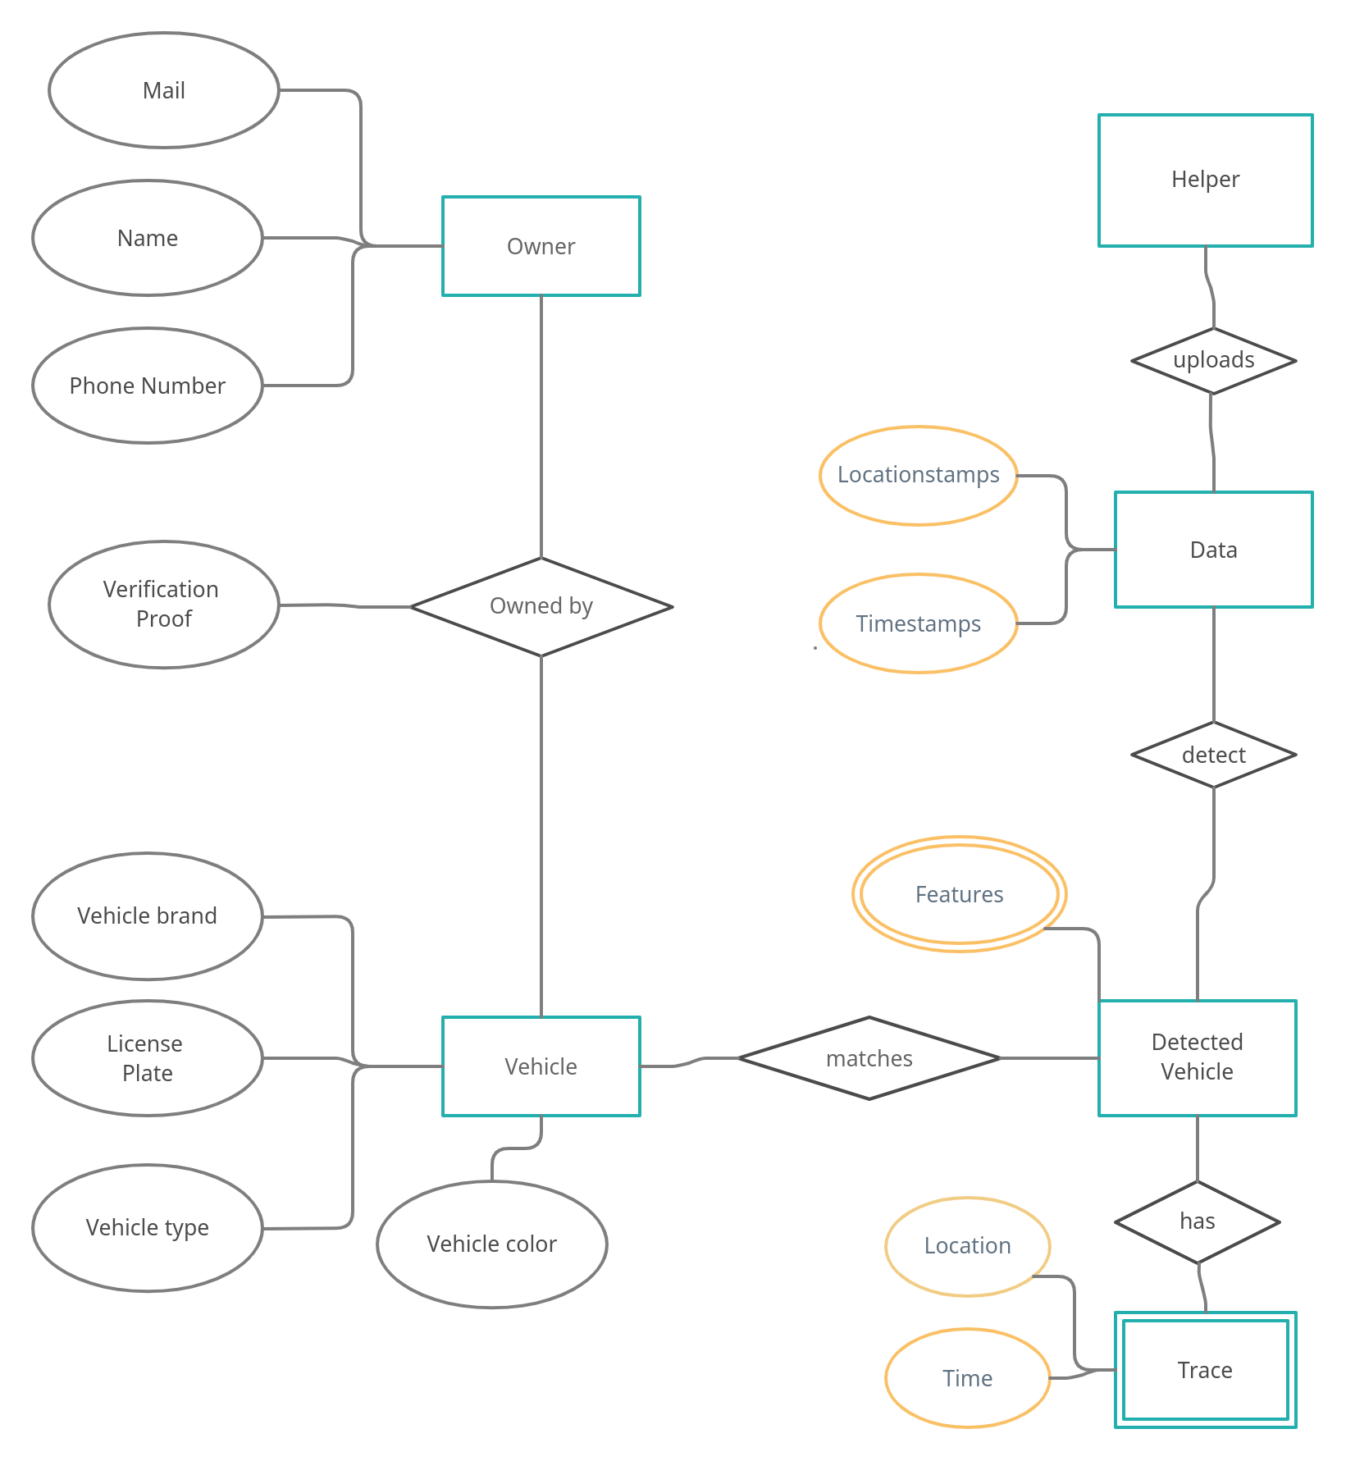ER Diagram stands for Entity Relationship Diagram, also known as ERD is a diagram that displays the relationship of entity sets stored in a database. In other words, ER diagrams help to explain the logical structure of databases. ER diagrams are created based on three basic concepts: entities, attributes, and relationships.

##### DATA FLOW DIAGRAM

A DFD shows what kind of information will be input to and output from the system, how the data will advance through the system, and where the data will be stored. It does not show information about process timing or whether processes will operate in sequence or parallel, unlike a traditionally structured flowchart that focuses on control flow, or a UML activity workflow diagram, which presents both control and data flows as a unified model.

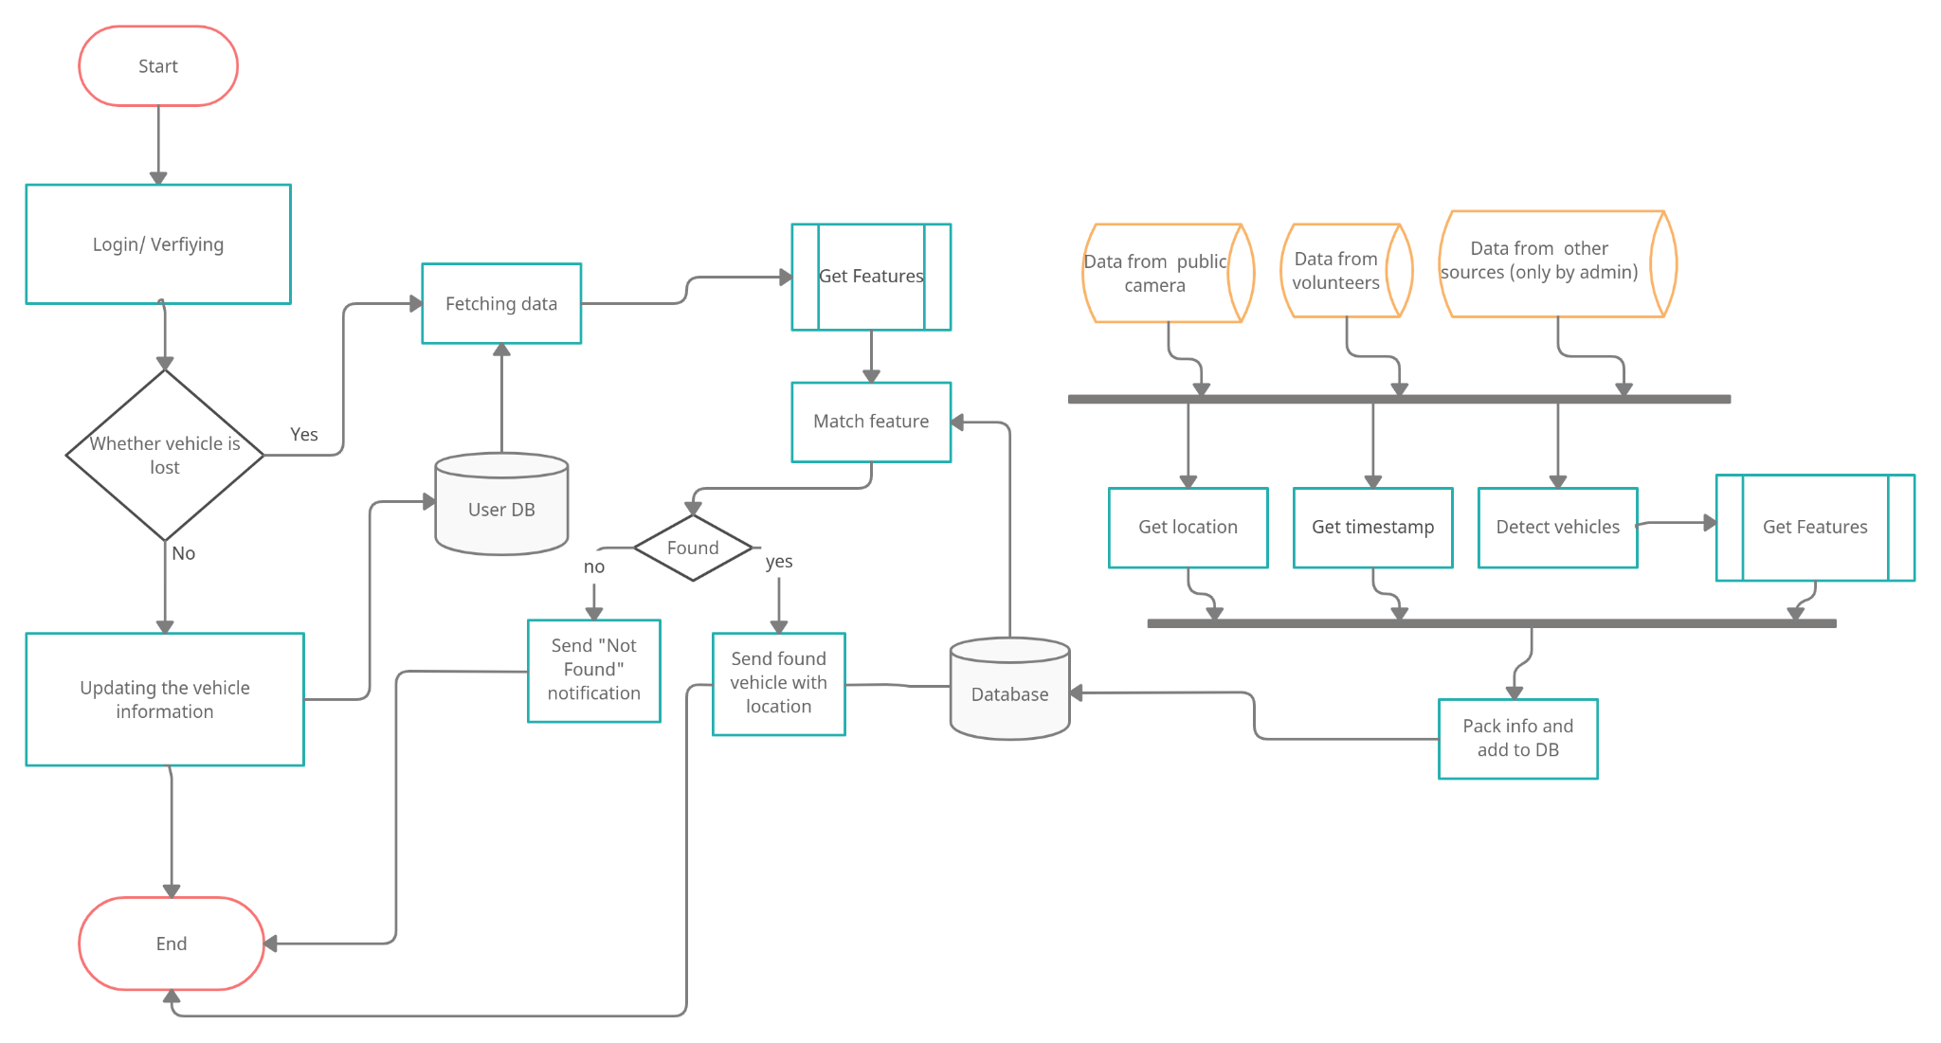

##### UML DIAGRAMS

**4.3.1 Use Case Diagram**

A use case illustrates a unit of the functionality provided by the system. The main purpose of the use-case diagram is to help development teams visualize the functional requirements of a system, including the relationship of "actors" (human beings who will interact with the system) to essential processes, as well as the relationships among different use cases. The use case has two actors: user and server. The user gives the image as input and the server operates.

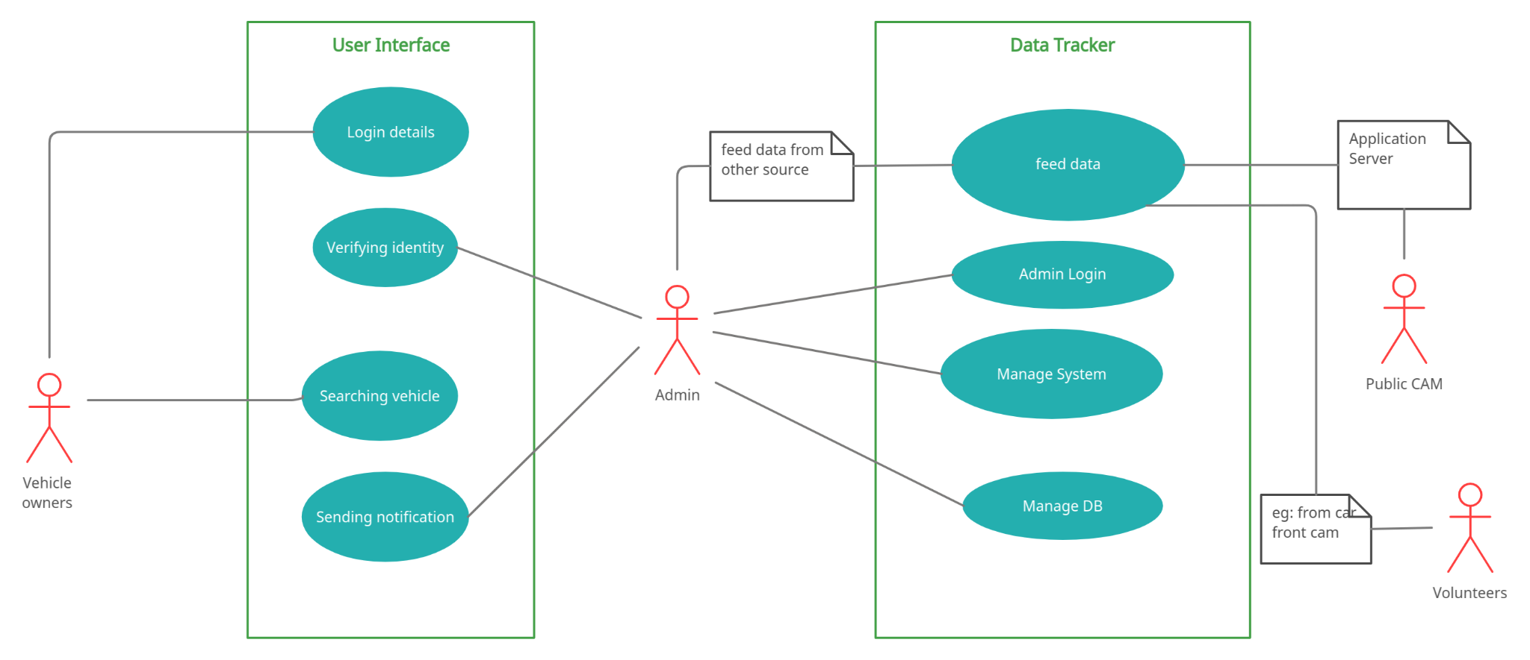

##### 4.5.2 SEQUENCE DIAGRAM

A use case illustrates a unit of the functionality provided by the system.

The main purpose of the use-case diagram is to help development teams visualize the functional requirements of a system, including the relationship of "actors" (human beings who will interact with the system) to essential processes, as well as the relationships among different use cases. The use case has two actors: user and server. The user gives the image as input and the server operates black-box.

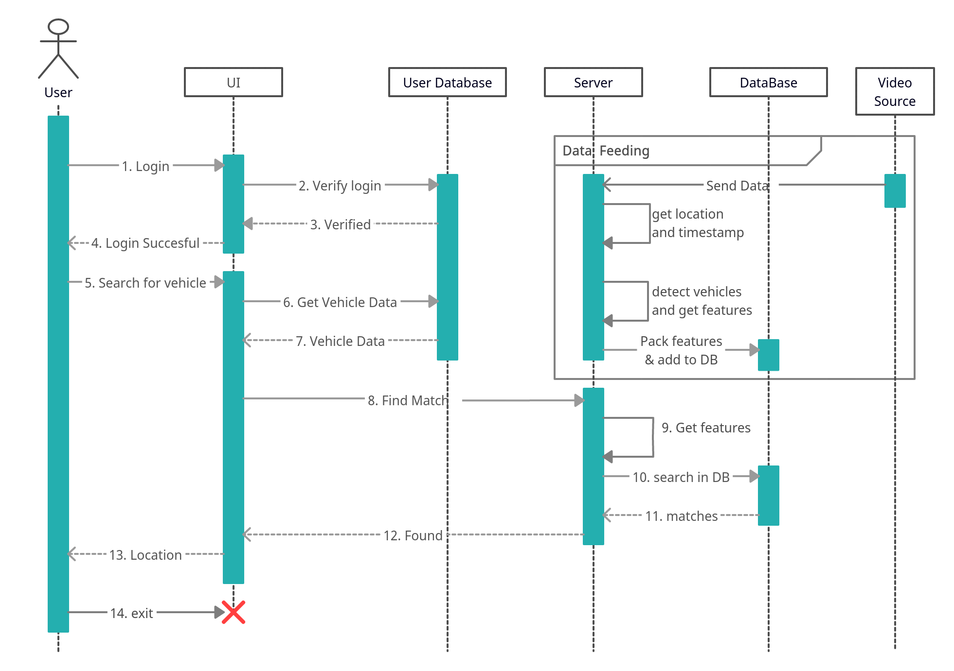

# CHAPTER-5 SYSTEM ARCHITECTURE

* 1. **Architecture Overview**
     1. **Owner’s Page Architecture**

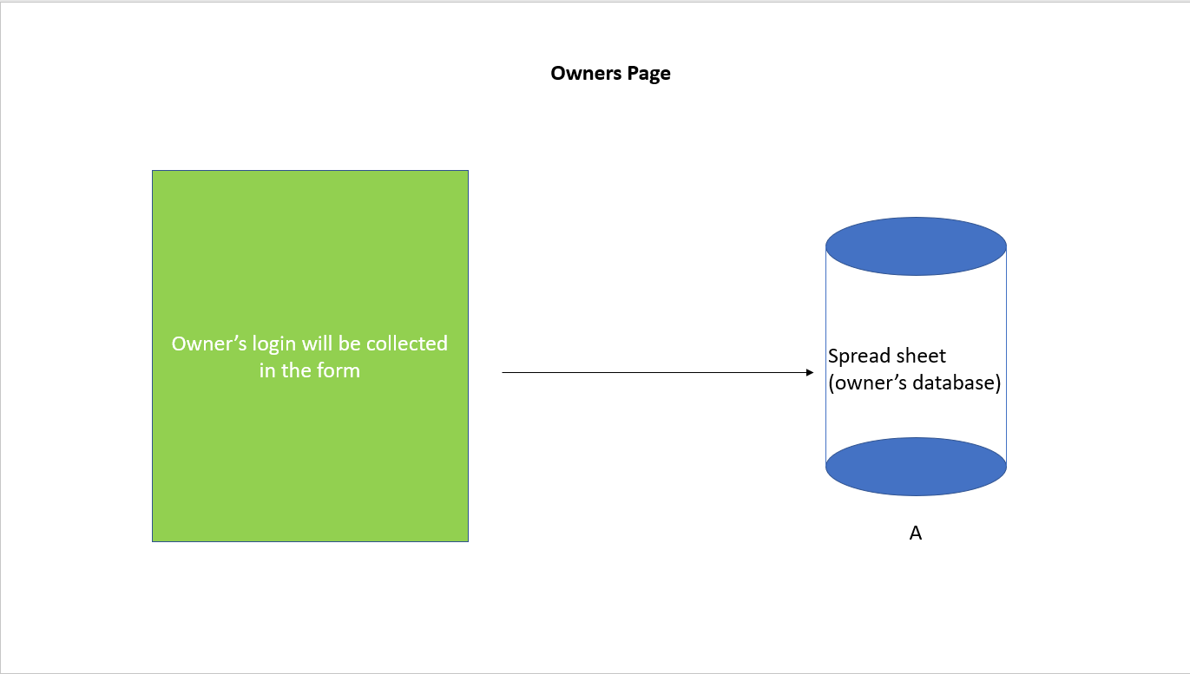

In this architecture, we are collecting data from the owners with the help of the owner login page via the form and it gets stored on the google sheet and also called as owner’s database A.

* + 1. **Helper’s Page Architecture**

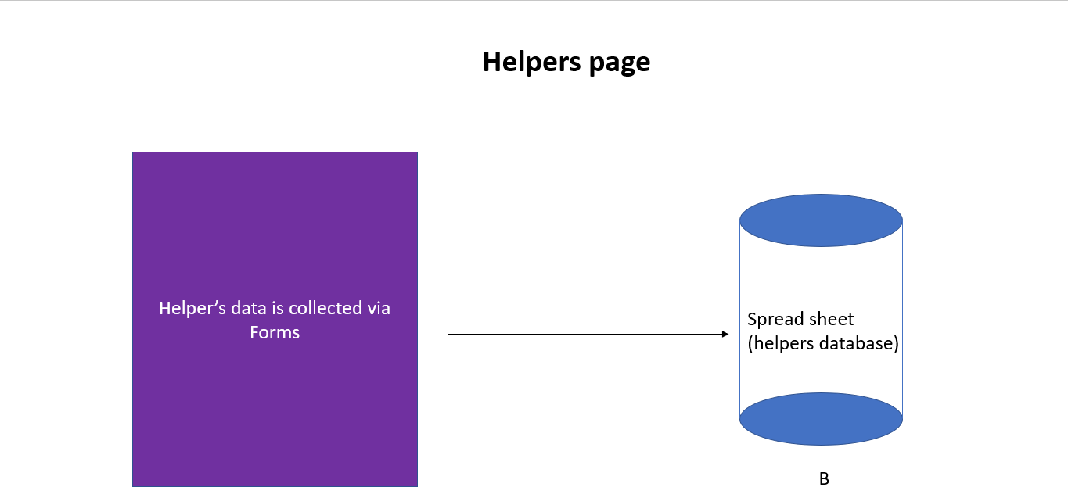

In this architecture, we are collecting data from the helpers with the help of the helper login page via the form and it gets stored on the google sheet and also called as helper’s database B.

* + 1. **Artificial Intelligence architecture**

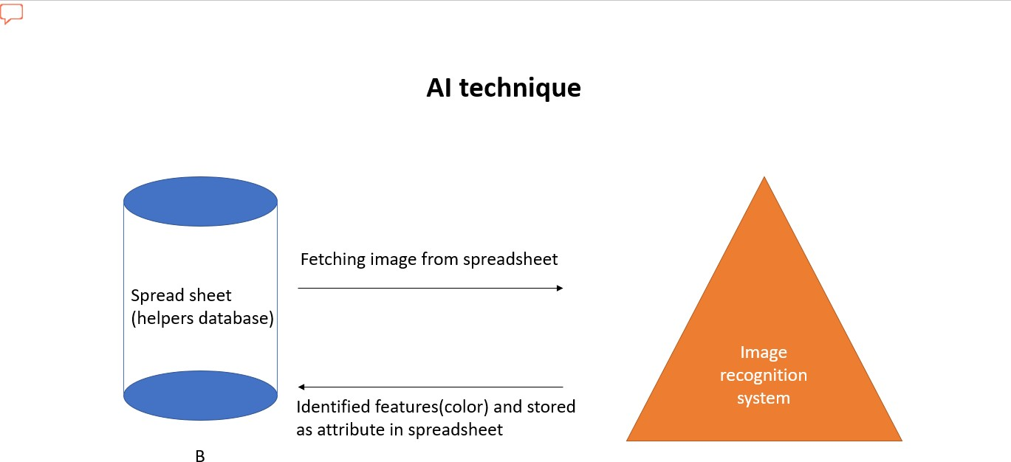

* + 1. 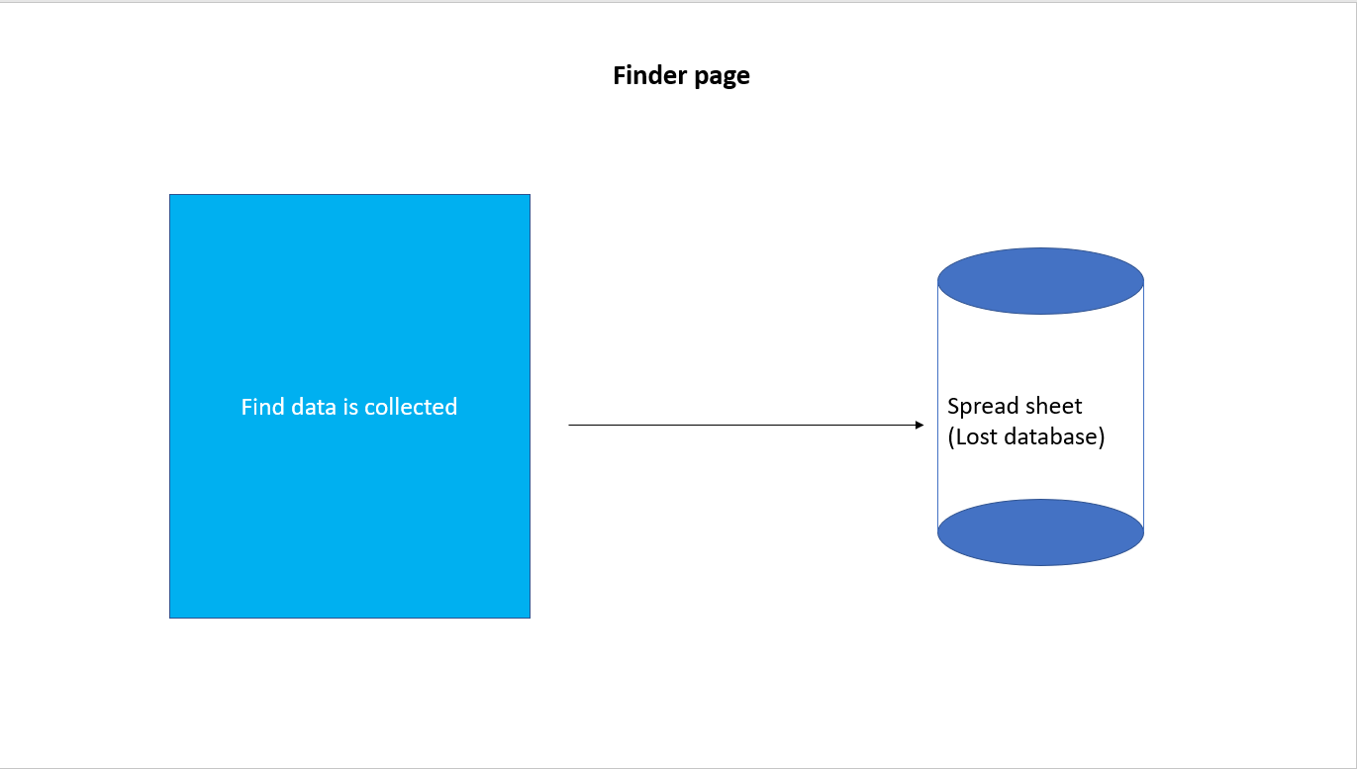**Finder Page Architecture**
    2. **Vehicle Searching Architecture:**

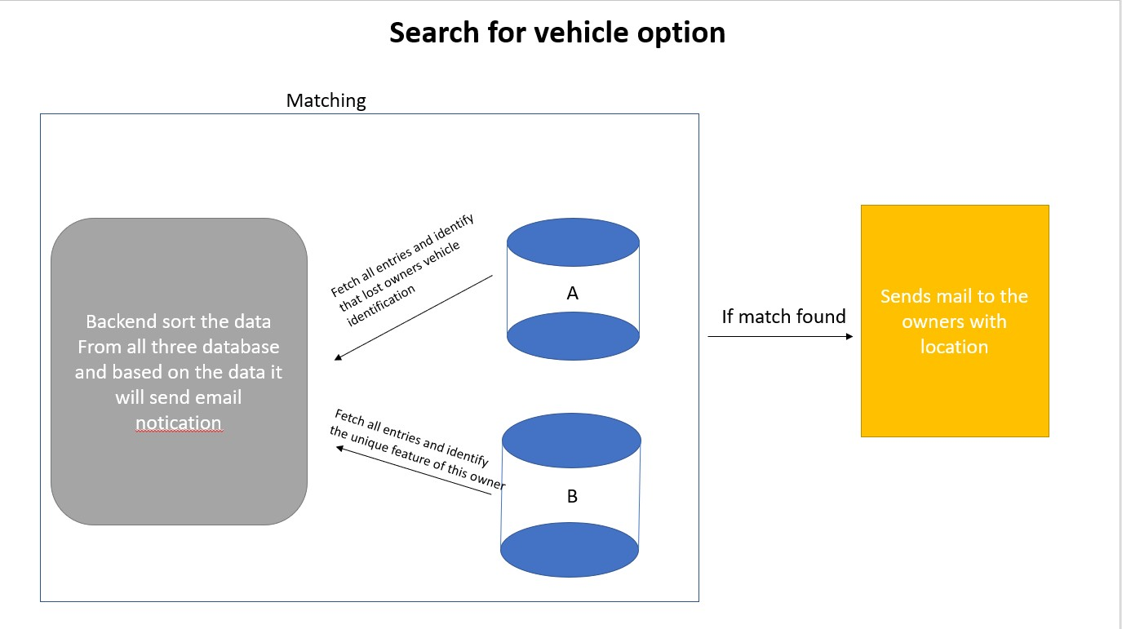

This is how the system will sort the collected data from the database and will send notification to the respective owners.

**CHAPTER-6 SYSTEM IMPLEMENTATION**

##### SYSTEM IMPLEMENTATION

* 1. **Google API**

Google APIs are application programming interfaces ([APIs](https://en.wikipedia.org/wiki/API)) developed by [Google](https://en.wikipedia.org/wiki/Google) which allow communication with [Google Services](https://en.wikipedia.org/wiki/Google_Services) and their integration to other services. Examples of these include Search, Gmail, Translate or Google Maps. Third-party apps can use these APIs to take advantage of or extend the functionality of the existing services.

The APIs provide functionality like analytics, [machine learning](https://en.wikipedia.org/wiki/Machine_learning) as a service (the Prediction API) or access to user data (when permission to read the data is given). Another important example is an embedded Google map on a website, which can be achieved using the Static maps API,Places APIor Google Earth API.

Google Apps Script is a cloud-based JavaScript platform which allows developers to write scripts only owners can manipulate API services such as Calendar, Docs, Drive, Gmail, and Sheets and easily create Add-Ons for these services with chromium based applications.

There are client libraries in various languages which allow developers to use Google APIs from within their code, including [Java](https://en.wikipedia.org/wiki/Java_(programming_language)), [JavaScript](https://en.wikipedia.org/wiki/JavaScript), [Ruby](https://en.wikipedia.org/wiki/Ruby_(programming_language)), [.NET](https://en.wikipedia.org/wiki/.NET_Framework), [Objective-C](https://en.wikipedia.org/wiki/Objective-C), [PHP](https://en.wikipedia.org/wiki/PHP) and [Python](https://en.wikipedia.org/wiki/Python_(programming_language)).

The Google Loader is a [JavaScript](https://en.wikipedia.org/wiki/JavaScript) library which allows web developers to easily load other [JavaScript](https://en.wikipedia.org/wiki/JavaScript) [API](https://en.wikipedia.org/wiki/API) provided by [Google](https://en.wikipedia.org/wiki/Google) and other developers of popular libraries. Google Loader provides a JavaScript method for loading a specific API (also called module), in which additional settings can be specified such as API version, language, location, selected packages, load [callback (computer programming)](https://en.wikipedia.org/wiki/Callback_(computer_programming)) and other parameters specific to a particular API. Dynamic loading or auto-loading is also supported to enhance the performance of the application using the loaded APIs.

* + 1. **Getting Sheet Spi**
       - First you need to go for developer console in google or just click this below link<https://console.cloud.google.com/>
* Then the developer console dashboard will appear as shown below

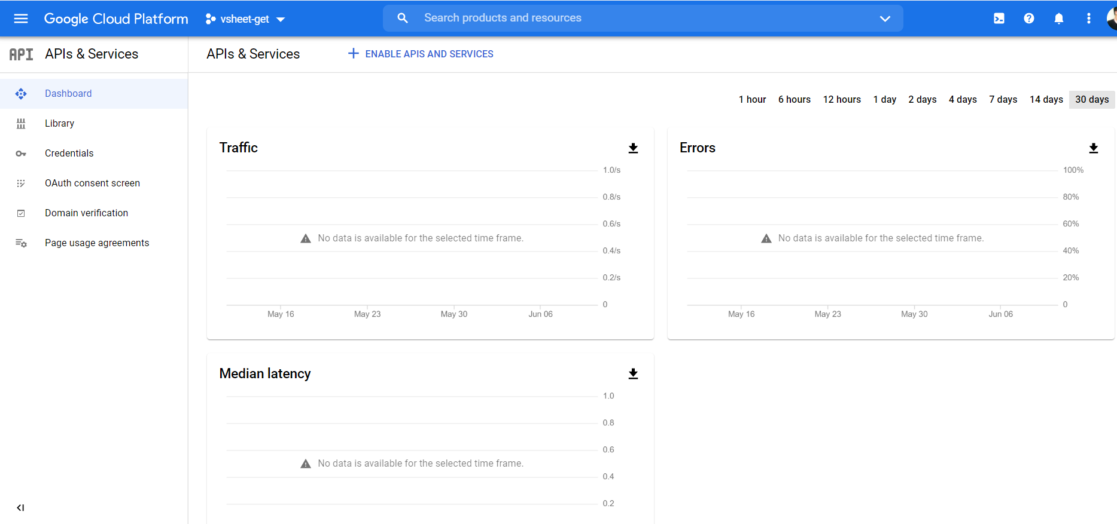

* In there, on the left corner you were able to see the Library tab. Once you click it will redirect to the api pages
* 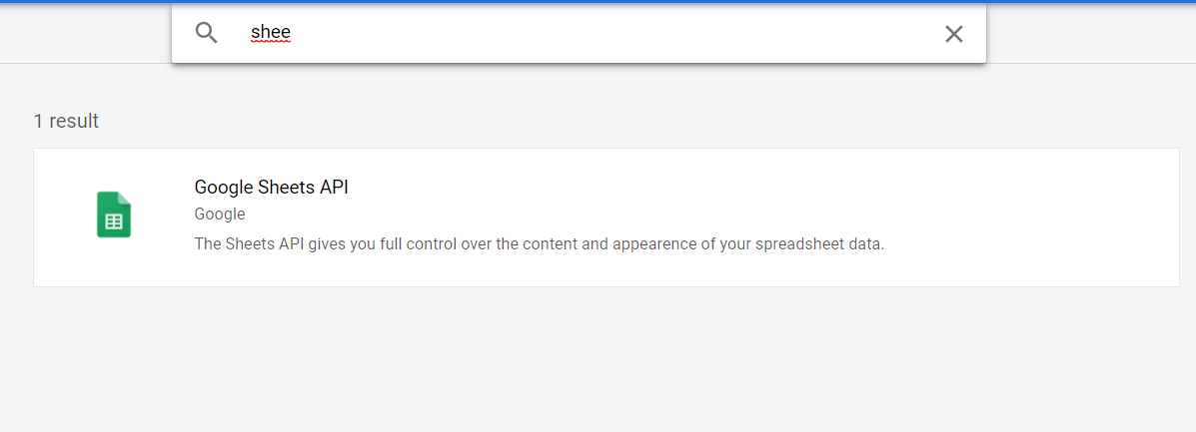Now we need the type of respected api we need. But for this experiment I need only sheet api so just type sheet api in the search bar.

##### Getting Credentials

* Once you installed api on your cloud console, now we need to create credentials.
* So to do that, we need to go to the credential tab in google developer console then we need to click the create credentials button there.
* Then we need to click Create OAuth client ID and click configure consent screen
* Now the screen below will appear.

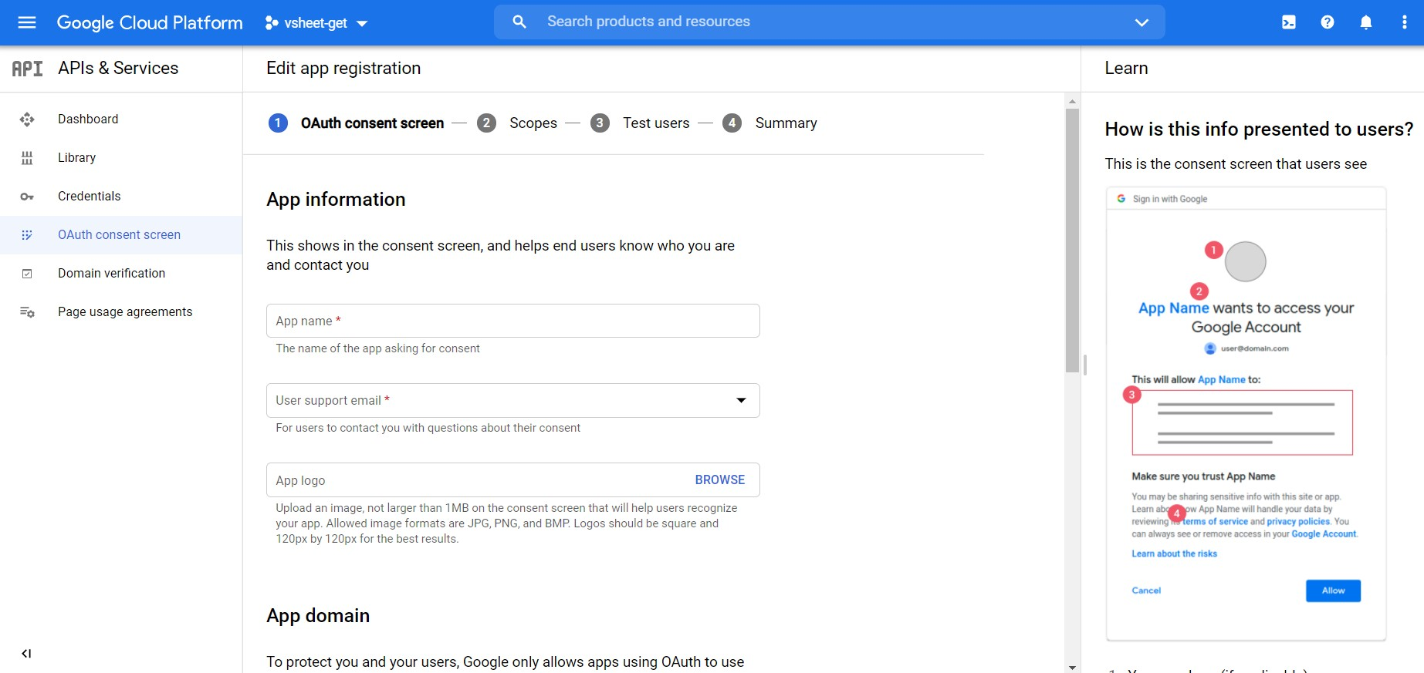

* Fill the necessary information about the project and click create new project. Now we need to create api key for secure database storage
  + 1. **Implementing API In Project**
* Once we generate the api key we need to implement the installed api in our project. In this project I’m going to use google sheet api. So we need to search for sheet api docs or click the below link <https://developers.google.com/sheets>
* 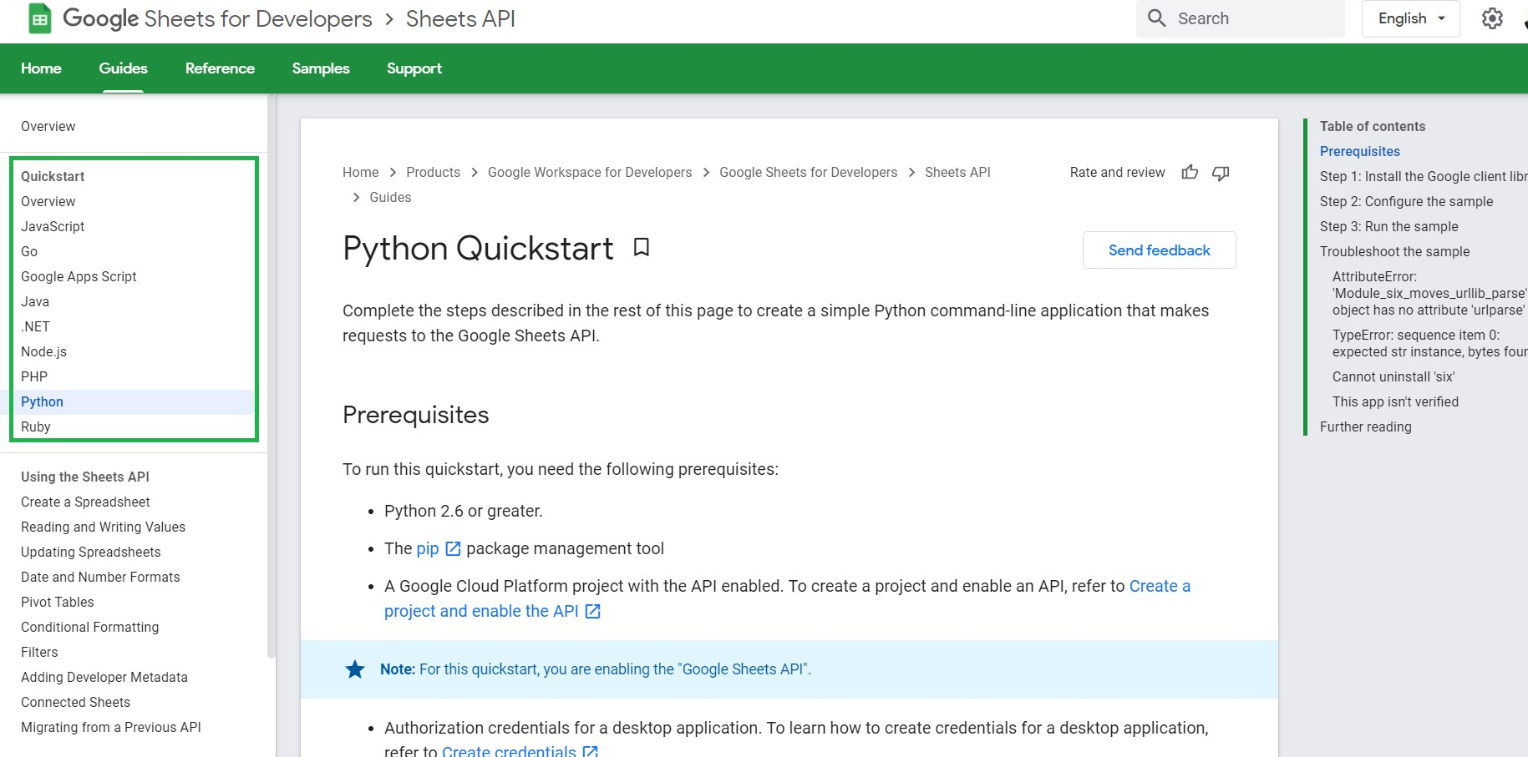Once you entered that site you could see different types method to implement sheet api and corresponding programming language as show below
* For our project, we have fetched the api using python programming language to access the database.

# CHAPTER-7 SYSTEM TESTING

##### System Testing

* 1. **UNIT TESTING**

Unit testing is conducted to verify the functional performance of each modular component of the software. Unit testing focuses on the smallest unit of the software design (i.e.), the module.

These types of tests are usually written by developers as they work on code (white-box style), to ensure that the specific function is working as expected. One function might have multiple tests, to catch corner cases or other branches in the code. Unit testing alone cannot verify the functionality of a piece of software, but rather is used to ensure that the building blocks of the software work independently from each other.

Unit testing is a software development process that involves a synchronized application of a broad spectrum of defect prevention and detection strategies to reduce software development risks, time, and costs. It is performed by the software developer or engineer during the construction phase of the software development life cycle. Unit testing aims to eliminate construction errors before code is promoted to additional testing; this strategy is intended to increase the quality of the resulting software as well as the efficiency of the overall development process.

Depending on the organization's expectations for software development, unit testing might include static code analysis, data-flow analysis, metrics analysis, peer code reviews, code coverage analysis, and other software testing practices.

##### WHITE BOX TESTING

White Box Testing is a test case design method that uses the control structure of the procedural design to drive cases. Using the white box testing methods, we derived test cases that guarantee that all independent paths within a module have been exercised at least once. White-box testing (also known as clear box testing, glass box testing, transparent box testing, and structural testing) verifies the internal structures or workings of a program, as opposed to the functionality exposed to the end-user. In white-box testing, an internal perspective of the system (the source code), as well as programming skills, are used to design test cases. The tester chooses inputs to exercise paths through the code and determines the appropriate outputs. This is analogous to testing nodes in a circuit, e.g., in-circuit testing (ICT).

While white-box testing can be applied at the unit, integration, and system levels of the software testing process, it is usually done at the unit level. It can test paths within a unit, paths between units during integration, and between subsystems during a system-level test. Though this method of test design can uncover many errors or problems, it might not detect unimplemented parts of the specification or missing requirements.API testing – testing of the application using public and private APIs (application programming interfaces) Code coverage – creating tests to satisfy some criteria of code coverage (e.g., the test designer can create tests to cause all statements in the program to be executed at least once), Fault injection methods – intentionally introducing faults to gauge the efficacy of testing strategies. Code coverage tools can evaluate the completeness of a test suite that was created with any method, including black-box testing. This allows the software team to examine parts of a system that are rarely tested and ensures that the most important function points have been tested.

Code coverage as a software metric can be reported as a percentage. Statement coverage, which reports on the number of lines executed to complete the test.61 Decision coverage, which reports on whether both the True and the False branch of a

given test has been executed100% statement coverage ensures that all code paths or branches (in terms of control flow) are executed at least once. This helps ensure correct functionality, but not sufficient since the same code may process different inputs correctly or incorrectly. Pseudo-tested functions and methods are those that are covered but not specified (it is possible to remove their body without breaking any test case).

##### BLACK BOX TESTING

Black-box testing (also known as functional testing) treats the software as a "black box," examining functionality without any knowledge of internal implementation, without seeing the source code. The testers are only aware of what the software is supposed to do, not how it does it. Black-box testing methods include equivalence partitioning, boundary value analysis, all-pairs testing, state transition tables, decision table testing, fuzz testing, model-based testing, use case testing, exploratory testing, and specification-based testing. Specification-based testing aims to test the functionality of software according to the applicable requirements. This level of testing usually requires thorough test cases to be provided to the tester, who then can simply verify that for a given input, the output value (or behavior), either "is" or "is not" the same as the expected value specified in the test case. Test cases are built around specifications and requirements, i.e., what the application is supposed to do. It uses external descriptions of the software, including specifications, requirements, and designs to derive test cases. These tests can be functional or non-functional, though usually functional. Specification-based testing may be necessary to assure correct functionality, but it is insufficient to guard against complex or high-risk situations.

One advantage of the black box technique is that no programming knowledge is

required. Whatever biases the programmers may have had, the tester likely has a

different set and may emphasize different areas of functionality. On the other 62 hands, black-box testing has been said to be "like a walk in a dark labyrinth without a flashlight. Because they do not examine the source code, there are situations when a tester writes many test cases to check something that could have been tested by only one test case or leaves some parts of the program untested. This method of test can be applied to all levels of software testing: unit, integration, system, and acceptance. It typically comprises most if not all testing at higher levels, but can also dominate unit testing as well. • Black box testing is done to find incorrect or missing function • Interface error • Error in external database access • Performance error • Initialization and termination errors

##### INTEGRATION TESTING

Integration Testing is a systematic technique for the construction of the program structure while at the same time conducting tests to uncover errors associated with interfacing. i.e., integration testing is the complete testing of the set of modules that makes up the product. The objective is to take untested modules and build a program structure tester should identify critical modules. Critical modules should be tested as early as possible. One approach is to wait until all the units have passed testing, and then combine them and then tested. This approach is evolved from unstructured testing of small programs. Another strategy is to construct the product in increments of tested units. A small set of modules are integrated and tested, to which another module is added and tested in combination. And so on. The advantages of this approach are that interface dispenses can be easily found and corrected. The major error that was faced during the project is linking. The connection between the cloud

database and module app is very crucial and some improper casting of different types like Object and Geopoint caused the app to 63 crash and this was rectified by properly casting the types for Object data types. Another major error that was faced was the real-time location update to the cloud when the truck is on the move, instead of black black-box on individually fetching the current location the utility called location change listener was used to automatically listen for location changes and it was moved to the cloud database.

##### TEST CASES & REPORTS

* + 1. **TEST CASES**

|  |  |  |  |
| --- | --- | --- | --- |
| **S. No** | **Test Case** | **Test Steps** | **Test Results** |
| 1 | Verify Login functionalities with the correct condition | Enter mail id: [abc@sample.com](mailto:abc@sample.com)  Enter password: xyz | Redirect to owners page |
| 2 | Verify Login functionalities with the wrong condition | Enter mail id: [abc@sample.com](mailto:abc@sample.com)  Enter password: Empty | Password not found stay in the same owner page |
| 3 | Sending Images to the platform | Send photos here: sample.jpg  Send Location: Poonamale, Chennai | Redirect to helper page |
| 4 | Sending Images to the platform  without proper data | Send photos here: sample.jpg  Send Location: Empty | Location not found. Staying the same page |

**CHAPTER-8 CONCLUSION**

**8. CONCLUSION**

The above-proposed system has provided comprehensive methods and an overview of the application that detects vehicles with the helping image capturing technique.

Vehicle Detector is an application that helps the owners to track their vehicle when they get lost by using the vehicle’s unique information. Our main goal is to provide the owners with a searching facility across the city using a Public Camera, GPS, and mobile capturing technique without raising the complaint to the cop. In this system, the user can share their vehicle’s identity and it will be stored on the user database. When the vehicle gets lost, the owner can ping on this platform about the vehicle lost. On the other side, data gets fetched and stored on a common database. If the information in both of these databases gets matched, the user/owner will receive a notification with an exact location, or else they can wait until it gets found. If there are any vehicle server vehicle issues successes or fraudulent information, then this whole system is taken care of by the admin. Hence this platform made the owners find the vehicle without any police complaints.

##### PERFORMANCE ANALYSIS REPORT EXISTING SYSTEM:

* + - Every day on average 209 vehicles are getting lost in India.
    - It may be due to theft or sometimes due to the owner's fault.
    - In the existing one, images are recorded by using CCTV cameras but still the project didn’t get implemented due to the inconvenient use of CCTV in our country.

##### PROPOSED SYSTEM:

* + - To overcome this, we use the capturing technique from unknown users and will sort the vehicle based on the unique information and we will send an alert to the owners.
    - In this, we will collect the database of the user’s vehicle information like color, scratches, seat color, dent marks, etc.
    - And if the user’s vehicle is getting lost, we could track it with our intelligence software.
    - We used capturing technique from the mobile, public cam,
  1. **FUTURE ENHANCEMENT**

There are numerous potential future scopes and improvements for the proposed system

* + - First, we would like to remove google sheet as a database and we are going to import either MongoDB compass or mongo as a cloud database(Atlas) for this project so that we can add or edit enormous amounts of data easy and so quick.
    - Then we would like to do web hosting via a digital ocean network instead of using Github pages and we would like to buy the domain for our project
    - Then we would like to feed more datasets into our machine learning framework and add additional features like seat identifying, car steering color, scratch features, etc for detecting a vehicle.

# APPENDICES

##### APPENDICES

* 1. **SAMPLE SCREENS Owner’s Page**

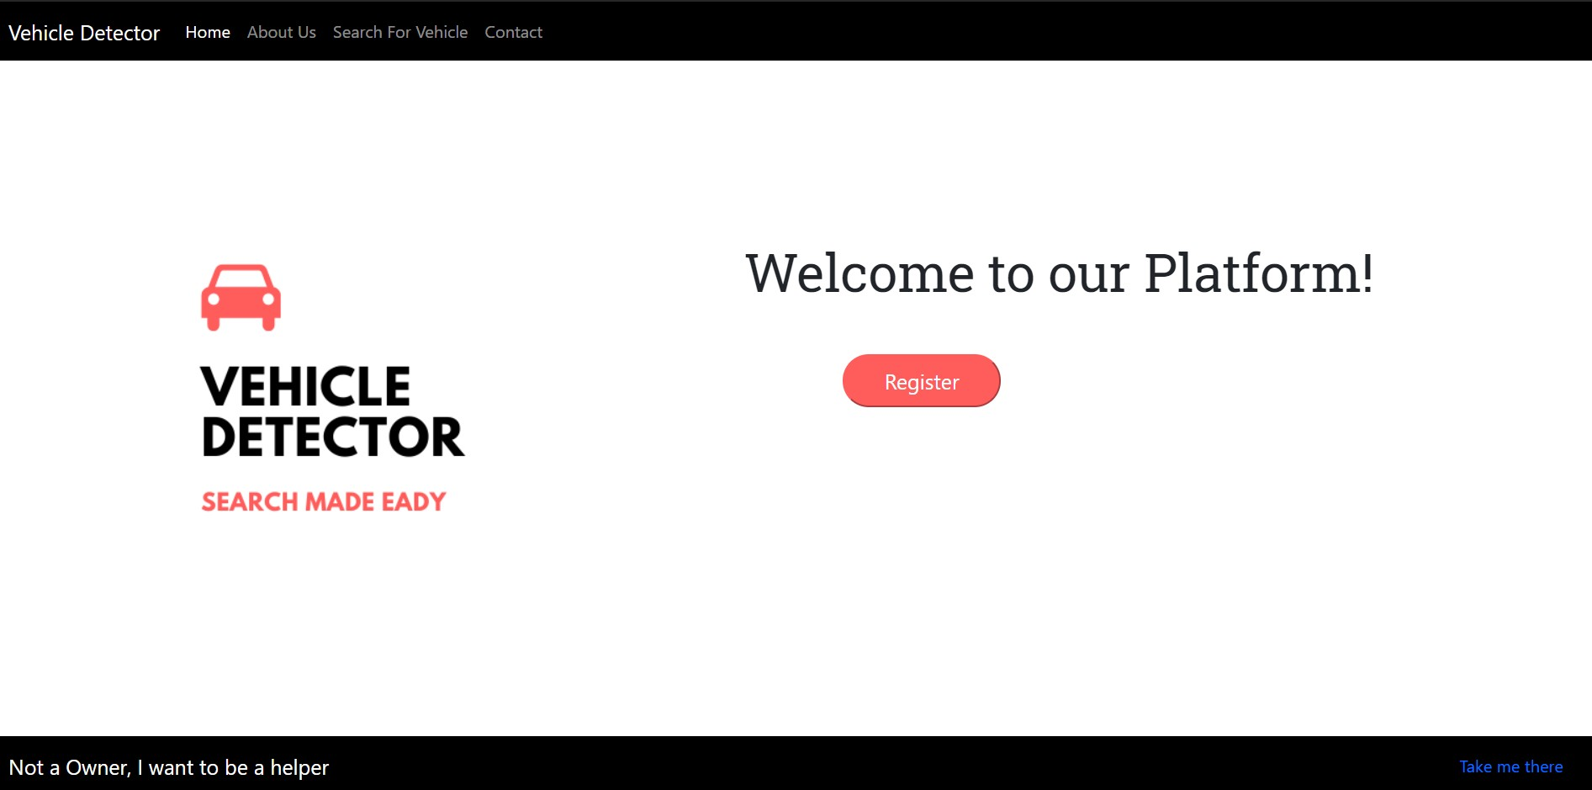

**Helper’s page**

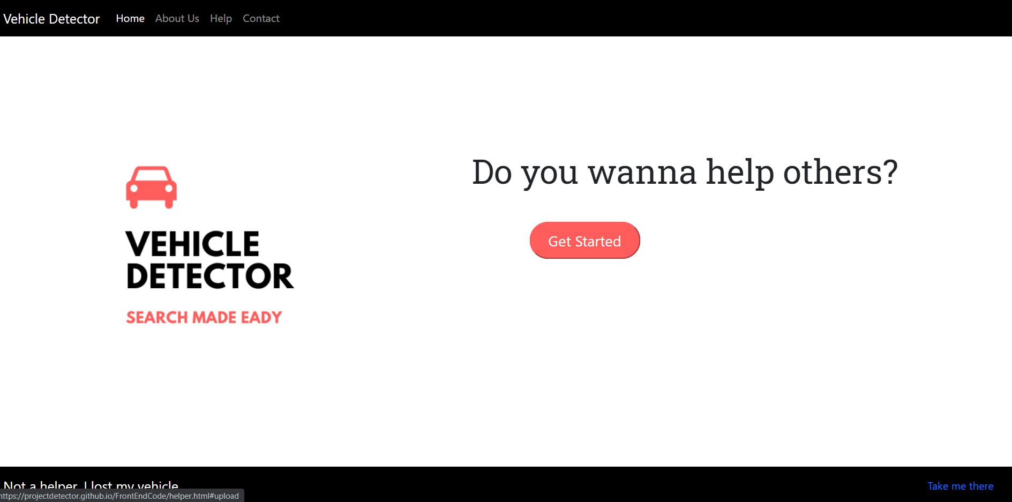

**Owner’s Registration**

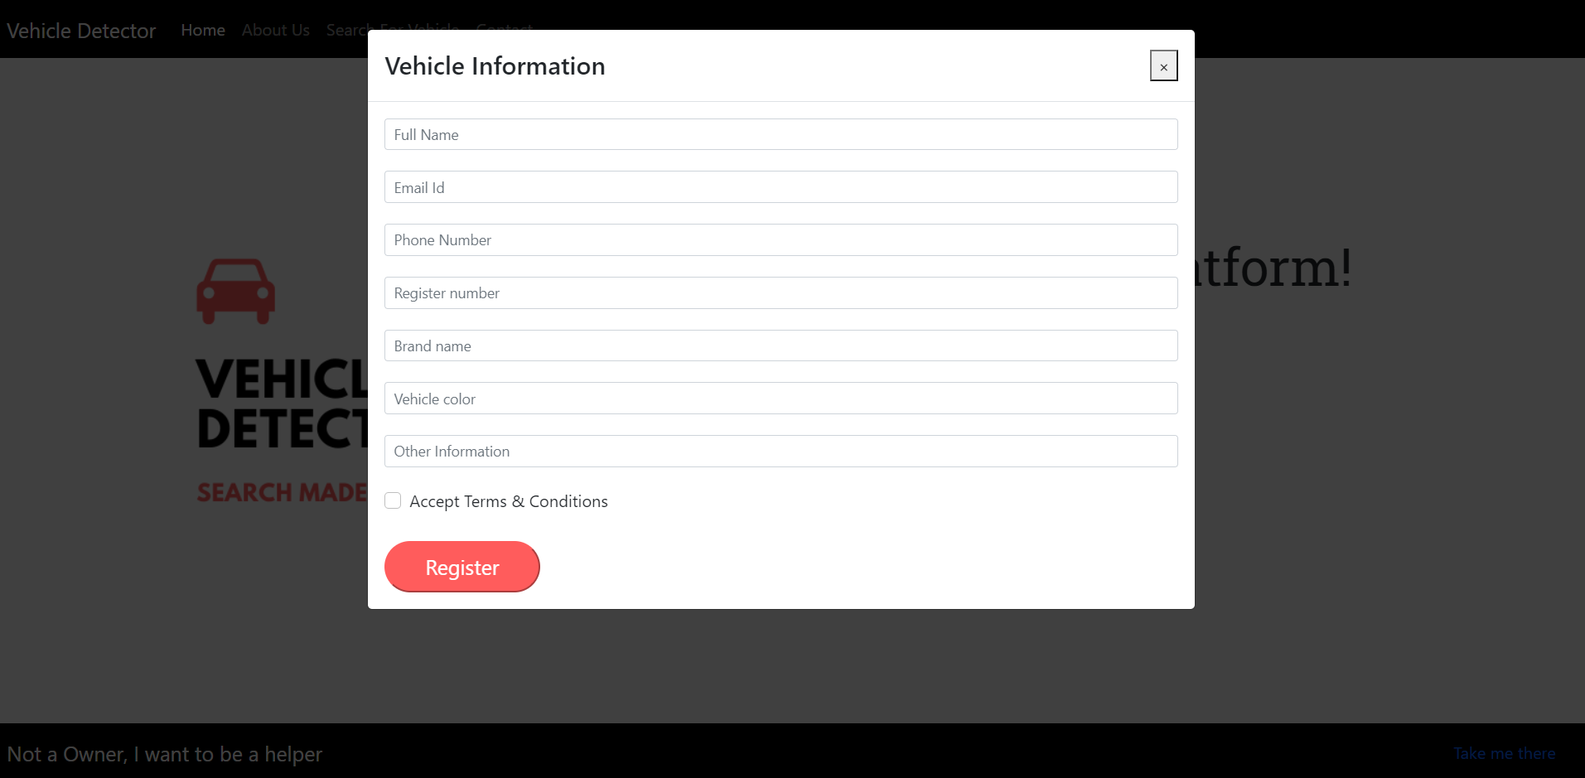

**Helper’s Form**

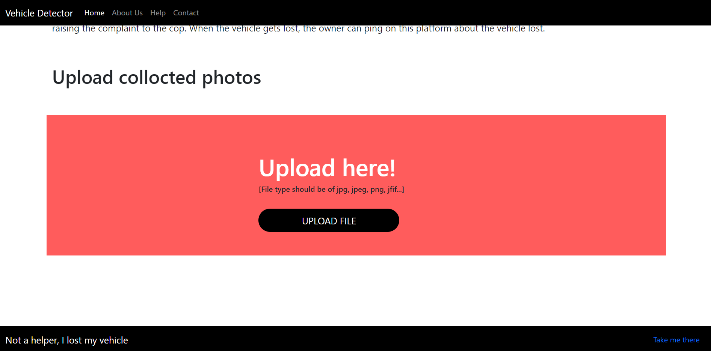

**Finder Form:**

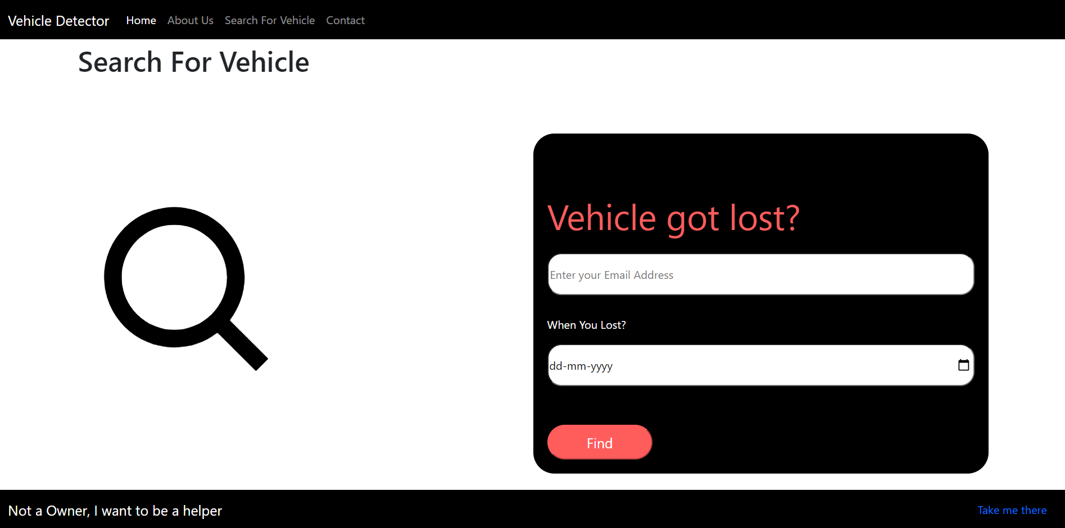

* 1. **CODING**
     1. **CLIENT-SIDE CODING**

**index. html**

<!DOCTYPE html>

<html>

<head>

<!--Title-->

<meta charset="utf-8">

<meta name="viewport" content="width = device-width, intial-scale=1, shrink-to-fit=no">

<meta http-equiv="x-ua-compatible" content="ie=edge">

<!--Title-->

<title>Vehicle Detector</title>

<!--Favicon-->

<link href="assets/image/logo.png" rel="icon">

<!--Bootstrap Css-->

<link

href="[https://cdn.jsdelivr.net/npm/bootstrap@5.0.0-beta3/dist/css/bootstrap.min.css](https://cdn.jsdelivr.net/npm/bootstrap%405.0.0-beta3/dist/css/bootstrap.min.css)" rel="stylesheet"

integrity="sha384-eOJMYsd53ii+scO/bJGFsiCZc+5NDVN2yr8+0RDqr0Ql0h+rP48c kxlpbzKgwra6" crossorigin="anonymous">

<link rel="stylesheet" href="node_modules/bootstrap/dist/css/bootstrap.min.css">

<!--Css file-->

<link rel="stylesheet" href="assets/css/style.css">

<!-- ===== BOX ICONS ===== -->

<link href='https://cdn.jsdelivr.net/npm/boxicons@2.0.5/css/boxicons.min.css' rel='stylesheet'>

</head>

<body>

<!--After filling form this window will appear-->

<script type="text/javascript">var submitted=false;</script>

<iframe name="hidden_iframe" id="hidden_iframe" style="display: none" onload="if(submitted){window.location='search.html';}"></iframe>

<iframe name="hidden_iframe1" id="hidden_iframe1" style="display: none" onload="if(submitted){window.location='registered.html';}"></iframe>

<!-- Nav bar-->

<!--Header nav-->

<nav class="navbar fixed-top navbar-expand-lg navbar-dark" id="navv">

<div class="container-fluid">

<a class="navbar-brand" href="#home">Vehicle Detector</a>

<button class="navbar-toggler" type="button" data-bs-toggle="collapse" data-bs-target="#navbar" aria-controls="navbar" aria-expanded="false"

aria-label="Toggle navigation">

<span class="navbar-toggler-icon"></span>

</button>

<div class="collapse navbar-collapse" id="navbar">

<div class="navbar-nav">

<a class="nav-link active" aria-current="page" href="#home">Home</a>

<a class="nav-link" href="#about">About Us</a>

<a class="nav-link" href="#search">Search For Vehicle</a>

<a class="nav-link" href="#contact">Contact</a>

</div>

</div>

</div>

</nav>

<!--Footer nav-->

<nav class="navbar fixed-bottom navbar-dark" id="navv">

<div class="container-fluid">

<a class="navbar-brand" href="#">Not a Owner, I want to be a helper</a>

<a class="nav-link active" href="helper.html">Take me there</a>

</div>

</nav>

<!-- Nav bar end-->

<!--Main-->

<div id="home">

<div class="container">

<div class="row">

<div class="col-md-5">

<img id="alter2" src="assets/image/logo.png">

</div>

<div class="col-md-7">

<p id="heading">Welcome to our Platform!</p>

<div class="container">

<div class="row">

<div class="col-2 col-sm-2 offset-2 offset-sm-2">

<button id="buttonstart" type="button" data-bs-toggle="modal" data-bs-target="#loginModal">

Register

</button>

</div>

</div>

</div>

</div>

</div>

</div>

</div>

<!--Main end-->

<!-- Code For Modal-->

<div id="loginModal" class="modal fade" role="dialog">

<div class="modal-dialog modal-lg" role="document">

<!-- Modal content-->

<div class="modal-content">

<!--Modal Header-->

<div class="modal-header">

<h4 class="modal-title">Vehicle Information </h4>

<button type="button" class="close" data-bs-dismiss="modal">&times;</button>

</div>

<!--Modal Body-->

<div class="modal-body">

<form action="https://docs.google.com/forms/u/3/d/e/1FAIpQLSeFwqk816lrCbldc_RcfmNrJ 4X_Xa9BWOM6vKeck_jP8yJG7g/formResponse" method="POST" target="hidden_iframe1" onsubmit="submitted=true" id="mG61Hd" jsmodel="TOfxwf Q91hve" data-response="%.@.[]]" data-first-entry="0"

data-last-entry="7" data-is-first-page="true">

<div class="form-row">

<!--Name-->

<div class="form-group col-sm-12" style="margin-bottom:20px;">

<input type="text" class="form-control form-control-sm mr-1" placeholder="Full Name" name="entry.1677927740" required>

</div>

<!--Mail Id-->

<div class="form-group col-sm-12" style="margin-bottom:20px;">

<input type="mail" class="form-control form-control-sm mr-1" placeholder="Email Id" name="entry.1785503304" required>

</div>

<!--Phone Number-->

<div class="form-group col-sm-12" style="margin-bottom:20px;">

<input type="number" class="form-control

form-control-sm mr-1" placeholder="Phone Number" name="entry.280605744" required>

</div>

<!--Register Number-->

<div class="form-group col-sm-12" style="margin-bottom:20px;">

<input type="text" class="form-control form-control-sm mr-1" placeholder="Register number" name="entry.140135176" required>

</div>

<!--Brand Name-->

<div class="form-group col-sm-12" style="margin-bottom:20px;">

<input type="text" class="form-control form-control-sm

mr-1" placeholder="Brand name" name="entry.159063284" required>

</div>

<!--Vehicle color-->

<div class="form-group col-sm-12" style="margin-bottom:20px;">

<input type="text" class="form-control form-control-sm mr-1" placeholder="Vehicle color" name="entry.623889169" required>

</div>

<!--Other Information-->

<div class="form-group col-sm-12" style="margin-bottom:20px;">

<input type="textbox" class="form-control

form-control-sm mr-1" placeholder="Other Information" name="entry.2069414667" required>

</div>

required>

<!--Agreement-->

<div class="col-sm-auto">

<div class="form-check align-items-center">

<input class="form-check-input" type="checkbox"

<label class="form-check-label"

for="exampleCheck3"> Accept Terms & Conditions</label>

</div>

</div>

</div>

<!--Buttons-->

<div class="form-row">

<button type="submit" id="buttonstart" class=" btn-sm ml-1" data-dismiss="modal">Register</button>

</div>

</form>

</div>

</div>

</div>

</div>

<!--Modal ends-->

<!--About us -->

<div id="about" class="container">

<div class="row">

<div class="col-sm-12">

<h1>About Us</h1>

</div>

<div class="col-sm-12">

<p id="blehh">Vehicle Detector is an application that helps the owners to track their vehicle when they get lost by using the vehicle’s unique information.

Our main goal is to provide the owners with a searching facility across the city using a Public Camera, GPS, and mobile capturing technique without raising the complaint to the cop.

When the vehicle gets lost, the owner can ping on this platform about the vehicle lost.

</p>

</div>

</div>

</div>

<!--End of About-->

<!-Search for vehicle-->

<div id="search" class="container" style="margin-bottom: 100px;">

<div class="col-sm-12">

<h1>Search For Vehicle</h1>

</div>

<div class="container" style=" margin-top: 80px;">

<div class="row">

<div id="searchicon" class="col-md-6">

<svg xmlns="<http://www.w3.org/2000/svg>" width="300" height="300" viewBox="0 0 24 24" style="fill:black;"><path d="M10,18c1.846,0,3.543-0.635,4.897-1.688l4.396,4.396l1.414-1.414l-4.396-4.396C 17.365,13.543,18,11.846,18,10 c0-4.411-3.589-8-8-8s-8,3.589-8,8S5.589,18,10,18z M10,4c3.309,0,6,2.691,6,6s-2.691,6-6,6s-6-2.691-6-6S6.691,4,10,4z"></path></svg>

</div>

<div class="col-md-6" style="background-color:black;border-radius: 30px; padding: 0px 20px 20px 20px;">

<p id="location"> Vehicle got lost?</p>

<form action="https://docs.google.com/forms/u/1/d/e/1FAIpQLScD8q6C36NEdkhwuEzOE VQfWSv2mioNyK7FNZ4qEdPsLZNaQg/formResponse" method="POST"

target="hidden_iframe" onsubmit="submitted=true" id="mG61Hd" jsmodel="TOfxwf Q91hve" data-response="%.@.[]]" data-first-entry="0" data-last-entry="2"

data-is-first-page="true">

<input id="eemail" name="entry.989431506" class="form-group col-sm-12" type="email" placeholder="Enter your Email Address" required>

<p style="color: white;">When You Lost?</p>

<input id="locaa" name="entry.438802586" class="form-group col-sm-12" type="date" required onclick="datee()">

<button type="submit" id="buttonstart" onclick="fetchInfo()">Find</button>

</form>

</div>

</div>

</div>

</div>

<!--End search-->

<!--Contact session-->

<div id="contact" >

<div class="container">

<div class="row">

<h1>Contact Us</h1>

</div>

<div class="row" style="margin-top: 100px; margin-bottom: 50px; background-color: black; color: white;">

<div class="col-md-4"></div>

<div class="col-md-4">

<h1>Developers</h1>

</div>

<div class="col-md-4"></div>

</div>

<div class="row">

<div class="col-md-4 col-12" style="margin-bottom: 40px;">

<h3>Kumaran KM</h3>

<h6>Mail Id: [kumaranmohan1106@gmail.com](mailto:kumaranmohan1106@gmail.com)</h6>

</div>

<div class="col-md-4 col-12" style="margin-bottom: 40px;">

<h3>Naveen SR</h3>

<h6>Mail Id: [naveenstudy2000sr@gmail.com](mailto:naveenstudy2000sr@gmail.com)</h6>

</div>

<div class="col-md-4 col-12" style="margin-bottom: 40px;">

<h3>Pradeish</h3>

<h6>Mail Id: [pradeish2001@gmail.com](mailto:pradeish2001@gmail.com)</h6>

</div>

</div>

</div>

</div>

<!--Script file-->

<script

src="[https://cdn.jsdelivr.net/npm/bootstrap@5.0.0-beta3/dist/js/bootstrap.bundle.min.j](https://cdn.jsdelivr.net/npm/bootstrap%405.0.0-beta3/dist/js/bootstrap.bundle.min.j) s"

integrity="sha384-JEW9xMcG8R+pH31jmWH6WWP0WintQrMb4s7ZOdauHnUtxw oG2vI5DkLtS3qm9Ekf" crossorigin="anonymous"></script>

<script src="[https://cdn.jsdelivr.net/npm/@popperjs/core@2.9.1/dist/umd/popper.min.js](https://cdn.jsdelivr.net/npm/%40popperjs/core%402.9.1/dist/umd/popper.min.js)" integrity="sha384-SR1sx49pcuLnqZUnnPwx6FCym0wLsk5JZuNx2bPPENzswTNFa QU1RDvt3wT4gWFG" crossorigin="anonymous"></script>

<script

src="[https://cdn.jsdelivr.net/npm/bootstrap@5.0.0-beta3/dist/js/bootstrap.min.js](https://cdn.jsdelivr.net/npm/bootstrap%405.0.0-beta3/dist/js/bootstrap.min.js)" integrity="sha384-j0CNLUeiqtyaRmlzUHCPZ+Gy5fQu0dQ6eZ/xAww941Ai1SxSY

+0EQqNXNE6DZiVc" crossorigin="anonymous"></script>

<script src="node_modules/bootstrap/dist/js/bootstrap.bundle.js"></script>

<script src="node_modules/bootstrap/dist/js/bootstrap.min.js"></script>

<script src="assets/js/index.js"></script>

<script src="assets/js/index2.js"></script>

</body>

</html>

##### SERVER-SIDE CODING

**server.py**

import smtplib

from email.message import EmailMessage

#google sheet package from gsheets import Sheets

#Authorizing the api

sheets = Sheets.from_files('FD4GS.json','FD4GS_cache.json')

#Fetching information from owners database

vi1 = sheets.get(' [vehicle information id] ') # Vehicle Information vi1_form1_ws = vi1.sheets[0]

entries1 = vi1_form1_ws.values()[1:] entries1 = [(i[2],i[6],i[1]) for i in entries1]

#Fetching information from search database

vi2 = sheets.get(' [search database id] ') # Search Database vi2_form1_ws = vi2.sheets[0]

entries2 = vi2_form1_ws.values()[1:]

entries2 = [(j[1],j[2]) for j in entries2]

#Fetching information from helper database

vi3 = sheets.get(' [helper database id] ') # Helper Database vi3_form1_ws = vi3.sheets[0]

entries3 = vi3_form1_ws.values()[1:] entries3 = [(k[2],k[3],k[1]) for k in entries3]

# Fetching common features between all three database

#a[0]is mail, a[1] is color, a[2] is name, b[0] is a mail,b[1]is date, c[0] is location, c[1] is color, c[2] is image link

maaail = 1

for b in entries2: for a in entries1:

if b[0] == a[0]: # matching mail matchess = []

linkk = []

for c in entries3:

if c[1].casefold() == a[1].casefold(): #matching color #storing location in list

data_matched = [c[0]] matchess.append(data_matched) #storing image links in list link_matched = [c[2]] linkk.append(link_matched) continue

#print("Mail:", b[0], "Location:", matchess)

#Making a mail template

f = open("textformat.txt", "w")

sent = "Hello " +str(a[2]) + "!" + " \n \n \n \t \tWe have collected certain images based on your features and thier locations are: \n \n "

for ii in range(0, len(matchess)):

sent = sent + "\t\t\t"+ str(ii+1)+ ") " + str(",".join(matchess[ii])) + " and the image link is " + str(",".join(linkk[ii])) + "\n \n"

continue f.write(sent) f.close()

#print(sent) fii=open("textformat.txt") final = fii.read()

# Sending Mail

msg = EmailMessage() msg['Subject'] = "Vehicle Matching"

msg['From'] = "Vehicle Detector Application" msg['to'] = b[0]

location = "Your cars are found in " + str(matchess) msg.set_content(final)

server = smtplib.SMTP_SSL('smtp.gmail.com',465)

server.login("[vehicledetectorproject@gmail.com](mailto:vehicledetectorproject@gmail.com)","kumarannaveenpradeish14") server.send_message(msg)

server.quit()

print("Mail"+ str(maaail)+" Sent!") print("************************************") maaail = maaail + 1

f.close() print("All emails sent!!!")

# REFERENCES

**REFERENCES**

* + - 1. A Survey of Deep Learning-based Object Detection

Licheng Jiao, Fellow, IEEE, Fan Zhang, Fang Liu, Senior Member, IEEE, Shuyuan Yang, Senior Member, IEEE, Lingling Li, Member, IEEE, Zhixi Feng, Member, IEEE, and Rong Qu, Senior Member, IEEE

*URL:* [*https://arxiv.org/pdf/1907.09408.pdf*](https://arxiv.org/pdf/1907.09408.pdf)

* + - 1. Faster R-CNN: Towards Real-Time ObjectDetection with Region Proposal Networks

Shaoqing Ren, Kaiming He, Ross Girshick, and Jian Sun

*URL:* [*https://arxiv.org/pdf/1506.01497.pdf*](https://arxiv.org/pdf/1506.01497.pdf)

* + - 1. YOLOv4: Optimal Speed and Accuracy of Object Detection

Alexey Bochkovskiy, Chien-Yao Wang, Hong-Yuan Mark Liao

*URL:* [*https://arxiv.org/pdf/2004.10934.pdf*](https://arxiv.org/pdf/2004.10934.pdf)