Assignment 4:

Stereo Matching

系級: 電機四

姓名: 林棋祥

學號: b04505004

1. 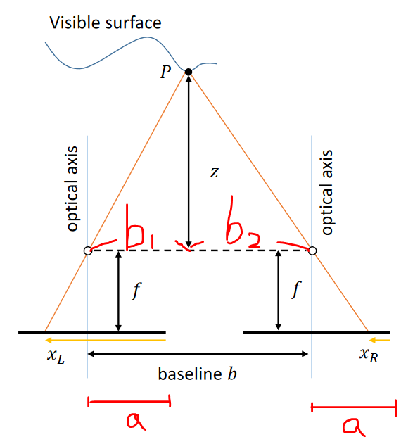  
   XL = ，XR =   
   d = XL - XR = =

得證之

1. 本題使用課堂上提及的*Fast Cost-Volume Filtering for Visual Correspondence and Beyond* 這篇論文實作。  
     
   cost computation: Square Distance (L2 distance)  
   cost aggregation: Joint Bilateral Filtering  
   disp. optimization: WTA (Winner Take All)

disp. refinement: Left-right Consistency Check, Hole Filling, Median Filtering  
  
  
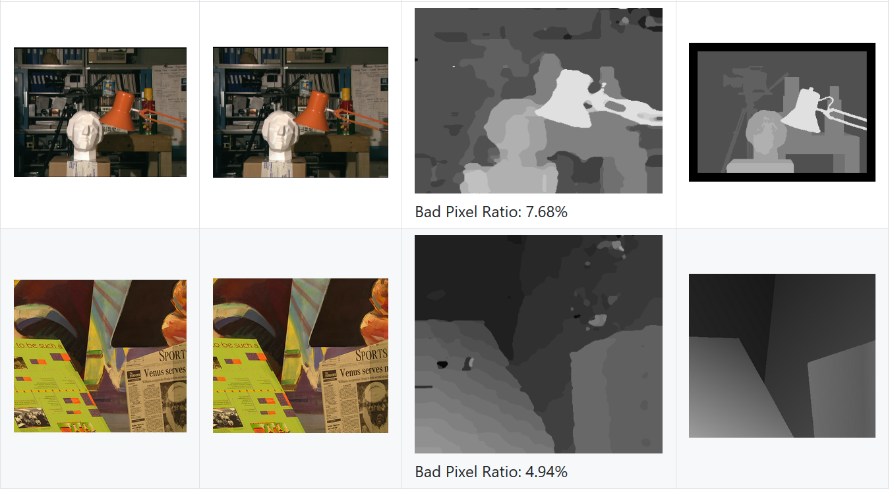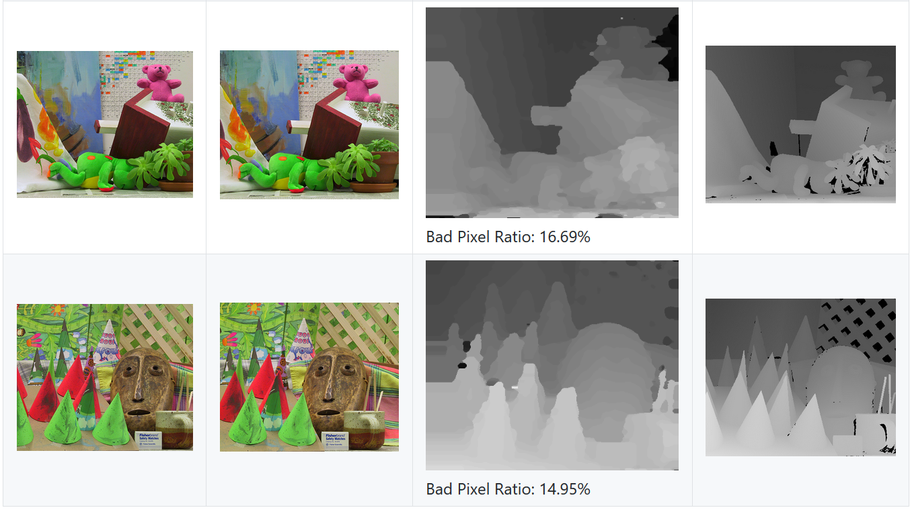 Average: 11.07%